Health Schemes

Background
In January 1995, the National Health Insurance Law of 1994 entered into force, establishing compulsory health insurance for every resident. The law prohibited health management organizations (HMOs, kupot holim) from denying insurance to anyone, and it established insurance fees based on a resident’s income and a specified rate. Unemployed residents are also required to pay health insurance based on a minimum that is periodically updated. The enactment of this law, one of the most important social laws adopted since Israel’s founding, marked the end of a struggle for the provision of healthcare services, which had begun even before statehood.
To a large extent, Israel’s healthcare services can only be characterized as a “healthcare system” since the British Mandate era. Until then services were provided primarily by local and voluntary organizations, with almost no planning, management, or central coordination. The Ottoman government provided some health services, which focused mainly on public health issues such as quarantine centers, examinations of immigrants, and a limited selection of government medical services. During the British Mandate era, an infrastructure of community and hospital-based healthcare services gradually developed, and with the founding of the state this infrastructure steadily expanded, alongside the spread and growth of the population. The main difference was that before statehood this system had been voluntary and operated in parallel to the British Mandate system, which created tension and redundancy. Nonetheless, the healthcare infrastructure that served the pre-state Jewish population had a very strong community network, including clinics in peripheral locations as well as prenatal and early childhood healthcare centers (tipot halav), among other services, and this provided an important foundation once Israel achieved statehood. The Mandatory government invested in public health as well, primarily to prevent the spread of contagious diseases, whereas it invested relatively little in the hospital system. The infrastructure of military hospitals developed by the British during World War II provided a foundation for military hospitals after Israel was founded. In the 1950s these were transferred to the Ministry of Health in what was meant to be an interim arrangement prior to their transfer to local authorities, a process that never took place and left the Ministry of Health responsible to this day for many hospitals, some of which are spread across several old facilities – as exemplified by Sheba Hospital and Assaf HaRofeh Medical Center. This contrasts with the manner in which the HMO Klalit constructed its hospital network, which began even before Israel’s founding and was based on infrastructures of higher quality. Another hospital system that the State of Israel “inherited” is the Hadassah network of hospitals, which, with the exception of Jerusalem, were transferred to other entities. Hadassah Tel Aviv, for example, was transferred to the Tel Aviv municipality as early as the 1930s.
A survey of developments in the healthcare system since the 1920s indicates that to a large extent those years shaped the character and organization of the healthcare system in Israel prior to passage of the National Health Insurance law, and to some extent to this day. The characteristics of this healthcare system included:
- A pluralistic healthcare network comprising many institutions and organizations.
- Adoption by the pre-state Jewish community leadership of a model based on HMOs in many aspects within the purview of the state-in-the-making, as practiced in various European countries. Later the healthcare system adopted certain characteristics of centralized control, on the one hand, and a market economy, on the other, thus making it more of a “mixed” than a distinct model. Even before statehood, the principles of relatively accessible care for the community, including in remote areas, and the political ideological composition of health organizations constituted unique features of the healthcare system, and they continue to shape its nature today.
- Financial activity characterized by a permanent deficit.
- Direct provision of health services by the Ministry of Health, alongside its ministerial functions.
- Direct provision of health services by the HMOs, alongside their role as an insurer.(1 p27-38)
After many attempts to enact a national health insurance law, the right political moment eventually arrived. It had first been necessary to separate Histadrut HaOvdim HaKlalit (the national trade union association) from Kupat Holim Klalit (the HMO originally affiliated with the Histadrut) at the political level, while also allowing the economy and healthcare policy to mature sufficiently. In the early 1990s, the political, economic, and professional conditions became ripe for legislation of the law on which Israel’s healthcare system is now based.
The guiding principle underpinning the National Health Insurance Law is that medical care in Israel is to be provided on the basis of medical justification, independently of the financial means of the insured. The law also defined a uniform basket of medical services that HMOs must provide, with government oversight over the operations of the HMOs. In addition to compulsory insurance, HMOs were granted the option of offering complementary insurance to the insured, for additional services not included in the public medical services basket. Health insurance fees are paid via the National Insurance Institute, allowing for fair competition among the HMOs, freedom of choice for citizens to select their preferred HMO, focused dues collection as needed, and guaranteed income for the HMOs. At the same time, the responsibility for managing the Ministry of Health’s budget was delegated to the Ministry of Finance.
The fees are collected by a single national entity – the National Insurance Institute. The public sources of funding for the HMOs are determined on the basis of capitation (accounting for 88.5% of all funding sources), that is, according to the number of insureds in each HMO, weighted by age and other socio-demographic factors. This mechanism is an important means for implementing the system’s policy of resource allocation. Its structure and implementation represent the financial expression of the system’s structure, management, precedence, and concept of social justice. Given that there is variance in the consumption of services across different age groups, allocations are based on the relative weight of each group in relation to its consumption of the medical services covered by the basket of services for which HMOs are responsible. Furthermore, for five severe diseases (end-stage renal failure, Gaucher disease, hemophilia, thalassemia, AIDS), HMOs receive an additional budgetary allocation based on the actual number of patients because these diseases are highly responsive to treatment. These days, in light of the changing reality, the Ministry of Health is formulating a new model for capitation and the designation of severe diseases.
In addition, HMOs are entitled to charge members a deductible fee for some of the services in the services basket. The Ministry of Health updates the maximum deductible that HMOs may charge for services and drugs approved by the Finance Committee of the Knesset (Israeli parliament). The original purpose of the deductible was to prevent the overuse of services (a market failure termed “moral hazard”), but in time it became a system for collecting fees from members. Having a deductible for some of the services constitutes a heavy burden for patients, undermines equality, and increases economic gaps within the population.
The following sections discuss the characteristics of morbidity and health in Israel and their impact on health needs.

Morbidity characteristics in Israel, with attention to demographic distribution
In the past decade there has been a decline in the mortality rate in Israel for most of the leading causes of death indicated as the underlying cause of death. Notably, the mortality rate among men and women for all deaths, adjusted by age, declined by 25% during 2000-2015. In the past year it rose by 3% among men and 1% among women.
In 2016 Israel recorded 43,966 deaths. Since 1999 the leading cause of death in Israel for both men and women has been cancer, and the second leading cause has been heart disease.
During 2013-2015, on average, cancer was the leading underlying cause of death for all ages, as well as for women aged 15-74 and men aged 25 and above. Heart disease was the leading cause among women aged 75 and above, and the second leading cause among men aged 45 and above and women aged 45-74. Accidents were the leading cause of death among men aged 15-24, and the second leading cause among men aged 25-44 and women aged 15-44. Suicide was the second leading cause among men aged 15-44 and the third leading cause among women age 15-44.

Age-adjusted mortality rate per 100,000 persons (2)
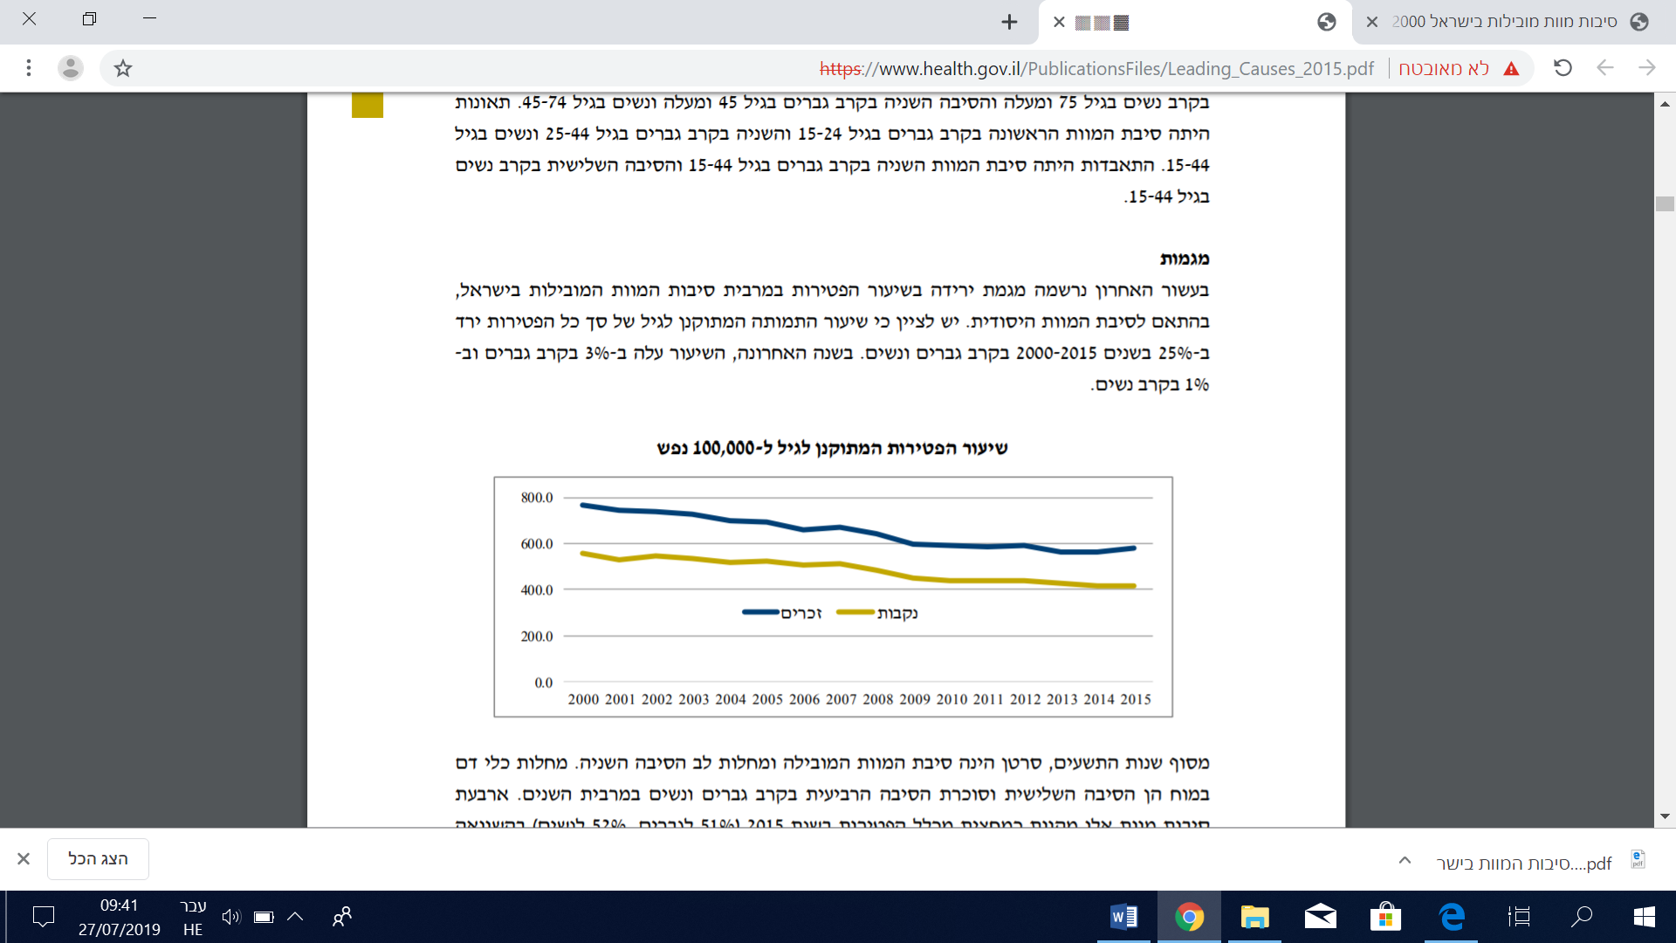
Since the end of the 1990s, cancer has been the leading cause of death and heart disease the second leading cause. Cerebrovascular diseases were the third leading cause and diabetes was the fourth among men and women in most of the years. These four causes accounted for approximately half of all deaths in 2015 (51% for men, 52% for women), compared with higher percentages in 2000 (57% for men, 60% for women).

Causes of death by gender (percentage)
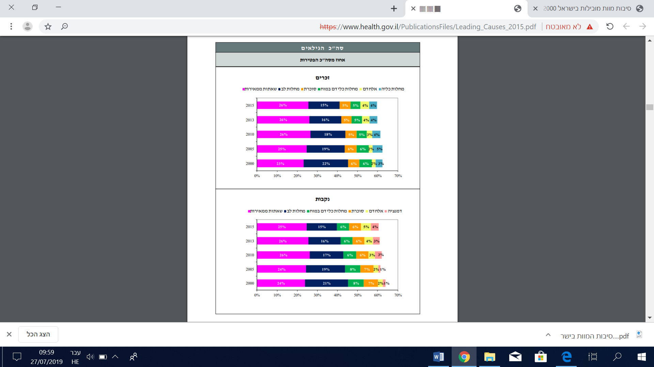
The age-adjusted mortality rate for heart diseases decreased significantly over the past decade, by 33% for men and 37% for women for the years 2013-2015, on average, relative to 2004-2006. A considerable decrease was also recorded for cerebrovascular diseases (32% for men, 35% for women), diabetes (25% for men, 29% for women), and kidney diseases (40% for men 38% for women). A relatively large decrease was also recorded for deaths caused by accidents (30% for men, 39% for women) and chronic lower respiratory diseases (16% for men, 22% for women).
For some causes of death an increase was recorded during 2013-2013, on average, relative to 2004-2006. The highest increase in mortality rate was recorded for dementia, by a factor of 2.5 for women and nearly 3 for men. A considerable increase was also recorded for deaths caused by septicemia (76% for men, 49% for women) and by Alzheimer’s disease (27% for men, 37% for women). The mortality rate for deaths caused by kidney diseases was increasing until 2006 and has been decreasing in recent years.

The 20 leading causes of death – percent of change 2004-2006 / 2013-2015 (age-adjusted mortality rate per 100,000 persons) (2)

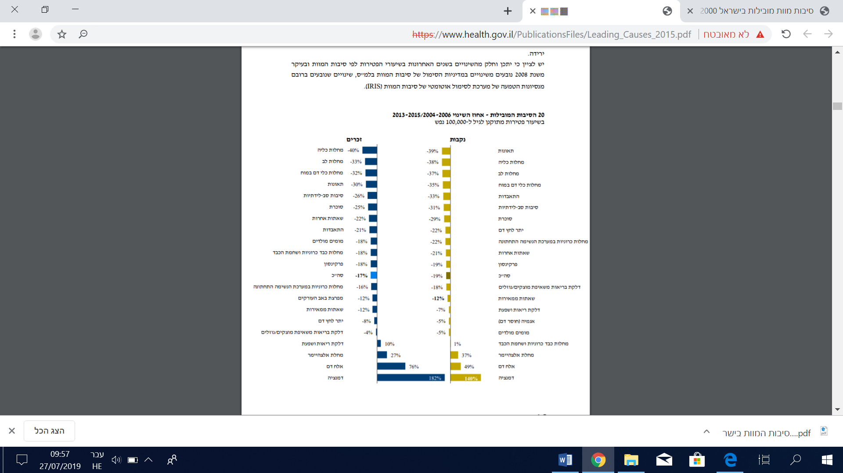

The distribution by sub-districts indicates differences in mortality rates by a factor of up to 1.6. The sub-districts of Be’er Sheva, the Jezreel Valley, and Acre had higher mortality rates than the Judea and Samaria Area, Rehovot, Petah Tikva, and the Golan Heights.

Overall adjusted mortality rates by sub-district, 2017
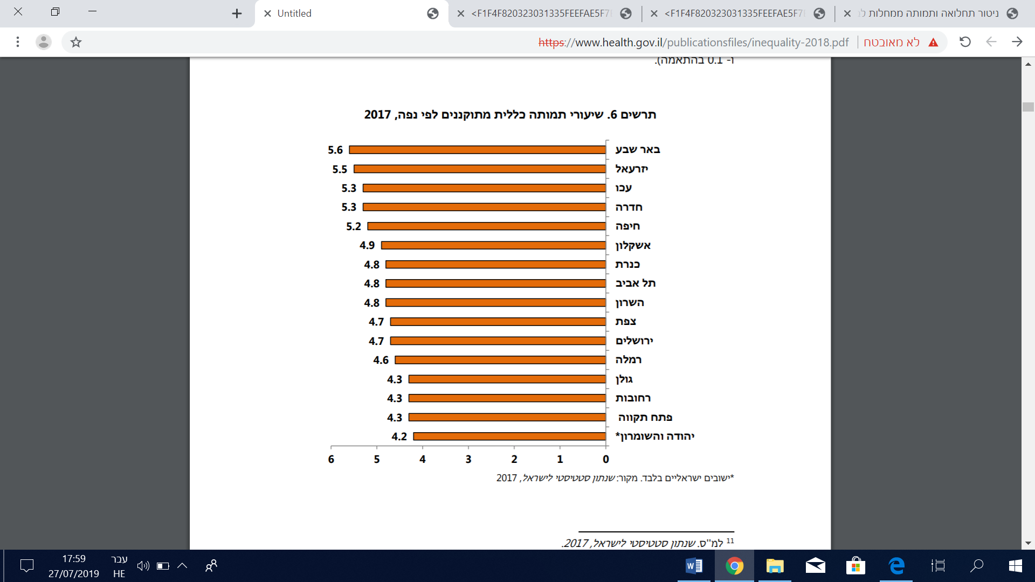
Cancer morbidity
The incidence of cancer varies generally by location and specifically across sub-districts, although a number of sub-districts consistently recorded values that differed from what was expected throughout or during most of the periods: The Haifa sub-district recorded a significant excess morbidity rate for most types of cancer examined (excluding prostate cancer in men) during most or all of the periods (excess morbidity varied between 9% and 14%). The Tel Aviv sub-district also recorded a significant excess morbidity rate for some types of cancer during all or most of the periods (3%-6% for women), as did the Ashkelon sub-district among men (6%-9%), the Rehovot sub-district among men (5%), and the Petah Tikva sub-district among women (4%). In contrast, the Jerusalem sub-district recorded a significantly lower than expected cancer morbidity rate among both genders for most types of cancer (excluding non-Hodgkin’s lymphoma) during most or all periods. The Jezreel Valley, Sea of Galilee, and Acre sub-districts also recorded low morbidity rates for some types of cancer during all or most of the periods.
In 2013 the International Agency for Research on Cancer (IARC) of the World Health Organization classified outdoor air pollution as carcinogenic to humans and noted a positive association with an increased risk of bladder cancer. According to current data on cancer incidence, excess lung cancer rates were recorded among men in the sub-districts of Hadera, Haifa, Jezreel Valley, Sea of Galilee, and Acre, and among women in the sub-districts of Haifa and Tel Aviv. The greatest excess during the latest period (2011-2015) was recorded in the Acre sub-district among men (38%) and the Tel Aviv sub-district (24%).(3)

Incidence of cancer across sub-districts by gender
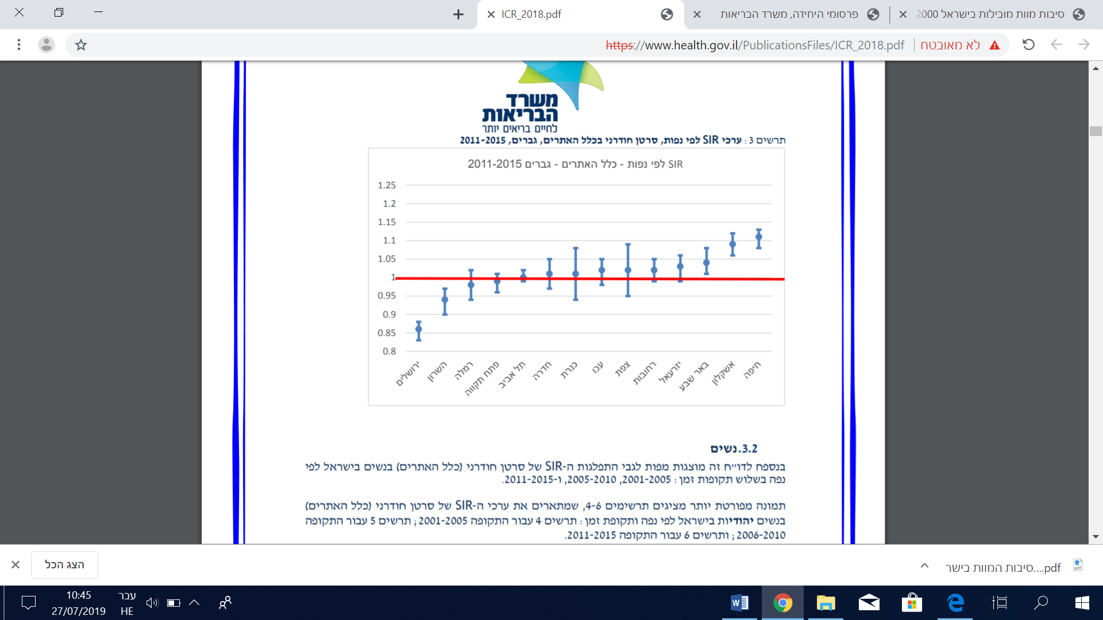
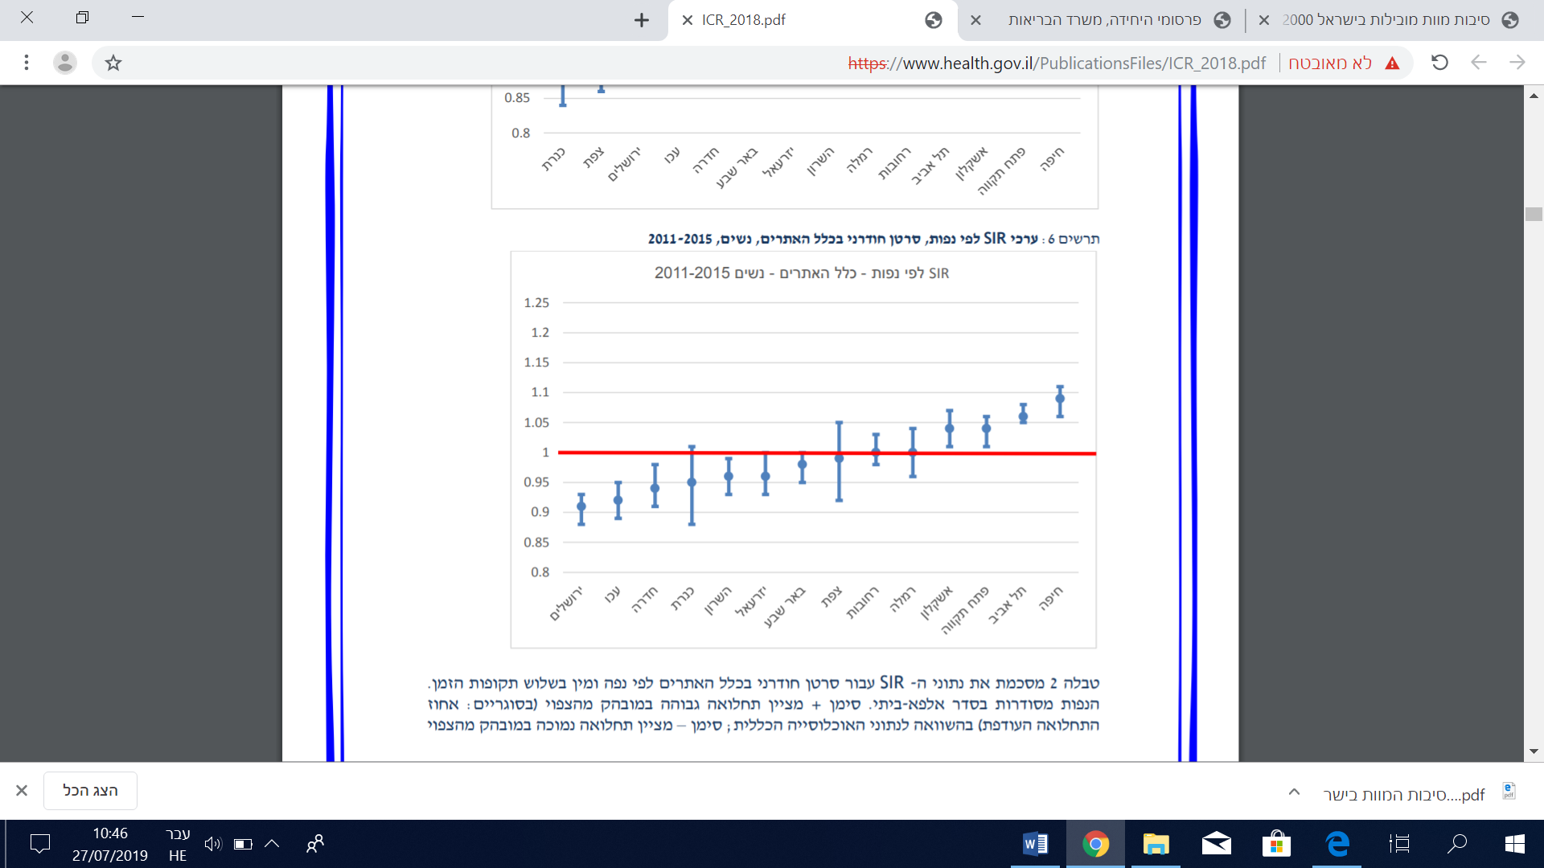

In 2016 Israel recorded a total of 30,569 cases of tumors that required reporting to the cancer registry. Of the reported cancer cases, 88% were malignant – 12,553 (47%) among men and 14,380 (53%) for women. Among the men, 84% were Jewish, 10% were Arab, and 5% were classified as other. Among the women, 84% were Jewish, 10% were Arab, and 6% were classified as other.
The main types of cancer, accounting for more than 50% of all the morbidity cases among men in Israel, were the same for Jews and Arabs. They included prostate cancer, lung cancer, colorectal cancer, non-Hodgkin’s lymphoma, and bladder cancer. Among Jewish men, however, prostate cancer accounted for 17% of all malignant tumors, compared with a figure of 9% for Arab men, and malignant melanoma accounted for 5.5%, whereas among Arabs it is very rare (<1%). In addition, among Arab men lung cancer accounted for 22% of all malignant tumors, compared with 12% among Jewish men.
Among Jewish and Arab women, likewise, there were similarities in the most prevalent types of cancer. For both population groups breast tumors accounted for about one third of all tumors, and colorectal tumors for about 9%-10%. Lung cancer, thyroid cancer, non-Hodgkin’s lymphoma, and uterine cancer were also prevalent among women.(3)

Percentage of all new cancer cases in 2016 by location, gender, and population group (malignant tumors only)
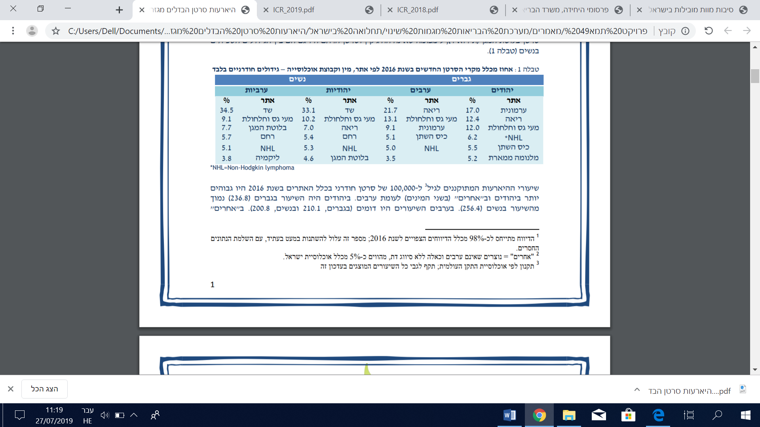
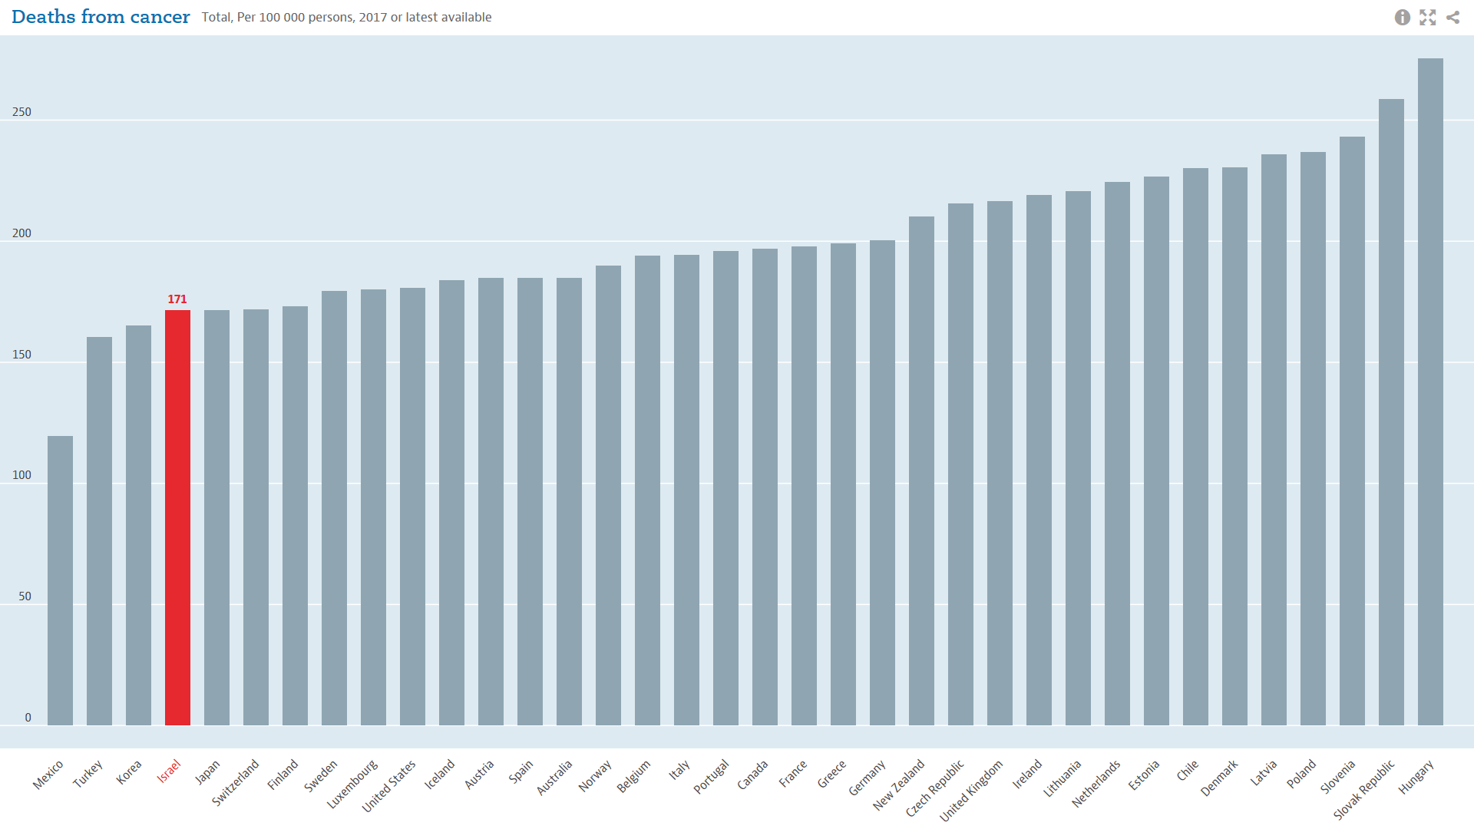

Heart diseases
In recent years heart diseases have been the second-leading cause of death in Israel among men aged 45 and above and women aged 45-74. The main behavioral risk factors for heart disease are smoking, nutritional imbalance, and lack of physical activity, which result in high blood pressure, high LDL cholesterol levels, overweight and obesity.
All heart diseases: These occur among both Jews and Arabs. Heart disease rates are higher among men, and the highest rate is among Jewish men. The rate among Jewish men is about 29% higher than the rate among Arab men. The rates among women are nearly identical between the two population groups.
Coronary heart disease: The rates are higher among men, with the highest rate among Jewish men. The rate among Jewish men is about 24% higher than among Arab men. The rate among Jewish women is about 69% higher than the rate among Arab women.

Incidence of heart disease diagnosed by a physician, Israel National Health Interview Survey (INHIS) (rates weighted by age)
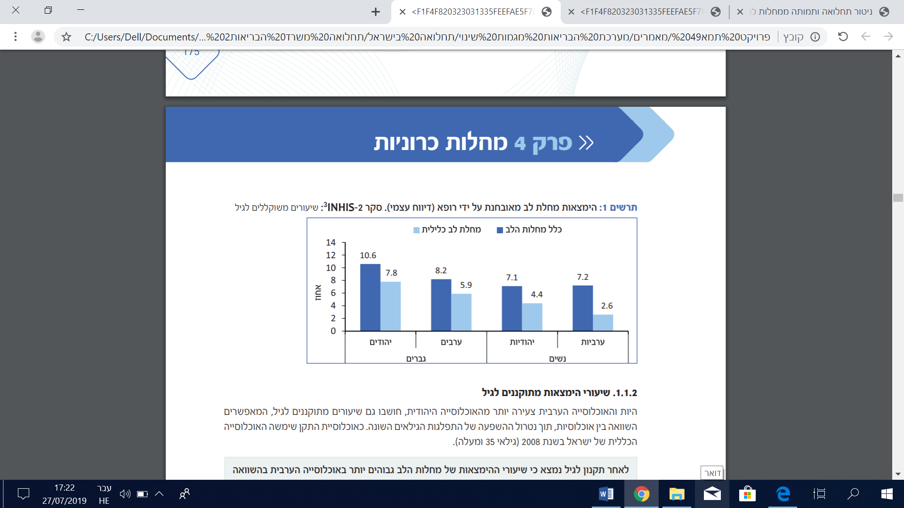
The incidence of heart disease is higher among men than among women for all age groups. The frequency of heart diseases increases with age for both genders. The rates of incidence peak at ages 75 and above, with 42.0% for men and 31.0% for women.

Incidence of heart disease diagnosed by a physician, INHIS (rates weighted by population group)
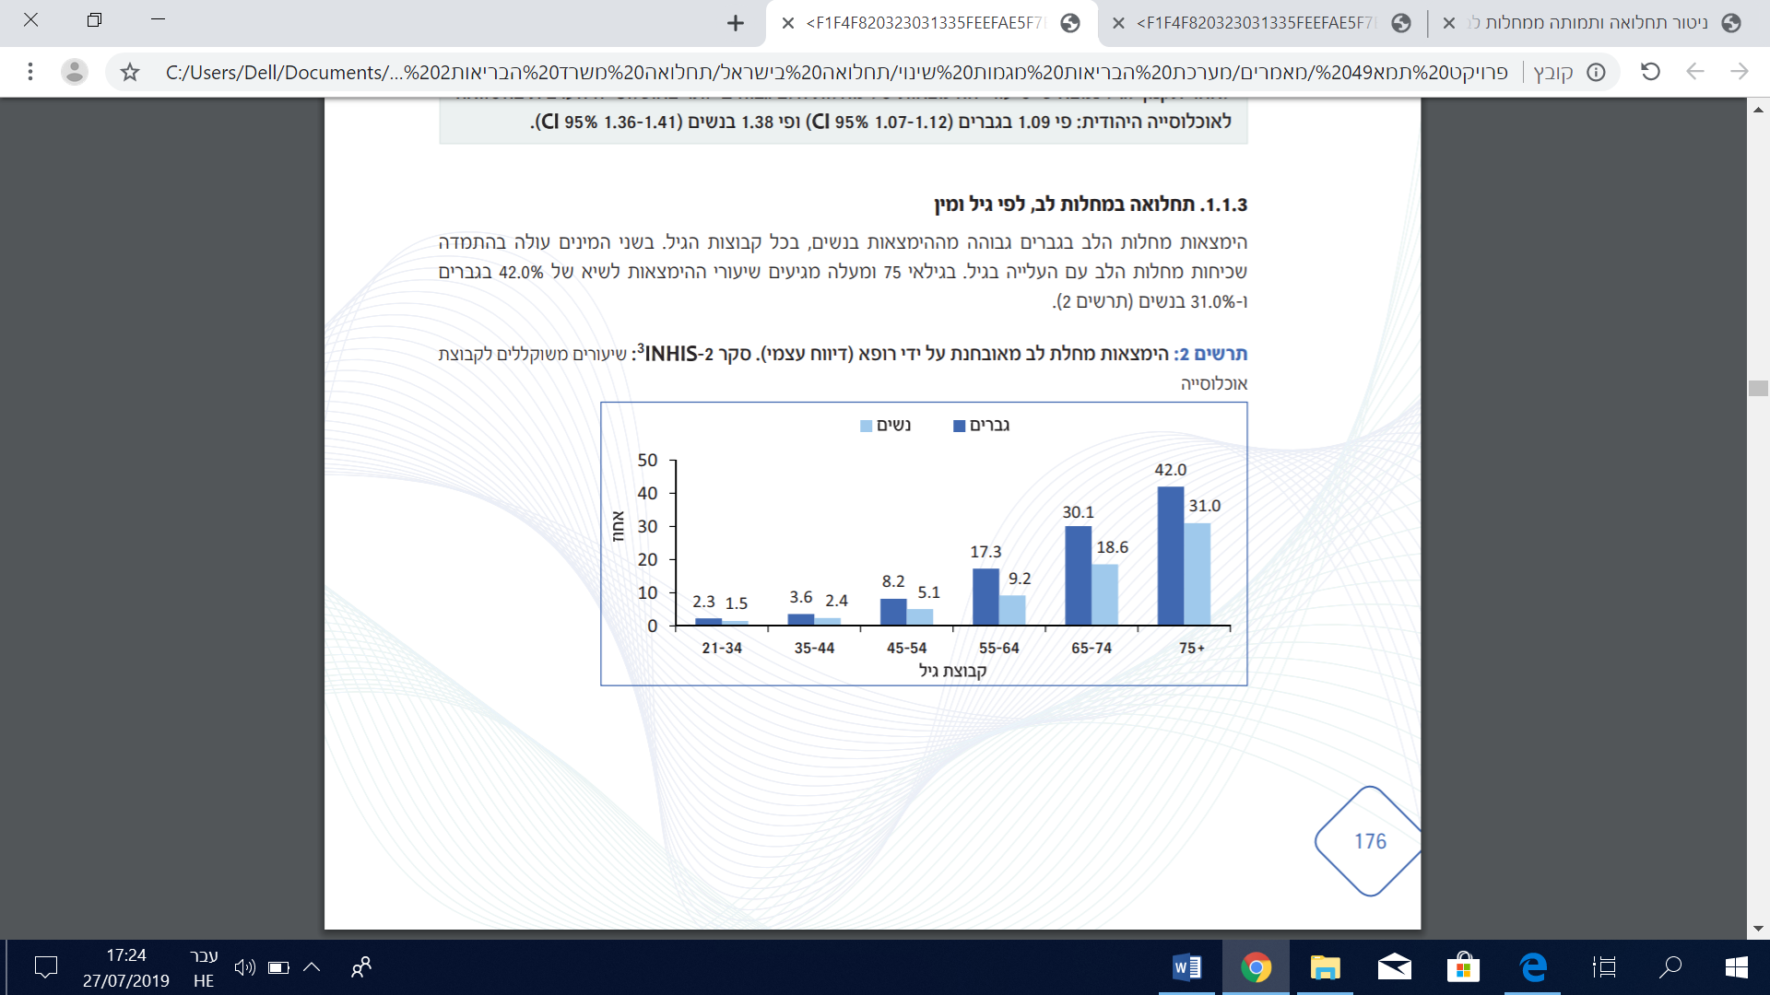
Heart disease rates among young men (up to age 45) are relatively low, and are comparable for Jews and Arabs. For ages 45-64, heart disease rates are higher among Arabs, and for age 65 and above the rates are higher among Jews. Among Jewish men the morbidity rates increase sharply at ages 65 and above, whereas they increase moderately among Arabs.
Among women, Arabs have higher rates of heart diseases, until age 75. At ages 75 and above, Jewish women have higher rates, although it should be noted that that the rate among Arab women is based on a very small number of cases within this age group. As with the men, among Jewish women there is a sharp increase in morbidity at ages 65 and above, compared with a moderate increase followed by steady rates among Arab women.

Incidence of heart disease diagnosed by a physician, by age and population group, INHIS
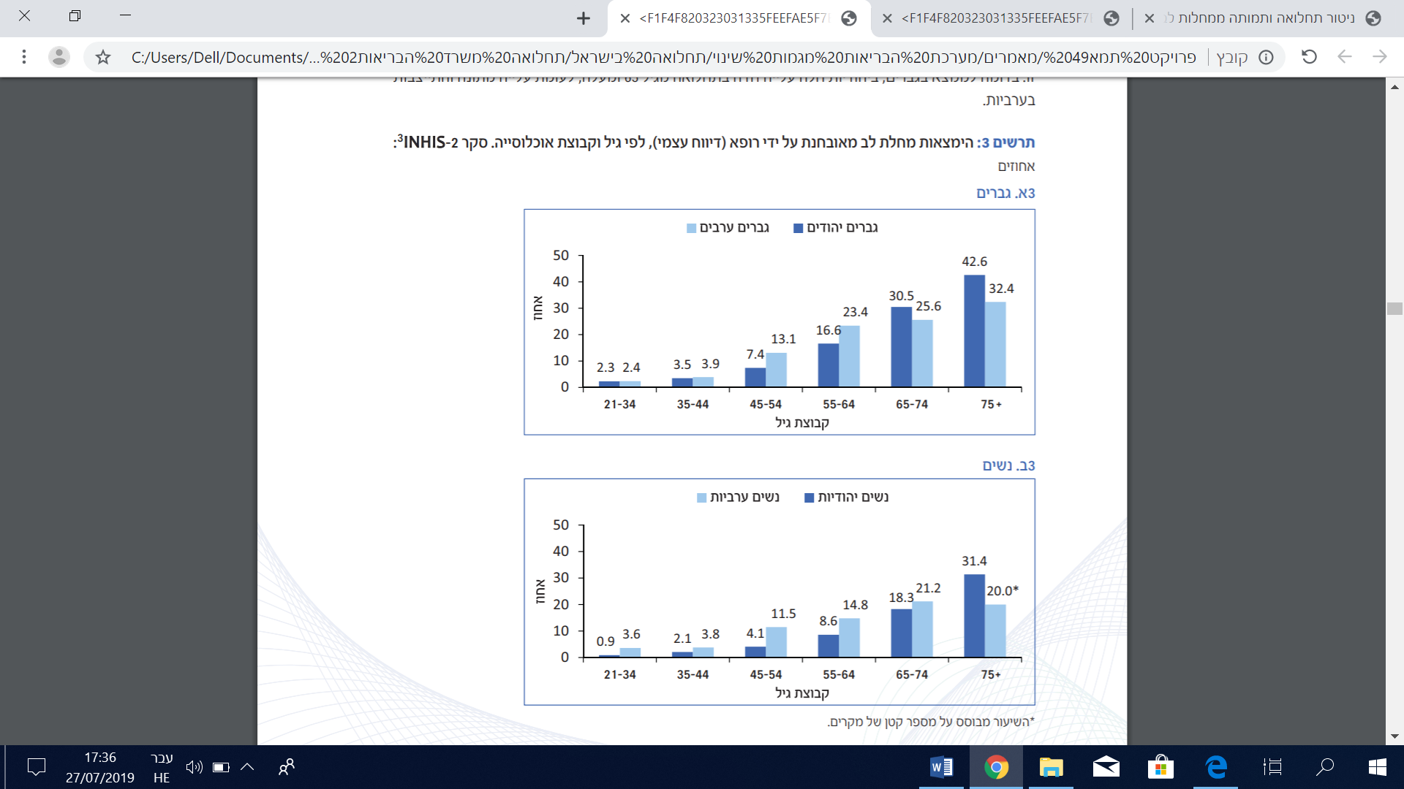
The coronary heart disease morbidity rates in Israel are lower than in most OECD states, for both men and women. Of the 33 OECD member states, Israel is ranked 25 for men and 23 for women.(4)

Coronary heart disease morbidity rates in Israel and other OECD countries by gender, 2010 (age-adjusted rates per 100,000)
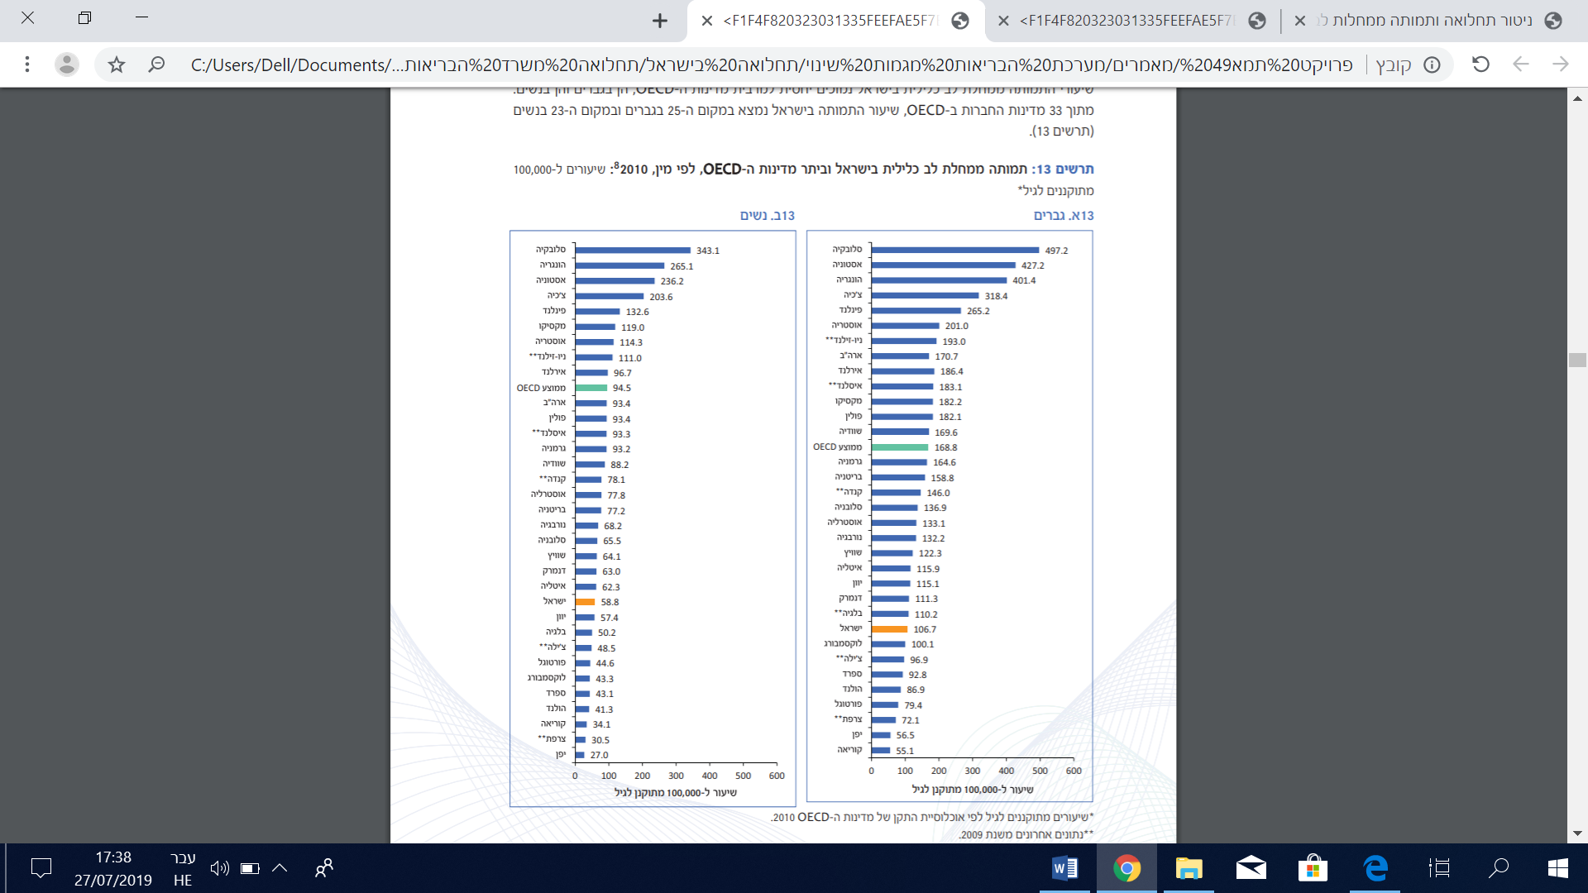
Stroke
Each year about 15 million people experience a stroke, which is a manifestation of cerebrovascular disease. The leading risk factors for a stroke are smoking and high blood pressure. Cerebrovascular diseases have been the fourth leading cause of mortality in Israel since 2008. Recent years have seen a decrease in the incidence of strokes in many developed countries, primarily as a result of increased attention to risk factors such as high blood pressure and smoking. At the same time, the absolute number of strokes is rising because the population is aging.
The incidence of strokes is higher among the Jewish population than the Arab population for both men and women. In both population groups, the incidence is significantly higher for men, by a factor of 2 for Jewish men compared with Jewish women and 1.5 for Arab men compared with Arab women.

Incidence of a stroke diagnosed by a physician for ages 45 and above, by gender and population group, INHIS (rates weighted by age).
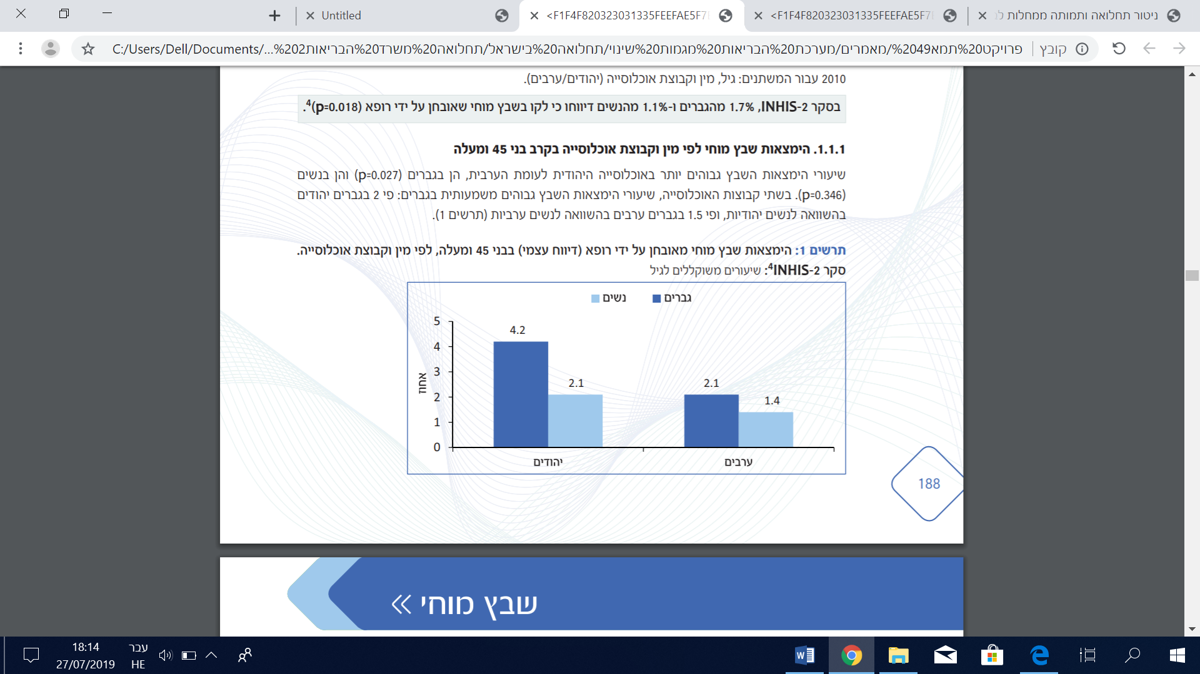
The incidence of strokes increases with age for both men and women. In the 55-64 age group there is a sharp increase in strokes among men, which continues at a more moderate rate for ages 65 and above. Among women, in contrast, there is a sharp increase at later ages (65-74), which continues in the age group of 75 and above. Below age 75 the rates among men are significantly higher than among women. The rate among men is higher by a factor of 1.5 than the rate among women at young ages (35-54) and higher by a factor of 3.6 in the 55-64 age group. At ages 65-74 the discrepancy diminishes, and at ages 75 and above the incidence of strokes is nearly identical among men and women (6.8% and 7.1%, respectively).(4)

Incidence of strokes diagnosed by a physician, by age and gender, INHIS, (rates weighted by population group)
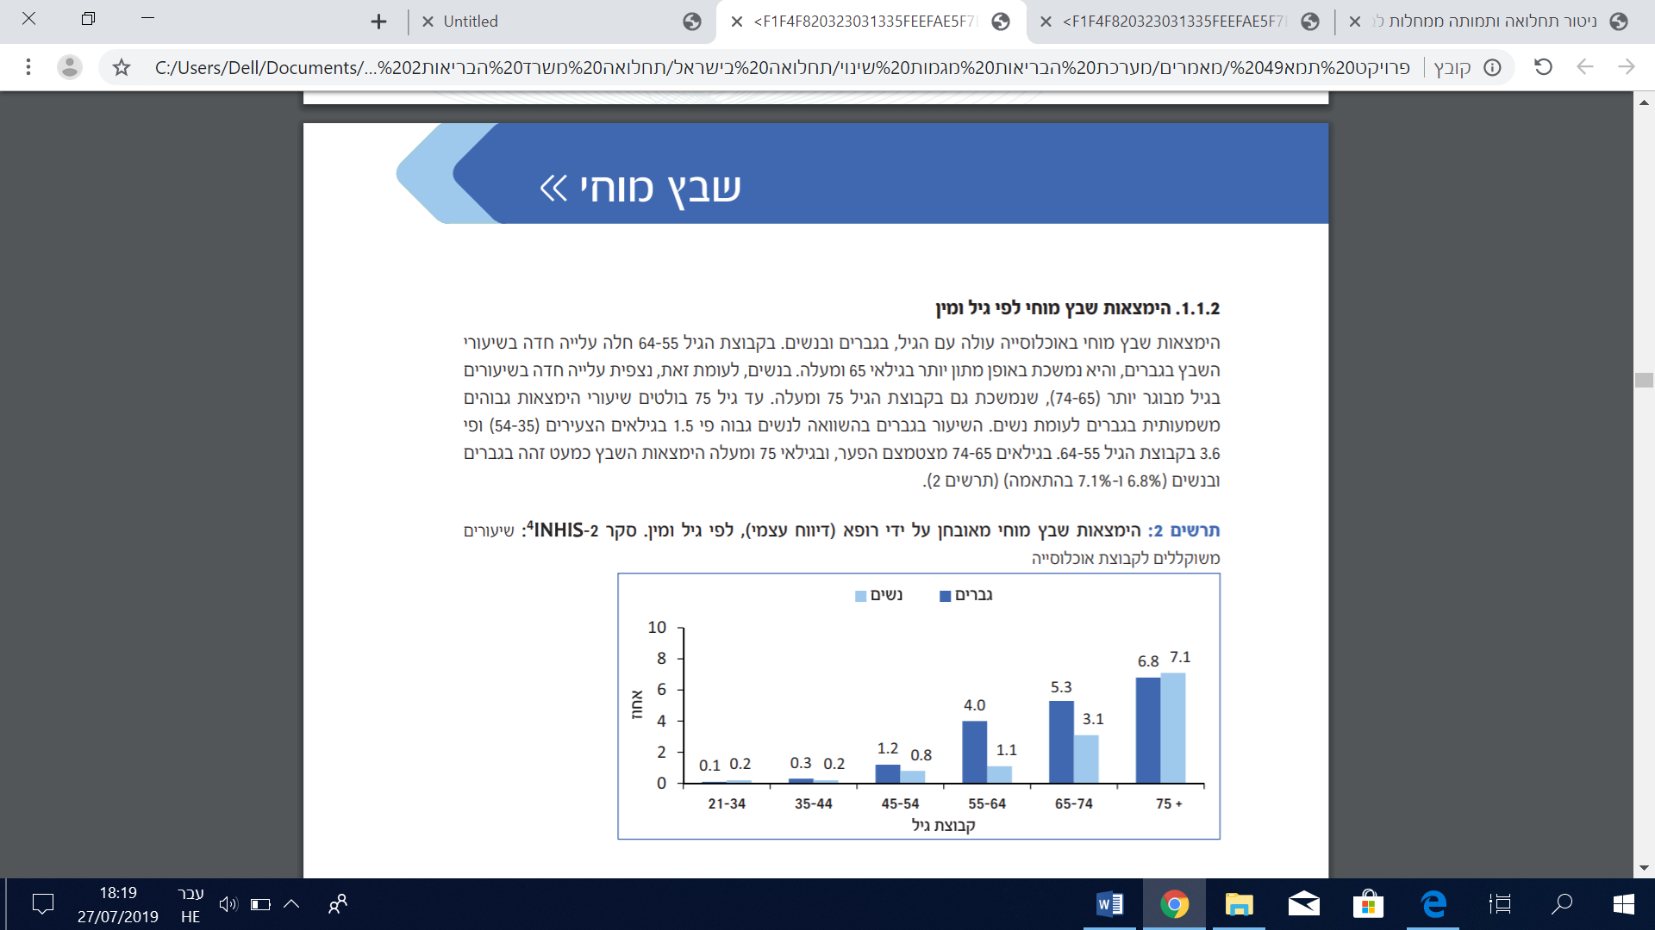
The mortality rates for strokes in Israel are lower than those of most OECD countries. Israel is ranked 31 among 33 for both men and women.
Diabetes
Diabetes is a chronic disease characterized by a high concentration of glucose in the blood. There are three types of diabetes: Type 1 (juvenile onset) occurs before age 30 and characterizes about 10% of diabetes patients. Type 2 diabetes usually occurs after age 30 and its prevalence increases with age. About 90% of diabetes patients have this type. The risk factors for developing type 2 diabetes include family history, lack of physical activity, overweight, high blood pressure, and previous gestational diabetes, among others. The third type, gestational diabetes, first occurs or first manifests during pregnancy and its symptoms are similar to those of type 2 diabetes.(5)
The incidence of diabetes within the population increases with age (excluding ages 85+) among men and women. Among the 65-74 age group there is a sharp increase in diabetes for men as well as women, which continues at a more moderate rate at ages 75-84. The incidence of diabetes is higher among men than women for all ages.(6)

Rates of diabetes in Israel by gender and age
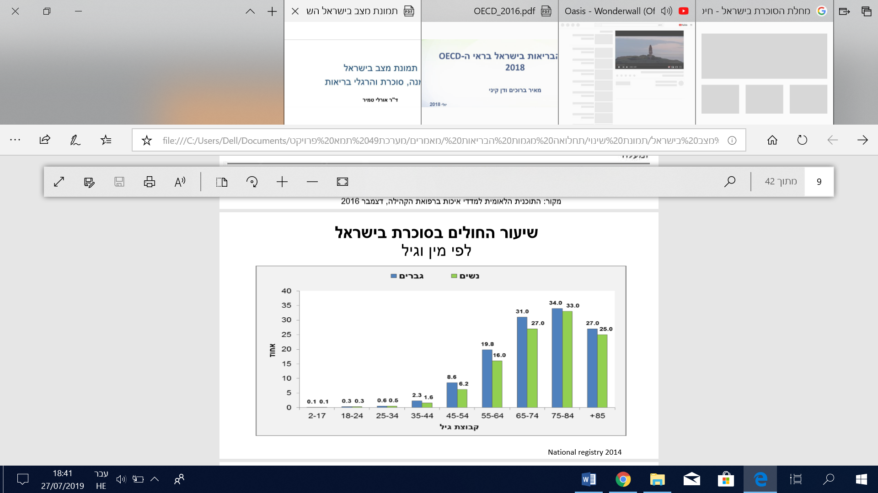

The incidence of diabetes is higher among the Arab population than the Jewish population for both men and women. In both population groups the incidence rises with age.

Incidence of diabetes among men by sector and age
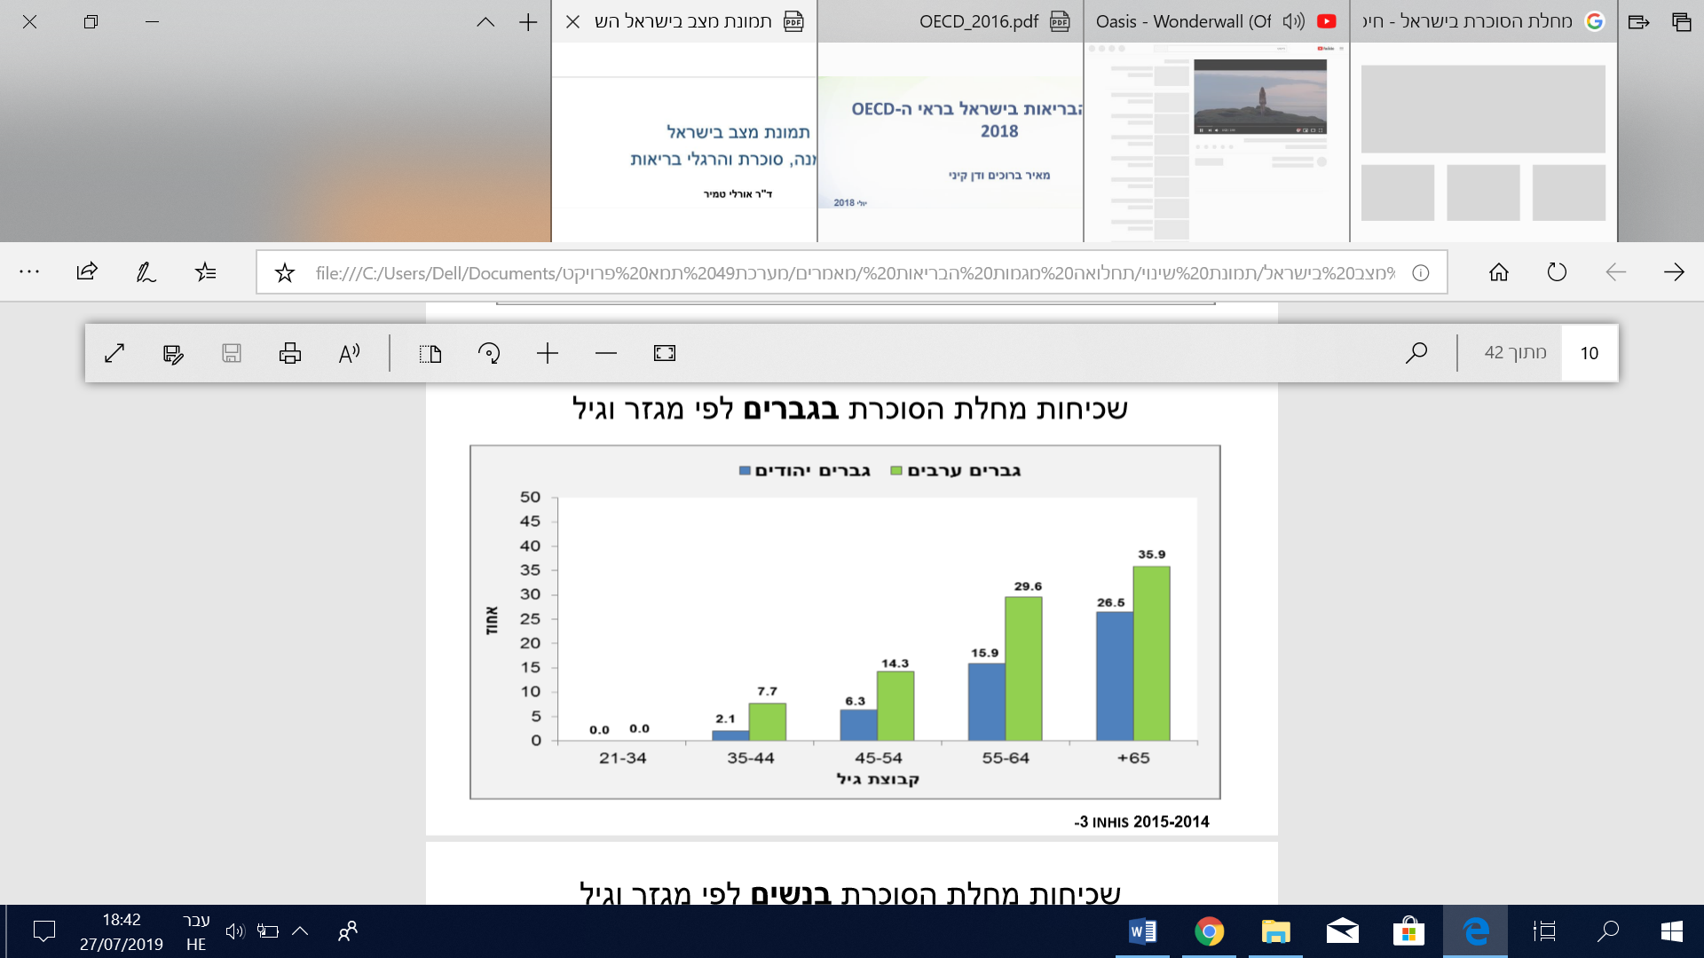

Incidence of diabetes among women by sector and age
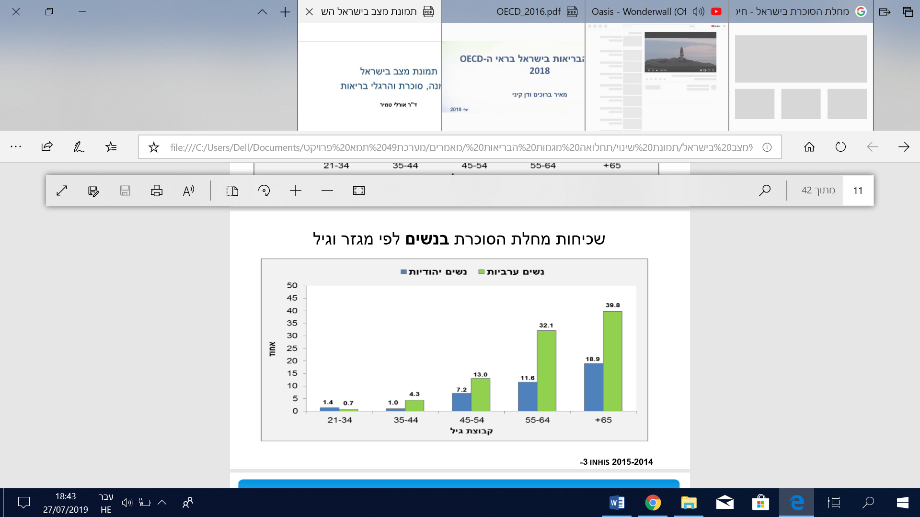

Diabetes incidence rates in Israel during 2002-2014 by socioeconomic status (7)

The above graph indicates a dramatic increase in diabetes, particularly among the socioeconomically disadvantaged.
(*) Socioeconomic status is based on entitlement to a waiver from paying a deductible when receiving services (as determined by the National Insurance Institute).
Notably, in 2011 the algorithm for assessing the incidence of diabetes was changed. It was expanded to include laboratory test results (thus the graph shows a sharp increase between 2010 and 2011).

Incidence of diabetes among Ethiopian immigrants: According to findings, the longer the immigrants have resided in Israel, the higher the incidence of diabetes among them. After 10 years of residence in Israel, the diabetes rate among Ethiopian immigrants reaches 17.6%.

Prevalence of diabetes among immigrants from Ethiopia as a function of duration of residence in Israel (6)
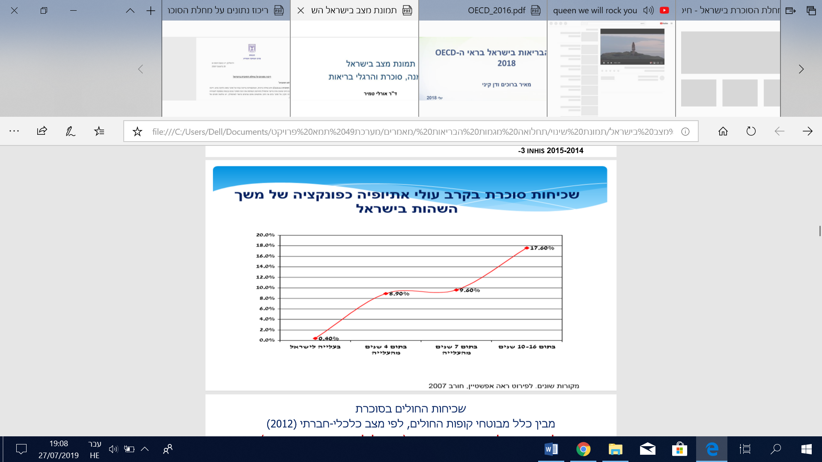
The prevalence of diabetes is higher among people with a low socioeconomic status (exempted from HMO deductible payments). The proportion of diabetics exempted from deductible payments is 4.5 times higher than the number of HMO members who are not exempted.

Percentage of HMO members with diabetes, by socioeconomic status
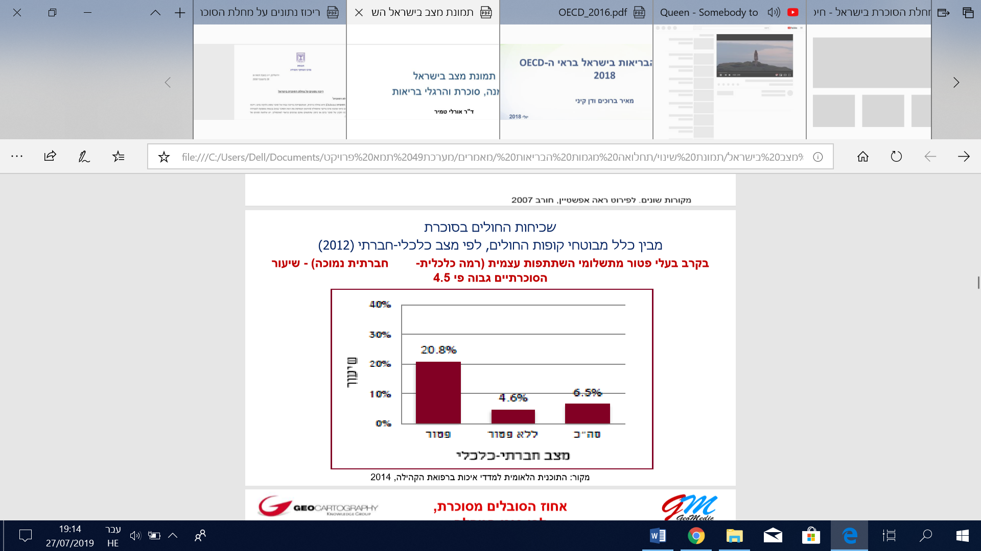
Among diabetics, the prevalence of controlled diabetes increases with age. Controlled diabetes was less frequent among diabetics aged 18-24 of both sexes (males: 41.6%, females: 48.5%) than diabetics aged 75-84 (males: 85.8%, females: 86.0%).(8)

Diabetics with well-controlled HbAlc levels, by age and gender, 2017
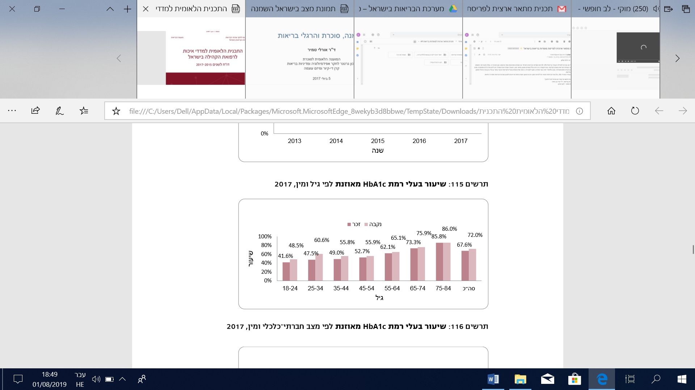
The prevalence of controlled diabetes among diabetics of both sexes is lower among people with a low socioeconomic status than people with a high socioeconomic status. As socioeconomic status increases, so too does the proportion of diabetics with controlled diabetes (for both sexes).

Diabetics with well-controlled HbAlc levels, by socioeconomic status and gender, 2017
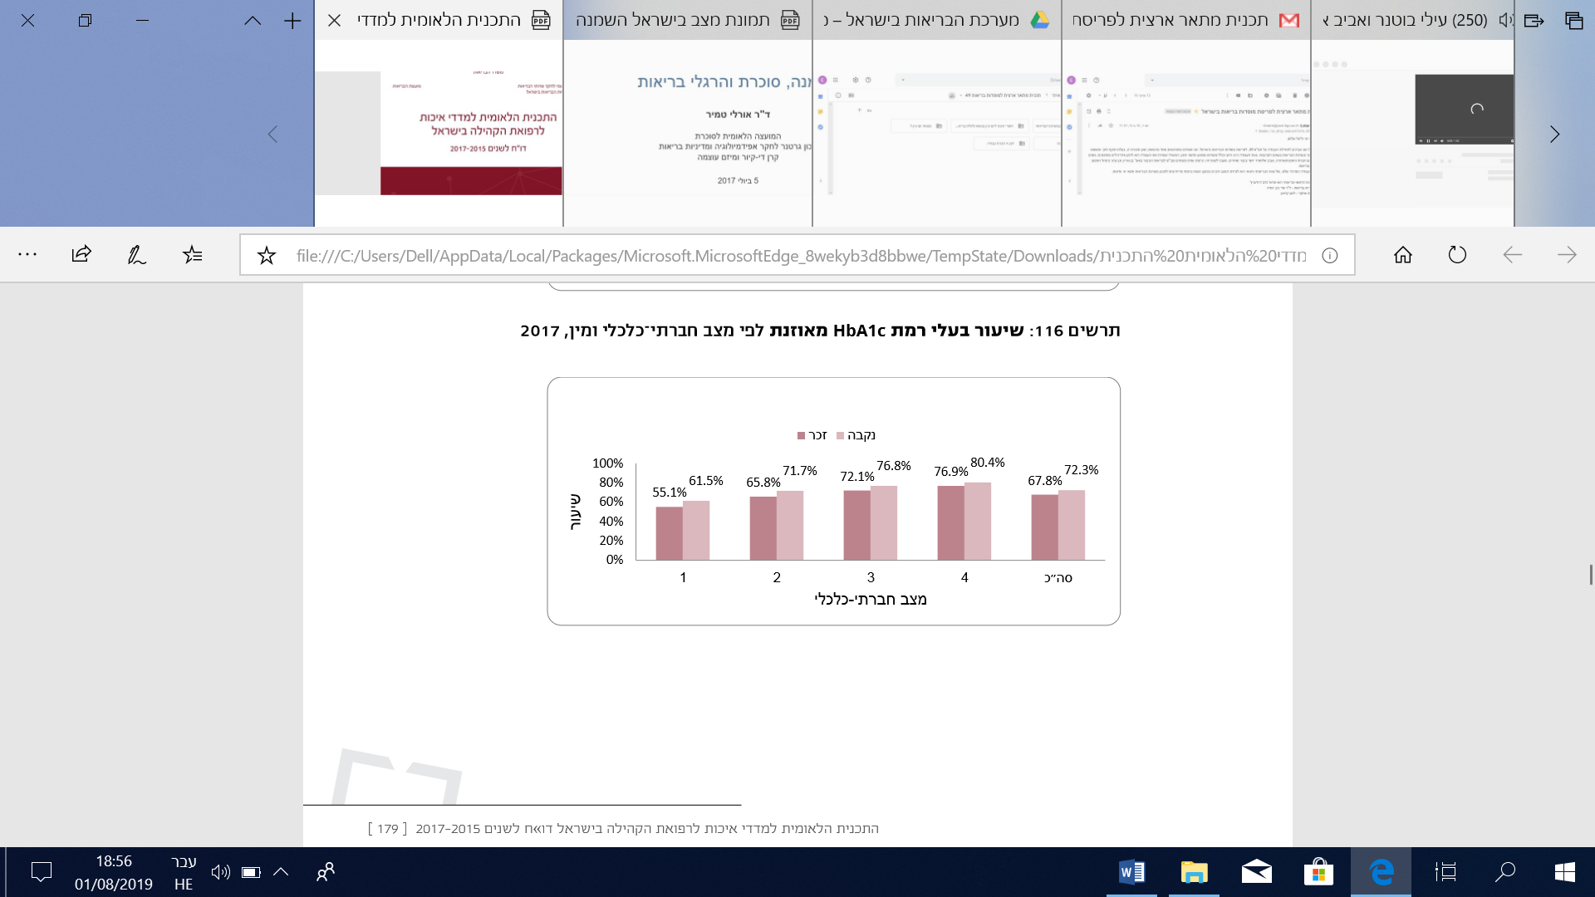

Lifestyle risk factors
Smoking
Cigarette smoking is one of the most dangerous behavior patterns in terms of health, as it causes many types of harm and severe diseases.
According to the Central Bureau of Statistics (CBS), as of 2017, 22.1% of people aged 20 and above reported that they smoke at least one cigarette per day – 29.9% of men and 14.7% of women. The highest rate of smoking was found among Arab men (47.5%). This was about 1.8 times the rate among Jewish men (25.8%). The lowest rate of smoking was found among Arab women (4.8%), which was significantly lower than the rate among Jewish women (16.2%). In both population groups smoking was found to be more prevalent among men than women, with a larger gender discrepancy in the Arab population. The rate of smoking among Jewish men was 1.3 times higher than the figure for Jewish women, whereas the rate of smoking among Arab men was 5.3 times higher than the figure for Arab women.

Rate of smoking among the adult population in Israel, by gender and population group (KAP Survey, 2017)
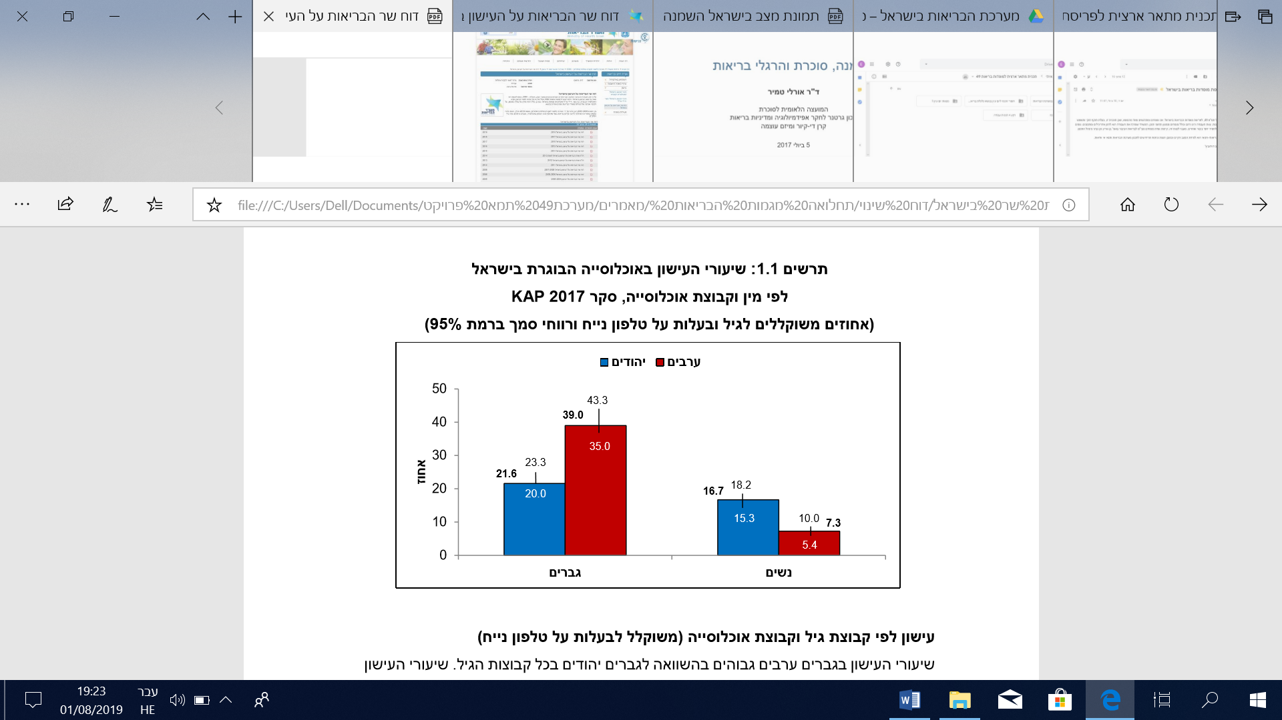
For all population groups the prevalence of smoking was found to be lower among interviewees with a high level of education (17.1%) than those with a low or medium level of education (23.2% and 29.1%, respectively). The highest rates of smoking were reported by interviewees with a medium level of education (29.4% for Jewish men, 29.0% for Jewish women, and 10.7% for Arab women), with the exception of Arab men, and the highest prevalence of smoking was found among those with a low level of education. For all levels of education, the rate of smoking was higher among Arab men than Jewish men, and higher among Jewish women than Arab women. The rate of smoking among Arab men with a high level of education was greater by a factor of 2 than the rate among Jewish men. The rate of smoking among Arab men with a low level of education was higher by a factor of 1.3 than the rate among Arab men with a high level of education. The rate of smoking among Arab women with a high level of education was lower by a factor of 2.2 than the rate among Jewish women with a high level of education.(9)

Rate of smoking among the adult population in Israel, by level of education and population group (KAP survey, 2017)
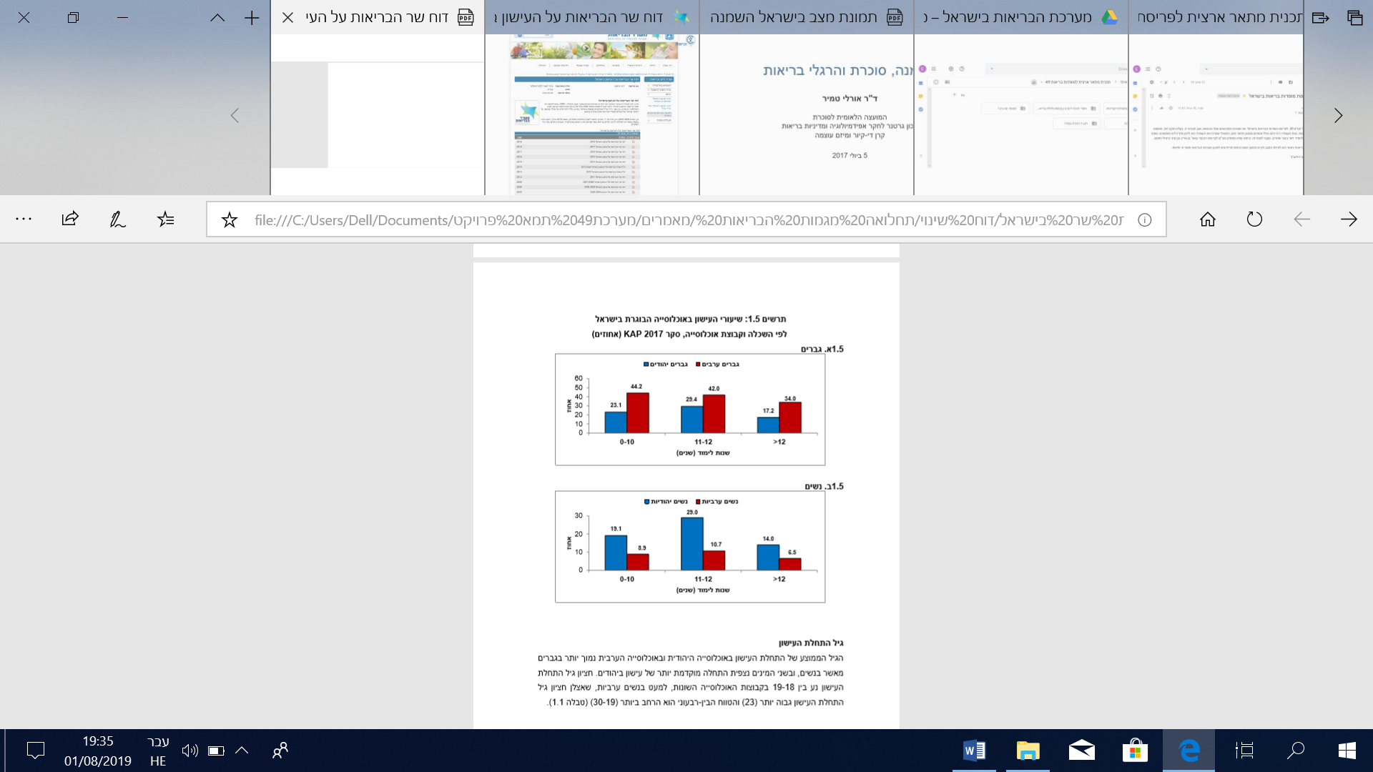
The percentage of smokers in Israel is relatively high compared with other OECD member states and 20% higher than the average for all OECD states.

Percentage of smokers aged 15 and above, Israel versus OECD states, 2016
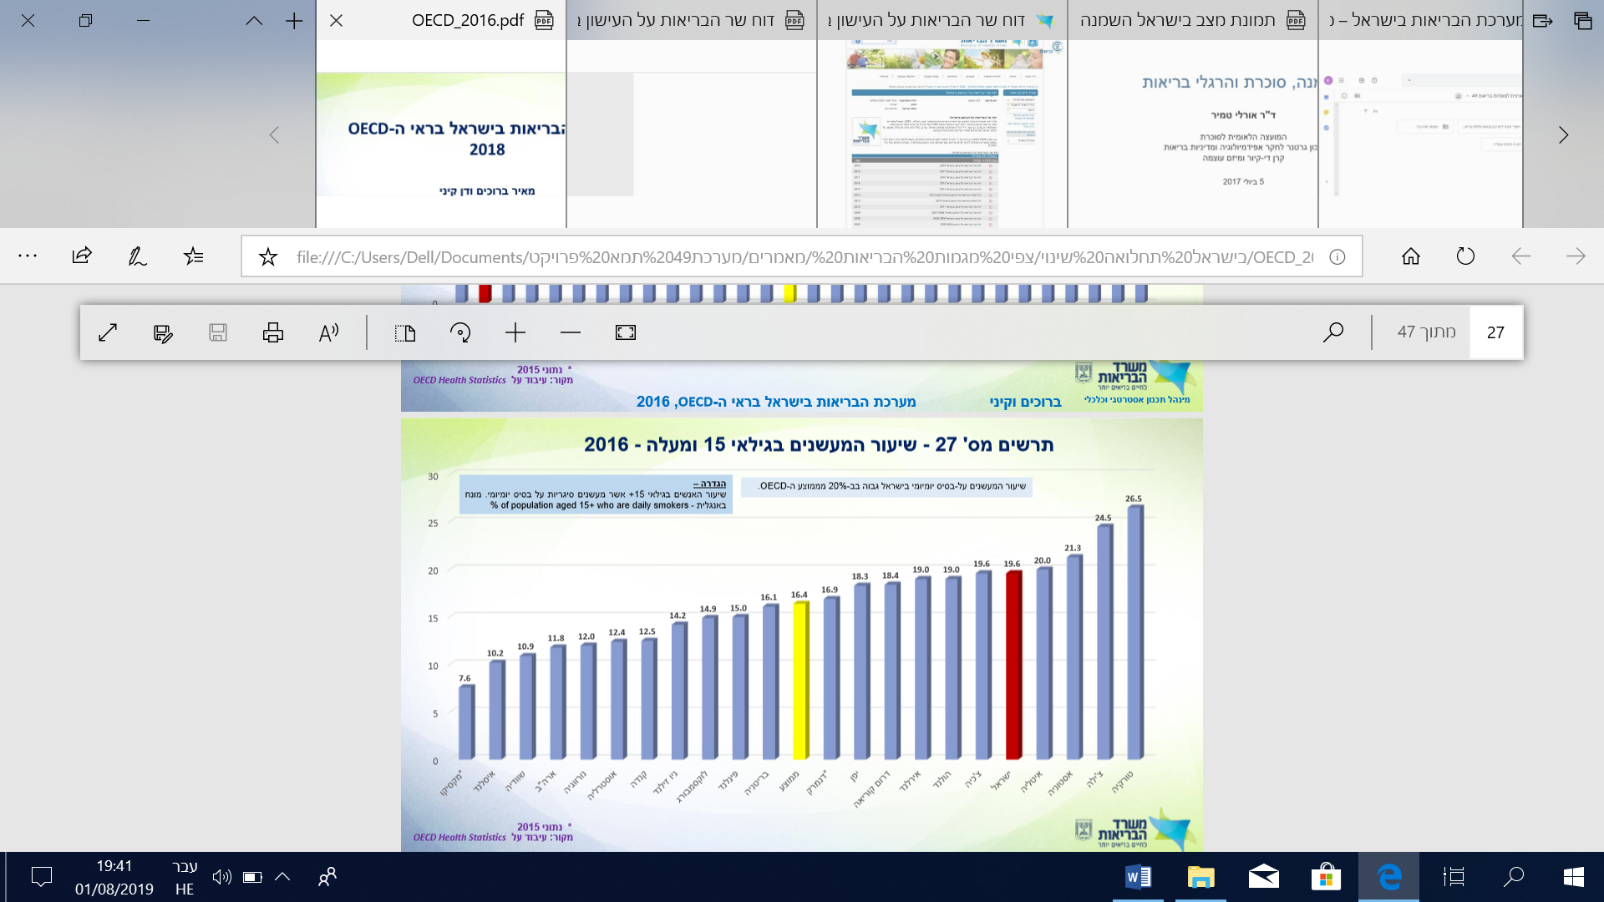

Obesity
Obesity is a major public health problem because of its short-term as well as long-term effects. The extent of obesity among the population has increased over time, and there is much evidence linking it to a large number of chronic diseases. It also reduces the lifespan and undermines quality of life. In developed countries obesity is recognized as the second most important cause (after smoking) of preventable death. Obesity also constitutes an economic burden. In a number of developed countries the economic costs of obesity range between 2% and 7% of healthcare expenditures. The expenditure for an obese adult is significantly higher than the expenditure for an adult of normal weight.(10)
In Israel, as of 2017, about half of those aged 20 and above (48%) are overweight, obese, or morbidly obese: 55% of men compared with 41% of women, 46% of Jews compared with 54% of Arabs, 37% of the 20-44 age group, and 60% of those aged 45 and above. For all age groups the prevalence of overweight is higher among men than women (39% compared with 26%, respectively).(11)

Population aged 20 and above, by body mass index (BMI) and gender, percentage, 2017
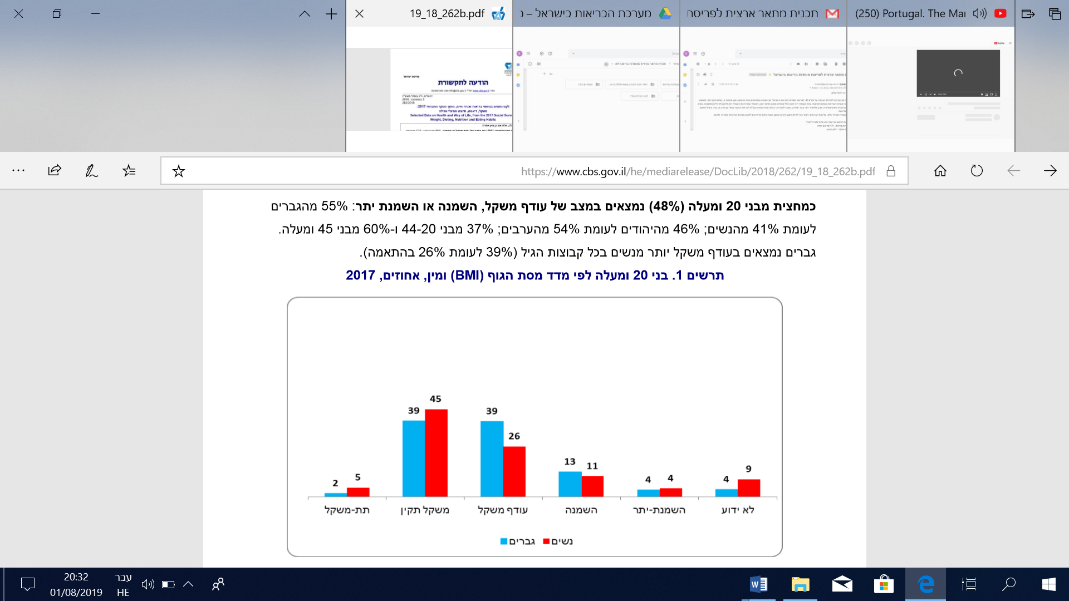

Rates of obesity and morbid obesity among diabetics in Israel (7)
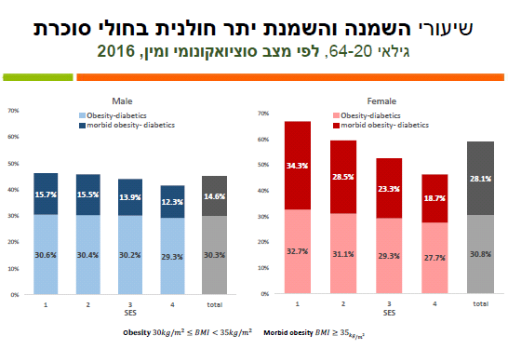
The above graph indicates that among diabetics, the lower their socioeconomic status, the higher their rates of obesity and morbid obesity. These discrepancies exist for both sexes but appear to be especially significant among women.

Socio-demographic trends and their impact on the healthcare system
In 2016 the worldwide elderly population (aged 65 and above) reached 626 million, accounting for 9% of the global population. By 2030 the number of elderly worldwide is expected to reach 997 million and account for 12% of the global population. A majority of the worldwide elderly population (56%) resides in Asia. The continent with the highest percentage of elderly is Europe (about 18% of the total population), where they will constitute about 23% of the population in 2030.
Israel has a relatively young population compared with most OECD states. In 2016 the population aged 65 and above accounted for about 11% of Israel’s total population, compared with an OECD average of 17%. In fact, only three states (Chile, Turkey, and Mexico) have a lower percentage of elderly.(12) According to CBS projections, however, even though the average age in Israel is significantly lower than the average for OECD states, the number of elderly is expected to increase considerably, reaching 1.66 million in 2035. This means that the elderly population will increase by 77% during 2015-2035, and its rate of growth will be 2.2 times greater than that of the general population for this period. The percentage of Arabs within the elderly population is expected to increase from 8% in 2015 to 14% in 2035. This data has dramatic implications for the healthcare system: an increase in the prevalence of chronic diseases (such as diabetes, heart diseases, and the like), and a higher number of chronic diseases per person and over the course more years, thus placing a heavier burden on Israel’s healthcare system.

Projected growth of the elderly population, 2015-2045 (as a percentage of the total population)
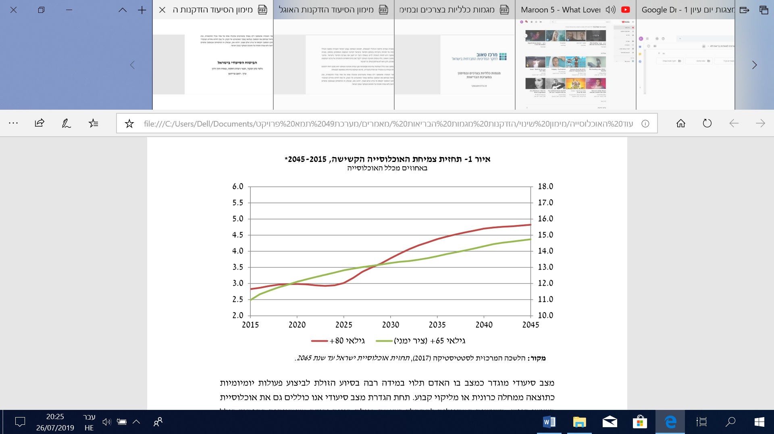
Israel’s elderly population increased rapidly as the large numbers of children born after World War II aged and the life expectancy increased significantly. An additional and unique characteristic that contributes to the aging of Israel’s population is the wave of immigration from the former Soviet Union during the 1990s. The population experienced a sharp increase within a brief period, and immigrants from the former Soviet Union, as a group, were heavily weighted towards older people rather than children and infants. According to current CBS projections, the percentage of elderly is expected to rise gradually from about 11% in 2015 to about 15% in 2045. The percentage of very elderly (ages 80+), which tends to be highly dependent on long-term care, is expected to remain at about 3% until the middle of the next decade, after which it will sharply rise to 4.8% in 2045.(13)
Matters of health have a strong impact on the life and welfare of the elderly. Deteriorating health, and especially the emergence of disabilities, greatly undermines their quality of life. It is therefore important, concurrent with the significant increase in life expectancy, to identify and underscore ways of improving life for the elderly, ensuring not only their longevity but also their quality of life.(14)

Conclusion
In the coming years the healthcare system will face a variety of challenges stemming primarily from the aging of the population and increased morbidity (from chronic diseases). This will increase the already existing burden on the healthcare system in terms of both community healthcare and hospitalization.
A chronically ill person consumes health services – at the community and hospital levels – on a scale that is several times higher than the average per person, and this is further multiplied in cases of chronic morbidity involving several diseases simultaneously. Moreover, chronic morbidity affects not only the elderly. We are already seeing significant percentages of children who suffer from respiratory diseases such as asthma.
Furthermore, differences were found in the nature of morbidity – and the outcomes of medical treatment – among population groups that vary by ethnic background and socioeconomic status. For example, the percentage of diabetics with well-controlled diabetes is higher among population groups with a high socioeconomic status than among diabetics with a low socioeconomic status. Likewise, differences were found in morbidity rates across Israel’s various sub-districts, with higher morbidity rates in the peripheries than the central regions.

C. Expected changes in morbidity trends and implications for the consumption of health services
Chronic diseases (long-term conditions lasting more than three months), with which a person might live for many years, are becoming more prevalent throughout the world and their impact on human health is increasing. Unhealthy lifestyles result in ever-growing numbers of heart diseases, diabetes, and the like. Moreover, thanks to technological developments, diseases that in the past were harbingers of a few months’ life expectancy, such as AIDS or even cancer, have become chronic diseases with which patients can live for many years. A chronic patient consumes healthcare services – in the community or through hospitalization – on a scale that is several times higher than the average per person, and this is further multiplied in cases of chronic morbidity involving several diseases simultaneously.(15)
These days chronic diseases also increasingly affect the younger generation and middle-aged population. For example, a significant percentage of children suffer from chronic diseases of the respiratory system, such as asthma, and about 20% of HMO members in Israel over the age of 45 suffer from two or more chronic conditions. Multiple chronic conditions are the most frequent impairment among several age groups.(16)
Chronic diseases also lead to increased consumption of healthcare services, negative health results, and high medical expenditures. It is estimated that about 75% of healthcare expenditures are dedicated to treating chronic patients. Furthermore, chronic diseases undermine an individual’s employability and income, and reduce the labor force participation rate and market productivity, while simultaneously accelerating early retirement, high turnover, and the incidence of disabilities. Accordingly, chronic patients pose a challenge to healthcare systems and a future threat to their ability to operate effectively.
The main difficulty faced by healthcare systems globally is the gap between demand, on the one hand, and supply as well as the ability to provide services, on the other. The needs of chronic patients are many and varied – their medical care is characterized by numerous medications and examinations, as well as numerous care providers and types of treatment. The patients, who are mostly elderly, undergo a vast and varied array of treatments and are the main consumers of healthcare services.
Furthermore, as life expectancy has increased, so too has the number of long-term care patients and the burden of their care. The growing numbers of life-extending medical discoveries contribute to growing costs of long-term care. According to Ministry of Health projections, the number of long-term care patients is expected to double in the next 15 years. The number of people who need long-term care is growing rapidly, and the duration of such care in Israel will continue to increase: their number is expected to reach 233,000 by 2020 and 342,000 by 2030.(17)
These findings underscore the importance of preventing and managing chronic diseases, as well as the importance of adequate numbers of medical staff and primary care providers. Although the balance between primary and specialist physicians in Israel has changed over the past decades, resulting in a proportional increase of specialists, the overall ratio of practicing physicians to the population in Israel has decreased in recent years, whereas in most OECD countries it is increasing. Similarly, the physician-to-population ratio – the number of practicing physicians per 1,000 persons – in Israel is lower than the OECD average (3.1, compared with 3.3).(17)
Moreover, the proportion of physicians over the age of 55 is the largest among OECD states, accounting for approximately half of all physicians, compared with an average of 34% for all OECD member states. The ratio of practicing nurses to the population in Israel is particularly low relative to OECD states – five nurses per 1,000 persons, compared with the OECD average of 9.3. The ratio between practicing nurses and practicing physicians in Israel is also lower than that of most OECD states – 1.3 in Israel compared with an average of 2.8 among member states.(17)
The next section will further explore the medical and long-term care personnel needs of the healthcare system. Following that we will examine possible changes in the structure and organization of healthcare services as a way of addressing the changing healthcare needs and morbidity trends.

D. The expected compatibility of medical staff and personnel with the needs of the healthcare system and physical infrastructures
The demand for healthcare services is increasing as a result of population aging, increased awareness on the part of health services consumers, and a rising quality of life. Accordingly, it is necessary to adapt the personnel of the healthcare system to its changing needs.
One example along these lines is the establishment in the Galilee of a medical school affiliated with Bar-Ilan University, which aims to train additional physicians in Israel. Currently there are five medical schools operating in Israel: at the Hebrew University, Tel Aviv University, Ben-Gurion University, the Technion in Haifa, and the Bar-Ilan Faculty of Medicine in the Galilee. In addition, as discussed below, many Israeli students attend medical schools abroad.

Physicians
Many factors have contributed to the imbalance in most OECD countries between the number of physicians and the need for them: the fact that training does not keep pace with the growing demand for healthcare services, a reduction in the number of working hours in the profession, a growing number of specializations, the average age of practicing physicians, and retirement rates.

Ratio of practicing physicians to 1,000 persons – 2016 (12)
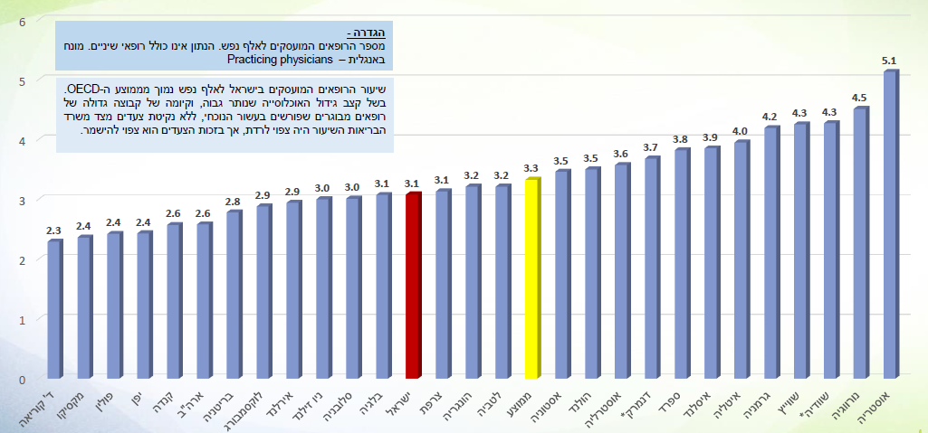

As the above graph indicates, the ratio of physicians to 1,000 persons in Israel is lower than the OECD average. In Israel the ratio is 3.1 practicing physicians per 1,000 persons, whereas the OECD average is 3.3 per 1,000 persons.

Number of new medical licenses issued by place of study, 2000-2014 (18)
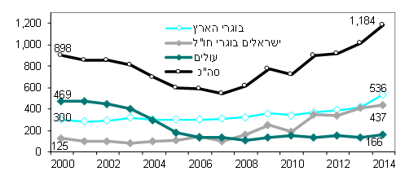

The number of new medical licenses rose to 1,184 in 2014, from 721 in 2010 and 547 in 2007. About half (45%) of the licenses were issued to graduates of medical schools in Israel and about one third (34%) to physicians trained in Eastern Europe. The number of graduates trained in Israel rose to 536, from 417 the previous year and 344 in 2010. In parallel, the number of Israelis who had trained abroad rose to 437 in 2014, from 188 in 2010 and 111 in 2005. These account for 37%, 26%, and 18% of all new licenses, respectively. In 2014 about half the licenses granted to graduates who had trained abroad were issued in Hungary (90), Jordan (70), Romania (69), and Italy (44). The percentage of licenses granted to women has been steady in the last three reported years, at 42% (51% of graduates trained in Israel and 23% of Israelis who graduated abroad).

Ratio of physicians below the age of 65 to 1,000 persons, 1990-2014 (18)
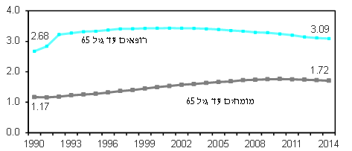

As of the end of 2014, Israel had 34,231 registered physicians, of whom 25,637 were below the age of 65 and 30,683 were below the age of 75. The ratio of physicians below the age of 65 dropped to 3.09 per 1,000 persons, from 3.11 the previous year and 3.39 at the end of 2005 (a 5% decrease). In 2014 a quarter (25%) of registered physicians were aged 65 and above, a 17% increase from 2005, and about one third (30%) were below the age of 45, a 34% decrease from 2005. The percentage of female physicians relative to all licensed physicians below the age of 65 rose to 43% (from 39% in 2000). As of the end of 2014, the percentage of graduates who had trained in Israel rose to 42% of all physicians below the age of 65, compared with 36% in 2000, and to 52% of all physicians below the age of 45, compared with 41% in 2000. A third (30%) had trained in the former Soviet Union, 5% had trained in Romania, 5% in Italy, and the rest (18%) had completed medical school in other countries.

Ratio of practicing physicians to 1,000 persons by district, 2013-2015 (three-year average) (18)
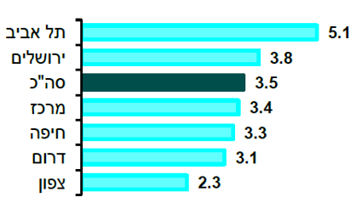

The data indicate that the highest ratio of physicians to 1,000 persons is in the Tel Aviv District, while the lowest ratios are in the Southern and Northern Districts. This fact points to the differences between the center and the peripheries in terms of accessibility to healthcare services.

Medical specialties in crisis
For various reasons, many medical specialties suffer from a shortage of personnel, an infrastructure that cannot meet the needs, an increasing workload, and remuneration that is incommensurate with the crisis. As a consequence good physicians are deterred from applying for these positions, and physicians at all levels – department heads, specialists, and residents – “flee” elsewhere, which raises serious concerns about the future of these specialties. Ultimately the crisis is most evident in personnel shortages and heavy workloads, the direct effects of which are first and foremost an impaired ability on the part of medical staff to provide proper medical care, inferior patient services, frustration, stress and burnout among physicians, and an inefficient system.
The characteristics of this crisis vary by specialty. An examination of the medical profession as a single case reveals a number of key characteristics: a shortage of physicians, a workload that impairs the medical staff’s ability to provide proper medical care, the percentage of active on-call shifts, a high number of on-duty shifts, an impaired quality of life, and a shortage of residents.
The Israel Medical Association (IMA) lists the following as specialties in crisis: neonatology, pediatric oncological hematology, family medicine, surgery, internal medicine, physical and rehabilitative medicine, pediatric intensive care, general intensive care, pathology, child and adolescent psychology, emergency medicine, geriatrics, and anesthesia. In addition, the IMA identified a number of fields where the crisis stems from lack of positions: nephrology, oncology, imaging (Roentgen), medical administration, and hematological oncology.
According to the IMA, the following solutions could improve the current situation:
- Increasing the current bonuses (specializations that do not currently provide a special bonus would be granted one based on the existing rate) – as a response to the physician shortage.
- Full-time work – based on specific consideration of each specialty: Currently physicians divide their work across several positions. Full commitment by physicians to the public healthcare system will make senior physicians available at hospitals throughout their working hours and strengthen physician-patient relations, among other things.
- By agreement between the physician and the employer, the aim would be to have physicians carry out all their work at their principal workplace, rather than work for several employers. In addition, various wage levels should be established on the basis of the current wages.
- Grants to attract physicians to a specialty (incentives to choose the specialty).
- Department heads – increasing the number of department heads.
- Increasing on-call shifts so that each specialty has a physician on-call every day of the month.
- Increasing on-call shifts to ensure a minimal number of specialists per department.
- Preventing burnout – reducing the number of weekly work hours.
- Position-specific bonuses.
- Specialist on-duty shifts – at different rates (multiple working days). (This recommendation applies not only to specialties in crisis).(19)

Forecast of physician supply for 2025
Over the years various commissions have been appointed in Israel to address personnel planning in the health professions. A 2010 report by the Committee for Planning Medical and Nursing Human Resources included a long-term projection based on existing data, aimed at forecasting the workforce supply of physicians and nurses in the healthcare system.
After measuring the rate at which personnel are trained in Israel and abroad against physician retirement rates as well as physician-to-patient ratios in various other countries, the Committee decided to recommend a ratio of 2.9 physicians to 1,000 persons as a minimum point of reference.(20)
According to its calculations, and assuming that the physician-to-patient ratio in Israel would continue to decline in the coming years, the Committee concluded that absent any intervention aimed at increasing the number of physicians who enter the healthcare system, the physician-to-patient ratio is expected to reach 2.83 physicians per 1,000 residents by 2020 and 2.6 by 2025. To reach the desired ratio, the Committee recommended expanding the capacity of existing training centers as well as establishing a fifth medical school, encouraging physicians trained abroad to return to Israel, and reducing the numbers of foreign students who study in Israel, as needed, in order to train more Israelis.

Nurses
Over the years the nursing profession and Israel has undergone significant changes, foremost among which was that it became an academic profession. Simultaneously, the training track for nurses who are not registered practical nurses was scaled back. The decrease in number of practical nurses without a commensurate increase in the number of new registered nurses, alongside reduced immigration to Israel, have contributed to a decline in the number of new nurses who join the healthcare system each year. This trend, along with the fact that in most states the ratio of nurses is on an upward trend, led to a considerable drop in the ratio of nurses in Israel compared with most OECD states, to the extent that Israel is currently experiencing a significant nursing storage.(20)

Ratio of nurses to 1,000 persons – 2016 (12)
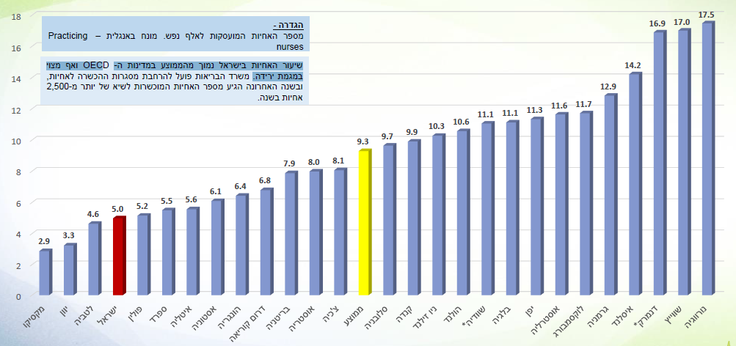
Not only is the ratio of nurses to 1,000 persons in Israel one of the lowest among OECD states, it is also continuing to fall. In Israel the ratio of nurses to 1,000 persons is 5.0, whereas the OECD average is 9.3 nurses per 1,000 persons.

Issuance of new licenses by year of receipt (18)
New licenses, not including recertification of practical nurses as registered nurses
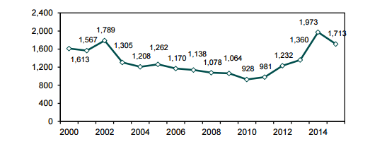
In 2002 a total of 1,789 new licenses were issued. After 2002 there was a downward trend until 2012. In 2014 a total of 1,973 new licenses were issued, after which there was another downward trend.

Ratio of nurses below age 65 to 1,000 persons, 2000-2015 (18)
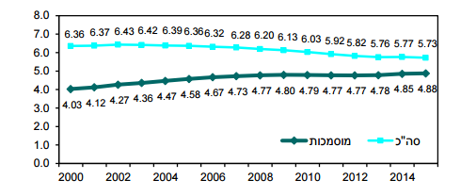

As the above graph indicates, the total number of nurses below age 65 is on a downward trend.

Ratio of practicing nurses to 1,000 persons, by district, 2013-2015 (three-year average) (18)
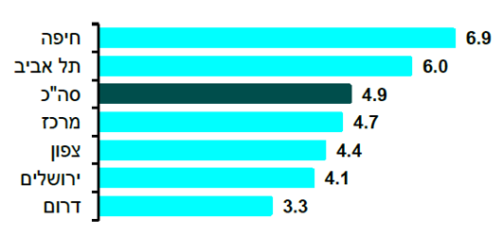

It is evident that there are significant discrepancies among the districts in the ratio of nurses to 1,000 persons. The ratio is higher in Haifa and Tel Aviv, and lowest in the Southern District.

Projected workforce supply of nurses in 2025, based on an expansion of training programs (20)
The main basis on which nurses enter the healthcare system is Israel’s nursing training programs. This is supplemented by the entry of new immigrants, who are relatively few in number and whose impact on the total number of nurses in Israel is insignificant.
Using data on the entry of nurses into the healthcare system versus their retirement, the Committee for Planning Medical and Nursing Human Resources estimated that a ratio of 5.8 nurses to 1,000 persons in 2025 was a preliminary and attainable target, the aim of which would be to stop the downward trend, so that the healthcare system could function properly. However, the Committee also recommended examining the possibility of raising financial and other resources that would enable more significant growth, in an effort to reach a ratio of 5.6 nurses to 1,000 persons before 2025.
In addition to this ratio, the Committee recommended a 20% increase in the nursing workforce, including the addition of nursing assistants and skilled support staff. The assistants would contribute to elderly care, among other areas, thereby freeing registered nurses from basic care and enabling them to focus more on providing advanced nursing care to severely ill patients.

E. Possible changes in the structure of medical services and its adaptation to evolving needs
The healthcare system faces new challenges, as noted above (an aging population, underfunding, and personnel shortage).
The first and most important change is to bolster primary medicine throughout the community – by increasing the integration and equality of population groups with varied, complex, and changing needs, and concentrating chronic treatment in the hands of the community’s primary care physician and support staff. Boult and Wieland (2009) presented a (basic) comprehensive primary care model that could provide continuous, effective managed care for older patients with a complexity of multiple chronic conditions. This model has the most potential to improve the quality of care and quality of life for patients, while also reducing the cost of their care. It is based on team care that includes a primary care physician and at least a nurse and another health specialist who work together with the community.
The elements of such care include:
- Comprehensive diagnosis and assessment;
- Developing a comprehensive treatment plan for the specific patient;
- Implementing the treatment plan (and follow-up to ensure its actual implementation);
- Proactive monitoring of the patient’s health and adherence to the treatment plan;
- Case management and coordination of care provided in the community, advisors, hospitalization, emergency room visits or other urgent care, and other care providers (e.g., dietitian, psychologist, social worker, etc.);
- In cases of patients released from hospital, assistance in reintegrating into the community (and preventing re-hospitalization);
- Assistance for patients in accessing social and other community services, particularly those that will help them remain active and promote their health.
The second change involves prevention and checkups. The main health problems in the developed world usually include chronic non-communicable diseases such as diabetes, heart diseases, and cancer. These result, among other factors, from the modern lifestyle. In fact, currently available knowledge indicates that individual lifestyle is a major factor in determining the risk of developing a chronic disease during one’s lifetime.
Primary prevention is concerned with maintaining a healthy lifestyle before the onset of disease. The aim of primary prevention measures is to reduce exposure to factors that increase the risk of a disease or diseases. These measures include behavioral change, reducing exposure to harmful factors, a change in policy, and a change in the physical and social environment. Although prevention is not usually seen as a core issue for the healthcare system, relative to issues involving patient care at both the provider and system levels, it is of great importance for human health.
Moreover, medical checkups are an important strategy for detecting an abnormal health condition among asymptomatic members of a specific population group, in order to intervene as soon as possible and prevent the onset of illness, suffering, or death. Early detection has potential advantages and disadvantages. The advantages of early detection are self-evident: the possibility of providing more targeted treatment at an earlier stage of the disease, thus reducing symptoms and costs, improving the chances of a full recovery, and sometimes even reducing mortality. Conversely, checkups can cause significant harm, such as side effects of the exam itself, anxiety while waiting for results, false-positive results, over-diagnosis, and misleading negative results that in turn lead to an unfounded sense of security and potential disregard of future symptoms.
The third change relates to hospital-level care for patients at home. Home care provides an alternative to hospitalization at general hospitals (and to internal medicine wards in particular) or follow-up care facilities. Readmission, a widespread and frequent phenomenon throughout the world’s healthcare systems, can be minimized by 30%. It is possible to reduce readmission by making treatments available in the community, educating patients at the time of their release from hospital, and improving communication between hospitals and the community so as to maintain continuity of care.
The fourth change involves the integration of digital tools and use of information technologies. In the late 1990s the World Health Organization adopted the concept of telemedicine as the delivery of healthcare services, where distance is a critical factor, by health care professionals using information and communication technologies. These services use current information for purposes of diagnosis, treatment, prevention of disease and injury, research, assessment, and providing health education to patients, as well as promoting the health of individuals and communities. Telemedicine can be seen as a way to bridge the physical distance between a patient and physician or among a patient’s various physicians.
The applications of telemedicine comprise five areas in which it is possible to provide consultation and assessment without direct contact with the patient:
- Home/mobile monitoring – the use of telemedicine for long-distance monitoring of health. Data (such as weight, blood pressure, glucose levels) is measured at the patient’s home and transmitted to the healthcare provider via the Internet.
- Diagnosis (teleradiology, teledermatology, telepathology) – the transmission of medical information such as x-rays, lab results, or prescriptions from one health professional to another for consultative or diagnostic purposes.
- Triage medical call center – urgent preliminary assessment using frontal or audio imaging transmitted by the patient. The information can be transmitted between the patient and healthcare provider or between a provider and a specialist.
- Consultation (e-consultation, e-visit, video visit) – interaction between the patient and healthcare provider or among providers using videoconferencing or other technologies.
- Procedures (telesurgery, healthcare assisting robot) – surgical procedures performed remotely, which require swift and precise transmission of information.

Conclusion
The changing patterns and scope of morbidity pose new challenges to the healthcare system, which must change accordingly. The next section examines some of the changes noted here in greater depth and describes how they can be implemented and employed to cope with the challenges to the healthcare system.

References
- Ben Nun G, Berlovitz Y, Shani M. Ma‘arkhot habri’ut be-Israel [Healthcare systems in Israel]. Tel Aviv (IL): Am Oved; 2005. Hebrew.
- Goldberger N, Aburbeh M, Haklai Z. Sibot ha-mavet ha-movilot be-Israel 2000-2015 [Leading causes of death in Israel, 2000-2015]. Jerusalem (IL): Ministry of Health; 2018. Hebrew.
- Silverman B, Stein Y, Keinan-Boker L. ‘Idkun he’ar‘ut sartan lefi nafot be-Israel 2001-2015 [Update on cancer incidence by sub-districts in Israel, 2001-2015]. Jerusalem (IL): Ministry of Health; 2018. Hebrew.
- Ministry of Health (IL). Bri’ut 2013 [Health 2013]. Jerusalem: Ministry of Health; 2014. Hebrew.
- Knesset Research and Information Center. Rikuz netunim ‘al mahalat ha-sukeret be-Israel [Collected data on diabetes in Israel]. Jerusalem (IL): Knesset Research and Information Center; 2010. Hebrew.
- Tamir O. Tmunat matsav be-Israel ha-shmena, sukeret ve-hergelei bru’it [State of affairs in the fat Israel, diabetes and health habits]. Ramat Gan (IL): Gertner Institute; 2010. Hebrew.
- Ministry of Health (IL). Taktsiv misrad ha-bri’ut li-shnat 2019 u-dgashei pe‘ilut merkazi’im [Ministry of Health budget for 2019 and main focuses of activity]. Slideshow presentation to the Knesset Finance Committee; February 2018. Hebrew.
- Ministry of Health (IL). Hatokhnit ha-le’umit le-madadei ikhut lerefu’at ha-kehila be-Israel dokh lashanim 2015-2017 [National plan for indicators of community healthcare quality in Israel, 2015-2017 report]. Jerusalem: Ministry of Health; 2018. Hebrew.
- Ministry of Health (IL). Dokh sar ha-bri’ut ‘al ha-‘ishun be-Israel 2018 [2018 report by the minister of health on smoking in Israel]. Jerusalem: Ministry of Health; 2019. Hebrew.
- Gross R, Ashkenazi Y, Hemo B, Ben-Shoham O, Doron D, Nahshon I. Hashmanat yeladim: gormei sikun, tahlua nilveit ve-shimush be-sherutim [Childhood obesity: risk factors, associated morbidity and service utilization]. Jerusalem (IL): Brookdale Institute; 2011. Hebrew.
- Central Bureau of Statistics (IL). Ha-seker ha-hevrati 2017: mishkal, dieta, tzuna ve-hergelei akhila [2017 social survey: weight, diet, nutrition, and eating habits]. Jerusalem: Central Bureau of Statistics; 2018. Leket netunim be-nos’ei bri’ut ve-orah ha’im [Collected data on health and lifestyle]. Hebrew.
- Bruchim M, Kinney D. Ma’arekhet ha-bri’ut be-Israel be-re’i ha-OECD 2018 [The healthcare system in Israel in relation to the OECD, 2018]. Jerusalem (IL): Ministry of Health; July 2018. 47 p. Hebrew.
- Cohen Kovacs G, Ramot-Nyska T, Haran Rosen M. Ha-bituakh ha-si‘udi be-Israel [Long-term care insurance in Israel]. Jerusalem (IL): Research Department, Bank of Israel; 2017. Hebrew.
- Brookdale Institute. Hazkenim be-Israel 2017 [The elderly in Israel, 2017]. Jerusalem (IL): Brookdale Institute; 2018. Hebrew.
- Trajtenberg, M Alterman R, Ben-David D, Perry D, Bechor S, Lev Ami S, Han I, Katz D, Elkan D. Atid tsafuf – Israel 2050 [A crowded future – Israel 2050]. Israeli Population, Environment & Society Forum; 2018. 38 p. Hebrew.
- ‘Itsuv mehadash shel ma’arkhot ha-bri’ut [Restructuring the healthcare systems]. Proceedings of the 15th Dead Sea Conference. Tel Hashomer (IL): Israel National Institute for Health Policy Research; 2015. Hebrew.
- Public Commission for Assessing the Future of the Insurance Sector (IL). Dokh ha-va‘ada ha-tsiburit li-vhinat ‘atid ‘anaf ha-bituakh [Report of the Public Commission for Assessing the Future of the Insurance Sector]. Tel Aviv: Bureau of Insurance Agents in Israel; 2017. Hebrew.
- Ministry of Health (IL). Koakh adam be-miktso‘ot ha-bri’ut 2015 [Manpower in the health professions, 2015]. Jerusalem: Ministry of Health; December 2016. Hebrew.
- Israel Medical Association. Miktso‘ot be-metsuka [Medical specialties in crisis] [Internet]. Ramat Gan (IL): Israel Medical Association [cited 2019 Aug 2]. Available from: https://www.ima.org.il. Hebrew.
- Ministry of Health (IL). Dokh ha-va‘ada le-tikhnun koakh adam refu’i ve-si‘udi be-ma‘arekhet ha-bri’ut [Report of the Committee for Planning Medical and Nursing Human Resources]. Jerusalem: Ministry of Health; June 2010. Hebrew.

Bibliography
Knesset Research and Information Center. Netunim be-nose ezrahim vatikim, hizdaknut ve-zikna be-Israel [Data on senior citizens, aging, and old age in Israel]. Jerusalem (IL): Knesset Research and Information Center; 2017. Hebrew.
Brill N, Boiko A. He‘arkhut le-hizdaknut ha-ukhlusiya – skira batkhum [Preparing for an aging population – a field survey]. Jerusalem (IL): National Economic Council, Office of the Prime Minister; 2015. Hebrew.
Ministry of Health (IL). I-shivyon be-bri’ut ve-hitmodedut ‘imo [Inequality in health and the means of coping with it]. Jerusalem (IL): Ministry of Health; 2019. Hebrew.
Silverman B, Dichtiar R, Fishler Y, Keinan-Boker L. ‘Idkun netunim legabei he’ar‘ut sartan u-tmuta li-shnat 2016 [Statistical update on cancer incidence and mortality, 2016]. Jerusalem (IL): Ministry of Health; 2019. Hebrew.
Organisation for Economic Co-operation and Development. Death from cancer [Internet]. Paris (FR): OECD. Available at https://data.oecd.org/.
Central Bureau of Statistics (IL). Shnaton statisti le-Israel 2018 [Statistical abstract of Israel, 2018]. Jerusalem: Central Bureau of Statistics; 2018. Hebrew.
Ministry of Health (IL). Mabat al ha-bri’ut 2011 [A look at health, 2011]. Jerusalem: Ministry of Health; 2011. Hebrew.

