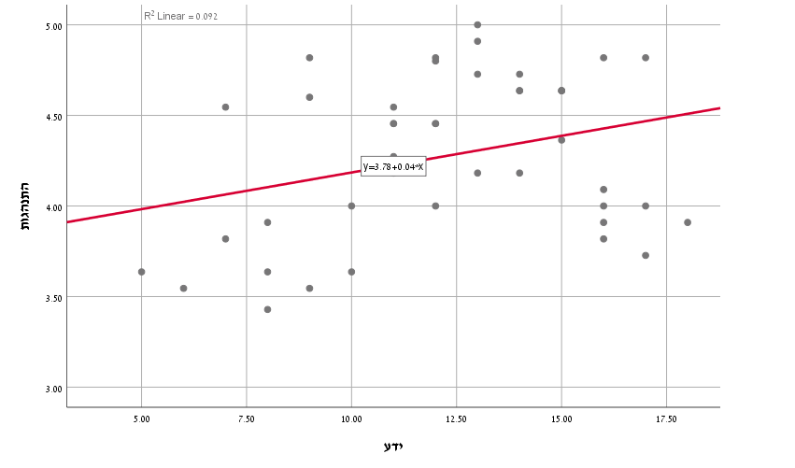

**Knowledge**

**Behavior accordance the guidelines**