24 September 2019

Mr. Yossi Wurzberger

Petroleum Commissioner

Ministry of Energy

**- Urgent -**

**Re: Revocation of Gas and Oil Exploration Licenses within the Boundaries of the Palmachim Disturbance**

Dear Mr. Wurzberger,

We are writing to you as a matter of urgency to request that the exploration licenses granted to Energean PLC for Zone D, Blocks 55, 56, 61, and 62 be revoked, in light of the exceptionally important value of the area’s nature (which includes protected species, species named in the IUCN Red List of Threatened Species, ecosystems identified by the GFCM as Vulnerable Marine Ecosystems, and even a species of coral that was evidently unknown to scientists previously). The area is located within the boundaries of the proposed Palmachim Disturbance marine reserve.

Briefly, two days ago we coincidently learned that area covered by the license you recently granted Energean for gas and oil exploration includes areas in the Palmachim Disturbance, a unique geological site of extremely important ecological value. As the following map indicates, most of the territory of the Palmachim Disturbance overlaps with Zone D.

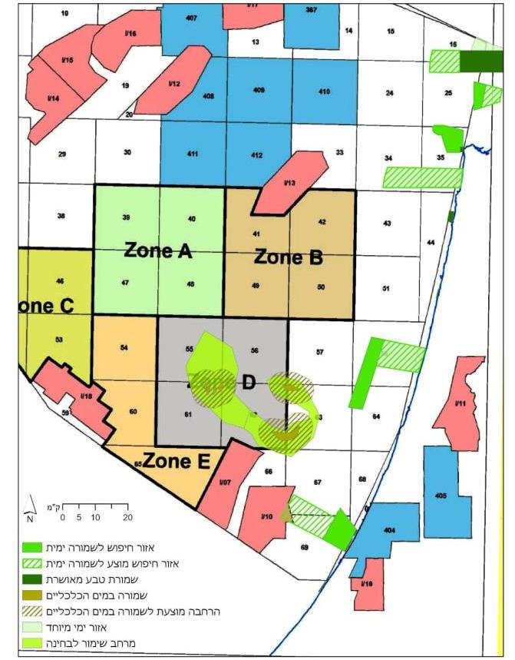

The importance of this area was recognized in the Strategic Environmental Assessment initiated by the Ministry of Energy, which gave the highest vulnerability ranking to sites in the Palmachim Disturbance, and later in a scientific study published by the Society for the Protection of Nature in Israel and Haifa University,[1] which received significant media attention.[2] Moreover, the Palmachim Disturbance has been designated as a proposed marine reserve in the context of the Marine Plan coordinated by the Planning Administration, with the participation of the Ministry of Energy. The Marine Plan has recently been adopted by the Committee for the Protection of the Coastal Environment.

The proposal for a marine reserve at the site of the Palmachim Disturbance, as adopted in the Marine Plan, includes areas beyond the specific sites indicated in the Strategic Environmental Assessment, in light of updated research findings that were presented to all the planning participants, including your Ministry. It is extremely important to have wide buffer zones, where harmful activities are prohibited, around the core center of coral reefs and methane seeps. Thus, unless harmful activities are prohibited within a radius of several kilometers surrounding the sensitive area, it is impossible to prevent negative impacts. Accordingly, the approach to preservation of the area must designate a wide territory for protection from harmful activity, both at the seabed and in the water columns. This would necessarily have to include preventing harm from acoustic waves and seismic surveys, which in the sea tend to traverse long distances at a high intensity, and there is evidence that they have a negative impact on marine life at distances of dozens of kilometers. In a recent publication (McCauley et al. (2017)), the researchers concluded that seismic surveys have a tremendous impact on the health of the sea in terms of time and distance.

Needless to say, gas and oil exploration (and production) activities would pose a major risk to the ecosystems in the proposed Palmachim Disturbance marine reserve, beginning with the seismic surveys and continuing until the activities conclude. A number of exceptionally valuable findings have been made in the Palmachim Disturbance, including: deep-water coral reefs, methane seeps, and spawning grounds of the endangered bluefin tuna, among others. Many studies have documented the severely adverse effects of seismic surveys on fish and invertebrates, as well as marine mammals and turtles.

It should be emphasized that deep-sea ecosystems are particularly vulnerable because of their slow growth rate. There is documentation of deep-water coral colonies that have reached the age of 4000 years, and such colonies could not regenerate after being harmed (this is precisely the reason that the Palmachim Disturbance was given the highest vulnerability ranking in the Strategic Environmental Assessment).

For these reasons we were most surprised to discover that you had ignored this entire base of knowledge, with which your Ministry should be very familiar, and decided to grant an exploration license to Energean specifically in this area.

Whether or not this happened by mistake, it is goes without saying that the decision is faulty and must be rescinded immediately.

In light of the above, the Society for the Protection of Nature in Israel is adamant that that the exploration licenses for Zone D should be revoked as soon as possible, and in the meantime you should immediately notify Energean that they are not entitled to begin activities in the area.

We request your response by the weekend, so that we might consider our next steps.

Sincerely,

Iris Hahn, CEO Noa Yayon, Legal Advisor

Society for the Protection of Nature in Israel

cc:

Udi Adiri, Director General, Ministry of Energy

Guy Samet, Acting Director General, Ministry of Environmental Protection

Shaul Goldstein, Director General, Israel Nature and Parks Authority

Members of the Petroleum Council

Nir Papay, Alon Rothchild – internal

1. <http://mafish.org.il/wp-content/uploads/2018/10/yam-amok-v7-single-pages-heavy-2.pdf>
2. <http://mafish.org.il/wp-content/uploads/2018/10/%D7%94%D7%90%D7%A8%D7%A5-261018-%D7%94%D7%99%D7%9D-%D7%94%D7%A2%D7%9E%D7%95%D7%A7.pdf>