**Measurements of the overall heat transfer coefficient of several layers of insulation materials: an application of greenhouse insulation with multilayer thermal screens**

Abstract

The total energy saving effect of different types of insulation materials and their integration with greenhouse covers is determined by measuring the total heat transfer coefficients through single and several layers of thermal screens using the hot box method. The goal is to examine different types of screen materials with a wide range of thermal radiation properties and their combinations incorporated with a dehumidification system in order to improve greenhouse insulation. It is shown that a high amount of IR radiation can be blocked by a cover combined with moveable thermal screens. The results indicate that with only one layer, the heat transfer coefficient is reduced by around 70% compared to covers without screens, while the contribution of additional layers containing aluminum foil strips may increase the performance to about 90%. The effect of IR radiation rejection on the rate of heat loss is examined, and it is found that low-emissivity materials have a greater effect on reduction of the heat transfer coefficient than materials with IR reflective properties.

Key-words: overall heat transfer coefficient, thermal screens, heat loss, greenhouse insulation

1 Introduction

One of the major objectives of intensive greenhouse production is to provide environmental conditions conducive to maintaining the growth cycle throughout the year and in different regions around the world. Crop cultivation in greenhouses as in open fields faces problems in resisting strong winds, rain, hail, snow, and other devastation risks. Despite all these obstacles, the crop industry must supply high quality products on a daily basis, according to market commitments. In order to receive predicted yields throughout the year, seedlings are planted continuously in different environmental conditions (sprouts are usually grown in isolation and transplanted in a greenhouse). In the modern greenhouse, round-the-clock automated cultivation processes are involved to increase productivity in each square meter of the greenhouse and to minimize risks in the production process.

The temperature of the air and soil in the greenhouse is very important for the cultivation of any crop and therefore it is necessary to know not only the temperature limits for specific plants but also how to adjust the indoor conditions to the local climate outside in different seasons and periods of the day. Day treatment is completely different from night care. During the day, photosynthesis is emitted along with an excess of heat. At night, it is cold (the day/night temperature difference is about 10º-15ºC) with high humidity (in desert areas, humidity can reach up to 70% in summer and 90% in winter). In warm countries, cultivation in a greenhouse usually occurs in winter, while screen-houses are used in summer. This growth process is not optimal, and methods for improving production are needed.

The analysis of conventional environmental control treatments within the greenhouse can help to determine the ways to advance the production process. Thus, in the winter during the regular season, natural or forced ventilation is usually sufficient during the daytime. However, heating is required at night (in Europe and the Mediterranean region), which in turn causes intensive evaporation, raising the need for a dehumidification process. In the summer, it is necessary to use a cooling system during the daytime; however, it is assumed that ventilation is sufficient at night. Natural ventilation systems are traditionally applied in cold regions, where air is supplied through openings in the facade and released through openings in the roof. Usually, a greenhouse is heated with fan heater pipes or heated sleeves and cooled using evaporative systems (known as fan and pad cooling) and active dehumidification systems [1-8]. It is common to install vents for additional air circulation in order to unify flow conditions, release air stuck in the corners, and remove excess moisture.

In total, contemporary systems are very energy-intensive, reducing cost effectiveness and increasing the amount of environmental pollution. Thus, a farmer today has two alternatives: keep the greenhouse as closed as possible using climate control systems or use the ventilation system described above. Both methods cause high fuel consumption, reduce cost effectiveness, and increase environmental pollution. This trend is reflected by the long-term status of global energy resources on the one hand and the growing awareness of environmental pollution and global warming problems on the other. Moreover, the use of low-grade fuel can cause environmental contamination which contributes to the outbreak of diseases developed through high humidity. To remove excessive humidity, ventilation of the greenhouse is increased, which raises fuel consumption, increasing the cost.

As a substitute approach, moveable energy-saving screens, or thermal screens, are commonly used in closed greenhouses. These screens roll in and out easily in order to provide stable climatic conditions, such as internal shading and insulation. Starting from the 1970s, comprehensive studies have been carried out to evaluate the energy saving efficiency of movable thermal screens, showing that such systems are capable of about 40% energy savings with a single layer of low-cost film or woven screens and up to 60% savings with thermally opaque screens (Roberts, 1970; Mears et al. 1974; Roberts et al., 1981; Hüseyin, 2003). Insulation of the greenhouse may be also obtained through various combinations of multi-layer covers and thermal screens. For example, adding a thermal screen reduces the heat transfer coefficient by 38% and 60% for transparent and reflective sheets, respectively [11, 12, 13, 14]. This means that the heat loss transmitted through the thermal screens can be reduced by 80-90% using the materials available today.

Desired climate conditions are expressed in terms of thermal radiation, leaf temperature, plant transpiration, level of CO2, and dry foliage [1, 2]. Temperature and air humidity control are required to maintain foliage temperature and transpiration rates in the greenhouse at desired levels on one hand, while keeping the plant foliage dry on the other [3]. Uniform climate conditions must be held at 18-23°C and 60-80% humidity to avoid physiological diseases for most plants. In most greenhouses, the acceptable foliage temperature is about 18ºC and the transpiration is about 40 gr/m2 per hour. The basic assumption of most studies of humidity controlled greenhouses is that drying systems should not be used [2, 4]. However, a system that incorporates heating and cooling along with dehumidification and the proper combination of thermal screens provides both uniform indoor conditions as well as energy conservation. Heating is used only to compensate for heat lost through the covering materials, while ventilation, used to remove excess humidity and avoid vapor condensation, is completely excluded using a dehumidification system. In this way, the system provides a simplified and efficient infrastructure that is much easier to install and maintain. Moreover, the use of such a system extends the suitability of the cover material due to the absence of condensation.

The main objective of this paper is to evaluate the properties of multilayer thermal screens, in terms of resistance to infrared radiation, and to determine the total energy savings under defined conditions. In order to compare the performance of a system that incorporates dehumidification with different combinations of screens, the heat transfer coefﬁcient of various commercial screens is investigated using the hot box method.

The next section describes the energy saving screen materials used in this study with a specific focus on IR opaque materials and their combinations, and the measurement procedure of the overall heat transfer coefficient is presented. Section 3 presents the overall heat transfer coefficient (U-value) for different combinations of commercial thermal screens, and the conclusions are presented in Section 4.

2 Materials and methods

2.1 Energy saving screen materials.

In general, the energy saving properties of thermal screens are related to buoyancy; diffusion and convection heat transfer; air permeability; and the humidity transport [9, 10, 11]. However, using a dehumidification system allows avoidance of condensation due to humidity excess and therefore eliminates the need for air permeability and extensive ventilation [12, 13, 14]. In this case, knitted permeable screens are no longer required, and it is possible to use whole sheets of materials that are much cheaper and easier to manufacture. Thus, the material emissivity becomes the main factor for reducing energy loss when choosing a thermal screen. The energy losses are dependent on the exchange of heat radiation between crop, dehumidification system, greenhouse screens, coverings, and the sky [15]. Depending on the time of day and weather conditions, unrolled screen layers with a sun/sky reflecting outer layer provide efficient insulation, keeping it cool on summer days and warm on winter nights. At the same time, using an IR reflecting inner layer, part of the thermal radiation from inside of the warm greenhouse can be absorbed and emitted by the screen material.

To maintain steady state conditions inside the greenhouse (constant temperature and humidity), the heat loss through the cover surfaces may be significantly reduced by using multilayer thermal screens, which cause shading stripes. Therefore, they can be effective when there is no sun, including at night, and may contribute to insulating the greenhouse during the extra heating hours of the afternoon. Different regimes of climate control in the greenhouse are clearly needed for different climatic conditions. For colder regions, heating and dehumidification are required overnight, and natural ventilation in the daytime is sufficient throughout the year. For Mediterranean climates, there are two energy-intensive periods: winter nighttime (heating and dehumidification) and summer daytime (cooling and chilling). During winter daytime and summer nighttime, only ventilation is required with or without dehumidification. In tropical regions with a hot and humid climate nearly the entire season, a cooling (with dehumidification) regime is required throughout the whole period. Besides, the thermal transparent covering materials (with no thermal screens) are useful for transferring photosynthesis active radiation inside and for taking the excess heat out of the greenhouse. Thus, combining (collapsing or expanding) the different types of screens depending on the external weather conditions affords proper control of light, temperature, and humidity, maintaining optimal levels for growing, preventing condensation in the greenhouse due to low outside temperatures, and saving significantly in energy costs.

Different types of commercial screens were tested individually and in combination in this work. The screens are made of polyethylene with stabilized UV protection (UVA) properties for both top covers and screens. In order to inhibit thermal radiation, screen materials contain infrared reflected additives (IR) or are comprised of polyester film strips with a thin layer of aluminum. The aluminum strips reflect over 90% of the solar radiation. The number of aluminum strips determines shading efficiency. For example, Aluminet IC-100, IC-30, and IC-0 have shading factors of 99%, 30%, and "clear," respectively. Aluminum foil (FoAl) is used as the most IR reflective material. Thus, using different combinations of covering with thermal screens allows control of the shading ratio required for plant development. Furthermore, using several layers of double-sided aluminized film provide almost 99% insulation in the summer, reducing solar gain.

2.2 Measurement of heat transfer coefficient.

Thermal properties of insulation materials intended for use as thermal screens in greenhouses have been evaluated by measuring the total heat flux passing through several layers of materials using hot box methodology (Vitoshkin *et al*., 2019). This method is commonly used to determine the thermal properties of insulation materials for building design, but it has also been proven less suitable for greenhouses which are affected by unstable outside conditions (Feuilloley and Issanchou, 1996; Papadakis, 2000; Lu and Memary, 2018). Here, assumptions of thermal equilibrium and homogeneous thermal properties are strictly required. This method does not consider the dynamic behavior of ambient conditions, low sky temperatures, or the effect of condensation. However, even with these limitations, the method can be efficiently utilized to determine the steady-state thermal properties of screens and to validate and compare the performances under different conditions. Moreover, the results of this study provide a wide range of empirical data for future development and validation of numerical simulations including dynamic models and modeling of thermal radiation in various geometries.

The overall thermal transfer coefﬁcient, U (W/m2ºC), is generally employed in calculating the rate of heat transfer passing through a single layer or through several layers of insulating material per unit area and per unit of temperature difference between the center of the box’s internal volume and the outside room temperature [18, 20, 23, 24, 25]. The U-value integrates the thermal conductivity of the material tested, including: the convective fluxes from the interior of the box toward the room, including the air between the layers; the radiative fluxes of long wave radiation through the several layers of materials and other elements of the box; the air current speed outside the box; and the ambient temperature. All heat transfer mechanisms are interdependent, and the system ultimately reaches thermal equilibrium on each side of the screen. By assuming a stationary regime and uniform radiation properties of all surfaces (gray diffusive surfaces with uniform temperature and incidental energy), the heat transfer passing through the screens can be calculated with the simple formula:

|  |  |
| --- | --- |
| $$U=(Q-Q_{l})/S(T_{in}-T_{out})$$ | (1) |

where *Tin* and *Tout* are the average bulk inside and outside air temperatures (ºC), respectively; *S* (m2) is the area of the screen surface; *Q* (W) is the energy provided by resistance; and *Ql* (W) represents side wall heat loss, calculated by the following equation:

|  |  |
| --- | --- |
| $$Q_{l}=U_{w}A(T_{in}-T_{out})$$ | (2) |

where *A* (m2) is the envelope surface area excluding the heated bottom surface. The hot box apparatus was built for empirical evaluation of the overall heat coefficient of several layers of screen materials (Figure 1). To assess the U-value of the combined thermal screens, two insulated boxes were involved simultaneously in order to maintain the same external conditions for comparative measurements of different types and combinations of screens. The experiment was carried out during the years 2015-2016 in the central region of Israel. The measurements took place in a shelter in order to minimize the effect of unstable ambient conditions and also to reduce the influence of direct solar and night sky radiation.

The inside dimensions of the box are 1m×1m×1m (length×width×height), with layers set at 0.3m height above. The side walls of the box consist of a 0.1m thick polyurethane foam panel coated by thick wood covers for structural stiffness and additional insulation. The screen layers are assembled under the interior of a unit volume, with a distance between each layer set at a height of 5cm. According to Nijskens et al. (1984), this is sufficient distance to establish stable thermal conditions. The screens are installed between squares polyurethane frames with an inner opening of 1m2 and thickness of 10cm and clipped by springs. It is possible to install up to six frames in different material combinations. The bottom of the box is heated with uniform electrical resistance by multi-pass s-shape flexible heating wire and covered with steel plating in order to provide uniform heat flux throughout the 1m2 surface.

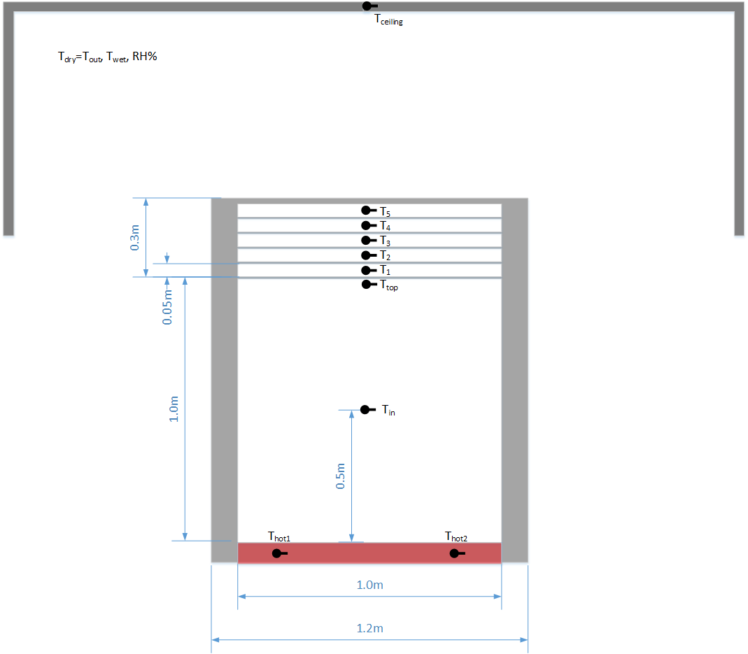

Figure 1: Schematic view of the hot box under the shelter, the box cross section dimensions and locations of thermocouples.

Heat loss through the hot box side walls is calculated by measuring the internal and external temperatures of the box using a 0.1m thick polyurethane plate on the upper frame. The heat loss through the four walls is measured during the whole period of testing, calculated with Equation 2 and averaged over eight measurements. The heat transfer coefficient, *Uw*, was taken as 0.4W/m2ºC for each box with about 3% relative uncertainty.

The power of the resistance heater is regulated by changing the voltage of the variable power transformer (24 Watt) using a stepper motor controlled by a programmed data-logger, which allows the incremental changing of power with high accuracy. It usually takes two hours to balance the system. After stabilization, the power value remains constant with a standard error up to 5%. The measurements are managed by a cellular application.

The temperature measurements are made using T-type copper-constantan thermocouples. The precision of the temperature measurements is about 0.05ºC due to time averaging and thermocouple precision. The locations of all thermocouples are illustrated in Figure 1: two thermocouples are installed at the heated bottom plate, one thermocouple measuring the inside temperature, *Tin,* is located in the center of the internal volume of the box, and the thermocouple measuring the temperature of the top of the box, *Ttop*, is located right under the first layer of the screen. Five thermocouples are inserted inside the air layer between each screen. The ambient temperature, *Tout*, is recorded by a meteorological station. The ambient indicators (*Tdry=Tout, Twet*, RH%) are mostly followed by outside indicators, whereas the values obtained during stable periods are taken for U-value calculations during the testing period. The measured parameters relating to the hot box temperatures and the external climate conditions are indicated in Figure 4a.

2.3. Measurement procedure.

The inside temperature is established by six set-point temperatures and maintained for eight hours accordingly. The set point temperatures are increased from 40ºC up to 55ºC in steps of three degrees. The measurements are conducted over two days under the conditions of each test. Temperature and supplied energy are recorded every eight hours; however, averaging (the calculations of heat transfer coefficients) is performed for only the last two hours when the stable heat flux is established through the system after initiating the heat supply. The measurement readings are scanned every second and averaged over every one minute via data-logger. Figure 4 illustrates the results obtained when the boxes are covered by polystyrene foam representing the insulation case. For the system with several layers of thermal screens, the inside temperature stabilizes within one hour, while, without thermal screens (or with a single screen), up to four hours is required to attain equilibrium. The outside temperature is varied between 25-32°C depending on the time of day and outside environmental conditions. Since the heat transfer coefficient can be determined in a short period when all environmental parameters are held stable and uniform, the following calculations are employed only for measurements taken during the stable period of inside and outside temperatures. Figure 4a shows the typical test results of inside and outside temperature for both boxes, corresponding to the two set points 49ºC and 52ºC during the last two hours chosen for further data processing. It can be seen that the internal temperatures agree with the set temperatures for both boxes. The standard deviations of averaged values are σ=0.15-0.2 and σ=0.012-0.015 for *Tout* and *Tin*, respectively. Figure 4b illustrates the corresponding differences between inside and outside temperatures which are kept constant during the time period considered and the calculated U-values as a function of time. The time averaged temperature differences are dT=31.2ºC and 37.2ºC with σ=0.15-0.19. The time averaged heat transfer coefficient is U=0.37 W/m2 ºC with σ=0.03-0.04 for all cases. This high accuracy justifies the use of the current hot box methodology for measuring the overall heat transfer coefficient.

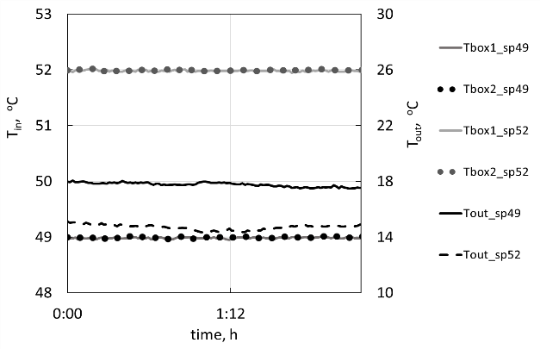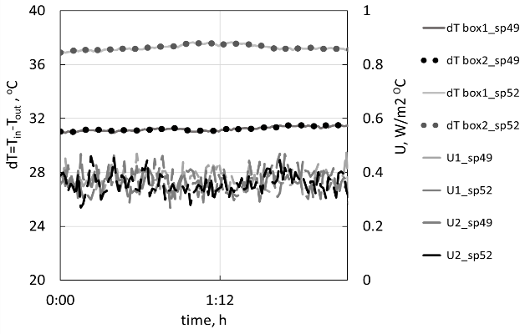

Figure 4: Typical test results for box covered by polystyrene foam for two set points 49ºC and 52ºC: a) time variations of outside temperature and inside temperature for two boxes; b) calculated time differences and heat transfer coefficient.

3 **Results**

The overall heat transfer coefficients as a function of the number of thermal screens are presented in Figure 5. The results correspond to experiments with polyethylene cover (UVA) and added several layers of IR screens; thermal screens of type IC-100, IC-30, IC-0 (IC-100 contain maximum aluminum strips; IC-30 gives 30% shading; IC-0 is a clear screen); and FoAl is a film. The figure shows that the heat transfer coefficient decreases rapidly for all screen types. The reduction of the overall heat coefficient can reach 30% by the addition of only one clear screen, such as IR and IC-0, and up to 70% for aluminum-containing screens, such as IC-100 and FoAL. Following the addition of screens, the coefficient decreases by approximately 10%. General approximation can be described by power law *U*(*n*)=8*n*-*m*, while the values of decay index, *m*, ranged from 0.6 to 1.4 depending on the insulation properties of the tested materials. These results are in good agreement with results obtained by Euilloley *et* *al*. (1989) for three screens with IC-100 coatings (representing strong insulation). According to our results, the overall heat transfer coefficients can decrease to less than 90% when five layers of FoAl film are used.

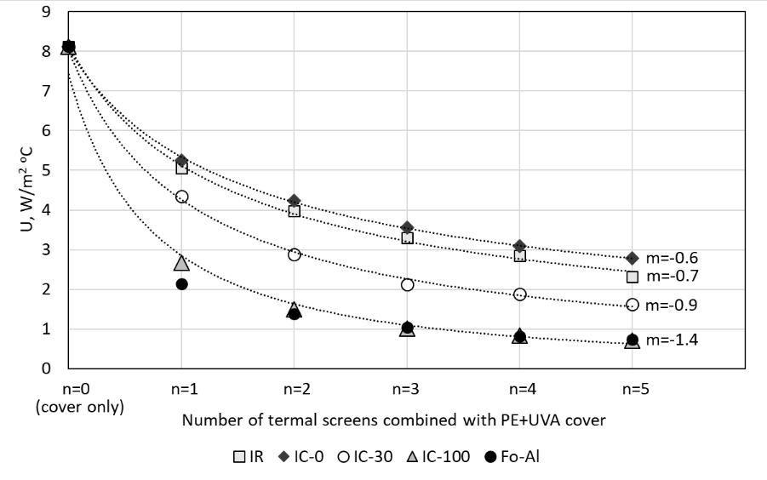

Figure 5. Overall heat transfer coefficient for UVA (polyethylene) covering and added thermal screens of type FoAl, IC-100, IC-30, IC-0, and IR; *m* represents decay index of power law trend lines *U*(*n*)=8*n*-*m*.

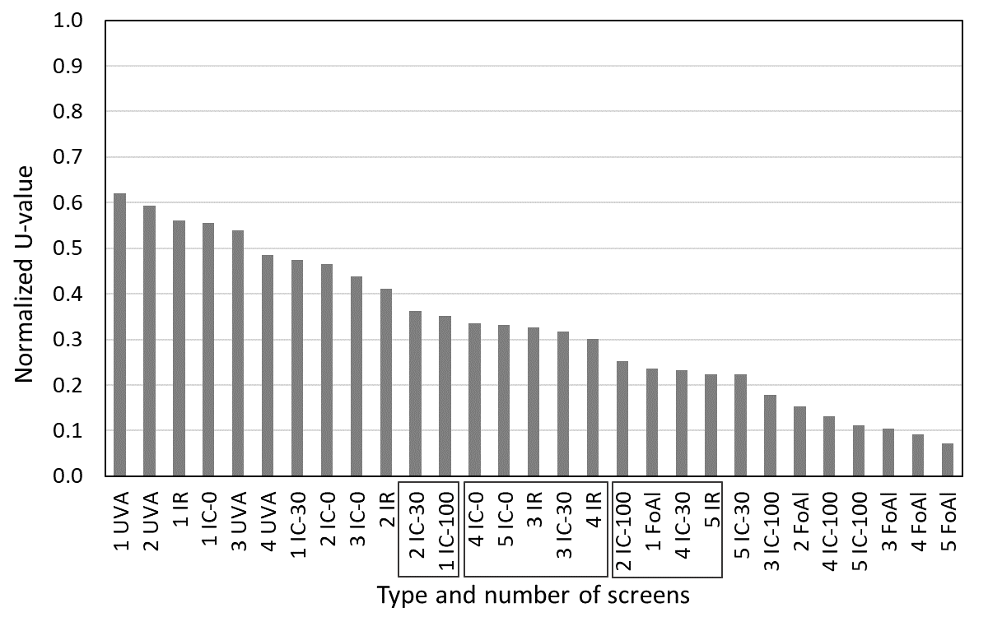

Figure 6: Normalized overall heat transfer coefficient for IR (infrared reflective) covering and different types of thermal screens (UVA, IR, IC-0, IC-30, IC-100, FoAl) with one to five layers. Rectangles on x-axis denote the sections with similar U-values.

The values presented in Figure 6 are of the heat transfer coefficients for different numbers of layers (from one to five) and types of thermal screens normalized by the value measured using one IR cover (*UIR*= 7.44W/m2C, σ=0.39) averaged over six set points and ten experiments. In order to compare different material combinations and identify the relative insulation performance of each set of material layers, the results of all tested sets are organized in descending order.

It is shown that the most effective insulation is provided by a set of three to five FoAl layers, as expected, while the U-value for four IC-100 layers (containing maximum amounts of aluminum strips) is higher by about 30%. Regardless of the monotonic behavior of U-values, there are three sections having close to equal values. These sections are denoted by rectangles on the x-axis. It is seen, for example, that one FoAl layer is permutable with two IC-100 layers or four IC-30s, or 5 IR layers, depending on the availability of materials and/or shading requirements.

It is also seen that even for clear screen materials, the reduction of the overall heat coefficient varies between 40% and 60%. This conclusion is relevant if both insulation and transparence properties are important simultaneously, for example, heat conservation during day time.

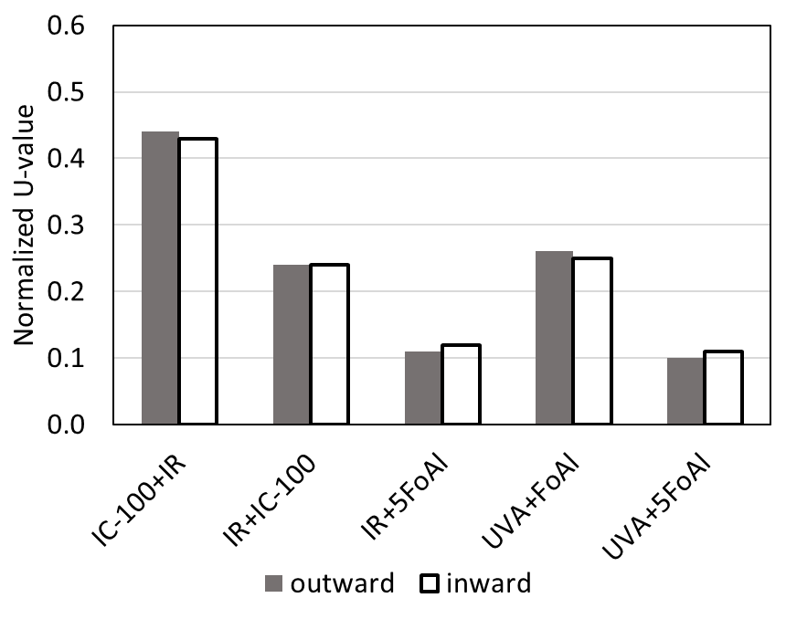

Figure 7: Normalized overall heat transfer coefficient for different combinations of low emissivity materials. The x-axis labels indicate cover material + screen with reflective surface facing inwards/outwards to hot-box interior.

Figure 7 illustrates the series of tests performed in order to evaluate the effect of radiometric properties of materials. According to results of theoretical investigation by Nijskens *et* *al*. (1984), transmittance has a prevalent effect on thermal screen losses compared to the reflectance and emissivity. Therefore, the low-emissivity materials IC-100 and FoAl (ε=0.04) with highest thermal insulation properties were examined in different combinations with UVA (ε=0.31) and IR (ε=0.64) covers and with reflective (glossy) surfaces facing inwards/outwards to the hot-box interior. It is shown that the heat losses can be reduced by 50% when the inner IC-100 layer is placed under an IR cover compared to when the inner IR screen is below the IC-100 cover. These results are in good agreement with the theoretical predictions of Nijskens *et* *al*. (1984). The following increase of insulation permitted by adding five FoAl screens reduces the heat transfer coefficient by an additional 50%, as described above. The same results are obtained for UVA covering. These results indicate that IR reflectance, as well as reflective direction, has no effect on the U-value.

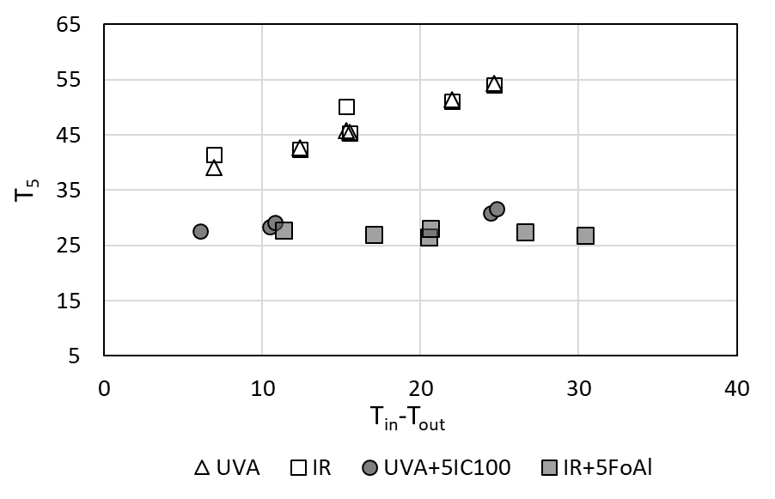

Figure 8: Temperature of air under a cover material installed on the top of the hot-box.

Considering the above observations, we examine the effect of insulation and reflectance on the temperature under the cover. Figure 8 shows the variation of temperature measured under the cover, *T5* on Figure 1, as a function of the difference between the inside and outside temperatures for two types of cover material, UVA and IR. It is seen that in the absence of insulating screens, the temperature increases linearly with the temperature differences, while it remains constant when strong insulation is installed. Similar behavior is observed for both types of materials.

**4. Conclusions**

The hot-box method has been employed to measure the overall heat transfer coefficient with high accuracy. The method allows evaluation of heat loss through different types of multi-layer thermal screens and comparisons among different combinations of screens. The multi-layer thermal screen technology could be further extended to provide improved greenhouse insulation.

Use of screens can reduce the overall heat coefficient from 70% (for one layer) and up to 90% (for multi-layer screens), thus reducing energy consumption in the greenhouse, accompanied by a smaller environmental impact and providing optimal breeding conditions.

The results show that best insulation performance is provided by a set of three to five FoAl screens. It is also shown that various sets of materials can be replaced by other sets with similar U-values, depending on the availability of materials and/or shading requirements.

The results show that using low-emissivity materials installed under the cover can reduce the heat transfer coefficient by 50%, while reflective direction has no effect on the U-value. These results are in accordance with theoretical predictions. The presented data can also be used for validation of theoretical and numerical (CFD) models, which allow comprehensive comparison between various material combinations and different environmental conditions in order to improve performance for cooling/heating and dehumidification systems.