Design Patterns for Teaching in Academic Settings in Future Learning Spaces (FLS)

Liat Eyal[1]* and Einat Gil[2]*

Levinsky College of Education

*Contact details:

Email—liate@levinsky.ac.il; einat.gil@levinsky.ac.il

Tel +972-506887171; +972-506558695

**Liat Eyal, PhD** is a senior faculty member at Levinsky College of Education, Tel-Aviv, Israel. Dr. Eyal is also the head of program for teachers' educators specializing in learning design in the information age at the MOFET Institute, a center for research and development in teacher education.

**Einat Gil, PhD** is a researcher of the learning sciences and a faculty member at Levinsky College of Education. Dr. Gil is the head of teaching innovation division within the Center for Innovation & Excellence in Teaching (CIET). She led the establishment of Future Learning Spaces and its integration in the college curriculum and culture.

# Abstract

A Future Learning Space (FLS) is a dynamic and a technology-rich learning environment that enables teaching and learning using innovative pedagogical methods. However, introducing innovation and technology into any educational setting, whether in K-12 schools or institutes of higher education, is known to be challenging. This paper introduces design patterns for teaching in FLS. The patterns emerged from creative teaching in a college of education, which was preceded by mentoring for some of the lecturers. The patterns relate to hybridity in the sense of formal and informal social structures and the combination of physical and digital tools mediating individuals' interactions with colleagues.

Based on a mining patterns process, we extract four design patterns for teaching in academic FLS. The patterns, which encapsulate threads of hybridity, are: Convergent groups; Teaching in an interactive orchestrated learning space; Presentation fair; Think-Join-Share. These patterns can be used as learning design scaffolds in a social constructivist approach in which pedagogy, technology, and space interact.

**Keywords**: Future learning space (FLS), design patterns, collaborative learning, technology-enhanced learning, higher education, hybrid learning environment

# Practitioner notes

Previous knowledge about this topic:

* With the increasing number of future learning spaces (FLSs) in higher education institutions, lecturers are expected to teach in ways that apply active learning approaches and methods.
* Several pedagogical frameworks for teaching in FLS are suggested in the field, such as: Pedagogy-Space-Technology (PST) (Radcliffe, 2009), Technology, Pedagogy, Content and Space (TPeCS) (Kali, Sagy, Benichou, Atias, & Levin-Peled, 2019), Knowledge Community and Inquiry (KCI) (Slotta, 2010) that integrate considerations about technology, pedagogy, and space.
* At the activity level, there are pedagogical design pattern (DP) repositories, which aim to facilitate active learning, some of which could be indirectly related to FLS.

What this paper contributes:

* Four novel design patterns for teaching in FLS are presented. The patterns relate to hybridity in two dimensions: (1) formal and informal social structures in learning processes and (2) the combination of physical and digital tools mediating individual and group interactions.
* The design patterns include context, forces, solutions, limitations, and examples in a way that can be easily adopted by novice lecturers.
* In the discussion, we suggest how these DPs indirectly promote educational and pedagogical values such as transparency, inclusion, and equality.

Implications for practice and/or policy:

* The presented DPs can serve as a scaffold for assimilation of innovative pedagogical practices at FLSs by lecturers in higher education institutions.
* They can stimulate the desire of lecturers in higher education institutions to adopt a set of values ​​that meet learners' needs in the information/data age and in technology-saturated environments and to enhance learning engagement.

# Introduction

Since virtual learning environments have become a widespread response to the need for knowledge construction, many attempts have been made to maximize the benefits of the physical encounters and direct interaction among learners in a traditional classroom environment. Lecturers in academic settings who apply innovative teaching and learning methods may find an obstacle in traditional classrooms organized in static rows of chairs facing the teacher and whiteboard. This setting does not encourage lecturers to challenge themselves with new methods. Since the mid-1990s, there has been documentation of alternative class design in the K-12 education system, and more recently in the higher education system. The emphasis is on flexible technology-enhanced classrooms, equipped with portable and aesthetic furniture, which invite active, learner-focused, and collaborative learning.

Some studies document the importance and benefits of teaching and learning in technology-enhanced classrooms, such as learners' interaction with the teacher as a facilitator, equitable learning for disadvantaged populations, enhancing learning outcomes, and increasing student satisfaction (Beichner, 2014; Chiu & Cheng, 2017).

Space shapes expectations about teaching and learning (Baeplar, Walker, Brooks, Saichaie, & Petersen, 2016; Gaffney, Gaffney, & Beichner, 2010). Baeplar et al. (2016) suggest three ways in which space is important to teaching and learning. The first is that it serves as a "mediator and moderator of instructor and student behavior" (p. 18). The second emphasizes the way the space is used as a designed activity by the lecturer (e.g. lecture, inquiry-based activity). The third relates to the physical characteristics of the space such as size, layout, and colors that potentially instill meaning for how the space might be used. The approach presented in the current article is based on a design pattern theoretical approach and considers interplay between space and activity design.

The FLSs at the Levinsky College of Education in Jerusalem, Israel have been operating for a year and a half. Dozens of lecturers have taught and conducted hundreds of activities in these spaces, and a great deal of knowledge about FLS has been accumulated and documented in a variety of ways. However, this knowledge was shared informally and not in a public forum. This paper will present design patterns for activities in an FLS.

We start with a literature review showing the characteristics of pedagogical models for FLS and principles for teaching in the FLS space. Then we present the distinct characteristics of the space established at the Levinsky College and the method by which we explored teaching activities in the space. Four design patterns selected for teaching in the space are presented. Finally, we discuss insights arising from the process, its products, and the implications of extracting design patterns as a means of implementing teaching in the FLS space.

# What are future learning spaces?

FLS is a new theoretical concept reflecting an emergent reality in the changing educational landscape (Freeman, Becker, & Cummins, 2017). It describes a combination of innovative pedagogy and technology that enables independent teaching, collaborative and interactive learning, and use of diverse technologies. In FLS, learners can share responsibility for content, technology, and space (Hod et al., 2016).

Traditional classrooms are designed to be teacher-centric instructional spaces, where students are consumers of knowledge and teachers maintain an authoritative role (Beichner, 2014). In contrast, FLS puts learners at the center, and learning is perceived as a social process. Learners become co-producers, not just consumers of learning content (Punie, 2007).

FLS or active learning classrooms (ALC) facilitate interactions among students who work collaboratively on tasks of interest to them. Movable furnishings and other features enable students to use the space to meet instructional goals that correspond with 21st century skills (Beichner, 2014). One learning goal is building knowledge through use of mobile and/or interactive technologies. The space can serve multiple purposes as an anchor for teaching, students' learning, course design, pre/in-service teachers' education, academic staff workshops, and simulation of teaching in those spaces (Gil & Mor, 2017).

One of the differences between FLS and ALC is that in the latter there is usually a layout design with fixed tables and an interactive whiteboard to facilitate group work (Baeplar et al., 2016; Charles, Whittake, Dugdale, & Guillemette, 2015). There is evidence of increased conceptual understanding, improved success rate, and greater motivation among students studying in ALC. Since the FLS at Levinsky College differs from the described design (none of the furniture is fixed), we consider the theoretical and practical knowledge associated with ALC and proceed using the concept of FLS, in which space might be utilized in additional ways (Charles, Lasry, & Whittaker, 2011). Further, no design patterns were found in the literature relating to ALC.

Painter et al. (2013) assert that a redesign of formal spaces can influence classroom practices. Furthermore, comparative studies suggest a more involved student dialogue takes place in FLS than in traditional spaces (Nordquis, 2016), and there is greater student satisfaction (Painter et al., 2013). In the intersection between architecture and pedagogy, a value-mediated space translates interior design and accessibility of technology into values (Argaman & Asa, 2017). Classroom design can reflect equality in students' participation, for example in accessing technology and information.

# Pedagogical models for teaching in FLS

Ellis and Goodyear (2016) describe three dimensions of learning in academic institutions: physical-hybrid-virtual, informal-formal, and personal-academic. They suggest a model highlighting an activity-focused analytical framework in which the physical space is one of the two dimensions in which the activity takes place, alongside the social dimension. The axis Task-Process-Product is woven through these dimensions. The Pedagogy-Space-Technology model (PST) was conceptualized during a large-scale FLS assimilation in Australia (Radcliffe, 2009). This model, shown in Figure 1, portrays three main constituents for the process in an active learning space, and the relations between them. These relations are described as enhancing, extending, etc. (Radcliffe, 2009).

[Insert Figure 1 here]

Regarding teachers' education, Kali et al. (2019) suggest adding spaces (S) into the TPACK model: Technological Pedagogical and Content Knowledge (Koehler & Mishra, 2009), so that it becomes Technology, Pedagogy, Content and Space (TPeCS), as shown in Figure 2. Therefore space becomes an important design consideration in class design for lecturers) Kali, et al., 2019).

[Insert Figure 2 here]

The Knowledge Community and Inquiry (KCI) model is another significant pedagogical model for the design of activities suited for FLS (Slotta, 2010). Among its design principles are inquiry-based activities, building collaborative community knowledge, the role of a teacher as an expert, facilitator, and orchestrator, and accommodating inquiry activities that happen simultaneously across the space (Slotta, Tissenbaum, & Lui, 2013).

For the purpose of integrating the FLS in Levinsky college, we chose the PST model (Radcliffe, 2009) as a reference point. The model was briefly presented to lecturers, to allow a threefold prism that might be useful as part of the lecturers' activity. We did not present the relations among the components in order to simplify it without restricting the innovation of the course lecturers.

# FLS activity design, principles and patterns

Recently, there has been growing awareness of FLS design for schools and informal educational settings (Sutherland & Fischer, 2014). Nevertheless, design principles and activity patterns for those spaces in higher education and/or teacher training are still in their initial stage.

Hod (2017) synthesizes insights from the learning sciences to school FLS, which relates to content-flexible versus content-specific spaces. Content-flexible spaces are dedicated to instruction or open learning, while content-specific spaces are used as a stage for learning or as sources of content (e.g. science). He describes eight FLS design principles including: flexibility, dynamic use of space in a way that is sensitive to the emergent needs of the learners, and lightweight infrastructure technology solutions such as cloud computing and free software. These principles are mainly directed at organization decision makers, suggesting how to build a more useful FLS with a flexible design to accommodate the perspectives of various stakeholders. They are less suited to the pedagogical aspects of teaching and learning. However, renovating a study space alone is not enough to ensure improvements in learning; this needs to be accompanied by research-based pedagogical techniques (Beichner, 2014).

Our aim is to relate to the design characteristics that lecturers need to consider, and to suggest practical tools for effective teaching. In terms of hybridity supported by FLS, we look at shifts between stages of activity, transitions between formal and informal social structures in the space, and the combination of physical and digital tools mediating individuals’ and groups’ interactions (Cook, Lander, & Flaxton, 2015; Ellis & Goodyear, 2016).

# Design patterns

Design Patterns (DPs) are patterns of practical knowledge formulated by experts to be applied in different contexts and shared with novices (Warburton & Mor, 2015). DPs originated in architectural sciences in the 1970s, and were later applied in other disciplines, including pedagogical design of teaching and learning (Iba, 2014; Laurillard, 2012).

DPs create a language that has the potential to generate an infinite number of forms (Alexander, Ishikawa, & Silverstein, 1977). Didactic organization of the class stages does not seem to limit creativity, but rather promotes it, allowing different contents to be taught in various ways: "Each individual pattern is formatted in a manner that makes it possible for others to evaluate and possibly modify it without losing the essence of it" (Köppe, Nørgård, & Pedersen, 2017, p. 3).

In this study, we harness the pedagogical design pattern format accepted by the Pattern Languages of Programs (PLoP) community[3] (e.g., Bergin, 2000; Kussmaul, 2016). Also, we develop several design patterns of "Pattern Language for Hybrid Education," which is a product of the EduPLoP16 and present the pattern categories for hybrid education (Köppe et al., 2017).

Increasing knowledge about DPs in the FLS environment and making this knowledge public will assist in scaffolding teaching in K-12 schools and higher education. This, in turn, can be leveraged into creating fluency and expertise of lecturers as teaching innovation leaders in current changing times.

# Context

The FLS space at Levinsky College was established in 2018 for the purpose of designing a hybrid, dynamic spatial arrangement for teaching and learning using a variety of pedagogies, integrating interactive technologies and a variety of information sources, and providing a place for broad visualization, collaboration, and communication for students and faculty members (Gil & Mor, 2017). The space is designed to allow for a focus on student-centered learning among relatively large groups. It also offers a place to introduce pre-service teachers to a model of how to implement innovative methods.

The Levinsky FLS has three connected rooms, each designed for specific yet versatile pedagogies: FLS1 is a collaborative learning space with five large screens connected to mini-pcs to enable visualization, communication, and group work (See Image 1). FLS2 is oriented to kinetic/play; this space has an interactive ceiling projector connected to a kinetic game platform (Wizefloor). FLS3 is a multi-purpose and 'light'-makers'[4] oriented space. All rooms have movable furniture. Since its establishment in March 2018, it has accommodated more than 70 courses from different disciplines and hundreds of course activities taught by over 60 lecturers who voluntarily applied to teach there. Most of the classes were taught in a non-traditional way. Lecturers could receive mentoring for activity design by a staff member of the Division of Teaching Innovation.

[Insert Image 1 here]

# Methodology

This study uses a design-based research (DBR) approach that included mining patterns processes: we design, develop, test, analyze, and refine four activity design patterns for teaching and learning in FLS, following Amiel and Reeves’ (2008) phases. DBR is an appropriate method for studying innovative learning environments including new educational technologies (Sandoval & Bell, 2004). It can be applied in order to improve teaching through close collaboration between researchers, designers, and practitioners (Amiel & Reeves, 2008; Wang & Hannafin, 2005). Table 1 summarizes the DBR phases as they were practiced in this study. Additional information is given following the table.

Table 1: Research instruments used for the different phases and outcomes

|  |  |  |  |
| --- | --- | --- | --- |
| Phase  (Amiel & Reeves (2008) | Data collection method | Participants | Outcomes |
| 1. Analysis of practical problems | Literature review; informal interviews with course lecturers | Researchers and lecturers; teaching innovation team | Development of the theoretical and conceptual framework; defining teaching in FLS problems and challenges |
| 1. Development of solutions | Conversations with course lecturers | Researchers and lecturers; teaching innovation team | Development of solutions/interventions |
| 1. Iterative cycles of testing and refinement of solutions in practice | Selective observations during the activities; field notes; conversations with participants during activities | Researchers and lecturers; teaching innovation team; students | Process of design patterns, testing and improvements in three cycles |
| 1. Reflection | Interviews (formal & informal) with course lecturers | Researchers and lecturers; teaching innovation team | Final design pattern and enhancing solution implementation |

1. **Analysis of practical problems**. Practical problems faced by researchers and practitioners working in collaboration were collected via a literature review and informal interviews with course lecturers who taught in the space, and who had been mentored by the teaching innovation team. This included descriptions of the implementation of innovative teaching methods and learning that took place in the FLS, challenges inherent to processes of activity and teaching design, ways of coping with them, and insights.
2. **Development of solutions.** In this stage, solutions were developed using existing design patterns and technological innovations. The process of mining and extracting practices (Warburton & Mor, 2015) was carried out with an emphasis on those that proved to be suitable for the described goals of the FLS, especially goals involving teaching that promotes collaborative, interactive learning, and which includes the use of technologies that enable learners to share responsibility for the content, technology, and space (Hod et al., 2016). The authors generalized elements, and defined the resultant theory-level patterns and design principles (Courey, Tappe, Siker, & LePage, 2013). These elements were organized into uniform design patterns according to a pattern template (Bergin et al., 2012; Iba, 2014) that can be transferred to and applied in the field. Each template includes: the *context* of the situation in which the pattern should be used, *forces* which make the context challenging, the *solution* to the problem, the *limitations* of the proposed solution, *implementation* that describes concrete actions, an *example* from experience and *resource requirements*. The patterns were selected according to the following criteria:
3. Generic - can be applied in a variety of contexts.
4. Varied - with a high level of variance.
5. Involving innovative pedagogy – such as active learning and collaborative learning.
6. Combines relevant characteristics of the space - movement in space, technology, and visualization, that are distinctive, relative to a traditional classroom.
7. Time unit for academic teaching - adjusted to 90 minutes.
8. **Iterative cycles of testing and refinement of solutions in practice.** Three iterative cycles were applied for each DP. The lecturers (including the authors of this article) applied the DPs in their courses and integrated them into the process of mentoring new lecturers, in order to test and refine the DPs for use in other contexts and disciplines.

4) **Reflection**. A process of reflection was undertaken to produce DPs and enhance solution implementation. Based on observations and individual interviews, we identify the limitations of each DP, the implementation process, and resource requirements. We emphasize the generalization and eloquence of each activity DP to allow integrating them into new contexts and publish them.

# Findings

In this section we describe four selected activity DPs for teaching and learning in FLS. Following that, in the discussion section, we address how these DPs might indirectly promote educational and pedagogical values such as transparency, inclusion and equality.

## Activity Design Pattern 1: Convergent Groups[5]

### Context

A lecturer conducts an activity in which every student has an opportunity to participate in the discussion, present a position or opinion, and be exposed to other students' positions and opinions, while constructing knowledge about the topic.

### Forces

These forces include difficulties in creating groups due to: a restrictive environmental organization; unequal participation in the group discussion; lack of record of the discussion; or the need to concentrate insights in a way that is not teacher-led (frontal lecture).

### Solution

The class should be split into several inquiry groups that work simultaneously on a task using large screens. When finished, each group presents its findings from their physical location.

Activity stages (See Figure 3):

1. Opening remarks and providing instructions in the plenary session;
2. Collaborative group inquiry includes documenting using a wireless keyboard and large screens;
3. Convergence of groups to plenary session; presentations of each group; reviewing the findings of the other teams, facilitated by the collaborative platform and large screen.
4. Discussion.

### [Insert Figure 3 here]

### Limitations

The ideal number of participants in each group is between three and five. The activity is suitable for a class with 12-35 participants.

In a large classroom, in which there are more than five groups, it will be difficult to allow each group to present. The teacher might divide the groups into ‘in-class’ and ‘out-of-class’ groups, suggest hybrid or multi-space learning, or have sessions on subsequent weeks.

The discussion should be led by the teacher, based on the information gathered.

### Implementation

The lecturer must plan a topic or a case study for discussion that is relevant to the learners and that allows observation on a variety of aspects and from various perspectives. The lecturer must also provide soft scaffolding for the purpose of organizing the accumulated knowledge in the discourse between the groups. The discourse when the groups converge should directly relate to information that was collected, to allow for critical, reflective thinking.

### Example

A class of third-year pre-service teachers received a case study in the field of class management. Each group analyzed the case from a different perspective such as: learner motivation, teacher planning, children's social climate, and teacher authority. They completed a table explaining the case and providing an appropriate solution. The proposed solutions were collected and voted on. The activity was conducted via the ‘Tricider’ application.[6]

### Resource requirements

* A large class (over 30 participants) is preferred.
* Projectors connected to laptops and/or large screens for each group.
* A laptop computer/tablet/smartphone for each group, to be used for voting.
* Accompanying website/application with task and embedded forms for voting if needed.

## Activity Design Pattern 2: Teaching in an Interactive Orchestrated Learning Space[7]

### Context

When there is a need to study a topic or phenomenon from multiple perspectives and/or experiences in a short time frame, while simultaneously gathering knowledge from participants.

### Forces

To facilitate experiential and inquiry learning in parallel locations for different facet of the content learned; to overcome the difficulty of managing a class in an orchestrated learning setting; the need to gather information from several groups’ learning experiences in a short timeframe, and consolidating them into a class database.

### Solution

Creating learning stations with exploratory tasks while each group works separately and in parallel to the other groups on different aspects of the subject. Each group advances through all the stations, documenting the data into one general repository.

Activity stages (Figure 4):

1. The lecturer briefly explains the activity.
2. Work at the stations: The class is divided randomly into groups, with each group assigned to a station. The activity at the station includes a task involving data collection and documentation using an online form on a mobile device, an activity website, and a large screen/projector. The group-stations rotate every 15-20 minutes within the physical space of the class.
3. Reflection and discussion the on experience, learning, and knowledge base.

### [Insert Figure 4 here]

### Limitations

A short inquiry/learning experience. Not all groups finish the task within the allocated time or at the same time.

### Implementation

There needs to be relatively high diversity between the tasks at the different stations, in order to stimulate interest.

The short time at each station needs consideration, since it does not allow for a long or in-depth process.

A signal for changing stations needs to be decided upon.

### Example

Learning about a large dataset with a class of approximately 30 students, who move between four stations, each with an activity website. The students explore aspects of a large dataset from open sources on the internet, which they research and discuss at each station. They answer four questions, and their answers are collected and embedded back into the website to serve as a knowledge board (Gil & Slotta, 2015).

#### Resource requirements

* A large class is preferred.
* Three to four projectors connected to laptops or three to four large screens (depending on the number of stations/groups and in accordance to the time allocated to group activity at each station).
* A laptop computer or tablet for each group to complete the online form.
* An accompanying website with a page for each task and embedded forms.
* A station rotation plan within the physical space.

## Activity Design Pattern 3: Presentation Fair

### Context

The instructor facilitates students' presentations of their products / projects / seminars at the end of the course and allows for engagement and assessment.

### Forces

The accepted formal academic format for presenting students' products in the plenum requires a long period of time; prolonged sitting; procedurally static; does not allow learners to choose what they would like to listen to or learn.

### Solution

A class design based on visual and parallel representations of learning outcomes and peer assessment in two rounds.

Activity stages (Figure 5):

1. The students are divided in two groups.
2. During the class, the first half (as individuals or in teams) presents digital infographic posters simultaneously in several locations in the FLS, using large screens. The second half of the class participates as the audience, and performs peer assessment using digital forms, preferably anonymously (See also [‘Peer Review’ DP](https://www.learningenvironmentslab.org/openpatternrepository/Peer_Review/OG): <https://tinyurl.com/y3o4gkdl>).
3. Halfway through the session, the groups exchange roles.

### [Insert Figure 5 here]

### Limitations

In parallel presentations, some students may present to a large audience, while others are left without an audience.

Not all students are able to see all of the potentially interesting presentations, since they might have to be giving their presentation at that time.

Although anonymous assessment is generally authentic, its result may be superficial.

More students improves the probability of a successful activity, but more screens/projectors are required.

### Implementation

The lecturer must prepare for the event in advance by dedicating time to designing the digital posters, planning the time management for the event, assigning each student to a group, and creating the assessment form with a QR code.

At the beginning of the meeting, the lecturer presents the activity instructions and requests all students participate to ensure that all presenters have an audience.

It is useful to establish criteria regarding the quality of the visual design of the poster / presentation and the quality of the oral presentation. It is recommended to combine closed and open-ended questions.

After the activity, the lecturer needs to send the digital accumulated assessment data to each presenter privately by email or via a learning management system.

### Example

During a course for second-career, pre-service teachers with 22 students, the class conducted research activities on the subject of 'innovative pedagogies'. They created an infographic poster, created using one of the digital tools offered (e.g. Canva, Venngage, Piktochart). In the final lesson, they present the main insights of their research each individual, pair, or group presented their poster using a large screen. The class used eight screens in two spaces, including the lecturer's podium. While half of the group was presenting, the other half served as an audience. They were required to choose at least three presentations to assess using a QR code.

Peer assessment for posters designed using a Google Form included the following questions:

1. Assessment for [student's name-from list]

2. Closed questions on a scale from 1 (very low) to 5 (very high):

* The poster is aesthetically designed
* The poster clearly outlines the main project / study unit
* The poster incorporates visual representations that support the content
* The oral explanation is interesting and accompanied by examples
* The presenter demonstrates proficiency in the content

3. Open ended questions:

Notes for preservation: [ ]

Notes for improvement: [ ]

#### Resource requirements

* A space without chairs or tables that allows for free movement among podiums (screens & podium).
* At least five large screens on which the students display their digital posters.
* Mobile phone / tablet for each student for peer assessment using a digital form.

## Activity Design pattern 4: Think-Join-Share[8]

### Context

When the instructor wants to allow each student to form a position on a certain topic without social pressure, and to be exposed to the viewpoints of others.

### Forces

Formulating an independent position without facing peer pressure is challenging in the classroom; the need to be exposed to the positions of others in a way that allows them to see a variety of viewpoints; the need to break away from a static classroom setting in which only some students discuss their opinions.

### Solution

Offering the time and an opportunity to establish a personal position, finding colleagues whose position is similar, formulating a joint position, and being exposed to different positions of colleagues.

Activity stages (Figure 6):

1. Individual work in which each student decides upon or formulates a position regarding a presented dilemma. Digital survey or personal digital platform can be used.
2. Each student joins a group of peers with a similar position. Together they formulate arguments regarding their choice. Digital sources and a collaborative platform can be used (e.g. Google docs/Padlet). Each group works together in front of a large screen.
3. Each group presents its position and arguments in the plenary from its seat/screen location using their large monitor. Optional: Review the positions of the other group members and write a summary position paper

### [Insert Figure 6 here]

### Limitations

There should be at least two different positions regarding a dilemma.

Possible positions are provided in advance. Lecturer might use this [DP: Student Debate](https://www.learningenvironmentslab.org/openpatternrepository/Student_Debate/alx): <https://tinyurl.com/y4eff3zw>

### Implementation

If groups sharing a position become too large, they should be split into sub-groups

It is important that groups have reference materials (theoretical articles, laws, videos, etc.) to help them formulate the arguments for their chosen position.

The instructor may want to supply scaffolds for writing an argument.

The instructor should ask students whether they changed their position following the presentations of their colleagues, and discuss this process.

### Example

A group of in-service teachers was presented with a dilemma about using social networks as part of a teacher-parent relationship. Each participant chose a perspective, namely that of: parents, teachers, school principal, or Ministry of Education. These various positions appeared on the large screens. Each participant stood near the screen on which his/her selected position was displayed. Each group drafted a position paper containing their arguments in a collaborative document and presented it to the plenary. Next, learners drafted a one-page document containing the entire range of positions.

### Resource requirements

* Projectors connected to laptops or large screens, one per group.
* A laptop computer/tablet/smartphone for each group to write the arguments.
* An accompanying website with a sharing platform (e.g. Google doc/slides / Padlet).

In closing this section, we recognize that it can be argued that the patterns are situated in specific physical arrangements. Nevertheless, it is possible to adapt them according to a given space and available resources, using a suitable pedagogical approach. Adaptation of these patterns into new environments could lead to further validation and insights.

In this paper, we advance the activity design discourse about teaching and learning in FLS. We offer four activity DPs as a representation of best practices. The DPs that emerge from a variety of rich teaching activities reflect some of the advantages of learning in FLS by providing flexible use of space, technology, and pedagogy (Hod et al., 2016).

In this hybrid learning environment (Ellis & Goodyear, 2016), the DPs are "viewing space as a component within a dynamic system in which design decisions in each component require adjustments in all others (Ellis & Goodyear, 2016; Hod, 2017). They describe and support dynamic shifts between stages of activity, characterized by fluid transitions between formal and informal social structures, such as group-led and teacher-led plenary in different modes of activities such as inquiry and discussion. Additionally, the DPs contain a combination of physical encounters and digital tools mediating individuals' interactions with colleagues (Cook et al., 2015), such as in presentations, peer assessment, and group rotation.

Using these DPs, we address a variety of challenges in the context of implementing innovative pedagogy: equal participation, documentation of learning, focusing attention and concentration in learning, constructing collaborative knowledge, coping with peer pressure, considering a variety of perspectives, and dynamism in class management. These DPs enable linking and putting into practice pedagogical principles and nurturing educational values that arise from the value-mediated space or activities therein (Argaman & Asa, 2017; Baeplar et al. 2016). Following Argaman and Asa (2017), who mention values of equality and justice in an active learning environment design, we identify: transparency in discourse, inclusion, aesthetics, choice, encouraging learners' independence, and extending respect to each learner.

Table 2 presents examples of how values promoted by pedagogical solutions might be related to environmental facilities of the FLS.

Table 2. Values promoted by pedagogical solutions and possible related environmental FLS facilities

|  |  |  |
| --- | --- | --- |
| **Pedagogical solution** | **Values promoted** | **Facility in the FLS** |
| Small open spaces that encourage learners' choice of location and promote diverse types of activity and group/self-regulation | Transparency Independence  Autonomy  Informality | An internal division of the space |
| Allows convenient group work, involves the learners, focuses attention, allows viewing from different locations in the space | Equality | Screen size |
| Allowing for egalitarian participation by transferring "control" from one student to another in adjusted distances | Inclusion | Wireless keyboard |
| Allowing dynamic change between the different stages of lessons with ease and speed to organize the class according to the different needs | Dynamics  Liberty | Mobile furniture |
| Suitable for activities based on dialogue in groups of learners | Inclusion | Good acoustics management |
| Respects the learners and creates a warm atmosphere that encourages learning | Respect | Aesthetics |

This study has implications in three areas: (A) assimilation of learning spaces, pedagogical innovation and the development of lessons in a socio-constructivist approach in academic institutions; (B) Impact on novice lecturers and training of future teachers, by allowing modeling for active learning instruction for FLS in higher education or school settings; (C) Research and development of teaching and learning processes in a variety of spaces and opportunities according to different goals.

Further validation of these patterns could be part of a future study in other academic institutions, with different course context, and/or within other FLS / ALC designs. Whether they yield similar or different results and whether they need to be refined for better learning process and/or suggested values is to be further investigated.

# Acknowledgments

The study was funded by the Levinsky College of Education. We would like to thank the EC-TEL reviewers and our advisor, Christian Köppe, for insightful comments on earlier versions of the paper.

# Statements on ethics and conflict of interest

There are no conflicts of interest involved in this study. We followed all rules and regulations regarding ethics.

# References

Alexander, C. Ishikawa, S. & Silverstein, M. (1977). *A pattern language: Towns, buildings, construction*. New York: Oxford University Press.

Amiel, T., & Reeves, T. C. (2008). Design-based research and educational technology: Rethinking technology and the research agenda. *Journal of Educational Technology & Society, 11*(4), 29-40.

Argaman, E. & Asa, Z. (2017). Equality and justice in the classroom as reflected in architectural language. *Israel Studies in Language and Society*, 10(*1*), 11-34.

Baeplar P., Walker J. D., Brooks D. C., Saichaie K., & Petersen C. I. (2016). *A guide to teaching in the active learning classroom: History, research and practice*. Sterling, VA: Stylus Publishing, LLC.

Beichner, R. J. (2014). History and evolution of active learning spaces*. New Directions for Teaching and Learning,* *2014*(137), 9-16.

Bergin. J. (2000). Fourteen pedagogical patterns. Proceedings from: *The European Conference on Pattern Languages of Programs (EuroPLoP).* Retrieved from: http://csis.pace.edu/~bergin/PedPat1.3.html

Bergin, J., Eckstein, J., Volter, M., Sipos, M., Wallingford, E., Marquardt, K., ... & Manns, M. L. (2012). *Pedagogical patterns: Advice for educators*. Joseph Bergin Software Tools.

Charles, E. S., Lasry, N., & Whittaker, C. (2011*). Scaling up socio-technological pedagogies:* PAREA report. Montreal, Canada: Dawson College.

Charles, E. S., Whittaker, C., Dugdale, M., & Guillemette, J. (2015). College level active learning classrooms: Challenges of using the heterogeneous ecology. Proceedings from: *The orchestrated collaborative classroom workshop* (pp. 39-44).

Chiu, P. H. P., & Cheng, S. H. (2017). Effects of active learning classrooms on student learning: a two-year empirical investigation on student perceptions and academic performance. *Higher Education Research & Development, 36*(2), 269-279.

Cook, J., Lander, R., & Flaxton, T. (2015). The zone of possibility in citizen led ‘hybrid cities’. Paper presented at *Workshop on Smart Learning Ecosystems in Smart Regions and Cities*, EC-TEL, Toledo, Spain, September 2015.

Courey, S. J., Tappe, P., Siker, J., & LePage, P. (2013). Improved lesson planning with universal design for learning (UDL). *Teacher Education and Special Education, 36*(1), 7-27.

Ellis, R. A., & Goodyear, P. (2016). Models of learning space: integrating research on space, place and learning in higher education. *Review of Education*, *4*(2), 149-191.

Freeman, A., Becker, S. A., & Cummins, M. (2017). *NMC/CoSN horizon report: 2017*. The New Media Consortium.

Gaffney, J. D., Gaffney, A. L. H., & Beichner, R. J. (2010). Do they see it coming? Using expectancy violation to gauge the success of pedagogical reforms. *Physical Review Special Topics-Physics Education Research*, *6*(1), 010102.

Gil, E. & Mor, Y. (2017). *Program - learning spaces and a simulation center and learning from cases*. Levinsky College of Education (In Hebrew).

Gil, E., & Slotta, J. D. (2015). Knowledge community and inquiry about big data among high school students with Interactive Orchestrated Learning Space. Proceedings from: *The Eleventh International Conference on Computer Supported Collaborative Learning* *(CSCL)*, June 2015, Gothenburg, Sweden.

Hod, Y. (2017). Future learning spaces in schools: Concepts and designs from the learning sciences. *Journal of Formative Design in Learning*, *1*(2), 99-109.

Hod, Y., Ben-Zvi, D., Charles, E., Kali, Y., McDonald, S. P., Rook, M. M., Slotta, J. D., Weiss, P. T., Whittaker, C., & Zhang, J. (2016). Challenges and opportunities for research and design of future learning spaces. In Y. Eshet-Alkalai, I. Blau, A. Caspi, N. Geri, Y. Kalman, & V. Silber-Varod, (Eds.), Proceedings from: *The Eleventh Chais Conference for the Study of Innovation and Learning Technologies: Learning in the Technological Era* (pp. 117-122). Ra’anana, Israel: The Open University.

Kagan, S. (1989). The structural approach to cooperative learning. *Educational leadership*, *47*(4), 12-15.

Kali, Y., Sagy, O., Benichou, M., Atias., A., Levin-Peled, R. (2019). Teaching expertise reconsidered: The Technology, Pedagogy, Content and Space (TPeCS) knowledge framework. *British Journal of Educational Technology*, *50*(5), 2162-2177.

Koehler, M., & Mishra, P. (2009). What is technological pedagogical content knowledge (TPACK)?.*Contemporary Issues in Technology and Teacher Education*, *9*(1), 60-70.

Köppe, C., Nørgård, R. T., & Pedersen, A. Y. (2017, March). Towards a pattern language for hybrid education. Proceedings from: *The VikingPLoP 2017 Conference on Pattern Languages of Program* (p. 11). ACM.

Kurti, R. S., Kurti, D. L., & Fleming, L. (2014). The philosophy of educational makerspaces: Part 1 of making an educational makerspace. *Teacher Librarian*, *41*(5), 8–11.

Kussmaul, C. (2016). Patterns in classroom activities for Process Oriented Guided Inquiry Learning (POGIL). Proceedings from: *The Conference on Patterns Languages of Programs* (PLoP).  
Retrieved from: https://www.hillside.net/plop/2016/papers/proceedings/papers/kussmaul.pdf

Laurillard, D. (2012). *Teaching as a design science: Building pedagogical patterns for learning and technology*. London: Routledge.‏

Nordquist J. (2016). Introduction to Learning Spaces. In Taylor, I. (ed). *Future campus: Design qualities of university buildings*. RIBA Publishing, London.

Painter, S., Fournier, J., Grape, C., Grummon, P., Morelli, J., Whitmer, S., & Cevetello, J. (2013). *Research on learning space design: Present state, future directions*. Society of College and University Planning.

Punie, Y. (2007). Learning Spaces: an ICT‐enabled model of future learning in the Knowledge‐based Society. *European Journal of Education*, *42*(2), 185-199.

Radcliffe, D. (2009). A pedagogy-space-technology (PST) framework for designing and evaluating learning places. In Radcliffe, H. Wilson, D. Powell & B. Tibbetts (Eds.), *Proceedings of the Next Generation Learning Spaces 2008 Colloquium, University of Queensland, Brisbane* (pp. 11-16).

Sandoval, W. A., & Bell, P. (2004). Design-based research methods for studying learning in context: Introduction. *Educational Psychologist*, *39*(4), 199-201.

Sharan, Y. & Sharan, S. (1990). *Cooperative learning: Theory and research*. New York: Praeger Publishers.

Slotta, J. D. (2010). Evolving the classrooms of the future: The interplay of pedagogy, technology and community. In K. Mäkitalo-Siegl, F. Kaplan, J. Zottmann & F. Fischer (Eds.). *Classroom of the future. Orchestrating collaborative spaces* (pp. 215-242). Rotterdam: Sense.

Slotta, J. D., Tissenbaum, M., & Lui, M. (2013, April). Orchestrating of complex inquiry: Three roles for learning analytics in a smart classroom infrastructure. Proceedings from: *The Third International Conference on Learning Analytics and Knowledge* (pp. 270-274). ACM.

Sutherland, R., & Fischer, F. (2014) Future learning spaces: design, collaboration, knowledge, assessment, teachers, technology and the radical past. *Technology, Pedagogy and Education*, *23*(1), 1-5.

Wang, F., & Hannafin, M. J. (2005). Design-based research and technology-enhanced learning environments*. Educational Technology Research and Development*, 53(4), 5-23.

Warburton, S., & Mor, Y. (2015). Double loop design: Configuring narratives, patterns and scenarios in the design of technology enhanced learning. In Y. Mor, M. Maina, & B. Craft (Eds.), *The art and science of learning design* (pp. 93–104). Rotterdam: Sense.

**Figures**

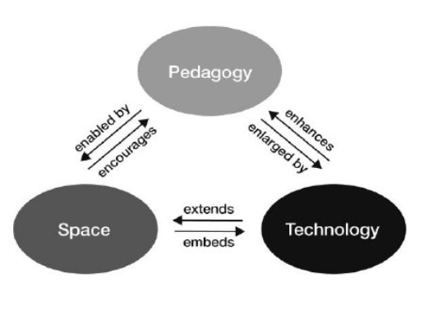

Figure 1. A Pedagogy-Space-Technology framework for designing and evaluating learning spaces (Radcliffe 2009, p. 13)

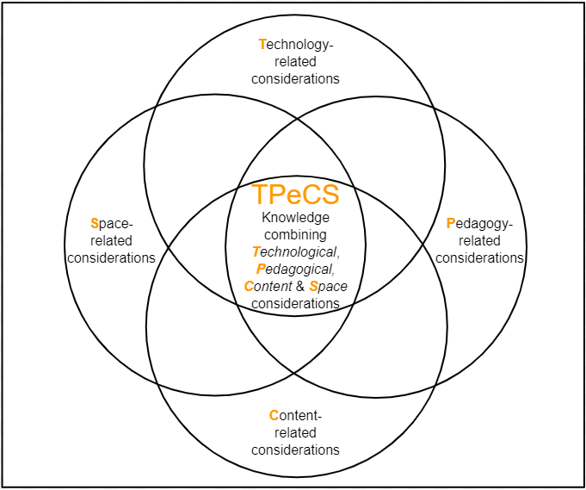

Figure 2. The TPeCS framework (Kali et al., 2019)

. G

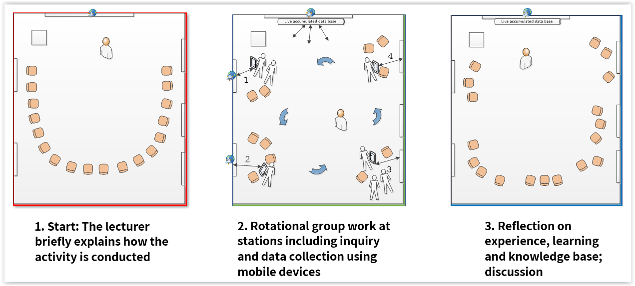

Figure 4. Activity Design Pattern 2: Teaching in an Interactive Orchestrated Learning Space (based on Gil & Slotta, 2015)

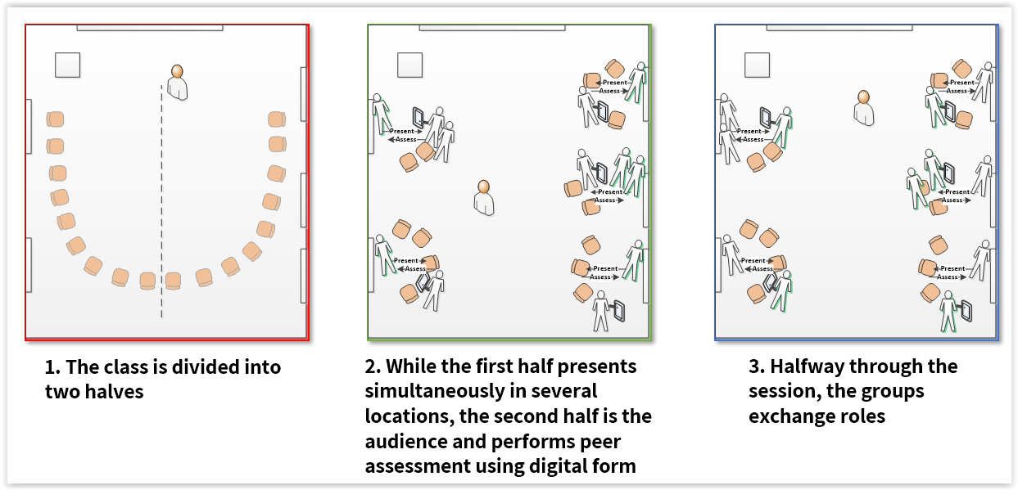

Figure 5. Activity Design Pattern 3: Presentation Fair

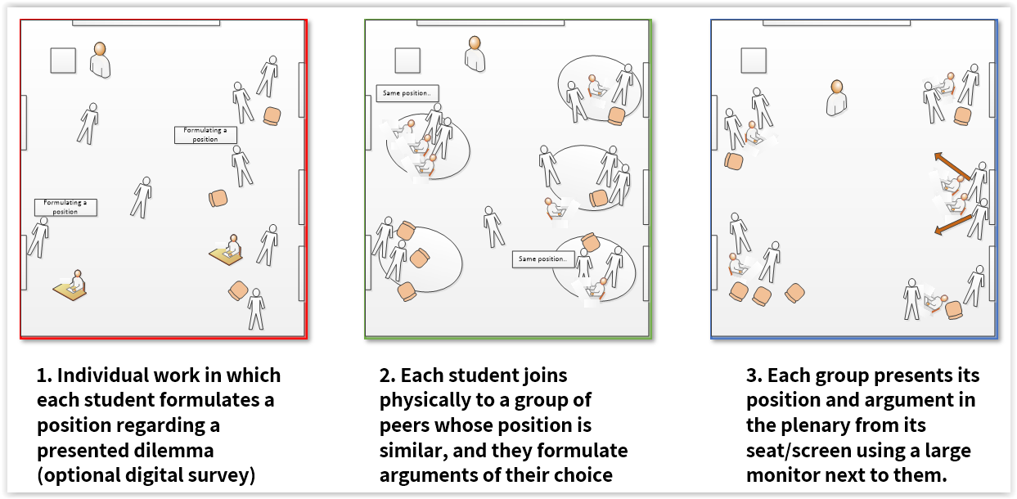

Figure 6. Activity Design Pattern 4: Think-Join-Share (based on Kagan, 1989)

Image 1. FLS1 – Collaborative space - the central room at the Levinsky College of Education

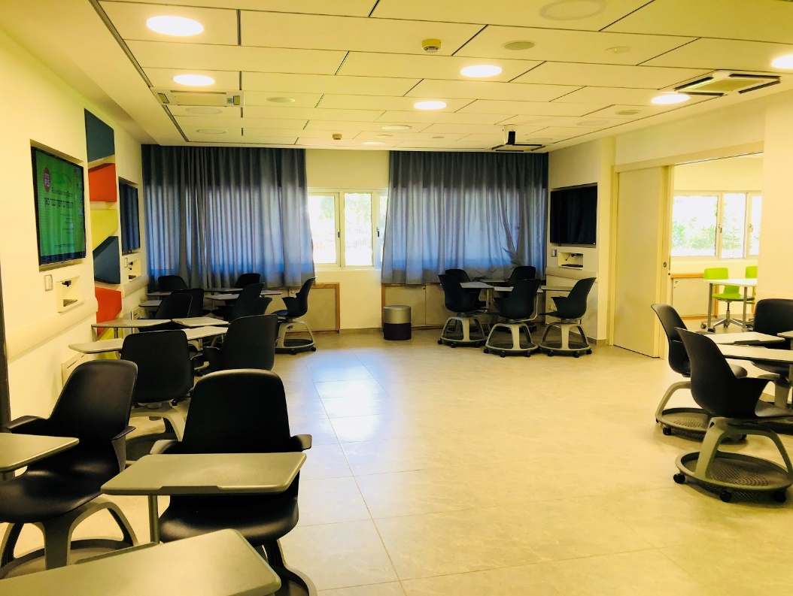

1. * Both authors contributed equally to this manuscript 
2.
3. <https://www.hillside.net/plop/2019/>
4. A ‘makerspace’ is a collaborative workspace for learning, constructing, and sharing products and processes that involve physical products. It might include new technologies and educational games, in addition to simple learning materials. It can offer an opportunity for learners to explore their own interests and to develop creative projects in a constructivist approach (Kurti, Kurti, & Fleming, 2014).
5. Similar to Sharan & Sharan (1990)
6. Tricider.com is an internet platform for decision making that allows for brainstorming, collecting ideas, collaboratively proposing solutions, and quick voting on them.
7. Gil & Slotta (2015)
8. Based on Kagan (1989)