Global and local identities on the balance scale:   
Predicting multicultural team leadership effectiveness

[AUTHOR NAMES/AFFILIATIONS]

**Abstract**

Although multicultural team performance depends to a great extent on leaders' behaviors, we still do not know much about what shapes their actions, allowing them to be effective in their role. This study takes the perspective that sees identities as a directional force for leaders’ actions and argues that the social identity configurations of multicultural team leaders influence both their individual consideration behaviors and leadership effectiveness. Building upon the global acculturation model, we test for the effects of four identity configurations, which are based on the relative strength and balance of global and local identity. We suggest that multicultural team leaders with balanced identity configurations, either both high-glocal, or both low-marginal, are more effective than leaders with unbalanced identity configurations with a dominant global identity or a dominant local identity and that this relation is mediated by the leaders’ individual consideration behaviors. Data was collected from 298 MBA students worked on a four-week, joint project in 77 multicultural teams. We used a polynomial regression method to capture the discrepancy levels between leaders’ global and local identity types, their effect on individual consideration behaviors, and consequent leadership effectiveness. The results generally supported the theoretical model, demonstrating that the most effective global leaders had balanced identity types and that this relationship was mediated by individual consideration behaviors. We discuss the theoretical and practical implications of these findings and its impact on global leadership.

Keywords: global leadership; global identity; multicultural teams; multiple social identities

**Introduction**

The growing presence of global organizations has led to the formation of multicultural teams consisting of culturally diverse members who operate across geographically dispersed zones [1]. Global organizations form multicultural teams that employ talented professionals from around the world, exploiting the large pool of diverse knowledge, skills, and perspectives [2,3]. Culturally diverse team dynamics frequently result, however, in disagreement and mistrust as a consequence of disruptive social categorization processes [4–6].

Mitigating process losses and utilizing the potential of multicultural teams are vital for global organization success [2,7] and can be enhanced by effective leadership [8]. However, despite the potential contribution of effective leadership behaviors to multicultural team effectiveness, empirical and theoretical research on factors that lead to leadership effectiveness in this context is scarce [9,10].

To contribute to this nascent research stream, we take the perspective that sees identities as a directional force for leaders’ actions (e.g., [11,12]), and rely on theories and findings pointing at multicultural identity configurations as drivers of effectiveness in the multicultural context [13–15], to suggest that multicultural team leaders’ cultural identity configurations direct their effective behaviors.

Research on how identity relates to effectiveness in the multicultural context embraced an acculturation perspective (e.g., [13,14]). These acculturation models suggest that identification strength is key for adaptation and effectiveness. This assumption relies in part on Berry’s acculturation model principles that explored the adaptation of immigrants to their host countries. According to this model, individuals with bicultural identity configurations who use an integration strategy (strong identification with home and host cultures) are considered the most effective, followed by individuals with assimilated or separated identity configurations (strong identification with a host or home culture, respectively). Last, marginalization (identity configuration of low identification with both) is considered an inferior acculturation strategy [16,17].

Research findings on identity configurations and effectiveness in multicultural contexts revealed, however, a different pattern. Marginal individuals demonstrated higher effectiveness and adjustment than did assimilated or separated individuals, although not as high as bicultural individuals [15,18]. This general pattern of findings presents a theoretical challenge to acculturation models that focused mostly on explaining the benefits of high identification with both cultures in the multicultural context [13,14]. As a result, scholars called for a better understanding of the nature of marginalism in a multicultural context, separating the discussion of marginalization from that of bicultural effectiveness, and highlighting advantages of autonomy and being emotionally detached from the cultural groups [15,18,19].

To address these calls and explore the research question regarding which, and in what way multicultural team leaders’ cultural identity configurations lead to effectiveness, and in particular, addressing marginals’ effectiveness in the multicultural context, our study takes an alternative approach. While noting the differences, we focus on the commonalities between configurations of balanced identities as a directive force for the behavior and effectiveness of leaders [20,21]. To do so, we rely on Harush et al.’s [20] recent development of the global acculturation model [13], which specifically addresses the relation between two salient cultural identities in the global multicultural team context. The *local identity[1]*, which reflects the individual's sense of belonging to the local-national culture, and the *global identity,* which reflects the individual's sense of belonging to a global, multicultural community [22,23]. In their conceptual development of this model, Harush et al. [20] suggested that in a multicultural context, in which individuals from diverse national cultures operate in a shared global context, the balance (degree of symmetry) between local identity and global identity in the individual’s self is a meaningful predictor of adaptive behaviors. The model proposes that both marginal (low-low identification) and glocal (high-high identification) individuals will demonstrate more inclusive and less exclusive behaviors than individuals with unbalanced identities, who dominantly identify with one culture only (global or local). This model relates to the cultural identity threat as a key mechanism behind the positive or negative responses of individuals to others’ actions within the mixed global cultural context (see also [24]). However, leaders do not only react, but also need to behave proactively in order to lead [25,26]. Therefore, in the multicultural team leadership context, additional theoretical and empirical development is necessary in order to understand the relationship between the balanced identity configurations of multicultural team leaders and their effective behaviors.

To address this theoretical and empirical gap, we conceptually develop the mechanism behind the idea that leaders balance between global and local identities is key in directing behaviors in the multicultural team context and empirically test the link between leaders’ identity configurations to their leadership behaviors and effectiveness. We use identity complexity theory [27] to argue that balanced identities (glocals and marginals) are high in identity complexity compared with unbalanced identity configurations. Then, we explain the cognitive, emotional, and behavioral advantages of high identity complexity for leaders of multicultural teams, arguing that leaders with high identity complexity have a more complex and accurate understanding of the social context, are less bias, and more tolerant towards diverse team members [27–29]. Last, we link identity configurations to leadership behaviors, relating these behavioral tendencies to a specific example of individual consideration behaviors [30]. Multicultural team leaders who use individual consideration behaviors, such as paying attention to follower’s diverse needs, and who are aware that needs and cultural perspectives can differ among team members, facilitate better utilization of the unique perspective of these members and are perceived as being more effective [8,31]. We empirically test the research model linking between leaders’ identity configurations to their individual consideration behaviors and their effectiveness. In all, our work provides theoretical development that explain the classification of marginals as balanced configuration at a low level of identification, presents a conceptual explanation of identity configuration effect on leaders’ cognitive, emotional, and behavioral tendencies and their effectiveness, delineating and empirically testing a model that connects leaders’ identity to their individual consideration behaviors and effectiveness. This theoretical development and empirical exploration add to a current understanding of multicultural team leadership effectiveness and contribute to leadership, identity, and multicultural team literature.

**Literature Review and Hypotheses Development**

***Local and Global Identities and Effectiveness in the Multicultural Environment: Acculturation Perspective***

The view individuals have of their sociocultural context is driven by their social identities [32]. Cultural identity is a specific social identity, defined as “a broad range of beliefs and behaviors that one shares with members of one's community” [33, p.190]. Researchers have used acculturation models to explain adaptiveness to, and effectiveness in a new cultural context, assessing the strength of both the home (original) and the host (new) cultural identity involved (e.g., [16,17]). Similarly, Shokef and Erez [13] presented the global acculturation model to explain individuals’ effectiveness in the global work environment, assessing local and global cultural identities. Shokef and Erez addressed individual’s original cultural identity using the concept of *local identity*, which is defined as a cultural identity that reflects a sense of belonging to individual’s national cultural group and to the shared meaning system, which embeds individuals in their local-national culture [34]. Individuals who strongly identify with the local-national culture tend to view members of their national culture as an important ingroup, which serves as a source of security [35]. In addition to their local identity, individuals who operate in global contexts can also socialize and develop a global identity [34]. Like other social identities that reflect a person’s sense of belonging to a social group that is meaningful to oneself [32], a global identity reflects an individual’s sense of belonging to, and identifying with the global work community, and specifically with global units such as multicultural teams [18,23,36]. Individuals with high levels of global identity are interested in overcoming cultural barriers and maintaining positive relationships with others who operate in the global context [22,37,38]. The global culture is an inclusive group including individuals from all nationalities sharing values of individualism, freedom of choice, competitiveness, performance orientation, openness to change and diversity, and interdependence [20,22,23]. However, while these values and social orientation may be part of the global business community, not all people around the world share them. Thus, global culture does not include all humanity, and global identification differ from identification with all humanity [39]. Conceptually, the global cultural group, while being a common ingroup to the multicultural team members, is not a superordinate group with nested national subgroups in it. The nature of the relationship with the local cultural groups is of cross-cutting categories [36].

To explain individual effectiveness in a global work context, Shokef and Erez [13] describe four identity configurations, based on the relative strength of the global and local identities: glocal type (high global-high local), marginal type (low global-low local), global type (high global-low local), and local type (low global-high local). Shokef and Erez [13,40] claim that individuals with glocal identity type are the most effective in global contexts due to their high identification with both cultures and their ability to integrate perspectives that relate to both their local culture and the global culture of their units. This claim builds on the logic of previous national-level acculturation models, which emphasizes identity strength and the advantages of identity integration, and consider marginalization to be the worst acculturation strategy [16,17,41,42]. However, we argue that the same logic does not apply to a multicultural context in which individuals from multiple “home” local cultures work in a shared global cultural context, simultaneously experiencing both cultures [40]. We, therefore, present an alternative logic, based on the balance between identities as a key for effectiveness in the multicultural team context.

***Identity Configurations, Balance, and Effectiveness in the Multicultural Environment***

Research findings on adaptiveness and effectiveness in a bicultural context revealed that bicultural individuals (who identify with two national [local] cultures), demonstrated higher creativity, effectiveness, and adjustment in cross-cultural contexts (e.g., [15,21,43–45]). Unexpectedly, findings also revealed that marginal individuals (who identify equally low with both home and host cultures) demonstrated similar pattern to those of bicultural individuals, generally demonstrating higher creativity, effectiveness, cultural intelligence, and adjustment than assimilated or separated individuals, although not as high as biculturals [15,18,44]. This general pattern of findings poses a theoretical challenge to acculturation models that a priori separated the discussion of marginalization from the general discussion of balance, or did not discuss marginalization at al. [13,14,18]. For example, the acculturation complexity model did not discuss marginalization, stating that individuals who adopt this strategy are less likely to feel accountable to any cultural group [14]. Other models separated the discussion on marginalization from the general discussion of balance, suggesting different logic to explain the findings regarding the effectiveness of marginalization [18,21]. Notably, as one possible explanation of their results, Tadmor et al. [15] suggested that like bicultural individuals, marginal individuals may also have a balanced identity structure, but with lower identification strength, which leads to higher identity complexity, cognitive complexity, and effectiveness.

In the multicultural context, Harush et al. [20] also suggested shifting the focus from identity strength per se, to balance as predictor of effectiveness in a multicultural context. Accordingly, individuals who display symmetry in their identification with global and local identities are classified as balanced identity types (glocal and marginal[2]). On the other hand, individuals with one dominant identity type are classified as unbalanced identity types (global or local) (see Fig 1). This shift in focus to the balance between identities still requires explanation of the nature of the identity balance and the way it drives leadership effectiveness in a multicultural context. To explain why and how balanced identity configurations drives the effectiveness of multicultural team leaders, we theoretically develop previous suggestions [15,20], linking balanced configurations to identity complexity [27] and delineates how these configurations are related to effective cognitive, emotional, and behavioral tendencies in the multicultural context.

-------------------------------

Insert Fig 1 about here

-------------------------------

**Fig 1. Extended global acculturation model.**

***Linking (Un)Balanced Configurations to Identity Complexity***

To explain why balanced identity configurations lead to multicultural team leadership effectiveness, we make the connection between identity balance and socialidentity complexity concept, which is individuals’ subjective self-representation of the interrelationship among their multiple social identities [27]. Lower complexity may result in a relationship in which a dominant identity suppresses other identities, while a more complex identity relationship allows individuals to simultaneously relate and consider their multiple identities.

Individuals with unbalanced identity configurations have one dominant identity (e.g., global or local) and another weak cultural identity. Roccas and Brewer [27] describe such an identity configuration as a *dominance* identity structure in which individuals identify with one primary group to which all other groups are subordinate. A dominance identity structure is a simplified representation that is low in identity complexity. Individuals who adopt the dominant representation, classify people based on the dominant social ingroup and categorize those who share this category as ingroup members and those who do not, as outgroup members. Such representation of ingroups denies or suppresses one of the identities to forge a simplistic, monolithic view and social categorization, bolstering the commitment to one identity over the other [27,28].

Individuals with balanced configurations (e.g., glocals and marginals) have no dominance or suppression of one identity by the other [20]. Thus, both glocal and marginal individuals can be high in identity complexity, which allows them to relate and consider different aspects of their cultural identities. Indeed, the social identity complexity perspective suggests that different types of individuals who use integration acculturation strategy and who identify strongly with both cultures have high identity complexity. Like other theories, this theory also refrains from discussing marginal acculturation strategy since both identities are relatively low in strength [27]. However, recently an alternative conceptualization of multiculturalism within individuals was presented by Vora and colleagues [46], suggesting that individuals’ level of multiculturalism is a function of one’s knowledge of, identification with, and internalization of more than one culture. Using this conceptualization, marginals may be high in knowledge but low in identification and internalization. Considering that marginal individuals do not hold a dominant identity and therefore do not deny or suppresses one of their identities, they can simultaneously use their knowledge about both the local and global cultural groups and relate to these groups, which is evidence for high identity complexity. This idea is in line with previous findings regarding marginals that were demonstrated higher levels of identity complexity and cognitive complexity compared to individuals who identified with one culture only [15].

***Linking Leaders’ Identity Balance and Complexity with Effectiveness in Multicultural Teams***

The high identity complexity of multicultural team leaders with balanced identity configurations can lead to cognitive, emotional, and behavioral tendencies that facilitate leadership effectiveness in the multicultural context.

The cognitive aspect of identity is related to the perception of group membership and the categorization of self and others into social groups [47]. Reliable representation of the multicultural social context can be valuable for a leader’s ability to lead a multicultural team effectively [48]. Higher levels of identity complexity enable the leader to be aware of simultaneous, multiple group categorization [28]. This in turn, contributes to the understanding that individuals can simultaneously be members in several different social groups [14,27,49]. The complex representation of the multicultural team allows leaders with balanced configurations to understand that members share a common global team identity but also have unique local identities and to address this context accordingly.

Leaders with one dominant identity and low cognitive complexity are, however, committed to a single identity, suppressing the other [27] and ignoring or failing to recognize the complexity of the multicultural social context. These leaders are likely to form a simplified representation of the multicultural context, either recognizing only the common global cultural team identity, or only the diverse local cultural backgrounds of team members.

Emotionally, leaders with balanced configurations are equally attached to both cultural groups, while leaders with unbalanced configurations are attached more to one cultural group over the other. The emotional aspect of social identity captures the feeling of belonging, the significance of group membership, and the motivation and concern for group welfare. Research findings suggest that the emotional aspect also has a significant impact on ingroup attitudes and outgroup bias [47]. Thus, leaders with unbalanced identity configurations are likely to be more motivated, to show concern for their preferred cultural group, and to be biased against other cultural groups. Leaders with balanced identity configurations are not attached to one group more than to the other and are less prone to bias [28,29]. It is important to note, regarding the emotional aspect of identification, that unlike the cognitive membership aspect, glocal and marginal configurations differ in their strength of identification. Leaders with glocal configuration who identify strongly with both cultural groups, may enjoy more identity motivational advantages and show concern for the group’s welfare. Leaders with marginal configuration do not poses this motivational advantage related to their identification with the cultural groups, but their multiculturalism may be meaningful due to their cultural knowledge [46]. Addressing this point, Fitzsimmons et al. [19] suggested that weak identification with both their local and global communities can be an advantage for effective global leaders, as it helps leaders avoid manifesting biased behaviors triggered by cultural stereotypes, understand the importance of these cultures for their followers, and use the cultures' positive aspects to promote their goals. Scholars have also suggested that more autonomy and cultural independence are advantages of marginal configuration [18,21]. Therefore, although the emotional advantages of glocal and marginal configurations differ, we do not expect to find differences between the two in terms of their effectiveness.

The behavioral advantage of leaders with balanced configurations in the multicultural context is that higher identity complexity allows behaving in an unbiased and a tolerant manner towards diverse others [27–29]. The equal levels of identification and high identity complexity present different possible explanations of these behaviors. These explanations are mostly based on the idea, and empirical support thereof, that when individuals share one ingroup of their multiple group memberships with others, biases are reduced and positive feelings and tolerance toward those other individuals are enhanced (see [27–29]).

Hitherto, we presented the cognitive, emotional, and behavioral advantages of multicultural team leaders with balanced identity configurations (glocal or marginal), which enhance their effectiveness in cross-cultural contexts. Their complex view, emotional balance, and behavioral tolerance are likely to produce behaviors that are more thoughtful and culturally responsive, and less biased than of leaders with unbalanced identity configurations (global or locals). On the other hand, leaders with unbalanced identity configurations who deny or suppress one of their identities, tend to adopt simplistic, monolithic views based on one identity dominance, bolstering the emotional attachment and commitment to one identity over the other. Local identity configuration leads to the classification of others as outgroups with no cultural adjustment to the multicultural group context. The suppression of the local identity by leaders with global identity configuration leads to a lack of acknowledgment of members’ unique local ingroups, which in turn leads to less thoughtful and adaptive leadership behaviors. We, therefore, hypothesize the following:

H1: *Multicultural team leaders with balanced identity types (glocal or marginal) will be more effective compared with leaders with one dominant identity (global or local).*

***Individual Consideration Behaviors as Mediator between Leaders’ Identity and Leaders’ Effectiveness***

Leaders need to enact their identities in order to be effective in their roles, as followers judge their leaders' effectiveness through their behaviors [12,25,50]. Hence, we explore what kind of leadership behaviors are effective in the multicultural team context, and how do the social identities of leaders facilitate these behaviors. We suggest that multicultural team leaders with balanced configurations use their complex cultural identity representation and unbiased emotional attachment to present effective leadership behaviors of *individual consideration*.

To be effective in their roles, multicultural team leaders must support the cultural diversity of their team members and acknowledge the positive aspects such diversity brings to the team [8,11,51]. Leaders who are high in individual consideration pay attention to the needs of their team members and are aware that these needs and perspectives can differ among them. They also note the unique motivations and aspirations of the team members for achievement and growth and act as coaches, helping them develop their potential and achieve increasingly higher levels of performance [30,52,53]. During this individualized consideration process, the team leader harnesses the team members' motivations to contribute to the collective good and facilitate a climate of team support in which they recognize the unique contribution of other members, leading to improved team communication and information exchange [30,54]. Indeed, individualized consideration behaviors of leaders contribute to both team cohesion and team performance [25,55].

Within a multicultural team context, the individual consideration of leaders contributes to the members’ sense of psychological safety to voice their unique perspectives and creates a climate in which all task-relevant information is shared and considered in the interest of obtaining the best possible team results [8]. The perception that leaders appreciate and encourage diverse opinions and perspectives makes team faultiness less likely to occur and enhances team members' sense of belonging [31]. These positive behaviors acknowledge the value of the unique, diverse local cultures of team members and the belongingness and inclusion of all members of the global team, in turn leading team members to evaluate such leaders as more effective [56,57].

Our conceptual development linking balanced configuration to identity complexity sets the stage for an explanation of the cognitive, emotional, and behavioral capabilities that allow multicultural team leaders with balanced configurations to demonstrate more individualized consideration behaviors compared with leaders with unbalance identity configurations. Leaders’ cognitive awareness of the social complexity and emotional balance reduces bias and enhances tolerance toward diverse members of the team [27–29]. Tolerance and awareness of differences among team members in their needs and perspectives, which stem from cultural diversity, are essential for leaders in order to demonstrate appropriate consideration behaviors [38]. Thus, leaders who have balanced identity configurations are more likely to pay attention to the unique voices, motivations, needs, and aspirations of culturally diverse team members. At the same time, such leaders harness such unique individual contributions to the global collective good as part of a shared team belongingness process.

On the other hand, multicultural team leaders with unbalanced identity configurations, who have one dominant identity that suppresses the others [27] and low levels of identity complexity, are less likely to demonstrate individual consideration behaviors and therefore less effective. Leaders with a global identity configuration, who suppress local identity, are likely to be less tolerant to specific individual needs that stem from belongingness to other cultural groups. They may fail to either acknowledge or take into account the fact that members belong to other local-national groups or value their team members' diverse and unique perspectives. Leaders with a local identity type are likely to classify others as outgroups, failing to harness cultural diversity to the collective good, and they will not possess the emotional, motivational, or cognitive capacity to demonstrate tolerance or cultural adjustment to the multicultural group context. Hence, we expect that a balance between leaders’ global and local identities leads to more individualized consideration behaviors in the multicultural team context, compared with an imbalance between these identities. Such individualized consideration behaviors are expected to mediate the relationship between identity balance and leadership effectiveness, leading team members to perceive their leaders as effective (e.g., [56,57]).

H2: *Multicultural team leaders with balanced identity types (glocal or marginal) will demonstrate a higher level of individualized consideration behaviors than leaders with dominant (i.e. imbalanced) identity types (global or local).*

H3: *The individualized consideration behaviors of multicultural team leaders will mediate the relationship between their global and local identity configurations and their leadership effectiveness.*

**Method**

***Participants***

The study sample included 298 MBA students from 40 nationalities who were enrolled at eight universities around the world (Finland, Hong Kong, India, Israel, Spain and the USA [3]) and who participated in a multicultural team project. Of the participants, 36% were European (9% from Italy, 7% from Germany, and 20% from other European countries), 20% were from the Far East (16% were Chinese), 16% were Israeli, 14% were North American, 7% were Indian, and 7% were from other miscellaneous areas (e.g., Latin America and Central Asia). The average age was 27.35 (S.D.= 5.70) and 64% were men. Most participants (69%) had previous work experience in industrial companies and most participants (75%) reported that they had worked in multicultural teams in the past (in industry or as part of international MBA programs). A pre-condition for participation in this project was a sufficient level of English proficiency for fluent intra-team communication (e.g., e-mails, chats, video conversations). The mean self-reported level of English proficiency was 4.54 (S.D.=.70, 1-5 scale) and 80% of participants were enrolled in English-language MBA programs.

***Procedure***

Participants were assigned to 77 virtual multicultural teams. Of these, 67 teams (87%) consisted of four members, and the remaining ten teams consisted of three members. Participants were randomly assigned to the teams according to three criteria: different countries, different nationalities, and different universities. Participants worked on a four-week team project as part of the requirements of their cross-cultural management courses. The project was a significant part of each participant's final course grade (between 40%-60%) and consisted of the following four phases:

***Phase 1*, Pre-Project:** Before beginning the project, all participants filled out a web-based questionnaire assessing their level of global and local identities. We used these scores to assess the identity configuration of the elected leaders at the end of Phase 2.

***Phase 2*, Getting to Know Each Other:** During the first nine days of the project, team members interviewed one another and became involved in discussions that expanded their knowledge of one another. This stage consisted of two or more simultaneous chats among all team members, intensive daily e-mail exchanges, and a discussion of a case study involving a personal moral dilemma. After becoming acquainted with one another, team members choose a country about which they were to write their final project together.

At the end of Phase 2, team members also elected “the most suitable team member” to become their team leader and lead them through their assignment in Phase 3. Similar to the general sample, about a third (67%) of the leaders were men with an average age of 27.87 (S.D.= 6.28). Of the leaders, 26% were European, 23% were from the Far East (21% Chinese), 22% were Israeli, 17% were North American, 9% were Indian and 3% were from other areas. The proportion of nominated leaders from English-speaking countries (17%) was close to the proportion of participants from such countries in the sample (15%), suggesting no bias in leadership emergence for native English speakers.

***Phase 3*, Team Project:** This phase, which lasted 19 days, consisted of the team assignment. The task was to develop guidelines for an expatriate assignment for a position in a country selected by the team (which was not the home country of any of the team members).

***Phase 4*, Project Wrap-Up:** At the end of the project, the members in each team evaluated the extent to which their leaders exhibited individual consideration behaviors, and how effective they were as leaders throughout the assignment.

***Measures***

*Global identity and local identity* of leaders were measured by self-report, using the identity scales developed and validated by Shokef and Erez [13,34,40]. Both scales consisted of five items and were on a 7-point Likert type scale (1 = not at all; 7 = very much). The global identity scale measured the individual’s sense of belonging to the global social group (e.g., “I see myself as part of the global international community”), while the local identity scale consisted of five items that measured the individual’s sense of belonging to the local-national group (e.g., “I define my self as an ____ (your nationality- e.g., American, Korean, etc.)”). Cronbach's alpha reliabilities for the two scales were, respectively, .92 and .91.

Confirmatory factor analysis (CFA) on a two-factor model (for the global identity scale and for the local identity scale) provided evidence of a satisfactory fit (χ2(33) =134.24, p<.01**;** CFI= .92; TLI= .90; SRMR = .078). We also compared this model with an alternative one-factor model, that demonstrated insufficient levels of fit indexes (χ2(34) =724.45, p<.001; CFI= .46; TLI= .26; SRMR = .240). Comparison of the χ2 of these two models revealed significant differences between the two models (Δχ2(1)= 590.21, P<.01), further supporting our two-factor model structure.

*Individual Consideration* was evaluated using a scale from the Multifactor Leadership Questionnaire -5X short (MLQ; Avolio & Bass; 2004)[3]. This scale consisted of four items and was measured on a 5-point Likert-type scale (0 = not at all; 4 = frequently, if not always). (Sample item: “Treats me as an individual rather than just as a member of a group.”) Cronbach's alpha reliability was .75.

*Leadership effectiveness* of team leaders was evaluated using a Leadership Effectiveness Scale modified for use in projects (based on [58]) that consisted of six items on a 5-point Likert-type scale (1 = strongly disagree; 5 = strongly agree). (Sample item: “Our team leader succeeded in his/her role during the project”.) Cronbach's alpha reliability was .94.

We conducted CFA to examine the distinctiveness of the two followers reported variables (individual consideration and perceived leadership effectiveness). The hypothesized two-factor model provided evidence of a satisfactory fit (χ2(34) =162.89, p<.01**;** CFI= .92; TLI= .90; SRMR = .066). We then compared this model with an alternative one-factor model, which demonstrated insufficient levels of fit indexes (χ2(35) =225.36, p<.01; CFI= .88; TLI= .84; SRMR = .077). A comparison of the χ2 of the two models revealed significant differences between the two (Δχ2(1)= 62.7, P<.01) and so we continued to examine these variables as two distinct constructs.

*Control variables -*To demonstrate the contribution of leaders’ global and local identity configurations on individual consideration and leadership effectiveness, we controlled for other leader characteristics that were found to be related to leadership effectiveness in general, and to the global context in particular. We controlled for leaders’ general self-efficacy (8 items [59]) and for leaders’ openness to experiences (5 items [60]). We also controlled for the number of spoken languages of both leaders and team members, as these can be related to global characteristics [18]. Finally, we controlled for team demographics that related to age and gender (Lee et al., 2008), using age diversity in the team (as expressed by the SD) and the proportion of women in the team [61].

***Analytical Strategy***

In this study, we use the method of polynomial regression with response surface to explore our hypotheses. This method suggests a solution to the problems associated with using difference scores to analyze discrepancies in ratings [62–64]. As this method “has more explanatory potential than do difference scores or traditional moderated regression analyses and holds promise for applicability to a wide range of research questions” [65, p.543]. Moreover, the method retains the independent effect of each component measure and exposes the unique contribution of each component measure to the variance of the outcome, which helps overcome confounded effects. Finally, unlike linear regression, polynomial regression reveals non-linear changes along the lines that assess the outcome [65,66].

Lee [44] claimed that although polynomial regression analysis and response surface methodology were commonly used for testing congruence hypotheses, they are also applicable for examining the joint effects of dual cultural identity configurations, represented by four combinations of the extreme values of these identities, as located at the four “corners” of the response surface.

We, therefore, used polynomial regression analysis and response surface methodology [64] to address the joint effects of dual cultural identity configuration and test our hypotheses. In our study, the four corners of the surface represent four different configurations of global and local identities. Corner A represents the glocal identity type - high global-high local identity configuration; Corner B represents the global identity type - high global -low local identity configuration; Corner C represents the marginal identity type - low global-low local identity configuration; and Corner D represents the local identity type - low global-high local identity configuration (see Fig 2). The four lines along the edges of the response surface connect balanced identity types with unbalanced identity types; hence, their analyses allow us to test our hypotheses [67]. The diagonal lines in Fig 2 connect the two balanced identity types (fit line- corners C-A) and the two unbalanced identity types (misfit line- corners B-D) and, although tested, are not central to any of our hypotheses.

-------------------------------

Insert Fig 2 about here

-------------------------------

**Fig 2. Schematic description of lines of interest between the four identity types.**

Prior to the analyses, the measures of global and local identities were scale-centered by subtracting the midpoint of the scale [62]. Additionally, as no reports on global and local leader identities were lower than the score of 2, we explored the response surface for these variables within the range of 2 to 7 (or -2 to 3 after subtracting the midpoint of the scale), to avoid extrapolations in our analysis [68]. The need to avoid extrapolation is specifically essential when using polynomial regression, as this method is extremely sensitive to possible bias when working beyond the range of the data [69–71].

To test our research model, we conducted a mediated multi-level polynomial regression procedure (based on the procedures described by Zhang, Wang, and Shi [72] and response surface modeling [64] using the SAS 9.4 MIXED procedure. We accounted for non-independence among team members with the same leader by applying random intercept polynomial models. Specifically, the dependent variables–leadership effectiveness (H1) and individual consideration (H2)–were regressed on five polynomial terms: leaders’ global identity, leaders’ local identity, their squares, and their multiplication product. Next, to test the nature of the relations between balanced and unbalanced identity types, we conducted additional analyses. First, based on the procedure developed by Lee and Antonakis [67], we tested equality between predicted values of the criteria (leadership effectiveness / individual consideration) at the four corner points, to examine whether the predicted values at the “balanced corner” points (glocal and marginal) are significantly higher than the values at the “unbalanced corner” points (global and local). We used the ESTIMATE statement of SAS MIXED procedure to estimate the differences between the values of both leadership effectiveness and individual consideration in different corners of the response surface, and conduct an approximate t-test, to test the significance of these differences.

Second, we tested the curvatures of the interest lines that connect the four corner points (namely, the balanced and unbalanced identity types) along the edges of the response surface. For this purpose, we developed equations to test the curvature significance of these four lines based on work by Cohen, Nahum-Shani and Doveh [73] (see Appendix A). Next, for lines with significant curvature, we also tested the tangent slopes along these lines (based on the procedure presented by Lee and Antonakis [67]. Each tangent slope equals to the slope of the tangent line drawn at a specific point along an interest line. This allowed us to examine the functional form of interest lines with greater precision.

To test our third hypothesis according to which individual consideration mediates the joint effect of leaders’ global and local identities on their perceived leadership effectiveness, we followed recommendations to confirm this hypothesis by proving significant relationship between the independent variable (*X*) and the outcome (*Y*) through the mediator (*M*) [74–76].

To evaluate the statistically significant indirect effect, we used the block variable method [72,77]. Accordingly, to obtain a single coefficient that represents the joint effect of the five polynomial terms (leaders’ global identity, leaders' local identity, their squares, and their multiplication), the five terms were combined into a block variable, which is their weighted linear composite. The joint indirect effect of global and local identities on perceived leadership effectiveness, through individual consideration, was calculated as the product of (a) the standardized regression coefficient of the block variable on individual consideration and (b) the standardized regression coefficients of individual consideration on leadership effectiveness, in the presence of the direct effects of leaders' global and local identities. We used the Monte Carlo method [78] to create 95% confidence intervals that assessed the indirect effect, with 20,000 replications, since this method can be applied while accommodating the interdependence induced by the clustering of our data [79].

***Results***

Table 1 presents the means, standard deviations, and correlations between the research variables.

-------------------------------

Insert Table 1 about here

-------------------------------

|  |  |  |  |  |  |  |  |  |  |  |  |  |  |
| --- | --- | --- | --- | --- | --- | --- | --- | --- | --- | --- | --- | --- | --- |
|  |  |  |  |  |  |  |  |  |  |  |  |  |  |
|  |  |  |  |  |  |  |  |  |  |  |  |  |  |
|  |  |  |  |  |  |  |  |  |  |  |  |  |  |
|  |  |  |  |  |  |  |  |  |  |  |  |  |  |
|  |  |  |  |  |  |  |  |  |  |  |  |  |  |
|  |  |  |  |  |  |  |  |  |  |  |  |  |  |
|  |  |  |  |  |  |  |  |  |  |  |  |  |  |
|  |  |  |  |  |  |  |  |  |  |  |  |  |  |
|  |  |  |  |  |  |  |  |  |  |  |  |  |  |
|  |  |  |  |  |  |  |  |  |  |  |  |  |  |
|  |  |  |  |  |  |  |  |  |  |  |  |  |  |

To test the joint effect of the global and local identities of leaders on both perceived leadership effectiveness (H1) and individual consideration (H2), we conducted polynomial regression analysis [64]. Perceived leadership effectiveness and individual consideration were regressed (separately) on leaders’ global identity and local identity in Step 1. The interaction between global and local identities, the square of global identity, and the square of local identity were added in Step 2. A significant *F* test for the three quadratic terms in Step 2, for both perceived leadership effectiveness (F=4.02, p<.05) and individual consideration (F=3.58, p<.05), indicated a non-linear relationship between global and local identities on these dependent variables [66]. This supported further examination of the quadratic relations (see Table 2).

-------------------------------

Insert Table 2 about here

-------------------------------

|  |  |  |  |  |  |  |  |  |  |
| --- | --- | --- | --- | --- | --- | --- | --- | --- | --- |
|  |  | |  | |  | | | | |
|  |  |  | |  | | |  | |  |
|  |  |  |  | |  |  | |  | |
|  |  |  |  | |  |  | |  | |
|  |  |  |  | |  |  | |  | |
|  |  |  |  | |  |  | |  | |
|  |  |  |  | |  |  | |  | |
|  |  |  |  | |  |  | |  | |
|  |  |  |  | |  |  | |  | |
|  |  |  |  | |  |  | |  | |
|  |  |  |  | |  |  | |  | |
|  |  |  |  | |  |  | |  | |
|  |  |  |  | |  |  | |  | |
|  |  |  |  | |  |  | |  | |
|  |  |  |  | |  |  | |  | |
|  |  |  |  | |  |  | |  | |

To better interpret the nature of the quadratic polynomial regression models, we plotted the response surfaces of the estimated models for perceived leadership effectiveness and individual consideration (see Fig 3 and Fig 4). Then, to explore Hypotheses 1 and 2, we first tested whether the predicted values of the four corner points on the response surfaces differed (see Table 3).

-------------------------------

Insert Table 3 about here

-------------------------------

Table 3

Testing the Equality between Predicted Values on the Response Surfaces

|  |  |  |  |
| --- | --- | --- | --- |
|  | Individual Consideration | | Leadership Effectiveness |
|  | Predicted Value at Specific Point | | |
| Points on the response surface | |  |  |
| A (Glocal) | | 2.84 | 4.30 |
| B (Global) | | 0.19 | 1.10 |
| C (Marginal) | | 3.01 | 5.16 |
| D (Local) | | 1.06 | 2.44 |
|  | | Differences Between Predicted Values | |
| Along the edges of surfaces | |  |  |
| A (Glocal) vs. B (Global) | | 2.65* | 3.20* |
| A (Glocal) vs. D (Local) | | 1.77† | 1.86† |
| C (Marginal) vs. B (Global) | | 2.82† | 4.07* |
| C (Marginal) vs. D (Local) | | 1.94 | 2.72† |
| Along diagonal lines | |  |  |
| C (Marginal) vs. A (Glocal) | | 0.17 | 0.86 |
| D (Local) vs. B (Global) | | 0.87 | 1.34 |

† p <.1, * p < .05, ** p < .01. Significance is calculated using approximate t-test.

Our results show that leadership effectiveness values at the glocal identity type corner (Point A) and marginal identity type corner (point C) were significantly higher than at the global identity type corner (Point B, p<.05) and marginally significantly higher than at the local identity type corner (Point D, p<.10). Results for the individual consideration criterion were similar for the differences between the glocal identity type corner and the global identity type corner (p<.05) and the local identity type corner (p<.10). A marginal difference was found between the marginal identity type corner and the global identity type corner (p<.10), and no significant difference was found between the marginal identity type corner and the local identity type corner (although significance was close to marginality, p<.12). There was also no significant difference between the values of the balanced identity corners (glocal and marginal identity types), nor between the unbalanced identity corners (global and local identity types), for both leadership effectiveness and individual consideration criteria. Next, we tested curvature significance of the four interest lines that form the edges of the response surface and that connect the unbalanced identity corners with the balanced identity corners (lines B-A, D-A, C-B, D-C), and the significance of the curvatures of the two diagonal lines (fit line- A-C, misfit lines B-D). Results revealed that the curvature was significantly negative for the lines between the local and marginal identity type corners (line D-C) and between the global and glocal identity type corners (line B-A), indicating that the surface curves downward in a concave manner for both perceived leadership effectiveness (B=-.12, p<.05) and individual consideration (B=-.11, p<.05).

-------------------------------

Insert Fig 3 and Fig 4 about here

-------------------------------

**Fig 3. The four identity types as predictors of leadership effectiveness.**

**Fig 4. The four identity types as predictors of individual consideration.**

Since the curvatures of these two lines were significant, we further tested tangent slopes at particular points (see Table 4). We found that the tangent slopes at the interest line between the local and marginal identity type corners (where global identity is fixed at a value of -2), were not significant for either leadership effectiveness or individual consideration when X (local identity) values were equal to -2,-1, and 0. However, the tangent slopes were marginally significant for individual consideration and significant for leadership effectiveness when local identity was equal to 1, and were significant for both of them when local identity was equal to 2 and 3 (see Fig 5, Fig 6, and Table 4). These lines, which demonstrate a concave shape, indicate that when the degree of discrepancy (i.e., unbalance) between global and local identity is low, there is no significant change in the level of leadership effectiveness and individual consideration. When the discrepancy is, however, high (global identity is equal to -2 and local identity is equal to 1, 2, or 3), a decrease is observed in both leadership effectiveness and individual consideration.

-------------------------------

Insert Table 4 about here

-------------------------------

Table 4

Wald Tests for Slopes of Tangents Along Edges of Response Surfaces

|  |  |  |  |  |  |  |  |  |  |  |  |  |  |
| --- | --- | --- | --- | --- | --- | --- | --- | --- | --- | --- | --- | --- | --- |
| Corresponding Point on Response Surface | When Y(global identity) = –2  CD  (Marginal) (Local) | | | | | |  | When Y(global identity) = 3  B A  (Global) (Glocal) | | | | | |
| Local Identity (x) | X= -2 | X= -1 | X= 0 | X=1 | X=2 | X=3 |  | X= -2 | X= -1 | X= 0 | X=1 | X=2 | X=3 |
| Individual Consideration | .16 | -.06 | -.28 | -.50† | -.72* | -.94* |  | 1.08* | .86* | .64* | 42* | .20 | -.02 |
| Leadership Effectiveness | .04 | -.19 | -.43 | -.67* | -.89** | -1.12** |  | 1.23** | .99** | .76** | .52* | .29 | .05 |

† p <.1, *p < .05, ** p < .01

-------------------------------

Insert Fig 5 and Fig 6 about here

-------------------------------

**Fig 5. Tangent slope significance along the local-marginal leadership effectiveness line.**

**Fig. 6. Tangent slope significance along the local-marginal individual consideration line.**

A similar pattern was found for the line between the global and glocal identity corners (where global identity is fixed at a value of 3). In both cases, when the degree of discrepancy was low (local identity (X) value was equal to 3 or 2), tangent slopes at these points were not significant, while at higher levels of discrepancies between global and local identities (where local identity (X) was equal to 1, 0, -1 or -2), they were (see Fig 7 and Fig 8, Table 4). These results support Hypotheses 1 and 2.

-------------------------------

Insert Fig 7 and Fig 8 about here

-------------------------------

**Fig 7. Tangent slope significance along the global-glocal leadership effectiveness line.**

**Fig 8. Tangent slope significance along the global-glocal individual consideration line.**

The curvatures of the interest lines along the edge of the surface between the marginal and global identity type corners (line C-B), as well as between the local and glocal identity type corners (line D-A) were not significant for perceived leadership effectiveness (B=.05, n.s.) nor for individual consideration (B=.05, n.s.). The tangent slope of the former line, however, was significant when global identity was equal to zero, for both leadership effectiveness (B=-0.84, p<.01) and individual consideration (B=-0.62, p<.05). This suggests that both leadership effectiveness and individual consideration decrease along the line between the (balanced) marginal identity corner and the (unbalanced) global identity corner, further supporting Hypotheses 1 and 2. The tangent slop at the same point was not significant for the line between the local identity type corner and the glocal identity type corner for either leadership effectiveness (B=0.32, n.s) or individual consideration (B=0.30, n.s.)

To test the mediating effect of individual consideration on the relationship between a leader'sglobal identity, local identity, and perceived leadership effectiveness (H3), we ran a mediation model. As shown in Table 2 (leadership effectiveness model, Step 2), the five polynomial terms served to predict perceived leadership effectiveness. In Step 3, we added individual consideration into the regression, which was found to be significant (0.57, p<.01). The standardized path coefficient of the joint effect of the global and local identities of leaders on individual consideration was B=.27 (*p<* .01), and the path coefficient for the relationship between individual consideration and leadership effectiveness was B=.55 (p<.01). We calculated the indirect effect by multiplying the coefficients of these paths and found the indirect effect to be significant (B=.15, 95% CI [.06; .24]). The results demonstrate that individual consideration mediated the joint effects of leaders’ global and local identities on leadership effectiveness, thus supporting Hypothesis 3.

Last, although not hypothesized, we explored both curvatures and slopes along the diagonal lines – between the balanced identity type corners (marginal and glocal (C-A)) and between the unbalanced identity type corners (global and local, (B-D)) all of which were found to be not significant for either leadership effectiveness or individual consideration.

**Discussion**

In light of the growing presence of multicultural teams in global organizations, it has become essential to advance the knowledge on how to enhance their performance [2,7]. Like other diverse teams, multicultural team performance can be enhanced by effective leadership behaviors [8]. Effectiveness in the multicultural environment has been recognized as related to multiple cultural identity configurations [13–15]. The need for a better understanding of the nature of such a relationship has been recognized in both organizational, cross-cultural, and leadership research literature (e.g., [80–82]). Yet, empirical research on how identity configurations of multicultural team leaders shape their behaviors, allowing them to be effective in their roles, is scarce [83].

This study contributes to the current literature by exploring the link between identity configurations of multicultural team leaders to their leadership behaviors and effectiveness. Specifically, we predicted that leaders with balanced glocal or marginal identity configurations would demonstrate higher levels of individual consideration than leaders with unbalanced identity configuration (local or global), and as a result, will be perceived by their team members as more effective. As expected, team members perceived leaders with balanced identity configurations, both glocal and marginal, as more effective than leaders with unbalanced local or global identity configurations. Moreover, leadership behaviors of individual consideration mediated this relationship. While the results of a polynomial regression for individual consideration as a criterion were less convincing when comparing surface corners, the relative interest lines revealed patterns that showed that the greater the discrepancy between global identity and local identity values, the greater the decrease in both leadership effectiveness and individual consideration. Such patterns further support our argument and hypotheses that the balance between the global and local identities of multicultural team leaders drives their individual consideration behaviors and effectiveness.

***Theoretical Contributions***

Our study suggests conceptual developments to the aspect of balance between identities and articulates the link between cultural identity configurations and leadership effectiveness in the multicultural context. In doing so, we contribute to the emerging research on the effect of multiple identity configurations link to complex organizational behaviors and multicultural literature (e.g., [2,84,85]), and offers theoretical contributions to the connection between three research streams–identity, multicultural teams, and leadership.

First, our study demarcates the boundaries of balanced identities to include balanced configurations not only at high levels but also at low levels of identification strength. Hitherto, the existing literature discussed marginalization mainly by explaining how low identification with cultural groups is linked to autonomy, cultural independence, and flexibility [18,21]. Our logic addresses individuals with balanced identity configurations (marginal and glocal) as multiculturals with knowledge of both groups but differ in their levels of identification [46]. This allows addressing commonalities in the way balanced identity configurations are linked to identity complexity.

Second, we follow the logic of Brewer and colleagues [27–29] to classify leaders with unbalanced identity configurations, that their dominant identity suppresses all others, as low in identity complexity. Whereas leaders with balanced identity configurations that do not suppress one identity with the other are classified as high in identity complexity. By linking between balanced identity configuration to high identity complexity, we provide mechanisms that explain effectiveness in the multicultural context. Cognitively, leaders with balanced configurations are more aware of the complexity of the common global group and the different local cultural groups of the multicultural team members, enabling them to act accordingly. Emotionally, leaders with unbalanced identity configuration are prone to bias in their commitment, as opposed to leaders with balanced configurations who are not. Our view regarding the emotional aspect complements a previous suggestion that marginal leaders, as cultural group members with low emotional attachment to these cultures, can “pick and choose what they deem to be appropriate from each culture rather than allowing society to dictate ascribed expectations” [15, p.537] (see also [19]). Our perspective presents a more comprehensive framework that addresses the differences in emotional advantages that lead to effectiveness- the motivational aspect of glocals, and the autonomy and flexibility of marginals. Behaviorally, identity complexity reduces bias and enhances tolerance [27–29], which allows leaders with balanced configurations to address the diversity among members of the multicultural team affectively.

Additionally, we theoretically link the advantages of balanced identity configurations to individual consideration behaviors. The reliable cognitive representation and awareness to team members’ unique cultural identities, the emotional balance, and the behavioral tolerance, all facilitate leaders’ ability to perform individual consideration behaviors like paying attention and motivate the needs and aspirations of diverse cultural team members [30]. In sum, our conceptual development and empirical support enhance our understanding of the link between identity configurations balance to effectiveness in a multicultural context.

The theoretical and empirical connections in our study between multicultural team leaders’ identity configurations to their individual consideration behaviors and leadership effectiveness present an additional contribution to the multicultural team leadership literature. Only several studies explored the relations between multicultural team leaders’ identities to related measures, focusing mostly on one identity (e.g., global identity) and on strength aspects (e.g., [11,38]). The current study explores four configurations of global and local identities, and the results highlight that identity balance between global and local identities is essential for leadership effectiveness in the multicultural context. It illuminates the potential of exploring multiple social-cultural identities configurations to gain a better understanding of different aspects of leadership.

Within a broader scope of leadership literature, the dominant self-concept-based leadership perspective (e.g., [86,87]) led to valuable knowledge about how leadership behaviors influence the identification of team members with their teams and leaders, and how these behaviors direct effectiveness in these teams [88]. As scholars have indicated, however, empirical research on the first part of the causal chain that explains how self-identity of leaders directs leadership behaviors is scarce, both in the general field of leadership and in the global context in particular [83,89]. Our study addresses this gap by demonstrating a relationship between leaders’ identity configuration their individualized consideration behaviors and their leadership effectiveness, in the context of multicultural teams. Hence, whereas leadership behaviors are most salient for team members, it is important to understand how self-identity concept aspects, such as social identification, contribute to the creation of these effective leadership behaviors. An exploration of the full scope of models describing the relationships between leader identity, leader behavior, and leader effectiveness will contribute to a better understanding of the leadership phenomenon.

***Managerial Relevance***

Our results indicate that during the training of multicultural team leaders, organizations should encourage leaders to recognize the existence of both local cultural aspects and global cultural aspects in this context. Research findings suggest that exposure to a multicultural team context can enhance one's understanding and identification with the global culture, and that this effect can have a prolonged impact [34]. Cross-cultural training can enhance the recognition of local cultural aspects as cultural sensitivity and an understanding of the nature of cultural diversity (e.g., [90]). Multicultural training should also emphasize the benefit of a balanced perspective within the teams. Specifically, leaders should learn to harness the culturally diverse aspects of their members to fulfill the organization's global team goal, by facilitating sense of cohesiveness and belongingness to the team and at the same time embrace unique aspects of cultural diversity (e.g., [91,92]). Leadership training should also focus on learning specific leadership behaviors, such as individual consideration behaviors, that are valuable to enhance proactivity among culturally diverse team members.

***Limitations and Future Research***

Our study offers insight about the relationship between the social identity configurations of leaders, their behaviors, and their effectiveness in the context of multicultural teams. These results constitute a foundation for future studies that will continue this line of research and overcome the study limitations.

Participants were MBA students, which may raise the question of the external validity of the setting. Four factors mitigate this concern. First, our participants were mostly part-time students who worked part-time or full time in global and local organizations. Most of them (75%) reported that they had worked in multicultural teams in the past. Hence, the profile of these students is similar to that of educated employees in organizations. Second, research reveals a high correlation between the effect sizes of field studies and non-field study settings [93]. Third, our participants communicated with each other intensively, on a daily basis, throughout the entire month, simulating fieldwork. Last, while we could not estimate how typical is our research setting, we found that its features are typical for many of the multicultural teams in the workplace. In a recent survey of a consulting group, 48% of the respondents never met other team members in person, which is an increasing trend [94]. Little formal authority is also a feature that is part of such teams [95]. The 2018’s trend survey suggested that most employees work in more than one team simultaneously (i.e., multi-team membership [96]). In such contexts, it is common that team members’ main formal authority is the professional manager, and the team leader is with less formal power, thus need more leadership skills. Future research should expand the exploration of the present study to multinational organizations.

An additional limitation stems from the research design. Due to the project timeline, we measured team members' reports of both individual consideration behaviors and leadership effectiveness only at the end of the project. Although this is not ideal, our CFA analysis demonstrated that team members' perceptions of individual consideration and leadership effectiveness were separate constructs. Moreover, scholars claim that followers develop their perceptions of leadership effectiveness based on their perceptions of their leaders’ behaviors [9,10], providing theoretical support for our research model.

Another aspect that requires consideration is the virtual context of our study. Although many of the multicultural teams in global organizations are virtual, some are co-located. These two types of teams differ in several contextual aspects since virtual multicultural teams are geographically dispersed and rely on technological means in order to communicate [2]. Such conditions can influence the relations between team members. For example, cultural diversity tended to be associated with higher levels of conflict and lower levels of social integration when teams were co-located compared to when they were dispersed [5]. Therefore, the saliency and intensity of some of the challenges that multicultural team leaders face depend on the context (virtual or co-located). In virtual multicultural teams, like in our study, most team members are physically located in different national environments when communicating with other members, including the leader. Under such conditions, local-national identities can be more salient than in co-located teams in which at least some of the members and the leader operate from the same location. Additionally, creating a shared global identity in virtual teams can be more challenging than it is in co-located teams [2], and the leader's ability to demonstrate individual consideration is more complicated due to limited social cues [97]. All these can affect both the relationship between the identity configuration and behaviors of leaders and followers and the impact of leadership behaviors on team and leadership effectiveness. We, therefore, recommend testing our model, or similar models, in co-located, multicultural teams.

Last, in our study, we focused on one leadership behavior, namely individual consideration. Still, other leadership behaviors can lead to leadership effectiveness in the multicultural context (e.g., empowerment leadership [98], brokerage [99]). Future research is required in order to understand the relationship between identity configurations and other leadership behaviors in multicultural teams as well as in other contexts.

***Conclusions***

Leaders play an essential role in leveraging the benefits and mitigating the challenges of multicultural teams. Still, understanding of the antecedents of effective leadership behaviors in this complex context is limited. By incorporating global acculturation and identity complexity principles to the multicultural team context, this study delineates how the balance between the global and local identities of leaders leads to effective leadership behaviors. In doing so, this study contributes to the research streams of leadership, multiple identities, and multi-cultural teams.

**Appendix A**

**Testing Curvature Along the Edge of a Response Surface**

Polynomial regression analysis [64] involves estimating a combined linear and quadratic regression model, represented by Equation 1:

(1) $Z=b_{0 }+ b_{1}X+b_{2}Y+b_{3}X^{2}+b_{4}XY+b_{5}Y^{2}+e.$

In our study, X and Y are global identity and local identity, respectively; Z is leadership effectiveness / individual consideration behaviors; b1 and b2 are the regression coefficients for global identity and local identity, respectively; b3 is the regression coefficient for the global identity squared; b4 is the regression coefficient of the interaction between global and local identities; and b5 is the regression coefficient of the local identity squared.

To test the curvatures of the four lines of interest along the edge of the response surface, we relied on the work presented by Cohen et al. [73] and Lee and Antonakis [67] and developed two equations.

Fig 2 demonstrates that the line between corners A (glocal identity type) and D (local identity type) represents subjects for whom the global identity value (X) is allowed to fluctuate freely in the defined range (from -2 to 3), whereas the local identity (Y) value is fixed to Y* (Y* = 3 for this specific line, at the highest level of the local identity continuum). Hence, for this line, we substitute Y with Y* in Equation 1. The resulting equation is:

(2) $Z=\left(b_{0 }+{Y^{*}*b}_{2}+{{\left(Y^{*}\right)}^{2}*b}_{5}\right)+ \left(b_{1}+Y^{*}*b_{4}\right)X+b_{3}X^{2}+e.$

The curvature along this line (where is X allowed to fluctuate) equals $b_{3}.$ Please note that the curvature is fixed and equals $b_{3}$, for any choice of $Y^{*}$.

The pattern for the mirror line, which connects corner B (global identity type) and corner C (marginal identity type), is the same. X (global identity) is allowed to fluctuate freely as for the previous line, and the local identity (Y) value is fixed to Y* (specifically for this line, Y* equals -2). Since the curvature does not depend on the specific Y*, as explained for the line above, the curvature of this line will also equal ${ b}_{3}$.

The line between corners A (glocal identity type) and B (global identity type), in which the global identity (*X*) value is fixed to X* (X* = 3 for this specific line), whereas the local identity value (*Y*) is allowed to fluctuate freely in the defined range (from -2 to 3). For this line, we substitute *X* with X* in Equation 1 to obtain:

$$(3) Z=\left(b_{0 }+ X^{*}*b_{1}+{\left(X^{*}\right)}^{2}*b_{3}\right)+\left(b_{2}+{X^{*}*b}_{4}\right)Y+b_{5}Y^{2}+e.$$

Hence, the curvature along this line (where Y is allowed to fluctuate) equals $b_{5}$.

Again, please note that the curvature for this line equals $b_{5}$, for any choice of $X^{*}$.

Since the pattern of the mirror line between corner D (local identity type) and corner C (marginal identity type) is similar (i.e., the global identity (*X*) value is fixed to X* (X* = -2 for this specific line)), and the local identity value (*Y*) is allowed to fluctuate freely in the defined range (from -2 to 3), this curvature also equals $b_{5.}$

**References**

1. Maznevski ML, Chui C. Leading global teams. In: Mendenhall , Osland JS, Bird A, Oddou GR, Maznevski ML, et al., editors. Global leadership: Research, practice and development. New York: Routledge;

2. Gibson CB, Huang L, Kirkman BL, Shapiro DL. Where global and virtual meet: The value of examining the intersection of these elements in twenty-first-century teams. *Annual Review of Organizational Psychology and Organizational Behavior*. ;1: 217–244.

3. Jimenez A, Boehe DM, Taras V, Caprar DV. Working across boundaries: Current and future perspectives on global virtual teams. *Journal of International Management*. 2017;23: 341-349.

4. Hinds PJ, Neeley TB, Cramton CD. Language as a lightning rod: Power contests, emotion regulation, and subgroup dynamics in global teams. *Journal of International Business Studies*. 2014;45: 536-561.

5. Stahl GK, Maznevski ML, Voigt A, Jonsen K. Unraveling the effects of cultural diversity in teams: A meta-analysis of research on multicultural work groups. *Journal of International Business Studies*. 2010;41: 690-709.

6. Van Knippenberg D, Mell JN. Past, present, and potential future of team diversity research: From compositional diversity to emergent diversity. *Organizational Behavior and Human Decision Processes*. 2016;136: 135-145.

7. Stanko TL, Gibson CB. The role of cultural elements in virtual teams. In: Bhaght RS, Steers RM, editors. Cambridge handbook of culture organizations and work. Cambridge: Cambridge University Press; 2009.

8. Kearney E, Gebert D. Managing diversity and enhancing team outcomes: The promise of transformational leadership. *Journal of Applied Psychology*. 2009;94: 77–89.

9. Adler NJ, Aycan Z. Cross-cultural interaction: What we know and what we need to know. *Annual Review of Organizational Psychology and Organizational Behavior*. 2018;5: 307-333.

10. Zander L, Mockaitis AI, Butler CL. Leading global teams. *Journal of World Business*. 2012;47: 592-603.

11. Lisak A**,** Erez M, Yung S, Lee C. The positive role of global leaders in enhancing multicultural team innovation. *Journal of International Business Studies*. 2016;47: 655-673.

12. Lord RG, Hall RJ. Identity, deep structure and the development of leadership skill. *The Leadership Quarterly*. 2005;16: 591-615.

13. Shokef E, Erez M. Global work culture and global identity as a platform for a shared understanding in multicultural teams. In Mannix , Chen Y, editors. National culture and groups. *Research on managing groups and teams*. San Diego, CA: Elsevier; 2006. pp. 325-352.

14. Tadmor CT, Tetlock PE. Biculturalism: A model of the effects of second-culture exposure on acculturation and integrative complexity. *Journal of Cross-Cultural Psychology*. 2006;37(2): 173-190.

15. Tadmor CT, Galinsky AD, Maddux WW. Getting the most out of living abroad: Biculturalism and integrative complexity as key drivers of creative and professional success. *Journal of Personality and Social Psychology*. 2012;103: 520-542.

16. Berry JW. Immigration, acculturation, and adaptation. *Applied psychology*. 1997;46(1): 5-34.

17. Berry, JW. Acculturative stress. In: Wong PTP, Wong LCJ, editors. *Handbook of multicultural perspectives on stress and coping*. Springer; 2006. pp. 287-298.

18. Lee YT, Masuda AD, Fu X, Reiche BS. (2018). Navigating between home, host, and global: Consequences of multicultural team members’ identity configurations. *Academy of Management Discoveries.* 2018;4: 180-201.

19. Fitzsimmons SR, Lee Y, Brannen MY. Demystifying the myth about marginals: Implications for global leadership. *European Journal of International Management*. 2013;7: 587-603.

20. Harush R, Lisak A, Erez M. Extending the global acculturation model to untangle the culture mixing puzzle. *Journal of Cross-Cultural Psychology*. 2016;47: 1395-1408.

21. Tadmor CT, Tetlock PE, Peng K. Biculturalism and integrative complexity: Testing the acculturation complexity model. *Journal of Cross-Cultural Psychology*. 2009;40: 105-139.

22. Arnett JJ. The psychology of globalization. *American Psychologist*. 2002;57: 774-783.

23. Erez M, Gati E. A dynamic, multi-level model of culture: From the micro level of the individual to the macro level of a global culture. *Applied Psychology: An International Review*. 2004;53: 583-598.

24. Chiu CY, Gries P, Torelli CJ, Cheng SY. Toward a social psychology of globalization. *Journal of Social Issues*. 2011;67(4): 663-676.

25. Dvir T, EdenD, Avolio BJ, Shamir B. Impact of transformational leadership on follower development and performance: A field experiment. *Academy of Management Journal*. 2002;45: 735-744.

26. Shamir B, Zakay E, Brainin E, Popper M. Leadership and social identification in military units: Direct and indirect Relationships. *Journal of Applied Social Psychology*. 2000;30: 612-640.

27. Roccas S, Brewer MB. Social identity complexity. *Personality and Social Psychology Review*. 2002;6(2): 88-106.

28. Brewer MB, Pierce KP. Social identity complexity and outgroup tolerance. *Personality and Social Psychology Bulletin*. 2005;31(3): 428-437.

29. Miller KP, Brewer MB, Arbuckle NL. Social identity complexity: Its correlates and antecedents. *Group Processes & Intergroup Relations*. 2009;12(1): 79-94.

30. Avolio BJ, Bass BM. Individual consideration viewed at multiple levels of analysis: A multi-level framework for examining the diffusion of transformational leadership. *The Leadership Quarterly*. 1995;6(2): 199-218.

31. Homan AC, Greer LL. Considering diversity: The positive effects of considerate leadership in diverse teams. *Group Processes & Intergroup Relations*. 2013;16: 105-125.

32. Tajfel H, Turner JC. The social identity theory of intergroup behavior. In S. 1986.

33. Arnett Jensen L. Coming of age in a multicultural world: Globalization and adolescent cultural identity formation. *Applied Developmental Science*. 2003;7: 189-196.

34. Erez M, Lisak A, Harush R, Glikson E, Nouri R, Shokef E. Going global: Developing management students’ cultural intelligence and global identity in virtual culturally diverse teams. *Academy of Management Learning & Education*. 2013;12: 330-355.

35. Van Der Bly MC. Globalization and the rise of one heterogeneous world culture: A micro perspective of a global village. *International Journal of Comparative Sociology*. 2007;48: 234-256.

36. Harush R, Lisak A, Glikson E. The bright side of social categorization: The role of global identity in reducing relational conflict in multicultural distributed teams. *Cross Cultural & Strategic Management*. 2018;25: 134-156.

37. Glikson E, Erez M. Emotion display norms in virtual teams. *Journal of Personnel Psychology*. 2013;12: 22-32.

38. Lisak A, Erez M. Leadership emergence in multicultural teams: The power of global characteristics. *Journal of World Business*. 2015;50: 3-14.

39. McFarland S, Brown D, Webb M. Identification with all humanity as a moral concept and psychological construct. *Current Directions in Psychological Science*. 2013;22(3): 194-198.

40. Shokef E, Erez M. Cultural intelligence and global identity in multicultural teams. In: Ang S, Van dyne L., editors. Handbook of cultural intelligence: Theory, measurement and applications. ; 2008. pp. 177-191.

41. LaFromboise T, Coleman HL, Gerton J. Psychological impact of biculturalism: Evidence and theory. *Psychological Bulletin*. 1993;114: 395-412.

42. Ryder AG, Alden LE, Paulhus DL. Is acculturation unidimensional or bidimensional? A head-to-head comparison in the prediction of personality, self-identity, and adjustment. *Journal of Personality and Social Psychology*. 2000;79: 49-65.

43. Cheng CY, Sanchez-Burks J, Lee F. Connecting the dots within: Creative performance and identity integration. *Psychological Science*. 2008;19: 1178-1184.

44. Lee YT. Home versus host—Identifying with either, both, or neither? The relationship between dual cultural identities and intercultural effectiveness. *International Journal of Cross Cultural Management*. 2010;10: 55-76.

45. Maddux WW, Galinsky AD, Tadmor CT. Be a better manager: Live abroad. *Harvard Business Review*. 2010;88: 24.

46. Vora D, Martin L, Fitzsimmons SR, Pekerti AA, Lakshman C, Raheem S. Multiculturalism within individuals: A review, critique, and agenda for future research. *Journal of International Business Studies*. 2019;50(4): 499-524.

47. Jackson JW. Intergroup attitudes as a function of different dimensions of group identification and perceived intergroup conflict. *Self and Identity*. 2002;1(1): 11-33.

48. Lakshman C. Biculturalism and attributional complexity: Cross-cultural leadership effectiveness. *Journal of International Business Studies*. 2013;44(9): 922-940.

49. Tetlock PE. Accountability and complexity of thought. *Journal of Personality and Social Psychology*. 1983;45(1): 74.

50. Lord RG, Brown DJ. Leadership processes and follower self-identity. Mahwah, NJ: Lawrence Erlbaum; 2004.

51. Harris PR, Moran RT. *Managing cultural differences: Global leadership strategies for the 21st century.* Routledge; 2004.

52. Avolio BJ, Bass BM. MLQ: Multifactor leadership questionnaire. Mind Garden; 2004.

53. Bass BM, Avolio BJ, Jung DI, Berson Y. Predicting unit performance by assessing transformational and transactional leadership. *Journal of Applied Psychology*. 2003;88: 207-218.

54. Bass BM. *Leadership and performance beyond expectations*. Collier Macmillan; 1985.

55. Callow N, Smith MJ, Hardy L, Arthur CA, Hardy J. Measurement of transformational leadership and its relationship with team cohesion and performance level. *Journal of Applied Sport Psychology*. 2009;21(4): 395-412.

56. Hardy L, Arthur CA, Jones G, Shariff A, Munnoch K, Isaacs I, et al. The relationship between transformational leadership behaviors, psychological, and training outcomes in elite military recruits. *The Leadership Quarterly*. 2010;21(1): 20-32.

57. Lowe KB, Kroeck KG, Sivasubramaniam N. Effectiveness correlates of transformational and transactional leadership: A meta-analytic review of the MLQ literature. *The Leadership Quarterly*. 1996;7(3): 385-425.

58. Denison DR, Hooijberg R, Quinn RE. Paradox and performance: Toward a theory of behavioral complexity in managerial leadership. *Organization Science*. 1995;6: 524-540.

59. Chen G, Gully SM, Eden D. Validation of a new general self-efficacy scale. *Organizational Research Methods*. 2001;4(1): 62-83.

60. Buchanan T, Johnson JA, Goldberg LR. Implementing a five-factor personality inventory for use on the internet. *European Journal of Psychological Assessment*. 2005;21(2): 115-127.

61. Chattopadhyay P, George E, Lawrence SA. Why does dissimilarity matter? Exploring self-categorization, self-enhancement, and uncertainty reduction. *Journal of Applied Psychology*. 2004;89(5): 892.

62. Edwards JR. The study of congruence in organizational behavior research: Critique and a proposed alternative. *Organizational Behavior and Human Decision Processes*. 1994;58: 51-100.

63. Edwards JR. Alternatives to difference scores as dependent variables in the study of congruence in organizational research. *Organizational Behavior and Human Decision Processes*. 1995;64: 307-324.

64. Edwards JR, Parry ME. On the use of polynomial regression equations as an alternative to difference scores in organizational research. *Academy of Management Journal*. 1993**;**36: 1577-1613.

65. Shanock LR, Baran BE, Gentry WA, Pattison SC, Heggestad ED. Polynomial regression with response surface analysis: A powerful approach for examining moderation and overcoming limitations of difference scores. *Journal of Business and Psychology*. 2010;25(4): 543-554.

66. Edwards JR. Alternatives to difference scores: Polynomial regression and response surface methodology. In Drasgow F, Schmitt NW, editors. Advances in measurement and data analysis. San Francisco, CA: Jossey-Bass; 2002. pp. 350-400.

67. Lee YT, Antonakis J. When preference is not satisfied but the individual is: How power distance moderates person–job fit. *Journal of Management*. 2014;40: 641-675.

68. Atkins PW, Wood RE. Self-versus others’ ratings as predictors of assessment center rating: Validation evidence for 360-degree feedback programs. *Personnel Psychology*. 2002;55: 871-904.

69. Cowden, 1963

70. Hahn, 1977 [

71. Motulsky HJ, Christopoulos A. Fitting models to biological data using linear and nonlinear regression: A practical guide to curve fitting. GraphPad Software Inc.; 2003.

72. Zhang Z, Wang MO, Shi J. Leader-follower congruence in proactive personality and work outcomes: The mediating role of leader-member exchange. *Academy of Management Journal*. 2012;55: 111-130.

73. Cohen A, Nahum-Shani I, Doveh E. Further insight and additional inference methods for polynomial regression applied to the analysis of congruence. *Multivariate Behavioral Research*. 2010;45: 828-852.

74. Memon MA, Cheah J, Ramayah T, Ting H, Chuah F. Mediation analysis issues and recommendations. *Journal of Applied Structural Equation Modeling*. 2018;2(1), 1-9.

75. Preacher KJ, Hayes AF. SPSS and SAS procedures for estimating indirect effects in simple mediation models. *Behavior research methods, instruments, & computers*. 2004;36(4): 717-731.

76. Zhao X, Lynch JG, Chen Q. Reconsidering Baron and Kenny: Myths and truths about mediation analysis. *Journal of Consumer Research*. 2010;37(3): 197-206.

77. Edwards JR, Cable DM. The value of value congruence. *Journal of Applied Psychology*. 2009;94: 654-677.

78. Preacher KJ, Selig JP. Advantages of Monte Carlo confidence intervals for indirect effects. *Communication Methods and Measures*. 2012;6: 77-98.

79. Lachowicz MJ, Sterba SK, Preacher KJ. Investigating multilevel mediation with fully or partially nested data. *Group Processes & Intergroup Relations*. 2015;18(3): 274-289.

80. Ashforth BE, Harrison SH, Corley KG. Identification in organizations: An examination of four fundamental questions. *Journal of Management*; 2008;34: 325-374.

81. DeRue DS, Ashford SJ. Who will lead and who will follow? A social process of leadership identity construction in organizations. *Academy of Management Review*. 2010;35: 627-647.

82. Hong HJ. Bicultural competence and its impact on team effectiveness. *International Journal of Cross Cultural Management*. 2010;10: 93-120.

83. Herman JL, Zaccaro SJ. The complex self-concept of the global leader. In Osland JS, Li M, Wang Y, editors. Advances in Global Leadership, 8. ; 2014. pp. 93-111.

84. Ramarajan L. Past, present and future research on multiple identities: Toward an intrapersonal network approach. *Academy of Management Annals*. 2014;8: 589-659.

85. Ramarajan L, Berger IE, Greenspan I. Multiple identity configurations: The benefits of focused enhancement for prosocial behavior. *Organization Science*. 2017;28: 495-513.

86. Lord RG, Brown DJ, Freiberg SJ. Understanding the dynamics of leadership: The role of follower self-concepts in the leader/follower relationship*. Organizational Behavior and Human Decision Processes*. 1999;78: 167-203.

87. Shamir B, House RJ, Arthur MB. The motivational effects of charismatic leadership: A self-concept based theory. *Organizational Science*. 1993;4: 577-594.

88. Epitropaki O, Kark R, Mainemelis C, Lord RG. Leadership and followership identity processes: A multilevel review. *The Leadership Quarterly*. 2017;28: 104-129.

89. Johnson RE, Venus M, Lanaj K, Mao C, Chang CH. Leader identity as an antecedent of the frequency and consistency of transformational, consideration, and abusive leadership behaviors. *Journal of Applied Psychology*. 2012;97: 1262-1272.

90. Okpara JO, Kabongo JD. Cross-cultural training and expatriate adjustment: A study of western expatriates in Nigeria. *Journal of World Business*. 2011;46(1): 22-30.

91. Shore LM, Randel AE, Chung BG, Dean MA, Holcombe Ehrhart K, Singh G. 2011 Inclusion and diversity in work groups: A review and model for future research. *Journal of Management*. 2011;37: 1262-1289.

92. Van Knippenberg D, De Dreu CK, Homan AC. Work group diversity and group performance: An integrative model and research agenda. *Journal of Applied Psychology*. 2004;89: 1008-1022.

93. Anderson CA, Lindsay JJ, Bushman BJ. Research in the psychological laboratory: Truth or triviality? *Current Directions in Psychological Science*. 1999;8: 3-9.

94. 2018 Trends in High-Performing Global Virtual Teams. Retrieved October 2, 2019, from [www.rw-3.com](http://www.rw-3.com)

95. Cheng CY, Chua RY, Morris MW, Lee L. Finding the right mix: How the composition of self‐managing multicultural teams' cultural value orientation influences performance over time. *Journal of Organizational Behavior*. 2012;33(3): 389-411.

96. O'leary MB, Mortensen M, Woolley AW. Multiple team membership: A theoretical model of its effects on productivity and learning for individuals and teams. Academy of Management Review. 2011;36(3): 461-478.‏

97. Vignovic JA, Thompson LF. Computer-mediated cross-cultural collaboration: Attributing communication errors to the person versus the situation. *Journal of Applied Psychology*. 2010;95(2): 265.

98. Sharma PN, Kirkman BL. Leveraging leaders: A literature review and future lines of inquiry for empowering leadership research. *Group & Organization Management*. 2015;40(2), 193-237.

99. Eisenberg J, Mattarelli E. Building bridges in global virtual teams: The role of multicultural brokers in overcoming the negative effects of identity threats on knowledge sharing across subgroups. *Journal of International Management*. 2017;23: 399-411.

Berry, J. W., Kim, U., Minde, T., & Mok, D. (1987). Comparative studies of acculturative stress. *International migration review*, *21*(3), 491-511.

Berry, J. W., Phinney, J. S., Sam, D. L., & Vedder, P. (2006). Immigrant youth: Acculturation, identity, and adaptation. *Applied psychology*, *55*(3), 303-332.

Phinney, J. S. (1991). Ethnic identity and self-esteem: A review and integration. *Hispanic journal of behavioral sciences*, *13*(2), 193-208.

Phinney, J. S., Horenczyk, G., Liebkind, K., & Vedder, P. (2001). Ethnic identity, immigration, and well‐being: An interactional perspective. *Journal of social issues*, *57*(3), 493-510.

Sanchez, J. I., Spector, P. E., & Cooper, C. L. (2000). Adapting to a boundaryless world: A developmental expatriate model. *Academy of Management Perspectives*, *14*(2), 96-106.

Worchel, & G. Austin (Eds.), *Psychology of intergroup relations (2ed)*( pp. 7-24). Chicago: Nelson-Hall.

|  |  |  |  |  |  |  |  |  |  |  |  |  |  |
| --- | --- | --- | --- | --- | --- | --- | --- | --- | --- | --- | --- | --- | --- |
|  |  |  |  |  |  |  |  |  |  |  |  |  |  |
|  |  |  |  |  |  |  |  |  |  |  |  |  |  |
|  |  |  |  |  |  |  |  |  |  |  |  |  |  |
|  |  |  |  |  |  |  |  |  |  |  |  |  |  |
|  |  |  |  |  |  |  |  |  |  |  |  |  |  |
|  |  |  |  |  |  |  |  |  |  |  |  |  |  |
|  |  |  |  |  |  |  |  |  |  |  |  |  |  |
|  |  |  |  |  |  |  |  |  |  |  |  |  |  |
|  |  |  |  |  |  |  |  |  |  |  |  |  |  |
|  |  |  |  |  |  |  |  |  |  |  |  |  |  |
|  |  |  |  |  |  |  |  |  |  |  |  |  |  |

|  |  |  |  |  |  |  |  |  |  |
| --- | --- | --- | --- | --- | --- | --- | --- | --- | --- |
|  |  | |  | |  | | | | |
|  |  |  | |  | | |  | |  |
|  |  |  |  | |  |  | |  | |
|  |  |  |  | |  |  | |  | |
|  |  |  |  | |  |  | |  | |
|  |  |  |  | |  |  | |  | |
|  |  |  |  | |  |  | |  | |
|  |  |  |  | |  |  | |  | |
|  |  |  |  | |  |  | |  | |
|  |  |  |  | |  |  | |  | |
|  |  |  |  | |  |  | |  | |
|  |  |  |  | |  |  | |  | |
|  |  |  |  | |  |  | |  | |
|  |  |  |  | |  |  | |  | |
|  |  |  |  | |  |  | |  | |
|  |  |  |  | |  |  | |  | |







**Fig 1. Extended global acculturation model.**

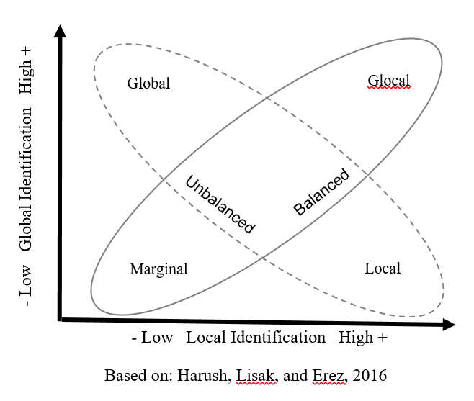

**Fig 2. Schematic description of lines of interest between the four identity types.**

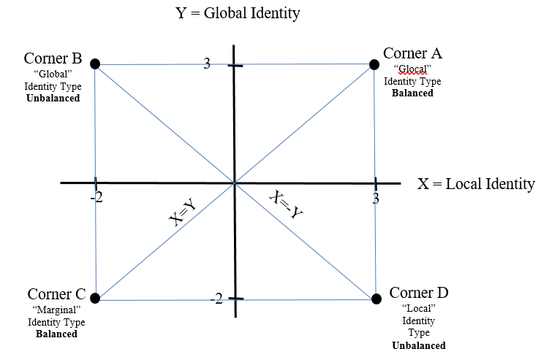

**Fig 3. The four identity types as predictors of leadership effectiveness.**

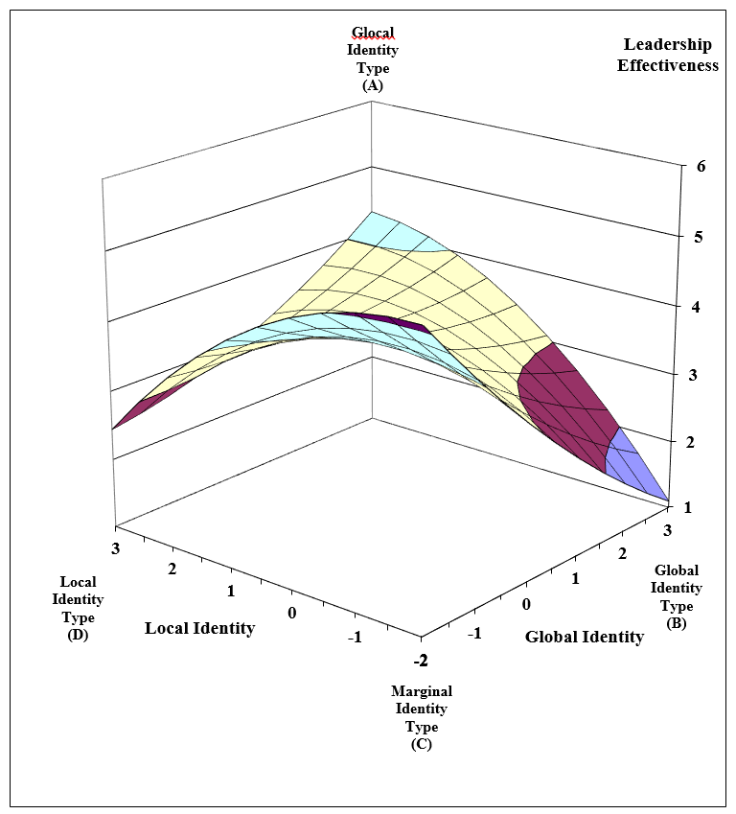

**Fig 4. The four identity types as predictors of individual consideration.**

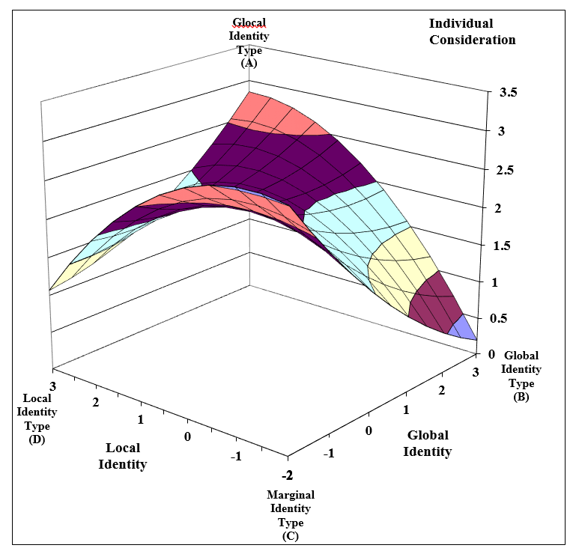

**Fig 5. Tangent slope significance along the local-marginal leadership effectiveness line.**

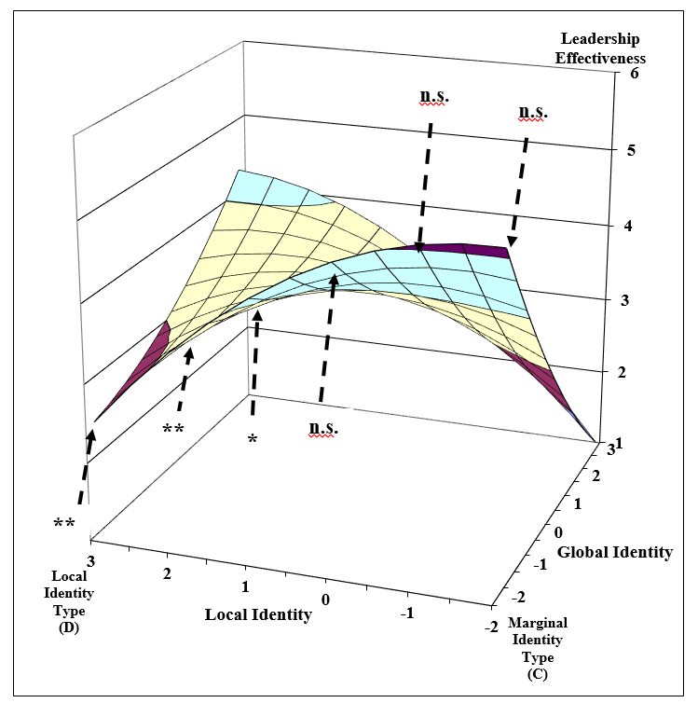

† p <.1, * p < .05, ** p < .01

**Fig 6. Tangent slope significance along the local-marginal individual consideration line.**

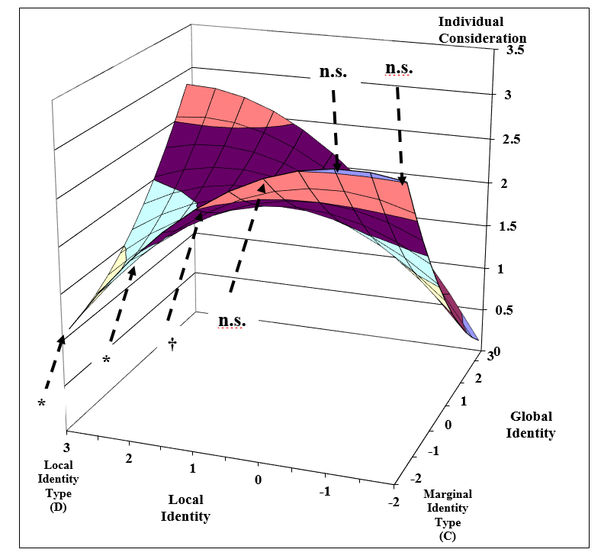

† p <.1, * p < .05, ** p < .01

**Fig 7. Tangent slope significance along the global-glocal leadership effectiveness line.**

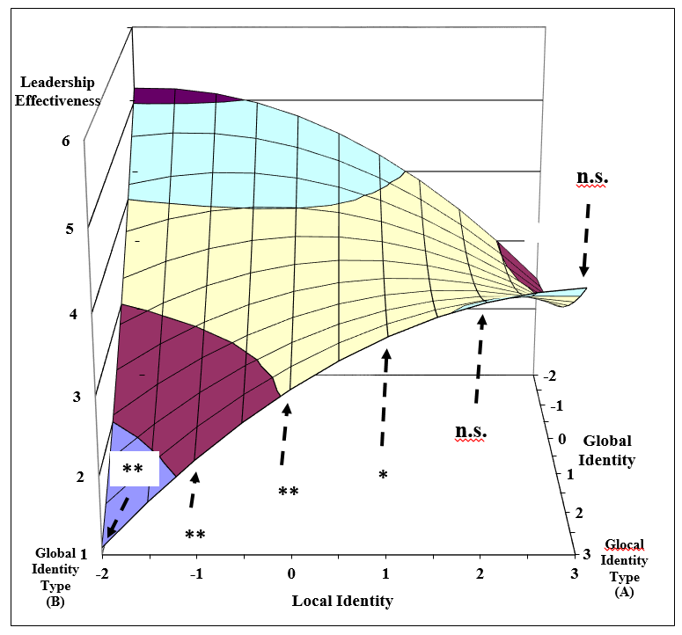

† p <.1, * p < .05, ** p < .01

**Fig 8. Tangent slope significance along the global-glocal individual consideration line.**

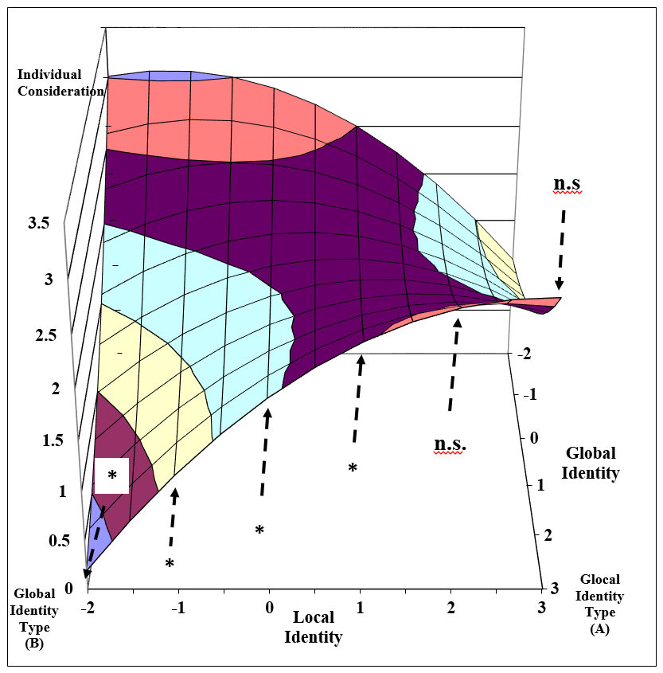

† p <.1, * p < .05, ** p < .01

1. Local identity is part of the global acculturation model (Shokef & Erez, 2006; 2008), and defined as identification with a particular national cultural group (Erez et al., 2013). Hence, both the term and the related scale measure national identification. Although “local-national identity” or “national identity” may represent this term more accurately, we chose to use the term "local identity" along our manuscript to maintain consistency with the existing literature.
2. To maintain consistency with the existing literature, we chose to continue to use the term "marginal". We use it, however, only to describe low levels of identification with local and global communities rather than to describe the individuals themselves.
3. These items were used by permission from the publisher, Mind Garden, Inc.