Version 1.3, October 2019

Exelot Customer Service Procedures

1. General Remarks

The Exelot Customer-Service Matrix:

* Exelot maintains an ongoing customer service center that responds six days per week to inquiries from customers in the destination country. Exelot reinforces its customer service at peak periods and during sales holidays.
* Exelot attributes the utmost importance to its level of customer service and the need to sustain very high satisfaction with its service among its customers, the merchants who ship by its means. The company communicates this importance to all of its employees and, in particular, to its customer-service reps.
* Exelot’s customer service is fully managed and supported by Zendesk software, which interfaces with the company’s logistics system. This system allows service reps to view and track shipments directly as well as via customs agents, the cargo terminal, and the distribution center.
* Service reps directly observe and track delayed shipments, items needing payment or certification, and shipment status with the various distributors.
* Service reps have systematic inquiry tables that they use to check and track shipments for customers regarding clearing customs, reporting arrival to distributor, distributor scans, [סריקות של המפיץ?] and shipment status.
* Service reps have systematic response templates that correspond to the various types of requests for service.
* Service reps, their manager, the customer-file manager, and the logistics manager can detect problems and irregularities from whole masters (MAWB) or batches of shipments and can also detect irregularities, delays, or failures at the level of individual parcels and shipments. This activity is supported by Exelot’s information system.
* General matters for ongoing care by customer service include parcel tracing, delivery time inquiries, status inquiries, requests for change of distribution point, delivery by messenger, VAT or duty collection inquiries, and specific certifications needed (e.g., Ministry of Communication or Standards Institution).
* When a delay of 48 hours or more is detected, the distributor is queried directly to make sure the process is continuing. SLA irregularities are also forwarded in the form of direct inquiries to the distributor and are tracked until an answer is obtained.

Direct connection with merchant:

* The merchant is given the particulars of a contact person—an Exelot customer-file manager for customer-service purposes.
* Exelot’s customer-service manager has a list of contact persons for handling customer inquiries or complaints that entail contact with the merchant’s site.
* The customer case manager is in direct contact with the merchant’s site to address these inquiries and provide solutions together with the merchant for the end customer.

Inquiries from end customer in destination country:

* End customers have immediate access to a simple and convenient template on the landing page of their site for tracking shipments, receiving answers, or contacting customer service. This template includes automatic tabs for the most common inquiries.
* The inquiry to Exelot is made via the company’s site or by referral from a customs agent if a customer has made inquiries with him or her.
* The company’s site in accessible in local languages (in Israel—Hebrew, English, and Arabic) and allows inquiries to be made and information to be received in each of them.
* Exelot augments its site with popups that provide customers with relevant content when necessary and at specific times, e.g., heavy-traffic sales holidays, alerts about unusual airport congestion, and New Year’s greetings.
* The company site provides full explanation of statuses reported to customers in order to facilitate parcel tracking.
* After a customer makes an inquiry, Exelot sends him or her an automatic notice to the effect that it will respond soon (within two business days at the most and around 24 hours on average).
* Exelot analyzes its response times and monitors them regularly.
* Every telephone inquiry allows customer to switch to the site in order to inquire about shipment status and perform tracking.
* The company site provides a full response with its own ticket, to which continued referrals and responses are fully linked.
* Response times to customer and closing of tickets are monitored at daily, weekly, and monthly intervals.
* Exelot regularly monitors customer responses on relevant social networks for ecommerce shipping, particularly from China.
* Regular customer-satisfaction surveys are performed to monitor satisfaction and make continual improvements.
* Customer-service reps take part in regular training and refresher activities.
* Once per week and once per month, the CEO reviews all customer-service data and meets with the customer-service manager.

2. Shipment Statuses and Tracking

* Exelot maintains a detailed array of statuses for reporting and tracking shipments and parcels at all points on the logistical chain.
* The array is integral to the company’s information systems and is aligned with the stages of shipment transit, from receipt of information from the merchant’s site to delivery to the end customer.
* Exelot has fifteen different topics for which sales reps provide customer service by means of systematic and structured response templates.
* The array of statuses is fully monitored by the logistics managers and supervisors and by Exelot’s customer service, and transit deadlines, handling of irregularities, and follow-up in view of customer requests for response are monitored as well.
* Exelot takes great care to close tickets within only one business day or to implement close monitoring of handling of irregularities.
* Customer information is cross-referenced in regard to customer orders or statuses not progressing, and in order to trace problematic batches / shipments or missing status updates.
* Reasonability of shipment duration at certain statuses is regularly monitored and, insofar as the duration seems irregular, the shipment is placed under specific and special care or monitoring.
* Exelot makes its tracking accessible to both merchantss sites and end customers.
* The Exelot site gives a detailed list of statuses in various languages.
* For some statuses, the system has a structured format for correct and systematic response:
* erroneous delivery statuses;
* shipment not traced at distribution point; such a shipment receives top priority and is directly and swiftly checked vis-à-vis the distributor.

The statuses shown on the Exelot site, as are updated from time to time, appear in the appendix below.

3. Customer Trace Procedure

1. Previous shipments;

2. Exelot Facebook page [פייס של אקסלוט?]

3. “Information,” 144

4. ME—search by means of the application

5. Merchant’s site

This is done by the logistics manager or the customer case manager and via a direct link to the site:

[11:22, 30.6.2019] <https://www.facebook.com/home.php?ref=wizard>

4. Updating merchant sites

Merchant sites are updated for message failures: site + dates + “message failure,” with the number of parcels filled in and an appropriate title added.

|  |
| --- |
| Update of merchant’s site or other site for message failure: fill in number of parcels and add appropriate title. |
|  |
|  |
| One or all SMS messages to the following ----- parcels failed |
| Please update the customer's phone number and ask them to contact us ASAP by the link below: <https://exelot.com/contact/?lang=he> [האם אין קישור באנגלית?] |
|  |
| *Payment for a second delivery is required for a shipment that returns from delivery point. |
|  |
| ***A quick response will prevent the parcel from being returned from delivery point and the customer will not have to pay for a second delivery**** |
| Inquiry with customer who is not traced: Cannot be delivered—No answer / incorrect phone / not available |
| Hi, |
| Please update a recipient's available phone number. |
| Unfortunately, we cannot deliver the shipment without available contact information. |
| Payment for second delivery will be required. |
| Delayed by customs—site, name, + urgent |
| Hi, |
| Please update a recipient's available phone number. Unfortunately, a charge for individual release and storage fee will be required for a customs-delayed parcel. |

5. Ticket / collection / flight summary handling procedure

Pursuant to the delayed parcel status update procedure—

**1. Collection**

1. Collection actions undertaken in accordance with the customer trace procedure.
2. Updating collection status (in addition to ticket) in the Contact Person field.
3. Updating customs agent for clearable items, including ID number.  
   ** Please remove XLT list + ID number from Ga’ash report [דו"ח געש] only.

2. **Update of nonpayment status for customers who fail to pay and sending additional message**: Customs-delayed due to: No Answer / Wrong Number / Not Available - VAT Payment Required

3. * Retain collection ticket one additional day for follow-up * If someone else paid, inform customs agent that clearing can take place. Otherwise, close the ticket.

4. Update status of all delayed shipments. Otherwise, their status will be stuck at Customs and not at Customs-delayed.

Important and not strictly upheld: Paperwork is required (photocopy of ID card, certifications)? Update as follows: Customs-delayed because: Paperwork is required.

6. Delayed shipment clearing procedure

Action must be taken to clear shipments and update customs agent and status accordingly:

1. Physical examination—highest priority

Contact customer for collection of ILS 88 payment.

If this payment is not made / not traced, status shall be updated to Physical Examination / Physical Inspection—Customs Agent (and, if necessary, Terminal), and check with them for what has to be done.

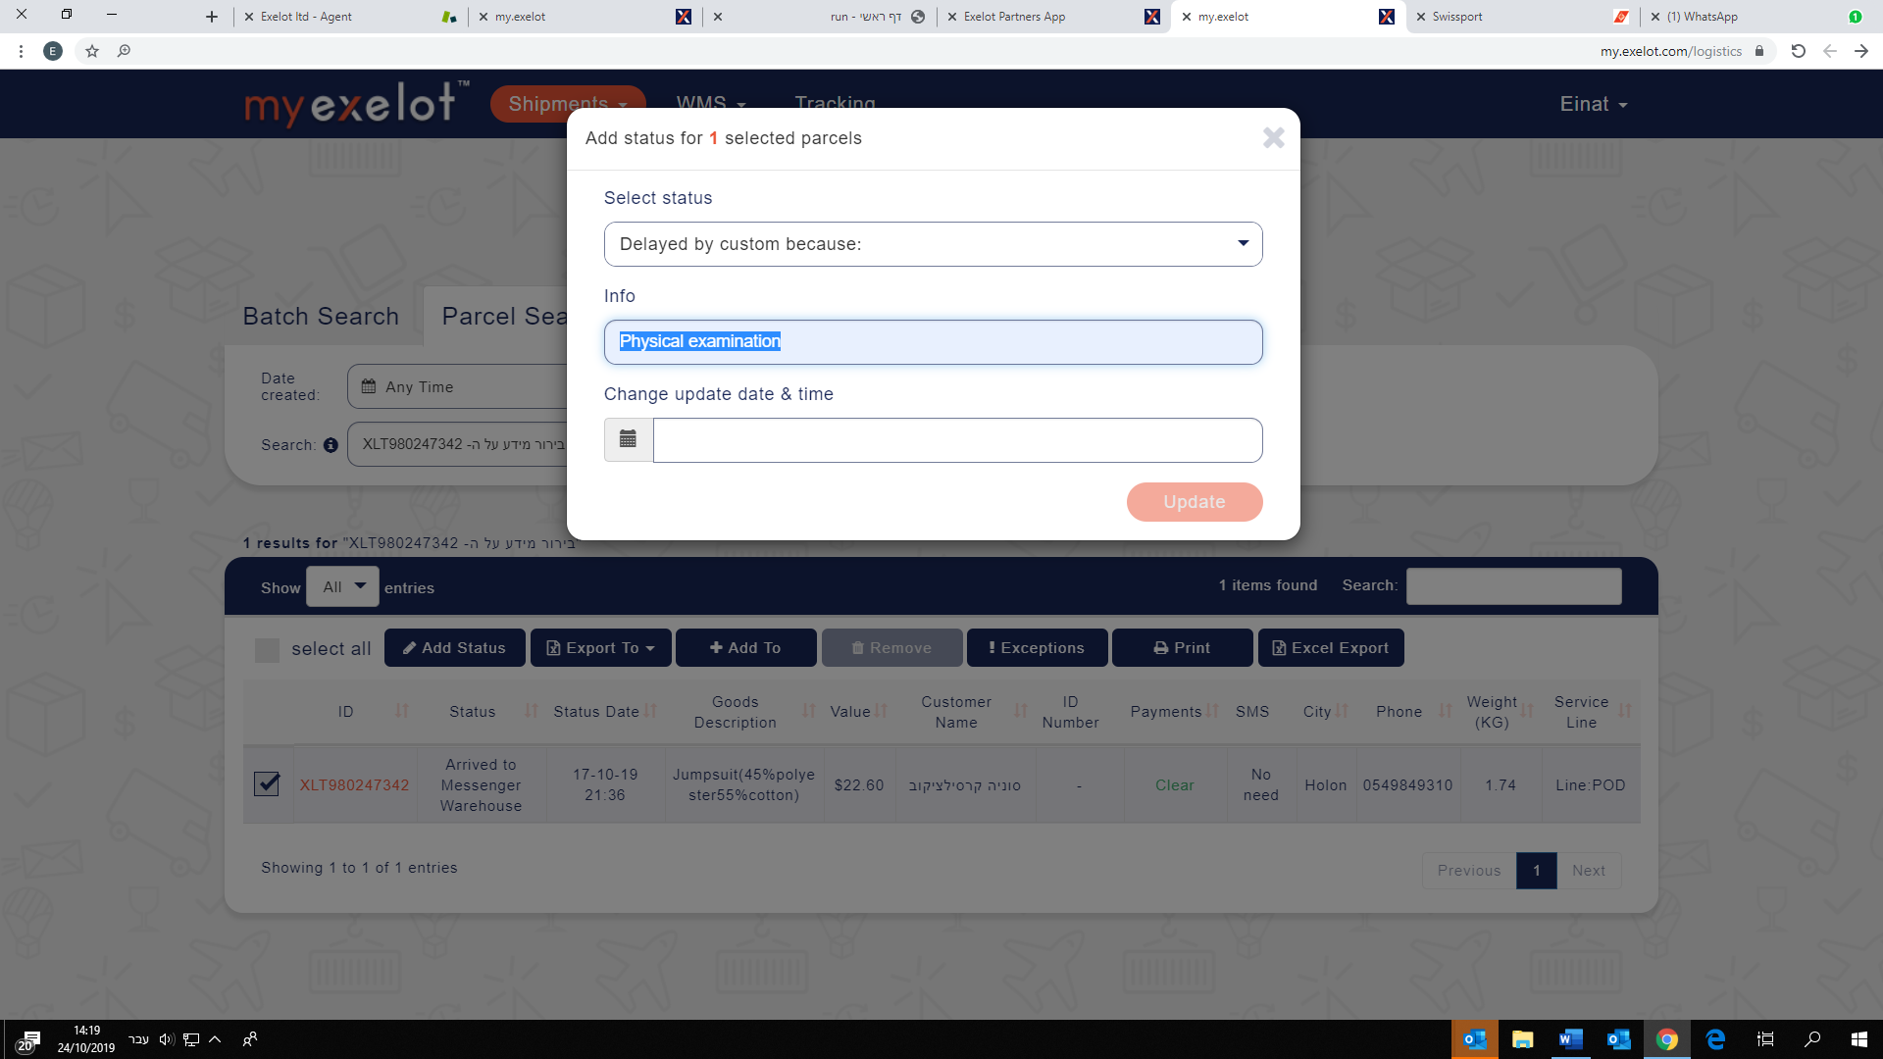

1. **Staff officer (**shipmentdelayed by staff officer / government official)—update status only, as recorded above.

* Unable to clear shipment at all.

Security check—need certificate.

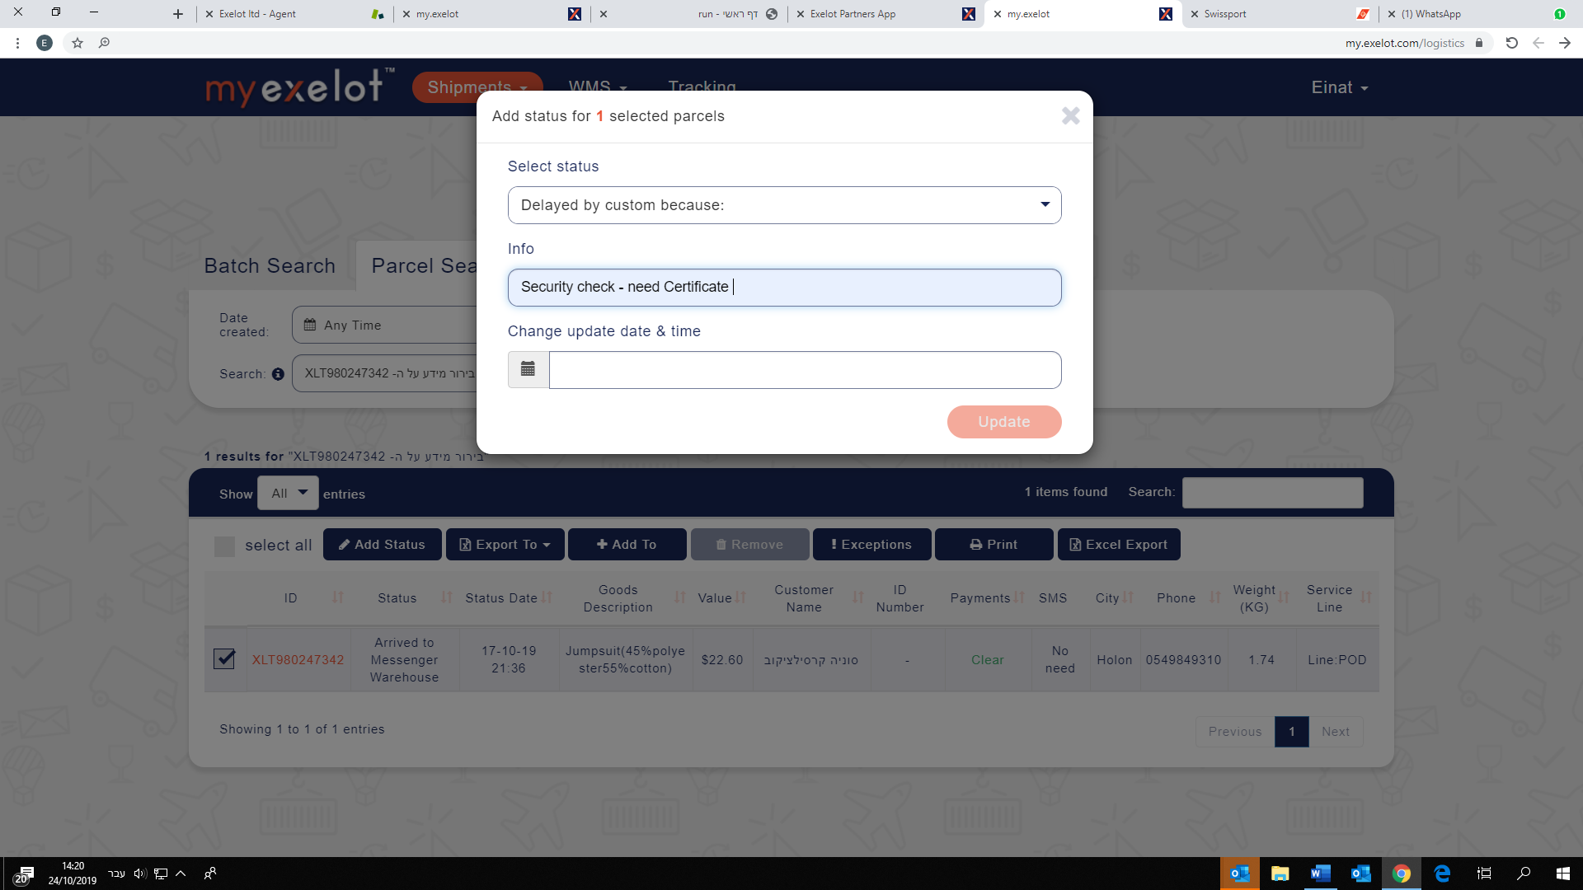

1. Paperwork check

Charge ILS 88 and update status as recorded above.

Paperwork check:

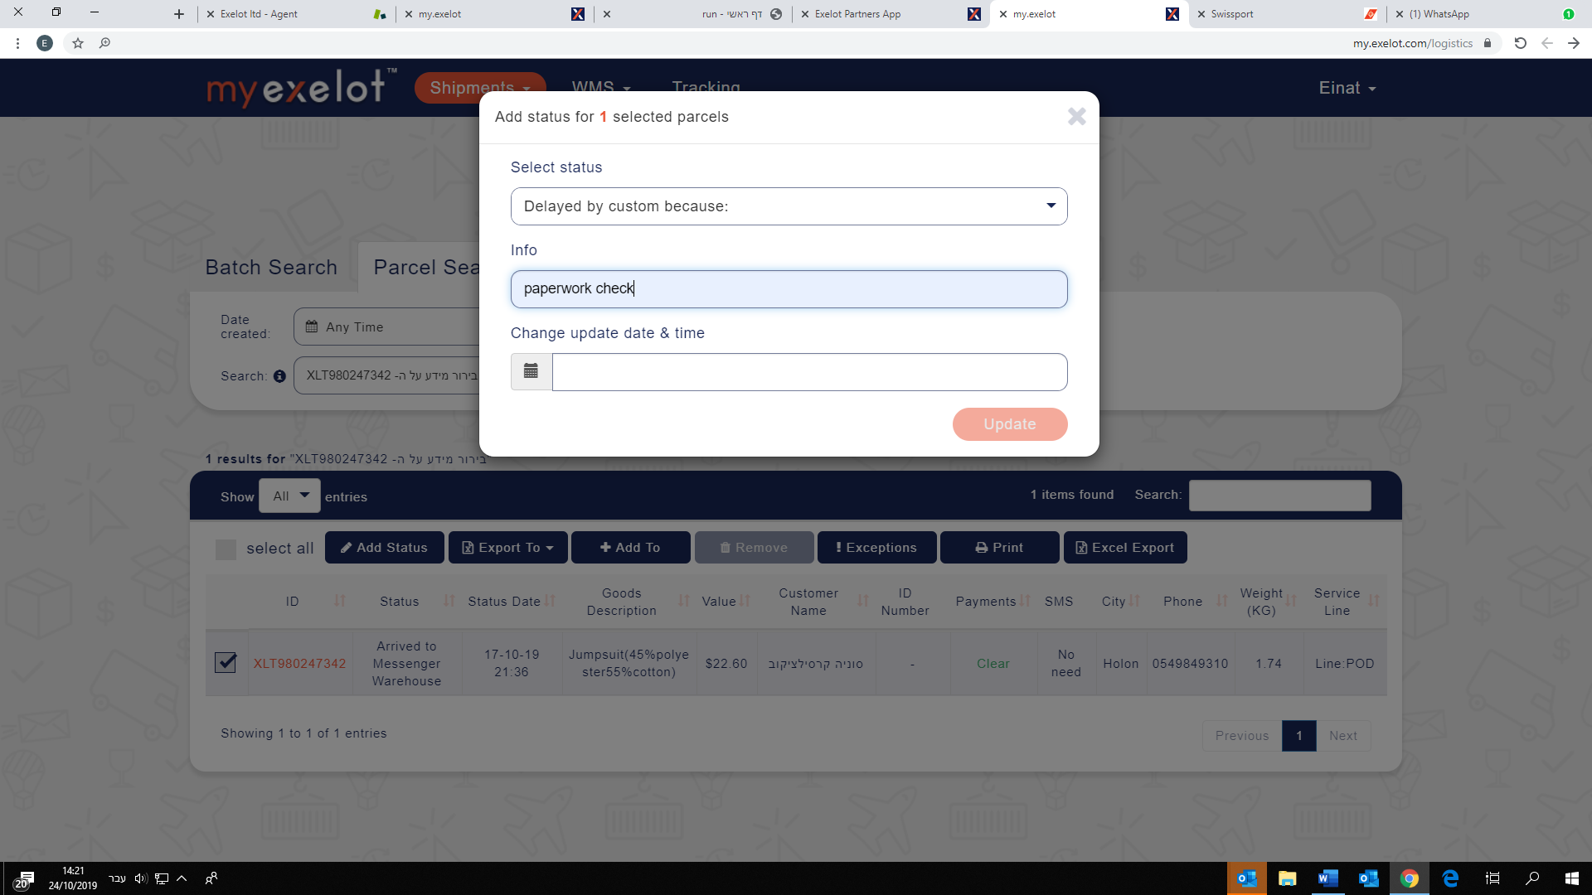

1. Delayed by security / police special patrol unit

No need to call; just update status:

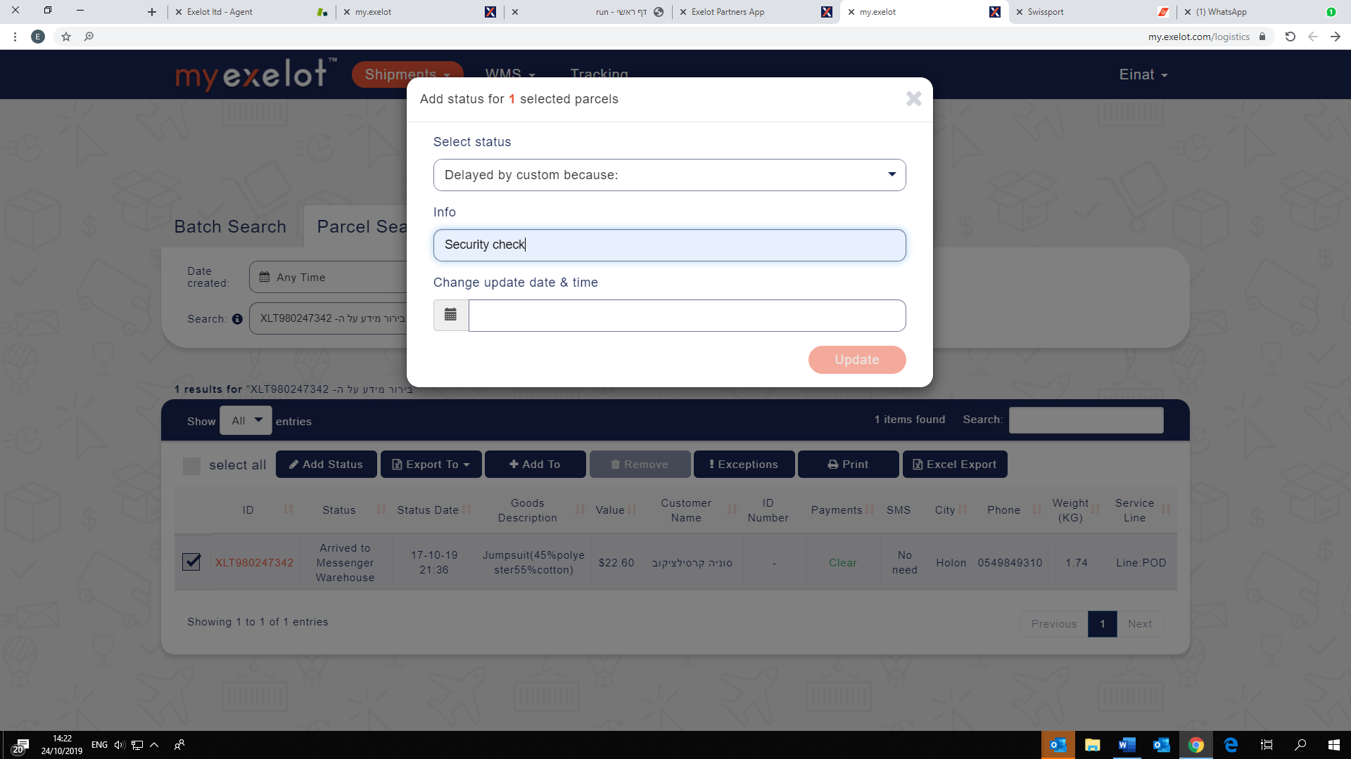

1. Paperwork required (invoice, product model)

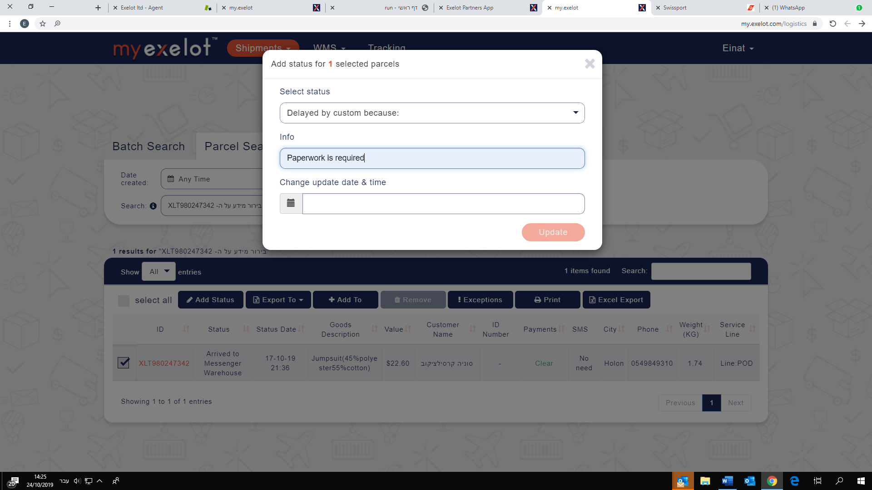

1. Government certification needed—Ministry of Communication / Ministry of the Economy / Civil Administration

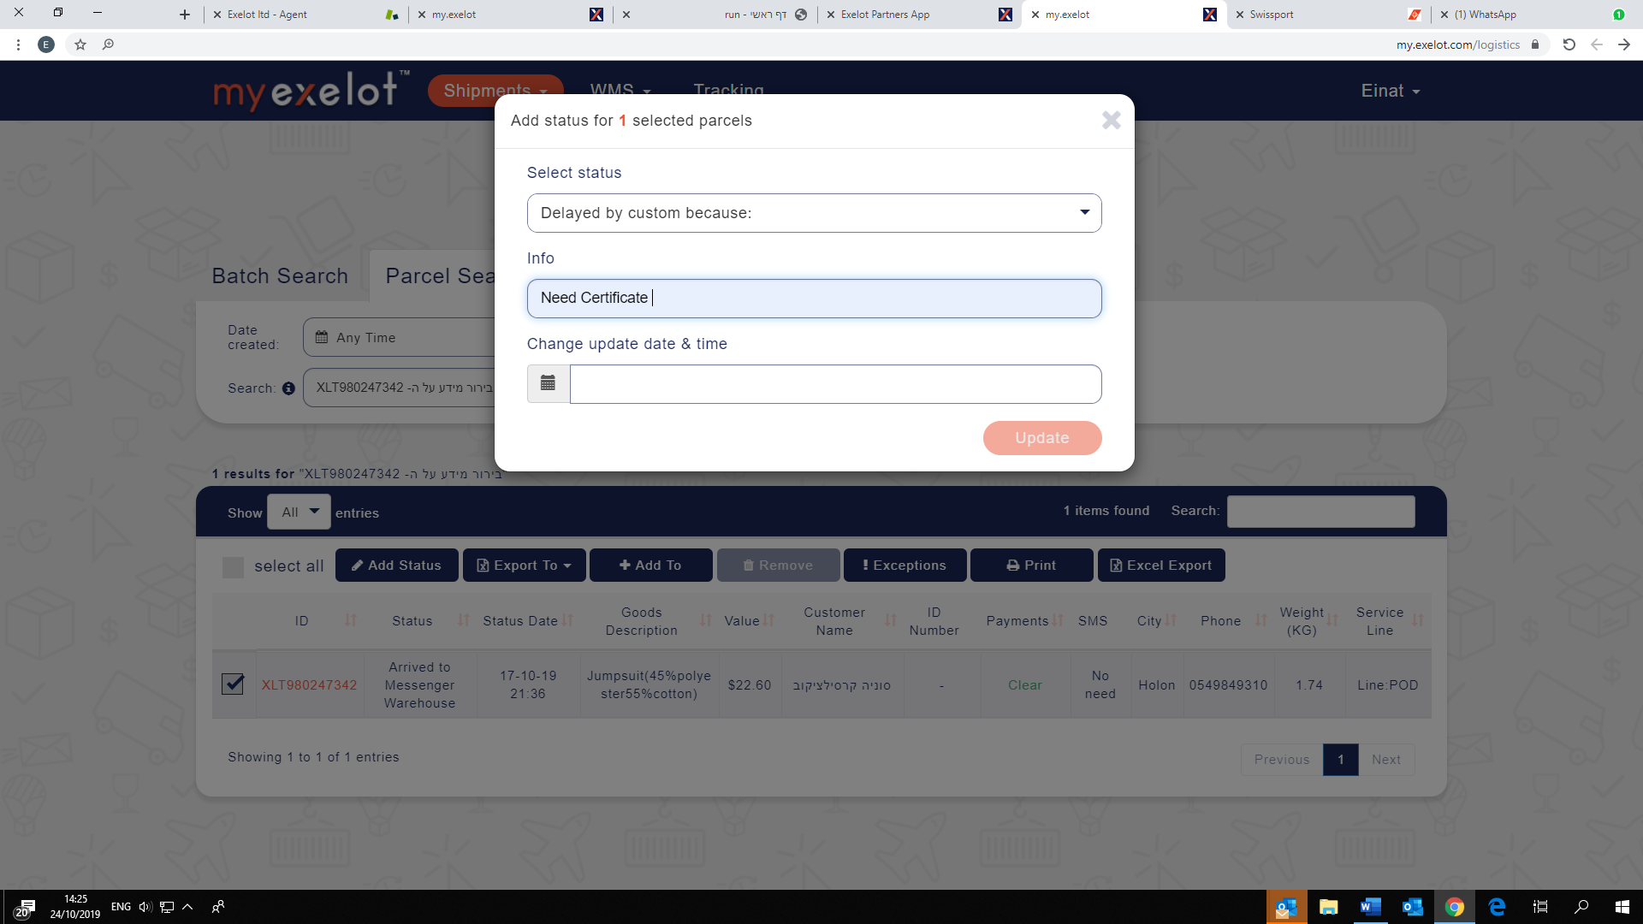

Import disallowed—no import permit.

Appendix: Explanation of Statuses and Notices

Below are the meanings of the tracking notices used for cross-border parcel shipments.

|  |  |
| --- | --- |
| סמל | **Digital information received**  Digital information including details of shipment and recipient has been received from the e-merchant’s site abroad. |
| סמל | **Arrived at TLV airport**  The shipment has landed at TLV airport and, after unloading, security, and sorting, is forwarded to Customs for inspection. |
| סמל | **Customs cleared**  Insofar as the shipment is liable to duty/VAT, payment must be arranged at once. Failure to make timely payment may result in demurrage and delayed delivery. |
| סמל | **In transit to messenger warehouse**  The shipment is en route to the messenger company’s sorting and distribution center. |
| סמל | **Arrived at messenger warehouse** |
| The shipment has reached the messenger company’s sorting and distribution center. A representative of the messenger company will call to set a time for delivery to end-customer’s home. |
| סמל | **Out for delivery**  The shipment is in the messenger’s possession and is en route to the customer. |
| סמל | **Delivered**  The shipment has been delivered to the customer. |

Appendix: Customer Satisfaction Survey

Satisfaction Survey—Distribution by Exelot

**Hello!**

**I’m ___ from Exelot. We’ve been handling your shipment no.___, which contains ___ from China.**

**Thank you for agreeing to participate in a very brief survey about the shipment that you received (just a few short questions):**

Survey for shipments delivered to home:

**1. How satisfied are you with the time it took for the shipment to reach you from the moment you received notice that the shipment had landed in Israel?**

1. Very satisfied

2. Satisfied

3. Not satisfied—please explain: ______________________

**2. How satisfied are you with the distribution company’s coordination of distribution with you?**

1. Very satisfied

2. Satisfied

3. Not satisfied—please explain: ______________________

**3. How satisfied were you with the messenger (reaching you within the appointed time window, attitude, and appearance)?**

1. Very satisfied

2. Satisfied

3. Not satisfied—please explain: ______________________

**4. How satisfied are you with the SMS messages that you were sent (were they clear and detailed)?**

1. Very satisfied

2. Satisfied

3. Not satisfied—please explain: ______________________

**5. Did you use an SMS message to update your address?**

1. Yes

2. No

**6. General remarks/suggestions:** _____________________________+

**Thank you very much for agreeing to take part in the survey.**

Survey for shipments waiting at distribution point

**Hello!**

**I’m ___ from Exelot. We’ve been handling your shipment no.___, which contains ___ from China.**

**Thank you for agreeing to participate in a very brief survey about the shipment that you received (just a few short questions):**

**1. How satisfied are you with the time it took for the shipment to reach you from the moment you received notice?**

1. Very satisfied

2. Satisfied

3. Not satisfied—please explain: ______________________

**2. From the time the shipment landed in Israel?**

1. Very satisfied

2. Satisfied

3. Not satisfied—please explain: ______________________

**3. How satisfied are you with the SMS messages that you were sent (were they clear and detailed)?**

1. Very satisfied

2. Satisfied

3. Not satisfied—please explain: ______________________

**4. Did you use an SMS message to update your address?**

1. Yes

2. No

**5. Was the distribution point nearby and accessible?**

1. Very satisfied

2. Satisfied

3. Not satisfied—please explain: ______________________

1. **How satisfied were you with service at the distribution point?**

1. Very satisfied

2. Satisfied

3. Not satisfied—please explain: ______________________

Survey for shipments picked up at distribution point

1. **You were sent SMS messages with details about the distribution point. Can you confirm that you received them?**

1. Yes

2. No

**2. How satisfied are you with the time it took for the shipment to reach you from the moment you received the notice?**

1. Very satisfied

2. Satisfied

3. Not satisfied—please explain: ______________________

**3. From the time the shipment landed in Israel?**

1. Very satisfied

2. Satisfied

3. Not satisfied—please explain: ______________________

**4. How satisfied are you with the SMS messages that you were sent (were they clear and detailed)?**

1. Very satisfied

2. Satisfied

3. Not satisfied—please explain: ______________________

**5. Did you use an SMS message to update your address?**

1. Yes

2. No

**6. Was the distribution point nearby and accessible?**

1. Very satisfied

2. Satisfied

3. Not satisfied—please explain: ______________________