Figure 1: Compliance of Israeli colposcopy clinics with international quality indices

A

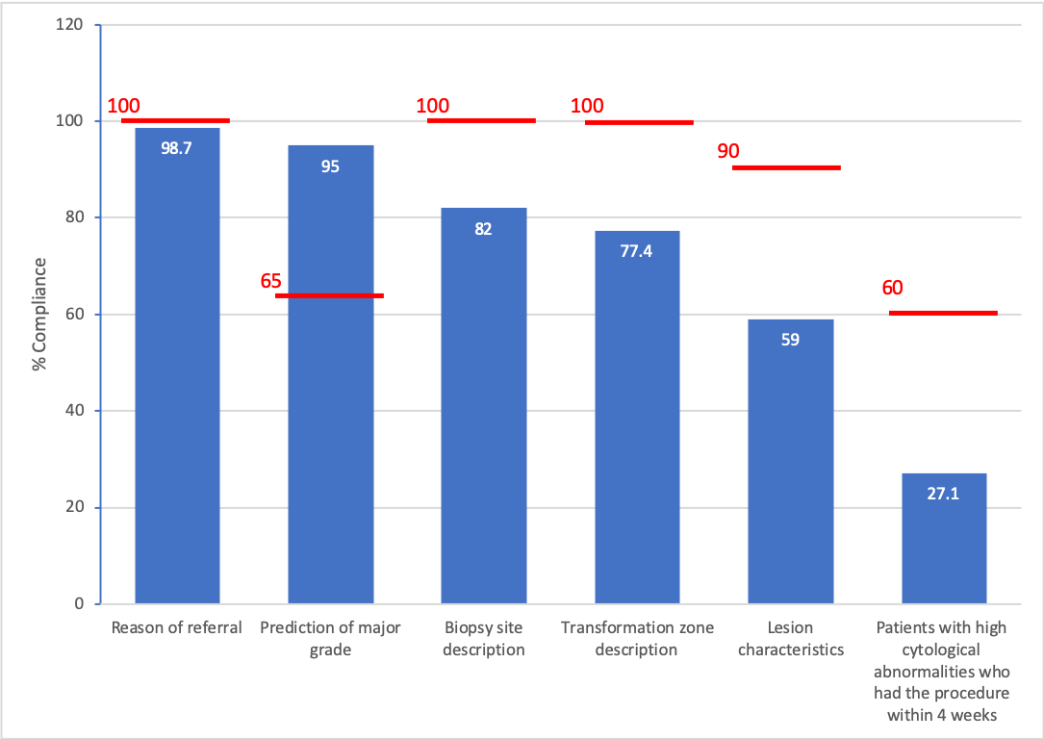

Comparison of all clinics to accepted international standards (red line).

B

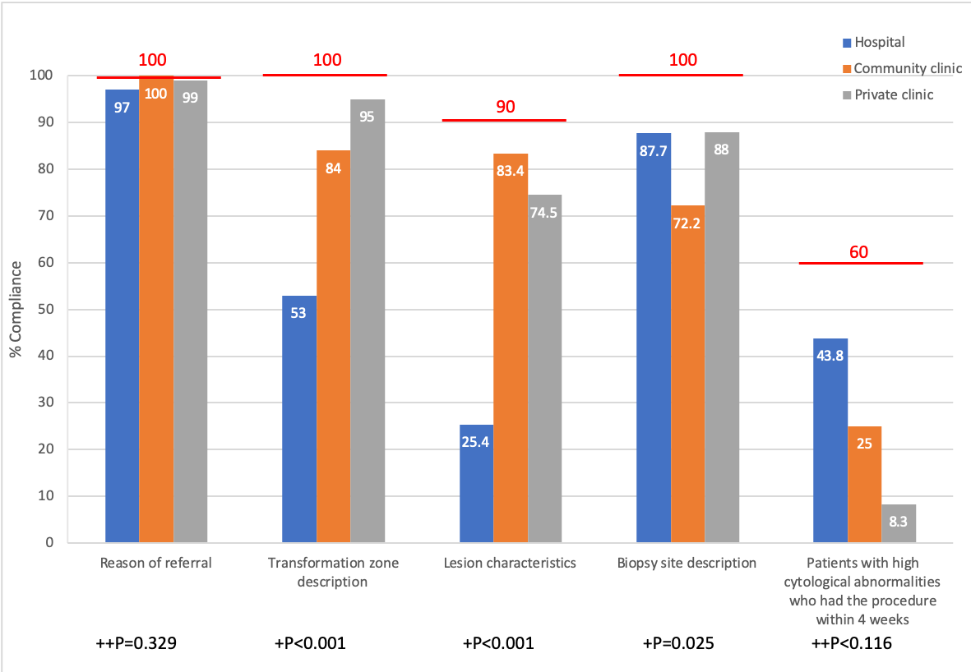

Comparison to worldwide standards divided into clinic types

++ Fischer’s exact test

+ Chi square test

Red line represents global compliance aims

Table 1: Logistic regression model for predicting documentation of lesion type

|  |  |  |  |  |  |
| --- | --- | --- | --- | --- | --- |
| Backwards elimination step | Explanatory variable | P | Odds ratio | 95% confidence interval | |
|  |  |  |  | Max value | Min value |
| First step | Clinic type -general | P<0.001 |  |  |  |
|  | Hospital1 | P<0.001 | 0.066 | 0.027 | 0.161 |
|  | Private clinic1 | 0.454 | 0.695 | 0.268 | 1.803 |
|  | Pap abnormality2 | 0.757 | 0.878 | 0.384 | 2.005 |
|  | Age (yrs) | 0.061 | 0.969 | 0.938 | 1.001 |
|  | Constant | P<0.001 | 15.841 |  |  |
| Second step | Clinic type -general | P<0.001 |  |  |  |
|  | Hospital | P<0.001 | 0.067 | 0.028 | 0.162 |
|  | Private clinic | 0.458 | 0.697 | 0.269 | 1.809 |
|  | Age (yrs) | 0.055 | 0.969 | 0.938 | 1.001 |
|  | Constant | P<0.001 | 15.586 |  |  |

1Compared to community clinic

2Compared to low Pap abnormality. High Pap abnormality was defined as ASC-H+

Table 2: Logistic regression model for predicting reporting of biopsy site

|  |  |  |  |  |  |
| --- | --- | --- | --- | --- | --- |
| Backwards elimination step | Explanatory variable | P | Odds ratio | 95% confidence interval | |
|  |  |  |  | Max value | Min value |
| First step | Clinic type -general | 0.038 |  |  |  |
|  | Hospital1 | 0.024 | 2.695 | 6.410 | 1.13 |
|  | Private clinic1 | 0.069 | 2.531 | 6.895 | 0.929 |
|  | Pap abnormality2 | 0.481 | 0.739 | 1.712 | 0.319 |
|  | Age (yrs) | 0.284 | 1.019 | 1.057 | 0.984 |
|  | Constant | 0.600 | 1.436 |  |  |
| Second step | Clinic type -general | 0.031 |  |  |  |
|  | Hospital | 0.025 | 2.666 | 6.289 | 1.128 |
|  | Private clinic | 0.045 | 2.747 | 7.407 | 1.022 |
|  | Constant | P<0.001 | 2.666 |  |  |

1Compared to community clinic

2Compared to low Pap abnormality. High Pap abnormality was defined as ASC-H+

Table 3: Logistic regression model for predicting documentation of transformation zone

|  |  |  |  |  |  |
| --- | --- | --- | --- | --- | --- |
| Backwards elimination step | Explanatory variable | P | Odds ratio | 95% confidence interval | |
|  |  |  |  | Max value | Min value |
| First step | Clinic type -general | P<0.001 |  |  |  |
|  | Hospital1 | P<0.001 | 0.184 | 0.091 | 0.371 |
|  | Private clinic1 | 0.015 | 3.777 | 1.294 | 11.026 |
|  | Pap abnormality2 | 0.001 | 0.264 | 0.125 | 0.561 |
|  | Age (yrs) | 0.239 | 0.984 | 0.958 | 1.011 |
|  | Constant | P<0.001 | 14.072 |  |  |
| Second step | Clinic type -general | P<0.001 |  |  |  |
|  | Hospital | P<0.001 | 0.186 | 0.092 | 0.375 |
|  | Private clinic | 0.020 | 3.544 | 1.223 | 10.272 |
|  | Pap abnormality2 | P<0.001 | 0.255 | 0.121 | 0.535 |
|  | Constant | P<0.001 | 7.671 |  |  |

1Compared to community clinic

2Compared to low Pap abnormality. High Pap abnormality was defined as ASC-H+

Table S1: Dependent variables – compliance with colposcopy quality indices

|  |  |  |  |
| --- | --- | --- | --- |
|  | **Index tested and international compliance aim** | | **Values** |
| 1 | Documentation of referral reason | 100%1 | Yes/No |
| 2 | Description of transformation zone | 100%1 | Described using new terminology/old terminology/not described |
| 3 | Biopsy site documentation | 100%1 | Described using new terminology/other method/not described/no biopsy |
| 4 | Colposcopic impression of lesion grade | 90%1 | Grade 1/grade 2/not documented/no lesion |
| 5 | PPV to predict CIN2+ lesions | 65%1 | Correlate/do not correlate |
| 6 | Percentage of patients with high cytological abnormalities (ASC-H+) who had the procedure within 4 weeks of Pap results | 60%2 | Pass/fail |

1NHSCSP guidelines, 2016

2ASCCP colposcopy standards, 2017

Table S2: Quality indices tested in addition to major indicators

|  |  |  |
| --- | --- | --- |
| **Index tested and international compliance aim** | | **Values** |
| Pap smear date recorded in medical history | No known aim | Yes/No |
| History of cervical treatments noted in referral notes | No known aim | Yes/No |
| Details of Pap abnormality in referral | 100%1 | Yes/No |
| Was the exam adequate? | 100%1 | Yes/No |
| Note if exam was normal/typical | No known aim | Yes/No |
| Documentation of lesion site (n=189) | No known aim | Yes/No |
| Documentation of date of biopsy results (n=200) | No known aim | Yes/No |
| Biopsy results (n=200) | No known aim | Yes/No |
| Date of treatment (n=89) | No known aim | Yes/No |
| LLETZ pathology results | No known aim | Yes/No |

1NHSCSP guidelines, 2016

Note: In the quality index of “if exam was normal/typical”, “normal” accords with newly accepted terminology. The synonym “typical” was also accepted and is in accordance with older terminology.

Table S3: Age of patients:

|  |  |  |  |  |  |
| --- | --- | --- | --- | --- | --- |
|  | Total (n=300) | Hospital (n=100) | Community clinic (n=100) | Private clinic (n=100) | P comparing all three groups |
| Age, years±Std (range) | 38.9±11.8  (17-80) | 37.3±11.8 | 38.1±10.5 | 41.2±12.6 | *0.131 |
| 17-35 | 139/300  (46.3%) | 49/100  (49%) | 50/100  (50%) | 40/100  (40%) | *0.099 |
| 36-50 | 118/300  (39.3%) | 39/100  (39%) | 40/100  (40%) | 39/100  (39%) |
| 51-65 | 32/300  (10.7%) | 10/100  (10%) | 8/100  (8%) | 14/100  (14%) |
| 66-80 | 11/300  (3.7%) | 2/100  (2%) | 2/100  (2%) | 7/100  (7%) |

*Kruskal Wallis test

Table S4: Pap results in referral for colposcopy exam

|  |  |  |  |  |  |  |  |  |
| --- | --- | --- | --- | --- | --- | --- | --- | --- |
| N (%) | Total (n=300) | Hospital (n=100) | Community clinic (n=100) | Private clinic (n=100) | P between all three clinics | P hosp vs private | P hosp vs comm | P comm vs private |
| Pap type |  |  |  |  | ++**0.049** | +  0.441 | ++  **0.017** | ++  0.113 |
| ASCUS | 157 (52.3%) | 61 (61%) | 41 (41%) | 55 (55%) | +0.14 |  |  |  |
| LGSIL | 89 (29.7%) | 21 (21%) | 39 (39%) | 29 (29%) | +**0.022** | +0.253 | +**0.008** | +0.179 |
| ASC-H | 22 (7.3%) | 7 (7%) | 6 (6%) | 9 (9%) | +0.790 |  |  |  |
| HGSIL | 30 (10%) | 11 (11%) | 12 (12%) | 7 (7%) | +0.561 |  |  |  |
| Glandular | 2 (0.7%) | 0 (0%) | 2 (2%) | 0 (0%) | ++0.331 |  |  |  |

+ Chi square test

++ Fisher’s exact test

Table S5: Compliance rates with quality indices

|  |  |  |  |  |  |
| --- | --- | --- | --- | --- | --- |
|  | Quality index | Aim (%) | Compliance in present study (%) | Conclusion | Difference to goal |
| 1 | Record of referral reason | 1100% | 98.7% | Fail | -1.3% |
| 2 | Description of transformation zone | 1100% | 77.4% | Fail | -22.6% |
|  | Using new terminology | 100% | 70.7% | Fail | -29.3% |
|  | Using old terminology | 100% | 6.7% | Fail | -93.3% |
| 3 | Record of biopsy site | 1100% | 82% | Fail | -18% |
| 4 | Lesion type description | 190% | 59% | Fail | -31% |
| 5 | Positive PPV for CIN2+ | 165% | 95% | Pass | +30% |
| 6 | Percentage of patients with high cytological abnormalities (ASC-H+) who had the procedure within 4 weeks | 60% | 27.1% | Fail | -32.9% |
|  | Additional parameters checked | | | | |
|  | Pap smear date recorded in medical history | None | 261/300 (87%) |  |  |
|  | History of cervical treatments noted in referral notes | None | 258/300 (86%) |  |  |
|  | Details of Pap abnormality in referral | 1100% | 282/300 (94%) | Fail | -6% |
|  | Was the exam adequate? | 1100% | 64.3% | Fail | -35.7% |
|  | Note if exam was normal/typical | None | 271/300 (90.3%) |  |  |
|  | Documentation of lesion site (n=189) | None | 129/189 (68.3%) |  |  |
|  | Documentation of date of biopsy results (n=200) | None | 189/200 (94.5%) |  |  |
|  | Biopsy results (n=200) | None | 194/200 (97%) |  |  |
|  | Date of treatment (n=89) | None | 86/89 (96.6%) |  |  |
|  | LLETZ pathology results (n=87) | None | 85/87 (97.7%) |  |  |

1NHSCSP guidelines, 2016

Table S6: Compliance rates with quality indices according to clinic type

|  |  |  |  |  |  |  |
| --- | --- | --- | --- | --- | --- | --- |
|  | Quality index | Aim (%) | Hospital | Community | Private | P between groups |
| 1 | Record of referral reason | 1100% | 97/100 (97%) | 100/100 (100%) | 99/100 (99%) | ++0.329 |
| 2 | Description of transformation zone | 1100% | 53/100 (53%) | 84/100 (84%) | 95/100 (95%) | +P<0.001 |
|  | Using new terminology | 100% | 33/100 (33%) | 84/100 (84%) | 95/100 (95%) | +P<0.001 |
|  | Using old terminology | 100% | 20/100 (20%) | 0/100 (0%) | 0/100 (0%) |
| 3 | Lesion type description | 190% | 17/67 (25.4%) | 50/60 (83.4%) | 38/51 (74.5%) | +P<0.001 |
| 4 | Record of biopsy site | 1100% | 64/73 (87.7%) | 56/77 (72.7%) | 44/50 (88%) | +0.025 |
| 5 | Patients with high cytological abnormalities (ASC-H+) who had the procedure within 4 weeks | 260% | 7/16 (43.8%) | 5/20 (25%) | 1/12 (8.3%) | ++0.116 |
|  | Additional parameters checked | | | | |  |
|  | Pap smear date recorded in medical history | None | 97/100 (97%) | 100/100 (100%) | 64/100 (64%) | +P<0.001 |
|  | History of cervical treatments noted in referral notes | None | 76/100 (76%) | 86/100 (86%) | 96/100 (96%) | +P<0.001 |
|  | Details of Pap abnormality in referral | 1100% | 89/100 (89%) | 94/100 (94%) | 99/100 (99%) | +0.013 |
|  | Was the exam adequate? | 1100% | 46/100 (46%) | 48/100 (48%) | 99/100 (99%) | +P<0.001 |
|  | Note if exam was normal/typical | None | 80/100 (80%) | 92/100 (92%) | 99/100 (99%) | +P<0.001 |
|  | Documentation of lesion site (n=189) | None | 32/69 (46.4%) | 49/66 (74.2%) | 48/54 (88.9%) | +P<0.001 |
|  | Documentation of date of biopsy results (n=200) | None | 66/73 (90.4%) | 77/77 (100%) | 46/50 (92%) | ++0.009 |
|  | Biopsy results (n=200) | None | 68/73 (93.2%) | 77/77 (100%) | 49/50 (98%) | ++0.035 |
|  | Date of treatment (n=89) | None | 28/30 (93.3%) | 33/33 (100%) | 25/26 (96.2%) | ++0.387 |
|  | LLETZ pathology results (n=87) | None | 29/30 (96.7%) | 30/30 (100%) | 26/27 (96.3%) | ++0.759 |

1NHSCSP guidelines, 2016

2ASCCP colposcopy standards, 2017

+ Chi square test

++ Fisher’s exact test

Notes:

* The quality index “Positive PPV for CIN2+” that the sum of the clinical data successfully passed global standards is not presented per clinic type due to low case numbers.
* The division between “new” and “old” terminology was done by the study designers and is not considered an international guideline. This was done in order to allow inclusion of physicians that still use the old terminology of un/satisfactory colposcopy.

Table S7: Relationship between level of Pap abnormality and documentation of quality indices

|  |  |  |
| --- | --- | --- |
| Level of Pap abnormality | Lesion type description | P value |
| Low | 78/130 (60%) | +0.732 |
| High | 27/48% (56.3%) |
|  | Record of biopsy site |  |
| Low | 126/148 (85.1%) | +0.816 |
| High | 38/46 (82.6%) |
|  | Description of transformation zone |  |
| Low | 200/246 (81.3%) | +0.001 |
| High | 32/54 (59.3%) |

+ Chi square test