**Long-term satisfaction evaluation of patients after vestibulectomy**

David A, Bornstein J

Department of Obstetrics and Gynecology, Galilee University Medical Center, Bar Ilan University, Nahariya, Israel

**Abstract**

**Objective**: Vestibulectomy is the only treatment with proven therapeutic benefit for provoked vulvodynia (vestibulodynia). However, little is known about whether surgical success is preserved over time. Patients who underwent vestibulectomy more than 10 years ago were followed-up to assess surgical success and overall satisfaction.

**Materials and Methods**: The follow-up was conducted through interviews testing quantitative variables such as frequency of intercourse and the degree of pain during various activities as well as qualitative variables such as satisfaction with the surgery and willingness to recommend it.

**Results**: Thirty-two patients participated in the study. All were operated on 12 to 24 years ago by the same surgeon. All experienced sexual intercourse without pain at some point after surgery (median: 4 months). Penetration was the most painful activity to all patients, averaging 9.13 on a pain scale (0–10) before surgery and dropping to 0.47 today (*P* < .001). Other activities mentioned as painful also improved significantly after surgery.

No patients reported worsening of pain over time, and 16% reported improvement; 87.5% were able to engage in sexual intercourse as they pleased right after the recovery period, and 97% do so today.

Ninety-four percent were highly satisfied with the surgery, 97% would undergo surgery again knowing what they do now, and 100% would recommend it to others, although 15% indicated the need to explore nonsurgical options in light of the prolonged recovery.

**Conclusions**: Noninvasive treatment should be discussed with patients before considering surgery, but in the absence of documented effects of other methods, vestibulectomy remains the best treatment for provoked vulvodynia.

***Key words****: vulvodynia, provoked vulvodynia, PVD, vestibulectomy, retrospective follow-up*

**Introduction**

Provoked vulvodynia (PVD), defined as pain upon touch or pressure without spontaneous or ongoing pain, is the most common cause of pain during sexual intercourse.[1] At physical examination, the patient displays heightened sensitivity even to the slightest touch without the presence of infection or any other dermatological or gynecological disease.[2] The prevalence of provoked vulvodynia has been estimated at 10% to 15%.3,4 Studies have indicated a vestibular mucus nerve hyperproliferation among women experiencing the problem,[3] a thriving of mast cells that may play a part in the regulation of nerve growth factors,[4] and various genetic and hormonal variables including hormonal contraceptives.[5]

Surgical treatment for provoked vulvodynia was first suggested by Woodruff et al[6] in 1981. Since then, thousands of variations have been carried out. A literature review by Marinoff et al[7] in 2006 found that 28 of 32 papers registered a surgical success rate of 80% or more. A review by Andrews[8] in 2011 reached similar conclusions, with an average surgical success rate of 79%. However, the definition of *surgical success* varies from one study to another. In addition, the small number of patients in each study, the short follow-up period, and differences between procedures and surgeons make it difficult to deduce definitive conclusions.

Previous long-term follow-up studies of patients who have undergone similar surgeries have reached varying results. For instance, Foster et al (1995)[9] conducted a follow-up 4 years postsurgery with a success rate of 88% (success was defined as significant reduction of pain), whereas De Jong et al,[10] also in 1995, reported only a 43% success rate 7 years postsurgery. Apart from these, we have not encountered studies that include a follow-up period longer than 18 months.

The purpose of this study was to determine whether vestibulectomy is an effective long-term treatment for provoked vulvodynia, based on the satisfaction rate of patients who have undergone the surgery. We performed a follow-up on women who had undergone identical procedures by the same surgeon at least 10 years earlier. The evaluation of the procedure’s success was based on several quantitative variables, in addition to the patient’s sense of satisfaction.

**Methods**

**Study array**

This was a retrospective follow-up study, with the research group defined by a medical problem within a certain time frame in the past. The data collected pertain to the appearance of the problem from that time until the present.

**Study population**

The study population included women who underwent vestibulectomy 10 years or more ago by the same surgeon, Prof. Jacob Bornstein. Eighty-five patient files were reviewed to mine the details needed to make contact. Afterwards, an Interior Ministry database was used to locate their addresses and contact information. In accordance with the requirements of the Helsinki Committee, the interviews were conducted in person and not by phone. Due to the long time that had passed since surgery, it became highly difficult to locate the patients, many of whom had changed their last names and places of residence. Only 50 patients (59%) were successfully located, and 32 of these (64%) were eventually interviewed for the study after having signed a consent form. Nine patients (18%) refused to be interviewed, 7 patients (14%) were not interviewed due to technical difficulties in scheduling an interview, and 2 patients (4%) did not remember undergoing such a procedure at all.

**Study variables**

The study variables were patient satisfaction, pain level, and frequency of intercourse. These were assessed via a designated questionnaire used in previous studies on provoked vulvodynia, after adjustments to the current study by the researchers.

**Statistical methods**

Quantitative data are described as averages and standard deviation or as mean and range. Qualitative data are described as prevalence and percentage. Ordinal data are described as quantitative and/or qualitative variables, accordingly. Reduction in pain levels over time was tested through a paired-sample test or a Wilcoxon signed-rank test. The choice between tests was based mostly on the gap distribution of the pain level between compared points in time. A significance value less than 5% is considered statistically significant.

**Results**

**Demographic data**

The 32 recruited patients underwent the surgery between the years 1991 and 2003. The age of patients at the time of surgery ranged from 20 to 31 years (average 24 years). At the time the interview was conducted, 27 women (84%) were in an ongoing relationship with a partner with whom they had regular sexual relations. Of those who had no partner, none mentioned dyspareunia as a reason for the lack of partner.

**Seeking further treatment after surgery**

Thirty women (94%) needed no further treatment beyond vestibulectomy. The 2 women who had undergone further treatment noted that the surgery was partially helpful. The additional treatment included intramuscular injections and topical creams. Another patient noted that she sought out a hypnotist but ultimately did not undergo hypnosis therapy.

**Sexual intercourse following surgery**

One hundred percent of the patients reported that they had experienced sexual intercourse without pain at some point after the surgery. Over 90% noted that they had experienced pain-free sexual intercourse for the first time within 12 months or less after the surgery (Table 1). The mean time until painless sexual intercourse was 4 months.

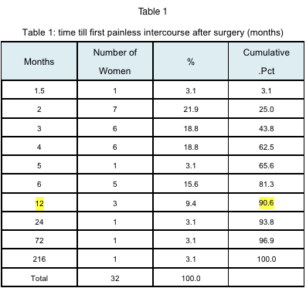

**Change in pain level compared to presurgery condition**

The patients were presented with a list of activities known to induce pain in the vestibule and were asked to rank, on a 0–10 scale, how much that activity hurt before the surgery compared to how much it hurts today (0 = *no pain at all*, 10 = *maximal pain*). As expected, 100% of the patients noted that before the surgery, penetration during intercourse was the most painful activity, scoring a 9.13 on the pain scale. Nonpenetrative sexual relations, touching the vaginal opening with a finger, and insertion of a tampon were described as painful activities, and in addition, significant pain was described following sexual relations and in postcoital urination, when such occurred. Postsurgery, there was a sharp and significant reduction (*P* < .001) in pain in all these activities, and particularly prominent was the reduction in pain during penetration from 9.13 to 0.47 on the pain scale, on average (Table 2). It should be noted that the surgery was performed on women with a significant level of pain that was strong and intolerable during intercourse.

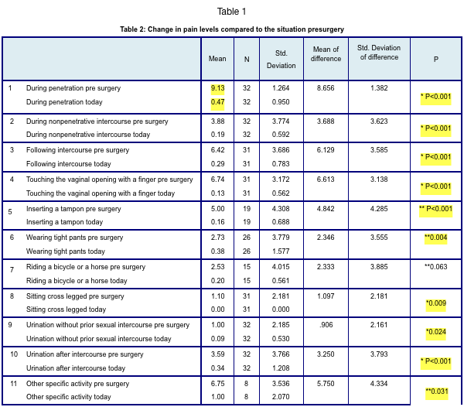

* Paired sample T-test

** Wilcoxon Signed Ranks Test

**Change in pain level over time (since surgery to the present)**

One hundred percent of the patients reported that following the recovery period after the surgery, there had been no recurrence or increase in pain over the years. Twenty-three patients (72%) noted that immediately following the recovery period, they were able to have intercourse without any pain, and this remained the situation to this day. Five patients (16%) reported some pain following recovery that receded gradually over the years, and 4 patients (12%) reported some pain, which remained the situation to this day.

**Frequency of intercourse**

One hundred percent of the patients reported improved ability to have intercourse immediately after the recovery period. Twenty-eight patients (88%) reported the ability to have sex as they pleased immediately after recovery, and the others reported some restrictions in having sex due to pain. When asked about their condition today, 31 patients reported the ability to have sex as they pleased, and 1 patient still reported restrictions in having sex due to pain (Table 3).

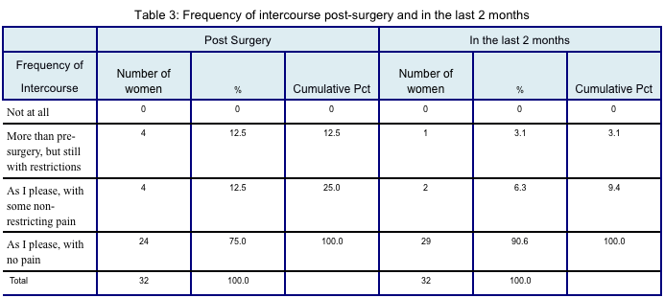**Satisfaction with the procedure**

One hundred percent of the patients reported an alleviation of pain since the surgery. Of these, 30 patients (94%) reported a significant improvement, and 2 patients (6%) reported a slight improvement (Graph 1).

Ninety-seven percent of the patients would undergo the procedure again, and 100% would recommend it to a friend suffering from the same problem. Five patients (16%) noted that in light of the lengthy recovery period, they would have preferred to exhaust nonsurgical treatment options before going under the scalpel (Graph 2).

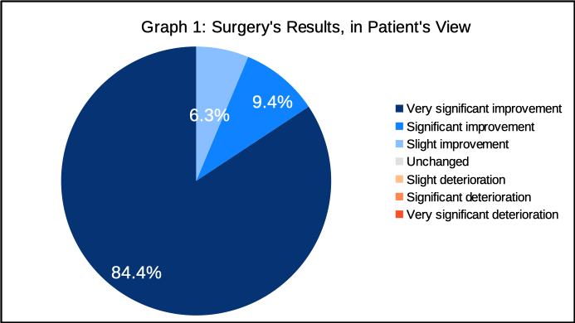

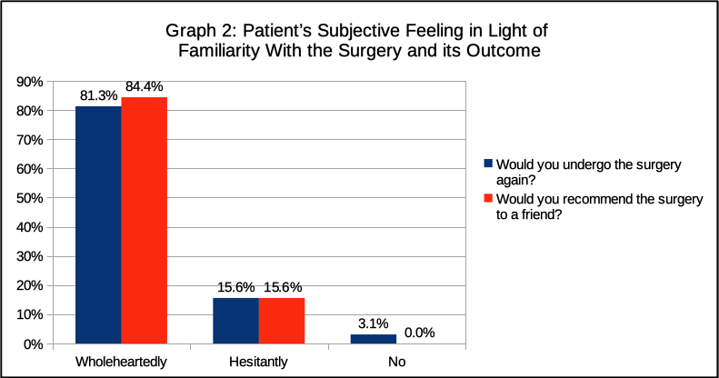

**Discussion**

PVD has remained an enigma for years. The cause of this problem has yet to be fully identified, and treatment remains in dispute. Although provoked vulvodynia’s surgical success has been reviewed several times and has been found to be the most effective treatment method, there is still a debate among experts as to whether all women suffering from PVD should be offered surgery or whether it should be reserved for those who have not been cured by nonsurgical treatments.

In 2016, Goldstein et al[11] published a comprehensive review of the evaluation and treatment of vulvodynia. This was in keeping with the paradigm change proposed by Bogliatto and Miletta,[12] which replaces the view of vulvodynia as a single ailment stemming from a single cause and having a single treatment with a multimodal approach that concentrates on etiological causes and the appropriate treatments for each case. This approach requires cooperation between medical and paramedical specialists in the field who use the same terminology[13] to communicate with one another and offer the patient the optimal diagnostic and therapeutic plan.

Even when vestibulectomy has been found suitable for a patient, it is important to note, alongside the procedure’s proven efficacy, the lack of a standard preferred surgical technique and the importance of having the surgery performed by a skilled surgeon in order to remove the maximum amount of tissue without needlessly endangering nearby organs. In addition, it is important to inform the patient of the lengthy recovery period after surgery and the possibility of postsurgical complications including bleeding, infection, pain, hemorrhage, opening of the surgical wound, formation of scar tissue, and formation of Bartholin cysts. Of these, Goldstein notes that as they are very rare, there is no need to over-emphasize their risks.

In a study by Tommola et al[14] in 2012, follow-up was performed on 66 women who had experienced PVD and were treated conservatively at first. Later, those whose cases were declared to be treatment failures underwent surgery. The study showed that 41% of the women were content with the conservative treatment, and the rest underwent surgery, with satisfaction and treatment success rates not varying greatly between those who had undergone surgery and those who had not. This study leads to the conclusion that surgery should be offered after attempting noninvasive treatment options. However, thus far, there are no guidelines for which noninvasive methods should be offered and whether all noninvasive methods should be exhausted before surgery. We note that in the part of our questionnaire where free-text comments could be added, 1 patient reported feeling that she had wasted too much time on noninvasive treatment methods that did her no good and that in retrospect, she would have preferred to go directly to the most effective solution for her, which was surgery. This comment is not, in our opinion, sufficient to change the entire therapeutic approach, but there is definitely a need to address the amount of suffering patients contend with and their emotional willingness to invest time and resources in treatment methods that, while being noninvasive, have significantly lower success rates.

In this study, if we define *surgical success* as the patient’s ability to have sex as she pleases, we find that 87.5% of the patients noted such ability immediately following the recovery period, and 97% of patients noted such ability at present, a decade or more following the surgery. These findings are consistent with data from previous studies and even exceed them (likely due to better isolation of variables than in other studies).

The objective of this long-term follow-up was to test whether the surgery’s results are retained over time, and the answer seems to be unequivocally affirmative. No patient reported recurrence or worsening of pain, and the patients’ ability to have sexual intercourse remained good, or even improved, over time. Penetration pain, which was very severe before surgery (9.13 on average, on a 0–10 scale), was almost completely alleviated, reaching 0.47 on average today.

Regarding subjective patient satisfaction, we also see that 100% of patients noted improvement following the surgery, with 84.4% answering this question with the highest possible score.

As for other treatment options, 94% of the patients needed no other medical intervention following the surgery. Two patients (6%) did avail themselves of another professional.

This study’s main advantage,beyond being the first of its kind with a time range of more than a decade postsurgery, is the inclusion of women who underwent surgery by the exact same method and by the same surgeon (Prof. Jacob Bornstein), which enabled us to reduce the discrepancies stemming from technical differences between surgeons and techniques and to obtain higher quality results.

A drawback of the study is that we managed to locate only 59% of the women, and of these, only 64% consented to participate. The reason for the low rate of location was the long period of time that had passed since the surgery. Some of the women lived out of the country or were not locatable through the population registry. A possible explanation for the 64% consent rate is the unwillingness of some of the women to reveal to their families that they had undergone the procedure; since the surgery, they may have married and may not have informed their partner about the surgery. (It should be noted that some patients consented to be interviewed by phone but withdrew their consent upon learning that the interview was to be in person.) It is likely that had the surgery been ineffective, these women would have consented to be interviewed in the hope that there is a new treatment available. Therefore, we do not view the response rate as an impediment to drawing our conclusions.

**Conclusion**

This study demonstrated that vestibulectomy, when performed by a skilled surgeon, is an effective surgical procedure with high success rates, possibly higher even than those described in literature, and it results in total elimination or significant reduction in the level of pain aroused mainly in penetration or insertion of objects. Results are retained over long periods of time, and improvement occurs over time in cases where the surgery does not immediately eliminate all pain. Women who have undergone the surgery report high levels of satisfaction and encourage other women who experience this condition to undergo the surgery in order to resolve their pain. In light of a lengthy recovery period as well as a small but extant risk of postsurgical complications, it is advisable to consider noninvasive treatment options prior to surgery, in concert with the patient. However, in the absence of such options with similar proven success, vestibulectomy remains the best treatment for this painful condition.

**References**

1. Harlow BL, Stewart EG. A population-based assessment of chronic unexplained vulvar pain: have we underestimated the prevalence of vulvodynia? *J Am Med Womens Assoc* 2003;58:82–88.
2. Friedrich EG. Vulvar vestibulitis syndrome. *J Reprod Med* 1987;32:110–114.

   3 Moyal-Barracco M, Lynch PJ. 2003 ISSVD terminology and classification of vulvodynia: a historical perspective. *J Reprod Med* 2004;49:772–777.

   4 Bergeron S, Binik YM, Khalifé S, Pagidas K, Glazer HI. Vulvar vestibulitis syndrome: reliability of diagnosis and evaluation of current diagnostic criteria. *Obstet Gynecol* 2001;98:45–51.
3. Halperin R, Zehavi S, Vaknin Z, Ben-Ami I, Pansky M, Schneider D. The major histopathologic characteristics in the vulvar vestibulitis syndrome. *Gynecol Obstet Invest* 2005;59(2):75–79.

   6 Bornstein J, Goldschmid N, Sabo E. Hyperinnervation and mast cell activation may be used as histopathologic diagnostic criteria for vulvar vestibulitis. *Gynecol Obstet Invest* 2004;58:171–178.
4.
5. Panzer C, Wise S, Fantini G, et al. Impact of oral contraceptives on sex hormone-binding globulin and androgen levels: a retrospective study in women with sexual dysfunction. *J Sex Med* 2006;3(1):104–113.
6. Woodruff JD, Genadry R, Poliakoff S. Treatment of dyspareunia and vaginal outlet distortions by perineoplasty. *Obstet Gynecol* 1981;57:750–754.
7. Goldstein AT, Klingman D, Christopher K, Johnson S, Marinoff SC. Surgical treatment of vulvar vestibulitis syndrome: outcome assessment derived from a postoperative questionnaire. *J Sex Med* 2006;3:923–931.
8. Andrews JC. Vulvodynia interventions—systematic review and evidence grading. *Obstet Gynecol Surv* 2011;66:299–315.
9. Foster DC, Butts C, Shah KV, Woodruff JD. Long-term outcome of perineoplasty for vulvar vestibulitis. *J Womens Health* 1995;4:669–675.

   12 de Jong JM, van Lunsen RH, Robertson EA, Stam LN, Lammes FB. Focal vulvitis: a psychosexual problem for which surgery is not the answer. *J Psychosom Obstet Gynaecol* 1995;16:85–91.
10.
11. Goldstein AT, Pukall CF, Brown C, Bergeron S, Stein A, Kellogg-Spadt S. Vulvodynia: assessment and treatment. *J Sex Med* 2016;13:572–590.
12. Bogliatto F, Miletta M. Vulvodynia. *J Low Genit Tract Dis* 2017;21:85–86.

    15 Bornstein J, Goldstein AT, Stockdale CK, et al. 2015 ISSVD, ISSWSH, and IPPS consensus terminology and classification of persistent vulvar pain and vulvodynia. *J Sex Med* 2016;13:607–612.
13.
14. Tommola P, Unkila-Kallio L, Paavonen J. Long-term well-being after surgical or conservative treatment of severe vulvar vestibulitis. *Acta Obstet Gynecol Scand* 2012;91:1086–1093.