Embedding Educational Computer Games into Lessons
Odelya Tzayada
Tel-Aviv University
In recent years, the widespread use of computer games for educational purposes has raised extensive interest among the research community in this field. The purpose of the current study is to propose a new methodological tool that provides a visual description of a sequence of instructional actions enacted by the teacher during a mathematics lesson that incorporates computer games. The proposed methodological tool uses Drijvers’ Instrumental Orchestration as a conceptual framework.

Literature Review
The use of computer games has advantages for students’ learning outcomes and motivation (Erhel & Jamet, 2013). A variety of educational computer games have been found to contribute to students’ knowledge, such as: a game in the domain of fractions along a number line (Riconscente, 2013); an arithmetic-based computer game that contains reflective features (Pareto et al., 2011); and proportional reasoning practice using a computer game (Vrugte et al., 2015). Additional studies have found that mathematical computer games can be more beneficial than pencil-and-paper exercises in improving students’ motivation for learning (Ke, 2008). Use of computer games can increase students’ sense of self-efficacy and improve their attitudes toward learning, an impact that persists even after the actual time of playing the game (Riconscente, 2013).
Several studies have examined the use of computer games in a broad learning context. For example, Ke and Grabowski (2007) compare the use of computer games in three different conditions: cooperatively within a game, competitively within a game, or in a non-game condition. They found the two conditions using a game were more beneficial for learning than the non-game condition. Another study found that learning preliminary algebraic thinking using a computer game, along with a short class discussion, improved users’ learning (Van den Heuvel-Panhuizen, Kolovou, & Robitzsch, 2013). In light of these findings, it seems that further examination of the ways that teachers use educational computer games, in a broad learning context, is needed.
Teachers’ role and behaviours when using computers in lessons can be conceptualized by the Instrumental Orchestration framework. Drijvers et al. (2013) define various types of orchestration that teachers can perform while conducting a lesson in a classroom environment involving computers. Eight orchestration types describe teachers’ interaction with the whole class and five describe their interaction with a student or pair of students.
The Israeli educational system defines four levels of thinking that students are expected to apply while engaged with a learning task. Two of these are considered lower levels of thinking (Knowing and recognizing; Algorithmic thinking), and two describe higher oOder tThnking (HOT): (evcedural thinking; Open search and Reasoning). Although there is no specific definition for a High thr are characteristics to describe it (Resnick, 1987): they aront-algorithmi,; they are iex,; and the way to ethe a solution isertain; and itthey requires therner to make judgments, and undertake iterpretation and self-regulation.

Research aims and question
The aim of the current research is to propose and test a methodological tool that traces teaching behaviours during lessons that integrate mathematical computer games.
Research Questions: How can teachers’ actions during a lesson that integrates a computer game(s) be displayed succinctly? caeacl(as this sucisplay can sayindicaboa lesson?

Methodology
The research participants were mathematics teachers in primary schools who participated in professional development (PD) courses during 2018/2019. As part of the course requirements, the teachers were asked to plan a lesson that embeds use of computer games, and to implement the lesson in their classes. During the PD course meetings, the teachers shared their experiences. All teachers’ reports were video documented and transcribed. Each teacher submitted a written report, which included a lesson plan and a reflective description.
Analysis of the lessons was conducted using a tool that was purposefully developed for this aim: Lesson Fluency Pictures. This tool was developed to provide an elaborate description of teachers’ actions during all parts of the lesson. It allows for consideration of various aspects of the lesson simultaneously, such as: orchestration type, participation setting, artefacts in use, level of thinking, and lesson sequence. Orchestration types describe the specific actions the teacher performs during the lesson, including instrumental orchestrations. The participation setting differentiates between various interactions during the lesson, such as teacher-class interaction, teacher-student interaction, or students working with an artefact deliberately integrated into the lesson by the teacher for students’ individual work but without the teacher’s help or guidance. Additional description portrays the level of thinking that characterizes the activity, the artefact in use, and a detailed description of the actions that embed the computer game(s) into the lesson. All parts of Lesson Fluency Pictures are joined in order to give a full description of a lesson sequence.
The tool was applied to 26 lessons. Some examples are shared in the next section.

Results and Discussion
To enable comparison of different lessons, we used a Lesson Fluency Picture as displayed in Figure 1. The first three lessons took place in computer labs. The fourth lesson was conducted in the regular classroom, with a laptop computer for each pair of students.
Each oval shape in Figure 1 represents actions enacted during the lesson. The horizontal axis illustrates the sequence of teaching actions from the beginning of the lesson (at the left-hand side of the picture) through the end of the lesson (on the right-hand side). The placement of the oval shapes along the vertical axis represents the level of thinking that characterizes the activity.
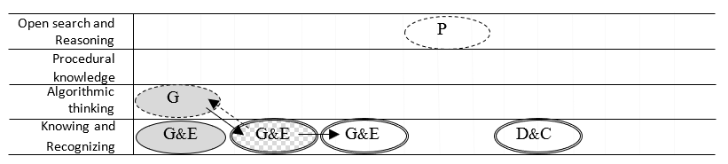
Figure 1a: Bracha’s Lesson Fluency Picture
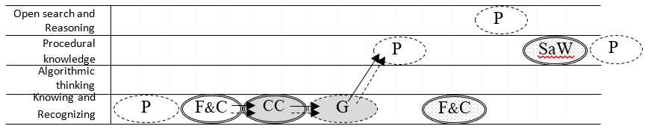
Figure 1b: Noa’s Lesson Fluency Picture
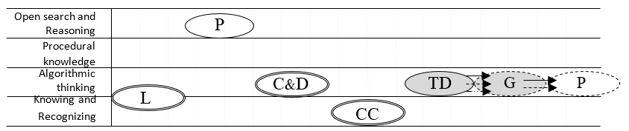
Figure 1c: Sigal’s Lesson Fluency Picture
///
Figure 1d: Ilana’s Lesson Fluency Picture
Legend:
- Each teacher action during the lesson is represented by a single oval shape.
- Outline types of the ovals indicate the participation setting: A double outline represents the teacher’s actions when working with the whole class; a single outline represents the teacher’s actions while interacting with one or two students; a dotted outline represents students working without teacher guidance.
- The shadings give information about the use of technology. A fully-shaded oval shape indicates action using a computer game; a white background indicates no use of computer technologies; an oval partially shaded with dots describes technology-supported actions other than computer games, such as a digital book; a chequered background signifies simultaneous use of computer game(s) with traditional artefacts, such as a worksheet.
- The arrows indicate three types of connections between the use of the computer game and the adjacent lesson sections: a continuous arrow signifies a mathematical connection; a dotted arrow signifies a pedagogical connection; and a dashed arrow signifies a technological connection.

Figure 1: Lesson Fluency Picture
The type of orchestration the teacher implemented while using the computer games varies between: Guiding and Explaining (G&E) the game content; Technical Demonstration (TD) of the game; Gaming (G), to describe students playing the game without the teacher’s help; and Concept Clarifying (CC), which refers to a clarification of mathematical concepts during the game.
The additional orchestrations displayed in the figure represent the teacher’s actions during the lesson that do not use a computer game. The white background represents teacher’s actions without any technology, such as: Paper (P) to represent students’ works on a worksheet or in their books, usually undertaken on their own. Some actions incorporate other technologies, for instance: Sherpa-at-work (SaW) to note that students demonstrate their work in the computerized environment, while their peers follow their actions displayed using an overhead projector. In Figure 1b, the technological environment was a digital book.
On the descriptive level, a comparison between lessons shows that each lesson was conducted differently. The instrumental orchestrations for using the computer games were differentiated, as were the participation settings. The timing during which the teachers used the computer games in the lessons varied as well.
Alongside this information, the Lesson Fluency Picture, taken as a whole including the arrows, provides qualitative information about the connections between the computer game that was embedded in the lesson with other parts of the lesson. In particular, considering the level of the thinking task expressed during the lesson, this tool can be used to evaluate lesson coherence.
This study makes several contributions. Its methodological contribution is the tool designed to provide a succinct description of various lessons, and which enables comparison between them. Its conceptual contribution is an expansion of the conceptualization offered by Drijvers et al. (2013), in terms of the features of the game (feedback), students’ age (primary school), and the learning environment (overhead projector as an exclusive computerized tool in class). This expansion allows for new orchestrations. The research also makes a practical contribution by enabling the instructional community to follow various aspects of a lesson while planning and implementing it.

