Pasha’s Prepared Food Menu

(Pasha Logo)
Prepared food space from HaAhuza
Salads Price per 100g  ® Coriander salad with cranberries and roasted almonds ₪10.90  ® Avocado salad 7.80  Tuna salad with mayonnaise 7.80  Sweet potato salad in chili with almonds 6.20  ® Waldorf salad 6.20  Red pepper and garlic, lemon, and olive oil salad 6.20  Quinoa salad with cranberries 6.20  ® Red quinoa tabouli salad 6.20  ® Homemade hummus with chick peas 4.80  ® Homemade tahini 4.80  ® Green tahini 4.80  ® Mashed eggplant with tahini 5.20  ® Mashed eggplant with vegetables 5.20  ® Mashed eggplant with mayonnaise 5.20  Asian eggplant in slightly spicy sauce 5.20  Eggplant dish in slightly spicy sauce container 19.90  ® Grilled roasted baladi eggplant container 19.90  ® Turkish salad 5.20  ® Matbucha salad 5.20  ® Moroccan schug (spicy) 5.20  ® Esther’s schug (lightly spicy) 5.20  ® Harissa salad 5.20  Pickled lemon condiment 5.20  Amba 5.20  ® Potato salad with eggs in mayonnaise 5.20  ® Egg salad in mayonnaise with Dijon mustard 5.20  ® Coleslaw salad – cabbage and carrot in mayonnaise 5.20  ® Red cabbage in mayonnaise and Dijon mustard 5.20  ® Moroccan-style cooked carrots 6.20  ® Grated carrots with cranberries 6.20  ® Grated carrots with coriander and lemon 6.20  ® White cabbage in homemade marinade 6.20  ® White cabbage with dried fruit 6.20  ® Red cabbage with nuts 6.20  ® Mixed vegetables in homemade marinade 6.20  Cucumber-dill salad 6.20  ® Red beet salad 6.20  Peeled hot pepper and garlic, lemon, and olive oil 6.20  Iraqi pickles (Torshi) 6.20  Homemade cucumber pickles 6.20  Syrian olives seasoned with olive oil and lemon 6.20  ® Seasonal fruit salad 6.20  Kosher – Glatt kosher meat Beit Yosef  Mehadrin chicken and vegetables  The wonderful flavors, the unique fragrances, and the beloved dishes – now in your home! | `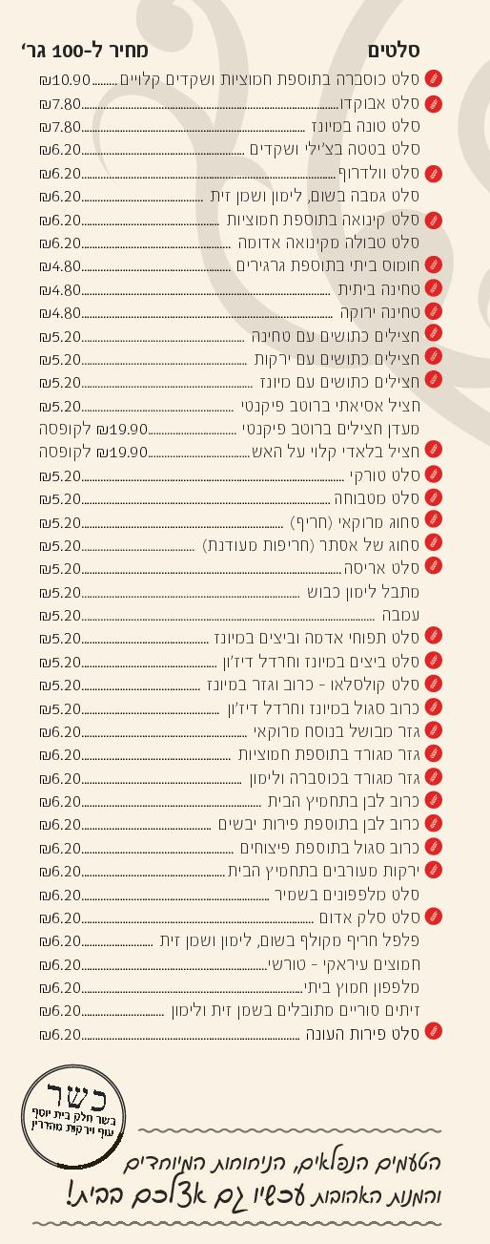
18 Pierre Koenig Street Talpiot | Phone: 02-6482220 | Fax: 02-6482221 | Site: pashajer.co.il | Find us on Facebook
Errors and omissions excepted

Cooked Vegetables Price per 100g  ΘAsian-style stir-fried mushrooms 9.90  Θ® Artichoke hearts and mushrooms 9.90  Θ©® Tanzia – dried fruit and walnuts 8.90  Θ® Italian-style grilled vegetables 8.90  Θ Turkish-style cooked vegetables 6.80  Θ® Moroccan-style cooked olives 6.80  Θ® Marrakesh chick peas 6.80  Θ Chinese-style stir-fried vegetables 7.80  Θ® Stir-fried beans with cherry tomatoes and sesame 7.80  Θ® Green beans in tomato sauce 6.80  Θ® Okra in tomato sauce 7.80  Θ® Peas and carrots in tomato sauce 6.80  Θ® Peas and zucchini in natural sauce 6.80  Θ Steamed cauliflower with cherry tomatoes and olive oil 7.80  Θ Steamed broccoli with garlic, olive oil, and coarse salt 7.80  Side Dishes / Carbohydrates Price per 100g  Θ White rice with almonds and raisins 5.20  Θ® White rice with coriander, cranberries, and roasted almonds 5.20  © Rice and vermicelli (Sh’ariah) 5.20  Θ Maalova rice with vegetables 5.20  Θ Wild rice with garden vegetables 5.20  Θ® Mujadara 5.20  Θ® Asian rice 5.20  Θ® Green Persian rice 5.20  Θ® Red Iraqi rice 5.20  Θ Turkish bulgur 5.20  Θ Moroccan couscous 5.20  Θ® Soup for couscous 5.20  © Vegetable noodles 5.20  © Penne in tomato sauce 5.20  © Fettuccini in pesto and basil 5.20  © Sweet potato with silan (date honey), garlic, and rosemary 5.20  Θ® Potato with garlic, olive oil, and rosemary 5.20  Θ® Asian-style potato 5.20  Θ® “Gourmet” potato 5.20  Θ French fried potatoes 5.20  Θ Dutch French fries 5.20  Θ Sweet potato fries 5.20  © Authentic Jerusalem kugel 5.20  © Potato kugel 5.20  © Assorted soups 39.90 each  © Maakuda pashtida (crustless quiche) 39.90 each  Assorted bread / challah / cake and cookies  Continued on the other side  ® Manufactured in a facility which uses gluten  Θ No meat or eggs  © Vegetarian | 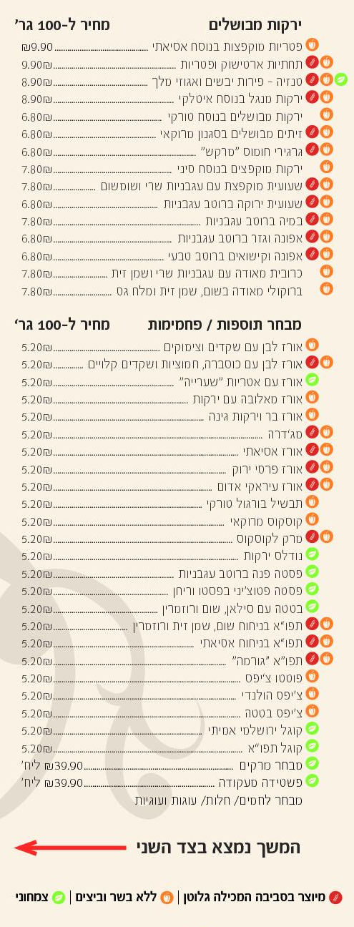
Assorted Kubbeh Soups Price per 100g  Hamusta kubbeh with slightly sour sauce 6.80  Orpali kubbeh (hamu) (meat-filled dumplings) 6.80  Beet kubbeh 6.80  © Vegetarian kubbeh in celery sauce 6.80  Assorted Stuffed / Fried Vegetables Price per 100g  Θ® Grape leaves stuffed with rice and tomatoes 7.80  Θ® Onion and cabbage stuffed with rice and tomatoes 7.80  Θ® Pepper stuffed with rice and blueberry raisins 7.80  Θ® Zucchini stuffed with tomato sauce and mint 7.80  Nablus kubbeh filled with meat 7.80  Θ Nablus kubbeh filled with mushrooms 7.80  Potato pancakes filled with meat 7.80  Θ Potato pancakes filled with mushrooms 7.80  Moroccan cigar filled with meat 7.80  Θ Moroccan cigar filled with potato 7.80  Panko-breaded phyllo cigar filled with meat 7.80  Cigar with siska meat filling 7.80  Meat shishbarak 7.80  © Crispy coated cauliflower 7.80  © Crispy coated broccoli 7.80  © Leek patties 7.80  © Vegetable pancakes (latkes) 7.80  Θ Potato pancakes filled with corn 7.80  Θ Chinese eggroll filled with vegetables 7.80  Θ Pastel filled with potato 7.80  Θ Onion rings 7.80  Assorted Baked Items Price per 100g  Filas pastry roulade filled with veal 8.90  Puff pastry filled with chicken breast and mushrooms 8.90  Arayes (meat-stuffed pitas) 8.90  Tortilla filled with meat 8.90  Tortilla filled with chicken 8.90  © Tortilla filled with vegetables 8.90  Assorted Fish Price per 100g  ® Salmon fillet, Moroccan-style 20.80  Salmon fillet, Asian-style 20.80  ® Salmon fillet with basil and pesto 20.80  ® Salmon fillet with herbs 20.80  ® Whole dennis (bream) on the grill 17.50  Fried mullet fillet 17.50  Fried tilapia fillet 17.50  ® Tilapia / mullet with herbs 12.50  ® Tilapia / mullet, Moroccan-style 12.50  ® Moroccan-style perch 12.50  Chraime fish kebab 12.50  ® Gefilte fish 12.50  ® Manufactured in a facility which uses gluten  Θ No meat or eggs  © Vegetarian | 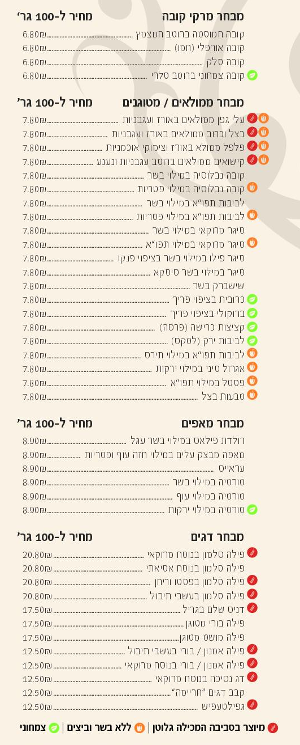
Assorted Chicken Dishes Price per 100g  ® Grilled boneless chicken thighs 18.70  Grilled boneless chicken thighs with pomegranate concentrate and ginger 18.70  ® Boneless chicken thighs in chili sauce 18.70  Boneless chicken thighs with herbs 18.70  Boneless chicken thighs with pistachio and cashew 18.70  Boneless chicken thigh shawarma 18.70  Jerusalem mix 16.50  ® Chicken liver in wine and onion sauce 10.90  Schnitzel coated in bread crumbs 10.90  Chicken fingers 10.90  Mexican chicken fingers 10.90  “Iraqi” chicken balls 10.90  ® Chicken steak 10.90  ® Grilled chicken legs 9.90  ® Grilled chicken thighs and drumsticks 9.90  Grilled chicken thighs and drumsticks with pomegranate concentrate 9.90  Chicken balls and cauliflower, sweet peas, and collard greens 9.90  Chinese-style stir-fried chicken strips 9.90  Chicken noodles and vegetables 8.50  ® Traditional chopped liver 8.50  ® Eastern-style chopped liver 8.50  Assorted Meat Price per 100g  Aged Argentinean entrecote 31.50  Beef fillet in shimeji mushroom sauce 31.50  Beef roast in mushroom sauce 16.50  Beef roast in chestnut and carrot sauce 16.50  Beef tongue in gravy with root vegetables 16.50  Beef stew with browned mushrooms 16.50  ® Szechuan-style beef strips 16.50  Grilled Asado fillet in beef gravy 16.50  ® Veal chorizo sausages 10.90  ® Homemade kebab 10.90  ® Greek kebab Souvlaki 10.90  ® Kebab filled with tahini 10.90  Abuhatzeira meatballs 8.90  Beef meatballs with sweet peas 8.90  Beef meatballs in tomato sauce 8.90  Moussaka in tomato sauce 8.90  Stuffed artichoke with celery and lemon sauce 8.90  Traditional hamin 6.80  Kosher – Glatt kosher meat Beit Yosef  Mehadrin chicken and vegetables  Prepared food store open 6 days a week  Rich and varied meat menu all week long  Available to order for seudot mitzvah, family occasions, and catering services  Continued on the other side  Free parking on Fridays also in the building’s lot | 