Teacher Employment Key 2018
Task |  | Employment units |  | Notes
Lecture
Weekly classroom hours |  | 275 |  | Including preparation and associated tasks^{A}
Lecturer who is course supervisor |  | According to Table B below |  | Associated tasks^{B}
Drill
Weekly classroom hours – basic course |  | 200 |  | According to classification¹ – including preparation and associated tasks^{C}
Weekly classroom hours – other course |  | 225
Weekly classroom hours – advanced course |  | 250
A supervising Teaching Assistant for a course with at least 10 graduate students (10 ≥ X) |  | According to Table A below |  | X – The number of students enrolled, associated tasks: ^{C + D}
A Teaching Assistant who gives an advanced course for the first time |  | 50
Grading exercises
40 sheets Type I |  | 100 |  | According to classification²
40 sheets Type II |  | 150
Laboratory training
Weekly training time |  | 100 |  | Not including preparation. Total tasks^{E} for every 100 employment units will be ± 15-20% (12-18) accumulated semestrial work hours.
Preparation |  |  |  | Y – Weekly training hours in the laboratory: every Laboratory Assistant will receive preparation units.
Advising
 |  | 50 per student |  | According to classification³
Advising a basic project |  | (Up to 10 students)
 |  | 25 for each additional student
Advising an advanced project |  | 125 per project per semester
Advising teacher in the fields of comprehensive design/landscape design in the Faculty of Architecture |  | 1200 |  | Mentoring a group of at least 10 students for scope of 10 weekly hours.
Coordinating advising in the fields of comprehensive design/landscape design with two or more mentors at one time |  | 100
Advising an advanced-degree trainee |  | 150 |  | Per trainee per semester (including vacation between semesters and summer semester)
Table A – Responsibilities of Teaching Assistants
 | Graduate students |  | Responsibility Units
 | 0-9 |  | 0
 | 10-59 |  | 40
 | 60-109 |  | 90
 | 110-159 |  | 140
 | 160-209 |  | 190
 | 210-259 |  | 240
 | 260-309 |  | 290
 | 310 or more |  | 340
Each course will have a supervising Teaching Assistant. A single Teaching Assistant is also a supervising Teaching Assistant. |  |  |  |  | 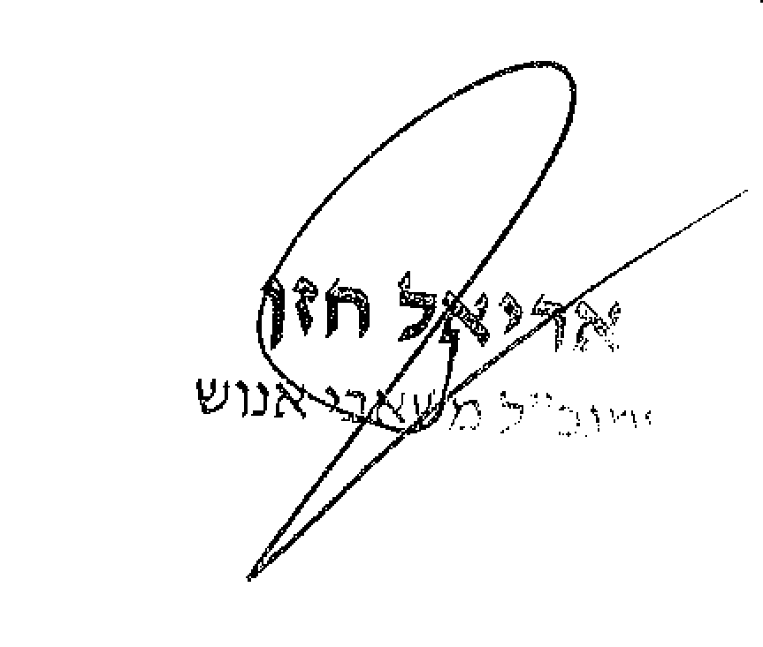


Table B – Supervising Lecturer
 |  |  | Number of graduate students |  | Supplemental employment units
 |  |  | 119-80 |  | 100
 |  |  | 199-120 |  | 150
 |  |  | 299-200 |  | 200
 |  |  | 399-300 |  | 250
 |  |  | 400 or more |  | 300
List of Included tasks:
A | Lecturer | 1-2 office hours, as needed; participating in composing exams (composing exams if a single lecturer); presence at exams, checking exams, reviewing appeals. Participating in staff meetings
B | Supervising Lecturer | All a lecturer’s tasks, in addition to: responsibility for the course and its routine management; checking homework assignments; responsibility for composing exams; responsibility for publishing grades. In individual cases, when an associate instructor is assigned as supervising lecturer of a particularly large course, specific approval can be requested from the Vice President for Academic Affairs (MANLA) to increase the scope of employment.
C | Teaching Assistant | 1-2 office hours as needed, updating educational materials*; composing homework assignments*; participating in composing and inputting exams and their solutions; presence at exams; reviewing exams; participating in marking exams; and attending staff meetings.
D | Teaching Assistant Supervisor | All Teaching Assistants’ (C) tasks, in addition to: website maintenance; responding to students; responsibility for updating educational materials; and composing homework exercises.* Responsibility for inputting exams and solutions; calculating and inputting scores.
E | Laboratory Assistant | Training in the laboratory; preparing the laboratory; updating educational materials and assignment; office hours; checking tasks (including reports); and similar academic tasks as is customary. Total tasks for every 100 employment units will be ± 15-20% (12-18) accumulated semestrial work hours.
* Composing the major portion of homework or educational materials is not included as part of this task.
Classifications
1 | Basic Course |  |  | A preliminary course (required by students from another faculty) and a required degree course.
 | Advanced Course |  |  | Advanced faculty course
 | Other Course |  |  | A required course in the faculty track, which is also an elective for other track(s).
- The department head can submit a detailed request to the Vice President for Academic Affairs (MANLA) to change classification of two courses (one for the other) in cases where the burden of instruction and difficulty level are incompatible with its classification.
- The department head needs to submit a detailed request to MANLA to change a basic/other type course to an advanced one. The number of the aforesaid courses per department will not exceed two simultaneously, except for exceptional cases where there is no advanced replacement course.
2 | Type I Exercises |  |  | Detailed examination at the supervisor’s discretion (registering receipt will not be considered an examination). |  | Total tasks for every 100 exercise units (EU) will be ± 15-20% (12-18) accumulated semestrial work-hours.
 | Type II Exercises |  |  | Detailed examination at the supervisor’s discretion of the homework exercises, most of which have not published a solution in the past.
3 | Basic Project |  |  | A project given to large groups (as a course project) and a required semestrial project for the "studio" track at the Faculty of Architecture.
 | Advanced Project |  |  | Project (in a course project) given for degree completion (in the last year of degree studies) for 1-2 students.


