**Use of French short-time working scheme during the Covid-19 crisis: an empirical analysis for the period March through May 2020**

Oana Calavrezo

[ocalavrezo@unédic.fr](mailto:ocalavrezo@unédic.fr)

Unédic and Université d’Orléans, CNRS, LEO, FRE 2014

Lewis Hounkpevi

[lhounkpevi@unédic.fr](mailto:lhounkpevi@unédic.fr)

Unédic

Florence Journeau

[fjourneau@unedic.fr](mailto:fjourneau@unedic.fr)

Unédic

Marie-Hélène Nguyen

[mnguyen@unedic.fr](mailto:mnguyen@unedic.fr)

Unédic

**Abstract**

In France, the short-time working scheme has been one of the principal responses to the Covid-19 crisis in order to safeguard jobs, making the country one of the most frequent users of this approach in Europe. As a temporary solution, which is generally countercyclical, short-time working enables businesses to adjust the number of hours worked to fit with fluctuating levels of activity, while seeking to avoid actual lay-offs.

In this paper, we analyze employers’ use of this solution during the period of lockdown, based on exhaustive administrative data up to June 22, 2020. One of the key aspects of our study is the comparison between current short-time working practices and those prevailing prior to the health crisis, including during the economic recession of 2008-2009.

To make use of short-time working, the employer must apply for prior permission from the authorities. Such an application reflects the employer’s expectation of using the scheme, with businesses often making advance applications for a number of short-time working hours well in excess of what they will actually use. We describe the approach taken by employers to the prior application in terms of hours and headcount requested as a function of the characteristics of their business and the nature of their application, and we also analyze the determining factors underlying the probability of having made a prior application.

Employers may then request the monthly reimbursement of wages paid to employees on short-time working. This is also known as a claim for compensation. We thus present the behavior observed through the data in terms of claims for compensation, again as a function of the hours and headcount concerned and the characteristics of the businesses, and the monthly figures for the rate of transformation of applications into claims for compensation between March and May, from the perspective of the claims filed and actual consumption of short-time working hours.

As employers have a year to file their claims for compensation, we also estimate, based on the data and using assumptions, what the final cost of the scheme will be and the actual number of employees put on short-time working for the months of March through May 2020.

**Key words**: short-time working, Covid-19

Introduction

To address fluctuations in activity levels, employers have various means to make adjustments: quantitative external flexibility tools (fixed-term contracts, temporary work, etc.), quantitative internal tools (overtime, modulation or annualization of working hours, etc.) and qualitative internal tools (such as multi-skilling). As an internal quantitative flexibility tool, short-time working, or *“activité partielle”* or *“chômage partiel”* in French, is an old system in France which allows businesses to adjust their volume of hours worked to fluctuations in activity levels while attempting to avoid redundancies for economic reasons (Calavrezo, 2009). By design, the short-time working scheme is intended to be used on a temporary basis.

Short-time working is currently a flagship measure promoted by the French authorities to fight against the repercussions for employment of the Covid-19 health crisis. The extent to which this scheme has been used in France during the health crisis is unprecedented, placing the country among the highest users in Europe[1]: at the height of the crisis, short-time working helped to protect around 9 million employees and over one million businesses. However, due to the limited timeframe, use of the scheme in France during the Covid-19 crisis has thus far not been studied in any depth and there is very little literature. This paper contributes to the literature on short-time working by providing an overview of use of the scheme during the period March through May 2020, coinciding with the period of lockdown when the scheme was most widely used. It forms a continuity with existing studies while comparing current use with practices prior to the health crisis, including those prevailing during the economic recession of 2008-2009. It is a mainly descriptive analysis. Indeed, in view of the recent nature of the data and the phenomena studied, it is far too early to envisage an analysis of the effectiveness of short-time working in terms of employment/unemployment trends, adjustments to the workforce or the survival of businesses.

The analysis is based on exhaustive administrative data from the French services and payment agency (ASP) up to June 22, 2020. These data help to understand the approach taken by employers in terms of short-time working since March 1, 2020, including the applications for prior permission reflecting employers’ expectations and the claims for compensation reflecting the actual consumption of short-time working hours by those businesses that had applied up to June 22. So, what we examine is the way in which employers use the scheme during the Covid-19 crisis.

The remainder of the work is organized as follows. The first section presents the regulations and formalities that must be conducted for employers to be able to benefit from the scheme. In the second section, we present the effects expected in theory and provide a brief overview of the available literature on short-time working. In the third section, we describe the data used and the chosen methodology. In the fourth section, we present the results. This section is broken down into three sub-sections. We begin by describing employers’ behavior towards the application for prior permission (Section 4.1). After that, we present the behavior observed through the data in terms of claim for compensation and the rate of transformation of the prior applications into claims for compensation on a monthly basis (Section 4.2). The two sub-sections (4.1 and 4.2) are based on an examination of the data concerning employers’ behavior towards the short-time working scheme up to June 22. Finally, as employers have a year to file their claims for compensation, we estimate, based on the data and using assumptions, what the final cost of the scheme will be and the actual number of employees put on short-time working for the months of March through May. The analysis is then concluded by providing the principal results and a description of the intended next steps.

|  |
| --- |
| **Inset 1: use of short-time working in Europe**  Most European countries have used short-time working schemes to mitigate the effects of the Covid-19 crisis, inspired by the German “Kurzarbeit” used so successfully during the financial crisis of 2008-2009. In the majority of cases, this type of measure already existed and was made more flexible.  Whereas the countries all share the same objectives (keeping businesses solvent to avoid bankruptcies and protect jobs, so that the business can start up again rapidly), the specific methods used vary from one to the next (see Unédic, 2020a for a presentation of the schemes in 8 European countries as at July 6).   * *Amount of compensation* – In Germany, employees on short-time working receive 60% of their net wages for the hours not worked (67% for employees with at least one dependent child), with the rate of compensation being progressive. In Belgium and Spain, as in France, the rate of compensation is 70% of gross salary. In Italy, Luxembourg, the United Kingdom and Switzerland, the rate of compensation rises to 80% of gross salary. * *Ceiling* – The ceiling for the compensation varies considerably: €8,998 in Switzerland, €5,355 in Luxembourg, €4,847 in France, €2,892 in Germany, €2,831 in the United Kingdom, €1,928 in Belgium, €1,098 in Spain (up to €1,411 for employees with several children) and €1,130 in Italy. * *Period of compensation* – In France (excluding long-term short-time working agreements or APLDs), Germany and Switzerland, businesses are granted one year. However, use of the scheme ceases on September 30, in Spain, and October 31, in Italy and the United Kingdom. In Luxembourg, full-time employees are allowed 1,022 unworked hours per annum. The period of compensation is not predetermined in Belgium.   On April 1, the European Commission proposed a new instrument known as Support to mitigate Unemployment Risks in Emergency (SURE), making €100 billion available to member states to help them finance their short-time working schemes at favorable rates.  More than 50 million employees are reported to have been covered by this scheme at end April, in the European Union, the United Kingdom and Switzerland, equivalent to over a quarter of the working population (26.8%; ETUI, 2020). Actual use of short-time working is lower insofar as not all businesses that applied have actually used it. In France, use of short-time working is among the highest rates.  Graph: proportion of the working population covered by such schemes at end April/early May 2020 (%)    Source: ETUI/WSI based on data provided by national employment agencies or statements from ministries, and Eurostat data on the working population (annual data for 2019).  Observation: For most countries, the figure is based on applications for short-time working, with actual use of such schemes being lower. On the contrary, figures for the United Kingdom and Czech Republic correspond to the proportion of the working population actually placed on short-time working. Any comparison between the different countries is therefore approximate. |

1. Regulations and employer behavior
   1. The regulations

In France, the short-time working scheme is a means to safeguard jobs, governed by law (French Labor Code Art. L 5122-1 et seq. and D 5122-1 et seq.)[2]. Short-time working in France is currently financed by the State at 67% and by the unemployment insurance, Unédic at 33%[3]. It is not a new scheme: the unions set the rules for the implementation of short-time working by the Inter-profession National Agreement (ANI) of February 21, 1968. Changes made since 2009, under of successive ANIs have resulted in more robust funding of the scheme. Short-time working enables employers to offset all or part of the cost of compensation paid to employees if activity is suspended or temporarily reduced due to economic difficulties or exceptional circumstances[4], within the limits of legal working hours (see below).

As of March 1, 2020, due to the Covid-19 epidemic, the scheme has undergone a number of major reforms due to the extent of the crisis. Here, we could cite Decree 2020-325 of March 25, 2020 concerning short-time working (simplified filing and processing of short-time working applications up to December 31, 2020, short-time working benefits paid to employers raised to 70% of gross hourly wages subject to a ceiling of 4.5 times the minimum wage (French SMIC[5]), Order 2020-346 of March 27, 2020 amended by various other orders, the Decree of March 31, 2020 amending the allowed number of annual working hours eligible for compensation under short-time working for the year 2020 (1,607 hours instead of 1,000 hours previously, up to December 31, 2020).

In addition, as of March 12, 2020 and at latest until December 31, 2020, the short-time working scheme is subject to major changes to ensure more effective compensation and to broaden access to benefits to employees and employers who were hitherto excluded[6].

These include:

* employees under private law of certain public sector employers, providing that the main business of these employers is industrial or commercial and that the income thus derived constitutes the majority of their resources. The law states that employers that are self-insured in terms of unemployment contributions must reimburse to Unédic the portion of short-time working benefits incumbent upon them;
* domestic employees and childcare workers employed by private individuals, according to specific compensation arrangements (compensation increased to 80% of the net hourly wage and paid by French social security - URSSAF or the equivalent body for agricultural workers - MSA; see also Inset 2);
* employees whose working hours are calculated in days and executive management, employees with open-ended employment contract (CDI) during periods in which no services are provided to a customer, people employed by a company with no presence in France (where the employer has an obligation to pay social security and unemployment contributions under French law for these employees), seasonal entertainment industry artists and technicians, employees of temporary employment agencies, employees of financially independent bodies that manage a public service of an industrial or commercial nature running ski lifts and ski runs (providing they are subject to the provision of the French Labor Code and that their employer pays unemployment contributions).

As of March 1, and up to December 31, 2020, the hours eligible under short-time working have been increased to collectively agreed working hours and no longer just the legal limit[7] (taking into account built-in overtime). In addition, complementary compensation (namely the difference between the salary and compensation for short-time working) has been exonerated from social security contributions, within a certain limit. Finally, a scheme to take into account short-time working on an individual basis has been put into place by Order.

As of May 1,, the short-time working scheme has been expanded and opened up, replacing daily social security payments (IJSS) and as exemptions under Article L. 5122-1 of the French Labor Code, to vulnerable employees at risk of developing an acute form of the SARS-CoV-2 infection, employees living with a vulnerable person, employees who are parents of a child under 16 or of a disabled person required to shield, or subject to eviction or confined to their home (see also Inset 3)[8].

As of June 1, and up to September 30, 2020[9], the sum under short-time working reimbursed to the employer has been set at 60% of the benchmark gross hourly wage (limited to 4.5 times the French minimum wage or SMIC), instead of 70% up to May 31. As for employees, they continue to receive 70% of their benchmark gross wages, which implies a balance to be paid by the employer. By an exemption, this measure does not concern establishments in sectors subject to special legal or regulatory restrictions, nor those in sectors particularly badly hit by the health crisis (tourism, restaurants, sport, culture, events, etc.), with the latter continuing to be fully compensated for the sums paid to their employees placed on short-time working until December 2020 (government announcement of July 29).

On June 24, the French government announced that as of October 1, 2020, the short-time working compensation paid to employees would be set at 60% of the benchmark gross hourly wage (limited to 4.5 times the French minimum wage or SMIC), within the framework of the common-law scheme. The sum under the scheme to be reimbursed to the employer will cover 60% of the cost of wages paid to employees, with the balance to be paid by the employer being equivalent to 40% of the amount paid to employees. Business in the tourist industry, badly affected by the health crisis, should benefit from full compensation up to December 31, 2020, meaning short-time working compensation maintained at 70% of the gross hourly wage (see also the previous paragraph).

Finally, a specific short-time working scheme to apply to a long-term reduction in levels of activity came into force on July 1, 2020[10]. Implementation of this scheme is contingent on the conclusion of a collective agreement including a commitment to maintain jobs and subject to prior approval by the authorities. This scheme is applicable for a period of 24 months, and is limited to agreements submitted to the authorities for approval at latest by June 30, 2022. Under this arrangement, the reduction in the working hours of employees is limited to 40% of the legal working hours and compensation is set at 70% of the benchmark gross hourly wage (limited to 4.5 times the French minimum wage or SMIC). The rate reimbursed to the employer is set, depending on the case in question, at 60% (agreements submitted to the authorities by October 1, 2020) or 56% (agreements submitted after October 1) of the benchmark gross hourly wage (limited to 4.5 times the French minimum wage or SMIC).

|  |
| --- |
| **Inset 2: Short-time working for domestic employees and childcare workers**  Given the context of the Covid-19 crisis, and in order to help private individuals as employers finding themselves in difficulty to pay their employees and protect the latter against job losses, the government extended the use of short-time working to cover domestic employees and childcare workers, on an exceptional and temporary basis[11].  For hours that should have been worked and have not been, the employer pays a fixed hourly rate equal to 80% of the net compensation stated in the employment contract. The rate may not be less than the applicable regulatory minimum net hourly rate. Above this amount, the employer may choose to make further payments at their own cost in order to guarantee the employee’s full net wage. The fixed sum is subject to full reimbursement by the State and Unédic, through the French social security body. For the employee, this amount is not subject to social security contributions but must be declared on their tax return.  Concerning the formalities, the short-time working scheme has been simplified to adapt it to the specific needs of individual private employers. The latter are exempt from the obligation to apply for permission from their “regional authority for business, competition, consumption, labor and employment” (DIRECCTE). The employer simply fills in a specific compensation form available from the French universal employment services check (CESU) or privately employed childcare worker (PAJEMPLOI) websites. As a consequence, the ASP data do not include a field for these individual employers.  In their press release of April 29, the French Ministries of Health and Finance announced that 55% of CESU employers and 32% of PAJEMPLOI employers had made use of short-time working in March (504,325 requests). Thus, in March, 361,770 domestic employee and childcare workers are reported to have benefited from short-time working compensation, for a total of €85 million[12]. In April, the cost to the French State and Unédic was €203 million. It then dropped in May to just €32 million. For Unédic, which finances 33% of the scheme, the total cost amounted to €106 million for the period March through May. |

|  |
| --- |
| **Inset 3: Exemptions for time off work for people obliged to remain at home and unable to work**  As of the start of the lockdown, employees obliged to remain at home to take care of their children[13], vulnerable people considered ‘at risk’ from the Covid-19 epidemic and employee sharing the same home as a vulnerable person, were able to take sick leave, in the absence of a teleworking solution.  To do so, the employee in question could either ask their general practitioner to sign them off on sick leave, under common-law, or register on the *declare.ameli.fr* site for long-term sick leave to obtain the necessary authorization.  Those employees on sick leave received daily benefits of up to 90% of their gross salaries, as for other types of sick leave. After 30 days (as of April 16, for some employees), the level of compensation drops to 66% of salary.  **More than 2 million people concerned**  At April 22, social security had registered almost 3.2 million cases of sick leave related to Covid-19: 2.3 million for childcare purposes, 320,000 for vulnerable people and 600,000 for actual sickness. To these figures must be added the more recent periods of leave for employees sharing the same home as a vulnerable person. Several periods of leave may concern the same employee. French social security estimates that 400,000 vulnerable employees, or people living with vulnerable people, were off work during the lockdown. According to the French economic observatory (OFCE) estimate, as at May 6, 1.6 million employees were on daily benefits for childcare (OFCE, 2020a).  **Move towards short-time working**  As of May 1, employees taking care of children and the more vulnerable to the Coronavirus now benefit from the short-time working scheme if they are still unable to carry out their professional activities (see Art. 20 of the second Amending Finance Law for 2020). Two thirds of the cost of compensation has therefore been transferred from social security to the State and one third to Unédic. This change of regime does not concern the self-employed, or off-work civil servants and public servants under contract.  Social security automatically stopped time off for childcare on April 30. The employee now sends the childcare declaration to their employer, who goes online to put into effect the normal short-time working process.  This measure helps to prevent too steep a drop in compensation: without being placed on short-time working, the level of compensation would be 66% of salary after 30 days off work and 50% of salary after 60 days for employees with a length of service of less than 5 years. Neither was it envisaged to make employers pick up the balance of the cost, in order to avoid the risk of further bankruptcies.  **What right to short-time working on the grounds of childcare or vulnerability post May 11?**  From the ASP data aggregated at the level ‘businesses’ it is not possible to identify workers on short-time working for reasons of childcare or vulnerability, nor is it possible for the applications for prior permission or claims for compensation. However, we must assume a gradual reduction in short-time working on childcare grounds for the period between May 11, and June 22. In reality, schools and crèches gradually reopened as of May 11, initially taking a limited number of children due to the social distancing rules. It was only after June 22, that it became compulsory for nearly all pupils to return to the classroom.  In an attempt to quantify the number of vulnerable people, OFCE has estimated the number of vulnerable people unable to adopt teleworking and with the right to the short-time working scheme to be 2.8 million (OFCE, 2020b). “In reality[…], it would appear that the use of short-time working has been […] very low”, for a number of reasons: the lack of communication about this protective measure, a different assessment of the risk of Covid by the employees themselves, the fear of stigmatization or the risk of being fired, and the need to be physically present at work. In order to quantify the extent of this lack of uptake, OFCE firstly attempted to identify vulnerable employees, exposed to the public due to their profession and unable to telework: 1.1 million people. A complementary approach consists of quantifying the number of vulnerable employees using public transport to commute to work and unable to telework: 380,000 people.  According to the employment and labor conditions Acemo-Covid survey, 38.4% of employees placed on short-time working in June made use of the scheme on the grounds of childcare or vulnerability to the virus (French agency for research, studies and statistics, or Dares, 2020a). These reasons concern at least two thirds of employees on short-time working in the fields of finance and insurance (69.8%), in the food industry (64.4%) and teaching, healthcare and social work (65.0%). On the other hand, use of short-time working for reasons of childcare or vulnerability only holds true in 4.2% of cases in the hotel and restaurant trade (where mandatory closures as part of the restrictions imposed on certain businesses remains the principal reason) and in 17.0% of cases in the information and communication sector (where the reduced number of opportunities and orders is the main reason for use of short -time working). |

* 1. Employer formalities

To make use of short-time working, employers must make an application for prior permission (DAP) to the regional authority for business, competition, consumption, labor and employment (DIRECCTE), accompanied by a statement from their Social and Economic Committee (CSE), where such a body exists to represent employees. This formality, and those discussed below, are carried out on the website *activitepartielle.emploi.gouv.fr/aparts/* (see Diagram 1). The application reflects the employer’s anticipated short-time working needs: employers may choose to make an application covering a few days or a few months and must declare the number of employees and working hours. The authorities then approve (or refuse in part or in whole) the application. Until December 31, 2020, the lack of a response from DIRECCTE within 2 days, implies acceptance of the employer’s request (previously 15 days). After this approval stage, we talk about an approved short-time working application (DA).

Diagram 1: The various employer formalities for use of short-time working

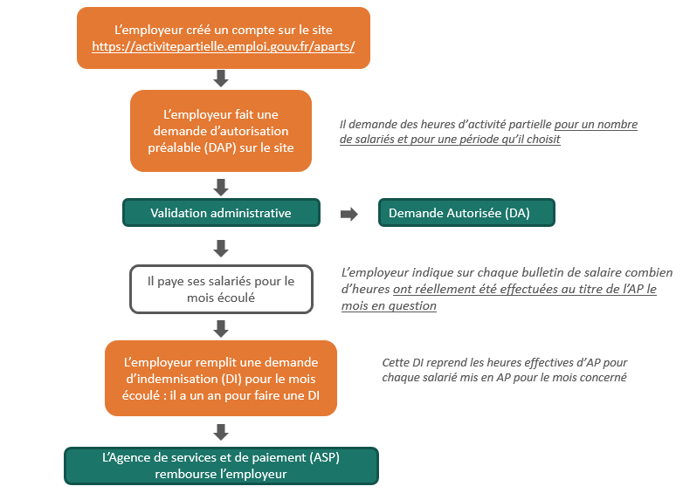

Source: Unédic

In case of an accident, extreme weather or due to exceptional circumstances, such as the Covid-19 epidemic, the formalities for employers are simplified and can be completed after the fact: from the date of placing their employees on short-time working, the employer may apply within 30 days and the statement from the CSE may be sent up to 2 months later.

If the employer has received prior approval for compensation under the short-time working scheme, they may make a request for the monthly reimbursement of the wages paid to the employees in question, which is also known as a claim for compensation (DI). They have one year to file this claim. The ASP then pays the amount requested by the employer in their claim.

1. Review of the literature
   1. Economic rationale for short-time working and theoretically expected outcomes

Short-time working is associated with beneficial effects on employment

The purpose of short-time working is to prevent temporary economic difficulties from destroying jobs or businesses that remain viable over the medium- to long-term.

For businesses, short-time working is an instrument to create intern flexibility enabling them to adjust their labor force in response to a shock to output by adjusting working hours rather than jobs. Like redundancies, this measure helps to reduce payroll costs in case of economic difficulties (insofar as the hours not worked under short-time working scheme are not, or only partially, paid by the business). However, unlike redundancies, short-time working makes it possible to avoid a loss of human capital by retaining skills within the company. When the business recovers the company can adjust its output more rapidly and avoid the costs of recruiting and training new employees (costs that can be particularly expensive where specific skills, or skills that are difficult to transfer from one business to the next, are required). Short-time working also helps to avoid the costs related to redundancies, which can be very high in countries where there is strict legislation on the protection of employment. Finally, this sort of scheme helps to smooth employee relations within the company and avoid mass layoffs that can be potentially damaging for the corporate image.

For the employees, short-time working is an important source of security as it protects their jobs and guarantees higher incomes than they would otherwise receive if fully unemployed. It also helps to avoid the lower wages that frequently result from changing jobs after a redundancy.

For the public authorities, short-time working helps to prevent redundancies when the economic situation deteriorates. It can also have a more long-term effect on employment and unemployment by lessening the risk of diminished employability arising from prolonged periods of unemployment (hysteretic effect of unemployment[14]). It can also improve the social climate in the country and levels of trust in the population.

The expected benefits can, however, be limited by certain negative effects

As with other forms of subsidized employment, short-time working can have negative effects; the “windfall effect” and “delaying the inevitable”, which can reduce its effectiveness.

The windfall effect occurs when short-time working finances jobs that would not have been lost if the scheme did not exist. This effect ultimately results in simple transfers of money that have no impact on protecting jobs.

Fraud may also exist due to the unprecedented extent of use of these schemes (work carried out during short-time working hours, fictional applications to the scheme, etc.). In reality, given the extraordinary situation, the administration simply does not have the human resources to conduct exhaustive checks on use of such schemes[15].

“Delaying the inevitable” occurs when short-time working protects jobs that are not viable long-term, due to structural difficulties (for example, a structural decline in sales). By preventing the redeployment of labor in declining businesses and sectors to areas of growth, these schemes can hinder medium- to long-term increases in productivity if they are kept in place for too long[16],[17].

In addition, short-time working can further exacerbate the polarization of the labor market by enhancing the employment stability of individuals on open-ended employment contracts and reducing it for those on fixed-term contracts. There is less incentive for businesses to place the latter on short-time working than those on open-ended employment contracts, because they cost less to lay off.

* 1. Studies on short-time working

The use of short-time working during the Covid-19 crisis in France has not yet been studied in any depth and there is little literature due to the limited timeframe. To our knowledge, only the descriptive statistics from Dares (see, for example, Dares, 2020b and c) and Unédic (Unédic, 2020b and c) analyze the first uses of the scheme. These studies highlight the unprecedented use of the scheme, and the varying approaches taken according to sector and the size of the business. The work done in the Acemo-Covid survey does, however, provide some original analyses of the combination of short-time working with other forms of labor management, such as teleworking, the reasons for using short-time working, the relationship between the scheme and training (see Inset 4), short-time working for childcare or vulnerable people (see Inset 3) and the signing of an agreement concerning short-time working (Dares, 2020a, d and e).

Before the economic crisis of 2008-2009, the short-time working scheme had been little used by businesses in France, and neither had it been greatly analyzed in the literature (see work on economics done by Calavrezo, Duhautois and Walkowiak). For example, Calavrezo *et al.* (2008), Calavrezo *et al.* (2009) and Calavrezo *et al.* (2010) respectively analyze the use of short-time working between 1995 and 2005, the impact of short-time working on redundancies on economic grounds (in companies with at least 50 employees between 1996 and 2004) and the effect of the scheme on the disappearance of places of business (for the period 2000-2005).

Before the crisis of 2008-2009, the scheme had been reinforced in France, as in many other countries, as it was being widely used. Its success during the recession of 2008-2009 caused a resurgence in academic studies of the scheme.

Therefore, on a macro-economic level, studies have included descriptive analyses of the use of such schemes, particularly in the European Union (for Germany: Brenke, Rinne and Zimmermann, 2013; for France: Calavrezo and Lodin, 2013 and Calavrezo and Duhautois, 2013; for several European countries: Panteia, 2012), whereas several others have attempted to assess the effects of short-time working on employment and unemployment during the recent crisis in European Union countries and, in general, in OECD countries (Arpaia *et al.*, 2010; Hijzen and Venn, 2011; Cahuc and Carcillo, 2011; Boeri and Brücker, 2011; Balleer *et al.*, 2016; Hijzen and Martin, 2013).

On the micro-economic level, several descriptive and causal studies analyze the determining factors in the use of short-time working, as well as the effects on employment and redundancies on economic grounds: for Germany: Boeri and Brucker (2011), Crimmann *et al.* (2010), Bellmann and Gerner (2011), Kruppe and Scholz (2014); for France: Calavrezo and Zilloniz (2016), Calavrezo and Ettouati (2014), Gonthier (2012); for France and Germany: Panteia (2012).

These empirical analyses of short-time working during the 2008-2009 crisis do not converge towards the same conclusions. The macro-economic studies mostly highlight a positive role for short-time working on employment in periods of recession in the short-term. On the other hand, the results of the micro-economic studies, which attempt to take into account the selection bias associated with the use of short-time working, are not concordant. Some studies conclude that, during the recent crisis, short-time working has not contributed to saving jobs or avoiding redundancies on economic grounds (Bellman, Gerner and Upward (2012), Kruppe and Scholz (2014)), whereas others point to a positive effect on employment (Boeri and Brücker (2011), Balleer *et al.* (2016), Niedermayer and Tilly (2017), Cahuc *et al.* (2018)).

|  |
| --- |
| Inset 4: Short-time working and training  The relationship between short-time working and training is an issue that systematically resurfaces during major crises. During the crisis of 2008-2009, it was encouraged by the legislator, with training being gradually authorized in an increasing number of fields. In the context of the Covid-19 crisis, vocational training schemes have been strengthened and adapted in order to meet the training needs of companies and employees placed on short-time working, thus supporting efforts to develop skills[18]. The *FNE-Formation* training scheme has thus been expanded to include all companies with employees on short-time working, taking into account the training costs committed to with no hourly ceiling. Training activities eligible for *FNE-Formation* are open to courses that may or may not lead to formal qualifications, skills assessments and the validation of prior experience (VAE), with the exception of mandatory training incumbent upon the employer[19]. To benefit from this scheme, companies must draw up a list of the individuals placed on short-time working and attending training (with the prior written consent of the latter), and contact their DIRECCTE to draw up a simplified agreement covering the amount. In exchange for the assistance, the employer must undertake to continue to employ the individual throughout the duration of the agreement.  The issue of the relationship between short-time working and training has hardly, if at all, been covered by the literature due to a lack of data and limited use of such arrangements, despite the incentives. Before the health crisis, based on the CVTS-4 survey of businesses with 10 or more employees, it appears that among the businesses which made use of short-time working in 2010, 24% claim to have combined periods of short-time working with periods of training (Beauvoir *et al.*, 2015).  During the current health crisis, the initial results once again show limited use of training during periods of short-time working. At end March 2020, based on the Acemo-Covid survey by Dares concerning businesses with 10 or more employees in the non-agricultural private sector, it appears that 4.7% of employees worked in a company that used training for employees on short-time working (Dares, 2020d)[20]. For June, Dares also shows limited use of training, even if higher than in March: at end June, 16% of employees were working in a company that used training for employees on short-time working, half of which was under the terms of an agreement involving an FNE-Formation subsidy (Dares, 2020a). The use of training during short-time working depends on the sector and the size of the company. It is more common in businesses from the information and communication sector (nearly 46% of employees in this sector work for a company that uses training for employees on short-time working) and, on the contrary, it is lowest in the coking and refining industry (0%). Use of training increases with the size of the company: for businesses with between 10 and 19 employees, 7% work in a company that has used training for employees on short-time working, as opposed to nearly 20% for companies with 500 employees or more.  It is generally quite difficult to train during when on short-time working (Beauvoir *et al.*, 2015). To explain the relatively low uptake of training during periods of short-time working, the literature points to various obstacles (see, for example, French employment and vocational training body - DGEFP - and European Commission, 2010):  - A problem of priorities: it is difficult for businesses to invest in training during periods of great economic difficulty.  - A problem of timing: short-time working and training need to be coordinated over fairly short periods and quite quickly. So, when using short-time working it can be complicated for a company to identify employees’ training needs; similarly, it is difficult to find competent trainers within a very short timeframe able to meet the company’s needs. There is also a problem with planning for training to meet the future needs of the labor market. These difficulties are less acute in larger companies that manage a large number of training programs.  - A more general problem of allocating resources between different types of training: some businesses might hesitate to organize training that does not correspond directly to their short-term needs. This highlights the difficulty of deciding between training programs that help to improve employability and those which help the employee to develop skills specific to the needs of the company.  - A problem of participation: employees attend training on a voluntary basis. |

1. Data
   1. Sources of data used

Administrative data on short-time working

In this paper we mostly use the exhaustive administrative data on the use of short-time working from the French services and payment agency (ASP). These data are intimately linked to the formalities completed by employers seeking to use the scheme on the Short-time Working Extranet (see Diagram 1). These formalities are generally completed by a business. They do not concern the employees of private individuals placed on short-time working (Acoss data; see Inset 2). However, as of May, the data include time off work for childcare or to look after the vulnerable, which were included from then on as part of the short-time working scheme (see Inset 3). However, to date the data available to us do not make it possible to identify time off work for childcare or to look after vulnerable people. Since end April 2020, Unédic has been receiving the four files described below on a daily basis. For this paper, we have used the report from June 22, 2020. The data are partial for June 22, as the report is generated in the middle of the day.

A “places of business” file provides information about the establishments registered on the Short-time Working Extranet. It mainly contains the following information: the unique identifiers of the place of business (SIRET register number of the business at the origin of the application as generated by the information system), the geographic location (French office of statistics - INSEE - Commune and *Département* codes), the business sector (main business or Naf2 business nomenclature code), headcount of the place of business (actual individuals and Full-Time Equivalents - FTEs; from employers’ declarations), the headcount of the company to which the business belongs (actual individuals and FTEs), date of registration on the ASP website and the status of the place of business (active, incomplete or inactive).

A “DAP” file that contains the *prior applications for permission* to the short-time working scheme. It mainly contains the following information: the unique internal identification number of the business, the DAP number (the last 2 digits of this number indicate whether or not it is an addendum to a DAP; the employer may file a DAP that they may then amend through addenda), the dates of the DAP (start date on which short-time working is requested and planned end date), headcount covered by the business’s application for short-time working (actual individuals), the number of short-time working hours requested by the place of business, the reason for applying to the scheme (economic conjuncture, difficulties with supplies of raw materials or power, an accident or exceptional weather event, transformation, restructuring or modernization of the facilities and buildings, other exceptional circumstances, for example Coronavirus, serious health problems, bombing), the type of activity envisaged (reduced level or suspension of activity), the proportion of employees concerned by short-time working (all or part of the headcount), and the status of the DAP (for example, ‘approved’, pending, rejected or withdrawn).

A “DA” file that contains the *approved applications* for short-time working. It mainly contains the following information: the unique internal identification number of the place of business, the corresponding DAP number, the DA number (the last 2 digits of this number indicate whether or not it is an addendum to a DA), the dates of the DA (start date on which short-time working was approved and the authorized end date), the authorized headcount to be placed on short-time working (actual individuals), the number of authorized short-time working hours or the status of the DA (stamp of the French Département unit after electronic signature, provisional, withdrawn, etc.). In the studies of short-time working prior to the Covid-19 health crisis, the concept of *authorized partial unemployment* was always used, complemented by the concept of *consumed short-time working*. For the Covid-19 crisis, the literature talks mainly about DAPs (applications) and not DAs (approved applications), as well as DIs (actual claims) – see work by Dares and Unédic. We have compared the DAPs with the DAs for the period of the health crisis and the difference in terms of the hours and employees concerned by short-time working turned out to be marginal: at June 22, the DAs represented 99% of the DAPs (in line with the implicit approval of DAPs within 48 hours because of the volume of DAPs overwhelming the human resources of the DIRECCTEs). For this reason, in this study, following on from the previous work done on the subject, our results reflect DAPs and not DAs.

A “DI” file that contains the *claims for compensation* aggregated at place of business level. It mainly contains the following information: the DI number (the last 2 digits of this number indicate whether or not it is an addendum), the DA and DAP numbers, the month concerned by the DI, the date of filing of the DI, the headcount covered by the DI, the short-time working hours subject to compensation, the amount of compensation, date of payment of the compensation, the status of the DI (for example, approved, pending or withdrawn). An employer files a DI for every month that they use short-time working. The employer has one year to make the claim for compensation. A DI does not cover a full month in the sense from the first day of the month to the last, but rather full weeks for which the employer must make their declaration on the Short-time Working Extranet. For March 2020, the DI can only cover a maximum of 4 weeks from March 2, to 29. For April 2020, the DI can cover a maximum of 5 weeks from March 30, to May 3. And for May 2020, the DI corresponds to a maximum of 4 weeks from May 4, to 31. Furthermore, the employer may only make the claim for the weeks covered by the corresponding DA/DAP[21].

Since the start of July 2020, Unédic has also received weekly files, including a DI file with information on every employee placed on short-time working on their monthly ‘consumption’ of the scheme (gender, age, socio-professional category, contractual working hours, type of breakdown of working hours (weekly, annual, etc.), number of hours worked or unworked per week, monthly amount of compensation, etc.). These data are currently being examined and will be used in our future work.

The different short-time working files can be matched to each other using the unique identifier of the place of business and the DAP number.

SIRENE register

The SIRENE register (French information system for the registration of places of business and companies) is managed by INSEE. The register includes all individual entrepreneurs and legal entities registered on the Trade and Companies Register and on the Register of Professions (*Répertoire des Métiers*), employing salaried staff (with the exception of private individual employers), subject to fiscal obligations, or beneficiaries of public financial transfers. In our work, we use two freely available SIRENE files: the list of places of business registered on April 1, 2020 (all places of business either active or closed in their current status on the register) and the list of companies on April 1, 2020 (all companies either active or wound up in their current status on the register). These data are used to match, as closely as possible, the field of places of business eligible for short-time working in France, meaning private sector places of business that are active on April 1, 2020 excluding private individual employers, and then categorize these places of business to explain the probability that such a place of business would have filed a prior application for permission to use short-time working. The field of places of business eligible for short-time working identified in this way is imperfect, which introduces bias into our approach. In reality, by concentrating on the field of private sector places of business, we exclude certain public sector establishments that may be eligible. The chosen field for places of business eligible for short-time working covers approximately 2.1 million establishments. It is close to the private sector figure given by Acoss (nearly 1.9 million in 2019, excluding the agricultural sector), with the breakdown by sector being almost identical. These data have another major limitation linked to the very large number of missing values for the size of the place of business (roughly one third of those eligible for short-time working), which is a pivotal variable for explaining use of the scheme.

* 1. Methodology used

Treatment of addenda

The untreated DAPs and DIs are slightly restated. For the DAPs, we retain those that start after March 1, 2020, the point at which the Covid-19 short-time working regulations came into effect. Duplicated entries are eliminated from the DAPs and DIs. A place of business may have filed several DAPs or DIs for the same month, and some of these will be addenda to the initial DAPs and DIs if the employer wishes to change their original request. If we do not take into account the addenda, we risk making overestimates from the data thus analyzed. For example, for a place of business with a total of 20 employees, the employer files a DAP for half the employees (10) for the week from April 13, to 19, requesting 350 short-time working hours. They then realize that they should have put all the employees on short-time working: an addendum to the DAP is filed for the same period (*i.e.* April 13, to 19) for the 20 employees, now requesting 700 hours. In the untreated table of DAPs, if we do not take into account the fact that the second line is an addendum of the first, we will overestimate the figures: in our example, 1,050 short-time working hours as opposed to the 700 hours actually requested for the period by the employer. So, the approach agreed after consultation with the government statistics department is to take into account only the latest available information for a DAP/DI.

Breakdown of short-time working hours requested per week in DAPs

We break down the short-time working hours requested in the DAPs for each week covered by a DAP pro rata to the number of calendar days included in that DAP. This methodology presents some limitations, given that the start and end dates indicated by the employer in the DAP are chosen on subjective grounds and can be different from actual use of the scheme. In terms of headcount, for each week covered by the DAP, we take into account a constant number of employees: the number given in the application.

Analysis of the place of business on a monthly basis

To analyze the transformation of DAPs into DIs, we choose an approach at the place of business level, repeated every month for March through May. You will recall that these are not calendar months but rather periods specific to the notion of the DI: March extends from Monday 2, to Sunday 29, April corresponds to the period Monday 30, to Sunday May 3, and May covers the four weeks from May 4 to 31 (see above). You will also recall that, even if this is insignificant, it is possible that a place of business may, for the same month, have filed several DAPs and/or several DIs (after correction for the addenda; for example, DAPs covering different periods of the month). For each place of business and every month, we aggregate separately the information for the DAPs and the DIs, before matching them by using the unique identifier of the place of business and the month in question.

Concerning DAPs, we add up the hours broken down by week, with reference to the place of business and the month in question. In terms of headcount, we take the maximum number of employees covered by a DAP for the weeks in the month.

For DIs, the approach is simple: the information is normally already stated by month and by place of business. If several DIs exist for the same place of business and the same month, after restating the addenda, the hours for which compensation has been claimed are simply added up and the maximum number of employees covered by the DI is taken into account.

Method used to estimate the monthly cost of the scheme and the actual number of employees (individuals and FTEs) put on short-time working each month

To estimate the actual number of employees who will have been placed on short-time working for the period March through May and the final monthly cost of the scheme, we base our calculations on DAP-DI data at June 22, aggregated at the place of business and month levels, and apply certain assumptions. Our approach uses data cross-referenced by business sector nomenclature code (Naf17) x size of place of business (3 classes of size: less than 20 employees, 20 to 499 employees and 500 employees or more) as these two aspects are among those that best illustrate the use of the short-time working scheme.

Our estimates are based on two main assumptions: on the one hand, we assume that all places of business having made a DAP will eventually file a DI and, on the other hand, we consider that the behavior of those places of business that have not yet filed a DI will be the same as that of those already having done so in terms of the actual consumption of short-time working hours, employees actually placed on short-time working and the hourly rate used for the scheme. The first assumption is plausible for the period of lockdown but has become less and less convincing since the gradual easing of the lockdown. Based on these assumptions, our estimates are close to those produced by Dares based on a different approach that in part uses information from the Acemo-Covid survey (see Sub-section 4.3 for a comparison of the results).

Thus, by cross-referencing the business sector x size of place of business data, we add the claims for compensation observed up to June 22, to our estimates for the places of business having made DAPs, but that have not yet filed their DIs, while assuming that the rate of transformation of their DAPs into DIs will be the same as that for places of business having already filed DIs at June 22. For example, to estimate the actual number of individuals placed on short-time working in March 2020, we add, by sector x size of place of business, the employees who have actually been placed on short-time working as shown by the claims for compensation filed as at June 22, and the estimated number of employees for those that have not yet filed a DI (or claim). This estimated number is arrived at by applying the proportion of short-time working among places of business that have filed claims to the number of employees included in the DAPs of those that have not yet filed a DI. The calculations are then aggregated by sector. Concerning the estimate of employee numbers in FTEs, the approach is similar but based on short-time working hours. So, we add to the short-time working hours observed in the DIs, the hours estimated for those places of business having not yet filed DIs, by applying the rate of actual consumption observed for those that have filed claims. These hours are then divided by the number of days x 5 to obtain FTEs (assuming 5 daily working hours, or 35 hours per week). For the month of March that covers DIs of 4 weeks, the estimated hours are divided by 28 x 5. Finally, concerning the cost of the scheme, we add to the amount of compensation claimed in the DIs at June 22, an amount estimated for the places of business that had not yet filed DIs. This estimated amount is arrived at by multiplying the average cost of a short-time working hour (for the business sector and the corresponding size of place of business) by the estimated number of hours for the places of busines having not yet filed a claim.

Analysis of the determining factors for the probability of having filed a prior application for permission for short-time working (DAP)

To analyze the determining factors underlying the propensity of filing a DAP, we match, at the place of business level, the field of places of business eligible in the French economy for short-time working derived from the SIRENE register (see above for the construction of this field) with the exhaustive information on the filing of DAPs based on the short-time working administrative data. In view of the difficulty of reconciling the field of places of business eligible for short-time working based in the SIRENE register with the very large volume of missing information regarding the size of places of business in the same data source, this is more of a trial attempt at explaining the probability of making a DAP. The results arising from this part are presented in this paper as they are both interesting and original in relation to the available literature. However, they must be considered with great caution, especially with regard to the link between the size of the place of business and the probability of having made a DAP, because of the limitations due to the data. This part of the analysis is complementary to our descriptive statistics on the hours and employees covered by DAPs, as it analyzes the DAP-related behavior at place of business level. Among the eligible businesses, we determine those that have, and have not, made a DAP. Using a probit model estimate, it is therefore possible to study the probability of a business having made a DAP, as opposed to one that has not, by examining a number of characteristics: the size of the place of business (two variables: less than 20 employees and 20 employees or more), its business sector (at the Naf17 level), its region (two variables: Greater Paris Region - Ile-de-France – and non-Greater Paris Region), its age (two variables: less than 16 years and 16 years or more)[22], the legal form of the company it belongs to (two variables: trading company or other legal form), as well as an indication of whether it is a company with a single or multiple places of business (two variables: single or multiple place of business). The criteria were established on the basis of the most obvious differences in term of descriptive statistics between the places having made a DAP and those that had not. The estimate presented in this paper reveals the “all other things being equal” correlations between the characteristics of the place of business and the fact of having made a DAP, but without being able to identify the causal links. Therefore, it does not make it possible to assess, as such, the possible effect of the different characteristics on the probability of having made a DAP. In order to analyze the robustness of the correlations thus revealed, several additional estimates were made based on different samples. This allowed us to test the influence of the large volume of missing values concerning the size of the places of business in the SIRENE[23] register and of the approximation of the field of places of business eligible for short-time working[24]. To be exact, by combining the two alternatives considered for the missing values with the two options for the eligibility of the businesses to the scheme, four models were produced. For the most part, the results achieved for the four estimates were robust with the exception of the size (see end of Sub-section 4.1 for more details). Here, we have chosen to present the estimate produced using the sample of places of business eligible for short-time working as identified in the SIRENE register, enriched by places of business that had DAPs but did not feature in the field of those eligible under SIRENE (a little less than 2.4 million places of business). Places of business with missing values for size were not removed as the missing values were at the level of variable 0 (*i.e.* the place of business that has not less than 20 employees). Wherever possible, we have estimated the missing values for size based on the information declared by employers in the short-time working data. Finally, regarding these variables, the places of business with DAPs have no missing values, while those not having made a DAP have 46% of missing values (Annex 8), which, as we have just said, weakens the interpretation of the correlation between size and the probability of having made a DAP.

1. Results
   1. Prior applications for permission for short-time working (DAPs)

In this part of the study, we describe the prior applications for permission (DAPs) as a whole. DAPs analyzed by month of reference and their transformation into claims for compensation (DIs) are presented in Sub-section 4.2. DAPs reflect employers’ expectations in terms of hours and employees to be covered by short-time working. As the number of short-time working hours applied for in a DAP is provisional, it can be very different from the employer’s actual use of the scheme. Only the DIs filed by employers can be used to determine the actual number of unworked hours.

Between March 1, and June 22, 2020, a little over 1.41 million prior applications for short-time working were lodged by 1.27 million places of business, representing 1.06 million companies[25]. The vast majority, or 91%, made only one DAP per place of business. As at June 22, total applications contained requests for almost 6 billion short-time working hours and covered about 13.6 million employees[26] (Table 1).

Covid-19: an unprecedented crisis with exceptional use of short-time working

Short-time working has become the flagship scheme used by the French administration to combat the repercussions of the Covid-19 health crisis on employment. The extent of use of the scheme in France during the health crisis is totally unprecedented (as stated above, nearly 6 billion short-time working hours approved up to June 22; Graph 1). The current crisis has completely changed traditional behavior towards short-time working: the sectors and places of business using it the most, depending on size, the arrangements put in place for the scheme, etc. (see below for comparisons of use of the scheme before the Covid-19 crisis).

From the early 2000s to the start of the recession of 2008-2009, short-time working was little used with companies preferring other forms of flexibility introduced, among others, by the adoption of the 35-hour working week (Calavrezo, 2009; Calavrezo *et al.*, 2008). In 2009, there was a peak in the use of short-time working, actually the biggest spike since the scheme had existed and prior to the current health crisis (Graph 1 and Annex 1): 260 million hours of short-time working authorized and nearly 90 million hours unworked (Graph 2)[27]. Even if, since 2009, the total use of short-time working had diminished, it was still greater than in the period preceding the 2008-2009 crisis (Beauvoir, 2014): approximately 10 million days authorized in 2019, compared to about 2 million in the early 2000s. This is partly linked to more widespread knowledge of the scheme, as well as various changes to the regulations making it more advantageous (see below).

Graph 1: Authorized short-time working between 2008 and 2020 (hours)

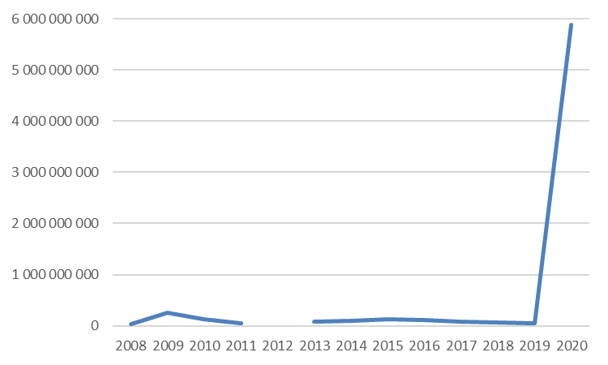

Sources: for 2008-2019, DGEFP – extract from Sinapse report of December 28, 2019 and ASP – extract from the Extranet of December 28, 2019, data not corrected for seasonal variations, mining by Dares; for 2020, ASP, Short-time Working Extranet, data at June 22, 2020; Unédic calculations

Field: France

Notes: For 2012, the data concerning authorized hours are not available. Q1-2013 and Q4-2019, also unavailable, have been estimated here by averages calculated for the available quarters for the years in question. The figure for Q1-2013 almost certainly underestimates the hours authorized, as for the most recent period, since 2010, there are always more authorizations for the first quarter of a year.

Short-time working is generally countercyclical

Short-time working hours are generally countercyclical (meaning that they increase when the economic conjuncture deteriorates, and decrease when the situation improves), with a lag in the order of two quarters (Graph 2, see also Calavrezo and Lodin, 2012)[28]. However, before the current health crisis, the link between use of short-time working and the economic conjuncture seemed to have diminished over time. Other factors can influence use of the scheme, such as various changes to the regulations or more widespread knowledge of the scheme among businesses, related to the significant increase in use of short-time working during the crisis in 2008-2009 (Nevoux *et al.*, 2017). For 2020, short-time working hours have seen a spectacular increase, due to the sudden halt of certain activities followed by an historic deterioration of the economy. Indeed, GDP in 2020 will suffer from a slowdown of the economy which is unprecedented in recent history, far greater than that seen during the financial crisis of 2008-2009. In its financial forecast of June 2020, Unédic estimated a drop in GDP of 11.2% for 2020 (Unédic, 2020d).

Graph 2: Short-time working authorized and consumed and GDP growth between 2008 and 2019

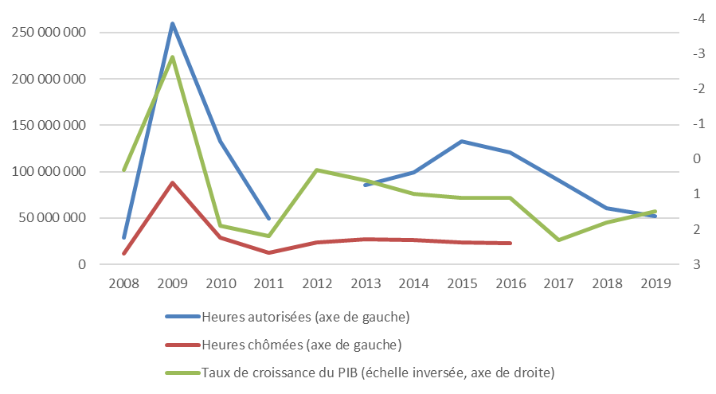

Sources: DGEFP – extract from Sinapse report of December 28, 2019, ASP – extract from the Extranet of December 28, 2019, raw data, mining by Dares; Unédic calculations; for the annual GDP growth rates (measured at previous year prices and chain-linked volumes), INSEE, national accounts - base 2014.

Field: France

Notes: For 2012, the data concerning authorized hours are not available. Q1-2013 and Q4-2019, also unavailable, have been estimated here by averages calculated for the available quarters for the years in question. The figure for Q1-2013 almost certainly underestimates the hours authorized, as for the most recent period, since 2010, there are always more authorizations for the first quarter of a year. The unworked hours are missing from Q1 2017 onwards for the whole economy, due to incomplete declarations in the automobile industry.

Places of business often make advance applications for short-time working hours well in excess of what they will actually use

Generally speaking, a place of business can only use short-time working if it has received prior permission from its regional authority for business, competition, consumption, labor and employment (DIRECCTE). In practice, it appears that they often make advance applications for short-time working hours well in excess of what they will actually use. Furthermore, the hours authorized and consumed do not necessarily evolve in an identical manner (Graph 2).

On average, for the period 1996-2005, short-time working for which compensation was actually paid represents a little less than 50% of authorized levels (Calavrezo, 2009). In 2008, a little over 40% of authorized hours were actually consumed. At the height of the economic recession of 2008-2009, in 2009, the short-time working hours consumed represented a little more than one third of the hours authorized. This rate of consumption then diminished overall to fall to 20% in 2016[29]. For 2020, it is too early to establish the rate of consumption for short-time working, given that businesses have one year in which to file their claims for compensation. However, in Annex 11, we present provisional rates of consumption (*i.e.* known at June 22), month by month from March through May 2020[30]. It appears here that for March 2020, 55% of the requested short-time working hours were consumed in the DIs filed up to June 22. The rate is 46% for April and 22% for May.

Almost two thirds of DAPs were made over three weeks of lockdown

The intensity of the DAPs is closely linked to the period of lockdown. Slightly less than two thirds of DAPs (64%) were made over three weeks of lockdown from March 23, to April 12 (Graph 3). The highest daily figure was nearly 80,000 DAPs in one day. At the end of the period analyzed in this paper, the number reduced significantly: since June 1, 2020, an average of about 2,300 DAPs have been filed per day. The cyclical shape of the curve is explained by lower levels being filed at the weekend.

Graph 3: Number of DAPs per date of filing in 2020

Source: ASP, Short-time Working Extranet, data at June 22, 2020, Unédic calculations

Field: DAPs filed from March 1, 2020; data restated for double counting and addenda, on whatever grounds, excluding private individual employers

Observation: to be exact, these are the dates for initial filing of the DAP

Five sectors account for nearly two thirds of the short-time working hours requested in DAPs and the numbers of employees in question

The short-time working hours requested in DAPs come mainly from businesses in science and technology, support and administrative services (18%; Table 1), sales and repairs of automobiles and motorcycles (17%), construction (12%), hotels, cafés and restaurants (11%) and manufacturing of other industrial products (9%). More than two thirds of the hours requested in DAPs belong to these five sectors (68%). On the other hand, the five sectors that cover the least number of short-time working hours requested in DAPs are coking and refining (close to 0% of the hours requested), agriculture, forestry and fishing (0.5%), the mining industry, power, water, waste management and environmental remediation (1%), real estate (1%), and the finance and insurance sectors (1.6%). The breakdown of employees concerned by DAPs by sector is extremely close to that which we have just presented as a function of requested short-time working hours (Table 1)[31].

Graph 4: Breakdown of authorized short-time working hours by major sector between 2008 and 2020 (%)

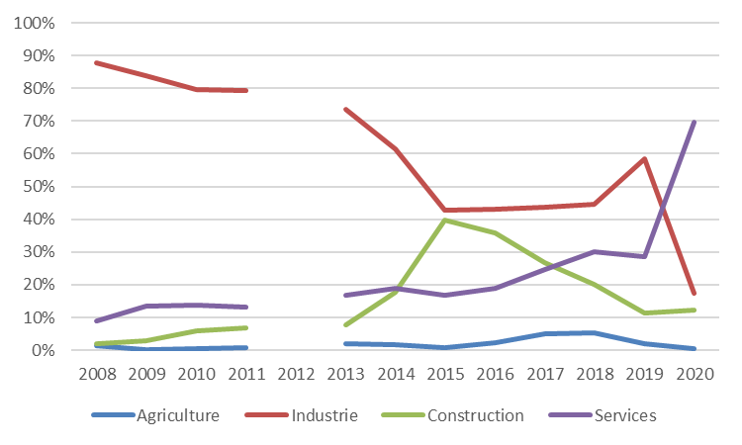

Sources: for 2008-2019, DGEFP – extract from Sinapse report of December 28, 2019 and ASP – extract from the Extranet of December 28, 2019, data not corrected for seasonal variations, mining by Dares; for 2020, ASP, Short-time Working Extranet, data at June 22, 2020; Unédic calculations

Field: France

Notes: For 2012, the data concerning hours authorized are not available. Q1-2013 and Q4-2019, also unavailable, have been estimated here based on averages calculated for the available quarters from the years in question.

During the Covid-19 crisis, the structure of use of short-time working has fundamentally changed: 18% of hours have been authorized in industry in 2020, compared to 84% in 2009

The breakdown by sector bears witness to the depth and uniformity of the shock created by the Covid-19 crisis, which has affected the entire French economy, thus modifying the structure of the way the scheme is used. Traditionally, it was industrial sites that most used the scheme. With the information known to date at June 22, 2020, industry concerns only 18% of the hours requested in DAPs in 2020 (Graph 4). This sector represented more than three quarters of the number of days authorized between 1995 and 2005 (Calavrezo and Lodin, 2012).

Table 1: Breakdown of requested short-time working hours and number of employees covered by a DAP by sector, size of place of business and size of company



Source: ASP, Short-time Working Extranet, data at June 22, 2020, Unédic calculations

Field: prior applications for permission (DAPs) starting from March 1, 2020, data restated for double counting and addenda, whatever the grounds, excluding private individual employers

For the ensuing period, industry remained predominant in the scheme, particularly during the peak of the economic crisis of 2008-2009: 84% of short-time working hours were authorized for industry in 2009 with two sectors representing 40% of total authorized hours in the economy (metalworking and manufacturing of metal products with the exception of machinery and equipment - 22% of authorized hours – and the automobile industry - 18% of authorized hours). Nevertheless, industry saw an unprecedented decrease for the period 2015 to 2018, in which it was close to 45% of authorized hours (Nevoux *et al.*, 2017). In 2019, the estimated percentage of authorized hours for industry is about 60%[32].

40% of requested short-time working hours concern small businesses

Since March 1, 2020, 40% of requested short-time working hours concern businesses with less than 20 employees (Table 1). A little over one half of the hours were requested by places of business with 20 to 499 employees. Lastly, those with 500 employees or more represented 9% of total hours requested by DAPs[33].

This breakdown was different before the health crisis, with small businesses being less significant. This result once again illustrates the specific nature of the current crisis.

Between 1995 and 2005, about 20% of short-time working days were authorized for businesses with less than 20 employees (Calavrezo and Lodin, 2012), while the majority of short-time working days were authorized for places of business with between 20 and 499 employees (60 to 70% of days authorized). Those with 500 employees or more accounted overall for about 20%.

In 2009, at the peak of the economic crisis, 11% of short-time working days were authorized for businesses with less than 20 employees, 62% for those with 20 to 499 employees and 27% for those with 500 employees or more[34].

If we consider the size of the company to which the business belongs, we can once again see that the smaller structures are more highly represented in DAPs made during the Covid-2019 crisis in relation to earlier periods. In fact, one third of DAP hours requested as of March 1, 2020 were done so by companies with less than 20 employees, 42% concern companies with 20 to 499 employees, and one quarter large companies with at least 500 employees. Before the Covid-2019 crisis, the proportion of companies with less than 20 employees was lower: 10 to 15% of the hours authorized from 2008 to 2013, and a little under one quarter from 2014 to 2019.

Almost 40% of requests for short-time working hours and numbers of employees concerned by DAPs are in the Greater Paris Region and Auvergne-Rhône-Alpes

The regions with the highest concentration of requested short-time working hours are the Greater Paris Region (25%) and Auvergne-Rhône-Alpes (12%), Occitanie, Hauts-de-France, Nouvelle-Aquitaine and Grand-Est (8% each; Map 1). The Greater Paris Region and Auvergne-Rhône-Alpes thus account between them for almost 40% of the hours requested. The breakdown by region is almost identical in terms of employee numbers (Annex 3).

Drilling down in terms of geographic level, the *Départements* having requested the most short-time working are Paris (8% of hours requested up to June 22; Annex 4), Nord (4%), Rhône (4%), Hauts-de-Seine (4%) and Bouches-du-Rhône (3%)[35].

Map 1: Breakdown of hours requested by DAP by region (%)

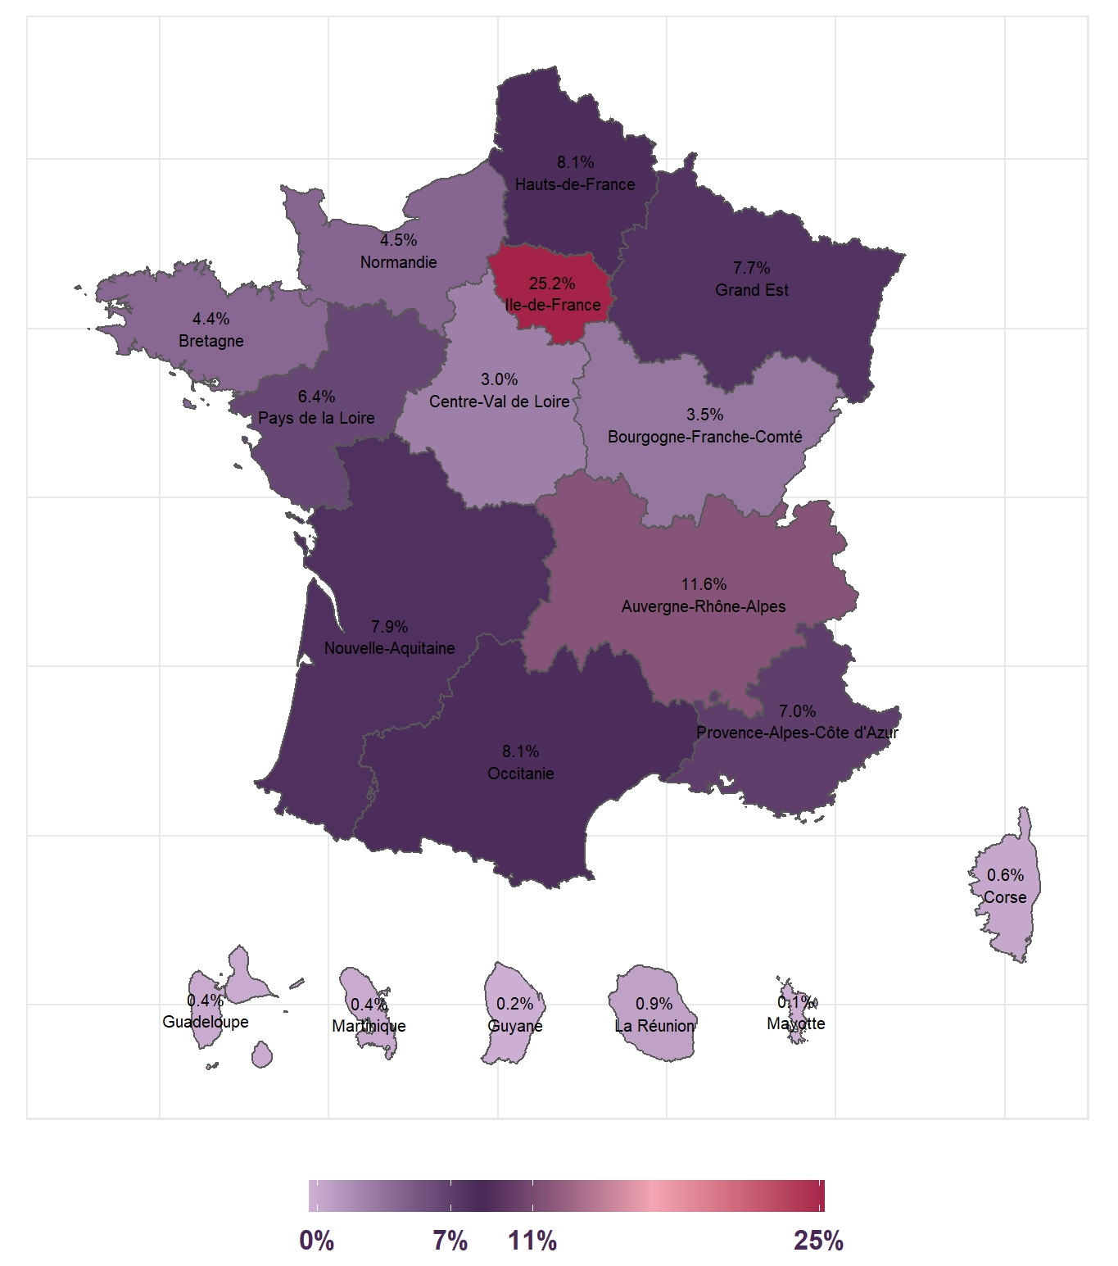

Source: ASP, Short-time Working Extranet, data at June 22, 2020, Unédic calculations

Field: prior applications for permission (DAPs) starting from March 1, 2020, data restated for double counting and addenda, whatever the grounds, excluding private individual employers, and the overseas local authorities of Saint-Barthélemy and Saint-Martin, French Polynesia, Saint-Pierre-et-Miquelon and Wallis-et-Futuna.

Graph 5: Short-time working hours requested by the DAPs, broken down by week for 2020 (estimate in millions of hours)

Source: ASP, Short-time Working Extranet, data at June 22, 2020, Unédic calculations

Field: prior applications for permission (DAPs) starting from March 1, 2020, ending at the latest on December 31, 2020, data restated for double counting and addenda, whatever the grounds, excluding private individual employers

Notes:

* A lesser number of DAPs extend beyond 2020. However, due to the low volumes for 2021, the graph focuses on 2020.
* The months highlighted in the graph contain the weeks for which employers must file their claim for compensation for that given month.

**It was during lockdown and until end June that the cover provided by short-time working was most used**

The hours requested by businesses in the DAPs are broken down by week as a function of the number of calendar days covered by the application (see Sub-section 3.2 for a description of the methodology used). It therefore appears that businesses requested the highest volume of short-time working hours for weeks 12 (March 16 – March 22) to 26 (June 22 – June 28), meaning from the start of lockdown to the end of June, with 235 to 315 million hours per week (Graph 5). On average over the period, roughly 300 million hours were requested by the places of business for each week[36].

As for the numbers of employees covered by the DAPs, there is maximum coverage over the same period (weeks 12 to 27; Annex 6). Therefore, for a week considered to belong to this period, the prior applications concern between 10 and 12.6 million employees, with the weeks in the month of May covering the most (approx. 12 million).

**The suspension of activity is the most frequently used form**

When making a DAP, the employer must include the envisaged method of implementation for short-time working, by providing two types of information. Firstly, they must stipulate the type of reduced activity they plan to put in place: it can either be reduced (for example, by reducing the activity by a few hours per day), or suspended, meaning a complete stoppage, closing down the place of business. Secondly, the employer indicates the proportion of the workforce concerned by the application for short-time working: it is either all or part of the headcount.

In 2020, 62% of the short-time working hours requested in the DAPs correspond to a suspension of activity, meaning temporary closure (Graph 6). This is the opposite of what was observed before the health crisis, when the most frequently used form of short-time working consisted of reducing employees’ working hours without completely stopping all activity. Over the period surrounding the economic crisis of 2008-2009, and more precisely between 2007 and 2010, this form concerned 94% of authorized short-time working days (Calavrezo and Lodin, 2012). Similarly, from 1995 to 2005, 91% of short-time working days corresponded to a reduction in working hours without closing the business[37].

A little over two thirds of short-time working hours have been requested for all employees in a given place of business in 2020 (68 %)[38]. This result is not at all a continuation of what had previously occurred for the period of the recession of 2008-2009: between 2007 and 2010, roughly half of the authorized days concerned all employees in a given place of business. For the period 1995-2005, only 17% of the authorized days concerned the full headcount (Calavrezo and Lodin, 2012). However, over more recent years, it seems that short-time working has mostly tended to cover the full headcount of the place of business: in 2015, 60% of approvals of short-time working leading to actual consumption applied to the full headcount (Nevoux *et al.*, 2017)[39].

**Graph 6: Breakdown of short-time working hours requested in DAPs in 2020, according to the envisaged type of reduction of activity (%)**

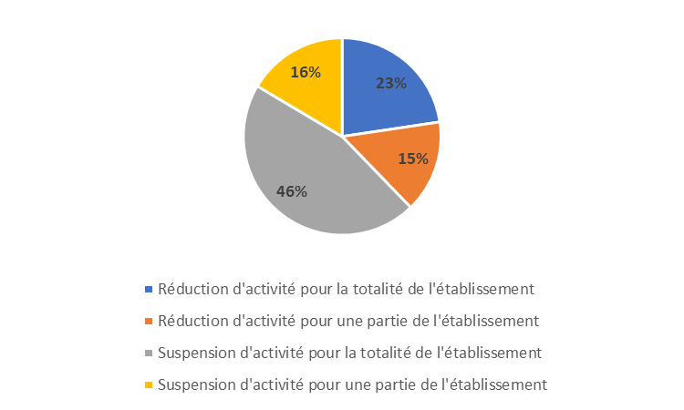

Source: ASP, Short-time Working Extranet, data at June 22, 2020, Unédic calculations

Field: data restated for double counting and addenda, whatever the grounds, excluding private individual employers

Note: 46% of short-time working hours requested in DAPs in 2020 consist of suspending activity for the full headcount.

**Very few DAPs refused by the administration**

At June 22, 96% of hours requested in 2020 had been approved by the administration. The 4% of short-time working hours not yet approved at that point correspond almost entirely to requests that were provisional, pending or under investigation. Almost no DAPs (close to 0%) had been refused by the administration: these concern just 7,300 employees of the 13.6 million covered by DAPs.

Since March 25, and up to December 31, 2020, the time allowed for express or tacit approval of prior applications has been reduced from 15 to 2 days. At June 22, 83% of hours are included in tacitly approved DAPs, meaning automatically after 48 hours. Even if the remaining 17% of hours requested had not been tacitly approved, their volume was nevertheless largely authorized. A total of 99% of the hours requested in DAPs had been authorized at June 22[40].

**Prior applications cover an average period of 15 weeks**

When making a DAP, the employer gives the start and end dates for the period covered by the application. On average, DAPs cover a period of 107 days, or 15.3 seven-day weeks. The statistic calculated here varies as a function of the business sector, the size of the place of business and the geographic location of the requesting party.

Overall, the figure increases slightly with the size of the business[41]. Those with less than 20 employees generally apply for an average 106 days, whereas those with between 500 and 999 employees apply for longer period (127 days on average).

The three sectors, by Naf17 code, with the longest requested periods are coking and refining (119 days), manufacturing of transport equipment (117 days) and hotels, cafés and restaurants (116 days). On the other hand, the three sectors to apply for permission for the shortest periods of short-time working are agriculture, forestry and fishing (94 days), other service activities (99 days) and construction (102 days).

The *Départements* with the longest requested periods of short-time working are Haute-Corse (146 days), Guadeloupe (136 days), Aveyron (135 days), Corse-du-Sud (125 days) and Meuse (122 days). The *Départements* with the shortest requested periods of short-time working are [Saint-Pierre-et-Miquelon](https://fr.wikipedia.org/wiki/Saint-Pierre-et-Miquelon) (57 days), Guyane (91 days), Ardèche (93 days), Savoie (93 days) and Hautes-Alpes (94 days).

**On average, employers request almost 440 short-time working hours per employee**

Up to June 22, an average 439 short-time hours per employee had been requested by DAP. If we express these hours per employee in complete weeks of short-time working, the figure corresponds to 12.5 weeks of 35 hours (see also Dares, 2020b)[42]. This statistic is complementary to that which we have just presented on the average duration of DAPs. The statistic presented in this part differs as a function of the size of the business and the sector, as well as the *Département*. Firstly, it decreases with size of the business: in those with less than 20 employees, employers request an average 469 hours of short-time working per employee (equivalent to 13.4 weeks of 35 hours), whereas those with 5,000 employees or more request an average 336 hours per employee (equivalent to 9.6 weeks of 35 hours)[43]. This result is related to the fact that smaller businesses have more often applied for short-time working as part of a full suspension of their activity: 72% of short-time working hours for businesses with less than 20 employees are requested as part of a suspension of activity, as opposed to 45% for those with 500 employees or more.

The three sectors (by Naf17 code) with the highest number of short-time working hours per employee are: hotels, cafés and restaurants (546 hours per employee, equivalent to 15.6 weeks of 35 hours), construction (499 short-time working hours per employee, equivalent to 14.3 weeks of 35 hours) and sales and repairs of automobiles and motorcycles(484 hours per employee, 13.8 weeks of 35 hours). On the other hand, the sectors in which employers request the least number of short-time working hours per employee are: education, healthcare and social work (an average 336 hours per employee, 9.6 weeks of 35 hours), other service  activities (362 hours per employee, 10.3 weeks of 35 hours), science and technology, and administrative and support services (382 hours per employee, 10.9 weeks of 35 hours).

The *Départements* with the highest numbers for short-time working hours per employee are: Aveyron (603 hours per employee, 17.2 weeks of 35 hours), Haute-Corse (590 hours per employee, 16.8 weeks of 35 hours) and Corse-du-Sud (551 hours per employee, 15.8 weeks of 35 hours). On the other hand, the *Départements* where employers request the least number of short-time working hours per employee are: Saint-Pierre-et-Miquelon (on average 208 hours per employee, 5.9 weeks of 35 hours), Savoie (340 hours per employee, 9.7 weeks of 35 hours) and Indre (349 hours per employee, 10.0 weeks of 35 hours).

**The probability of having made a DAP is higher for places of business belonging to companies with multiple sites, trading companies not located in the Greater Paris Region (Ile-de-France) and those that are less than 16 years old**

Here, we present an attempt to estimate the probability for an employer to have filed a DAP (see Annex 9). The results given below must nevertheless be viewed with some caution due to the difficulty of precisely identifying places of business that are eligible for short-time working and the many missing values on size of business (see Sub-section 3.2 for more details). These results are also valid for the sample used in this paper. The descriptive statistics that refer to the places of business according to whether or not they made a DAP are presented in Annex 8. For the sample used here, it is apparent that a little over half of private businesses eligible for short-time working have filed a DAP (nearly 54%).

The “all other things being equal” analysis very definitely confirms the descriptive statistics. The fact of belonging to a trading company or a company with multiple sites increases the probability of having filed a DAP. In fact, trading companies are overrepresented among those having filed DAPs: 79% of places of business with DAPs belong to trading companies, compared to 68% for places of business without DAPs (Annex 8). Similarly, companies with multiple places of business are overrepresented among those having filed DAPs, even if the gap is small: 29% of places of business having filed a DAP belong to companies with multiple places of business, as opposed to 26% for those without DAPs.

On the other hand, being located in the Greater Paris Region and the age of places of business reduces the propensity to having filed a DAP. 20% of places of business with DAPs are located in the Greater Paris Region versus 31% of businesses having not filed a DAP. This result is complementary to that for the breakdown of hours requested in the DAPs by region (see above): there, the Greater Paris Region represented the highest share of short-time working hours (one quarter of hours requested), in line with its significant working population. In terms of age, 25% of business having made prior applications are more than 16 years old, compared to 29% for businesses without a DAP.

As expected, the probability of having filed a DAP is also correlated to the business sector. Compared to the sales and repairs of automobiles and motorcycles sector (*i.e.* the benchmark for the “all other things being equal” analysis), belonging to certain sectors such as agriculture, forestry and fishing, science and technology, administrative and support services and finance and insurance diminishes the probability of having made a DAP, whereas doing business in other sectors such as hotels, cafés and restaurants, construction or the manufacturing of other industrial products increases the probability. These results confirm the descriptive statistics (Annex 8) and are also, in general, in the same vein as the results obtained in terms of the breakdown of the hours requested by DAP that showed the five sectors most using the scheme. The only exception concerns science and technology, administrative and support services that account for the highest share of the hours requested in the DAPs (18%, in line with their high headcounts) and which, at the same time diminishes the probability for a place of business filing a DAP. In fact, among the places of business without a DAP, the proportion belonging to this sector is higher than that for places of business not having filed a DAP (20 versus 14%).

Concerning the correlation between the size of the business and the propensity of having filed a DAP, we are not able to produce a clear result from this analysis. 89% of places of business having filed a DAP have less than 20 employees versus 51% for those with no DAP. However, we cannot conclude that there is an overrepresentation of smaller businesses among those that have filed a DAP, because of the extremely large number of missing values for the size of those without DAPs (46%).

Additional work has been carried out in order to test the robustness of the econometric results. The correlations presented above are broadly reflected in three alternative estimates, apart from those concerning the size of the places of business (see also Sub-section 3.2).

* 1. Short-time working claims for compensation

Here, we firstly present some general information regarding claims for compensation (DIs). We then focus on the month by month analysis of the links between DAPs and DIs. More than once, we examine the DAPs on a monthly basis for the purpose of verifying if the structure of the DAPs in general as a function of the sector or size of business (see previous Sub-section 4.1) is different from that of the DAPs covering the months March through May. The results of this part are based on observation of the data. In Sub-section 4.3, we provide estimates of the actual use of short-time working for the period March to May based on observation of the data and assumptions as to the behavior of the businesses that had not yet filed DIs.

Generally speaking, for any given month, once the employer has actually placed their employees on short-time working, they firstly draw up salary slips before completing the DI (see also Diagram 1). An employer makes one DI per month of use of short-time working, filling in the information for each individual employee on short-time working. In this study, we use data for DIs aggregated at the place of business, and not the individual level (see Sub-section 3.1).

At June 22, 2020, a little over 2.9 million short-time working DIs had been filed[44] by 1.2 million places of business[45], representing nearly 1 million companies. An employer may have made one DI for several months or even several Dis for the same month, although the latter is very marginal[46]. Therefore, at June 22, 11% of places of business concerned by the filing of a DI had filed only one, 29% had filed two, 58% three and 2% at least four.

Graph 7: Number of DIs filed by filing date and month of reference

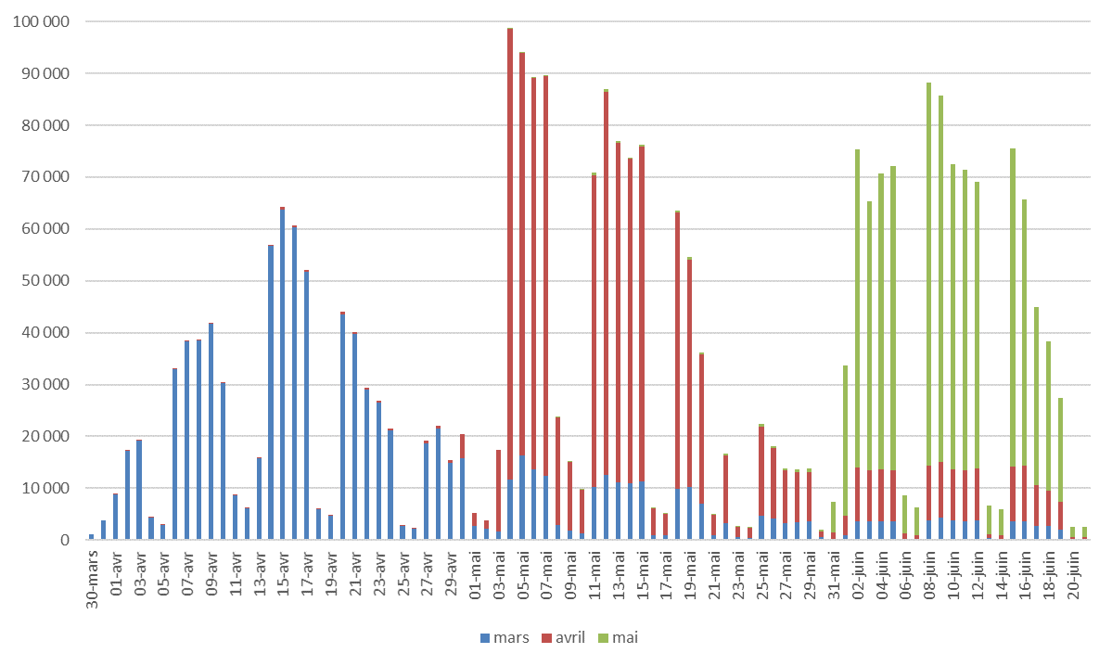

Source: ASP, Short-time Working Extranet, data as at June 22, 2020, Unédic calculations

Field: data restated for double counting and addenda, whatever the grounds, excluding private individual employers

Many claims for compensation (Dis) are filed around the cut-off date for the DSN declaration

Many DIs are filed around the 5th and 15th of the month, which corresponds to the cut-off dates for the French Nominal Social Security Declaration (DSN): 5th for employers with more than 50 employees and 15th for those with less (see Graph 7). Once the declaration has been done, the employer has the information needed to complete the DI.

Concerning the months of April and May, we observe many DIs filed at the very start of May and in June respectively: this could be linked to businesses becoming more accustomed to working with the scheme, enabling them to make their claims earlier in the month, just after paying the wages. This increase in the number of DIs also reflects higher use of the scheme in April and May.

Bigger businesses file their claims later than smaller ones

We now analyze the links between DAPs and DIs month by month for the period March through May 2020. As we are using short-time working data up to June 2, 2020, we focus mainly on the interpretation of the results for April (characterized by the highest use of the scheme) and March (the month for which we have the most data with which to study behavior in terms of DIs). May is nevertheless presented in the study as the results, albeit provisional, seem to us to be sufficiently robust to be included. In addition, the data used here do not allow for analysis beyond the month of May. To examine the transformation of DAPs into DIs, we take a by place of business approach (see Sub-section 3.2 for more details).

Employers have one year to file their DI. For March, which is the month with the most data, 91% of places of business with a DAP covering the month of March had filed a DI by June 22, (Table 2). We see that businesses tend to spread their claims for compensation over time: this is seen in the fact that at June 22, some of them are still making claims for compensation for short-time working in March (even if the volume is relatively low). The rate of transformation of DAPs into DIs is 85% for April and 67% for May[47].

The smaller businesses make more frequent claims than the bigger ones (see also Inset 5 for a presentation of the use of short-time working in large companies). This result is valid for the three months analyzed (Table 2). For March, 92% of places of business with less than 20 employees with a DAP covering the month filed one DI, compared to 74% for businesses with 500 employees or more. In addition, the larger places of business generally file their DIs later than the smaller ones, as witnessed by the shape of the curves describing the proportion of places of business with a DAP that filed a DI for the month of March, according to the date of filing of the DI (Graph 8)[48]. There are several possible reasons: firstly, the larger businesses have more cash, allowing them to wait longer for reimbursement by the ASP: secondly, they wait for the payroll software to be adapted and are able to automatically extract the information needed to compete their DIs. Also, the recent changes to the legislation now allow for joint filing by several places of business within the same company (see Decree **2020-794 of June 26, 2020 regarding short-time working).**

Filing of DIs also varies with the business sector. At June 22, it is apparent that the hotels, cafés and restaurant sector had filed the most DIs (for April, 94% of businesses in this sector having made a DAP covering the month had also filed a DI) and, on the contrary, coking and refining businesses had filed the least (42% for April; Table 2).

Table 2: Proportion of places of business among those having made a DAP, by sector and size of business (%)

Source: ASP, Short-time Working Extranet, data at June 22, 2020, Unédic calculations

Field: data restated for double counting and addenda, whatever the grounds, excluding private individual employers

Graph 8: Proportion of places of business having made a DAP that filed a DI for the month of March, according to the date of filing of the DI and size of business (%)

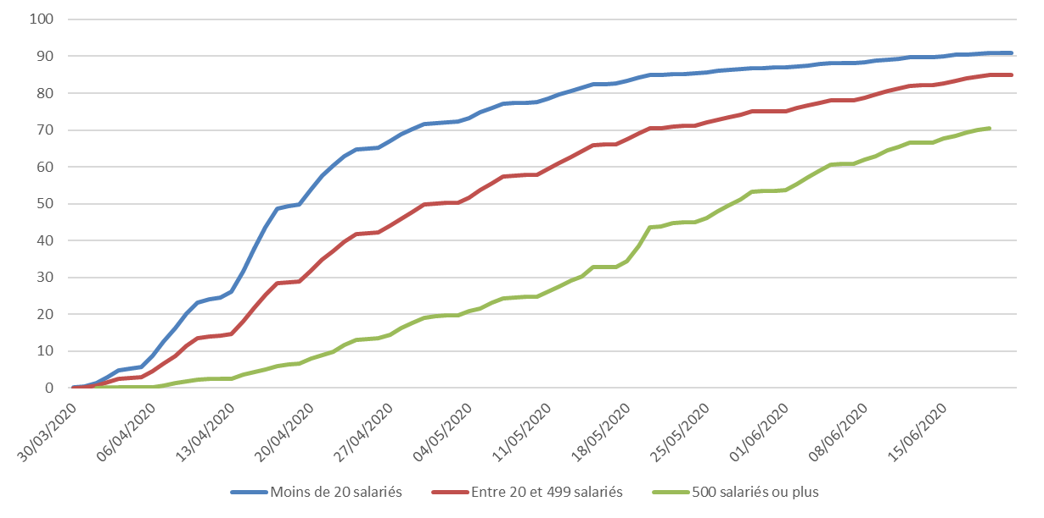

Source: ASP, Short-time Working Extranet, data at June 22, 2020, Unédic calculations

Field: data restated for double counting and addenda, whatever the grounds, excluding private individual employers

Note: at June 22, the proportion of places of business having made a DAP that filed a DI for the month of March is slightly lower than in Table 2 because of the missing values for the date of filing of the DI (1% of DIs with missing values; the DIs with no date of filing are generally provisional/pending completion).

|  |
| --- |
| **Inset 5: Short-time working and large companies**  A large company is defined as a company with at least 5,000 employees. However, a company with less than 5,000 employees but revenue of more than €1.5 billion and a balance sheet worth more than €2 billion, is also considered to be a large company. This is one of the four categories of company defined by the law (Article 51 of the French Law on the modernization of the economy) for the purpose of statistical and economic analysis by INSEE.  In 2015, in France, 287 large companies employed 3.9 million people (Full-Time Equivalent), or 29% of the total (INSEE, 2018).  At June 22, 2020, roughly 200 companies with more than 5,000 employees, corresponding to approximately 18,200 places of business, had filed a prior application for short-time working covering a total of 1.4 million employees and 500 million hours.  On average, these large companies file their claims for compensation later. For the month of March, about 85% of large companies having made DAPs for that month had filed at least one DI. This figure is equal to 64% for the month of April and just 21% for the month of May. The DIs of large companies represent respectively 36%, 21% and 4% of the total hours requested to June 22, for the months of March, April and May. The large companies had sometimes only filed DIs for some of their places of business. For March, the month with the most data, a little less than half of them had filed a DI for all their places of business. |

On average, one place of business has put a little less than 10 employees on short-time working each month

At June 22, the DIs for the month of April concern an average of 9 employees and slightly less than 1,200 short-time working hours by place of business (Graph 9). The average number of employees put on short-time working by a place of business for one month is relatively stable from March through May (about 9 employees in March and April, and roughly 8 in May). However, the figure is slightly higher for March and April, probably due to more data being available for the DIs, and especially the DIs of larger businesses.

Concerning the average number of unworked hours by place of business, it varies month by month depending on the number of weeks in the month of the health crisis (2 weeks of lockdown in March, 5 for April and 1 in May along with 3 weeks of gradual easing of the lockdown).

Graph 9: Average number of short-time working hours and employees by place of business

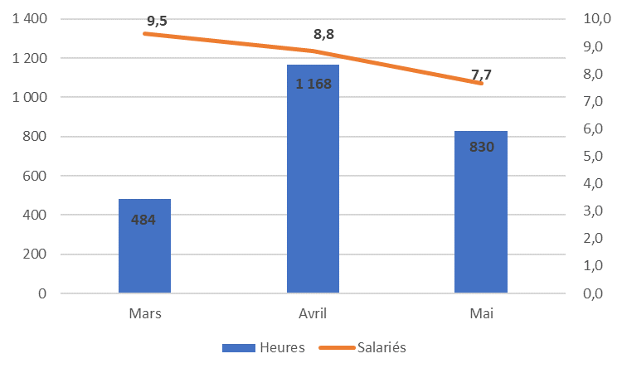

Source: ASP, Short-time Working Extranet, data at June 22, 2020, Unédic calculations

Field: data restated for double counting and addenda, whatever the grounds, excluding private individual employers

**Graph 10: Proportion of employees covered by a DI in the headcount of employees in the private sector, by sector (%)**

Sources: ASP, Short-time Working Extranet, data at June 22, 2020, Acoss for headcount numbers in the private sector Q1-2020 (except for agriculture: private sector headcount numbers, estimates Q1-2020, INSEE, Dares, Acoss); Unédic calculations

Field: short-time working data restated for double counting and addenda, whatever the grounds, excluding private individual employers (sector TZ) and extraterritorial businesses (sector UZ)

**Graph 11: Proportion of employees covered by a DAP in the headcount of employees in the private sector, by sector (%)**

**In April, a little less than 40% of private sector employees were covered by short-time working DIs**

Here, we estimate the influence of the short-time working scheme on the French economy in terms of employees. In April, at the height of the health crisis, 38% of private sector employees were covered by DIs (Graph 10) and 67% by DAPs (Graph 11). We also estimate that, in April, the short-time working hours for which employers had claimed compensation at June 22, represented about 20% of the hours worked by employees in the economy, whereas the hours requested in DAPs represent about 45% of hours worked[49].

In April, the sectors in which employees were most concerned by short-time working were: hotels, cafés and restaurants (82% of employees in this sector were concerned by DIs and 99% by DAPs), other service activities (66% of employees in this sector were concerned by DIs and 90% by DAPs) and construction (65% of employees in this sector were concerned by DIs and 93% by DAPs).

A very short time lapse between the filing of DIs and reimbursement of the employer by the ASP

The vast majority of compensation for the month of March was paid within less than one week after the filing of the DI: for March and April, over 80% of DIs were paid by the ASP within 6 days of the employer filing them (Graph 12). For the months of March and April, for which we have more data, a minority of DIs (less than 1%) were paid more than 2 weeks after filing.

Graph 12: Time lapse between the filing of DIs and payment of compensation (in days)

Source: ASP, Short-time Working Extranet, data at June 22, 2020, Unédic calculations

Field: data restated for double counting and addenda, whatever the grounds, excluding private individual employers

Note: the statistics for lapses of 1 day or greater than 15 days have not been presented in this graph due to the low employee numbers.

For April, at the height of the health crisis, claims for compensation concerned 7.1 million employees for 700 million unworked hours

For the month of April, almost 1.3 million places of business filed DAPs (Table 2) covering 12.3 million employees (Annex 10) and a little more than 1.5 billion short-time working hours (see Table 3). 82% of these hours requested in DAPs for the month of April concerned places of business that had filed a DI at June 22, equivalent to about 1.3 billion short-time working hours (Table 3). 76% of the employees covered by DAPs concerning the month of April correspond to businesses that have filed a DI (Annex 10). The claims for compensation for the month of April (as known at June 22) covered 7.1 million employees (Annex 8) and 700 million short-time working hours (Table 3).

The month of April therefore stands out as the highest in terms of use of the short-time working scheme: the numbers of hours and employees covered by DAPs and DIs for March and May were lower than in April. For March, nearly 1.1 million places of business filed DAPs for 10.8 million employees and just over 530 million short-time working hours. The DIs for March concerned 6.3 million employees and just under 295 million short-time working hours.

As for the month of May, a little over 1.2 million places of business filed DAPs for 12.3 million employees and approximately 1.2 billion hours (4 weeks, including one of actual lockdown and 3 of gradual easing)[50]. DIs for May, as known at June 22, covered 4.4 million employees and 270 million hours of short-time working.

**In April, the average short-time working hours for an employee was 99 hours in the month**

With the information available at June 22, the average short-time working hours for an employee was 99 hours in a month of April that included 5 weeks of lockdown (Table 4), equivalent to 2.8 weeks of 35 hours. In March, average short-time working for an employee was 46 hours for two weeks of lockdown, whereas for May the figure was higher (61 unworked hours per employee) for 1 week of lockdown and 3 of gradual easing. Before the current health crisis, the average monthly reduction of employees put on short-time working was lower[51]. Over the period 2007-2010, an employee on short-time working for a given month had an average 30-hour reduction in working time (Calavrezo and Lodin, 2012), whereas in 2015 employees on short-time working saw an average decrease in time worked of 32 hours per month (Nevoux *et al.*, 2017).

In April, DAPs concerned an average of 123 hours per employee, or 3.5 weeks of 35 hours (to be compared to the 5 weeks for which employees could have effectively been on short-time working in April according to the DIs). You will recall that in Sub-section 4.1 of this study, we showed that, altogether, the DAPs made in 2020 concern almost 440 hours per employee.

In April, employees with the most significant reduction in working hours over the month due to short-time working worked in the sectors hotels, cafés and restaurants (124 unworked hours per employee), real estate (113 hours per employee) and sales and repairs of automobiles and motorcycles (110 hours per employee). On the contrary, employees working in the following three sectors saw the lowest reductions in working hours for the month of April, in line with the information contained in the DIs: coking and refining (65 hours per employee), education, healthcare and social work (77 hours per employee) and manufacturing of electrical, electronic and computer equipment and manufacturing of machinery (80 hours per employee).

The average reduction in hours worked over the month decreases with the size of the place of business: in April, employees in businesses with less than 20 employees saw an average reduction in hours worked of 110, compared to 85 hours for employees working for businesses with 500 employees or more.

**As for the DAPs in general, the same five sectors stand out in terms of use of the scheme for the months of March through May**

For April, the sectors with the highest number of short-time working hours requested in the DAPs for the month are sales and repairs of automobiles and motorcycles (18.4%; Table 3), science and technology, administrative and support services (16.8%), construction (13.9%), hotels, cafés and restaurants (10.4%) and manufacturing of other industrial products (8.8 %). On the contrary, the sectors with the least number of requested hours in the DAPs for April are coking and refining (almost 0.0%), agriculture, forestry and fishing (0.5%) and the mining industry, power and water, and waste management and environmental remediation (1.0%). Overall, we find the same sectors as those identified for the breakdown of hours requested in the DAPs as a whole (see Table 1). You will recall that this analysis was carried out for the purpose of verifying whether the structure of the DAPs in general is repeated in the DAPs covering the period March through May. Furthermore, the breakdown by sector of the hours requested by the DAPs concerning the month of April is the same as that for March and May (Table 3).

Concerning the short-time working hours actually consumed by businesses in April 2020 in terms of the DIs filed up to June 22, we find exactly the same sectors making the most or least use of the scheme. Nevertheless, the order is slightly different for the sectors most using short-time working in April as businesses in the hotels, cafés and restaurants sector are in second position with nearly 16% of hours subject to compensation for the month, compared to 10% for the hours requested in the DAPs covering the month of April (see above). In total, the 5 sectors most using the scheme account in April for a little over 70% of short-time working hours actually receiving compensation. The results for hours compensated for corresponding to April are broadly the same as those for March and May. However, for May, we once again find the sectors most using the scheme, but in a different order with a much higher share for hotels, cafés and restaurants (over 25% of short-time working hours in the DIs for the month of May), which takes first place for this month.

Overall, the results by sector in terms of short-time working hours are very similar when examining the numbers of employees concerned by the scheme (Annex 10).

**Places of business with less than 20 employees cover the majority of hours and employees subject to compensation for March through May**

The breakdown of hours requested in the DAPs for the months of March through May by size of place of business is close to that for the DAPs as a whole (Tables 1 and 3). For April, 44% of the short-time working hours in the DAPs covering that month were requested by businesses with less than 20 employees, 48% by businesses with between 20 and 499 employees and the remaining 8% by those with 500 employees or more. This breakdown is also found for the months of March and May.

When examining the breakdown of short-time working hours actually consumed according to the DIs, the situation is different. Small businesses with less than 20 employees constitute the majority of hours receiving compensation. For April, 54% of the hours consumed at June 22, are attributed to businesses with less than 20 employees, 41% to those with between 20 and 499 employees and 5% to those with 500 employees or more. The majority of hours subject to compensation for the months of March and May also concern smaller businesses.

In addition, the results of this month by month analysis as a function of the size of place of business are similar when considering the employees concerned by short-time working (Annex 10).

**The average cost of one hour of short-time working is approximately €10**

At June 22, the cost of the compensation claimed by employers for the month of April stood at €7.2 billion for the State and Unédic (excluding private individual employers), of which roughly €2.4 billion for Unédic (Table 5). For March and May, the cost of compensation claimed is lower: about €2.9 billion for March (of which €980 million for Unédic) and nearly €2.8 billion for May (of which €930 million for Unédic).

The average hourly cost is €10[52], slightly higher for the months of April and May (Table 5). The cost of an hour of short-time working varies as a function of the business sector and the size of the place of business using the scheme. In line with the average wages, the sectors with the highest average hourly cost for April are coking and refining (€15.5), information and communication (€13.8) and finance and insurance (€12.7). On the contrary, the sectors with the lowest hourly costs are manufacturing of foodstuffs, drink and tobacco-based products (€8.8), hotels, cafés and restaurants (€9.2) and other service activities (€9.6).

Furthermore, the hourly cost of short-time working increases with the size of the place of business using the scheme. For April, the average hourly cost was €9.9 for businesses with less than 20 employees, compared to €12.2 for those with at least 500 employees[53].

Table 3: Breakdown of short-time working hours contained in the DAPs and DIs by sector and size of place of business for the period March through May (%)

Table 4: Average short-time working hours per employee as a function of the sector and size of place of business (hours)

Table 5: Amount of compensation claimed in the DIs and hourly cost by sector and size of place of business

**In April 2020, businesses having filed DIs had placed on short-time working three quarters of the employees covered by their DAPs**

The actual rate of consumption of short-time working in relation to the expectations of employers can be understood in a number of ways. The first way of examining consumption would be to compare the hours and number of employees concerned by actual use of the scheme as measured through the DIs filed by employers with the hours and number of employees covered by the DAPs (*rate of consumption 1*). This indicator, often highlighted in the literature on short-time working in France, confuses the fact that not all places of business file DIs with the same level of consumption of short-time working as for places of business that actually use the scheme. This indicator is presented in Annex 11. In terms of employees concerned by the scheme, 59% of those covered by the DAPs for the month of March had actually been placed on short-time working at June 22, 58% for the month of April and 36% for May. Concerning this indicator, the lower figure for the month of May is explained by the combination of two effects: firstly, there is less data available for the DIs and, secondly, in line with the easing of the lockdown in May, businesses would be expected to make less use of the scheme. It is interesting to note that the rates of consumption thus defined are higher in terms of *employees* compared to the rates of consumption for short-time working *hours*. This suggests that the employers’ expectations in terms of *employees* on short-time working are closer to what actually happens than those concerning short-time working *hours*.

The second way of approaching the calculation of the rate of consumption would be to determine an indicator in terms of short-time working hours and employees concerned by the scheme by comparing the DIs with the DAPs, but this time only within the subset of places of business that use the scheme, meaning limiting it to those that actually file a DI (*rate of consumption 2*). These rates of consumption calculated for cross-matched data for the business sector (Naf17) and the size of business (in 3 classes: less than 20 employees, 20 to 499 employees and 500 employees or more) are used in Sub-section 4.3 to estimate the actual use of short-time working for the period March through May, as well as the cost of the scheme.

The values *rate of consumption 2* are structurally greater than those for *rate of consumption 1* (see Table 6 and Annex 11). For the month of April, businesses having filed a DI at June 22, had consumed an average 56% of the short-time working hours requested in their DAPs and had placed 75% of the employees covered by the DAPs for the month of April on short-time working. As indicated for the *rate of consumption 1*, the values of *rate of consumption 2* in terms of employees are higher than those related to short-time working hours, thus reflecting better planning by the employers that filed their DIs, in terms of employee numbers. The values depend on the sector and size of the place of business.

**Table 6: Rate of consumption of short-time working in terms of hours and employees for places of business having filed a DI by sector and size of place of business – *rate of consumption 2* (%)**

* 1. Estimates of the final cost of the scheme and numbers of employee actually placed on short-time working

Here, we estimate the total cost of the scheme and the numbers of employees actually placed on short-time working for the period March through May 2020. The cost of compensation at June 22, for the months of March through May presented in Sub-section 4.2 are not final because the employers have one year to file their claims for compensation. Our estimates are based on two principal assumptions (see also Sub-section 3.2 for more details): firstly, we assume that all businesses having made a DAP will eventually file a DI and, secondly, we consider that the behavior of those places of business having not yet filed a DI will be the same as that of those already having done so in terms of consumption of short-time working hours, employees actually placed on short-time working (*rate of consumption 2* see Sub-section 4.2) and the hourly cost of the scheme. We cross-matched data for the business sector (Naf17) and the size of business (in 3 classes: less than 20 employees, 20 to 499 employees and 500 employees or more).

We estimate that the final figure will be 7.2 million employees concerned by short-time working for the month of March, for a total amount of compensation of almost €3.3 billion, of which €1.1 billion for Unédic (excluding private individual employers[54], see Table 7 for details of actual numbers of employees placed on short-time working and the monthly and per sector costs). The estimated 7.2 million employees includes people who had been placed on short-time working for at least one hour during the month of March and, in line with the start of the lockdown in France, over the last two weeks of March. In Full-Time Equivalents over the month, we estimate that 2.3 million employees were placed on short-time working.

With the information available at June 22, we estimate that almost 9.1 million employees could actually be concerned for the month of April, for a total cost of around €8.8 billion, of which €2.9 billion for Unédic (excluding private individual employers). In Full-Time Equivalents over the month, we estimate that 4.8 million employees were placed on short-time working in April.

For May, we estimate that nearly 8.2 million employees could actually be concerned, for a total cost of about €4.9 billion, of which €1.6 billion for Unédic (excluding private individual employers). For the estimates for May, we make the same assumptions as previously. In view of the lockdown as of May 11, the assumption that all places of business having made a DAP will actually file a DI is quite robust. However, even with this assumption, our estimates are quite close to those made by Dares using a different methodology (7.9 million actual individuals and 3 million FTEs for the July 20, estimates by Dares). Generally speaking, the estimates presented for the months of March through May are very close to those produced by Dares.

Funding of the short-time working scheme has a major impact on the unemployment benefits system as it causes both a rapid rise in disbursements under the system and a considerable shortfall in contributions. Compensation for short-time working is not subject to unemployment or general social security contributions. On the basis of the estimated costs up to June 22, we believe that the total shortfall in terms of contributions for Unédic will be €270 million for March, €720 million for April and €410 million for May (excluding private individual employers).

With the information available at June 22, 2020, we estimate that the overall cost of short-time working for the period March through May will be close to €18.4 billion, of which nearly €7.1 billion for Unédic (the sum of direct costs being €17 billion, of which one third for Unédic, added to which are the indirect costs related to the shortfall in contributions of about €1.4 billion).

In its financial forecast of June 2020, Unédic estimates that the total cost of short-time working in 2020 will be approximately €30 billion (Unédic, 2020d). By way of comparison, the cost of the scheme over recent years has been €100 million and, at the height of the crisis of 2008-2009, in 2009, it was close to €360 million (Annex 12).

**Table 7: Estimates of the number of employees placed on short-time working and the cost of the scheme from March through May, by sector**

**Conclusion**

In France, the short-time working scheme has been one of the principal responses to the Covid-19 crisis in order to safeguard jobs, making the country one of the most frequent users of this approach in Europe. As a temporary solution, which is generally countercyclical, short-time working enables businesses to adjust the number of hours worked to fit with fluctuating levels of activity, while seeking to avoid actual lay-offs.

In this paper, we analyze employers’ use of this solution during the period of lockdown, based on exhaustive administrative data up to June 22, 2020. One of the key aspects of our study is the comparison between current short-time working practices and those prevailing prior to the health crisis, including during the economic recession of 2008-2009.

To make use of short-time working, the employer must apply for prior permission (DAP) from their regional DIRECCTE. The DAP reflects the employer’s expectation of using the scheme, with businesses often making advance applications for a number of short-time working hours well in excess of what they will actually use. In **Sub-section 4.1**, we describe the approach taken by employers, as a whole, to the prior application.

Between March 1, and June 22, 2020, a little over 1.4 million short-time working DAPs were filed by nearly 1.3 million places of business, representing a little over one million companies. At June 22, the DAPs covered a total of almost 6 billion requested short-time working hours and approximately 13.6 million employees. So, on average, an employer requests nearly 440 short-time working hours per employee. The Covid-19 crisis stands out as an unprecedented crisis with exceptionally high use of short-time working: with the information available at June 22, it is clear that employers had requested about 23 time more short-time working hours in 2020 compared to 2009. Nearly two thirds of the DAPs were made over the three-week period between March 23, and April 12. Furthermore, it is during the lockdown and until the end of June that there was the greatest coverage by short-time working: on average over the period about 300 million short-time working hours were requested by businesses for each week. The prior applications for permission covered an average period of 15 weeks.

During the Covid-19 crisis, the structure of the use of short-time working fundamentally changed in comparison to the past. Five sectors have so far accounted for almost two thirds of the short-time working hours and employee numbers requested by DAPs in 2020: science and technology, administrative and support services, sales and repairs of automobiles and motorcycles, construction, hotels, cafés and restaurants, and manufacturing of other industrial products. Industry had traditionally been the main user of short-time working: in 2009, 84% of the total hours were approved for industry, compared to 18% in 2020. In terms of size of place of business, in 2020, 40% of requested short-time working hours concern smaller businesses of less than 20 employees. The numbers for these smaller businesses were much lower before the health crisis. The requested short-time working hours are concentrated in certain regions: almost 40% of short-time working hours and employee numbers covered by DAPs correspond to the Greater Paris and Auvergne-Rhône-Alpes Regions.

In Sub-section 4.1, we also present an attempt at estimating the probability for an employer of having filed a DAP. The probability is higher for companies with multiple places of business and trading companies not located in the Greater Paris Region, and that are less than 16 years old. As expected, the propensity of having filed a DAP also correlates to the sector of activity.

Once the employer has obtained prior authorization for compensation under the short-time working scheme, they may make monthly claims for the reimbursement of the wages paid to the employees in question, which is also known as a claim for compensation (or DI in French). They have one year to file the DI. In **Sub-section 4.2**, we present the behavior as observed through the data in terms of claims for compensation and the transformation of prior applications (DAPs) into actual claims for compensation (DIs), month by month for the period March through May. In April, at the height of the health crisis, 38% of private sector employees were concerned by DIs and 67% by DAPs. Still in April, businesses having filed DIs had actually placed on short-time working three quarters of the employees for whom they had made DAPs. DIs are filed in greater numbers on or around the 5th and 15th of the month, corresponding to the cut-off dates for the French Nominal Social Security Declaration (DSN). We also observed that the larger places of business tend to file their DIs later than the small ones. On average, a place of business has put slightly less than 10 employees on short-time working each month.

The vast majority of compensation for the months of March through May was paid within one week after the filing of the DI: for April, over 80% of DIs were paid by the French services and payment agency (ASP) within 6 days of the employer filing the DI.

The claims for compensation covered 7.1 million employees for 700 million unworked hours in April. And, in the same month, an employee had been put on an average 99 hours of short-time working. The average cost of one hour of short-time working is approximately €10: this depends on the sector of activity and the size of the place of business using the scheme.

As for the DAPs as a whole, the same five sectors stand out in terms of use of the scheme for the months of March through May and, as a result, those with less than 20 employees account for the majority of the hours and employees receiving compensation.

As employers have one year to file their claims for compensation, we estimate, in **Sub-section 4.3**, based on information observed through the data and using assumptions, what the final cost of the scheme will be and the actual numbers of employees to have been placed on short-time working for the months of March through May. With the information available at June 22, we estimate that almost 9.1 million employees may in the end have been concerned for the month of April, for a total cost of about €8.8 billion, of which €2.9 billion for Unédic (excluding private individual employers). In Full-Time Equivalents (FTEs) for the month, we estimate that 4.8 million employees were put on short-time working in April.

Funding of the short-time working scheme has a major impact on the unemployment benefits system as it causes both a rapid rise in disbursements under the system and a considerable shortfall in contributions. Compensation for short-time working is not subject to unemployment or general social security contributions. On the basis of the estimated costs up to June 22, we estimate that the total shortfall in terms of contributions for Unédic is €720 million for April.

The analyses conducted in this study are mainly descriptive. In reality, in view of the recent nature of the data and events being examined, it is far too early to envisage an analysis of the effectiveness of short-time working in terms of employment/unemployment trends, adjustments of the labor force or the survival of businesses. Several further steps are envisaged for this research. Firstly, we plan to more closely examine the determining factors underlying the probability of having filed a DAP and undertake an analysis in terms of the factors that explain the propensity of having filed a claim for compensation. Secondly, based on the individual compensation data currently being examined, we plan to analyze the short-time working patterns of employees covered by the scheme. Thirdly, we will attempt to analyze the relationship between short-time working and training, based on administrative data. Fourthly and finally, over the longer term, we plan to examine the role of this scheme in labor management, and its effectiveness.

**Annex 1: Changes in the number of short-time working days authorized between 1995 and 2010 (millions)**

Notes: for the period before 2006, files produced by the departmental agencies for labor, employment and vocational training (DDTEFP) in collaboration with Dares, provided information on short-time working authorizations. For this reason, we cannot illustrate the actual consumption of long-term short-time working.

In 2006, the procedure for gathering data on short-time working was modified, and this affected the reliability of the data; it was therefore not possible to use them for the year 2006. Over the period 1995-2001, the administrative data indicate the number of days of short-time working authorized and, for the period 2002-2005, the number of hours of short-time working authorized. For the period 2002-2005, the number of days of short-time working authorized per place of business is arrived at by multiplying the number of hours authorized by 5 and then dividing by the working hours practiced by the place of business (35 or 39 hours). The number of short-time working days authorized by place of business is also calculated for the period 2007-2010 based on authorized short-time working hours.

Field: Mainland France.

Sources: DDTEFP, Dares for the period 1995-2005 and DGEFP (Sinapse) for the period 2007-2010; calculations Calavrezo and Lodin (2012).

Annex 2: Breakdown of short-time working hours consumed by major sector (%)

Sources: DGEFP – extract from Sinapse report of December 28, 2019, ASP – extract from the Extranet of December 28, 2019, raw data, mining by Dares; Unédic calculations

Field: France

Note: Due to incomplete declarations in the automobile sector, the hours of short-time working consumed in this sector, in industry and in the total economy have been missing since Q1 2017 in the data produced by Dares.

**Annex 8: Characteristics of places of business according to whether they have, or have not, filed a DAP (%)**

**Annex 9: Probability for a place of business having made a prior application for permission (DAP)**

Source: ASP, Short-time Working Extranet, data at June 22, 2020, SIRENE register at April 1, 2020, INSEE; Unédic calculations; short-time working data restated for double counting and addenda, whatever the grounds

Field: active, private sector businesses with salaried employees, excluding private individual employers eligible for short-time working; France

Note: here we present the factors and the materiality thresholds (*10%, ***1%) for a probit model estimate

**Annex 12: State and Unédic expenditure on short-time working (€ millions)**

* From May to December 2009.

Observation: between 2007 and 2014, expenditure by the State and Unédic corresponds to the payments made during the years in question (disbursements). They may include, in part, expenditure corresponding to previous years. For 2015, State and Unédic expenditure corresponds to the amounts actually consumed for 2015. For 2016 to 2017, these are Unédic statistical estimates based on accounting data. For 2020, these are Unédic forecasts.

Field: the whole of France.

Sources: for 2007 to 2010, *Dares analyses 2012 and 2014* (India and Unédic financial reports; Dares calculations), for 2011 to 2014, *Dares analyses 2016* (Chorus, Unédic financial report 2011 and ASP for 2012 to 2014; Dares calculations), for 2015, *Dares analyses 2017* (Sinapse and ASP; Dares calculations), for 2016 to 2019, Unédic calculations based on Unédic accounting data and, for 2020, these are Unédic calculations produced as part of its financial forecast of June 2020.

1. See Inset 1 for a brief overview of the use of short-time working in Europe.
2. This section is based partly on the summary report on unemployment insurance at July 10, 2020 (Unédic, 2020b). The short-time working regulations described here were in force at end July.
3. The State/Unédic agreement on short-time working is currently being amended.
4. Cases where used: economic conjuncture, difficulties with supplies or raw materials or energy, accidents, exceptional meteorological events, transformation, restructuring or modernization of the business, or any other exceptional circumstances such as the Covid-19 epidemic.
5. The employer may choose to pay, at its own cost, complementary compensation, up to the full salary of the employee.
6. Orders 2020-346 of March 27, 2020, 2020-428 of April 15, 2020 and 2020-460 of April 22, 2020 and implementing Decrees 2020-425 of April 16, 2020 and 2020-522 of May 5, 2020.
7. Order 2020-346 of March 27, 2020, Art. 1 a.
8. Amending Finance Law 2020-473 of April 25, 2020 for 2020 (Art. 20). Decree 2020-1098 of August 29, 2020 stating August 31, 2020, with the exception of regions in which a state of emergency due to the health crisis has been declared, as the end date for placing on short-time working hours employees sharing the home of a vulnerable person. The most vulnerable employees may continue to be placed on short-time working by medical prescription.
9. Decree 2020-810 temporarily amending the hourly rate for short-time working compensation.
10. Law 2020-734 of June 17, 2020 concerning “miscellaneous provisions related to the health crisis, other emergency measures, and the withdrawal of the United Kingdom from the European Union”, Art. 53; Decree 2020-926 of July 28, 2020 regarding the specific short-time working scheme applicable to long-term reductions in levels of activity.
11. Order 2020-346 of March 27, 2020 announcing emergency measures in terms of short-time working. Decree 2020-1059 of August 14, set August 31, 2020 as the end date for the exceptional short-time working scheme for domestic employees and childcare workers.
12. The press release of April 29, indicated a cost of €76 million for the month of March; this figure was revised upwards to €85 million in the central social security body (ACOSS) bill to Unédic on July 6.
13. Parents of children under 16 or of a disabled person, whose employer has closed or is required to shield, or subject to eviction or confined to home.
14. The hysteretic effect of unemployment expresses the idea that structural unemployment is not independent from the actual unemployment rate. This is particularly true where major and prolonged unemployment contributes to increasing the structural rate of unemployment, for example due to the loss of employability that the long-term unemployed can suffer.
15. The French Labor Ministry has announced 50,000 inspections for the end of summer 2020.
16. Even if a job is viable for the long-term, short-time working can lead to an excessive reduction in the number of hours worked (compared to the ideal situation) when the temporary difficulties faced by a business continue for some time. In this case, it can be preferable for the employee to look for a job in a company with healthier finances and for the company in difficulty to hire back an employee once those difficulties have been overcome.
17. In addition, when redundancies are inevitable, short-time working can potentially be costly for the public purse, as the period spent on short-time working does not reduce the right to unemployment benefits.
18. <https://travail-emploi.gouv.fr/le-ministere-en-action/coronavirus-covid-19/proteger-les-travailleurs-les-emplois-les-savoir-faire-et-les-competences/proteger-les-savoir-faire-et-les-competences/article/formation-professionnelle-des-salaries-en-activite-partielle>
19. Furthermore, under an exemption to the current regulations, new sources of funding for VAEs have been created for employees during periods of lockdown, including when on short-time working.
20. The nature of the Acemo-Covid survey does not allow for the direct analysis of the proportion of employees placed in training during short-time working, but that of employees working in a company making use of the scheme.
21. For example, an employer that makes a DAP between March 16, and May 31, 2020, for their DI for the month of March, must fill in the information concerning the employees placed on short-time working for two weeks: between March 16, and 29.
22. Variables chosen in relation to the distribution quartiles of the age of the places of business: less than 3 years, between 3 and 8 years, between 8 and 16 years and 16 years or more.
23. For roughly one third, the information concerning the size of the place of business is not available in the SIRENE register (nearly 700,000 businesses). We estimate this characteristic for roughly 200,000 places of business based on the information available in the short-time working data. Two alternatives were tested: for the first, the missing values were retained (variable “missing value” for the size of the place of business) and for the second, we reduced the sample size by removing places of business where the size was missing. The same approach is used for the region, but with a very low incidence: the geographic location is missing for about 10,000 of the 2.1 million places of business.
24. A not insubstantial proportion of places of business having made a DAP does not feature in the field of those eligible for short-time working, as selected in the SIRENE register (about 200,000 out of the nearly 1.3 million that had made a DAP). This can be explained in a number of ways: for example, our selection of eligible places of business (*i.e.* private, active businesses with salaried employees) was made on April 1, whereas the information concerning DAPs is up to June 22. Two approaches were used to test the robustness of the estimates in relation to this point: firstly, we only included the places of business eligible for short-time working belonging to the field matched with the SIRENE register so as to not distort the logic of identification in that field and, secondly, for the 200,000 places of business with DAPs that are not found in the field of those eligible in the SIRENE register, we removed the filters for closure, employability of employees and legal form (*i.e.* private sector businesses), so that almost all places of business having made a DAP were included in the estimate (this second approach makes it possible to include almost all businesses having made a DAP, but also distorts the way in which those eligible for the scheme were included).
25. These are DAPs restated to allow for addenda. Before restating, between March 1, and June 22, 2020, a little less than 1.7 million DAPs were observed.
26. For places of business with more than one DAP covering different periods, certain employees included in several DAPs are counted more than once here.
27. For the period preceding the health crisis, 1993 also stands out as it too was a year of major recession. In 1993, short-time working reached a peak with 24 million days authorized (for changes in the use of short-time working between 1985 and 2010, see Calavrezo and Duhautois, 2013).
28. To ensure clarity of the link between short-time working and the economic conjuncture, 2020 is not presented in Graph 2.
29. 2016 is the last year for which Dares has published annual statistics for short-time working hours actually consumed. In fact, due to incomplete declarations in the automobile sector, the short-time working hours consumed in that sector, in industry and in the total economy have been missing since Q1 2017. If we exclude the automobile sector, it appears that the rate of consumption remains close to 20% for 2017 and 2018. Otherwise, for the years before 2017, the rate of consumption excluding the automobile sector was close to that calculated for the economy as a whole.
30. These rates are slightly different from those we have just presented as they compare the short-time working hours requested in the DAPs with the hours actually consumed according to the claims for compensation filed on a given date. Over the period of the Covid-19 health crisis, Unédic, Dares and DGEFP have only used data concerning DAPs and DIs. In fact, the prior applications for permission have not been used as, in connection to the automated 48-hour approval process, the vast majority of DAPs coincide with the DAs or approved applications. As at June 22, the DAs represented 99% of DAPs.
31. However, in certain sectors, the proportion of employees covered by the DAPs is slightly higher than that of the hours requested (for example, science and technology, support and administrative services with 20.1% of employees covered by DAPs, as opposed to 17.5% of the hours requested; Table 1), whereas in other sectors, the proportion of employees concerned is, on the contrary, slightly lower (see hotels, cafés and restaurants with 8.9% of employees covered and 11.0% of the hours requested).
32. See Annex 2 for a description of changes to the breakdown of hours consumed between 2008 and 2016. The number of short-time working hours consumed fell sharply between 2014 and 2015 in the automobile sector, whereas it rose in construction and services (Nevoux *et al.*, 2017).
33. The breakdown of employees covered by DAPs in 2020 as a function of the size of the applying place of business is very close to what we have just described (Table 1).
34. As of 2011, Dares has no longer published statistics on the breakdown of hours authorized by size of place of business. However, we do have statistics as a function of the size of the company that the place of business belongs to, as well as statistics up to 2015 on the short-time working hours consumed by size of place of business.
35. The breakdown of employees covered by DAPs by *Département* is very close to that for the hours requested (Annex 5).
36. Except for week 12.
37. The latest statistics published by Dares in relation to this aspect concern 2015 and more exactly those authorizations having resulted in actual consumption of short-time working: 70% of them consisted of reduced working hours (Nevoux *et al.*, 2017).
38. In terms of employees covered by DAPs, the statistics are close to those for the hours requested: 58% of employees covered by DAPs in 2020 belong to places of business that requested a suspension of activity, and 65% to places of business that applied for their full headcount (see Annex 7).
39. In 2020, among the reasons given by employers, “Coronavirus” is, as expected, the most common by far: this reason represents a little less than 95% of the hours requested in DAPs and of employees covered by said DAPs. However, this percentage is an understatement of the requests directly linked to the health crisis as employers might also have stated other grounds, such as “health”, “economic conjuncture”, etc. Before the current health crisis, the vast majority of short-time working hours were requested on the grounds of the economic conjuncture: this is the reason given for 98% of the short-time working days authorized over the period 2007-2010, 90% of days authorized between 1995 and 2005 (Calavrezo and Lodin, 2012) and 80% of short-time working authorizations leading to the actual consumption of hours in 2015 (Nevoux *et al.*, 2017).
40. In line with the closeness of the information contained in the DAPs and DAs, in this paper we present only the results of the DAPs.
41. Except for businesses with 1,000 employees or more.
42. We do not have directly comparable statistics for the period prior to the current health crisis. The available statistics cover the actual consumption of short-time working and are calculated on a monthly basis: for the period 2007-2010, an employee on short-time working during any given month experienced an average reduction of 30 hours activity (Calavrezo and Lodin, 2012), as opposed to 32 hours in 2015 (Nevoux *et al.,* 2017).
43. This result is broadly the same when seen from the point of view of the size of company to which the place of business belongs.
44. These are DIs restated to eliminate double counting and addenda. Before restating, we observed a little fewer than 3.1 million DIs.
45. 990,000 places of business filed one DI in March, 1,070,000 in April and 820,000 in May.
46. After restating for double counting, 0.1% of place of business with DIs for March had more than one DI for that same month. This percentage is equal to 1.9% for April and 0.9% for May.
47. These statistics are calculated by aggregating the information on DAPs and DIs at the level of each place of business, by month (see Sub-section 3.2 for a presentation of the approach taken).
48. March was chosen for this graph as we have the most data to observe the DIs.
49. Estimates based on employee working hours in 2017 (INSEE, national accounts).
50. Let’s not forget the reclassification on May 1, as short-time working, of time off for childcare or that of vulnerable people. The French observatory for the economic conjuncture (OFCE) has estimated the number of employees off work for childcare during lockdown to be 1.2 million. About 400,000 people are deemed to have been off work for vulnerability during the period of lockdown (see Inset 3).
51. The statistics available before the Covid-19 crisis were not calculated in the same way as those presented in this paper.
52. For each month, the average cost is calculated using the amount of compensation claimed in the DIs at June 22, and the number of employees placed on short-time working according to the information contained in the DIs.
53. The results for April in terms of sector and size of business are broadly similar for those shown for March and May (Table 5).
54. See Inset 2 on private individual employers.