Page 8 - Diagram

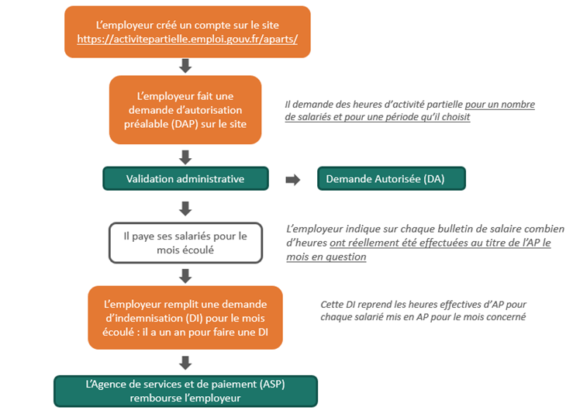

The employer creates an account on the site

The employer makes a prior application for permission (DAP) on the site

*The employer requests short-time working hours for a number of employees and a period of their choice*

Administrative approval

Application authorized (DA)

The employer pays the employees for the past month

*The employer states, on each salary slip, the actual number of short-time working hours for the month in question*

The employer completes a claim for compensation (DI) for the past month: they have one year to do so

*The DI states the actual short-time working hours for each employee put on the scheme for the month in question*

The French Services and Payment Agency (ASP) reimburses the employer

Page 21

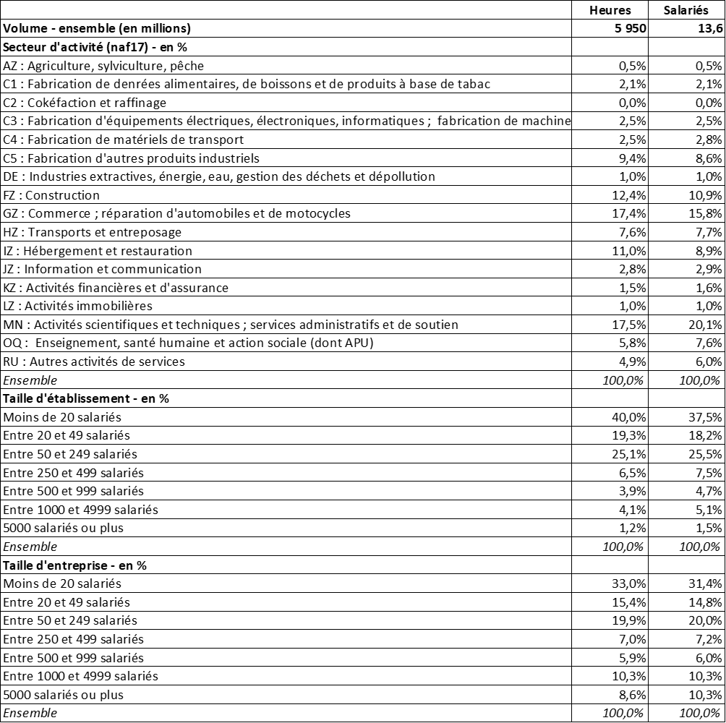

|  |  |  |
| --- | --- | --- |
|  | **Hours** | **Employees** |
| **Volume – total (millions)** | **5,950** | **13.6** |
| **Sector of activity (naf17) (%)** |  |  |
| AZ: Agriculture, forestry and fishing | 0.5% | 0.5% |
| C1: Manufacturing of foodstuffs, drinks and tobacco-based products | 2.1% | 2.1% |
| C2: Coking and refining | 0.0% | 0.0% |
| C3: Manufacturing of electrical, electronic and IT equipment, manufacturing of machinery | 2.5% | 2.5% |
| C4: Manufacturing of transport equipment | 2.5% | 2.8% |
| C5: Manufacturing of other industrial products | 9.4% | 8.6% |
| DE: Mining industry, power and water, waste management and environmental remediation | 1.0% | 1.0% |
| FZ: Construction | 12.4% | 10.9% |
| GZ: Sales and repairs of automobiles and motorcycles | 17.4% | 15.8% |
| HZ: Transport and storage | 7.6% | 7.7% |
| IZ: Hotels, cafés and restaurants | 11.0% | 8.9% |
| JZ: Information and communication | 2.8% | 2.9% |
| KZ: Finance and insurance | 1.5% | 1.6% |
| LZ: Real estate | 1.0% | 1.0% |
| MN: Science and technology; administrative and support services | 17.5% | 20.1% |
| OQ: Education, healthcare and social work (incl. admin.) | 5.8% | 7.6% |
| RU: Other activities and services | 4.9% | 6.0% |
| *Total* | *100.0%* | *100.0%* |
| **Size of place of business or establishment (%)** |  |  |
| Less than 20 employees | 40.0% | 37.5% |
| 20 to 49 employees | 19.3% | 18.2% |
| 50 to 249 employees | 25.1% | 25.5% |
| 250 to 499 employees | 6.5% | 7.5% |
| 500 to 999 employees | 3.9% | 4.7% |
| 1,000 to 4,999 employees | 4.1% | 5.1% |
| 5,000 employees or more | 1.2% | 1.5% |
| *Total* | *100.0%* | *100.0%* |
| **Size of company (%)** |  |  |
| Less than 20 employees | 33.0% | 31.4% |
| 20 to 49 employees | 15.4% | 14.8% |
| 50 to 249 employees | 19.9% | 20.0% |
| 250 to 499 employees | 7.0% | 7.2% |
| 500 to 999 employees | 5.9% | 6.0% |
| 1,000 to 4,999 employees | 10.3% | 10.3% |
| 5,000 employees or more | 8.6% | 10.3% |
| *Total* | *100.0%* | *100.0%* |