Three episodes of basilar tip occlusion necessitating thrombectomies in a patient with subclavian artery dissection distal to the vertebral artery origin: A case report and literature review

Nadav Bitton, Anat Horev

Summary: This report depicts a case of a very unusual stroke etiology that was at first overlooked. We thought it important to share this unusual pathology as a probable explanation for recurrent basilar occlusive stroke.

Introduction

The subclavian arteries give rise to the vertebral arteries before continuing on to supply blood to the upper limbs. This anatomy places the subclavian arteries in a unique position that, when they are compromised, might produce injuries to both the brain and the respective arms.¹

Although uncommon,^{2,3} dissection of a subclavian artery has been associated with anomalies of the aortic arch, with iatrogenic injury, and with blunt trauma.⁴⁻⁶ Previous research has implicated injuries proximal to the subclavian arteries as progenitors of stroke,⁷⁻⁹ specifically basilar artery stroke. In contrast, to our knowledge, subclavian dissection distal to the origin of the vertebral artery has never been described in association with stroke.

Basilar artery stroke entails a poor prognosis, with death or severe disability occurring in 90% of cases.¹⁰ Repeat basilar strokes and treatment (including thrombectomy and recurrent administration of tissue plasminogen activator [tPA]) have been reported several times in the past,¹¹⁻¹⁵ with varying degrees of residual disability. To our knowledge, no study to date has reported a successful outcome of 3 or more basilar artery occlusions treated with mechanical thrombectomies.

We present a rare case of a 56-year-old woman who experienced 3 episodes of stroke in the tip of the basilar artery, all occurring within a month after an injury to the distal subclavian artery. This patient’s case was successfully managed with endovascular thrombectomy and, eventually, with sacrifice of the right vertebral artery. The patient has returned to a fully functional state and has remained free of repeat strokes to date.

Case Report
We present a case of recurrent stroke in the tip of the basilar artery, secondary to proximal occlusion of the subclavian artery. The patient was a 56-year-old woman, a nonsmoker, and an amateur volleyball player, with no significant risk factors for stroke. The patient presented with acute homonymous hemianopia and numbness of the left side. Physical examination indicated left-sided facial palsy, left-sided 4/5 weakness, decreased sensation in the right arm and leg, and left-sided dysmetria. Noncontrast computed tomography (CT) of the head did not show an infarct or any other finding. Computed tomography angiography (CTA) of the head and neck suggested an occlusion in the distal right posterior cerebellar artery. No other vascular findings were reported. The patient was treated with intravenous (IV) tPA and admitted to the neurological department. Ten hours from the time IV-tPA was started, the patient became mute and uncooperative. This time, noncontrast CT showed an acute right occipital infarct without any other significant findings. A CTA scan showed a basilar-tip occlusion, and a thrombectomy was performed. The thrombectomy involved 1 pass with a stentriever, with full recanalization (Thrombolysis in Cerebral Infarction [TICI] 3) achieved. After thrombectomy, the patient’s condition improved significantly. A mild left-sided weakness was added to the neurological deficits reported at the time she was admitted.

During the patient’s hospitalization, the following tests were conducted: transthoracic cardiac echocardiography, transesophageal cardiac echocardiography, 24-hour Holter monitoring, a full hypercoagulopathy workup (including APLA and LAC), tumor markers and rheumatic markers, total-body CT, hemoglobin A1c, and a lipidogram test. All findings were within normal limits. Because no clear etiology for the recurrent stroke was found, warfarin (Coumadin) treatment was empirically started after a team discussion, with a recommendation to repeat some of the tests in the near future, during and after in-house rehabilitation.

Less than a month into in-house rehabilitation, the patient acutely became mute and developed a severe left-sided weakness. Noncontrast CT did not show a new infarct or hemorrhage, but CTA suggested an acute basilar-tip occlusion. Thrombectomy with a stentriever was performed, with resulting full recanalization after 1 pass. After thrombectomy, the patient returned to her previous neurological status, with mild worsening of her left-sided weakness.

During the second angiography and thrombectomy, an occlusion was noted in the right subclavian artery, less than 1 cm distal to the origin of the right vertebral artery. A review of previously performed CTA tests and angiography for this finding showed that this occlusion was present from the day of the patient’s hospital admission, probably misdiagnosed owing to its rarity (and so not routinely searched for). A strong suspicion was raised that the occlusion of the subclavian artery distal to the vertebral artery may have been the source of the recurrent embolic events.

A multidisciplinary discussion team was assembled, consisting of a neurologist, neuroradiologist, hematologist, and vascular surgeon. A decision was made not to treat the occlusion endovascularly or surgically, owing to unclear significance of the finding at that time and to limited data on the subject.

Coumadin treatment was continued, and aspirin was added—again, empirically. Because the left vertebral artery was codominant and patent, a tentative decision was made by the team that in the case of another stroke to the same territory, the right vertebral artery would be sacrificed at its origin. This decision was supported by the idea that the occlusion in the subclavian artery, located less than 1 cm distal to the origin of the right vertebral artery, probably caused a turbulence of flow at the area and was the source of the embolic events.

Five days later, the patient’s condition deteriorated again, and she lost consciousness. Computed tomography angiography again suggested an occlusion at the tip of the basilar artery, and the patient underwent angiography and a thrombectomy (the third time in 1 month). After a single-pass stentriever thrombectomy from the basilar tip, full recanalization was achieved (TICI 3)(Figure 1). After the thrombectomy, investigative angiography was conducted in an attempt to cross the occlusion of the subclavian artery, with no success. In addition, an aspiration attempt with a SOFIA 6 catheter (MicroVention, Inc, Aliso Viejo, California) was conducted from the proximal area of the occlusion, with minimal recanalization achieved (Figure 2). We noticed multiple large clots in the catheter, which supported our impression that the subclavian occlusion was the source of the recurrent strokes. At this point, a decision was made to completely occlude the origin of the right vertebral artery with coils to prevent further embolic events through this path. A successful occlusion of the vessel was performed. After the sacrifice of the vessel, a run from the contralateral vertebral artery showed excellent filling of the basilar artery and its branches, with retrograde filling of the right vertebral artery down to the V2 cervical segment (Figure 3). After the procedure, the patient woke up with no significant new deficits.

The patient completed her rehabilitation and was discharged home with minor deficits. Four months later, she had remained free of new strokes. An ultrasound of the shoulder showed that the shoulder had sustained trauma to soft tissues, which may explain the damage to the subclavian artery and nearby tissues. When asked, the patient mentioned an injury to the right shoulder sustained during a volleyball game; thereafter, she experienced mild tenderness in that region, but not severe enough to necessitate a medical workup.

Discussion
We report here a very unusual case of a healthy 56-year-old woman who suffered 3 life-threatening strokes at the same area in less than 1 month. The fact that this patient was able to survive 3 basilar-tip occlusions and subsequent thrombectomies and remain independent, with a modified Rankin Scale score of 2, is very unusual. In addition, the etiology underlying these strokes is extremely unusual. We speculate that an occlusive dissection of the subclavian artery slightly distal to the origin of the vertebral artery, secondary to microtrauma, was the source of these embolic episodes.

Spontaneous or minimally traumatic subclavian dissection is rare and has therefore been researched and studied in few publications.^{4,7-9,16-19} Possible reasons for the rarity of this diagnosis are that it may spontaneously resolve and that it has minor to no symptoms. These factors may cause subclavian dissection to be underdiagnosed. The precise pathogenesis of any arterial dissection is unclear; however, subclavian dissection has been associated with hypertension, trauma, vasculopathy, migraine, drug abuse, and minimal trauma associated with sports.⁴

Garewal and Selhorst described a nonocclusive subclavian dissection proximal to the origin of the vertebral artery that caused multiple strokes. It was treated conservatively with anticoagulation and did not need thrombectomy.⁷

Ananthakrishnan et al described a case of a 62-year-old who spontaneously developed left-arm pain, mild dizziness, and absent distal left-sided pulses secondary to a dissection of the proximal subclavian artery and vertebral artery root.⁹ The patient was treated successfully with a subclavian stent.

Scheffler et al described a 58-year-old woman with paresthesia in the left upper extremity after playing golf, secondary to nonocclusive dissection of the proximal subclavian artery. A good outcome was achieved with fibrinolysis, anticoagulation, and a slow return to activity.⁸

Winblad et al described a case of a 54-year-old man who presented with posterior circulation strokes secondary to subclavian dissection that involved the origin of the vertebral artery. In this case also, thrombectomy was not indicated. The patient recovered well after conservative treatment with anticoagulation.⁴

These 4 cases were the only cases we were able to find in the literature describing spontaneous or minimally traumatic subclavian dissection presenting with ischemic symptoms. A small number of cases described events of subclavian artery dissection, presenting as a focal or radiating pain in the shoulder and arm area.¹⁹

We could not find a case that described a large occlusion of the cerebral artery necessitating a cerebral thrombectomy, nor did we find a case describing an occlusion distal to the origin of the vertebral artery as the cause of strokes. Regardless of the specific etiology, no cases were found in the literature describing a patient who underwent 3 cerebral thrombectomies in 1 month.

In the case we describe here, the subclavian occlusion was overlooked during the first 2 CTA scans and thrombectomies performed. The subclavian occlusion was distal to the origin of the vertebral artery, and therefore, we are not sure whether early diagnosis of the subclavian artery occlusion would have changed our initial management. After 3 episodes of basilar artery occlusion in 1 month (2 of which occurred under full anticoagulation treatment) and after a full workup without other possible etiology, we decided to sacrifice the vertebral-origin vessel.

References

1. Assenza M, Centonze L, Valesini L, Campana G, Corona M, Modini C. Traumatic subclavian arterial rupture: a case report and review of literature. World J Emerg Surg 2012;7:18. 10.1186/1749-7922-7-18
2. Cox CS Jr, Allen GS, Fischer RP, et al. Blunt versus penetrating subclavian artery injury: presentation, injury pattern, and outcome. J Trauma 1999;46:445–9. 10.1097/00005373-199903000-00017

3. Elkbuli A, Shaikh S, McKenney M, Boneva D. Subclavian artery avulsion following blunt trauma: a case report and literature review. Int J Surg Case Rep 2019;61:157–60. 10.1016/j.ijscr.2019.07.061
4. Winblad JB, Grolie T, Ali K. Subclavian artery dissection. Radiol Case Rep 2012;7:626. 10.2484/rcr.v7i4.626
5. Hirose H, Temes RT. Acute subclavian artery occlusion by blunt trauma: a case report. Heart Surg Forum 2005;8:E412–4. 10.1532/HSF98.20051155
6. Myers SI, Harward TR, Cagle L. Isolated subclavian artery dissection after blunt trauma. Surgery. 1991;109:336–8. PMID: 2000567

7. Garewal M, Selhorst JB. Subclavian artery dissection and triple infarction of the nervous system. Arch Neurol 2005;62:1917. 10.1001/archneur.62.12.1917

8. Scheffler P, Uder M, Gross J, Pindur G. Dissection of the proximal subclavian artery with consecutive thrombosis and embolic occlusion of the hand arteries after playing golf. Am J Sports Med 2003;31:137–40. 10.1177/03635465030310010801
9. Ananthakrishnan G, Bhat R, Zealley I. Spontaneous subclavian artery dissection causing ischemia of the arm: diagnosis and endovascular management. Cardiovasc Intervent Radiol 2009;32:326–8. 10.1007/s00270-008-9380-y
10. Lindsberg PJ, Mattle HP. Therapy of basilar artery occlusion: a systematic analysis comparing intra-arterial and intravenous thrombolysis. Stroke 2006;37:922–8. 10.1161/01.STR.0000202582.29510.6b
11. Khan A, Itrat A. Safe readministration of intravenous thrombolysis in recurrent basilar thrombosis. J Stroke Cerebrovasc Dis 2018;27:e48–9. 10.1016/j.jstrokecerebrovasdis.2017.09.066
12. Qureshi AI, Siddiqui AM, Kim SH. Reocclusion of recanalized arteries during intra-arterial thrombolysis for acute ischemic stroke. Am J Neuroradiol 2004;25:322–8.
13. Chiti A, Pizzanelli C, Terni E, et al. A case of recurrent basilar artery occlusion successfully treated with repeated intravascular procedures. Neurologist 2011;17:95–7. 10.1097/NRL.0b013e3181e5ec33. PMID: 21364363
14. Taylor RA, Wu GF, Hurst RW, Kasner SE, Cucchiara BL. Transient global amnesia heralding basilar artery thrombosis. Clin Neurol Neurosurg 2005;108:60–62. 10.1016/j.clineuro.2004.11.004
15. Klepanec A, Harsany J, Haring J. Endovascular treatment of acute ischemic stroke in patients with recurrent intracranial large vessel occlusion. Interv Neuroradiol 2020;26:376–82. 10.1177/1591019920911532
16. Funada A, Ino H, Fujino N, et al. Idiopathic dissection from left subclavian artery to brachial artery: spontaneous repair with conservative management. J Cardiol Cases 2010;1:e49–51. 10.1016/j.jccase.2009.07.002

17. Williams S, Jaramillo AP, Posch M, Prince SA, Hamera L. Idiopathic left subclavian artery dissection. Cureus 2020;12:e12151.10.7759/cureus.12151

18. Onishi H, Yamamura O, Matsuo S, et al. Localized right subclavian artery dissection detected by accident on an ultrasound examination: a case report and literature review. Internal Medicine 2019;58:73–8. 10.2169/internalmedicine.1451-18

19. Marik P, Mclaughlin M. Spontaneous subclavian artery dissection: a pain in the neck diagnosis. BMJ Case Rep 2013;2013:bcr2013201223. 10.1136/bcr-2013-201223

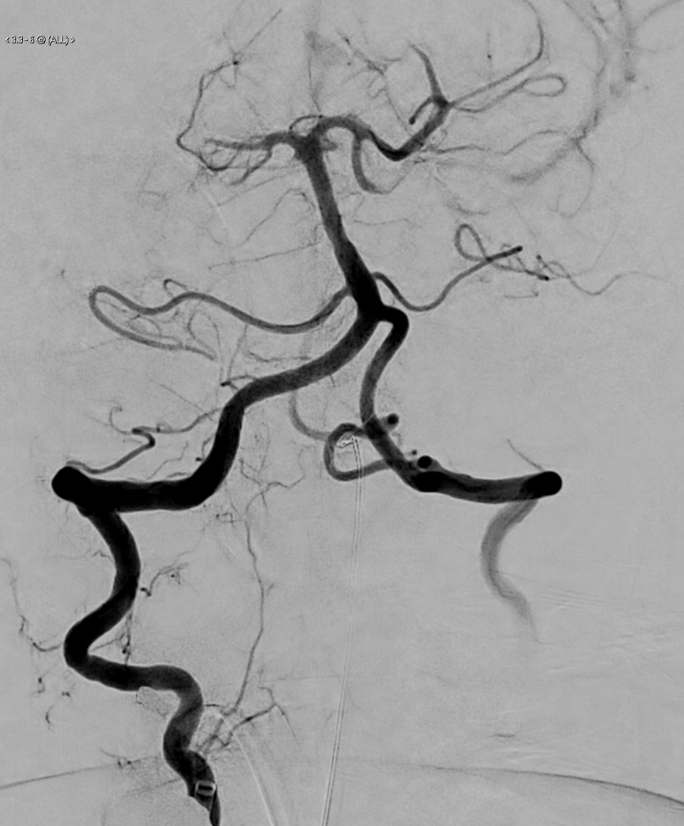 | 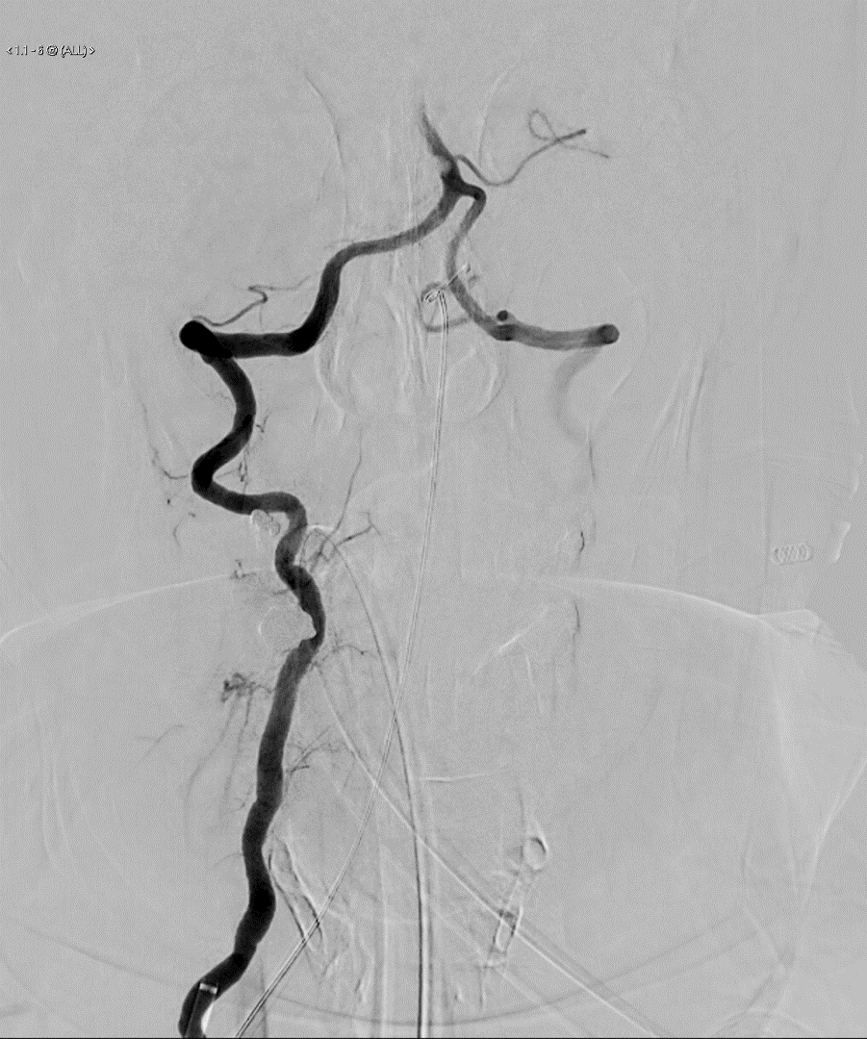
Figure 1: Prethrombectomy (left) and postthrombectomy (right)

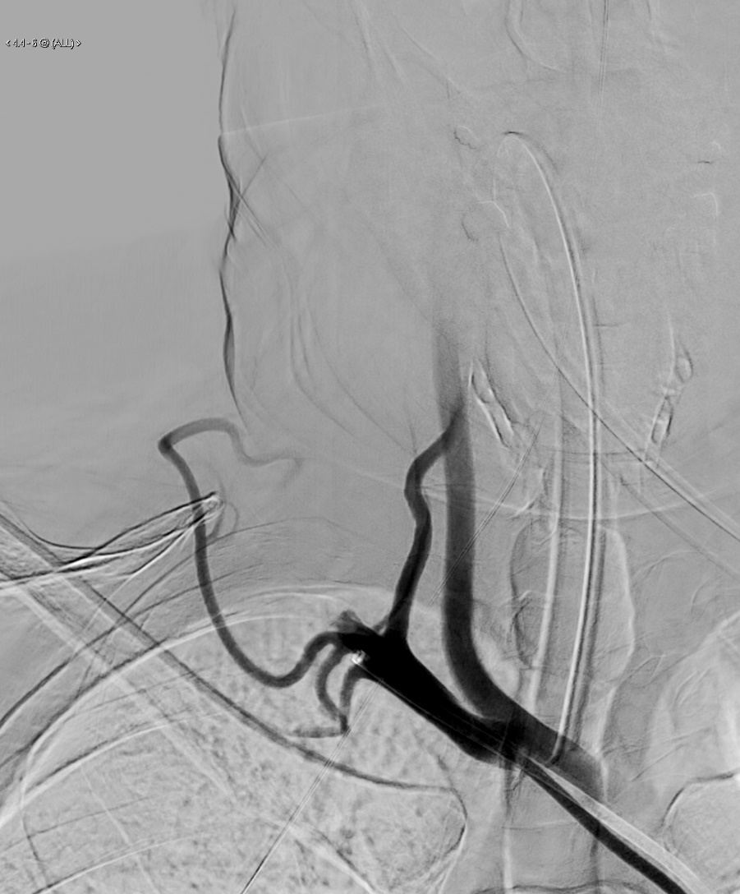  (A) | 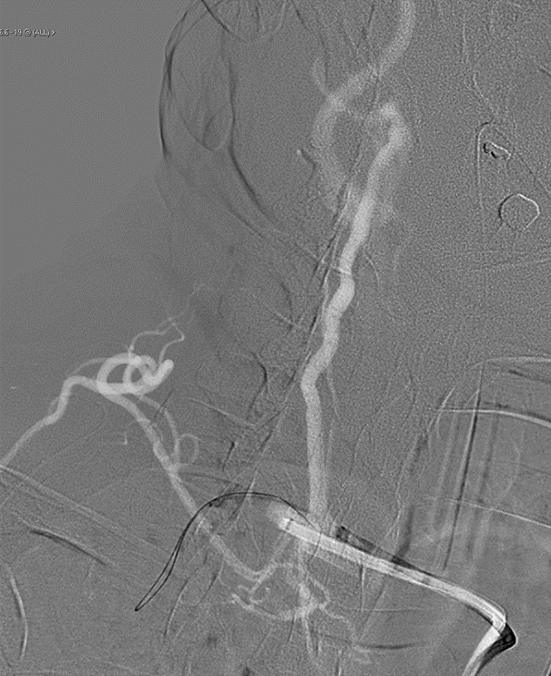(B)
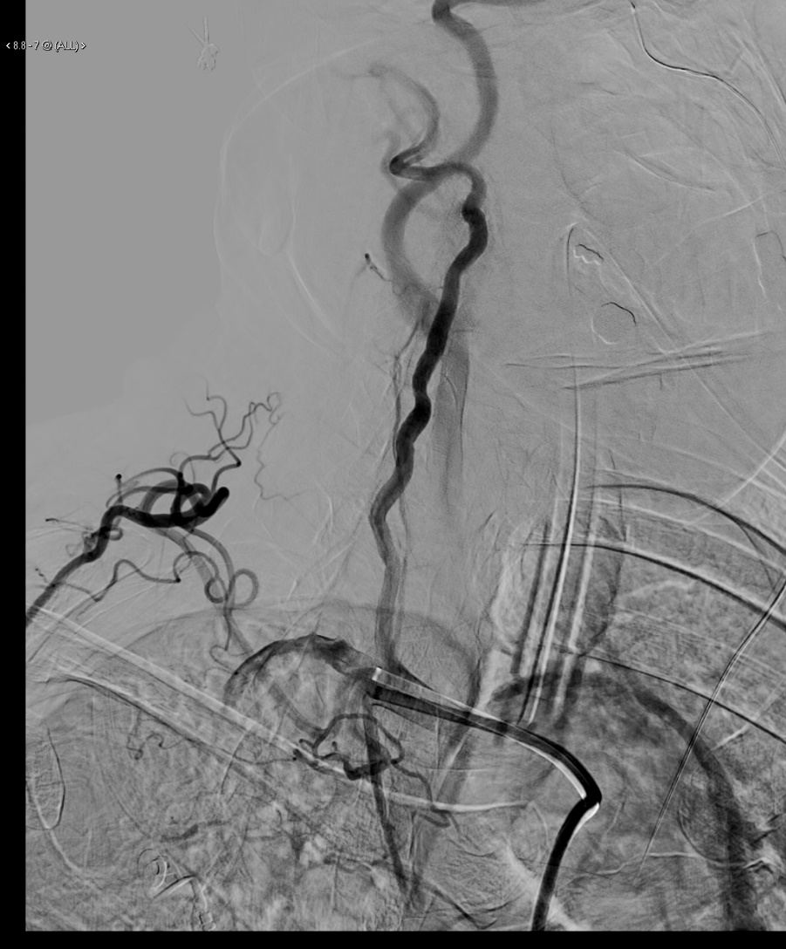
(C)
Figure 2: (A) Prethrombectomy, (B) during thrombectomy, and (C) postthrombectomy

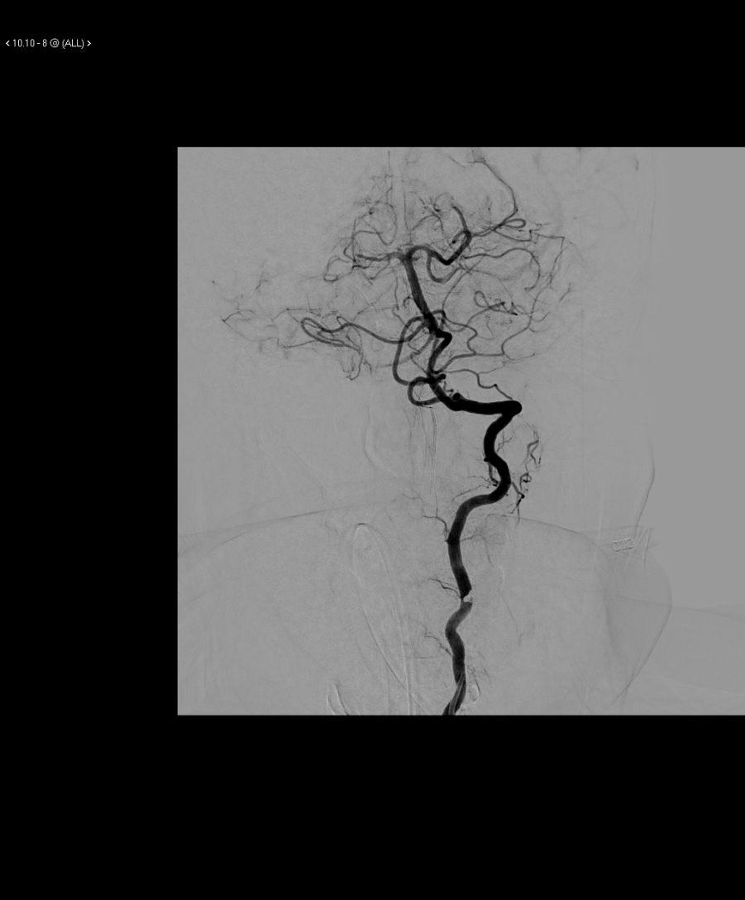  (A) | 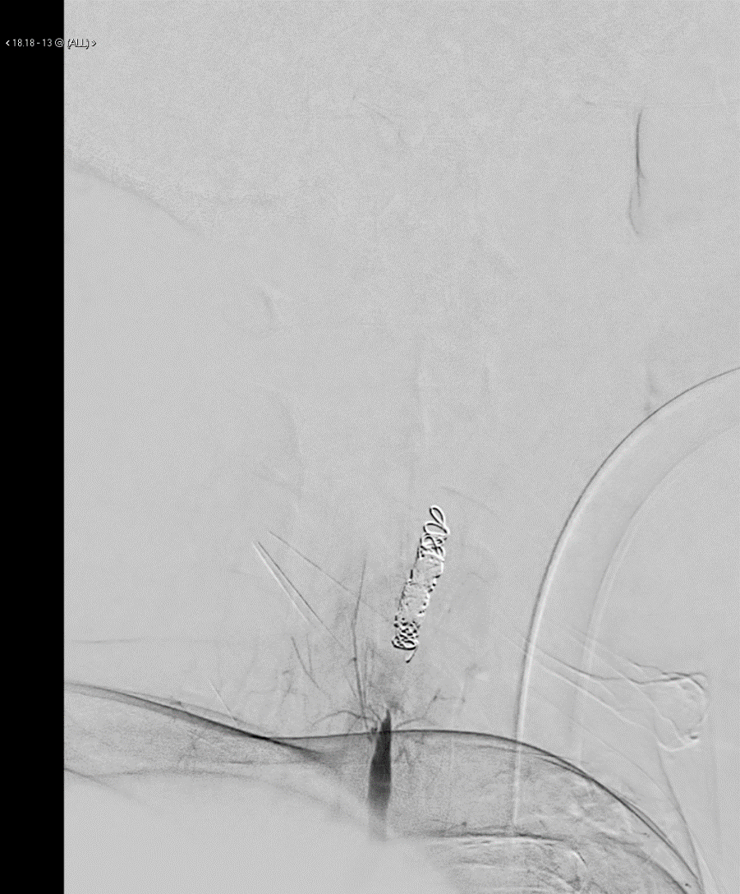  (B)
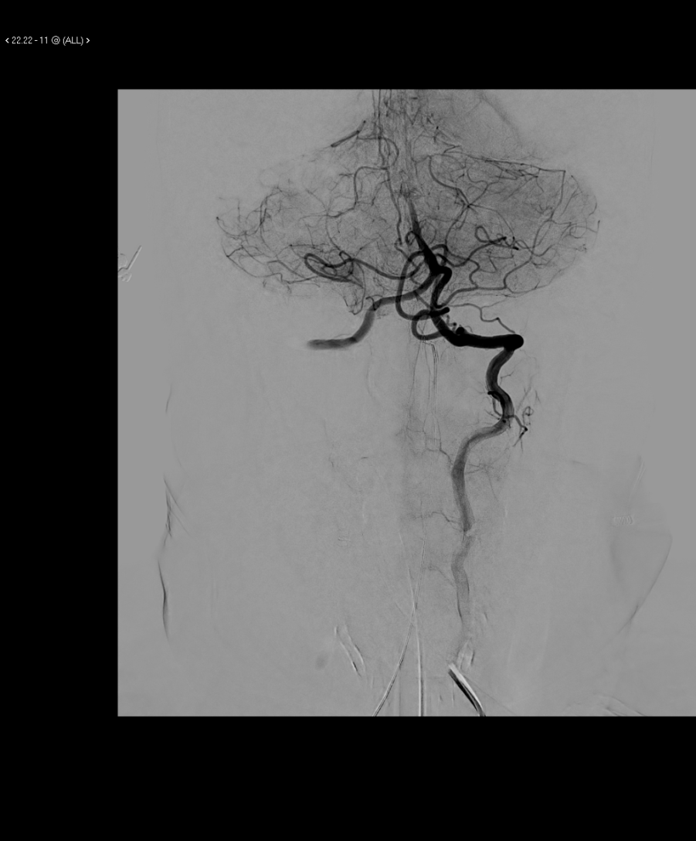
(C)
Figure 3: (A) Right vertebral run before left vertebral occlusion, (B) left vertebral origin run after occlusion, and (C) right vertebral run after left vertebral occlusion

