Teaching Creativity in Early Childhood Education:

Professional Identity Formation and Language Acquisition

Dr. Smadar Moore, Dr. Nira Valla, Rivka Gortler, Dr. Ofra Bachar, Thelma Florentin, Dr. Ronit Ronen Tamir, Dr. Nili Laor-Blassblag

Faculty of Education, Kibbutzim College of Education, Technology and the Arts

**Abstract**

This article presents a study conducted by the pedagogical instructors of the Creativity in Early Education track at the Kibbutzim College of Education in Israel, among a study population of female students in this educational track and its alumni who are working as kindergarten or elementary school teachers. The study was designed according to a retrospective and reflective perspective among instructors. This enabled them to examine the training processes that they conduct, and provided an opportunity to formulate and conceptualize a model of the training used in this educational track. The study findings indicate that the original principles of the training process, which were developed forty years ago by the founders of this educational track as led by Sarah Shapir, have been maintained in the current training model, despite systemic changes over the years. These principles form the basis for the development of a personal, professional, and creative identity among its students. The process was found to contribute to the acquisition of a language and educational approach for teaching creativity, to affect the self-perception and self-awareness of early education teachers and trainees, and help them to understand their educational worldview. The training model that emerged from the research findings is characterized by three main axes: visual-conceptual representations, multidirectional learning, and visualizing connections. These occur in three primary arenas: the practicum in kindergartens, arts courses withing the training program, and the pedagogical instruction that integrates all aspects of this educational track. The model detailed in this article makes theoretical and empirical contributions to knowledge about training processes among college students of early childhood education.

**Introduction**

The Creativity in Early Education track at the Kibbutzim College of Education in Israel was established in 1978 by several of the college’s lecturers, led by Sara Shapir. This was a unique training course in Israel. It was established as distinct from the early education track, and was designed for students who wish to integrate arts and creativity into their learning and teaching.

Cultivating creativity presents one of the most interesting challenges for any teacher, as it involves understanding the true dynamics of creative work. In this educational track, personal choice is seen as key to the development of a creative individual, although this is not its only core principle. Since its development and until today, this track has integrated the creative ethos into education through the arts such as theater, movement, music, visual arts (Shapir, Anar, & Farber, 1995). It also considers multiple intelligences (Gardner, 1996) which are reflected in educational practice (Landau, 2001; Robinson 2016). It makes parallels between training processes and educational processes in the field.

According to the perspective of this track, educators, as key figures in the educational endeavor, need in-depth understanding so that have a foundation of abilities they can rely on when interacting with children and adults (Avinon, 2014; Klein & Yablon, 2008). To this end, training in the Creativity in Early Education track [from here called the Creativity track for short] sharpens students’ awareness of their own multiple intelligences and supports, strengthens and develops their creativity. Further, it helps them encourage and develop children’s sense of wonder, discovery, play, learning, social interaction, and interrelated skills, as interwoven aspects of this special developmental stage. The training develops participants’ ability to allow themselves and the children they teach to express themselves in multifaceted ways. It gives teachers an in-depth understanding of young children, and helps them develop sensitivity, caring, and empathy. This training is in line with the principles of educator and feminist Nell Noddings (2012), who states that creating an environment in which caring relationships can occur should be a goal of all teachers and educational policy makers. Noddings states her hope that caring teachers can help their students enter the adult world as people who are concerned about and care for others.

Over the years, training in the Creativity in Early Education track has been conducted as a tradition that was passed down verbally, according to the principles established by its founders (detailed below). Each new pedagogical instructor and lecturer who entered this track received guidance and mentorship from the department heads and veteran instructors, and learned from them the “secrets” of its educational and teaching methods. Although some materials have been put into writing and the training processes have been documented, no empirical research has been conducted. Further, no theoretical material has been written that presents the training processes for teaching creativity in early childhood education in general, or for the Creativity in Early Education track at the Kibbutzim College in particular.

Several years ago, the Kibbutzim College underwent a systemic change, and transformed its early education track into a full department consisting of three tracks: teaching creativity, a dialogical approach, and special needs education for young children. This change led to retrospective and reflective observations among the pedagogical instructors of the track regarding for teaching creativity regarding its training processes. This assessment of the training processes that they carry out provided an opportunity for crystallization and conceptualization, which led to the empirical research described in this article. The current study was conducted by the six pedagogical instructors of this track and the head of the early childhood education department. It examines the creative training processes, as reflected in the testimonies of the track’s students and alumni.

The findings indicate that the principles and processes established by the track’s founders have been crystallized into a model. The model includes the means of acquiring a language of creativity at the various stages of training, developing a professional identity among teachers of creativity, and application of the language and identity by alumni in their work in kindergartens and elementary schools. This article presents the topic of creativity in education, presents student testimonies from the interviews, and offers a training model that emerged from the research findings. In this respect, this article fills in gaps in the literature and traces the development of a language for teaching creativity and the professional identity of teacher-trainees in the Creativity in Early Education track.

**Developing Creativity**

Guilford (1950), one of the first theorists of creativity, studied the structure of human intelligence and analyzed the elements of creative thinking. He defined creativity as branching, multidirectional thought patterns that combine cognitive flexibility and the ability to identify multiple solutions to a given situation. According to Guilford, creativity encompasses originality and sensitivity, and at its core is the ability to come up with new solutions and innovative ideas.

The Creativity in Early Education track at the Kibbutz College was constructed based on this definition and principles, as part of a pedagogic approach to teaching creativity to young children. The principles of this track and the means of implementing them are reinforced by Robinson’s (2016) conception of creativity as a process in which valuable original ideas are developed. Therefore, creativity is linked to two other concepts: imagination and innovation. In Robinson’s view, creativity involves activation of the imagination, the ability to conceive of things that are not directly observed through one’s senses, and application of these ideas. Innovation, in the context of creativity, is the ability to manifest new ideas in reality. Robinson argues that this does not imply that only certain people can be creative. That is a myth, like other myths, such as that creativity cannot be taught, or that creativity is related only to the arts, or that artistic creativity is linked to uninhibited self-expression. In Robinson’s view, creativity stems from multiple capabilities that are inherent to all humans. Further, creativity is possible in all areas of life: science, the arts, mathematics, technology, cooking, teaching, politics, and business. Like many other capabilities, innate creativity can be nurtured and refined through engaging in the mastery of skills and increasing one’s knowledge and ideas.

Landau (1997) asserts that a creative personality, is “open, sensitive, inquisitive, flexible, playful; excels in the fluency and flexibility of ideas, combines logic and imagination, the subjective and objective; does not organize information into limited categories, and postpones judgment to later stages of the creative process.” Regarding the outputs of creativity, she adds that: “the expression of creativity is not necessarily a tangible product, but can also be an insight, idea or emotional experience” (Landau, 1997, p. 227).

Gad Alexander (2016) recognizes a sense of wonder as a basis of creativity, alongside imagination. However, inclination or ability to imagine something are not sufficient to produce a creative work; discipline is required. The process involves a sequence of thoughts, beginning with the initial sense of wonder or encounter with a challenge, and leading to the creative product or solution. This process develops new understandings, which even if they are not original according to expert standards, had been previously unfamiliar to the learner. In Alexander’s view, the transition from the initial identification of a challenge or the awakening of wonder and its culmination in a creative output or solution is not always smooth and easy; progress often involves multiple obstacles and opportunities for failure.

Further, according to Robinson, creativity is not simply generating original ideas and freeing of the imagination. Development of creativity includes refining, assessing, and focusing on creative work. There must be original thinking on the part of the individual, but equally necessary are a critique of the work process and its appropriateness and value, at least for the person who is producing the work.

Basic conditions for the development of creative forces, according to Rogers (1973), are security and inner freedom. Therefore, a necessary condition for the development of creativity is an empathic environment that values every individual. Landau (1997) further notes that while creativity is inherent to humans, it should be developed and nurtured by an environment that provides freedom, security, and tools for coping. Landau (2001) formulated the creative process in a four-step model: preparation, incubation, insight, and assessment. Robinson (ibid.) also argues that creative work often goes through similar typical stages. This dynamic process does not always end as it began, and often involves making new connections, crossing disciplines, and using metaphors and analogies. Creativity is not intended to be a linear process, in which the learner acquires the required skills before beginning the process. Creative work in any field involves ongoing mastery of skills and concepts.

Another training approach that is used in the Creativity in Early Education track is heutagogy (Hase & Kenyon, 2007), a pedagogic approach to self-directed learning. Heutagogy places learners at the center, and considers them responsible for promoting, critiquing, evaluating, and appreciating their own learning. This ideological approach refers to principles of learning such as: learners’ desire to expand their knowledge, deepening their enjoyment of learning, developing learners’ self-confidence in their ability, offering opportunities to assimilate their learning into experiences through attentiveness and development of skills, planning, and ongoing self-directed learning (Kuzminski, 2014). The central idea of heutagogy is that the learner chooses the process of self-directed learning with the guidance of the teacher. This is inherent in the educational conception of Jean-Jacques Rousseau and was later developed by Rogers (1973). According to Rousseau and Rogers, children know what they need and what interests or intrigues them. Therefore, Beck and Kuzminski (2016) argue, the concept of heutagogy is appropriate for all ages.

**Principles and Concepts of Learning in Training Teachers of Creativity**

The educational principles used by Shapir et al. (1995) in building their model of education for creativity and nurturing creative educators are still used as anchors in the training of kindergarten teachers in the Creativity track:

* Immersion in an ongoing process of change, characterized by the ability to adapt while transitioning from one situation to another;
* Viewing each achieved goal as the beginning of the next goal, so the educational process is endless;
* Non-conformity, challenging accepted norms, and thinking critically;
* Remaining in a state of uncertainty or ambiguity, and being willing to bear intentional or unintentional ambiguity in areas such as guidelines, products, processes, and interpersonal relationships;
* Observation from new and unusual points of view, considering perspectives that differ from one’s first impressions or intuitive observations of a phenomenon or occurrence;
* Reducing dependence on external assessment, building an internal basis for assessment, so that learners can evaluate their own learning;
* Development of an autonomous personality, meaning one does not simply fulfill requirements, but also expresses doubts and thinks critically;
* Legitimizing diversity, understanding that there is not one truth, giving equal consideration to differing perceptions;
* Delaying judgment, replacing judgment with critical observation from various angles before making a decision;
* Use of interdisciplinary teaching methods that enable the maximum activation of multiple senses, and making connections between educational and artistic content.

These principles are reflected in the theories, concepts, and practices that are used in the training process at Kibbutzim College.

**Multiple Intelligences**

Gardner's (1996) Theory of Multiple Intelligences is one of the anchoring principles of training for creativity in education, and is used throughout the three years of the training program at Kibbutz College’s Creativity track. Gardner defined seven functional abilities or intelligences: linguistic-verbal, logical-mathematical, visual-spatial, bodily-kinesthetic, musical, interpersonal and intrapersonal. Awareness of these diverse abilities makes it possible to teach and learn in different ways, and to create multi-layered connections with others (Gardner, 1996). Using multiple intelligences as an infrastructure for educational work develops educators’ ability to allow children to express themselves, connect, develop, and learn out of a sense of competence and self-confidence (Armstrong, 1996). Use of multiple intelligences in early childhood education enables effective learning based on the multiplicity of communication channels within the brain. Children develop a variety of skills so that they can express their inner worlds and create complex meanings for the concepts that they acquire intensively at a young age (Margaliot, 2012). Training in each of these multiple intelligences and in the ability to combine them underlie the teaching of creativity.

**Reflection and Questioning**

Reflective observation is another significant principle, which continues throughout the three years of training. The concept of reflection has several meanings. One is self-observation, self-reflection, self-awareness, or an inner eye with which people can look at themselves. This allows individuals to collect information about themselves in all areas (thoughts, feelings, body image, etc.) and make adjustments or corrections as needed (Birnbaum, 1997). Shem Tov (2015) argues that reflection is associated with problem solving, and can be used in situations of doubt and deliberation. Another of its characteristics, therefore, is reframing such situations in order to find solutions and deal with their complexity. Reflection is essential for any learning process that seeks to deepen learners’ understanding of their actions, considerations, thoughts, and feelings.

Asking questions during the learning process enables reflective observation. According to Maxine Green (2019), the task of education is to create situations that encourage young people to start asking questions and look for the underlying reasons for events. Questions arise from a curious attitude towards life and one’s environment, and make it possible to find missing information. It is essential to provide to learners with information that encourages them to ask effective questions that will further enhance their understanding of the information, enable them to organize the information, and eventually lead them to the solution of the problem. Asking questions is also an important skill for performing reflective and meta-cognitive processes. Questioners observe and control the reflective process through inner dialogue: they ask themselves questions and answer them. These questions help the learners become aware of requirements for performing a given task, set goals for planning courses of action, and assess their achievements. These questions focus on three stages: before, during, and after the learning process (Kaniel, 2006).

**Observation and Self-inquiry**

Teachers’ self-awareness of their own ways of thinking enables them to create in-depth connections with their students and understand the children’s diverse needs and abilities. Raising awareness of one’s thought processes involves reflective thinking, in which the thought process itself becomes the object of observation and analysis, in other words: thinking about thinking. The term “meta-cognition” coined by Flavell (1976) refers to individuals’ ability to think about and navigate their own thoughts and cognitive processes. Vygotsky (1986/1934; 1978) emphasizes the importance of social interactions and the use of spoken language as tools for constructing the meanings of knowledge and for developing thinking skills. Given this, reflective thinking about the interactions between teachers and young students and the interactions among the children in kindergartens and elementary schools will advance teachers’ meta-cognitive abilities.

**The Arts as an Engine of Growth**

Another important principle underlying the teaching of creativity is that the arts are a source for students’ growth, paralleling their application as a teaching practice. According to Green (2019), pursuit of the arts develops a certain kind of spiritual knowledge, greater sensitivity to and awareness of meanings, quality, wholeness, and human relations. As she states, “…the special value of the arts in education lies in the fact that they speak to us directly, and invite insights without moral preaching and without the forced effort of training and practice,” (ibid., p. 10).

**Methodology**

The current study was conducted using a qualitative approach, based on the perception that reality is as complex, dynamic, and unquantifiable as people’s inner worlds. Reality encompasses a multiplicity of subjective realities that are based on the structured meanings attributed to them, according to each individual’s viewpoint (Denzin & Lincoln, 2000). Qualitative research investigates the complexity of human interactions through the interpretation presented by the research participants (Strauss & Corbin, 1990). It examines influencing factors from the perspective of the person being affected (Shakedi, 2011). The current study used the Grounded Theory approach, according to which a theory emerges from analysis of the research findings (Jason & Glenwick, 2016).

It is important to emphasize an unusual feature of this study, namely that the research was conducted by the entire team of pedagogical instructors of the Creativity track and the head of the early childhood department at Kibbutzim College. Most of the instructors had been students in the Creativity in Early Education track, and returned to be instructors after years of working as teachers in kindergartens and elementary schools.

The guiding principles of this educational track are reflected in the training of the staff, who are well acquainted with processes of reflective observation, meta-cognitive thinking, and raising self-esteem. The collaborative, reflective, and creative processes that are used in the training were also applied among the researcher-instructors.

The study population consisted of five first-year students, five second-year students, and twelve graduates of the Creativity in Early Education track who were working as kindergarten or elementary school teachers. All participants were female.

**Research Tools**

**In-depth interviews.** At the end of the first year of training, semi-structured in-depth interviews were conducted with students at the end of their first year of training. This was done in order to learn about how they acquire a language of teaching creativity and to investigate their thoughts, insights, and considerations regarding their experiences in the first year. Additionally, an in-depth interview was conducted with a founder of the Creativity track. This interview served as a basis for understanding the key themes in the ethics of training educators to teach creativity.

**Document analysis.** The researchers analyzed documents related to the application of college students’ training experience while they were working in schools (Kacen & Krumer-Nevo, 2010) and which show the college students’ creative work with the kindergarten children, such as such as: an outline of planned activities, a description of the activities offered, and a reflective approach following the activities. This enabled the researchers to learn about the creative methods of thinking and teaching that the college students use and develop during their work in the schools.

**Focus groups.** Two focus groups were conducted with alumni of the Kibbutz College’s Creativity in Early Education track who have worked in the field of education for between one and five years. Each group consisted of six to eight educators. Each focus group conversation began with open questions that invited participants to describe their experiences from the training and their application in the field. This enabled the researchers to learn about the experiences and work processes of teachers who were trained in the Creativity in Early Education track, from their shared interpretation.

**Data Analysis**

The analysis of data collected in qualitative research includes intuitive elements or characteristics. Analysis provides meanings, interpretations, and generalizations regarding the phenomenon under study (Gibton, 2001). The thematic analysis focuses on what the respondents say, not the way they say it (Shakedi, 2007). The categorical approach used in this study is appropriate for examining a phenomenon common to multiple people (Lieblich, Tuval-Mashiach, & Zilber, 2010).

The data analysis in the current study was conducted in several stages. In the first stage, codes, categories, and key themes were identified for the data collected with each of the research tools. In the second stage, a comparison was made between themes that emerged from the data. Triangulation was conducted between the various research tools (in-depth interviews, focus groups, reflective documents written by the teacher-trainees), in order to obtain a broad picture from various perspectives. This contributed to increasing the reliability of the study (Lincoln & Guba, 2000).

**Research Ethics**

The study was conducted by the team of educators in the Creativity track. Some of the study participants were current students. This raised the need for a mechanism to ensure the ethics of the research. First, the head of the research team gave a clear and detailed explanation to the college students in each year and class regarding the purpose of the research, its importance and the ways in which it would be conducted. Participants were informed that their participation in the study was voluntary and that they could terminate their participation at any time. The college students and early education teachers signed a specially worded informed consent form, which ensured that their rights would not be violated and that their training would not be affected by their participation in the study. It was made clear to the study participants that their complete privacy would be maintained and their names would remain anonymous. The study was approved by the Ethics Committee of the Kibbutzim College.

**Results**

**Crystallization of a Language and Professional Identity for Teachers of Creativity**

The college students encounter the language of creativity in the first semester of the first year. This involves processes of getting to know themselves, the group, and the pedagogic approach to teaching creativity. They learn tools for self-reflection, observation of learning processes, change, and development, and to apply these tools, perhaps for the first time. They are introduced to concepts and methods related to observing, expressing, and processing what they learn, which are translated into a language of creativity. They are asked to process their learning while searching for personal meaning within all learning arenas, courses, and instructional classes.

Prominent principles in this language acquisition process include: development of the ability to deal with ambiguous or uncertain situations; the importance of challenging accepted norms; development of authenticity; observing situations from different perspectives; and delaying judgment. Another emphasis during the first year of study is on developing self-esteem and reducing dependence on others. This authenticity, in the words of one interviewee is described as: “Truth. This is the word I feel most strongly here. To be very honest in the face of everything that happens,” (Arbel).[1]

We will present here the process of crystallization of a professional identity among educators teaching creativity according to three axes that follow the chronological development of the training program. These axes are intended to instill, by the end of the process, the formation of professional identity and the assimilation of a language of creativity. The following section presents the tools that are used during the three years of training to develop a worldview regarding creativity that allows alumni to apply these concepts in their work in the field.

**The visual-conceptual representation axis.** As indicated by its name, the visual-conceptual representation axis deals with the translation between words and images, the visual representation of ideas, concepts, and processes through the use of the various arts. A task called the ‘junction’ or ‘station’, assigned at the end of the first semester of the first year, gives the college students the opportunity to apply meta-cognitive thinking to the learning process. This enables the acquisition and assimilation of the principles of a language of creativity. In this assignment, the students were asked to create a visual product, using diverse materials and means of expression, which represents the process they went through during the semester and also relates to the future. Creative thinking is evident in the students’ reflective approach to the task, in the deep meaning they attach to working with the materials, and the thought processes the assignment invokes. It is clear from their words that the materials they used are not seen as simplistic, but rather as inspiration for investigating and expressing themselves: “I really considered the materials. I wanted to use materials that would help me explain myself. I did not want to do just anything ... there is something that is beyond that. You go through a process of searching that is much deeper than the thing itself, the material itself,” (Dana).

The students expressed understanding that their work is an expression of an idea: “I already have an explanation; I have this thing, something that I feel like I have to bring out and make a product out of it,” (Noa). Further, the materials represent the idea: "I touched materials I wasn’t familiar with, and suddenly ideas came up ... something in me was incubating, and then something else came out ... The process is built from several ideas,” (Bat Chen).

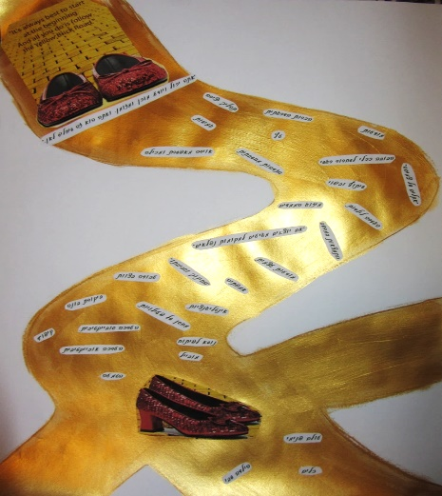

Figure 1: “The Junction”

During this assignment, the students looked at themselves and represented their cognitive-emotional position within the training process (Figure 1). Using physical art materials, they created the “junction” where they are located. They were told to ask themselves what they had experienced thus far, what they felt along the way, what they have learned, and what they gained from the learning process. This assignment, as well as other assignments that preceded it, required students to expose themselves and share with the group, while thoroughly examining the meaning of learning for themselves. Presenting their creations to their peers in the training class allowed for a re-examination of their encounter with the group and addressing deep feelings and personal challenges, both in terms of content and in terms of modes of representation, which are also part of the learning track.

In designing her product for the “junction” assignment, Rotem represented her learning process in the form of glasses (Figure 2): “The seminar is here to give us ‘new glasses’ so we can see the environment in a different and better way.” Her written explanation refers to her observations of the world and choices she made in the creative process, which reflect the learning process she underwent. She wrote words on the frames of the glasses that describe the learning process: process, creative thinking, responsibility. Inside the lenses are miniature representations of significant ideas and theories she encountered each semester (i.e., Maslau, Gardner, Korczak). On the frames appear words related to the personal process: love, listening, inclusion, respect, and confidence. Referring to the future, Rotem wrote: “I choose to wear these glasses as I travel further down my path.” In each lens, she left free space and an opening through which she could insert items representing additional things she learned later.

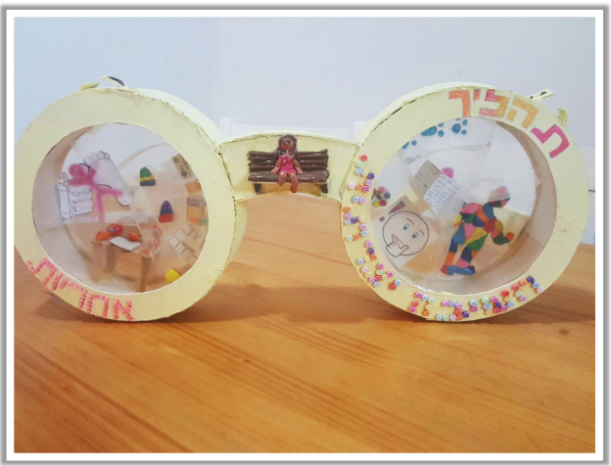

Figure 2: “The glasses”

During the first year of training, the college students leave their comfort zone, experience uncertain, ambiguous situations, and encounter a worldview in which there is not a single truth. They must find their own way, and strengthen their ability to cope in such situations. Another student, Bat Chen, represented the process at the end of the first semester through an image of a seedling planted under a hat (Figure 3): “I began to flourish ... to find a new interest ... to experience a new way [...] I am not in my natural place, in the ground. I left my comfort zone, my home, and went to try new places. The place I am now is in the head underneath the hat.” She attached to the hat words that describe the processes she went through and the creative language she acquired, adding: “It is possible to change the words. I can. It all depends on me, I am responsible for those words, and they can change.”

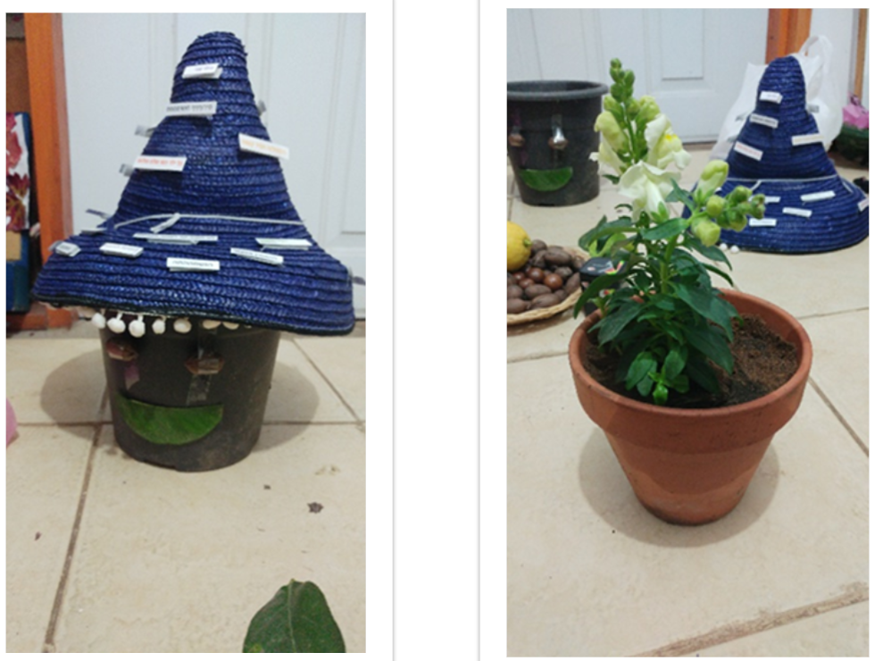

Figure 3: The seedling in the hat-planter

In addition to changes along the visual-conceptual axis, the students develop and assimilate a language of creativity. The students’ responses indicate that by the middle of the first year, their abilities of reflection and self-awareness are already emerging. This is an essential stage in the development of creativity and a language of creativity. “It was like writing a diary for me. I write thoughts, and other thoughts pop up that are connected to them. Then ‘the token drops’ and I understand the idea. Now I am ready to write even four extended reflections! It's just fun!” (Dana).

Cognitive development is also evident in the use of concepts from a common language of creativity, or in using characteristic expressions that create a sense of partnership: “As we like to say in this track: ‘Where does this meet you?’” Beyond improving their cognitive and other abilities, it is evident that the students take a broad view of the issues and try to define the characteristics of creative thinking: “In my opinion, it is not fixed - it is about trying something different each time,” (Noam). The learning process encourages observation from different directions and an ongoing search for different forms of expression.

In accordance with the spiral structure of the training, students are involved with issues related to the visual-conceptual representation axis throughout their training. In the third year, the training program is built around a specific visual-conceptual representation, which serves as a source of inspiration in the learning process that the instructor goes through along with the group of students. Each year has a central theme that forms the basis of the representation and a visual way of presenting it (physical materials, a collaborative visual representation, and more). Every month, each student augments her project with another a layer or addition that represents her ongoing development. In this way, each student’s professional development is accumulated in the third year of the training program (Figures 4 and 5 depict the beginning and end of the process of building a visual representation titled ‘The Spine’). This process invites participants to reflect on an ongoing process that includes ambiguity and uncertainty about its end, and is built on the cornerstones of creative thinking.

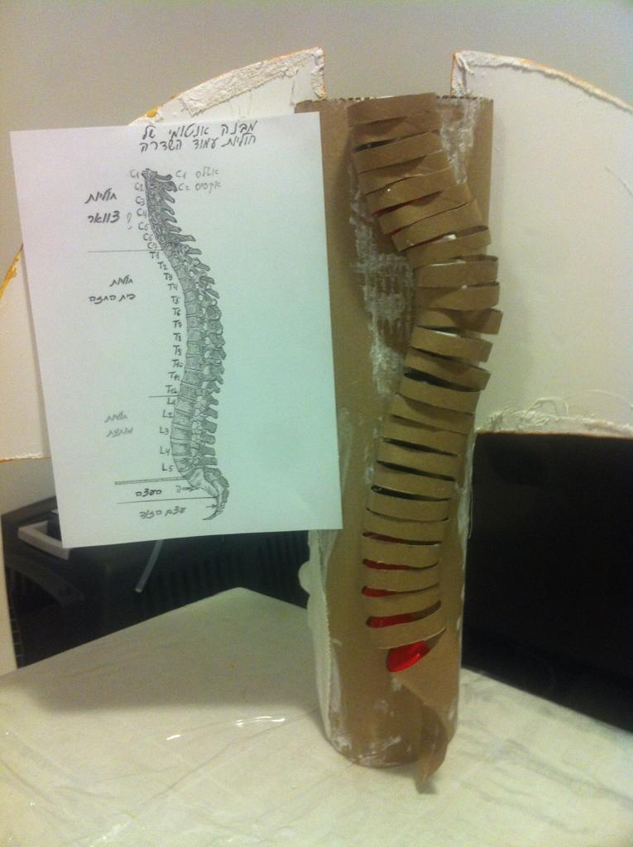 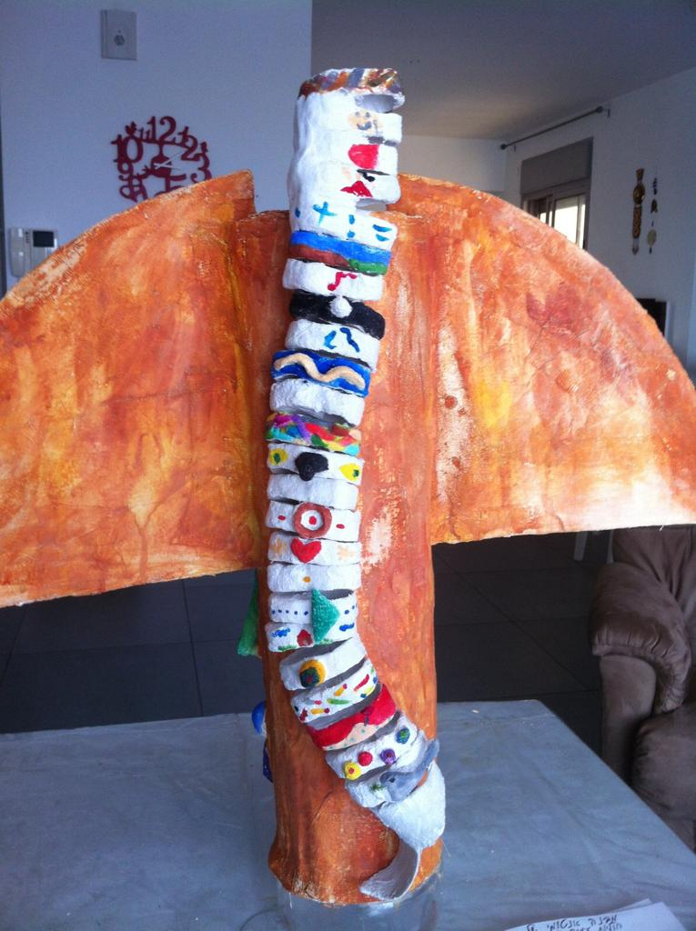

Figure 4: "The Spine" at the beginning of the year Figure 5: “The Spine” at the end of the year

Learning to deal with ambiguous situations during the training helps the students develop and strengthen their self-confidence and allows them to identify the authentic desires of the teacher-trainees and graduates: “It’s definitely the most creative route. Sometimes something happens along the way, and we don’t know how to deal with it. That’s when we manage to pull magic out of the hat,” (Stav).

The tasks assigned in the third year that reflect the visual-conceptual representation axis transform the training into an authentic work process that legitimizes diversity among the students and the uniqueness of each individual. This helps shape the graduates’ professional identity and teaching methods. In the students’ view, this is a guiding principle of the training: “The creative approach allows me to really be very, very authentic in what I do. The approach allows me to be unafraid of being told no! I learned that I can dream and fight for my dreams, so I do it [....] This is something ‘creativity’ really offers - an understanding of what is important to me.” (Sharon).

**The multidirectional learning axis**. Learning and teaching creativity is a multidirectional process. The assumption is that education does not take place in only one direction, from adult to child, but that all participants are in the process of learning, with an ongoing dialogue between the teachers and students. In order to illustrate this axis, we will present the kindergarten practicum, an arena of experiences that begins mainly in the second year of training, in which greater emphasis is placed on implementing multidirectional learning processes: “Unlike the first year, learning [this year] included more fieldwork, peer learning, and connecting to our world,” (Inbal).

The college students’ responses in the interviews and focus groups indicate that they are aware that multidirectional learning processes take place during the training and in the practicum. They point out they learn not only from the instructor or kindergarten teacher, but also from their peers and even the children in the kindergarten: “During the year, we were given responsibility for some of the learning in the [instructional] course. For example, Thelma [the instructor] allowed us [the students] to determine the topics of the lesson,” (Goni). Observing these parallel processes allows them to begin to formulate their educational worldview: “In the yearly curriculum for the kindergartens, there are goals set for the kindergarten teacher. But as a kindergarten teacher, I would like the children to be partners in determining the path,” (Ronit). Similarly, another interviewee said: “In the first semester, I felt that the issue of responsibility came from a place of awareness of my learning process. It’s like growing flowers from bulbs. Just as I am responsible for maintaining the conditions for growth until the bulb flowers, I am responsible for the conditions of my learning,” (Inbal).

At the end of the second year of training, students begin to form an awareness of the spiral creative learning process, which runs like a thread throughout the three years, and is based on the cornerstones of the creative path: a multidirectional learning process that is applied in the kindergarten practicum and is represented through making connections and reflecting on the contents that are expressed through integration of the arts. The findings show how the creative learning process is perceived by the college students, and how they identify their personal style and the begin to build a professional identity: “This year the course has given me all the tools I need to grow a flower: hoe, flowerpot, watering can, sunshine, and a timer that shows progress. I am approaching the third year full of positive, instructive, and empowering experiences,” (Inbal).

The graduates referred to multidirectional learning / teaching in their training, and said they apply it in their educational work. The training in the Creativity track is done via parallel processes (college classes and practicum in kindergartens) with an emphasis on authenticity in the training process: “I see that first of all, in order to educate, I must first know myself, know who I am. I must first be influenced by myself; self-love. Especially for them, you need to be creative, especially for them, this educational track was made. This is what sets us apart from other educators. We succeed in bridging this gap because we continue to learn. It’s interesting, because many creative people continue to learn.” (Stav). In multidirectional education, the connection between learners and teachers is essential: “Sometimes I bring out something from where I am, and the class is not ready for it, it does not work, and vice versa - they offer something from themselves and it isn’t suitable for me, it does not work. But when we do connect, then wonderful things happen,” (Shir). By using the word ‘connect’ Shir referred to a meeting between the processes experienced by each of the parties. Shared learning from both directions becomes possible and leads to “aha!” experiences. This is commonly thought of as the third stage of creativity, the stage of insight (see the model in Landau, 2001).

**Envisioning connections axis.** In the training process, students learn to create connections: between theory and practice; between themselves and their inner child; between themselves and the kindergarteners; between various arts, ideas, insights; between the various instructional classes, courses, and disciplines; and between the tools and methods of educational practice. Once a year, a meeting is held in which each class presents the results of the processes they underwent during that year of study. A session called ‘Envisioning Connections’ enables students in each year of the training to look at outputs from other stages of the process. This gives students a retrospective view of various aspects of the approach to teaching creativity, which form a network of meanings and connections between: theory and practice; individual and group processes; the college students’ learning processes during training and the kindergarteners’ learning processes; instructional classes and other disciplines including the arts; and among the tools and methods used in the training. The connections that students see among these various issues enable the construction of a holistic worldview of creativity that includes improvisation, reflection, teamwork, and empathy. As Dana said, “Everything has to do with everything. I love it so much because I make those links myself. Because it helps me.”

The interviews with the first-year students indicate that they use and apply “creative discourse” with the theoretical concepts they learned. As Dana described the process in her first year of training: “I came in with some knowledge about education, what education is in my eyes and what it is for children ... This year flooded me with all these ideas, but I didn’t know how to link them or what to do with them. Mostly, I made order and a lot of connections. At some point, I thought I was talking about things all the time and making things [visual-conceptual representations] as if these are things that happen just to me and maybe I’m doing something wrong [laughs]. We came here to learn about the kids, not to learn about me ... As we like to say in the Creativity track, it’s a process of learning what educational path I want to follow in the future.”

According to the surveyed students, the connection between practice and theory sharpens their perception and understanding of the developmental, emotional, and social processes they learned about in the assigned reading materials: “This article really sharpened my perception... I read some of the articles and say ‘Hey, it’s like that with me too,’” (Noam). Each student’s connection with herself deepens and sharpens her awareness of her strengths and weaknesses: “I am more serious and responsible than I thought ... when the direction is right, everything is positive. I am one hundred percent in this process and it is a journey of discovery for me; this has never happened to me before,” (Hagar) A student’s connection to herself is sometimes revealed through observing a child: “I saw a child who was alone and quiet – that child is me ... these children are us…” (Ronit). In the first years, the connection to themselves makes the learning more significant: “What I love about this year is learning about myself, about my inner world and only then about the child ... everything is parallel between us and the children,” (Bat Chen)

From the interviews, it emerged that in parallel with the connections to the self, connections are made with the children. By seeing the professional development processes that the college students undergo as parallel with the developmental processes that the kindergarten children undergo, they better understand their own development and that of the children: “I really saw the process I underwent, and how all my outputs are connected with each other, and that they really create the process for me. It’s the same way for the children,” (Dana). This expresses a view that this is the proper way to identify with the children and develop empathy for them: “If there is a child who imagines things and talks to himself, now I really understand it and do not stop him and ask him ‘Who are you talking to?’ I will let him talk,” (Danit).

Another recurring theme, as noted by a second-year student, pertains to the connections between theory and practice: “Many connections between the various topics raised in class continue in the work in the kindergarten and touch on personal processes,” (Goni) The students described the clarification of the connections made during the learning process, so that at the end of the year they have a sense of accumulated knowledge and learning that took place during the first two years of training: “When I started this [second] year, I was used to content [from the first year] that mainly included creativity and personal exposure [...] In the second semester [of the second year], the connections were made, and the scattered ends left behind in the first semester began to connect together,” (Inbal). The art courses and general courses taught in the third year are interconnected to make an infrastructure for the development of a professional identity of a teacher of creativity, a process that takes place during the training and is reflected in the teaching of this track’s graduates.

The graduates noted the coherence of the training in the Creativity track, and the connections made there: “The training is very consistent – even though in creativity there is something very scattered; nevertheless, to some extent over the years, there was a thread that connected the projects,” (Arbel). This principle in training becomes a principle in teaching. There are connections between educators and children, among adults (teamwork), as well as integration between the disciplines: “Then [when we were students] we saw that there really is a lot of interaction and a lot of things that are intertwined. For me [as a teacher] it was important that the learning in school be meaningful [....] it can be done differently… I see the impact of my studies on my work, mainly in my integrative style; that is, I always try to interact with all kinds of disciplines on any particular subject,” (Stav).

The graduates cited the creative discourse that links them to the children as a way to find an answer to the children’s needs: “I understand that I have children with different needs and that I can think differently about them,” (Arbel). Another student said: “I strive to make an opportunity for dialogue, to examine what is happening to the child and what is happening to me and how together we can make a change,” (Shir).

**Formulating a Creative Worldview**

In the interviews and focus groups, the graduates focused on the emotional-mental work done in the training. Four components were specifically mentioned as creating an infrastructure for formulating a creative worldview: improvisation, reflectivity, group work, and empathy. Improvisation, a tool that originated in theater, is taught as a central field of knowledge during the three years of training. Students learn to improvise and to apply tools draw from the field of theater to educational practice. They use improvisation during in difficult moments during the educational work the begin after the training: “There are situations where I feel like I'm freaking out for a moment, but then I kind of improvise and something suddenly changes, and that’s terribly important.” (Adi). After their training, the students transfer the improvisation skills to teaching: “When we succeed in making something from nothing, some kind of treat, when something happens to us in the moment and we don’t know how to deal with it – then we pull the magic out of the hat,” (Stav).

The graduates also said that the reflections they underwent during the training help them develop a higher empathic ability towards the children. They indicate that the more reflective they are, the higher their ability to understand themselves and the needs of the children in situations of stress: “... I can get out of my own needs for a moment, and move on to the child, to see why he behaves like this, what he needs,” (Or).

In one of the focus group conversations, the group’s pride in their department was apparent: “We would do things that are highly unconventional and people would see that and say ‘those are the ones from the creativity track,’” (Stav). The group becomes a tool for personal development and self-reflection. At the same time, the graduates noted that the group format did not erase their individual personal identities: “Twenty young women came into the class. We stayed the same twenty people, who shed our shells, but we still stayed ourselves. They did not change us. They did not shape us into something uniform. They let us find our identities and our ways of expression, each one in a place that is comfortable for her,” (Shir). When one person spoke, the others smiled in agreement, making it obvious that they speak a common and familiar language.

According to the graduates, creativity is: “... the ability to take ‘what is’ and to change it and bring it out in another way, without rocking the boat too much”; “I think what I have taken from this process and track is that I should always look for something new,” (Shir). In their view, creativity is an open approach, which encourages imagination and fulfillment, which, as they say, is in the details: “The smallest things give me an opening to make something special happen in class,” (Adi). Creativity “allows me to be very, very authentic in what I do. It allows me not to be afraid of being told no, because I really do what I want. [...] I learned that I can dream and fight for my dreams, so I do it, for better or worse, because I have no idea what is written in the curriculum. But in the end, everyone here is reading and writing, so I’m probably fine,” (Lital).

**Conclusions: Crystallization of a Training Model**

Through analysis of students’ responses, it became clear that the principles of the training program in the Creativity track creates connections between processes and content in a spiral structure, so that each year’s training is based on the processes and content that occurred in the previous year, and expands upon them. During three stages of training (corresponding to three years of study), the professional-creative identity of the students is formed, intensified, and given its unique character. In the first stage, the focus is on the college students themselves. They look inward, discover their abilities, and acquire and assimilate the language of creativity. In the second stage, the focus is on the children they will teach. Students become familiar with that age group, its developmental components, and various pedagogies and diverse educational approaches. In the third stage, the training processes spiral back to the students’ personal process, in light of the insights they assimilated during the first two years, and focus on refining their professional perspective regarding what they believe.

The spiral structure of the training in this track passes through the three axes described above: the visual-conceptual axis, the multidirectional learning axis, and the visualizing connections axis. These are reflected in three arenas of training / learning: practice, in the format of the practicum in kindergartens; arts courses in which students experience the various types of arts; and pedagogical instruction classes and meetings in which reflective processing of learning and experience is conducted (Diagram 1). Thus, multidirectional learning occurs through experience in the practicum, when they simultaneously teach and learn from the kindergarten children. In this multidirectional learning, they apply tools from the visual-conceptual axis, which they received in the pedagogical instruction classes or art courses. In the pedagogical training arena, multidirectional learning takes place through the collective reflective processing in the classroom and during the kindergarten practicum. Subsequently, learning is reflected and expressed in both places together. In addition, in the art classes at the college, connections are formed between the various arts and the content taught in courses such as developmental psychology, nature studies, holidays, critical reading of the Bible, and more. In the kindergarten practicum, the college students experience and apply multiple connections, while encouraging the children to make and express their own connections.

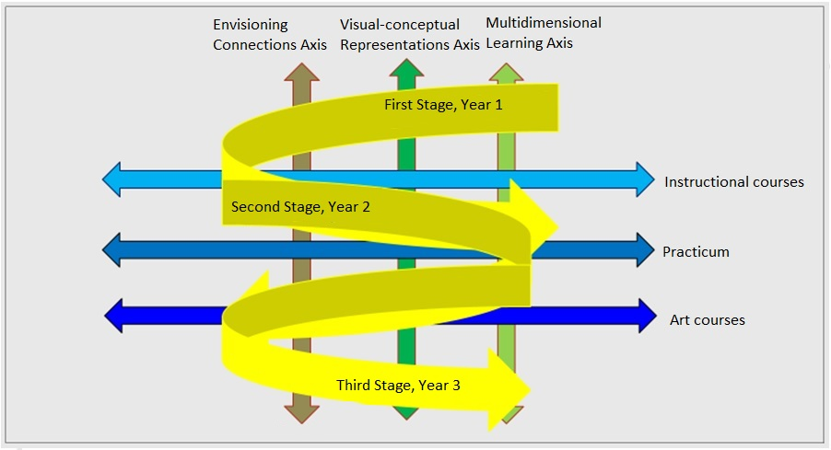

**Diagram 1: Model of the training process in the Creativity in Early Education track**

The three-stage training that takes place in the parallel arenas of the kindergarten practicum, instructional college classes, and art courses, allows students to receive cumulative training along the three axes, helping them acquire and assimilate a language of creativity, develop their skills as teachers of creativity, and nurture children using the distinctive language of the Creativity in Early Education track.

Throughout the three years of training, the students develop and crystallize an understanding of the core of “education for creativity” and creative thinking. They internalize the insight that creativity is not limited to the arts in the narrow sense, but is a worldview that is broadly applied in education: “The track is creative not necessarily because of the arts, but because of the creative ways to reach each and every child,” (Stav). Moreover: “When I began this track, I was sure that creativity and I were on two parallel lines. As time went on, I found the connection. I discovered the creative thinking that lies within me. When the way was right for me, when I was given the opportunity to show my way of thinking to express myself and create, I rediscovered myself, I found the Arbel who learns and is able and capable. Those were three years of building, designing and discovering myself [...] The most important thing I have received is the confidence that I can do it!" (Arbel). The imagination and innovation (Robinson, 2016), discovery and wonder (Alexander, 2016), that are rooted in a sense of inner security and freedom, which are the conditions for the development of creativity (Rogers, 1973), make the college students valuable in their own eyes, and capable of creative thinking, expressing values, and empathy (Glasner, 2016).

This discovery did not occur only among the students. We, the instructors, also experienced the wonder of discovery. For years we have worked according to the principles formulated by the founders of this track. We have designed curricula, participated in the selection and construction of courses, and mentored students at the college and in the field. But only after conducting this study did the full picture became clear to us. We discovered that we were, in fact, acting according to a model for the application of the principles. We had not been aware of this training model, which enables the formation of a professional identity of a creative educator.

The model extracted from the study makes it possible to understand how the training methods used in this track are adapted to its fundamental principles, which have been maintained since its inception. These principles are reflected in the words of the current students and graduates, as one said: “Creativity is like a kind of compass. It is always here [points to her heart]. Sometimes it deviates, but it is here, always coming back.” This type of research is groundbreaking, just as the Creativity track was at the time of its founding. We hope that this model will lead to further research regarding programs to train educators to teach creativity to young children. Further, we hope it will inspire future research on how this model and its underlying principles can be applied to formation of the professional identity among this population and in the world of training for early education teachers.

**References**

Armstrong, T. (1996). *Multiple intelligences in the classroom*. ASCD.

Avinon, Y. (2014). Cultivating intuitive thinking in education. *Education and its Environment: The Kibbutzim Seminar,* *36*, 103-118.

Birnbaum, M. (1997). *Alternatives in achievement evaluation*. Tel Aviv: Ramot Publishing.

Denzin, N. K. & Lincoln, Y. (2000). *Handbook of Qualitative Research* *(2nd ed.).* Thousand Oaks, CA: Sage Publications.

Flavell, J. H. (1976). Metacognitive aspects of problem solving. In L. B. Resnick (Ed.), *The Nature of Intelligence* (pp. 231-235). NJ: Hillsdale, Erlbaum.

Gardner. H. (1996). *Multiple intelligences: Theory put into practice*. Tel Aviv: Branco Weiss Institute.

Gaskel, J. (2011). Individual and group interviews. In Martin V. Bauer and George Gaskell (Eds.), *Qualitative research: Methods for analyzing text, image and sound* (pp. 49-68). Raanana: The Open University.

Gibton, D. (2001). Field-based theory: The meaning of the data analysis process and the construction of the theory in qualitative research. In N. Sabar Ben Yehoshua (Ed.), *Traditions and currents in qualitative research* (pp. 195-227). Lod: Dvir.

Green, M. (2019). *Releasing the imagination: Essays on education, the arts, and social change.* Translated by Tami Elon-Ortal; Scientific editor: Nimrod Aloni. An abbreviated version of the English version. Bnei Brak: United Kibbutz Publishing.

Guilford, J. P. (1950). Creativity*. American Psychologist, 50,* 444-454.

Hase, S. & Kenyon, C. (2007). Heutagogy: A child of complexity theory: *An International Journal of Complexity and Education, 4*(1), 111-118.

Jason, L. & Glenwick, D. (2016). (Eds.). *Handbook of methodological approaches to community-based research: qualitative, quantitative, and mixed methods.* New York: Oxford University Press*.*

Kacen, L., & Krumer-Nevo, M. (Eds.) (2010). *Data analysis in qualitative research*. Be'er Sheva: Ben-Gurion University of the Negev Publishing House.

Kaniel, S. (2006). *Education for thinking: Cognitive education for the control of consciousness*. Tel Aviv: Ramot - Tel Aviv University.

Klein P., & Yablon J. (2008). (Eds.). *From research to practice in early childhood education.* Jerusalem: Committee for the Examination of Early Childhood Education, The Israeli National Academy of Sciences.

Kuzminski, L. (2014). *Voice and choice of training for teaching*. Lexi-Kay 28-3 Kay Academic College of Education.

Landau, A. (1997). Creativity. In Y. Keshti, M. Arieli, & S. Shelsky (Eds.), *Lexicon of education and teaching* (pp. 227-228)*.* Tel Aviv.

Landau, A. (2001). *The courage to be talented*. Tel Aviv: Dvir.

Lieblich, E., Tuval-Mashiach, R. And Zilber, T. (2010). Between the whole and its parts and between content and form. In L. Kacen and M. Krumer-Nevo (Eds.), *Data analysis in qualitative research* (pp. 21-42). Beer Sheva: Ben Gurion University of the Negev.

Lincoln, Y. S., & Guba, E. G. (2000). Paradigmatic controversies, contradictions, and emerging confluences. In N. K. Denzin, & S. L. Lincoln (Eds.), *Handbook of qualitative research,* (2nd ed.) (pp. 163–188). London: Sage Publications.

Margaliot, A. (2012). *In the full sense of the word*. Mofet Institute.

Noddings, N. (2012). The caring relation in teaching.*Oxford Review of Education 38*(6), 771–781.

Robinson, K. (2016). *Creative schools: The revolution that is growing from below and changing education*. Jerusalem: Keter.

Rogers, R. K. (1973). *Freedom to study*. Tel Aviv: Poalim Library.

Shakedi, A. (2007). *Words that try to touch: Qualitative research - theory and application*. Tel Aviv: Ramot Publishing - Tel Aviv University.

Shakedi, A. (2011). *The meaning behind the words: Methodologies in qualitative research - in practice.* Tel Aviv: Ramot Publishing - Tel Aviv University.

Shapir, S., Anar, T., & Farber, M. (1995). *Integrating arts in teaching: Creativity education*. Published by the Ministry of Education and the Mofet Institute.

Shem Tov, N. (2015). *Improvised teaching: This is not a bad word*. Tel Aviv: Mofet Institute.

Strauss, A. L. & Corbin, J. (1990). *Basics of qualitative research: Grounded theory procedures and techniques*. Newbury Park, CA: Sage.

1. All names are pseudonyms.