**Marking the Jews**

**Opening paragraph**

When World War II broke out, the Germans ordered Jews to wear a badge to mark their Jewish identity.

In certain areas Jews had to wear a yellow patch shaped like a Star of David, and in other areas they had to wear a white armband with a blue Star of David.

The order that they must be marked was humiliating for Jews. It made it possible to identify them as Jews and separated them from other people. Jews who did not wear the mark on their clothing could be punished.

**Opening photo**

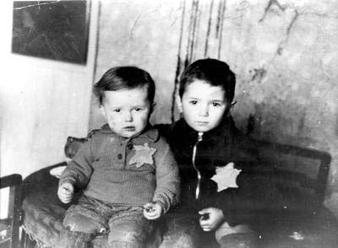

**Children in the Kovno Ghetto**

**Written testimony section**

**Why do they mark us?**

“I’m thirteen, Saba (a girl’s name) in fifteen; but we’re no longer young. I glance quickly at Saba and my eyes rest for a moment and the yellow Star of David on her coat. I want to cry out of anger. Why? Why do they mark us? Why do they humiliate us so?”

Ruth Minsky-Sender, age 13, Lodz, Poland, in *Through Our Eyes: Children’s Experience of the Holocaust*, edited by Yitzhak B. Teitelbaum (Jerusalem: International School for Holocaust Studies, Yad Vashem, 2004), p. 76 [Hebrew].

“Before long an order was issued requiring all Hungarian Jews to sew a yellow Star of David on their outer clothing in order to differentiate them and make them stand out. This humiliation hurt me very much… I was the only Jew in my class, and you can easily imagine that it was not with a light heart that I entered school on the first day I wore the yellow patch.”

Moshe Zandberg from Hungary, in *Through Our Eyes: Children’s Experience of the Holocaust*, edited by Yitzhak B. Teitelbaum (Jerusalem: International School for Holocaust Studies, Yad Vashem, 2004) [Hebrew].

Below is a list of different emotions. Click on the emotions that Ruth and Moshe felt following the order to wear a yellow patch, and drag them into the yellow patch shown.

Anger @

Sadness @

Worry

Humiliation @

Jealousy

Pride

“I was not ashamed of the patch…”

“… I remember we were two friends. The first time we went outside with this patch, we also took out her necklaces (she also had a necklace with a Star of David), and we walked along proud of being Jews! I was not embarrassed by the patch. I was actually proud!”

Bilha Shefer, Germany, Yad Vashem Testimonies Archive

Bilha Shefer was born in Germany in 1932. She describes how she wore the yellow star for the first time and how proud she felt when she went out to the street with it – in contrast to Ruth, who felt humiliated.

Why do you think the two girls had such different feelings?

**Object section**

The badges that Jews had to wear differed across different countries in terms of shape, color, and where they were placed on the clothing. Click on the following link and have a look at the variety of badges.

<https://www.yadvashem.org/he/artifacts/featured/jewish-badges.html>

What is the most noticeable difference among the badges?

Color

Shape

**Language**

**Drawing section**

The following two drawings show children wearing different markings.

Look at the two drawings:

**Holocaust Children and the Yellow Star**, Paul Fux

**The Armband Seller in the Ghetto**, Halina Olomucki

In what way are the drawings similar? In what way are they different?

Write your conclusions in the table:

|  |  |
| --- | --- |
| What is different? | What is similar? |
|  |  |

**Video testimony section**

Zvi Aviram – 30:52 – 31:47 <https://youtu.be/kLYqWiMt8zA>

Zvi Aviram, who was born in Germany, describes how he refused to wear the yellow patch. Watch his testimony – why do you think he did not wear the patch even though he knew he could be punished?