**Interaction between Risk and Resilience Factors in Body Dissatisfaction: Body Diversity and Body Comparisons**

Shir Ada Basson and Noam Weinbach

School of Psychological Sciences, University of Haifa, Haifa, Israel

Corresponding Author: Noam Weinbach, School of Psychological Sciences, University of Haifa. Abba Khoushy Ave 199, Haifa, Israel, 3498838 Email: [nweinbach@psy.haifa.ac.il](mailto:nweinbach@psy.haifa.ac.il)

Declarations of interest: none

# **Abstract**

Internalization of the thin-ideal leads women to develop their sense of self-worth by comparing their body size with those of others. Exposure to body diversity has been suggested as a buffer against the harmful manifestations of the thin-ideal. The current study examined how far different forms of body comparison interact with the effects of exposure to body diversity on state body image. Female adolescents and young adults (N = 241) were randomly allocated to one of three experimental groups. Participants in each group watched a sequence of photos of pairs of women with diverse body sizes. State body image was assessed before and after the tasks. In one group, participants merely watched the images without an ancillary task. In a second group, they compared the body sizes of the two women depicted in the photos. The third group compared their own body size with those of the women in the photos. Replicating previous findings, we found that watching diverse bodies improved state body image. However, this improvement was eliminated when participants engaged in body comparisons. Moreover, for participants with low trait body image, a comparison of their own bodies to those in the photos increased their body dissatisfaction. The results were not moderated by age. This study demonstrates that making body size comparisons may transcend the positive effects of body diversity exposure, and it highlights the importance of understanding the interactions between risk and resilience factors for body dissatisfaction.

Key words: body diversity, body comparison, body dissatisfaction, thin ideal

# **Introduction**

The body standards presented in the media are often unrealistic and constitute a central channel for the development and preservation of body image concerns among women (Aparicio-Martinez et al., 2019). Research has shown that the images of women presented on contemporary media platforms show women thinner than ever before, contributing to and increasing the ideal of extreme thinness (Bozsik et al., 2018; Fouts & Vaughan, 2002; Greenberg et al., 2011).

Several prominent meta-analyses have suggested that exposure to the thin-ideal has a wide range of negative implications for individuals’ body image (Want, 2009). Media exposure to images representing the thin-ideal have been found to be associated in women with generalized body dissatisfaction, overinvestment in the appearance, and disordered eating behaviors (Grabe et al., 2008). Other studies have shown an association of thin-ideal exposure with higher levels of state self-objectification (Harper & Tiggemann, 2008), negative mood (Convertino et al., 2019; Harper & Tiggemann, 2008; Livingston et al., 2020), low explicit self-esteem (Balcetis et al., 2013; Hawkins et al., 2004), and body image anxiety (Chatard et al., 2017). These findings indicate that body image is heavily influenced by thin-ideal exposure.

The negative impact of thin-ideal exposure is especially relevant during adolescence, which is a critical period for the development of the body image. Adolescents experience cultural, social, physical, and psychological changes that come together to uniquely influence body-image perceptions (Reel et al., 2015). Adolescents are significantly more vulnerable to intense body-image-related pressures than adults (Carey et al., 2014; Markey, 2010). These pressures are often transmitted through social media platforms. Adolescents show the highest levels of social media use among all age groups (Markey, 2010), and they mainly use visual-based social media platforms (Burnette et al., 2017). It has also been shown that among 13- to 15-year-old girls, body-image concerns and thin-ideal internalization become more severe the longer that they spend on social media (Tiggemann & Slater, 2013). The greatest decrease in body satisfaction after exposure to thin-ideal imagery is found in adolescents under 19 years old (see review in Blaivas et al., 2002). Considering the ongoing exposure to thin-ideal images in the media, it is not surprising that this is a central pathway through which adolescents evaluate their appearance, comparing their own bodies to those of others.

Body comparison is a dominant risk factor for the maintenance of poor body image (Anixiadis et al., 2019; Fardouly & Rapee, 2019). According to Social Comparison Theory (Festinger, 1954), human beings have an innate drive to evaluate their own social and personal worth. In the absence of an objective, non-social basis for making a determination, comparisons with others must be made. A central aspect of the evaluation of body attractiveness is the comparison of the self to available social standards (Want, 2009). Brown and Tiggemann (2016) showed that body comparison mediates the effects of exposure to images of attractive peers or celebrities on Instagram and body dissatisfaction among adult women. Moreover, engaging in body comparison is associated with higher levels of negative mood (Anixiadis et al., 2019) and the desire to change one’s body and face (Fardouly & Rapee, 2019). A meta-analysis of studies in adolescents found that the association between body comparison and body dissatisfaction is stronger among younger age groups (Myers & Crowther, 2009).

In the light of the harmful manifestations of thin-ideal exposure and body comparisons, it is important to assess potential resilience factors. A growing body of literature has suggested that exposure to body diversity may operate as a buffer against thin-ideal exposure (Bell et al., 2017; Rodgers et al., 2019; Stewart & Ogden, 2020). It has been shown that body diversity exposure and body satisfaction are highly correlated (Bell et al., 2017; Ogden et al., 2020; Rodgers et al., 2019; Stewart & Ogden, 2020). Moreover, a recent experimental study showed that exposure to body diversity (i.e., exposing participants to pictures of bodies of different sizes) resulted in higher body compassion and body satisfaction, as well as stronger negative attitudes towards the thin ideal among young women (Ogden et al., 2020), illustrating a causal impact of body diversity on body satisfaction.

The potential role of body diversity exposure as a buffer against thin-ideal exposure seems promising. Nevertheless, several uncertainties regarding the role utility of body diversity exposure as a means of promoting healthy body image remain. First, it remains unclear how exposure to body diversity interacts with known risk factors for the maintenance of body dissatisfaction, such as body comparison. Specifically, previous studies that assessed the influence of body diversity exposure on body image did not ask participants to compare their own bodies with those depicted in the images (Convertino et al., 2019; Ogden et al., 2020; Rodgers et al., 2019; Stewart & Ogden, 2020). Moreover, studies on body diversity did not include adolescents, an at-risk group, as a specific group of interest and did not include adolescents below the age of 16 (Convertino et al., 2019; Ogden et al., 2020; Stewart & Ogden, 2020). Finally, studies of body comparison did not expose participants to diverse body images (Brown & Tiggemann, 2016; Convertino et al., 2019; Tiggemann & Polivy, 2010). In a natural environment, individuals commonly compare their appearance with those of their peers, colleagues, and friends, who tend to have more diverse bodies than those depicted in the media. Thus, understanding the impact of body comparison on body diversity exposure would be more ecological.

In the current study, we elucidated potential interactions between body diversity exposure and body comparisons among female adolescents and young adults. Taking an experimental approach, we examined the causal influence of different types of body comparison on state body image after exposure to body diversity. In this study, adolescents and young adults were randomly assigned to one of three experimental groups. Each group completed an online task in which they were exposed to diverse body sizes presented in pairs on two sides of the screen. Participants’ state body image was assessed before and after the tasks. The three groups differed only in what they were asked to do while watching the body images. In one group, they merely observed the images, in the second group they compared the body size between the two images presented, and in the third group, they compared their own body size with those depicted. The ages of the participants (adolescents vs. young adults) and trait body image (high vs. low) were assessed as potential moderators.

The main hypotheses of the proposed study were in line with those of previous research (Ogden et al., 2020; Stewart & Ogden, 2020), namely, that merely observing diverse bodies would improve state body image. However, comparing their own bodies with those depicted on the screen (i.e., self-to-other comparison) was expected eliminate the beneficial effects of exposure to body diversity. The influence of comparing body size between images on the screen and state body image was tested on an exploratory basis, as no previous studies have assessed how comparing others to others influences the comparer’s state body image. However, this condition is important for isolating the element of self-reference in body comparisons. Finally, we expected that adolescents would show a greater decline in their state body image than young adults when comparing self-to-other, and especially among those with poor trait body image.

# **Methods**

*Participants*

The current study included a sample of 241 female participants, divided into two age groups: adolescents (N = 121, age range 12–18 years) and young adults (N = 120, age range 18–30 years). The participants were randomly assigned to one of the three experimental groups as detailed below. To assess the trait body image as a potential moderator, participants were further divided between high vs. low trait body image based on the median score for the Body Shape Questionnaire (BSQ) within each age group. The adult participants were recruited via the University of Haifa participants’ pool and social media in exchange for course credit or payment. The adolescent group was recruited via social media in return for a monetary reward. All participants were invited to participate in an online experiment on body image.

*Measurements*

*The Body Image State Scale*

The Body Image State Scale (BISS; Cash et al., 2002) was used to measure the state body image of the participants before and after experimental manipulation. The BISS is a multi-item measure that assesses the momentary evaluative experiences of one’s physical appearance. This scale contains six items representing six domains of current body experience, such as satisfaction/ dissatisfaction with one’s overall physical appearance. Responses to each item are based on a 9-point bipolar Likert scale, semantically anchored at each point. The instructions were presented at the top of the screen and stated: “For each of the items below, check the box beside the one statement that best describes how you feel right now, at this very moment.”

*The Body Shape Questionnaire*

Trait body image was assessed using the 14-item version of the BSQ (Dowson & Henderson, 2001). This questionnaire focused on shape and weight concerns. Questions are scored on a 6-point Likert scale ranging from 1 (never) to 6 (always). Participants were asked to consider their feelings and thoughts for the last four weeks. The Cronbach’s alpha value for the BSQ in the current study was 0.95.

*Body mass index assessment*

Weight and height were based on self-report in order to calculate participants’ body mass index (BMI; kg/cm2).

*Experimental tasks*

The study included three experimental conditions: no body comparison group (No-BC), self-to-other body comparison (self-to-other BC), other-to-other body comparison (other-to-other BC). Each group completed a different task. In all three tasks, participants were shown a fixation mark at the center of the screen for 1,000 ms, followed by images of two women’s bodies on both sides of the screen (Figure 1). The images on both sides were of the same woman but differed only in the weight category (see below for elaboration on pictorial stimuli). The weight categories used were underweight, average body size, and overweight to manipulate exposure to body diversity (validation of the body diversity manipulation is detailed below). The task included the presentation of three types of pairs: overweight-underweight, overweight-average, and underweight-average. The task contained 120 trials, divided equally into two blocks. In the No-BC group, participants were only asked to observe the images (each image was presented for 1,500 ms). In the other-to-other BC group*,* the participants were asked to decide which of the two body images on the screen had a lower body weight, using the left and right arrow keys on the keyboard. In the self-to-other BC group, the participants had to make a left or right key choice based on the image they judged to be more similar to themselves in terms of body size. The experimental tasks were designed using Psychopy and were run online using the Pavlovia repository (Peirce et al., 2019).

*Pictorial stimuli*

The body images used in the study were created using a virtual dressing room website ([www.metail.com](http://www.metail.com)). The images included photos of 20 women with different skin tones, facing the camera, wearing underwear, in three weight categories. Weight category division was based on BMI according to the above: underweight: BMI range 16.01–17.91, average weight: BMI range 22.26–23.71, overweight: BMI range 31.24–35.89. In total, there were 20 models in each weight category, resulting in 60 images overall.

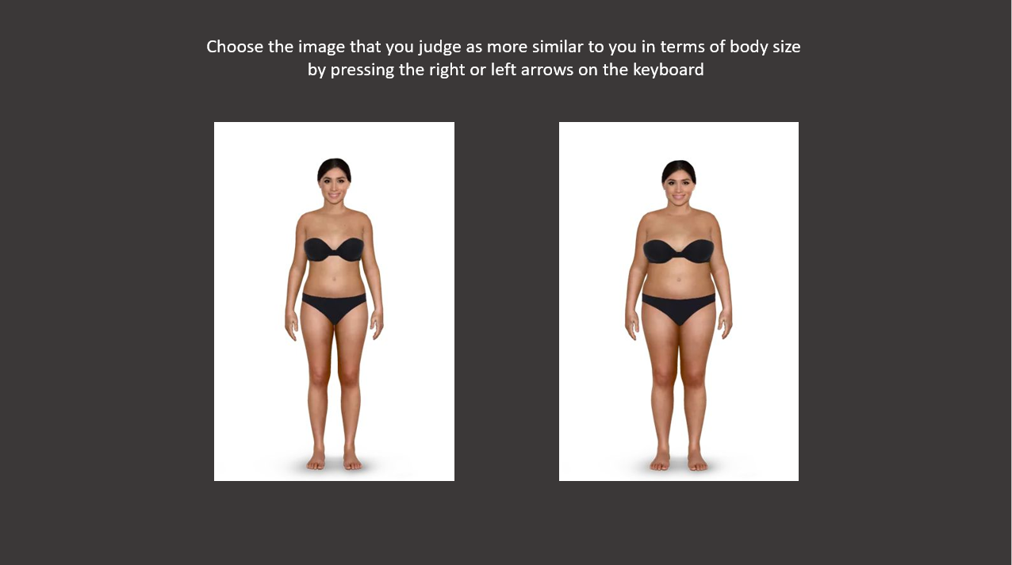

**Figure 1.** An example of an experimental trial in the self-to-other BC task. Images were created with permission of a virtual dressing room website (www.metail.com).

*Validation of the body diversity exposure manipulation*

To ensure that the body images that were selected for the current study represent exposure to body diversity, we conducted a small pilot in which the images were centrally presented to young adult female participants on a trial-by-trial basis. State body image was assessed before and after the manipulation. The results replicated previous findings on the beneficial effects of body diversity exposure (Ogden et al., 2020; Stewart & Ogden, 2020) and showed a significant pre-to-post decrease in body dissatisfaction (*p* = .005). Full methods and data for this pilot are presented in the Appendix.

*Procedure*

The participants were invited to take part in an online study via advertisements on social media. The study was approved by the Department of Psychology IRB committee at the University of Haifa. All participants signed an informed consent document before beginning the study. For participants below the age of 18, consent was obtained from the parents as well. After consent was acquired, participants received an online link to complete the BSQ and reported their height and weight. Then, participants were assigned randomly to one of the three experimental tasks. Before and after the experimental task, state body image was measured using the BISS. Finally, participants were debriefed regarding the purpose of the study.

# **Results**

*Demographic and clinical characteristics of the sample*

The two age groups were not different in terms of BMI or trait body image (see Table 1).

**Table 1.** Means and standard deviations (in parentheses) of demographic and clinical measures as a function of age group.

|  |  |  |  |  |  |  |  |
| --- | --- | --- | --- | --- | --- | --- | --- |
|  | Adolescents |  | Adults |  | *p* |  | Cohen’s d |
| Age | 15.72 (1.5) |  | 22.91 (3.16) |  |  |  |  |
| BMI | 20.95 (3.48) |  | 22.65 (3.40) |  | <.001 |  | -0.49 |
| BSQ | 42.48 (17.13) |  | 42.30 (16.75) |  | .901 |  | 0.01 |

*Note.* BMI = body mass index; BSQ = body shape questionnaire;

*Results of the experimental tasks*

Data were checked for outliers by assessing the means and standard deviations of the response times in each experimental task. One participant was excluded for having extremely slow reaction times in the self-to-other BC task (3.96 standard deviations above the mean).

To ensure that the participants were equally distributed to the different group conditions, we carried out univariate analyses of variance (ANOVAs) showing that there were no a-priori differences between the experimental groups in trait body image (BSQ), *F*(2, 237) = 1.22, *p* = .29, *ƞ2p* = .01, or baseline levels of state body image, *F*(2, 237) = 0.53, *p* = .58, *ƞ2p=*.005.

To assess our main hypotheses, state body image (measured with the BISS) was analyzed using a mixed-factors ANOVA with age group (adults / adolescents), condition (no BC, other-to-other BC, self-to-other BC) and trait body image (high / low) as independent between-subject factors and time of measurement (before / after) as a within-subject independent variable. Contrary to the hypotheses, the age group effect was not significant and did not interact with any other variable (all *p* < .39). However, the results indicated a three-way interaction between trait body image, condition, and time of measurement *F*(2, 218) = 5.09, *p* = .007, *ƞ2p=* .04 (see Figure 2).

Planned comparisons assessed time × group interactions in the high and low trait body image groups separately. The analyses showed that among participants with low trait body image, there was a pre-to-post decrease in body dissatisfaction in the no-BC group, *F*(1, 228) = 5.92, *p* = .019. This decrease was also observed in the other-to-other BC group, *F*(1, 228) = 17.31, *p* < .001. Furthermore, in line with this hypothesis, there was no similar decrease in the self-to-other group. In fact, the results showed an increase in body dissatisfaction after participants compared their own body to those depicted in the images, *F*(1, 228) = 4.15 *p* = .049.

Among participants with high trait body image, the analyses showed a significant decrease in body dissatisfaction in the No-BC group, *F*(1,228) = 4.20, *p* = .048, but not in the other-to-other BC group, *F*(1,228) = 0.049, *p* = .827 or in the self-to-other BC group, *F*(1,228) = 0.813, *p* = .37.

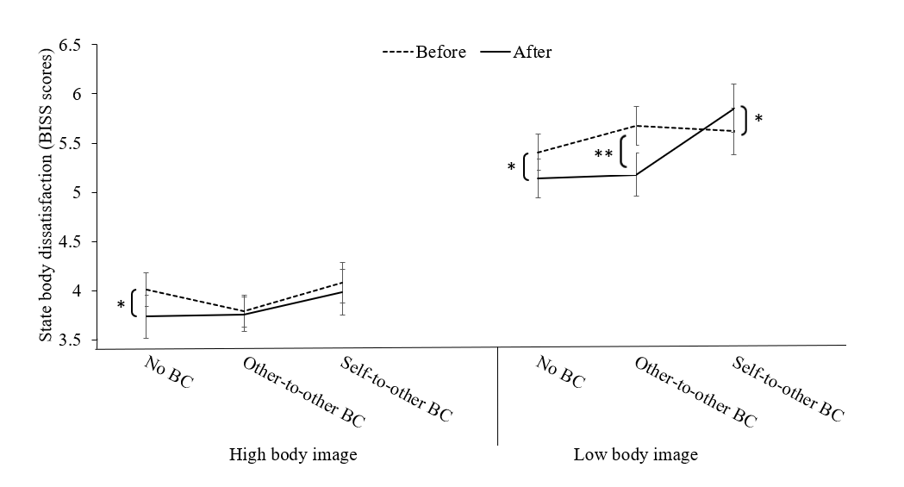

**Figure 2.** Results of the BISS score as function of tome measurement, condition group, and trait body image. Error bars represented standards errors. * *p* < .05, ** *p* < .01

# **Discussion**

The present study examined the ways in which exposure to body diversity and body comparison influence state body dissatisfaction among female adolescents and young adults. Participants either merely observed photos representing body diversity or engaged in one of two forms of body comparisons while observing the photos (i.e., comparing self-to-other or other-to-other). In line with our hypothesis, observing images that represent body diversity without any action reduced state body dissatisfaction in all groups. However, a comparison of the body sizes of the images presented to one another (i.e., other-to-other BC group), body diversity exposure reduced body dissatisfaction in those with low but not high trait body image. Importantly, when participants compared their own body size to those depicted in the pictures (i.e., self-to-other BC group), body diversity had no effect on those with high trait body image but led to an increase in body dissatisfaction in those with low trait body image. In contrast with this hypothesis, the age group did not moderate any of the reported effects.

While many studies separately assessed risk factors and protective factors for body dissatisfaction, this study offers a new perspective on how well-established risk factors (i.e., body comparisons) and resilience factors (i.e., body diversity exposure) interact. Multiple studies have shown that thin-ideal exposure increases body dissatisfaction among women (Anixiadis et al., 2019; Blaivas et al., 2002; Brown & Tiggemann, 2016; Convertino et al., 2019; Want, 2009). A growing body of literature has demonstrated that exposure to body diversity can act as a buffer against thin ideal exposure and increase body satisfaction (Bell et al., 2017; Ogden et al., 2020; Rodgers et al., 2019; Stewart & Ogden, 2020). The findings of this study further support this conclusion by showing that exposure to diverse body sizes increased body satisfaction among female adolescents and young adults. While previous studies have manipulated body diversity by presenting videos of women with different body sizes (e.g., Ogden et al., 2020b; Stewart & Ogden, 2020), this study used a highly controlled paradigm in which the same women appeared in three optional weight categories.

This study also demonstrated that the benefits of body diversity exposure depend on how the way in which participants relate to the depicted images. Specifically, we showed that engaging in different types of body comparisons while being exposed to body diversity can influence body satisfaction. out results revealed that when participants compared their own bodies to those depicted in the images, body diversity did not increase body satisfaction. In fact, for those with low trait body image, body satisfaction was significantly reduced in this condition. Previous studies of body comparisons did not take into consideration the different types of body comparisons that can be made (Anixiadis et al., 2019; Brown & Tiggemann, 2016; Fardouly & Rapee, 2019; Tiggemann & Polivy, 2010). This study showed an increase in body dissatisfaction among those with low trait body image only when comparing self-to-other but not when comparing other-to-other. This emphasizes the important role of self-reference in modulating body satisfaction when engaging in body comparisons.

No interaction was seen between age group and any other variable. This finding is inconsistent with previous research, which emphasizes adolescents’ high vulnerability to body-related pressures, body dissatisfaction, and unhealthy appearance-related attitudes and behaviors, and it did not support the study hypothesis (Blaivas et al., 2002; Webb & Zimmer-Gembeck, 2014). Thus, body diversity exposure and body comparisons may operate in similar ways among between female adolescents and young adults.

Several potential clinical implications of the current study should be noted. First, the findings further indicate that exposure to body diversity is an important method to promote healthy body image. Such exposure may increase awareness and a more realistic and open-minded view regarding the diversity in sizes and shapes of women’s bodies (Rodgers et al., 2019). Addressing body diversity may encourage the establishment of healthy internal representations of ideals, norms, and standards regarding body size (Ogden et al., 2020). Nevertheless, the findings indicate that when investigating protective factors against body dissatisfaction, it may be crucial to consider their potential interaction with risk factors. Specifically, we showed that the harmful influence of comparing one’s body size with others transcends the beneficial effect of body diversity, especially in those with low trait body image. Thus, any program intended to promote healthy body image by discussing body diversity, should, at the same time, target reductions in body comparisons.

Several limitations to the current study should be acknowledged. First, participants completed the task at homes using an online link, which may have limited our control of the environment in which participants completed the experiment. Second, all participants were presented with the same images, which included only young adult women. Thus, the younger adolescents in our samples might have had difficulty relating to the images. Third, BMI was determined using self-report, which limits its reliability. Fourth, in the current study we did not screen participants for past or current presence of eating disorders.

Despite these limitations, the current study extends the knowledge regarding body diversity exposure and its interaction with body comparisons. The results reported here provide evidence for the beneficial effects of body diversity exposure on body satisfaction. Nevertheless, the findings also suggest that the ways in which people relate to diverse body sizes is an important factor that can determine its influence on body image. Hence, this study sheds light on the dynamic relationship between risk and resilience factors in body satisfaction. Future experimental investigations should seek to extend our knowledge of other ways in which risk factors and reliance factors for body dissatisfaction interact.

**Acknowledgments**

We thank Noa Shkotai for her help with data collection.

# **Appendix A**

To validate that the images of women’ bodies selected for the current study adequately represented body diversity, we conducted a small-scale study to assess whether exposure to these images replicate previous results regarding the beneficial influence of body diversity exposure on state body image (Ogden et al., 2020; Stewart & Ogden, 2020)

*Method*

*Participants*

The study included a sample of 40 female young adults (age range 18–30 years, *M* = 24.95, *SD* = 2.65) who were randomly allocated into two experimental groups. All participants were recruited via social media (e.g., Facebook, WhatsApp) in return for a monetary reward.

*Measurements*

*Self-report questionnaires*

The participants’ state body image was assessed before and after the experimental manipulation using the body image state scale (BISS).

*Body diversity vs. no diversity exposure*

Participants were randomly allocated to one of two exposure conditions: body diversity exposure or no diversity exposure (N = 20 in each group). In each trial for both exposure manipulations, a fixation mark appeared on the screen for 1,000 ms, followed by an image of a woman’s body that was centrally presented. The instructions at the top of the screen instructed participants to “Watch the images.” Each image was presented for 1,500 ms. In the body diversity exposure condition, the images presented were similar to those within the main study and included 20 women models that appeared in three weight categories: underweight, normal, and overweight. In the no-diversity exposure condition, only body images of the low weight category were presented. The exposure manipulation consisted of 120 images in both condition (i.e., six repetitions for each of the 20 models for the no-diversity exposure condition, and two repetitions for the diversity exposure condition).

*Results*

The results were analyzed using a mixed-factors analysis of variance (ANOVA), with BISS scores used as the dependent measure and condition (diversity \ no diversity) as an independent between-subject factor, with time of measurement (before \ after) as a within-subjects independent variable. Consistent with the hypothesis, the results showed a significant decrease in body dissatisfaction after (*M* = 4.70, *SD* = 0.90) compared to before (*M* = 4.91, *SD* = 0.78) exposure in the body diversity condition, *F*(1, 38) = 9.82, *p* = .005. No such difference was found in the no-diversity condition (before; *M* = 4.63, *SD* = 1.57, after: *M* = 4.49, *SD* = 1.65), *F*(1, 38) = 1.04, *p* = .31. These results indicate that the images selected for the main study are adequate for use as a body diversity exposure manipulation.