[hw: Hamburger Abendblatt from July 28, 1999]

HAMBURG

HAMBURG [hw: personal]

Telephone 34 72 33 40 and 34 72 28 01 Fax 34 72 33 45

Eliad Sharony: Bernstein Was Like a Father to Him

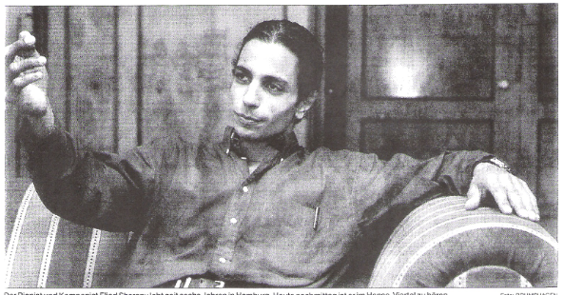

The pianist and composer Eliad Sharony has lived in Hamburg for the past six years. This afternoon, his music can be heard in Hansaviertel. Photo: BRUMSHAGEN

**M**usic is my world, my life.” For someone who is 30 years old, Eliad Sharony uses unusually big words without pathos, spontaneously. When this realization first overcame him, the pianist and composer from Israel, who has lived in Hamburg for the past six years, doesn’t quite remember. “I first got a piano when I was 15. Before, I had only played a keyboard and a lot of sports. At some point, the music was there and came into me like a seed.” Like an explosion: Only one year later, the son of two Jewish-Yemeni teachers, who grew up near Tel Aviv, entered the “Jerusalem Rubin Academy for Music and Dance.” One year after that, Leonard Bernstein became aware of the young musician - he taught and supported Sharoni even after his graduation from the Academy with honors and his service in the military until Bernstein's death in 1990. “It took me a long time to get over the death of the Maestro,” the spirited pianist with the joyful laugh and arresting eyes said, suddenly serious, “I lost a second father, and a mentor.”

Sharoni found comfort in his music, gained strength from his deep faith. And from his meeting with the psychologist and agent Ruth Zucker, who began promoting him after having heard him at a concert in Israel. Through her, the bearer of a Federal Cross of Merit, Sharoni came to Germany: to the Schleswig-Holstein Music Festival in the masterclass of Justus Frantz. He happened to stay in Hamburg: “Friends lived here.” And also another teacher and mentor: Professor Eliza Hansen, teacher at the Academy for Music and Theater. “He's a truly passionate person, someone it is a joy to help,” she wrote in her student’s diploma after two years, “a very gifted young person, who rightly sees music as his calling.”  
Today, Eliad Sharoni has created three demo tapes, and has also composed music for films and for the musical “The Dybbuk.” “I don’t yet know what musical direction I’ll take. But I know my path. And I will show the people who have believed in me that their effort was worth it.”