War of Words: Virtualizing the Israeli –Palestinian Conflict on Facebook in Times of Crisis
Iman Garra-Alloush and Wissam Magadley
Abstract
The current study examines expressions of political opinions on Facebook in the wake of politically charged events occurring in the Israeli-Palestinian context. Using content analysis, we compared 539 randomly selected Facebook comments written by both Jews and Palestinians living in Israel, 296 by Jewish Israelis and 243 by Palestinian Israelis, in response to three political incidents that sparked heated discussions and exchanges of ethno-political insults between the two groups on social networks. For each incident, comments were categorized into the two major categories of offensive and friendly. The comments were then analyzed and the percentages of comments posted by Jewish Israelis and Palestinian Israelis in each category were compared. According to the findings, 66% of the total number of comments were categorized as offensive, of which 44% were posted by Jewish Israelis and 25% were posted by Palestinian Israelis. The findings reflect the tense and fragile relationship between Jewish and Palestinian citizens of Israel, and highlight the role of social network platforms such as Facebook in unleashing extreme political opinions, which may not surface otherwise.
Keywords: Israeli-Palestinian conflict, politically charged events, political expression, Facebook, Palestinian-Israelis.
Introduction
The increasing popularity of social media sites such as Facebook as platforms for expressing political content and opinions has been attracting increased research attention in recent years (e.g., Jang et al., 2014; Vraga et al., 2015). The easy and affordable access to Facebook, together with the heterogeneous and largely unknowable audience associated with it, provide rich ground for political disagreement and the exchange of heated and fiery online posts between users with differing political views (Coe, Kenski, & Rains, 2014). The growing expression of political disagreements on social media sites is attributed to the sites’ structures, that weaken social boundaries and facilitate contact among users holding conflicting political views (Brundidge, 2010).These factors are particularly pertinent in conflict-ridden countries such as Israel, whose citizens, Jewish and Palestinian, have been embroiled in the ongoing, long-standing, and still irresolvable Israeli–Palestinian conflict (Halperin & Bar-Tal, 2011).

In the Israeli context of heightened political conflict, discussing highly divisive political issues or events on social media platforms such as Facebook will most certainly result in confrontations and personal repercussions (John & Dvir-Gvirsman, 2015). These consequences are likely to be even more acute when the political issue under discussion is situated along the ethno-political demarcation line between Arabs and Jews. In this context, an individual’s willingness to express candid political opinion on Facebook, particularly in highly charged political times, may depend on whether the person belongs to Israel’s majority Jewish population, or to its minority Arab population. Parties to interethnic conflicts, such as the Israeli-Palestinian conflict, frequently have unequal levels of power and do not exhibit the same sense of threat or security (Rouhana & Fiske, 1995). As a result, those belonging to a majority or more powerful group are more likely to express their genuine opinions, whereas individuals in the minority may be less likely to express their true political opinions in order to avoid potential repercussions.
This study aims to explore and compare Jewish and Palestinian Israelis’ willingness to express political opinions on Facebook in the context of the Israeli-Palestinian conflict, particularly following highly charged political events. The comparison is based on content analysis of 539 randomly selected Facebook comments written by both Jewish and Palestinian Israelis in response to three news items about politically motivated incidents that sparked heated discussions and exchanges of ethno-political insults between Jewish and Palestinian Israelis on social media..The incidents under investigation include the killing of 'ash'at Milhim' the shooting of 'sraa Abed' both Palestinian Israelis, and the support by tnesset MemberJBezalel Smotrich of the Bayit HaYehudi (Jewish Home) Party for'segregated Jewish-Arab maternity wards in Israeli hospitals. Before examining theseTincidents wn more depth, fome historical and political background on the Palestinian minority in Israel is needed in order to clarify the context of this study.f
Background
Palestinian Israelis
After the Arab–Israeli war of 1948, only 156,000 Palestinians remained in that part of Palestine which had become the State of Israel. Cut off from the rest of the Palestinian people and physically, socially and culturally isolated from the rest of the Arab world, the remaining Palestinians formed a socially and politically weakened group in Israel (Al-Haj & Rosenfeld, 1990; Boymel, 2007). Although they were granted Israeli citizenship and received full legal rights, as a minority, Palestinian-Israelis have chronically suffered from limited political representation and a debilitated social, economic and educational infrastructure (Bekerman & Maoz, 2005). Referring to their political and social marginalization, the Israeli novelist David Grossman (1992), used the oxymoron “present absentees” to describe Palestinians in Israel.
Israel’s formal policy towards its Palestinian citizens has been determined by three main factors: the democratic character of the state; the Jewish-Zionist nature of the state; and security considerations. In the event of any conflict among these factors, the latter two prevail (Al-Haj, 2004; Al-Haj & Yaniv, 1983; Smooha, 1990). Because of the state’s democratic character, Palestinians in Israel have nonetheless enjoyed opportunities for political organization and activity, through which they have sought to improve their status and negotiate to advance the Palestinian case (Al-Haj, 2004).
However, the status and conditions of the Palestinians in Israel have been linked to and deeply affected by the Israeli-Palestinian conflict and the wider Arab-Israeli conflicts. These conflicts have profoundly influenced relations between Jews and Palestinians in Israel and have shaped the political identities of both groups. The conflicting and competing narratives regarding the conflict adopted by these groups continue to feed the perpetual tensions, animosity, suspicion and distrust between them (Amara, 2017). Furthermore, Jewish Israelis tend to perceive Palestinian Israelis as a “hostile minority” and a “security risk” because of their links with the Palestinians in the West Bank and the Gaza Strip, as well as with Arabs in neighboring Arab countries. These perceptions further deepen the schism between Jews and Palestinians in Israel, and have had a major impact on Israel's policies regarding surveillance and control of its Palestinian citizens (Al-Haj, 1996; Al-Haj, 2004; Smooha, 1989). The status of Palestinians in Israel has become even more vulnerable since the Al-Aqsa Intifada, which erupted in 2000 within the context of a serious crisis in the peace process (Al-Haj, 2004).

Palestinian Israelis and Political Expression in the Public Sphere
Despite Israel’s democratic character, Palestinian Israelis were for long reluctant to publicly display symbols of their Palestinian identity or express their political views towards the state of Israel for fear of security related repercussions. This apprehension may be a reaction to Israel’s effective employment of strategies of political control and surveillance on the Palestinian minority living within its borders since the founding of the state, despite the latter having always enjoyed Israeli citizenship (Sa'di, 2013). Cohen (2006) demonstrates that Israel was able to exercise tight surveillance with the help of the many collaborators and informers that it recruited to spy on and relay information about their colleagues, neighbors and friends to the authorities.
This situation has changed in recent years with the growth of social media. Now, expressing ones' identity and political views, traditionally done in private, has become mediatized through social networks sites such as Facebook (Enli & Thumim, 2012). Indeed, there has been a significant amount of research exploring the role of social media, and Facebook in particular, as an avenue for political expression and speech (e.g., Bond et al., 2012; Jang et al., 2014). Furthermore, scholars have stressed the importance of studying the unique nature of the Facebook context for expressing political content and conducting political discussion (Jang et al., 2014; Vraga et al., 2015).
Facebook as a Pplatform for Ppolitical Ddiscussion
Facebook’s uniqe qualities rnder it a distinct formatpfor political expression. The platform’s accessibility, combined witha he ease of interactingiwith hundreds of people simultaneously,,enableausers to convey information to aast audiences (Kuo et al., 2013), including those with differingwopinions, which rarely happens in most face-to-face social situations (Mutz, 2006). ConsequentlyH incendiary political posts on Facebook can result in heated debates, offended audiences, and even damaged relationships (Dvir-Gvirsman, Tzfati, & Menchen-Trevino, 2014; John & Dvir-Gvirsman, 2015). uring times of political crisis, Tontroversiesyand disagreements on Facebook can escalate to an extreme level, with tolerance and acceptance declining dt the same time tHuckfeldt, Johnson, & Sprague, 2004). This is particularly true in israel, a nation with the highest level of hFcebook users in the world (Karniel & Lavie-Dinur, 2012; Mor, KliglerVilenchik, & Maoz, 2015;.
John and Dvir-Gvirsman (2015) found that in the Israeli context of heightened conflict, discussing politics on Facebook could prove risky, resulting in confrontation and adverse repercussions. For example, John and Dvir-Gvirsman reported that during the 2014 Gaza War, Jewish Israelis judged other users harshly on the basis of their political statements, and sometimes blocked those users’ contents or unfriended them. Similarly, Mor, Kliger-Vilenchik & Maoz (2015) found that Jewish Israeli Facebook users were aware that posting political content, both in times of heightened political conflict and in calmer times, entailed risks such as disappointing family members, ending friendships and even damaging future career opportunities. However, despite the accompanying risks, they found that the majority of Facebook users were highly motivated to express their opinions on sensitive political issues. Mor, Kliger-Vilenchik & Maoz contend that because these users value open discussion, they are willing to pay the price.
For Palestinian Israelis, however, discussing politically sensitive issues on Facebook during times of heightened political tension can involve higher political risks. The consequences can be far more serious and extend beyond heated exchanges of racial slurs with fellow Jewish Facebook users. Posting an inappropriate comment can lead to the loss of employment or even arrest. In one case, during the 2014 Gaza War, an Arab educational psychologist was fired from her job at the Lod municipality after posting on Facebook that she was pleased about the death of Israeli soldiers. The mayor of Lod municipality, Ya'ir Rivivo, took to Facebook to announce her dismissal from her job and to launch into an angry tirade against her:
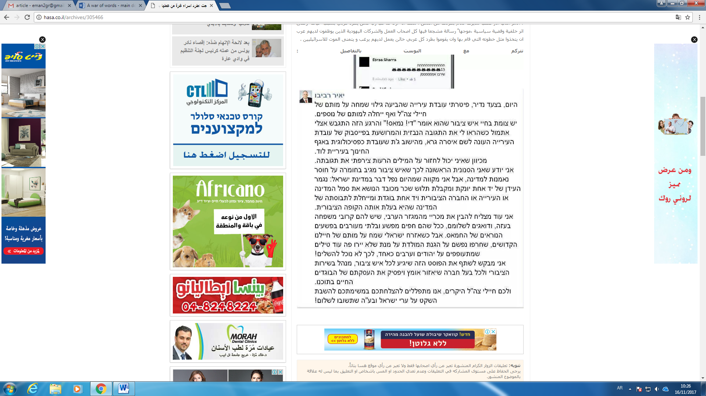

Another incident that was widely shared on Facebook and received extensive coverage on major Israeli and international news outlets was the arrest of Anas Abu Daabes, a well-known Palestinian Israeli blogger and social activist. Abu Daabes had posted a comment in Arabic on Facebook satirizing Palestinians who had expressed their delight on social media about the wildfires that blazed through Israel in November 2016. However, the police, having relied on automatic translation software to translate his post, misinterpreted his comments and mistakenly accused him of inciting Palestinian Israelis to commit further arson attacks. Incidents like these can make Palestinian Israelis reluctant to express their political opinions, particularly during times of heightened political tension. Furthermore, such incidents send a clear message to Palestinian Israelis that their Facebook posts are taken more seriously by the Israeli security apparatuses than are those of their Jewish counterparts. To support this claim, following the arrest of Abu Daabes, many Palestinian Israeli Facebook users posted screenshots of similar comments made by Jewish Israeli Facebook users that contained actual direct incitement to commit arson in Arab areas.

The Events under Examination
The first incident studied was the shooting of Israa Abed, 29, who was shot multiple times in the bus station in the city of Afula in October 2015. A video of the shooting shows Abed, a Nazareth resident, standing alone, surrounded by heavily armed Israeli police, before she was shot and badly wounded. She was suspected of planning to carry out a stabbing attack. The Israeli press reported that she had been holding a knife, a claim that was refuted by her father, who insisted that the police mistook her sunglasses for a knife.
The second incident was that of Nashat Milhim, the gunman who killed three Israelis in a shooting rampage in Tel Aviv in January 2016. Milhim, a Palestinian Israeli from the village of Arara, escaped the shooting scene and remained at large for a week before he was tracked down in his hometown by Israeli security forces and killed in an ensuing gunfight.
The third incident examined was the controversy surrounding a proposal made in April 2016 by Betzalel Smotrich, a 36-year-old member of Knesset (MK) from the ultra-nationalist Bayit Yehudi (Jewish Home) party, which is part of Prime Minister Netanyahu's coalition, calling for segregation between Jewish and Arab mothers in maternity wards in Israeli hospitals. His statement sparked an outrage from both left and right wing politicians and set social media ablaze with reactions.

Methodology
Krippendorff (2013) defines content analysis as a research technique whereby contextual inferences can be made from the text for the purpose of attaining replicable and valid results. Using this technique, researchers can address the consequences of communication enabling them to locate the cause and effect of communication throughout its explicit content (Drikson & Maschi, 2015). "It provides new insights, increases a researchers' understanding of particular phenomena, or informs practical actions" (Krippendorff, 2013, p.24).
Holsti (1969) offers a broad definition of content analysis as: "any technique for making inferences by objectively and systematically identifying specified characteristics of messages" (p. 14). Under Holsti’s definition, the technique of content analysis is not restricted to the domain of textual analysis, but may be applied to other areas, such as coding student drawings (Wheelock, Haney, & Bebell, 2000), or coding actions observed in videotaped studies (Stigler, Gonzales, Kawanaka, Knoll, & Serrano, 1999). In order to allow for replication, however, the technique can only be applied to data that are durable in nature. Content analysis enables researchers to sift through large volumes of data with relative ease in a systematic fashion (GAO, 1996). It can be a useful technique for enabling investigators to detect and describe the focus of individual, group, institutional, or social attention (Weber, 1990). Using content analysis, inferences can be made and then be corroborated using other methods of data collection. Krippendorff (1980) notes that "[m]uch content analysis research is motivated by the search for techniques to infer from symbolic data what would be either too costly, no longer possible, or too obtrusive by the use of other techniques" (p. 51).
Facebook has become a global documenting arena wherein anybody can express and chronicle whatever content they wish through posts, comments, links, and even screenshots. Before the advent of Facebook and other social media outlets, it was extremely difficult for individuals to document their attitudes and real-time reactions and discourse about current events. Today, the task of reporting and chronicling public attitudes is much easier given the pervasive use of social media.
In order to understand public reactions to politically charged events in the context of the Israeli-Palestinian conflict, the study applied content analysis to 539 randomly selected Facebook comments. The comments were screenshotted randomly from different Israeli Facebook pages and included comments of both Jews and Palestinians living in Israel that were made in response to controversial news items arising from the conflict between Jews and Palestinians.
In total, 296 comments by Jewish Israelis and 243 comments by Palestinians living in Israel were collected. The nature of the comments was then categorized. Comments including obscene, anti-social, or inflammatory language were categorized as comments with “offensive reactions.” Comments with clearly positive language or reactions were categorized as “friendly comments/reactions.”
Findings
As stated previously, this study examined reactions of Israeli Jews and Palestinians towards controversial events as expressed on Facebook and divided these reactions into two groups of offensive and friendly comments. This section presents a sample of the comments posted in response to the three incidents under study, together with their translations. A table summarizing the findings for each incident is also provided.
Incident I: The Shooting of Israa Abed
The following are samples of the comments posted by different Jewish Israeli Facebook users following this incident:
Comment 1 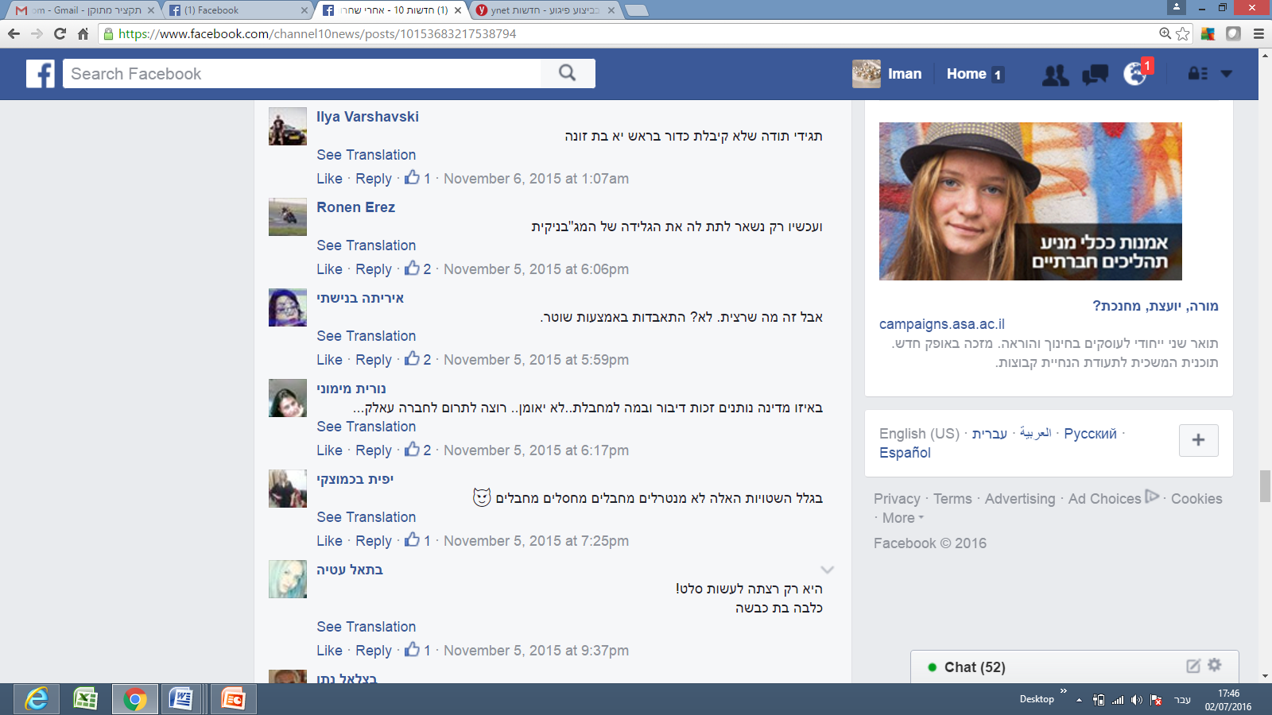
Translation: “Just be grateful that you didn’t get a bullet in the head, you bitch.”

Comment 2
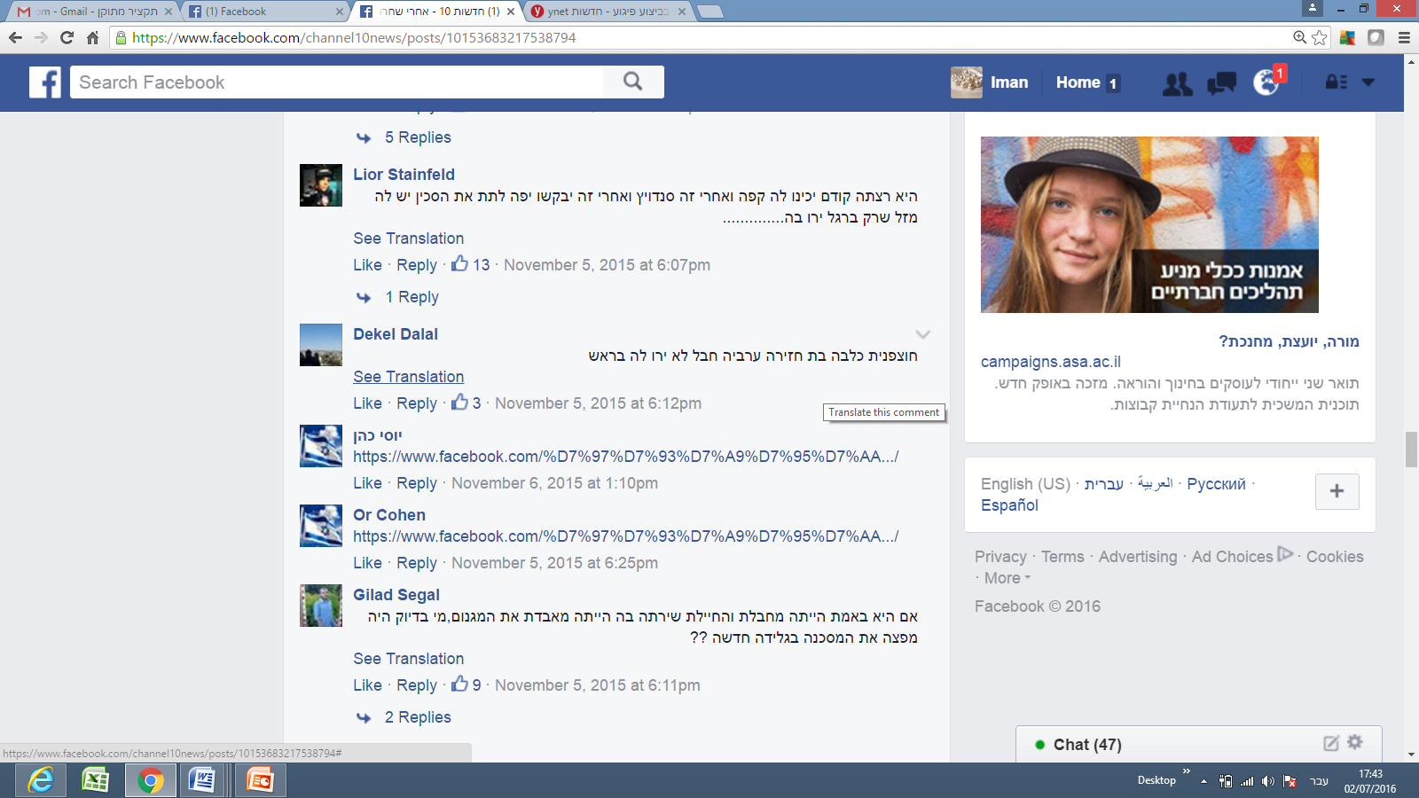
Translation: “You’re an Arab pig; it’s too bad you weren’t shot in the head.”
Comment 3
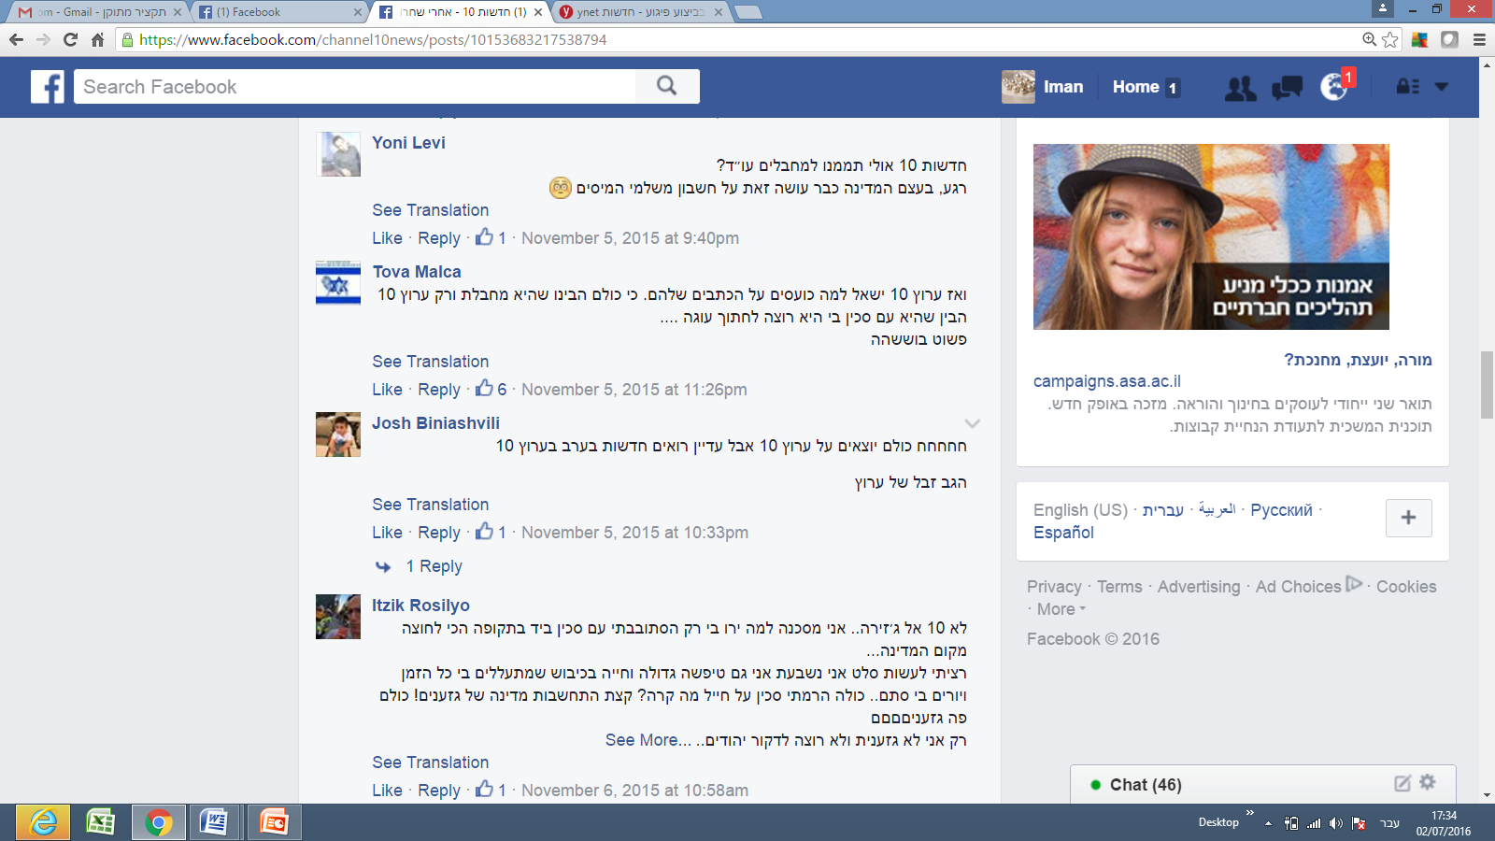
Translation: “Not Channel 10, but Al Jazeera. [the following was written sarcastically, but as if quoting Israa Abed]: ‘I’m an unfortunate victim. Why did they shoot me? I was only wandering in the street with a knife in my hand during one of the most stressful times since the establishment of the state.’
“[Continuing sarcastically]: ‘I only wanted to prepare salad. I swear. I am a big idiot living under occupation. They abuse me all the time, and shoot at me for no reason... All I did was raise a knife towards a soldier! So, what?! Just show a bit of consideration, you country of racists! You are all racists! I am the only one who is not racist, and I don’t want to stab Jews....’”
Table 1: Attitudes Expressed on Facebook Following the Israa Abed Shooting
 | Jewish Israelis | Palestinian Israelis | Total
Offensive Comments | 45:48  94% | 26:50  52% | 56:98  73%
Friendly Comments | 3:48  6% | 24:50  48% | 42:98  28%

Incident II: The Shooting of Nashat Milhim
The following are samples of the comments posted by Jewish Israeli Facebook users following this incident.
Comment 1
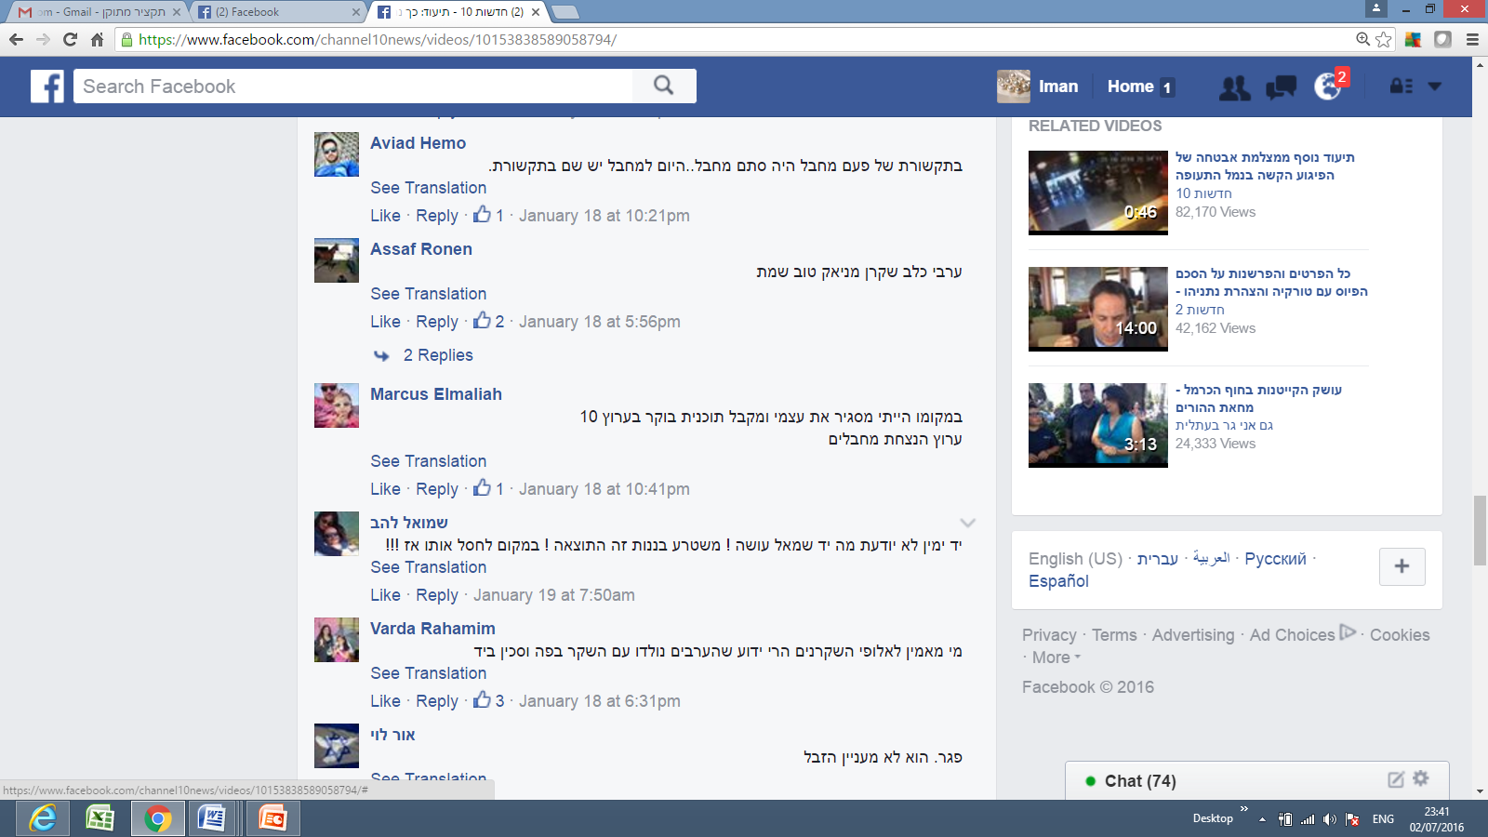
Translation: “An Arab dog, liar, maniac; good that he’s dead.”
Comment 2
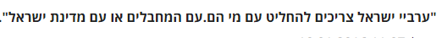
Translation: “Israeli Arabs should decide with whom they stand. With the terrorists or the State of Israel?”
Comment 3

Translation: “Who would believe the champions of lying [meaning Arabs]? Everyone knows that Arabs are born with a lie in their mouths and a knife in their hands.”

Table 2: Attitudes Expressed on Facebook Following the Killing of Nashat Milhem
 | Jewish Israelis | Palestinian  Israelis | Total
Offensive  Comments | 128:150  85% | 19:93  20% | 147:243  60%
Friendly  Comments | 22:150  15% | 74:93  80% | 96:243  40%

Incident III: MK Bezalel Smotrich’s Call for Segregating Arab and Jewish Mothers in Israeli Hospital Maternity Wards
The following are samples of the comments posted by Jewish Israeli Facebook users following this incident.
Comment 1
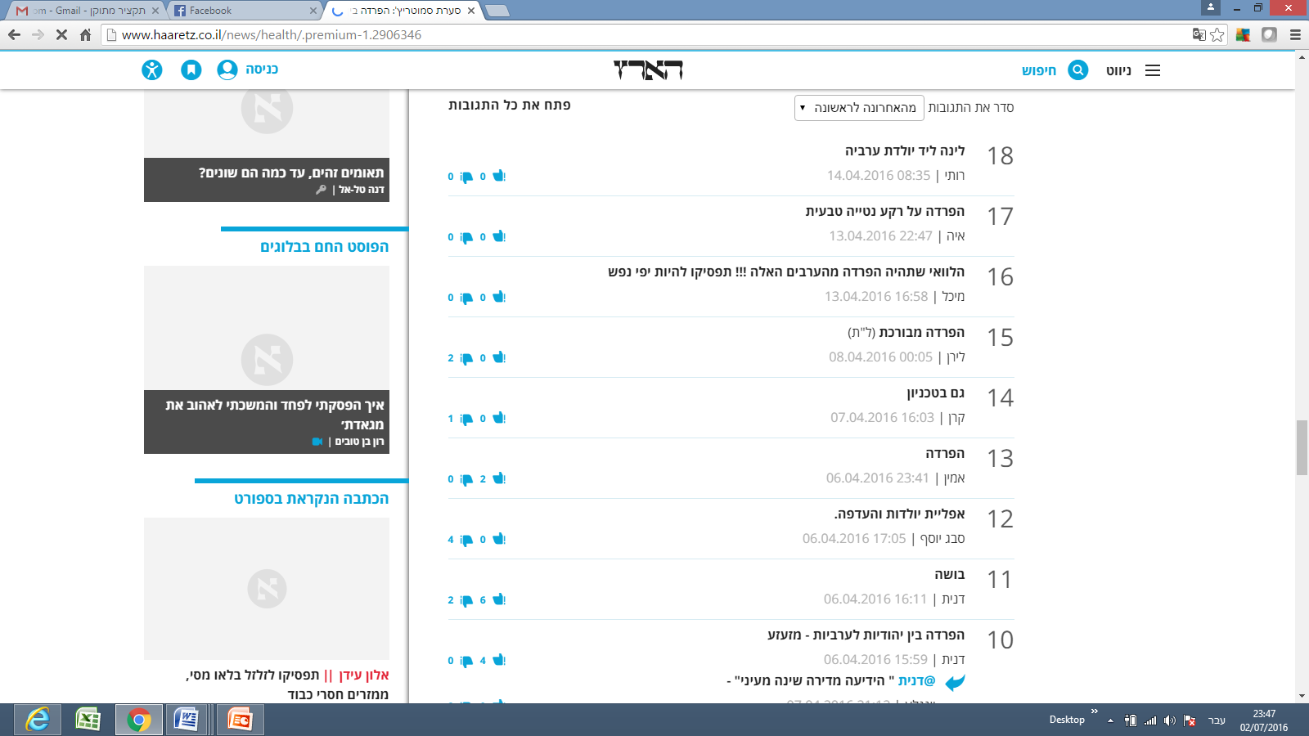
Translation: “I wish there would be segregation from those Arabs!!! Stop being so overly-sensitive!”
Comment 2
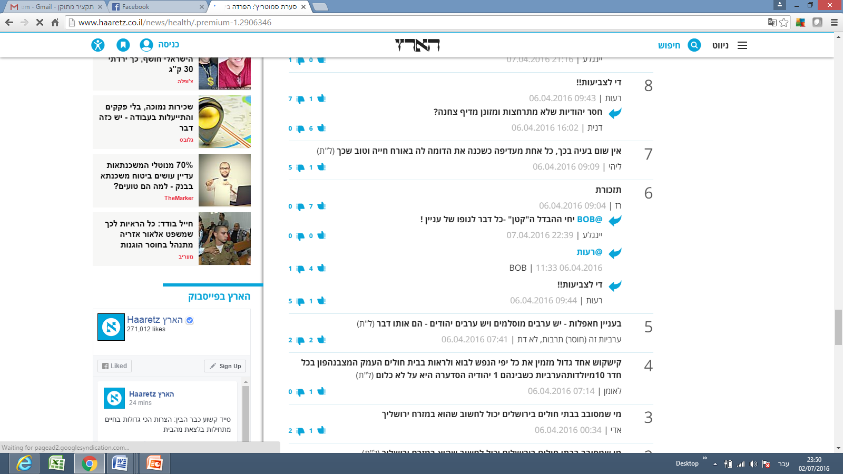
Translation: “Regarding get-togethers: there are Arab Muslims and there are Arab Jews [referring to the Jews who oppose the segregation] ─ they are both the same."
“Arabness is a (lack) of culture, not a religion.”

Comment 3
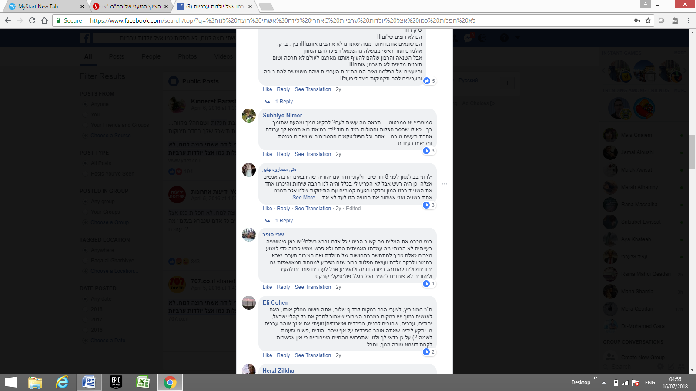
Translation: “Smotrich, you dirty rag... what have you done to the people? We will vomit from you and from people supporting you. As if we lack celebrations and clans from the Jewish side! Stop it for God's sake. Do us a favor and go find yourself some other job... you and all the disgusting Knesset Members who sit in the Knesset vomiting their ideas.”

Comment 4 (written by a Jewish Israeli citizen):
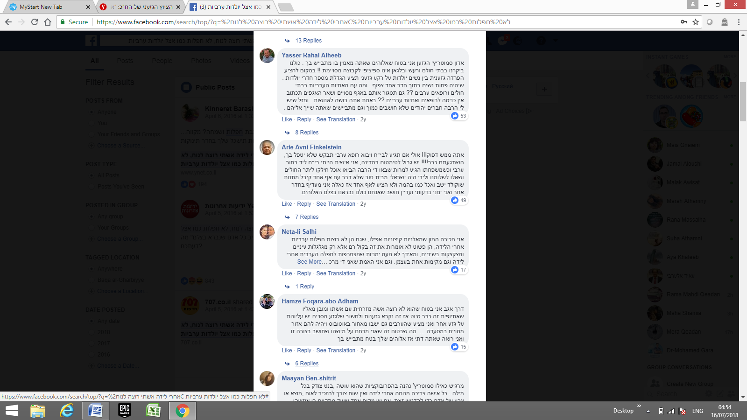
Translation:
“You [addressing Smotrich] must be crazy! Maybe if you go to a hospital and an Arab doctor comes to treat you, you will ask him not to take care of you! Are you all crazy! [...] Even though my political opinions are right-wing, I still believe that we are all created alike in God’s image. “
Table 3. Reactions to the Statement Calling for Segregating Arab and Jewish Mothers
in Maternity Wards

 | Jewish Israelis | Palestinian Israelis | Total
Offensive  Comments | 47:98  47% | 92:100  92% | 139:198  70%
Friendly  Comments | 51:98  52% | 8:100  8% | 59:198  30%

These findings point to a high percentage of negative reactions expressed by both parties under study following controversial incidents. Of the 296 comments made by Jewish Israelis, 220 (74%), were categorized as negative reactions, and 137 of the 243 comments made by Palestinian Israelis (56%), expressed negative reactions towards Jews. The total negative comments from both parties amounted to 66% of the total number of comments gathered for the study, with 357 of the 539 comments expressing negative attitudes.

Discussion
The frequency with which both Jewish Israelis and Palestinian Israelis used offensive language about the other group, as well as their strong negative attitudes toward the other regarding the incidents under examination, reveal a fragmented and polarized political and social landscape vulnerable to significant inflammation or incitement. These findings also support the proposition that peaceful channels of communication between Jewish and Palestinians Israelis are rare. In addition, it is clear from the findings presented that Jewish Israelis commenting on Facebook are far more likely to use offensive language than are their Palestinian Israeli counterparts. One possible explanation for this result is that Jewish Israelis, believing that they are less likely to face legal or security-related consequences, feel more secure about expressing their true opinions; regardless of how offensive they are. In contrast, Palestinian Israeli commentators are more reluctant to express their views freely, as they feel more vulnerable to facing pressure from or even arrest by Israel’s security apparatuses than do their Jewish counterparts.
A further examination of these findings also raises the question of the relative absence of left-wing views expressed. Mass communication theories, specifically Noelle-Neumann’s spiral of silence theory (1979), which posits that some people are not willing to state their real opinions due to fear of isolation from the overwhelming majority opinion, may help clarify this phenomenon. According to Noelle-Neumann, public opinion amounts to “pressure to conform.” In essence, public opinion is a general social climate, a prevailing moral and aesthetic trend in society that monitors human activity much like a “public eye” from which nobody can remain unseen (Noelle-Neumann, 1985, p. 84). Furthermore, she argues that the essential meaning of the term lies in “the interaction between the inclinations, abilities, and convictions of the individual and the agreement of the many, to which the individual has to subordinate himself if he does not want to place himself in isolation outside society” (Noelle-Neumann, 1979, p. 151). According to Noelle-Neumann, it is through the media of mass communication that people in modern societies come to learn about public opinion. This is certainly the case in the context of social media networks and can help explain why the overwhelming majority of the posts by Jewish Israelis examined expressed anti-Arab sentiments.
In addition, in many cases in the past, Palestinian Israelis experienced adverse consequences when they revealed negative attitudes towards the Jewish community. For example, a Palestinian Israeli woman was fired from her job at a Jewish Israeli municipality after writing on her Facebook wall that she wished more Israeli soldiers had been killed following the death of some Israeli soldiers.
Another well-known incident, which was frequently discussed and shared on Facebook pages and other media platforms, including Al Jazeera and all Israeli mainstream media, such as Channels 2 and 10, was that of the popular Arab journalist Anas Abu Daabes, who had written a satirical Facebook post during a time when wildfires were raging in Israel. The post, after having been translated using Google Translate, lost its satirical meaning and was interpreted as an incitement for Arab/Palestinian Israelis to commit arson, leading to Abu Daabes’ arrest.
These incidents likely dissuaded Palestinians Israelis from revealing their true attitudes towards Jewish citizens, especially during times of crisis or regarding controversial issues. Many Palestinian Israelis using Facebook are convinced that their Facebook posts are scrutinized more closely by Israel’s security apparatuses than are those of their Jewish counterparts. In the case of Abu Daabes, for example, many Arab Facebook users shared screenshots on their walls of other comments by Jewish Facebook users which clearly called for arson.
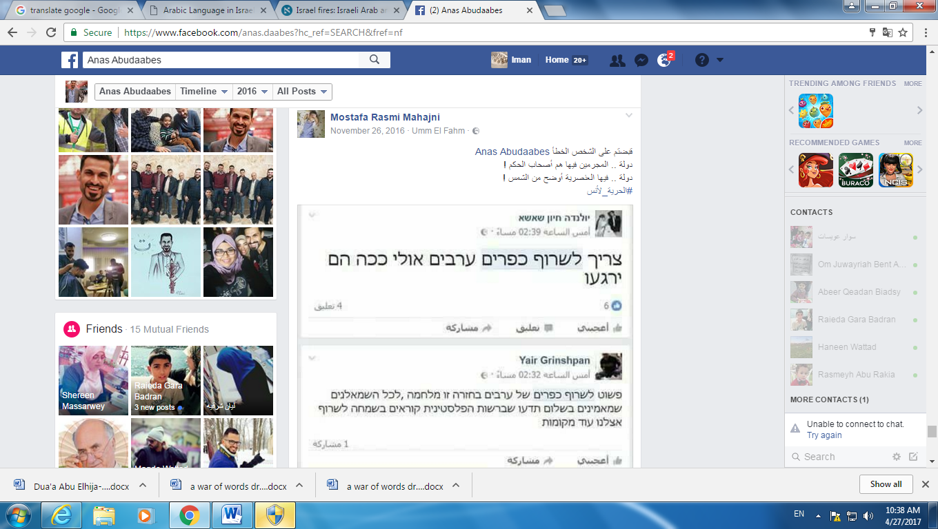
Translation of the Arabic text: “You’ve arrested the wrong person, Anas Abu Daabes. In this country the criminals are the governors! In this country racism is as clear as the light of the sun!
#Freedom to Anas!”
Translation of the Hebrew texts:
Comment 1: “We have to burn all Arab villages; maybe this way they’ll calm down.”

Comment 2: “We simply need to burn Arab villages in return. This is a war, and all the leftists who believe in peace should know that in the Palestinian Authority, they are happily calling for more fires in our country.”

The findings also demonstrate a difference between Jewish Israelis’ reactions to controversies involving physical threats or confrontations and to controversies involving ideological or ethical issues, such as that of segregating Arab and Jewish women in maternity wards. The latter case evoked far fewer offensive comments from Jewish Israelis than did the Abu Daabes incident. However, even these friendlier comments revealed a sub-category of attitudes, with Jewish Israelis criticizing Jews who sympathized or affiliated with Palestinian Israelis. Palestinian Israelis were also much more confident about expressing their opinions about the segregation controversy, as the issue clearly involved racism rather than a threat of physical harm.

Bibliography
Al-Haj, M. (1996). Education among the Arabs in Israel: Control and social change. Jerusalem: Magnus.
Al‐Haj, M. (2004). The political culture of the 1990s immigrants from the former Soviet Union in Israel and their views toward the indigenous Arab minority: A case of ethnocratic multiculturalism. Journal of Ethnic and Migration Studies, 30(4), 681-696.
Al-Haj, M., & Rosenfeld, H. (1990). Arab local government in Israel. Westview Press.
Amara, M. (2002). The place of Arabic in Israel. International journal of the Sociology of Language, 53-68.
Amara, M. (2003). The Collective Identity of Arabs in Israel in an Era of Peace. Israel Affairs. 9(1-2), 249-262.
Amara, M. (2017). Arabic in Israel: Language, Identity and Conflict. Routledge.
Avgerinakou, A. (2003). Flaming in computer-mediated interactions. Pragmatics and Beyond New Series, 273-294.
Bekerman, Z., & Maoz, I. (2005). Troubles with identity: Obstacles to coexistence education in conflict ridden societies. Identity, 5(4), 341-357.
Ben-Rafael, E., Shohamy, E., Hasan Amara, M., & Trumper-Hecht, N. (2006). Linguistic landscape as symbolic construction of the public space: The case of Israel. International Journal of Multilingualism, 3(1), 7-30.
Bligh, A. (2003). The Israeli Palestinians: an Arab minority in the Jewish state (No. 27). Psychology Press.
Bond, R. M., Fariss, C. J., Jones, J. J., Kramer, A. D., Marlow, C., Settle, J. E., & Fowler, J. H. (2012). A 61-million-person experiment in social influence and political mobilization. Nature, 489(7415), 295.
Boymel, Y. (2007). Blue and white shadow–the policy of the Israeli establishment and its activities among the Arab citizens: the formative years: 1958–1968. Haifa [Hebrew].
Brundidge, J. (2010). Political discussion and news use in the contemporary public sphere: The “accessibility” and “traversability” of the Internet. Javnost-The Public, 17(2), 63-81.
Coe, K., Kenski, K., & Rains, S. A. (2014). Online and uncivil? Patterns and determinants of incivility in newspaper website comments. Journal of Communication, 64(4), 658-679.
Cohen, H (2006). Good Arabs. Jerusalem: Keter (Hebrew)
Dvir-Gvirsman, S., Tzfati, Y., & Menchen-Trevino, E. (2014). The extent and nature of ideological selective exposure online: Combining survey responses with actual web log data from the 2013 Israeli Elections. New Media & Society, 18, 857-877.
Enli, G. S., & Thumim, N. (2012). Socializing and self-representation online: exploring Facebook. Observatorio (OBS*), 6(1).
Grossman, D. (1992). Present absentees. New Library-Hakkibutz Hameuhad Publishers, Tel Aviv.
Halperin, E., & Bar-Tal, D. (2011). Socio-psychological barriers to peace making: An empirical examination within the Israeli Jewish society. Journal of Peace Research, 48(5), 637-651.
Holsti, O. R. (1969). Content analysis for the social sciences and humanities. Reading. MA: Addison-Wesley (content analysis).
µhttp://www.aljazeera.com/news/2015/10/terrorist-state-151011084548356.html§
µhttp://www.haaretz.com/israel-news/1.682928§
µhttp://www.haaretz.com/israel-news/1.696321 Last access 17.04.2016§
µhttp://www.jpost.com/Israel-News/Report-Various-Israeli-hospitals-separate-pregnant-Jewish-Arab-on-request-450271§ Last access 17.04.2016
Huckfeldt, R., Johnson, P. E., & Sprague, J. (2004). Political disagreement: The survival of diverse opinions within communication networks. Cambridge University Press.
Jang, S. M., Lee, H., & Park, Y. J. (2014). The more friends, the less political talk? Predictors of Facebook discussions among college students. Cyberpsychology, Behavior, and Social Networking, 17(5), 271-275.
John, N. A., & Dvir-Gvirsman, S. (2015). “I Don't Like You Any More”: Facebook Unfriending by Israelis During the Israel–Gaza Conflict of 2014. Journal of Communication, 65(6), 953-974.
Karniel, Y., & Lavie-Dinur, A. (2012). Privacy in new media in Israel: How social networks are helping to shape the perception of privacy in Israeli society. Journal of Information, Communication and Ethics in Society, 10(4), 288-304.
Krippendorff, K. (1980). Content analysis. Beverly Hills. California: Sage Publications, 7, l-84.
Krippendorff, K. (2013). Content Analysis. An Introduction to Its Methodology. Sage, London.
Kuo, F. Y., Tseng, C. Y., Tseng, F. C., & Lin, C. S. (2013). A study of social information control affordances and gender difference in Facebook self-presentation. Cyberpsychology, Behavior, and Social Networking, 16(9), 635-644.
Mor, Y., Kligler-Vilenchik, N., & Maoz, I. (2015). Political expression on Facebook in a context of conflict: Dilemmas and coping strategies of Jewish-Israeli youth. Social Media+ Society, 1(2), 2056305115606750.
Mutz, D. C. (2006). How the mass media divide us. Red and blue nation? Characteristics and causes of America’s polarized politics, 1.
Noelle-Neumann, E. (1979). Public Opinionand the Classical Tradition: A Re-evaluation. Public Opinion Quarterly, 43(2), 143-156.
Ramon, S., Campbell, J., Lindsay, J., McCrystal, P., & Baidoun, N. (2006). The impact of political conflict on social work: Experiences from Northern Ireland, Israel and Palestine. British Journal of Social Work, 36(3), 435-450.
Rouhana, N. N., & Fiske, S. T. (1995). Perception of power, threat, and conflict intensity in asymmetric intergroup conflict: Arab and Jewish citizens of Israel. Journal of Conflict Resolution, 39(1), 49-81.
Sa'di, A. (2013). Thorough surveillance: The genesis of Israeli policies of population management, surveillance and political control towards the Palestinian minority. Manchester University Press: Manchester, UK.
Smooha, S. (1989). Arabs and Jews in Israel (Vol. 1, pp. 2-3). Boulder: Westview Press.
Smooha, S. (1990). Minority status in an ethnic democracy: The status of the Arab minority in Israel. Ethnic and Racial Studies, 13(3), 389-413.
Smooha, S. (1992). Arabs and Jews in Israel (Vol. 2, pp. 1-22). Boulder: Westview Press.
Smooha, S., (1984). The orientation and politicization of the Arab minority in Israel (No. 2). University of Haifa, Jewish-Arab Center, Institute of Middle Eastern Studies.
Vraga, E. K., Thorson, K., Kligler-Vilenchik, N., & Gee, E. (2015). How individual sensitivities to disagreement shape youth political expression on Facebook. Computers in Human Behavior, 45, 281-289.
Wheelock, A., Haney, W., & Bebell, D. (2000). What can student drawings tell us about high-stakes testing in Massachusetts? TCRecord. org.
Yiftachel, O. (1992). The Arab minority in Israel and its relations with the Jewish majority: A review essay. Studies in Comparative International Development, 27(2), 57-83.

https:// Workplaces Discipline Israeli Arabs for Facebook Posts Against Gaza Incursion read more: https://www.haaretz.com/israel-news/1.606681
Author (if available). Title of article. (full date of article). Retrieved from: http://www.haaretz.com/israel-news/1.682928 vs. Author (if available). Title of article. (full date of article). Retrieved from http://www.aljazeera.com/news/2015/10/terrorist-state-151011084548356.html
Author (if available). Title of article. (full date of article). Retrieved from http://www.haaretz.com/israel-news/1.696321
Author (if available). Title of article. (full date of article). Retrieved from http://www.jpost.com/Israel-News/Report-Various-Israeli-hospitals-separate-pregnant-Jewish-Arab-on-request-450271
Author (if available). Title of article. (full date) Retrieved from http://hasa.co.il/?p=305466
The Facebook post in question ended with the tag:#satire_not_serious and #the_smoke_is_blinding_the_eyes_and_heart. See the link to the original post which was mistranslated: Author (if available). Title of article. (full date of article). Retrieved from https://www.facebook.com/anas.daabes/posts/10209996280477068 See also the comment on the story in Haaretz: Author (if available). Title of article. (full date of article). Retrieved from http://www.haaretz.com/israel-news/.premium-1.755367
See: https://www.facebook.com/permalink.php?story_fbid=1248838305139564&id=100000402186492

