Incorporating Sustainability into Chemistry Education by Teaching through Project-Based Learning

Muhamad Hugerat

The Academic Arab College for Education in Israel - Haifa

22 Hahashmal St., Haifa 33145, P.O. Box 8349, Israel

[muha4@arabcol.ac.il](mailto:muha4@arabcol.ac.il)

Abstract

Currently, human beings are interfering intensively with our environment, and this can have both direct and indirect impacts on our quality of life. As a result, we go to great lengths to explain human damage to the environment, and the ways in which such damage can be reduced. Options for environmental damage reduction include education for green behaviors, such as recycling, decreasing consumption, and transitioning to renewable energy. In this article, three projects are presented: *“Green Scientific Stories”, “The Solar Village”* and *“Microscale Chemistry Home Experimentation”*, all of which were designed to incorporate sustainability into chemistry education via project-based learning. It is demonstrated how taking part in these projects in school and at home has increased student awareness of sustainability. Being involved in executing the projects has pushed students to advocate for the environment, and for the protection of our planet in the future.

Introduction

‘Sustainability’ is the totality of various aspects that affect the chances of survival of the human race, its continuity, and its quality of life (Bodner, 2014; Burmeister and Eilks, 2013).

The first discussion of sustainability took place in 1960, as human activity had already caused significant environmental damage following World War II (Anastas and Eghbali, 2010). Sustainability (or sustainable status) is a condition whereby resources are being replenished at a rate that is either faster than or equal to their rate of degradation; thus, these resources can be sustained for a long time (Burmeister and Eilks, 2013).

Sustainability has become an important issue that needs to be addressed in modern societies. It deals with our responsibility as humans to make sensible and economical use of the Earth’s resources, to allow future generations to live on a planet that is inhabitable and continually rich in resources. In order to achieve successful long-term technological, environmental and societal sustainability, all members of (and groups within) society will need to contribute, by making minimum use of irreplaceable natural sources and by providing and developing new technologies (Eilks and Rauch, 2012).

According to Eissen (2012), sustainability is an approach that promotes ideas and action designed to prevent the collapse of ecosystems and social systems. According to Tal (2009), ecological sustainability is the ability of an ecosystem to continue to exist with the same level of diversity and function, and to satisfy the needs of the present without endangering future generations’ ability to use a variety of resources.

In view of the concept of sustainability, the challenge today is how to produce what is in short supply, and what the consumer wants, without having a negative impact on the environment (Benstein, 2011).

It is of great importance to integrate sustainability and green chemistry into the curricula of all students, and especially into the curriculum for *in-* and *pre-*service teachers. Providing pre- and in-service teachers with sustainability-related experiences, which are relevant to their current and future students, is an important component of their training to become effective chemistry instructors (Burmeister et al., 2013). Teachers should be aware of the applications of chemistry to industry, health, and technology (Braun et al., 2006).

Universities and colleges must be at the forefront of sustainability projects to increase public awareness of the environment, of strengthening knowledge of sustainability and the environment, of the technology relevant to these issues, and of the desire to create a sustainable future (Pike et al., 2003). Education plays an important role in the development of behaviors, but not every educational method can lead to changes in behavior. Only educational projects which focus on a particular behavior can create a change in that behavior. To advance the topic of education for sustainable behaviors, knowledge must be imparted which reflects the internal connections between humans and natural systems (Karpudewan et al., 2014).

Project-based learning (PBL) is one of the best methods for developing broad learning capabilities among students (Barak, 2012; Terasawa, 2016). It promotes student interest in science and improves their understanding of science content (Langbeheim, 2015). In this method, the inquiry process is organized around a project, and output is designed to motivate student activity. The learning here involves accomplishing complex tasks, the output of which is usually an ‘artifact‘ (or a concrete product), such as a model, picture, or presentation. Students present their product to an audience (the presentation), explain their product, and then reflect on their learning process. The teacher constructs tasks, asks challenging questions, and directs and encourages the development of information and social skills among their students. Finally, the teacher evaluates the learning and knowledge that their students have obtained from the experience (Ministry of Education, 2014).

PBL creates a link between practical and intellectual activity (Solomon, 2003), promotes significant learning, associates new learning with previous experience and knowledge, and enables students to experience a variety of communication and presentation situations (Westwood, 2006). In addition, it constitutes a more efficient method than traditional learning, because it helps students to adapt to different learning styles (Kaldi et al., 2011) and provides a wide variety of learning possibilities, so that each student can participate and choose an individually appropriate learning level. The element of choice is an important component of student success (Bell, 2010). The PBL method enables students to acquire knowledge and abilities through inquiry and involvement in complex problems and challenges (Coyne, et al., 2016; Hugerat, 2016).

According to Hugerat (2016), PBL encourages students to develop self-learning skills, which are very important in the new age of information technology. Using a PBL approach induces a creative classroom atmosphere, in which students generally perceive project work as enjoyable and entertaining.

One of the major aims of modern education is to support pupils in developing a sense of responsibility for the environment. Hence, schools and other places of education have a significant role to play in the promotion of sustainable development and environmental conservation through teaching and learning using PBL. It is possible to encourage the formation of positive environmental values by educational means, and to teach the skills and cognitive basis that are required for active participation as both individuals and members of a community. According to Zoller (2004), sustainable development requires a radical change in environmental “behavior” and a person’s “thinking environment”.

In this chapter, three projects are described which make chemistry more relevant, both in everyday life and to teaching sustainability.

*The sustainability learning objectives of the projects:*

After implementing these educational projects, it was intended that all participants should be able to:

* Define and apply sustainability principles.
* Explain how natural, economic, and environmental factors influence the educational projects, either by fostering or preventing sustainability.
* Consider sustainability principles, while developing personal and professional values through implementation of the projects.
* Recognize and assess how sustainability affects their lives, and how their own actions influence sustainability.
* Think critically about sustainability across a diversity of cultural values and multiple scales of relevance (from local to global).
* Know more about the importance of sustainability in daily life.
* Take personal action to maintain a sustainable environment.

These learning objectives were applied to three educational projects, as follows:

*1. Project Incorporating Sustainability by Teaching “Green Scientific Stories”:* Green scientific stories are creative and imaginative learning tools that can influence children to pursue sustainable lifestyles. Early education through chemistry stories for sustainability can help “green” decisions become the default mode for future generations.

*2. Project Incorporating Sustainability by Teaching “The Solar Village”:* Teaching children to value solar energy via an educational project that creates a solar village in their schoolyard encourages them to think of the yard as a sustainability laboratory. Bringing solar energy into schools as an educational project increases the use of solar energy as an alternative green energy in the community at large. In addition, such projects increase public awareness of the environment and strengthen general knowledge of sustainability and environmental issues, the technology relevant to these issues, and the desire to create a sustainable future.

*3. Project Incorporating Sustainability by Teaching “Microscale”:* Laboratories can be miniaturized for sustainability. A miniaturized environmental laboratory protects environments both near and far. The microchemistry system presents a solution to the problem of environmental pollution, because microchemistry equipment is disposable, less costly, and easy to use. This increases awareness of sustainability and how to prevent environmental pollution.

*Project Incorporating Sustainability by Teaching “Green Scientific Stories”*

Albert Einstein said: “Imagination is more important than knowledge”; this is significant when it comes to the problem-solving aspects of science. The Storyline Approach is an inquiry-based teaching method, based on a strategy first introduced by Kieran Egan (1986).

A story structure can provide students with a framework for concept formation and for retention of the concept. Storytelling is also a gentle and effective way to teach and pass on lessons and values (Trostle-Brand and Donato, 2001; Grugeon and Gardner 2000). Human brains seem to retain material which is presented in story form much better than information provided as a list of unrelated facts (Haven, 2000; Weaver, 1994). In the classroom, stories can be used to introduce a topic, capture the attention of listeners, and demonstrate abstract ideas. In addition to being an effective teaching tool, it can be discovered that telling stories is fun for both the listeners *and* the teller (Trostle-Brand and Donato, 2001; Grugeon and Gardner 2000). Storytelling also helps to build bridges between people and the natural world and stories can help listeners develop empathy for the animals and plants that share our world (Strauss, 2006; Taylor, 2010).

Telling a story has been shown to be a good way to teach children different subjects and explain different phenomena in a kindergarten (Grugeon, 2000; Hewlett, 2008; Turner and Bage 2006). However, before a story is chosen to introduce to the children, several questions must be asked, such as: Will the subject of the story be appropriate for the children’s attention span? Is the subject introduced in such a way that it will provide a new solution to a problem, which the children will easily understand? What solution does the story provide? To answer these questions, a story must be carefully chosen for the children, and several points must be taken into account (Grugeon, 2000; Hewlett, 2008; Turner and Bage, 2006), including:

* Adjustment of the story for children of several different ages.
* Presentation of the story subject matter in a way that is familiar to the children.
* Using story characters that children are accustomed to and taken from environments that the children are already familiar with, such as the family sphere, their neighborhood, or the animal world. For example, plants might act like a human being would in their relationships with others and react in a similar manner, emotionally: speaking, crying, playing, and being happy or sad.
* Considering how the story introduces its general concept.
* Providing solute in the story that are both acceptable and effective.

*The influence of story on extending a child’s imagination:*

A story engages the entire mind, in terms of (for example) intelligence, memory, deduction, understanding and acceptance, and all of these elements are connected to the imagination (Trostle-Brand and Donato, 2001; Haven, 2000, Weaver, 1994; Feasey, 2006). A story:

* Exposes a child to different types of excitement and to different cultures.
* Satisfies many aspects important to children, such as amazement, wonder and the unexpected.
* Offers a child new avenues for creativity and methods for adopting new modes of behavior. This, in turn, supports a child’s capability to behave in a positive way.
* Gives a child a lot of information which a scientific subject alone cannot provide; this information does not require great effort, on the child’s part, to retain and understand.

Writing ‘green‘ scientific stories for sustainability makes chemistry more relevant to everyday life (Hugerat, 2007). Early education through chemistry stories for sustainability can help green decisions become the default mode for future generations. The stories are a creative and imaginative learning tool which can influence children to pursue sustainable lifestyles.

The project is based on covert processes in teaching science, which use problem-solving questioning and debating methods.

*Working Program*

*The First Step:*

Writing a simple science story to convey an environmental science topic (sustainability). The teacher or expert writes the story.

*The Second Step:*

The teacher divides the story into several parts, using an open-ended inquiry method. In addition, after each chapter she asks the students a number of questions and expects them to come up with arguments that will both solve the problem presented and provide an opening for the next chapter. The teacher then opens a class discussion to hear different arguments from the students.

*Figure 1:*

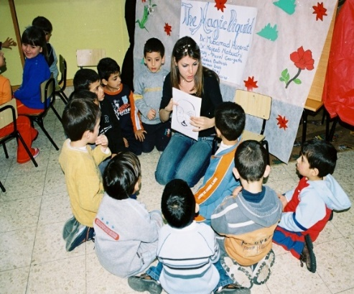 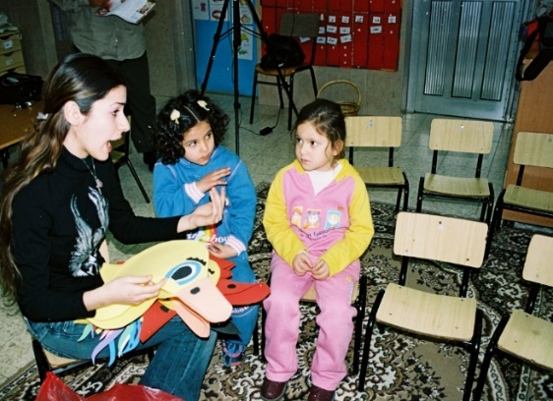

*The Third Step:*

At the end of each chapter, the teacher asks the students: “What do you expect will happen in the next chapter?” This method is repeated until the class reaches the end of the story.

*The Fourth Step:*

The teacher works together with the students on summarizing the story and describing it from four different aspects - the scientific-environmental, the social, the educational, but (mainly) the sustainability aspect.

Example 1: “Rose in the Dark”

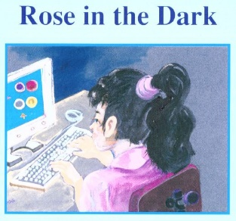

1. “Rose” is a computer-loving girl who sits for hours in front of a screen in a dark room, without caring for food or playing with her friends. The her face and body look pale, so her mother decides to take her to the clinic to meet with her family doctor.

*Q1: Why does Rose look pale?*

*Q2: Why does her mother take her to see the family doctor?*

*Q3: Give Rose some suggestions - how can she be healthier?*

1. Rose’s family doctor gives her some medication, warns her against sitting too long in front of the computer, and advises her to eat freshly prepared meals and to go out to play with her friends. In the corner of the doctor’s clinic stand two similar potted plants. The doctor asks Rose to watch what he is does next, carefully. He takes the first pot and pours a little water into it, then places it next to the window where it can get both light and air. He places the second pot in the closet, where it is dark and there is neither water nor light. The doctor asks Rose to return to the clinic after a week.

*Q1: Can you explain why the doctor asks Rose to watch what he is doing with the plants?*

*Q2: What do you expect will happen to the plant in the first pot?*

*Q3: What do you expect will happen to the plant in the second pot?*

*Q4: Why does the family doctor ask Rose to return the clinic after a week?*

1. After one week, Rose returns to the clinic with her mother. When she arrives at the clinic, she looks at the plant by the window and it is in excellent condition. Flowers have blossomed on it, and their scent perfumes the room. The second plant, inside the closet and in darkness, has not bloomed and its green leaves have become yellow and smell bad.

*Q1: Did your expectations match the results of the pot plant experiment? Were your expectations higher than the actual results of the experiment?*

*Q2: By looking at the results, can you explain why the doctor did this experiment?*

1. Rose looks at the doctor and says: “Thank you doctor; now I understand the message you were giving me using the pot plants.”

*Q1: What is the doctor’s message to Rose?*

*Q2: How do you think Rose will behave when she gets home?*

*Q3: What do you think would happen to a human being if it were kept in darkness forever?*

*Q4: Is there a natural situation which would create total, eternal darkness?*

*Q5:* *How can we act to prevent this situation, and preserve the planet on which we live?*

***Summary:*** Performing the *“Rose in the Dark”* project raises awareness of sustainability. It also strengthens three other aspects for students: the scientific-environmental aspect, the social aspect, and the educational aspect:

*The scientific-environmental content* appears in the adaptation of the plant organism, and its need for water, light and oxygen in order to complete its growth process. Like any other organism, the plant needs care in order to grow, and humans also need good living conditions so that they can thrive.

*The social content* emerges through the fears of the mother for her daughter. In the story, Rose’s mother watches her young daughter’s pale face with tearful eyes. When Rose’s father returns in the evening and sees her mother in an abnormal state, they decide, after discussing it, to take Rose to the family doctor.

*The educational content* appears in doctor’s advice for Rose; he subtly shows that his task is not only to give Rose medicine, but to demonstrate his point to her through a scientific experiment. The doctor does not simply give the result of the experiment to Rose, neither does he tell her why he is performing this particular activity, instead he leaves it up to Rose to reach conclusions on her own.

Example 2: “The Polluted Lake“

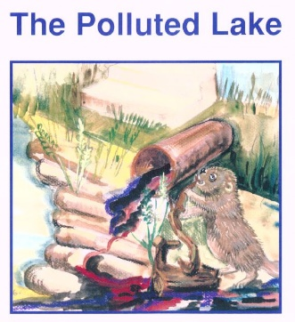

1. The story tells of an animal named Beaver who lives on the banks of a lake, next to a waterfall. Two days pass, and he does not see the duck family. Beaver decides to visit them, and on the way he asks the rabbit-doctor to join him.

*Q1: Why does Beaver decide to visit the duck family?*

*Q2: Why does he ask the rabbit-doctor to join him?*

1. When they arrive at the duck family’s house, everyone is amazed. Little duck is lying on the ground, with white liquid coming out of his mouth…

*Q1: What do you think has happened to the little duck?*

*Q2: How would you help him?*

1. … which later turns out to be something he drank from the polluted water in the nearby lake. The rabbit-doctor says: “I will go to my house and fetch medicine”. In cooperation with his animal friends, Beaver decides to bring tree branches to close the opening of the water spout…

*Q1: Why is the lake polluted?*

*Q2: What you think of Beaver’s decision? Do you think you would take the same action as him?*

*Q3: What do you think will be the consequence of Beaver’s actions?*

1. … which brings rubbish from the village into the lake and pollutes it. Thus, the friends succeed in cooperating with each other to redirect the water and rubbish back to the houses in the village, so that the lake water is safe to drink and swim in. The rabbit says, “I heard the people of the village talking about the mistake they made”…

*Q1: Why does Beaver take this action?*

*Q2: What is Beaver’s message to the people of the village creating the pollution?*

*Q3: Would you behave like Beaver?*

*Q4: What do you think happens if we throw all our rubbish and sewage into lakes and the sea?*

*Q5: Is there a situation in nature which would create total and eternal pollution?*

*Q6: How will you act to prevent water pollution in future?*

*Q5:* *How can we act to prevent this situation and preserve the planet on which we live?*

***Summary:*** Performing the “*The Polluted Lake”* project raises awareness of sustainability. It also strengthens three other aspects for students: the scientific-environmental aspect, the social aspect, and the educational aspect:

*The scientific-environmental content* lies in how the story addresses the issue of environmental pollution in general; how each individual must take responsibility for the environment and contribute to rescuing it from pollutants. The story also shows how individuals should help to reduce anything which may be detrimental to the environment and not dump waste in estuaries, because this can cause disease in the plants and animals living in that habitat.

*The social content* is in the mentioning and repetition of the word ‘family’. For example: “Beaver was worried about the duck family”; “For two days, I haven’t seen any of the duck family”; “Beaver decided to visit the duck family”; and beaver asking the rabbit-doctor to join him on his visit to the duck family.

The story also demonstrates how we can solve our problems if we work together; Beaver, together with his animal friends, decided to bring tree branches to close off the nozzle of the pipe bringing rubbish from the village, which had been pouring into the lake and polluting it.

*The educational content* is in the collective work of the animal friends to cooperate in redirecting the water and rubbish back to homes in the village. Everyone realizes that throwing rubbish into natural water sources leads to pollution, which then causes disease.

*Project Incorporating Sustainability by Teaching the “Solar Village”*

A teacher who motivates students, stirring their curiosity and ability to research and explore, will create a worthy student who contributes to local social and economic development. A generation can thus arise, which is not only capable of inventing and designing appliances that are needed by the community, but also of becoming good citizens in their society (……).

From a historical perspective, the use of projects in science instruction dates back to 1908, when Rufus Stimson, a teacher at Smith Agricultural School in Northampton, Massachusetts, coined the term, “home projects” (Stevenson, 1928). The purpose of these projects was to provide students with the opportunity to apply the school’s teachings to their farm work at home. “Child-centered learning”, “learning by doing”, and “applying school teachings in the home” are the core values of project-based science instruction. This method was further strengthened by the work of constructivists, such as Piaget (1969, 1970) and Vygotsky et al. (1978). Both Piaget and Vygotsky focused their work on child-centered learning and knowledge construction through practice and reflection. The work of progressive and constructivist science educators laid the foundation for project-based science instruction in the United States, and elsewhere.

One of the major aims of modern education is to support pupils in developing a sense of responsibility for the environment. Hence, schools and other places of education have a significant role to play in the promotion of sustainable development and environmental conservation (Eilks and Rauch 2012).

Teaching children to value solar energy through educational projects (e.g. by building a solar village in the schoolyard), and encouraging students to think of the school backyard as a sustainability laboratory, are both effective approaches (Hugerat et al., 2003).

Hugerat (2016) found that teaching science by using the project-based teaching method significantly improved student-teacher relationships, and enhanced students‘ enjoyment. These factors led to the creation of a good educational climate that enabled the teacher to achieve the lesson’s objectives and the students to benefit.

Schools are ideal places in which to use solar energy. Any changes and improvements to schools are highly visible and closely followed. Bringing solar energy into schools may therefore increase the use of solar energy in the community at large. Schools make good showcases for the benefits of solar photovoltaic electricity, and pupils may educate their parents about how solar energy is clean and limitless, and how it uses the sun to create energy for lighting, heating and cooling. This approach also emphasizes the importance of energy to a technological society, and describes how alternative energy sources like solar energy are quiet, do not create pollution, do not require much land or water with which to operate, and can be used to generate both electricity and fuels (Hugerat et al., 2004; Hugerat et al., 2011).

The youth of today feel disenfranchised by their elders. All they hear about is how dire their environmental future is, and how little effort previous generations are putting into change. By encouraging the installation of solar power in their schools, students will see firsthand the benefits of natural energy, and grow up interested in its uses and production. With so many future careers available in the green energy sector, projects like this will provide students with the drive and enthusiasm they need to succeed in that sector (Hugerat et al., 2004; Hugerat et al., 2011).

In the project designed for this study, students built a working model solar village inside their school grounds (Hugerat et al., 2003). The project emphasizes the importance of energy for a technological society and the advantages of using alternative energy sources. The project involved pupils from three elementary schools in Israel, who became active participants in building systems that run on solar energy (Hugerat et al., 2004; Hugerat et al., 2011). Project-based teaching methods were shown to be effective approaches for introducing the principles behind various types of renewable energy to students. By working on the projects, students not only gained a better understanding of the basic concepts of various types of renewable energy, but were also able to apply those concepts to the design of hardware and systems.

*Working Program*

*The First Step:*

Preparation of a school study program, to contain the following (Hugerat et al., 2011):

* Training for all school staff in solar energy, its uses, and the need for this energy in enhancing advanced technology. (In this step, it is very important that the teacher running the project has experience with different technological methods, and that he/she is able to prepare study materials for the pupils about solar energy as a topic, in preparation for the solar village project.)
* A tour for teachers of either a place which applies solar energy for daily use, or a place which investigates the use of solar energy.

*The Second Step:*

Demonstrating the subject of the educational project to the students. In this study, an advanced technology instrument on the subject of solar energy was shown to pupils (see Figure 2).

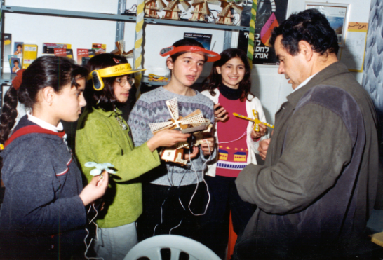

*Figure 2.* A teacher introduces solar energy instruments to the students

*The Third Step:*

In activities within an investigation group, students deal with the scientific, technological and social aspects of solar energy. The teacher introduces the students to an investigation and activities on the subject of solar energy. The students work as a team to construct solar kits, which operate using solar energy.

*The Fourth Step:*

The students build a large model solar village inside the school and learn that many things require energy to operate - lighting, TVs, computers, communications and transport. The students build a small car which drives in the school courtyard, and a water pump that operates using solar energy (see Figure 3).

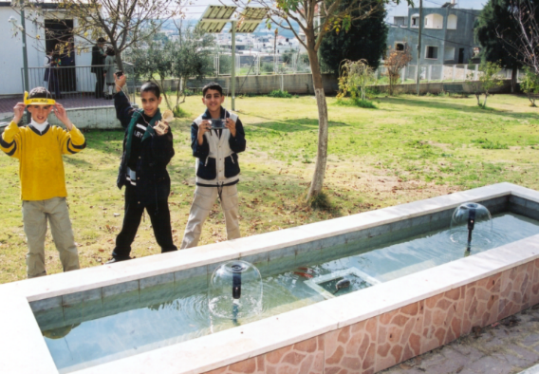 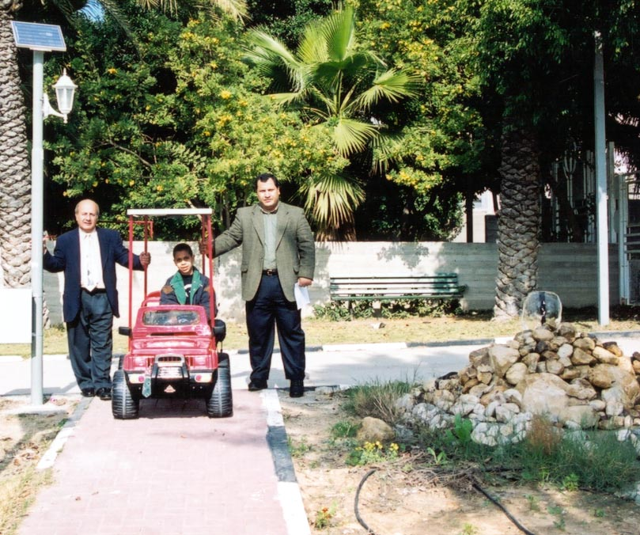

*Figure 3.* Students test the water pump that operates using solar energy (left);

the solar energy car being driven in the school yard (right)

*The Fifth Step:*

In the investigation group, students conducted experiments using photocells instead of conventional batteries. Over one year, a laboratory needs a large amount of battery power to operate different apparatuses, and this is very expensive compared to using a photocell. A photocell will last for a long time if kept in good condition, and it can be used indefinitely, thereby helping to reduce pollution (Cantrell, 1978; Carless, 1993).

The sustainable nature of solar electricity - along with its associated large resource potential and falling costs - has motivated a rapid increase in the deployment of utility-scale solar electricity generation plants in recent years (Davis, 1983). As the installed capacity of photovoltaics (PVs) continues to grow, cost-effective technologies for solar energy storage will be critical to mitigating the intermittency of the solar resource, and to maintaining the stability of the electrical grid (Tomas, 1996; White, 1979; Carless, 1993).

Electrolysis is a process that produces chemical change (especially decomposition) when an electrical current flows through an electrolyte. From the last century onwards, the electrolysis of a solution has been widely demonstrated to students in schools, in order to illustrate oxidation-reduction reactions, as well as to demonstrate the potential use of an external source of energy to drive non-spontaneous chemical reactions (Hugerat et al., 2003; Cantrell, 1978). Among the various technologies available for producing hydrogen, water electrolysis that uses electricity from renewable power sources (instead of electricity from a conventional battery) shows great promise. Hydrogen generation via solar water splitting represents a promising solution to these challenges, as H2 can be stored, transported and consumed without generating harmful by-products (Hugerat et al., 2003, Davis, 1983).

After producing hydrogen and oxygen gases via the electrolysis of water and studying that process, students realized that hydrogen can act as an energy carrier, and that as an energy carrier it has many properties that are useful to humankind. In this investigation group, students read a short explanation of hydrogen as an energy carrier, and then used solar electric panels to produce hydrogen and oxygen gases via the electrolysis of water (see Figure 4). The students then tested for the presence of flammable gases, and propose and balance the chemical reaction for the process of the electrolysis of water.

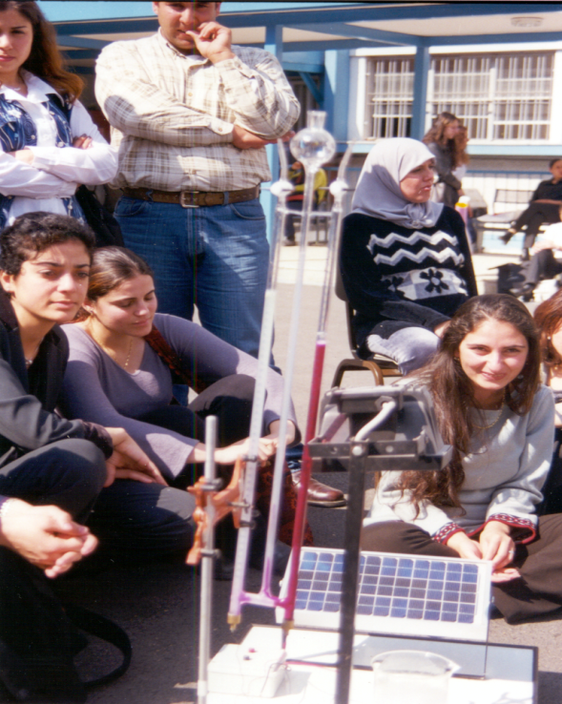

*Figure 4*. Students use solar electric panels to produce hydrogen and oxygen gases via the electrolysis of water

*The Educational Project Effect:*

* Students learn how to deal with environmental phenomena, to analyze the causes for (and outcome of) things which they observe, and to examine the relationships between such things. This process helps students to develop different thinking styles and a comprehensive perception of different phenomena. The implementation of projects like “The Solar Village” gives students a feeling of proximity to their environment and invites them to protect it. The implementation of such projects leads to changes in the way students think and to improvements in both their skills and creativity. A great majority (80.5%) of the students involved in the project showed support for converting the solar village project into reality in their home towns (Hugerat et al., 2011).
* The project also gave parents the opportunity to get involved in the activities that their children carried out at school, because they were requested to help the children obtain some data for the project. As a result, in the future, parents may become more involved in sustainability, the environment, and the use of non-polluting alternative energy, further helping to preserve our planet. The majority of parents (95.3%) are supportive of projects that give their children the opportunity to participate, because they think that projects like the solar energy village are very important to their children; it gives their children both an environmental education and an opportunity to work as advocates for the environment (Hugerat et al., 2011).
* Execution of the project led to greater cooperation and improved relationships between teachers and students, and made the teaching process more interesting. This, in turn, led to students improving their learning skills, especially those related to the planning and execution of research, carrying out assignments, and the ability to ‘search and discover’ in order to understand (and become more aware of) environmental phenomena. The teamwork between participating teachers also influenced other members of the faculty, creating a more positive and vital working environment. This encouraged all the teachers to adopt new and more effective thought processes and teaching methods. The project also increased community appreciation of the school and its values, in the eyes of both parents and the Ministry of Education. The results show that almost all the teachers (95.4%) are now willing to participate in environmental educational projects in the school. This indicates the positive impact of the solar village project (and similar projects) on schools which carry it out (Hugerat et al., 2011).

***Summary***: Performing the solar village project raises awareness of sustainability and clean energy, as well as increasing students‘ social engagement. The results of implementing the project show that it was widely accepted by students, parents and teachers. The three different groups are all in support of such projects, because they have significant educational impact, a positive effect on student morale, and they promote both thinking and creativity. Socially, such projects offer everyone the opportunity to participate, to become acquainted with issues relevant to our shared environment, and to have a positive effect on our daily life. From a learning perspective, such projects increase students’ knowledge of their surroundings, especially their knowledge about our dependence on the sun as a source of clean energy in future.

*Project Incorporating Sustainability by Teaching the “Microscale Chemistry Home Experimentation”*

Environmental protection is an important issue in chemical education. Maintaining a pollution-free environment and handling chemical waste responsibly are subjects which are of increasing concern to educators, universities and schools. The best way to alleviate this concern is to eliminate chemical waste at the source, by using pollution prevention in schools and teaching environmental responsibility. As well as encouraging safety in the laboratory, this approach can save money and help to ensure that schools meet their legal requirements (Skinner, 1988; Zhou et al., 2005; Ibanez et al., 2008).

Due to increased concern about the problems of environmental pollution, alongside rising laboratory costs, strategies for teaching and learning chemistry through laboratory work now require certain modifications. One possible solution is to switch from using traditional, large-scale metalware equipment to using non-traditional microscale plastic or glass equipment (Singh, et al., 1999; Zhou et al., 2005). The micro-science system is a good solution to the above problem, because the equipment is less costly and easy to use. An important consequence, especially for chemistry, is that chemicals are used in much smaller quantities, thereby saving consumable costs and greatly reducing hazards and environmental impact (Bradley, 2000; Kalogirou and Nicas, 2010).

A Microscale Chemistry Experiment (MCE) is an approach to conducting practical chemistry that can help overcome increased concerns about environmental pollution problems, as well as rising laboratory costs. An MCE is accomplished by using miniature labware and significantly reduced amounts of chemicals. Microchemistry is an innovative approach and an effective teaching tool. Microscale experiments can contribute by providing a quality chemical education via an environmentally safe approach (Singh, et al., 1999; Zhou et al., 2005; Hugerat and Schwarz, 2008).

At school level, an MCE means working practically with substances in a volume range of between 5 and 0.05 mL (1 drop). It offers a safer way to perform chemical experiments, by using smaller quantities of chemicals. This has the advantage of reducing cost, reducing safety hazards, and allowing many experiments to be done more quickly, both in and outside of the laboratory (Singh, et al., 1999; Zhou et al., 2005; Hugerat and Schwarz, 2008).

Microscale experiments are supposed to lessen the problem of pollutant disposal. Similar to traditional laboratory equipment, used substances can also be replaced with equivalents. Experiments can instead use food, detergents, household chemicals or solids taken from the kitchen and garage. These substances can easily be purchased in supermarkets, home improvement stores or pharmacies, for a lower cost, and dealing with and transporting them is less regimented. In addition, the handling of these resources is more motivating, since students are working with substances that already play a role in their lives (Jorge et al., 2008).

Building a miniaturized research microscale laboratory at school provides an active learning environment for all students during the year, as well as attracting the community. This, in turn, encourages teachers to build a long-term miniature laboratory in the school in future (Bradly, 2000).

The advantages of incorporating microscale chemistry into experimental hands-on teaching laboratories, with students within the classroom, include:

* Finding a solution to the problem of environmental pollution, because the microscale equipment is disposable, less costly, and easy to use.
* Students are encouraged to experiment and develop their own electrolysis experience. Laboratory activities can be done quickly, even at home.
* Microscale: saves time and money
  1. Saves time: by leaving more opportunity for conversation, reflection and evaluation while protecting the environment by using smaller amounts of chemicals: fewer chemicals, less waste (less is more!).
  2. Saves money: by replacing special laboratory materials with cheaper, household materials.

Many methods for volumetric water analysis have been developed since the German chemist A. W. von Hofmann (1803 – 1892) constructed his apparatus for the electrolysis of water. At the end of the nineties, MCE appliances for the electrolysis of brine were introduced by Hugerat (2008, 2009, 2010, 2013), and in- and pre-service teachers were starting to use disposable plastic pipettes, needles, pencil leads, and neutral electrolytes to design different types of microscale Hofmann Apparatus. Hugerat et al. (2010) made galvanic and electrolytic cells from pieces of disposable material such as a cola can, pencil leads, 1-mL blisters and 2-mL injection bottles. Hugerat et al. (2013) introduced into schools a small and cheap plastic container, with a 2-mL plastic pipette pierced by two hypodermic needles, and a 9-Volt battery, with which enough oxyhydrogen gas can be made (and transferred into a well) to make a safe explosion, every one minute.

*Working Program*

*The First Step:*

The teacher asks the students to collect the following materials: a syringe, a smallest-size hypodermic needle, soft drink cans, blisters, TetraPaks, dropper bottles, and a drinking straw (or a spatula), most of which can be found in most households.

Sterile syringes might be obtained in pharmacies, a nurse might collect empty vials or 5ml injection bottles (Liquemin Roche), and 1-2 plastic pipettes (see Figure 5) may be collected by students with help from their parents or the teachers.

Many sources of chemicals can also be found in the household, such as packing soda, sodium sulfate, table salt, and red cabbage.

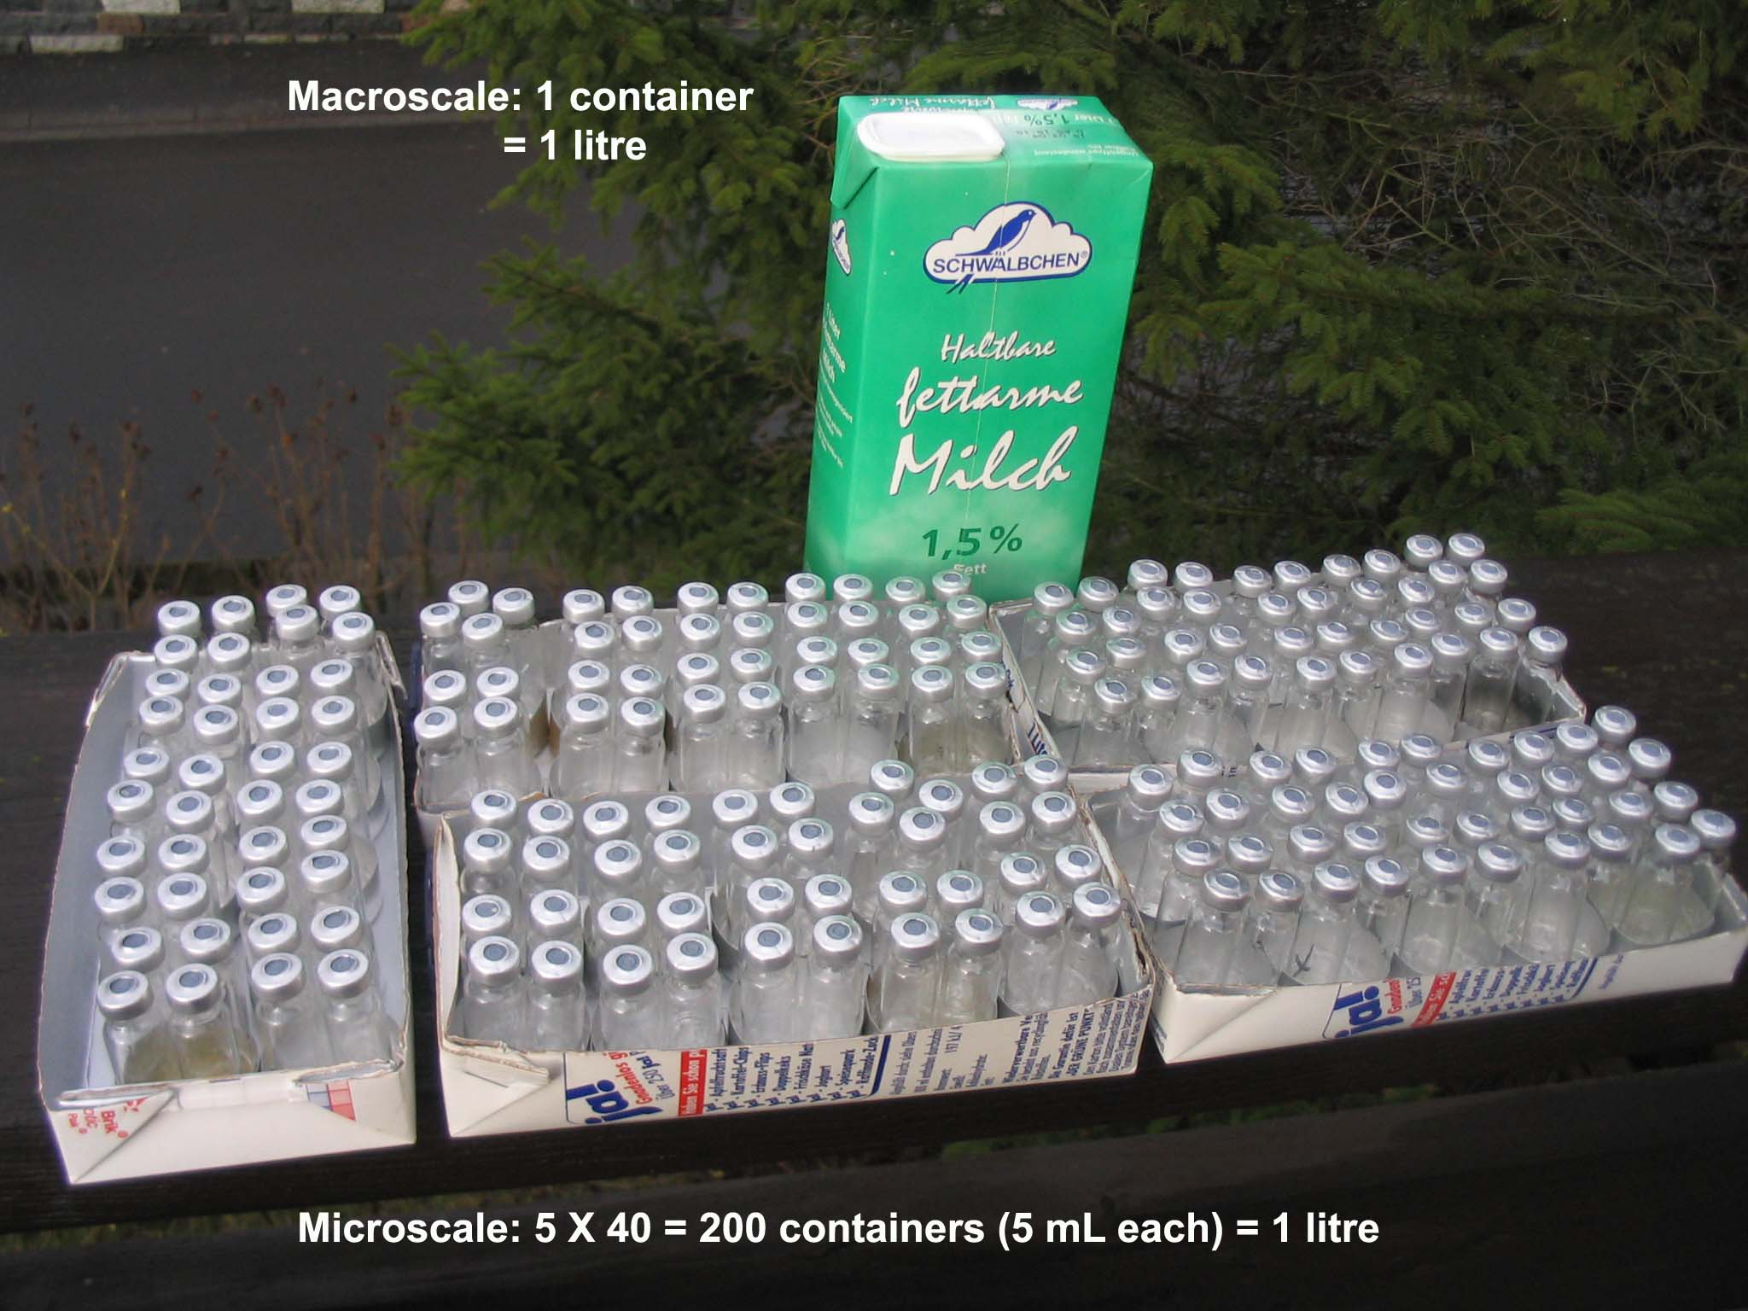

*Figure 5.* Microscale materials can be collected from home, clinics, the family doctor, or a hospital

*The Second Step:*

The teacher asks the students to cleanse the materials, to avoid the danger of infection, or any other risk associated with materials that are not properly sterilized. Under teacher supervision, the materials are place in boiling water for a few minutes, to undergo a perfect sterilization process. The teacher explains to students that materials should not be used without first performing cleaning and sterilization. Once everything is ready, the teacher tells the students that these tools will be used by them as tools for performing various labs.

*The Third Step:*

The teacher hands out worksheets to the students about disposable materials, sustainability, and the dangers of plastic for the Earth and water-cycle if we simply throw it away without thinking. The students are asked to work in groups to discuss these issues and how they relate to their own lives.

With the guidance of the teacher, students suggest building their laboratory from these disposable materials. The teacher then asks the students to suggest any experiments for which they can use these disposable materials.

*The Fourth Step:*

The students, with guidance from their teacher, build the conventional “Hofmann apparatus” (macroscale) and the alternative “Hofmann apparatus” (microscale) using disposable materials, as follows:

* The “Hofmann Apparatus for Decomposition of Water” – introduced by the German chemist, A. W. von Hofmann (1813 – 1892) – is still present worldwide, in schools and universities. The apparatus is comprised of two tubes (connected by a third), which are supplied with platinum electrodes and powered by DC. Water mixed with sulfuric acid as electrolyte is decomposed, leaving hydrogen and oxygen in a volume ratio of 2:1.
* A first step in modifying the Hofmann apparatus was to replace the electrodes with paper clips and the electrolyte with sodium sulfate solution, mixed with red cabbage juice.
* A Hofmann apparatus for microscale home experimentation consists of a small honey package, pierced by two hypodermic needles. The needles have been extracted from an insulin syringe. The electrolyte is still sodium sulfate solution, mixed with red cabbage juice. The electrodes (or paper clips) are connected to a 9-Volt rechargeable battery. Two 5-ml injection bottles (Liquemin Roche) full of electrolyte are placed on the electrodes, upside-down.
* In working groups, the students discuss the results and make conclusions.

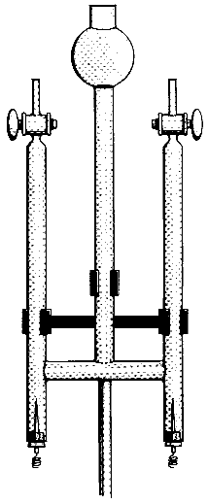 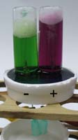 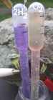

*Figure 6.* Traditional glass Hofmann apparatus, 200 ml (left), microscale Hofmann apparatus, 10 ml, from disposable materials (middle and right), designed by Hugerat et al. (2010, 2013).

*The Fifth Step:*

The teacher asks the students to be more creative and think about different household materials which they could use for this experiment, to build their own Hofmann Apparatus. Alternatively, the teacher ask, how might they use the same materials to set up another chemical process?

***Conclusion:*** Microscale Chemistry Experimentation can supplement, and sometimes replace, demonstration experiments in schools, colleges and universities, or even at home. Methodological and didactic methods may be supplemented with the economic and ecological advantages of MCE, including the following:

* Experimenting is no longer restricted to the limited timescales allowed in school.
* Each student can perform his/her own experiment, as materials are simple and cheap.
* Home experimentation using small quantities can even be done outdoors.
* Students (when assisted and supervised by teachers) can quickly acquire basic skills and an understanding of sustainability.

The simple and familiar apparatus should make these experiments available for safe use in chemistry classes at all levels. Students that have conducted the aforementioned experiments with alternative Hoffmann apparatus have shown excitement and found the lessons fun, especially when visually observing electrolysis occurring. We believe that this approach not only motivates students to be more creative in designing new apparatus for the teaching and learning of chemistry, it also encourages them to learn in a more active way, raises their awareness of sustainability, and prevents contamination of the environment by using non-polluting household and disposable materials.

*The Microscale Solvated Electron Using Disposable Materials*

The existence of solvated electrons was speculated long ago. The earliest known example of an established electron excess in a liquid is alkali metals, which produce stable blue solutions owing to solvated electrons in liquid NH3 (i.e. ammoniated electrons).



Here, a simple experiment is presented which produces solvated electrons using materials commonly available in undergraduate laboratories (such as lithium metal from a small battery or computer-cleaning fluid), without the dangers associated with the use of solid Na or K metals (i.e. vigorous reactions or explosions), and in a reasonably safe manner. The production of liquid ammonia and the use of a simple and inexpensive source of a metal alkali are also interesting from an educational standpoint (Ibanez et al., 2011).

***Summary:*** Microscale experiments are supposed to avoid the problems of pollution disposal. Furthermore, they are also supposed to reduce the potential risks in handling substances, because much smaller amounts of chemicals are used in these experiments. Microscale chemistry is a laboratory-based, environmentally safe, pollution-prevention approach that is accomplished by using miniature glassware and significantly reduced amounts of chemicals.

***Conclusion:***

Performing the *“Green Scientific Stories”, “Solar Village”* and *“Microscale”* projects to incorporate sustainability using PBL raises awareness of sustainability and clean energy, and increases student engagement. It also strengthens three other aspects for students: the scientific-environmental aspect, the social aspect, and the educational aspect.

***References:***

Anastas, P.; Eghbali, N. CPP *Chemical Society Reviews.* **2010**, *39* (1), 301-312.

Barak, M. From ‘Doing’ to ‘Doing with Learning’: Reflection on an Effort to Promote Self-regulated in Technological Projects in High School *European Journal of Engineering Education*. **2012**, *37* (1), 105-116.

Bell, S. Project-based Learning for the 21st Century: Skills for the Future. *The Clearing House* **2010***, 83* (2), 39-43.

Bodner, G. Green Chemistry and Sustainability Education in the U.S. *Education for Sustainable Development and Chemistry Education.* **2014**, 113-122.

Bradley, J. D. The Micro-science Project and its Impact on Pre-service Teacher Education. *The World Bank*: Washington, D. C, 2000.

Braun, B.; Charney, R.; Clarens, A.; Farrugia, J.; Kitchens, C.; Lisowski, C.; and O’Neil, A. Completing our Education: Green Chemistry in the Curriculum. *Journal of Chemical Education.* **2006***, 83* (8), 1126-1129.

Burmeister, M.; Eilks, I. An Understanding of Sustainability and Education for Sustainable Development among German Student Teachers and Trainee Teachers of Chemistry. *Science Education International.* **2013***, 24* (2), 167-194.

Burmeister, M.; Schmidt-Jacob, S.; Eilks, I. German Chemistry Teachers’ Understanding of Sustainability and Education for Sustainable Development — An Interview Case Study. *Chemistry Education Research and Practice.* **2013***, 14* (2), 169-176.

Cantrell, J. S. Solar Energy Concepts in the Teaching of Chemistry. *Journal of Chemical Education.* **1978***,* *55,* 41.

Carless, J. *Renewable Energy: A Concise Guide to Green Alternatives.* Walker & Co.: New York, 1993.

Coyne, J.; Hollas, T.; Potter, J. P. Jumping in: Redefining Teaching and Learning in Physical Education through Project-based Learning. *A Journal for Physical and Sport Educators.* **2016***, 29* (1), 43-46.

Davis, C. E. Solar Energy Experiment for Beginning Chemistry. *Journal of Chemical Education.* **1983***,* *60,* 158.

Egan, K. *Teaching as Storytelling.* Althouse Press: London, Ontario., 1986; Routledge: London., 1988; University of Chicago Press: Chicago, 1988.

Eissen, M. Sustainable Production of Chemicals – An Educational Perspective. *Chemistry Education: Research and Practice.* **2012***, 13* (2), 103-111.

Eilks, I.; Rauch, F. Sustainable Development and Green Chemistry in Chemistry Education. *Chemistry Education Research and Practice.* **2012***, 13* (2), 57-58.

Feasey, R. Using Stories and Poems in Science. *Primary Science Review.* **2006**, *92*,8-10.

Grugeon, E.; Gardner, P. *The art of Storytelling for Teachers and Pupils.* David Fulton: London, 2000.

Haven, K. *Super Simple Storytelling*. Teacher Idea Press: Englewood, CO, 2000.

Hewlett, C. Science from Stories. In *Teaching Science in the Primary Classroom;* H. E. Ward, Ed.; Paul Chapman Publishing: London, 2008; pp. 94-104.

Hugerat, M. How Teaching Science using Project-based Learning Strategies Affects the Classroom Learning Environment. *Learning Environments Research.* **2016**, *19* (3), 383-395.

Hugerat, M.; Ilaiyan, S.; Abu-Rayya, M.; Basheer, S. Acid-Base Demonstration through Electrolysis of Water Solution Using a Solar Panel. *Journal of Science Education.* **2003***, 2* (4), 96-97.

Hugerat, M.; Ilaiyan, S.; Zadik, R.; Zidani, S.; Zidan, R.; Toren, Z. The Impact of Implementing an Educational Project, The Solar Village, on Pupils, Teachers, and Parents. *Journal of Science Education and Technology.* **2004***, 13* (2), 277-284.

Hugerat, M.; Mamlok-Naaman, R.; Eilks, I.; Hofstein, A. Professional Development of Chemistry Teachers for Relevant Chemistry Education. In *Relevant Chemistry Education - From Theory to Practice*; Eilks, I.; Hofstein, A., Eds.; Sense Publishers: Rotterdam, 2015; pp. 369-386.

Hugerat, M.; Najami, N.; Abu-Much, R.; Khatib, W.; Hofstein, A. Making the Learning of Acid-Base Concepts More Relevant - A Research Study*.* *Journal of Laboratory Chemical Education* [Online], **2018**, *6* (2), 36-45. DOI: 10.5923/j.jlce.20180602.04 (accessed Sept. 24, 2019).

Hugerat, M.; Saker, S.; Odeh, S.; Agbaria, A. Teaching Children to Value Solar Energy. *US-China Education Review.* **2011***, 1* (6), 804-818.

Hugerat, M. New Inexpensive Apparatus for Electrolysis. *Journal of Chemical Education.* **2008**, *10* (2).

Retrieved from: URL=<http://www.juen.ac.jp/scien/cssj/cejrnlE.html>

Hugerat, M. Electrolysis of Water Using Accessible Materials: A Case Study of its Implementation with Middle and High School Teachers*.* *Journal of Science Education.* **2009***, 2* (10), 115-118.

Hugerat, M.; Schwarz, P. Microscale Electrolysis Using Disposable Materials. *The Chemical Educator.* 2008*, 13*, 1-4.

Hugerat, M.; Basheer, A.; Kortam, N. Usefulness of Plastic Hoffman Apparatus in Chemistry Classes: A Case Study of Its Implementation with High School Teachers. *Creative Education.* **2013**, *4*, 446-451.

Hugerat, M.; Basheer, A.; Abu-Much, R.; Basheer, S. Using Inexpensive to Free Materials to do Chemistry Experiments with all School Ages. *Journal of Chemical Education.* **2010**, *13* (2).

Ibanez, J. G.; Hernandez-Esparza, M.; Doria-Serrano, C.; Fregoso-Infante, A.; Singh, M. M. *Environmental Chemistry: Microscale Laboratory Experiments;* Springer: New York,2008.

Ibanez, G. J.; Guerra-Milan, F. J.; Hugerat, M.; Vazquez-Olavarrieta, J. L.; Basheer, A.; Abu-Much, R. Readily Made Solvated Electrons*.* *Journal of Chemical Education.* **2011***, 88*, 670-672.

Kaldi, S.; Filippatou, D.; Govaris, C. Project-based Learning in Primary Schools: Effects on Pupils’ Learning and Attitudes. *Education 3–13*. **2011***, 39* (1), 35- 47.

Kalogirou, E.; Nicas, E. Microscale Chemistry: Experiments for Schools. *Science in School*. **2010**, *Issue 16, 27-32.*

Karpudewan, M.; Ismaila, Z.; Rothat, W-M. Ensuring Sustainability of Tomorrow through Green Chemistry Integrated with Sustainable Development Concepts (SDCs). *Science Education Research and Education for Sustainable Development.* **2012**, *13*, 120-121.

Langbeheim, E. A Project-based Course on Newton’s Laws for Talented Junior High-school Students. *Physics Education.* **2015***, 50* (4), 410-415.

Mat Said, A.; Ahmadun, F. L. R.; Paim, L. H. J; Masud, J. Environmental Concerns, Knowledge and Practices Gap among Malaysian Teachers. *International Journal of Sustainability in Higher Education*. **2003**, *4* (4), 305-313.

Mintz, K.; Tal, T. Education for sustainability in higher education: a multiple-case study of three courses. *Journal of Biological Education*. **2013**, *47* (3), 140-149.‏

Mintz, K.; Tal, T. Sustainability in Higher Education Courses: Multiple Learning Outcomes. *Studies in Educational Evaluation*. **2014**, *41*, 113-123.‏

*Project based Learning. Education for Thinking*. Ministry of Education: Pedagogic Secretariat, Department of Pedagogic Development, Jerusalem, 2014 (In Hebrew).

Piaget, J. *Science of Education and the Psychology of the Child*; Orion Press: New York, 1970.

Pike, L.; Shannon, T.; Lawrimore, K.; McGee, A.; Taylor, M.; Lamoreaux, G. Science Education and Sustainability Initiatives: A Campus-recycling Case Study Shows the Importance of Opportunity. *International Journal of Sustainability in Higher Education*. **2003***, 4* (3), 218-229.

Singh, M.; Szafran, Z.; Pike, R. M. Microscale Chemistry and Green Chemistry: Complementary Pedagogies. *Journal of Chemical Education*. **1999**, *76,* 1684.

Skinner, J. *Microscale Chemistry: Experiments in Miniature*; Royal Society of Chemistry: Cambridge, UK, 1998.

Solomon, G. Project-based Learning: A Primer. *Technology and Learning-Dayton*. **2003***‚ 23* (6), 20-30.

Stevenson, J. A. *The project method of teaching*; Macmillan: New York, 1928.

Strauss, K. *Tales with Tails: Storytelling the Wonders of the Natural World*; Libraries Unlimited: Westport, Connecticut, 2006.

Taylor, N. *Using Stories to Support Science at KS1*, Science Assessment. 2010. Retrieved from <https://teachernickt.files.wordpress.com/2010/06/science-assessment.pdf> (Accessed on 22.09.19).

Terasawa, I. Challenge Study: A Project-based Learning on a Wireless Communication System at Technical High School. *Higher Education Studies*. 2016*, 6* (1), 110-115.

Tomas, M., Ed. *Solar electricity*; John Wiley and Sons: New York, 1996.

Trostle-Brand, B. L.; Donato, J. M. *Storytelling in Emergent Literacy:* *Fostering Multiple Intelligences*. Delmar: Albany, NY, 2001.

Turner, J.; Bage, G. Real Stories, Real Science. *Primary Science Review.* **2006**, 4-6.

Vygotsky, L. S.; Cole, M.; John-Steiner, V.; Scribner, S.; Souberman, E., Eds. *Mind in Society: The Development of Higher Psychological Processes*. Harvard University Press: Cambridge, MA, 1978.

Weaver, M., Ed. *Tales as Tools.* National Storytelling Press: Jonesborough, TN, 1994.

Westwood, P. *Teaching and Learning Difficulties: Cross-curricular Perspectives.* ACER Press: Camberwell, Vic., 2006.

White, J. C. Solar Energy Potential. *Journal of Chemical Education*. **1979**, *56,* 337.

Zhou, N.; Habelitz-Tkotz, W.; Giesler, D.; El-Marsafy, M. K.; Schwarz, P.; Hugerat, M.; Najdoski, M. Quantitative Microscale Chemistry Experimentation. *Journal of Science Education*. **2005**, *6 (2),* 84.