**Sound-IT**

SE-1-1

By: Kevyn Krancenblum; kevinkr@ac.sce.ac.il  
 Lior Liberov; liorli1@ac.sce.ac.il

Advisors: Dr. Natalia Vanetik

Shamoon College of Engineering, Beer-Sheva

Sound-IT is a research project aimed at using artificial intelligence and computer vision to recognize emotions in videos and create tunes that fits those emotions. We created four models to determine the emotional tone of a video: facial expression detection, background hue recognition, body emotion recognition, and lip reading. After that, a tune that matches the detected emotion is generated. The proposed method offers a potential solution to the problem of high costs associated with composing and recording original music for films. The first results of the model are positive with an 85% correlation between music and videos.

**Keywords:** emotion recognition , computer vision, action recognition, music generation, RNN, keypoints,

**GalLavi Laser Tattoo Removal**

SE-1-2

By: Yossi Abu ; yossiabu6590@gmail.com  
 Mickey Vitkovsky ; vimiki9@gmail.com

Advisors: Dr. Alexander Churkin

Shamoon College of Engineering, Beer-Sheva

Tattoos have been a part of human culture for thousands of years, but as the popularity of tattoos has increased, so has the demand for tattoo removal. The purpose of the project is to provide a friendly and convenient tattoo removal tool. The application shows the user the process and the method of treatment, accompanied by videos and photos, schedules meetings, and creating a visualization of the tattoo removal. The application will allow the site administrator to upload and change the content. The application will be available on android, ios, and web platforms.

**Keywords:** Tattoo, Tattoo Removal, App, Visualization, Platform.

**Here App**

SE-1-3

By: Eliran Ashtamker; ashtamker087@gmail.com  
 Omer Attias; attias1405@gmail.com

Advisors: Dr. Alexander Churkin1

1Shamoon College of Engineering, Beer-Sheva

Individuals diagnosed with attention and hyperactivity disorders often encounter difficulties with daily tasks, rendering timely completion challenging. To address this issue, a unique application has been developed to support this population. This app enables users to personalize their day by organizing their thoughts, managing and defining tasks, and setting reminders. Our principal objective is to raise awareness of attention and concentration disorders, to mitigate social stigma, and to empower users in achieving their goals. The challenges encountered in app development included obtaining Google's approval for calendar synchronization and developing the application for iOS devices.

**Keywords:** Attention and hyperactivity disorders, Personalization, Task management, Time management, Awareness, Social stigma, Empowerment, Thought organization, Reminders, Calendar synchronization.

**Abstract Title**

SE-1-4

By: Lin Dahan; lindahan164@gmail.com  
 Linoy Harush; linoyha93@gmail.com

Advisors: Dr. Alexander Churkin

Shamoon College of Engineering, Beer-Sheva

Loss and grief have always been a part of our lives. The need to commemorate those dear to us upon their deaths is a solution to the phenomena accompanying the grieving process, which brings with it from despondency to serious and terminal illnesses .The project uses different psychological approaches to dealing with grief and takes them into digital world by using commemoration as a tool. The application allows users to go through the mourning process in a personalized way, by creating a commemorative profile and sharing it with family, friends, and anyone who passes by the grave of the deceased.

**Keywords:** loss, grief, mourning, commemoration, death, digital world, application, psychological approaches, grave, deceased.

**Hebrew Text Simplification using Machine Learning**

SE-1-5

By: Israel Avihail; [israel.avihail@gmail.com](mailto:israel.avihail@gmail.com)  
Maor Moav; [maormo9876@gmail.com](mailto:maormo9876@gmail.com)  
Ariel Epshtein; [ariel32168421@gmail.com](mailto:ariel32168421@gmail.com)

Supervisors: Dr. Marina Litvak, Dr. Hadas Chassidim

Shamoon College of Engineering, Beer-Sheva

People with weak language skills, such as young children and the linguistically challenged, face difficulties reading complex text. The Hebrew language's rich morphology presents unique challenges when creating an Automatic Text Simplification system (ATSs). To tackle these challenges we present SimplHe, an ATSs that modifies Hebrew text to enhance readability and understandability by reducing complexity factors such as structure, length, and unfamiliar words using Machine Learning and Natural Language Processing. Our system achieved a 39.2 SARI score on a novel dataset. This system, implemented as a web-plugin, may potentially aid people with language barriers.

**Keywords:** Text Simplification, ATS, NLP, Hebrew, summarization, pipeline, text readability, language model.

**Machine Learning Prediction for Cancer Patients' Medication Treatment**

SE-1-6

By: Tal Ohana ; taloh13@gmail.com

Advisors: Prof. Hadas Hasidim1

Sami Shamoon College of Engineering, Beer-Sheva

Prof. Moshe Elkabats2, Prof. Angel Porgador3, Dr. Ofir Cohen4  
Immunology Department, Ben Gurion University, Beer Sheva

Many efforts have been made over the last decade to enhance cancer treatment by utilizing novel biological tools in immunotherapy. Our goal is to develop a machine learning system that can predict the efficacy of medication therapy for cancer patients. Preliminary data from the BGU lab (IcAR) was used, including cancer cell information, genetic sequencing, and other parameters. Computational examination of different models revealed a correlation in 87% of a single number of cancer cells, determining the best tool for predicting successful and targeted cancer therapy. This approach will bridge the medical-software divide and pave the way for future research.

**Keywords:** cancer treatment, immunotherapy, machine learning, drug therapy, computational analysis, successful therapy, targeted therapy, future research.

**BetterLife**

SE-1-7

By: Elinor Tamar Elal elinoel@ac.sce.ac.il  
 Moran Shalom moransh2@ac.sce.ac.il

Advisors: Dr. Hadas Hasidim, Ms. Lina Lerner

1Shamoon College of Engineering, Beer-Sheva

Anxiety and stress are prevalent a society such as ours where success and achievement are highly valued. The limited availability and accessibility of experts can make it difficult for individuals and have a negative impact on daily functioning. This project aims to provide real-time anxiety support using a dedicated application that connects individuals to anxiety specialists. The system will also provide instructional videos to help manage anxiety attacks and will provide feedback to help individuals improve the management of their anxiety symptoms.

**Keywords:** stress, experts, anxiety attack, instructional videos.

**Data visualization using 3D printer for blind students**

SE-1-8

By: Areen Abu Caf ; areenab@ac.sce.ac.il   
 Adim Azbarga ; adeemaz@ac.sce.ac.il

Advisors: Dr. Hadas Chassidim, Dr. Yochai Twitto

Shamoon College of Engineering, Beer-Sheva

Engineering faculties have a small number of visually impaired students, possibly due to the difficulty of courses that include graphic elements for this population. To address this issue, we are developing an application that can convert graphic data, such as decision trees and symbols, into 3D models for printing on any 3D printer. The system involves two users: the printer owner and a teacher who can contact each other through the system. The illustration of graphs in a 3D model allows visually impaired students to integrate into a variety of courses in a more accessible way.

**Keywords:** Visual impairments, 3D printer, file conversion, blind students, software engineering, data visualization, STL files.

**Alzheimer’s Game Therapy**

SE-1-9

By: Yuval Efrat; yuvalef@ac.sce.ac.il  
 Yarden Tamar Hayut; yardenhayut1@gmail.com

Advisors: Dr. Yochai Twitto1

1Shamoon College of Engineering, Beer-Sheva

Alzheimer’s disease is a neurological disorder that affects memory, thinking, and behavior, and is the most common cause of dementia in older adults. Although the causes are not fully understood, studies suggest that stimulating the brain at a high frequency can improve cognitive skills and reduce symptoms. To address this, we developed a game app using Flutter and dart, hosted on Firebase, that contains three games focusing on memory, speed, and thinking skills. Patients can customize difficulty levels based on their progress, and the app provides information on managing the impact of Alzheimer’s disease.

**Keywords:** Alzheimer’s, game app, dementia, older adults, cognitive skills.

**Algorithm & Data Structure Visualizer**

SE-1-10

By: Evgeny Odinzov; eodinzov94@gmail.com  
 Ron Vayner; ronv.sce@gmail.com

Advisors: Dr. Irina Rabaev1

1Shamoon College of Engineering, Beer-Sheva

Algorithms and Data Structures are cornerstones of modern-day software development. They are prevalent in every developer’s career and are often intricate and expansive in what they encompass. As such, they are often difficult to learn for newer students.  
Our project aims to create an Algorithm Visualization program (AVDS) designed to make these subjects easier to learn by providing students with an interactive UI.  
AVDSes have been shown to improve the quality of teaching, making them essential in modern studies.

**Keywords:** Algorithms, Data Structures, Visualization, Teaching, Software, Teaching aid, Software Engineering, Computer Science, Algorithm Visualization for Data Structures (AVDS), Learning, Development.

**Data structure and algorithms web simulator**

SE-1-11

By: Yovel Aloni; yovelal@ac.sce.ac.il  
Gil Ben Hamo; gilbe1@ ac.sce.ac.il

Advisors: Dr. Irina Rabaev1:

1Shamoon College of Engineering, Beer-Sheva

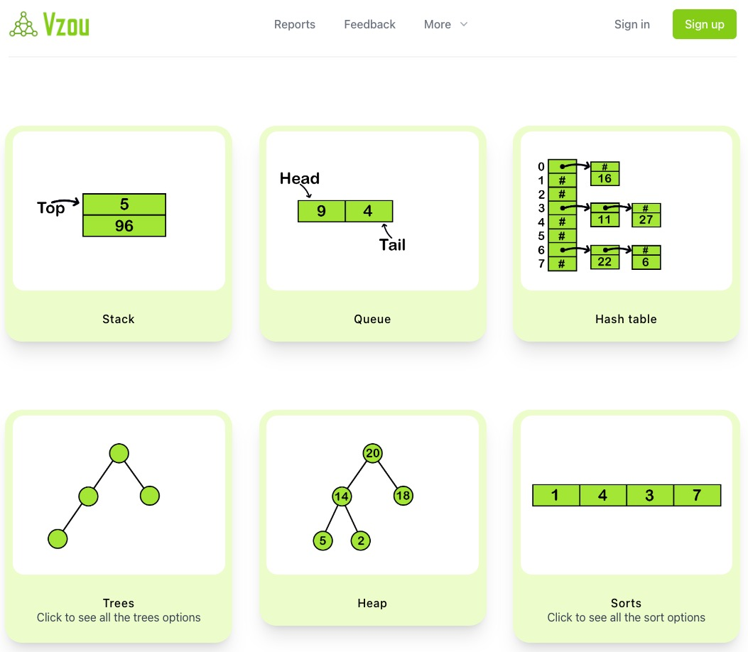

Algorithms and data structures play a critical role in computer science and software engineering, but students often face difficulties in understanding them. Traditional teaching methods have their limitations; thus, more effective visual teaching techniques such as Algorithm Visualization (AV) have been developed. AV illustrates the algorithm's steps through transition effects and animations.   
We aim to develop an online AV tool to enhance teaching by utilizing animations, pseudocode, runtime information, and user interaction by controlling the input, speed, and steps of the animation. The data collected from the tool can be statistically analyzed to improve the learning experience.

**Keywords:** Algorithms, Data Structures, Algorithm Visualization (AV), Teaching Methods, User Interaction, Usage Statistics.

**Gender and Age Classification of Handwriting Images.**

SE-1-12

By: Tamar Aminov; tamaram@ac.sce.ac.il  
 Liran Smadja; liransm@ac.sce.ac.il

Advisors: Dr. Irina Rabaev1, Dr. Marina Litvak1

1Shamoon College of Engineering, Beer-Sheva

Automated age and gender classification from handwriting images is a research area that focuses on developing machine learning algorithms and deep learning models to analyze different features of handwriting. Features are used to extract meaningful patterns that can be used to predict the age and gender of the writer. Age and gender classification from handwriting images has many potential applications. However, this field still faces many challenges, such as the lack of large-scale annotated datasets. In this project, we perform extensive experiments to check the applicability of state-of-the-art deep learning models to accurately classify the age and gender of the author.

**Keywords:** Automated Age and Gender classification, Deep Learning, Handwriting Analysis, Document Image Analysis.

**Writer identification in handwritten document images**

SE-1-13

By: Hamad Abo Sbet; hamadab3@ac.sce.ac.il  
 Mohamad Abo Jaber; mohammga@ac.sce.ac.il

Advisors: Dr. Irina Rabaev, Dr. Marina Litvak

Shamoon College of Engineering, Beer-Sheva

The problem of verifying the authorship of handwritten documents is an important task in many fields, e.g., criminology and historical research. This project tackles the writer verification problem using a neural network trained with various methods to enhance accuracy. We decided to use top-rank loss method for this task, coupled with few-shot learning, which has not been used for image identification before.

**Keywords:** writer verification, handwriting analysis, document image analysis, deep-learning network, top-rank, few-shot learning.

**WinGame**

SE-1-14

By: Daniel Dahan; Danieda4@ac.sce.ac.il  
Roni Jack Vituli; ronizvi@ac.sce.ac.il

Advisors: Dr. Karim Abu Affash:

Shamoon College of Engineering, Beer-Sheva



The WinGame project provides an intuitive and user-friendly platform for game enthusiasts to predict results and bet, aiming to increase social gambling and user engagement.   
Israel lacks accessible websites for this purpose, and navigating foreign sites may pose difficulties. To address this gap, WinGame provides an online platform accessible through web browsers and mobile devices. The platform includes features like real-time gaming, live streaming, group betting, news updates, and social betting.   
WinGame's vision is to provide a secure and convenient site that transcends geographical limitations, connecting game enthusiasts worldwide and presenting the world of games to a broader audience.

**Keywords:** WinGame project, game enthusiasts, predict results, bet, social gambling experience.

**MORE THAN FOOD**

SE-2-1

By: Haim Rubin haimrubin1@gmail.com  
 Matan Fadida matanfadida7@gmail.com

Advisors: Dr. Alexander Churkin

1Shamoon College of Engineering, Beer-Sheva

Restaurants can use our application to allow their diners to open the restaurant menu with a QR code, read reviews and ratings on each dish, place an order directly to the kitchen and see the preparation status at any given moment and, at the end of the meal, to pay, receive a tip recommendation, and also divide the payment between the diners. Also, the application will help the staff manage the restaurant and allow the kitchen to receive the orders in a pleasant and convenient way.

**Keywords:** menu, mestaurants, food order, tips, service, waiters, QR, management, orders, rating, review, kitchen, payment

**SkinDiseaseAI**

SE-2-2

By: Nadav Ishai; nadavis@ac.sce.ac.il  
 Dolev Peretz; peretpe@ ac.sce.ac.il

Advisors: Dr. Marina Litvak1, Dr. Natalia Vanetik1

1Shamoon College of Engineering, Beer-Sheva

Dermatological issues are increasingly common in family clinic visits, and severe facial skin problems can have negative impacts on mental health. Dermatologists play a crucial role in accurately diagnosing skin conditions since accurate diagnosis is essential for successful treatment outcomes. To address this concern, we aim to create a system utilizing machine learning and image processing analysis to automatically diagnose skin diseases. We created a large image dataset for six skin lesion types, then trained and evaluated numerous models on this dataset. Our best model achieves 87% accuracy and provides website links explaining the detected lesion type through a user-friendly interface.

**Keywords:** skin disease, machine learning, CNN, computer vision, image processing.

**Automatic detection of privacy violations in GitHub projects**

SE-2-3

By: Tomer Ben Shimol; tomerbe3@ac.sce.ac.il  
 Eliyahu Amuyev; eliam2@ac.sce.ac.il

Advisors: Dr. Marina Litvak 1

Jenny Guber2

1Shamoon College of Engineering, Beer-Sheva

2University of Haifa

Privacy violations occur when personal information is accessed or used without consent, and detecting them is important to prevent harm and protect privacy. In this project, we trained machine-learning models that can accurately classify issues related to privacy violations. We collected and annotated a new dataset of issues reported in GitHub projects then experimented with different text representation and classification models and reported their evaluation results on this dataset. Our findings can assist GitHub users in managing privacy issues more effectively. Improved classification could enhance trust and help protect sensitive information, benefitting social media and software development collaboration platforms.

**Keywords:** Privacy, Privacy violations, classification, issues.

**Imformation hiding in an image**

SE-2-4

By: Haiel Dahan; haiel12345@gmail.com  
 Yakir Ovadia; yakirov@ac.sce.ac.il

Advisors: Dr. Michael Kiperberg1

1Shamoon College of Engineering, Beer-Sheva

The rise of technological innovation and digitalization has led to an increase in data transfer. As a result, information security has become critical. Steganography is one of the techniques used to secure information by hiding confidential data in digital media. However, software like StegExpose can reveal such information, leading to security risks. The project aims to develop a new steganographic method that can identify the most suitable areas, pixels, and bits in digital images for hiding information, making it more secure than existing methods. Our solution will prevent successful steganalysis and disclosure of secret information.

**Keywords:** Stego-image,Steganography,Steganlysis,StegExpose,LSB-steganography

**Social interface between students and the elderly**

SE-2-5

By: Ziv Abutbul; zivabutbul94@gmail.com  
Omer Ben David; gunr121@gmail.com

Advisors: Dr. Hadas Chassidim:

1Shamoon College of Engineering, Beer-Sheva



The aim of GoldMan is to mitigate the problem of loneliness among the elderly. Loneliness is a persistent and prevalent negative emotion that can lead to depression and suicide. The application offers a simple and accessible interface through which elderly people can create social connections with students. The ability to meet younger people increases the likelihood that the elderly will feel valued, and their knowledge and experience will be appreciated. Older adults can search for students in their vicinity who share their interests in order to develop friendly relationships, while students can use their free time to connect with older adults.

Keywords: GoldMan, loneliness, elderly, social connections, depression, suicide, interface, students, older adults, interests, friendly relationships.

**Gluc Safe**

SE-2-6

By: Maxim Shapira; itsjustmax9@gmail.com  
Tali Tevlin; tali19te@gmail.com

Advisors: Ms. Svetlana Rosin:

1Shamoon College of Engineering, Beer-Sheva



Gluc Safe is an application developed using Flutter and Firebase designed to help individuals with type 1 diabetes manage their glucose levels effectively. The app allows users to track their glucose levels, set medication reminders, and log meals. With an intuitive user interface and visual representations of glucose data through graphs and charts, Gluc Safe enables users to understand the impact of food and medication on their glucose levels. Additionally, users can export their glucose levels data for analysis and sharing with healthcare providers. Gluc Safe is a comprehensive tool that empowers individuals to take control of their diabetes management.

**Keywords:** Diabetes, Flutter, Firebase, glucose, health, medications, tracking

**Abstract Title**

SE-2-7

By: Andrey Ruch; andreru@ac.sce.ac.il  
 Elad Yehuda; eladye2@ac.sce.ac.il

Advisors: Ms. Svetlana Rosin

Shamoon College of Engineering, Beer-Sheva

Cleanliness and order are crucial for a high quality of life, but finding cleaning staff is a tedious process. The methods for finding work or employees in this field are outdated and based on luck. "Cleany" connects employers and cleaners in a reliable and focused way. The interface enables an active and fair search process, providing solutions for finding workers for both short-notice jobs and for longer term duties.

**Keywords:** Web application, cleanliness, order.

**My Dentist**

SE-2-8

By: Itzhak Rahamim; [rahamit@ac.sce.ac.il](mailto:rahamit@ac.sce.ac.il)   
 Chen kachlon; [chenka@ac.sce.ac.il](mailto:chenka@ac.sce.ac.il)

Advisors: Ms. Svetlana Rosin

Shamoon College of Engineering, Beer-Sheva

The need for, and dependence on, computerized systems that will improve medical services is increasing over time. The goal of this project is to provide an efficient tool for managing dental clinics while consolidating all the operations needed for dentists in a single application which is supported on web, iOS, and Android platforms. The project ensures that every operation is secure and intuitive for the doctor. It is designed for the private market and will enable management of employees, patient files, financial operations, schedules, and treatments. This way, we will optimize the clinic's services and the quality of its service.

**Keywords:** Teeth, Clinic, Dentist, Doctor, Treatment, Application, Service, Management, System.

**CarRace**

SE-2-9

By: Alon Teplitsky; alon.ttp@gmail.com  
 Sagi Biran; sagibit@gmail.com

Advisor: Ms. Alona Kutsyy

Shamoon College of Engineering, Beer-Sheva

Our project aims to develop a comprehensive Business Intelligence (BI) system for the Israeli automobile industry. Our system will help companies and individuals collect, store, and analyze large amounts of data from various sources and transform them into actionable insights. This project is more efficient than its competitors, operates better, and is innovative. The literature highlights the importance of digital transformation for improving efficiency, competitiveness, and decision-making in the auto industry. Implementing BI systems in the auto industry requires integration, user training, adoption, and support. We used MySQL server, NGINX Reverse Proxy, DBL Database tool and Locker Studio for our project Implemention.

**Keywords:** Business Intelligence, automobile industry, data, actionable insights, efficiency, competitiveness, decision-making, digital transformation, integration, user training, adoption, support, MySQL server, NGINX Reverse Proxy, DBL Database tool, Locker Studio.

**Application for secure/encrypted chat**

SE-2-10

By: Abed Jamal; abedgm@ac.sce.ac.il  
 Morad teaha; Moradte@ac.sce.ac.il

Advisor: Mrs Alona kutsyy

Shamoon College of Engineering, Beer-Sheva

In the last decade there were a lot of new Chat applications in the market, but with that growth security became a major concern. People became more concerned about their privacy and with rumours that big companies were tracking their users activity. To address these issues, we developed our application “Secret Chat” that uses advanced encryption security “AES” to encrypt users’ data on its way to the receiving device. We save all the keys inside the user device rather than on the server and we provide all the API needed for the best user experience.

**Keywords:** Chat, Encryption, end2end, Privacy, DataSecurity.

**Digital Payment Application - EasyPay**

SE-2-11

By: Shani Melihov: shanibo@ac.sce.ac.il  
Linoy Cohen: linoyco@ac.sce.ac.il

Advisors: Mrs. Alona Kutsyy 1

1Shamoon College of Engineering, Beer-Sheva

Today, many payment applications exist to simplify the process. This has become increasingly popular and has led to widespread adoption by business owners and individuals. However, those without smart devices face a problem. To address this, we developed a web application accessible via any device with internet access. It functions similarly to PayPal, with added features such as creating a secure personal account, transferring/receiving payments from businesses/people, adding up to three credit cards securely, updating personal information, and viewing the last five transactions. Additionally, the application interfaces with a digital payment page at a business and allows actions through NFC, including flexible foreign currency conversion.

**Keywords:** Web application, NFC chip, Digital payment, Foreign exchange, Paypal.

**FiTrivia**

SE-2-12

By: Shay Weitzman, [Shaywe@ac.sce.ac.il](mailto:Shaywe@ac.sce.ac.il)  
Yinon Hadad, Yinonyi@ac.sce.ac.il

Advisors: Dr. Irina Rabaev:

Shamoon College of Engineering, Beer-Sheva

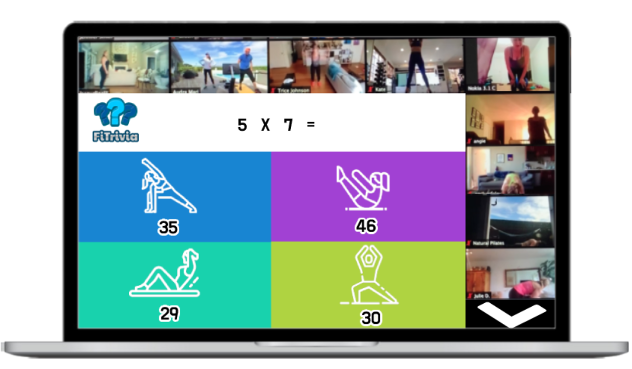

"FiTrivia" is a cross-platform mobile application that combines trivia questions with physical exercise. Users must perform various exercises, such as squats or push-ups, to answer multiple-choice questions. A machine learning model then determines whether the exercise is completed and the duration of the exercise, to award points based on answer accuracy and exercise length. The app aims to encourage users to stay engaged with interactive learning while promoting a healthier lifestyle. Key features include machine learning, exercise tracking, and the gamification of exercise.

**Keywords:** mobile app, physical activity, health and wellness, interactive learning, personal fitness, cross-training, machine learning, multiple-choice questions, computer vision.

**Mock MRI Software**

SE-2-13

By: Lev Alhazov; leval1@ac.sce.ac.il  
Shlomo Shnur; shlomsh7@ac.sce.ac.il

Advisors: Dr. Irina Rabaev 1, Dr. Hadas Chassidim1 :

1Shamoon College of Engineering, Beer-Sheva

In collaboration with the pediatric department of Soroka Hospital, Beer-Sheva

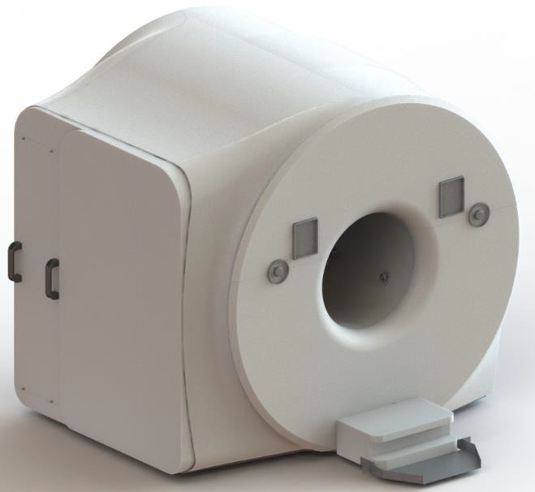

Magnetic Resonance Imaging (MRI) is a non-invasive diagnostic technique that uses strong magnetic fields and radio waves to create detailed images of internal body structures, including in children. However, children often move during scans and may require sedation, which can be costly and risky. Our project aims to improve pre-MRI training efficiency and accuracy by utilizing Farneback’s optical flow algorithm for motion detection. This will enable users to detect small movements during scans, and help instructors better teach children how to behave during scans, leading to better outcomes in pediatric MRI scans while reducing costs and health risks.

**Keywords:** Magnetic resonance imaging (MRI), motion artifacts, pre-MRI training, mock MRI, computer vision, GUI, motion detection, accuracy, efficiency, cost reduction, risk reduction, Farneback, optical flow.

**Plant Classification**

SE-2-14

By: Fadi Amon; fadiam@ac.sce.ac.il  
 Rasheed Abu Mdegem; rasheab1@ac.sce.ac.il

Advisors: Dr. Irina Rabaev, Dr. Marina Litvak

Shamoon College of Engineering, Beer-Sheva

Identifying rare desert plants remains challenging due to the unavailability of large datasets of rare species. As of today, classical deep-learning models require a lot of training data. To address this issue, this project aims to develop a plant classifier using a Neural Network model using the Few-Shot Learning (FSL) method. FSL is particularly known for its effectiveness on small datasets, hence we employed it here to train the neural network on a small dataset, resulting in high classification accuracy for these elusive plants.

**Keywords:** plant classification, small database, neural network, rare desert plants, Few-Shot Learning (FSL).

**Bsitter**

SE-3-1

By: Mali Bartal; malibartal@gmail.com

Advisors: Dr. Alexander Churkin

1Shamoon College of Engineering, Be’er-Sheva

In recent years, searhing for jobs via social networks has become common because it allows people to do so easily at any time. This aim of this project is to create a social network connecting babysitters and customers. In the application there is a database of customers and babysitters which can be mapped by filtering fields including location, fee, and availability. There is a chat function to provide communication between customers and babysitters. Also, it is possible to see reviews of a babysitter and thus assess the quality of the service they provide.

**Keywords:** babysitting, job search, social network, the stable marriage problem, chat.

**EasyCook Mobile Application**

SE-3-2

By: Liron Himbert; lironbenharrouch@gmail.com  
 Udi Elbaz; juadh006@gmail.com

Advisors: Dr. Irina Rabaev

Shamoon College of Engineering, Beer-Sheva



EasyCook is a smart device application designed to help users make the most out of the food products they have at home. By utilizing an API database of food products, the app helps users create a personal pantry and search for recipes based on its contents. With features like an OCR algorithm for adding products through receipt pictures and an intuitive interface for recipe creation, EasyCook is an all-in-one solution for reducing food waste, saving time and money, and promoting healthy eating habits. The result is an app that makes cooking fun and easy.

**Keywords:** mobile application, recipes, food management, pantry, API, OCR, cooking

**FunPun**

SE-3-3

By: Boaz Bitton; Boaz2119@gmail.com  
 Matan Ben Ishay; Matan12333445@gmail.com

Advisors: Dr. Karim Abu Affash

Shamoon College of Engineering, Beer-Sheva

English is a vital language taught in many schools worldwide, but students of varying ages in Israel often struggle due to limited vocabulary. This project addresses this issue by implementing an innovative teaching method focused on positive reinforcement and associations. Research indicates that traditional teaching methods are ineffective for modern learners, making this approach essential. The unique process aims to enhance vocabulary acquisition and memory retention, leading to higher test scores and increased speaking confidence. The ultimate goal is to help students communicate more effectively in English, a skill essential in today’s global society.

**Keywords:** English, Vocabulary, Positive Reinforcement, Association, Innovative Teaching Method.

**Workers Community**

SE-3-4

By: Shahd Alnaami; shahdal@ac.sce.ac.il

Advisor: Dr. Karim Abu Affash

Shamoon College of Engineering, Beer-Sheva

The Workers community project is a local mobile application that is a platform for professionals to present their work, reach more customers, and receive an additional source of income. Moreover, the application will help users to find workers quickly, as soon as possible, and in the closest place. The application allows people who know about repairing things such as electrical appliances or painting walls to find work.

**Keywords:** Workers Community, mobile application, professionals, customers, source of income.

**Sudoku – Think Better**

SE-3-5

By: Israa Qweder; israaqw@ac.sce.ac.il  
 Ranin Abu Jaafar; raninab@ac.sce.ac.il  
Rawan Afinsh; rawanaf@ac.sce.ac.il

Advisor: Dr. Yochai Twitto1

1Shamoon College of Engineering, Beer-Sheva

Sudoku is a popular game that requires a solution whilst taking constraints into account. Sometimes a player stops playing before finishing a game due to the difficulty of the board. We present a sudoku app that includes hints, based on an SAT optimization algorithm, that allows us to guide players if they have difficulty solving the problem. In doing so, we encourage the player to complete the puzzle without looking at the full solution. The project was developed using the React Native JavaScript programming language in the Visual Studio Code workspace and Firebase as a database in Android Studio.

**Keywords:** Sudoku, SAT, hinting, optimization, gameplay.

**A new Dataset for Automatic Recognition of Complex Sentences in Hebrew Texts**

SE-3-6

By: Shira Malka; shirma3@ac.sce.ac.il  
 Ron Bar Zvi; ron.bzeve@gmail.com

Advisors: Dr. Natalia Vanetik1, Dr. Marina Litvak2

1Shamoon College of Engineering, Beer-Sheva

State institutions websites are usually defined with elevated Hebrew language, which can cause reading and comprehension issues, especially for disadvantaged groups such as immigrants, the elderly, and people with intellectual disabilities. Sentence simplification aims to modify a sentence in order to make it easier to comprehend. Because Hebrew is a low-resourced language, we built our own dataset comprising of 1000 sentences collected from governmental websites and annotated with binary labels related to sentence complexity. This dataset can be employed in the future for training machine learning models for automatic detection of complex sentences. We reached 72.4% agreement on sentence complexity labels using Kappa score.

**Keywords:** Machine learning, Natural Language Processing, Hebrew, Sentence Simplification, Text Simplifier

**Find4MyCar**

SE-3-7

By: Bahjat Nsasra , bahjans@ac.sce.ac.il

Advisors: Dr. Alexander Churkin

Shamoon College of Engineering, Beer-Sheva

Car breakdowns are normal, and it is not possible to predict where or when a breakdown will occur. The problem is the lack of information and the difficulty of searching for a suitable tow truck company for the correct type of car close to the location of the breakdown. A similar problem can arise when searching for a suitable garage for a defect that occurred with the car. The Find4MyCar application searches for towing companies or garages closest to the user’s location, taking into account the vehicle type, types and availability of towing vehicles, and the type of malfunction.

**Keywords:** towing company search, garage search, car breakdowns, vehicle types, location.

**Buyinvestment**

SE-3-8

By: Ofir Golan , ofirgo@ac.sce.ac.il  
 Gabi Levin; gabrile@ac.sce.ac.il

Advisors: Dr. Alexander Churkin

Shamoon College of Engineering, Beer-Sheva

In recent years, inflation has been rising annually, causing money saved in the bank to lose value without investment. However, many people are not familiar with the world of investment, and some are afraid to invest their personal funds without adequate knowledge. Additionally, there has been a significant increase in online shopping. The aim of this project is to bridge the gap between the stock market and online shopping, encouraging users to invest as part of their daily routine. The application will enable users to invest a percentage of their online purchases in stocks and monitor their investments.

**Keywords:** Inflation, Investment, Stocks, Stock market, Shopping, Online.

**Chibis & Dungeons**

SE-3-9

By: Tal Shaked [talsh16@ac.sce.ac.il](mailto:talsh16@ac.sce.ac.il)  
Rafael Azriaiev [rafaeaz@ac.sce.ac.il](mailto:rafaeaz@ac.sce.ac.il)

Advisors: Mrs. Alona Kutsy1

1Shamoon College of Engineering, Beer-Sheva

Chibis & Dungeons is a mobile RPG game with a unique auction house system. This  
system allows players to buy, sell, and trade in-game items with ease, providing a seamless and engaging experience while also providing a fun game to play. The auction house system is being built as an API that can be used in other mobile games as well, enabling developers to incorporate this feature into their games. By creating this innovative feature, we aim to provide a new level of interactivity and excitement for players, while also opening new possibilities for game developers to create unique experiences.

**Keywords:** Gaming, Mobile application, trading, Auction house, RPG, game development, API

**Quite-Waves**

SE-3-10

By: Israel Hen ; israelhen153@gmail.com   
Avigdor Tolidano; avigtoli1991@gmail.com

Advisors: Dr. Alona Kutsyy

1Shamoon College of Engineering, Beer-Sheva

We have developed a framework to assist us with finding security vulnerabilities in Internet of Things devices, specifically network cameras, while providing a friendly interface. We want to encourage relevant parties to proactively address security issues in IoT devices. Our framework provides plugin capabilities to enhance security testing robustness. By targeting potential vulnerabilities such as default/weak passwords in network cameras, we wish to emphasize the need to proactively address security concerns in the rapidly expanding IoT industry by all members. We hope to attract further research in this area and inspire the development of more robust security protocols for IoT devices.

**Keywords:** IoT, Wi-Fi, Bluetooth, cameras, vulnerabilities, awareness, proactive security

**Hiding Data in Executables**

SE-3-11

By: Daniel Arbiv; daniear2@ac.sce.ac.il

Advisors: Dr. Michael Kiperberg

Shamoon College of Engineering, Beer-Sheva

This project implements a steganography technique for hiding binary data within an executable file. The program can encode binary data within the file without altering its functionality by replacing assembly instructions with equivalent ones according to a binary input. This approach provides a secure and efficient way to transfer sensitive data within existing files without detection. Additionally, using steganography techniques adds an extra layer of security by hiding the existence of the data. This project combines the principles of assembly programming, binary manipulation, and steganography to provide a unique and effective data-hiding solution.

**Keywords:** steganography, executable, assembly instructions, binary data, binary manipulation, data hiding.

**Do Not Copy**

SE-3-12

By: Tal Ohayon; taloh2@ac.sce.ac.il  
 Refael Robinov ; refarob@ac.sce.ac.il

Advisors: Dr. Michael Kiperberg

1Shamoon College of Engineering, Beer-Sheva

This project aims to deal with academic misconduct, especially copying, through an innovative test administration system. A personalized exam form is created for each student using a unique algorithm based on the lecturer's exam prototype, which reduces the potential for copying. The system automates the answering and grading process, optimizing the testing process and reducing human error. The system operates in two stages: issuing a unique exam form after reading the student's ID card and recording the response to a comprehension question. The goal is to increase academic integrity by introducing individual exams to students, ultimately reducing cheating during exams.

**Keywords:** copying, algorithm, mixing, illegal tools, student ID card. testing process.

**Eat&Fit**

SE-3-13

By: Viktorya Hlustov; vickyhl@ac.sce.ac.il  
 Yuval Avitan; yuvalav1@ac.sce.il

Advisors: Dr. Michael Kiperberg 1, Alex Veksler

1Shamoon College of Engineering, Beer-Sheva

In recent years, awareness of fitness, nutrition, and global obesity has increased. Many studies provide information and tools to improve body systems. After the long-term effects of the coronavirus epidemic, there is a need for solutions for a healthy lifestyle. The target audience of our website, "Eat&Fit," is people interested in weight loss/weight maintenance. The project aims to encourage people to adopt a healthy lifestyle. Measures of success in our project are people achieving their goals and maintaining a healthy lifestyle.

**Keywords:** diet, healthy lifestyle, nutrition, fitness, nutrition menus, calories, success indicators, the coronavirus epidemic.

**ScheduleME**

SE-3-14

By: Netanel Menashe Barel; netanelbarel75@gmail.com  
Yahav Barel Berkovich; yahav2811@gmail.com

Advisors: Dr. Michael Kiperberg:

1Sami Shamoon College of Engineering, Beer-Sheva



ScheduleMe is a web application that simplifies event scheduling. It uses advanced algorithms and flexible customization options to automatically generate optimized schedules that meet users’ constraints and preferences. Users can input their desired parameters, such as date ranges, time windows, and participant availability, and the app will create a schedule that fits their requirements. The app also offers real-time collaboration tools and integrates with popular calendar platforms such as Google Calendar and Outlook. With ScheduleMe, users can streamline their event planning process and reduce stress by automating scheduling tasks, whether they are planning a conference, a meeting, or a social event.

**Keywords:** web application, event scheduling, constraints optimization

**Easy Kitchen**

SE-4-1

By: Somaa Altory; alturso@ac.sce.ac.il  
 Tmeem Nsasra ; tmeemns@ac.sce.ac.il

Advisors:Dr. Irina Rabaev

Shamoon College of Engineering, Beer-Sheva

Have you ever struggled to come up with meal ideas despite having a fully stocked pantry? Our app is here to help. With features like pantry management (add/delete recipes), the ability to mark recipes as favorites, and the option to add ingredients using barcodes, our application makes cooking quicker, easier, and more convenient. Users can browse recipes, search by category, and filter recipes based on available ingredients. Say goodbye to kitchen stress and hello to delicious meals with our app.

**Keywords:** mobile app, kitchen aid, pantry management, recipes, firebase.

**Spy-Touch**

SE-4-2

By: Sergey Glotov sergegl@ac.sce.ac.il  
 Vladislav Charny vlad.charny@gmail.com

Advisor: Dr Michael Kiperberg

Shamoon College of Engineering, Beer-Sheva

Today, messaging applications are widespread, but their services need higher levels of security. Spy-Touch is a messaging app designed to provide users with a highly secure and private communication platform. The app includes various features to help maintain confidentiality and privacy, such as end-to-end encryption and disappearing messages. One of the standout features of Spy-Touch is the ability to hide it from the phone screen for added privacy. The app is designed to focus on security, ensuring that users can communicate freely without fearing their private information being compromised.

**Keywords:** privacy, secured, encryption, communicate.

**E-Commerce website**

SE-4-3

By: Wasem Jbaren; wasemjbaren@gmail.com

Advisor: Dr. Michael Kiperberg

1Shamoon College of Engineering, Beer-Sheva

The site is intended for buying and assembling computers. The site is divided into categories and manufacturers. Each category includes products for purchase. In addition, the site provides a cart that allows customers to collect the products they want to buy. Users can pay for their products using a credit card with the option of receiving a delivery service. The site will provide the customers with all computer products in an efficient way while assisting the customer with a novel method of computer assembly.

**Keywords:** PC, Credit card,Website, E-commerce.

**EasyPark**

SE-4-4

By: Yosef Haimjan; yosefha4@ac.sce.ac.il  
 Shalev Gabay; Shalega@ac.sce.ac.il

Advisors: Dr. Michaek Kiperberg, Dr. Hadas Chassidim

1Shamoon College of Engineering, Beer-Sheva

The challenges associated with vehicle maintenance, such as a lack of parking spaces, carbon emissions, and a decline in quality of life, require intelligent solutions. These challenges increase yearly due to the increase in the number of vehicles and the imbalance between the supply and demand of parking spaces. This project aims to deal with these challenges by developing an application to find and share parking spaces while providing a friendly user experience. The project aims to increase the supply of available parking spaces, optimize their use and increase competition in the market while allowing users to benefit from additional income.

**Keywords:** Sharing parking, Vehicle, User experience, Parking solutions, Supply and demand, Application, Additional income , Quality of life.

**Telecar Chatbot**

SE-4-5

By: Shaked Turgeman; shakedtls@gmail.com  
 Anton Finkelshtien; Antonfin1902@gmail.com

Advisors:Ms' Alona Kutsyy:

1Shamoon College of Engineering, Beer-Sheva



The "Telecar" project uses a simple Chatbot interface to connect between potential drivers to cars ownerscar leasing. Due to the high price and the demand for home electric charge, it is not possible for all the users to purchase electric cars. Today. the uses of Chatbot apps are very common in many big companies. Telegram is a popular and secure application, with all communication end-to-end enctypted. After a first sign-in, The TeleCar bot allows users to set a schedule for car lease, publish posts and search for existing "car-on-demand" posts according to some parameters.

**Keywords:** Telegram API,ChatBot Paging simple GUI, ORM-object-relational mapping, Telegram Bot.

**Ideal Body**

SE-4-6

By: Eytan Babaev; [eytanba@ac.sce.ac.il](mailto:eytanba@ac.sce.ac.il)  
 Yuval Varshavski; yuvalvarshevsky@gmail.com

Advisors: Ms. Victoria Brayman

Shamoon College of Engineering, Beer-Sheva

Ideal body is an application that helps users track their progress in losing weight and to reach their ideal weight. The application offers a variety of tools that will help them achieve their goals, such as daily monitoring of calorie intake and expenditure, monitoring the amount of water drunk per day, monitoring of weight loss progress, and various training and nutrition programs. The app is user friendly and easy to use, and helps users to create a healthy lifestyle that works for them, helps them to stay on track, and reach their ideal weight.

**Keywords:** weight loss, healthy lifestyle, fitness, health, nutrition, motivation.

**Abstract Title**

SE-4-7

By: Michael Shveynfurt; mihaish@ac.sc.ac.il  
Artiomm Bodilovski; artiobo@ac.sce.ac.il  
 Anna Shveynfurt; rabynan@ac.sce.ac.il

Advisors: Mrs. Alona Kytsyy1

1Shamoon College of Engineering, Beer-Sheva

NFTs are decentralized digital signature certificates of ownership for virtual/physical assets. Anyone can develop and trade them; anything can be an NFT. They have become very popular but the technology behind them is complex that, leading to security issues that can lead to informational and financial loses. In our project, we will research the veracity of security issues involved in the creation of NFTs and all technologies behind them such as blockchain and smart contracts. The purpose of the project is to research and find a solution to the security problem embedded in NFTs and their creation.

**Keywords:** blockchain, NFT, security, smart contracts, new technologies, WEB 3.

**The Mexican Game**

SE-4-8

By: Ilan Malka ; ilanma@ac.sce.ac.il  
 Tal Mimouni ; talmi2@ac.sce.ac.il

Advisors: Dr. Karim Abu Affash

Shamoon College of Engineering, Beer-Sheva

One of the consequences of the confinement due to COVID-19 has been a sharp increase in the use of mobile games. Our project is a game in Android application format, inspired by a real game played with a pair of dice and an object used to hide them. It is possible to play it locally with several friends, the goal being to be the last remaining player on the board by trapping your opponents. The game is easy to use and accessible to everyone. The purpose of this application is to have fun with friends, while thinking and working on your ability to develop strategies.

**Keywords:** game, dice, strategy, android, application, fun.

**Interactive Class**

SE-4-9

By: Adan Rwashdi; adanrw@ac.sce.ac.il

Advisor: Dr. Yochai Twitto1

1Shamoon College of Engineering, Beer-Sheva

Effective communication within the educational environment is crucial for student success. The Interactive Classroom App addresses this need by providing a platform that facilitates real-time collaboration and knowledge sharing between students. The app aims to foster an open learning environment where students feel comfortable seeking clarification and actively participating in discussions. By enabling students to review, rate, and comment on questions posted by their peers, the app promotes collaborative learning. Moreover, it enables lecturers to gain valuable insights into class performance. The Interactive Classroom App has the potential to enhance student outcomes and promote a deeper understanding of course material.

**Keywords:** interactive learning environment, cooperative learning, statistical class data, tracking understanding levels, interactive questions.

**Nov-ill**

SE-4-10

By: Lyale Azbarka; [lyaleaz@ac.sce.ac.il](mailto:lyaleaz@ac.sce.ac.il)   
 Mohammed Assad; [mohamas1@ac.sce.ac.il](mailto:mohamas1@ac.sce.ac.il)

Advisors: Dr. Yochai Twitto

Shamoon College of Engineering, Beer-Sheva

Nov-ill is a digital store app for private pharmacies, enabling them to deliver their products through a digital interface. The system aims to provide customers with easy access to private pharmacy products. Patients can upload a prescription and the medications are delivered to their homes. The project aims to improve the availability of medication and enable private pharmacies to save on operating costs and digital marketing. Additionally, the app increases sales by improving the availability of products to customers, thereby increasing revenue. It also promotes competition by enabling private pharmacies to enter the digital market and compete with big pharmacies.

**Keywords:** Digital store application, private pharmacies, digital interface, availability of medicines, savings in operating costs and digital marketing, sales volume, competition in the digital market.

**DARNA**

SE-4-11

By: Ahmed Alshafaee; ahmedal1@ac.sce.ac.il  
 Arkan Abo Shheta; arkanab@ac.sce.ac.il

Advisors: Dr. Karim Abu Affash

Shamoon College of Engineering, Beer-Sheva

The DARNA app is a social platform for property management that enables building managers to efficiently manage their properties with a focus on the needs of tenants and renters. The app provides a convenient mobile interface for communication with tenants. Features include collaboration, reminders, expense tracking, fault management, and more to provide value to customers and improve the work of building management representatives.

**Keywords:** Darna, Tenants, Landlord, Payment reminders, Viewing expenses

**Easy beasy**

SE-4-12

By: Sujood Eldda ; sujood.eldda@gmail.com  
 Arin Alnbary; arinalnbary@gmail.com

Advisor: Dr. Karim Abu Affash

Shamoon College of Engineering, Beer-Sheva

Customers spend much time in supermarkets trying to locate the exact locations of desired products. When a food chain offers online purchasing services, the time to pick up the products becomes supercritical. The project aims to make the physical shopping experience more efficient. The system will allow customers to locate products they want and guide them to each product’s location in the supermarket, while using barcode scanning that allows for more functionality and payment without waiting in line, which will streamline the buying process.

**Keywords:** Scanning, navigation, QR code, time utilization, supermarket, payment.

**GO-HSTT**

SE-4-13

By: Salem Guda; salemgu@ac.sce.ac.il  
 Samer Elkrinawi; samerel@ac.sce.ac.il

Advisors: Dr. Yochai Twitto1

1Shamoon College of Engineering, Beer-Sheva

Building a timetable for high schools is a global problem for educational institutions. Managing these systems on an ongoing basis is another challenge. The problem consists of resources and constraints. The resources include teachers, study hours, study rooms, study subjects, and more. The constraints include time constraints, room availability, and availability of teachers. The GO-HSTT app allows administrators to build a timetable considering resources, constraints, and other requirements. The application contributes to the efficiency of the utilization of the study rooms; the teachers' time; and the time used in planning, building, and upgrading the school timetable by the school administrators.

**Keywords:** timetable for high school, placement of resources, placement according to constraints, efficient utilization of school resources.

**MyBaby**

SE-4-14

By: Eden Barsheshet; edenba2@ac.sce.ac.il

Advisors: Mrs.Victoria Breiman.:

1Shamoon College of Engineering, Beer-Sheva



As a result of global inflation and increasing prices, supermarkets and drugstores are reporting an increase in the number of thefts of baby food products. In parallel, non-profit organizations are receiving more requests from parents who are in financial distress.   
"A father spent a whole night in detention after he stole food for his baby from Super-Pharm(drugstores) in the city where he lives".   
The aim of this project is to establish a place where parents can give basic baby products to other parents who are unable to purchase them due to their socioeconomic situation.

**Keywords:** Basic baby products, non-profit organization, inflation.

**Stuck service**

SE-4-15

By: Osama khawaled; [osamakh@ac.sce.ac.il](mailto:osamakh@ac.sce.ac.il)  
 Mohammed Abbas; mohamab38@ac.sce.ac.il

Advisors: Prof. Ayala Bitan1, Dr. Yona Fridman2

1Shamoon College of Engineering, Beer-Sheva

2“Filtuna” Factory, Beer-Sheva.

Stuck Service is a software application that helps people whose cars are stuck on the street. It provides a convenient, fast, and reliable service by dispatching people with the ability to help free a stuck car. The app allows users to request help and track the status of their request in real-time. It also features a rating system that allows users to rate the service provider based on the quality of service received. Overall, Stuck Service is an excellent choice for anyone looking for a reliable roadside assistance service.

**Keywords:** Stuck , fast , help , service ,assistance.