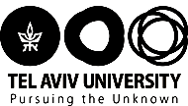

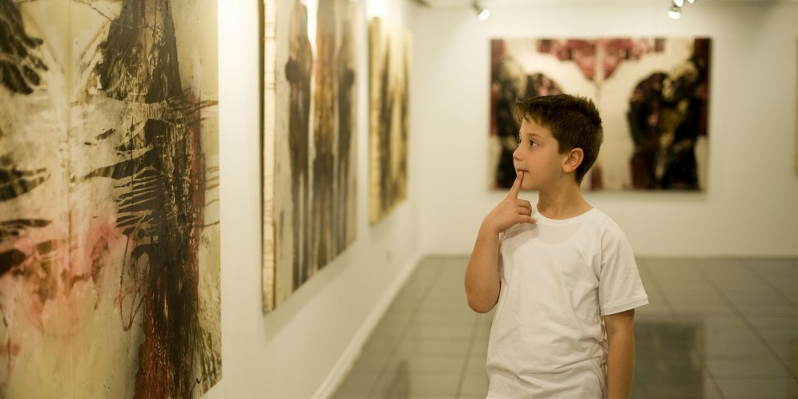

Art in the Community Program
Cultivating future generations of Israeli art enthusiasts and museumgoers
Appendix to the Proposal:
Summary of Project Pilot
and
Proposed Budget for the 2018-2019 Academic Year
For: Irith Rappaport
2018 July
Appendix to the Proposal:
Art in the Community Program

Summary of the project pilot undertaken during the 2017-2018 academic year
The first pilot of the Art in the Community Program was carried out during the second semester of the past academic year. The program's goal is to harness the knowledge and social consciousness of TAU art history students toward bridging gaps in art education. The program further aims to expand the community of art museumgoers.
The pilot activity was carried out within the framework of a unique new academic course, called “The White Cube and Community Activism,” which was developed especially for this purpose. Twelve students from the Art History excellence track participated in the course – in this instance, all were women. The students studied the theoretical basis behind the program, discussed issues relating to activism and community involvement in art museums, and underwent intensive training preparing them to serve as guides at the Tel Aviv Museum of Art. Following this training, the students guided 40 fifth-graders over the course of three days of activities, each lasting four hours. The fifth-graders came from the Nofim Elementary School in Kiryat Shalom, a neighborhood of south Tel Aviv whose residents are mostly of a low socio-economic status.
The course requirements were of a high level. Students were required to learn a large amount of new material in a short time; to implement tools and develop skills for guiding in a museum; to formulate appropriate lesson plans reflecting both the central topics of study and their own personal interest in the theoretical content and values discussed during the lectures; and, of course, to guide groups of fifth-graders during three days of activities.
Looking back on the course and the student-led activities, it is clear that both of the program’s target audiences – the university students and the fifth-graders – benefited from an enriching and experiential learning space, which inspired critical thinking and encouraged social change.

Principles and achievements of the program
- Course staff and partners:
- Facilitation of the course at Tel Aviv University: Dr. Rona Sela and Ishai Shapira Kalter, with assistance from Dr. Sefy Hendler, head of the Art History Department, and Rachel Warshavski, director of the Connected Plus program and the Unit for Social Involvement.
- Facilitation of activities at the Tel Aviv Museum of Art: Shani Almog, director of the Education Department; Anat Superski and Rafat Chatab, guiding staff.
- Nofim Elementary School: the school principal, Smadar Mors, guided this activity from its initial planning stage.
- Achievement Program, Education Welfare Department at the Tel Aviv municipality: Shira Brown guided the partnership with the Nofim School.
- Topics covered in the theory course (for the university students):
- Community activism and art museums – theoretical and practical aspects.
- Social involvement and art.
- Long term impacts of projects that give to the community.
- Accessibility of the museum to disadvantaged populations.
- Expansion of the museum's target communities.
- Focus on narratives of disadvantaged populations from visual and museum-based perspectives.
- Formation of a connection to the museum through one’s personal-societal narrative.
- Visual accessibility of content and narratives.
- Bringing the museum, and the issues with which it deals, closer to the community.
- Helping young people connect to the museum and discover their own narrative in the exhibition halls.
- Art education – tools for museum tours, ‘reading’ art, what works of art are trying to express, how (or whether) art reflects life.
- Inclusion of content relating to repressed populations in art education.
- Community, activism, and art – local art as a test case.
- Guest lectures:
- Community activism – sociological issues.
- Museum guiding as a tool for shaping consciousness and creating change.
- Education and accessibility of content for young populations – by the Education Department of the Tel Aviv Museum.
- Ron Tal's movie "The Museum" was screened at the end of the course.

- Summary of the activities with the primary school children:
During these sessions, the university students taught the children how to observe works of art; what the role of a museum is; how to interpret works of art and what questions they raise; the difference between formalistic elements and moral questions that are expressed in works of art; and the points of contact between all of these. Since this was the first time many of the children had visited the museum, emphasis was placed on providing tools that would help them visit again in the future, encouraging them to ‘befriend’ the museum and return with their parents. Through the tours and activities, the university students exposed the children to connections between the topics addressed in the works of art and aspects of their own lives, with the aim of helping them connect to the museum and creating a meaningful, positive, and inviting experience for them -- through both visuals and values.

The activities focused on appreciating visual art -- both Israeli and international -- with an emphasis on social and gender-related questions. The art works discussed were primarily those that seek to illuminate social, artistic, and visual issues, while directly or indirectly addressing these children’s own environment, and while attempting to connect their personal and collective histories with the museum’s exhibits.

Beyond the encounter with the world of art, these meetings raised the children’s awareness of other important topics as well. For example, in one of the groups, which dealt extensively with the subject of gender in art, some of the girls participating declared at the end of the session that, in the future, they will be prime ministers. In this case, the sessions served as a tool for personal and gender empowerment.

Another example is a group that was guided by a university student with a hearing and speech disability. The children were very fond of her. During the sessions, she taught the children some words in sign language, and exposed them, first-hand, to many dimensions of the experience of living with physical disabilities. Moreover, the parents of one of the children in the class also have hearing and speech disabilities. According to the children’s teacher, the encounter with this guide at the museum was very meaningful for this particular child. The teacher noted that the child is usually very ‘closed,’ yet following these sessions, and especially after witnessing the personal example of this university student, he opened up considerably.

It is important to note that, for many of the university students, this was their first community project and their first opportunity to harness the knowledge they acquired at university toward advancing social and educational goals. During the course, the university students spoke extensively about the importance of social action, both for society at large and for the individual involved.

- Central topics taught by the university students:
- The importance of observation: What does one see and identify in a work of art?
- Israeli art (before and after the establishment of the state, continuing through the conceptual art of the 1970s, ‘Want of Matter’ art, and contemporary works).
- European art (19th century, early 20th century, interwar period).
- Explanations of the various media and the differences between them (painting, sculpture, collage, video, etc.).
- Curatorship, strategies of curatorship (also guided by Tel Aviv Museum of Art Curator Noa Rosenberg).
- Visiting all the museum exhibitions which were age-appropriate for the school children.
- Role of the museum as a preserver of culture; the importance of cultural preservation.
- Differences between collection exhibitions, temporary exhibitions, and solo exhibitions.
- Feminism.
- The concept of 'home.'
- Otherness.
- Nationalism.
- Engraving at the museum's workshop.
- The architecture of the building.
- What does the museum not have, and why? Is everyone represented equally at the museum?

Academic credit:
Among the conclusions reached by the team leading this program was a decision to increase the number of academic credits earned by the university students next year from two points to four points. This decision is intended to ensure that the credits received accurately reflect the great effort invested in the course both by the students and by the faculty.

Proposed budget for the upcoming academic year – 5779 (2018-2019)

In order to facilitate the project in a similar format during the upcoming academic year, with one group of up to fifteen students, Tel Aviv University seeks a contribution of 87,500 NIS from Ms. Irith Rappaport. This funding will be apportioned to the various elements of the initiative in accordance with the itemization below:

The item | Budget for one group (up to fifteen students) in NIS
Coordination and academic instruction of the course | 40,000
Teaching assistant | 20,000
Yearly membership to the Tel Aviv Museum of Art for the university students | 3,000
Miscellaneous – advertising, purchasing literature, unexpected expenses | 7,000
Tel Aviv University administrative expenses | 17,500
Total | 87,500

As a sign of our appreciation, the university will be pleased to name this program in accordance with the donor’s wishes, and the program will retain the name chosen for the entire duration of the contribution. All events, publications, and activities connected to the program will bear this name as a testimony to the vision and generous support of the donor.

