Maraviroc for restraining vascular cognitive impairment and dementia

2. Supporting Data

Maraviroc has been developed for treatment-experienced patients who are infected with HIV and have only CCR5-tropic HIV-1 detectable. It is presented as immediate-release, film-coated tablets containing 150 mg or 300 mg of Maraviroc (active substance). The excipients used in the formulation of Celsentri are those typically used in tablet formulations. The tablet core contains cellulose microcrystalline, calcium hydrogen phosphate anhydrous, sodium starch glycolate and magnesium stearate. The film coat is a conventional Opadry II Blue film-coating system, which consists of polyvinyl alcohol, titanium dioxide, talc, macrogol 3350, soy lecithin and indigo carmine aluminum lake (E132). Celsentri 150 mg and 300 mg film-coated tablets are blue, biconvex and oval, debossed with Pfizer on one side and MVC 150 or MVC 300 on the other. The tablets are packed in HDPE bottles (with PP closure) or PVC/Al blisters. Active Substance Maraviroc is chemically designated as 4,4-difluoro-N-[(1S)-3-[(3-exo)-3-[3-methyl-5-(1-methylethyl)-4H-1,2,4-triazol-4-yl]-8-azabicyclo[3.2.1]oct-8-yl]-1-phenylpropyl]-cyclohexanecarboxamide (CAS) or 4,4-difluoro-N-{(1S)-3-[exo-3-(3-isopropyl-5-methyl-4H-1,2,4-triazol-4-yl)-8-azabicyclo[3.2.1]oct8-yl]-1-phenylpropyl}cyclohexanecarboxamide (IUPAC). According to the biopharmaceutical classification system (BCS), Maraviroc is classified as a high-solubility compound. Its pKa values are 3.3 and 7.9 corresponding to the protonation of the 1,2,4-triazole ring and tropane nitrogen, respectively. The product specification is standard for tablets and contains tests with suitable limits for identity of active substance (UV and HPLC), assay (HPLC), dissolution (HPLC), content uniformity (HPLC), impurities (HPLC) and skip-test for microbial bioburden and excipients identification. The stability of the product is in accordance with ICH guideline Q1A (R2).
Pharmacology
Primary pharmacodynamics: The mode of action of Maraviroc was studied at 3 levels in in vitro studies: (1) characteristics of receptor binding of Maraviroc (3 H-labelled) to recombinant human CCR5 using HEK-293 cell membrane preparation; (2) inhibition of viral protein attachment and fusion; and (3) viral replication assays. The affinity of Maraviroc for the human CCR5 was reflected in a KD 0.86 nM, which is comparable to that for the macaque CCR5 receptor (KD 1.36 nM). Studies on the potential to block binding of endogenous human CCR5 ligands and to interfere with the functional activity of the receptor were conducted. Receptor binding studies reported IC50 values of Maraviroc in the range of 3.3 to 7.2 nM for inhibition of binding of MIP-1α, MIP-1β and RANTES and no intrinsic agonist activity. Functional activities as reflected in assays of calcium flux and cAMP levels were inhibited with IC50 values in the range of 4 to 30 nM.
Safety pharmacology program: The potential of Maraviroc to interfere with major physiological systems was investigated in a series of in vitro and in vivo studies. In summary, with respect to the safety pharmacology data, no relevant effects were seen at low doses on the renal, respiratory and central nervous system (CNS); however, the following aspects are of note: Nonclinical tests showed that Maraviroc has potential to inhibit or block the Ikr current and prolong cardiac repolarization, hence exhibiting a potential to cause QT prolongation. Clinically significant QT interval prolongation was not reported in healthy individuals exposed to Maraviroc. Direct comparisons/extrapolations of in vitro concentrations to therapeutic plasma levels with calculations of “safety factors” may not always be meaningful, but literature data indicate that a factor of 30 for in vitro/in vivo concentrations can be interpreted as reassuring. The in vitro results could thus indicate a low level of concern for potential cardiovascular effects. The mechanism of action involved in the postural hypotension seen in the clinical studies is not clear, but CCR5-mediated effects on vasculature were presented as a possible hypothesis.
Clinical aspects
Pharmacokinetics: Maraviroc pharmacokinetics was studied in 28 phase I/IIa studies (complete profiles) and 3 phase IIb/III studies (with sparse sampling). The evaluation was performed after single-dose intravenous administration (1–30 mg) as well as oral single-dose (1–1200 mg) and multiple-dose administration (3–900 mg twice daily [BID] and 1200 mg once daily [QD]). The following formulations were used during development: powder for oral solution in phase I, 5 mg/25 mg/50 mg/100 mg/150 mg tablets in phase I/IIa and 150 mg in phase IIb/III. An intravenous formulation was used to determine absolute bioavailability. The commercial formulations (150 mg, 300 mg) have not been used in the clinical trials. The analytical methods used to analyze Maraviroc have been adequately validated.
Absorption: The absorption of Maraviroc is highly variable with multiple peaks. The mean Tmax was between 2 and 3 hours with individual values ranging from 0.5 to 8 hours (with food). The absolute bioavailability for Maraviroc was 23% at 100 mg, and it has a predicted bioavailability of 31% at 300 mg. The absorption of Maraviroc is dose dependent, likely attributed to saturated efflux transporters in the intestine. Maraviroc is highly soluble in aqueous media across pH 1–7.5, has an efflux ratio >10 in Caco-2 cell monolayers and is a substrate for P-gp and the multidrug resistance protein.
Bioequivalence: The research tablet formulation (150 mg) as well as the commercial tablet formulations are completely dissolved within 30 minutes (>90% within 15 minutes), and hence, dissolution will not be rate limiting for the absorption of Maraviroc. Bioequivalence was shown between the commercial 300 mg tablet and research formulation (2 x 150 mg). The solution had a 12% higher bioavailability than the research tablet.
Metabolism: The metabolism of Maraviroc was evaluated in 3 healthy male subjects after administration of 300 mg 14C Maraviroc as an oral solution in a fasted state. Whole blood samples and plasma samples were collected on days 1 to 6 at specified times up to 120 hours post-dose to measure plasma Maraviroc and UK-463,977 concentrations and radioactivity and for metabolite profiling, respectively. Urine and feces were collected to measure urinary and fecal radioactivity and for metabolite profiling up to at least 120 hours post-dose on day 1. UK-463,977 concentrations were also determined in urine. Unchanged Maraviroc was the main circulating component in plasma (42% of plasma radioactivity), and the metabolites UK-408,027 (22%), an amine analogue (11%) and UK-463,977 were also identified in plasma. The metabolites UK-408,027 or UK463,977 appear not to accumulate with time.
MVC achieves concentrations within the EC90 range in CSF and showed viral suppression in CSF. The CSF:plasma ratio of Maraviroc was reported as 0.03 (0.01–0.10).^{15,16}
Hepatic impairment: A study involving patients with mild and moderate hepatic impairment (Child-Pugh A and B) as well as individuals with normal hepatic function has been conducted. Administration of Maraviroc (300 mg single dose) to patients with mild and moderate hepatic impairment resulted in mean values of AUClast that were 25% and 45% higher, respectively, than in individuals with normal hepatic function (geometric means and corresponding 90% confidence intervals [CI] for the comparisons were 125% [84.7%, 185%] and 145% [100%, 212%]). Smaller differences in Cmax were noted with mean values 11% and 32% higher for mild and moderate impairment compared to normal function, respectively. As expected, mean CL/F decreased with increasing hepatic impairment, although the differences between mild hepatic impairment and normal hepatic function were minimal. Mean CLR was higher in individuals with moderate hepatic impairment compared to those with normal hepatic function. The mechanism for this increase in CLR is not known. Mean Tmax and t1/2 did not appear to be affected by hepatic impairment. The data are limited with wide confidence intervals for the comparisons to individuals with normal hepatic function.
Renal impairment: Studies in patients with renal impairment have not been performed. In patients without concomitant administration of CYP3A4 inhibitors, renal excretion constitutes a minor elimination pathway (about 23% of total clearance). In these patients, decreased renal function will likely have a limited effect on Maraviroc exposure. In patients with concomitant administration of CYP3A4 inhibitors, e.g., protease inhibitors, renal clearance will constitute up to approximately 70% of total clearance.

Clinical safety
Phase 1 single- and multiple-dose studies in healthy volunteers, conducted in 2001 and the first half of 2002, demonstrated that Maraviroc was safe and well-tolerated in multiple doses up to 300 mg BID, that it had a pharmacokinetic profile compatible with QD or BID oral dosing, that it could be combined with other ARVs and that doses ≥100 mg BID resulted in exposure above the geometric mean antiviral IC90 in vitro.^{17,18}
Patient exposure in phase I studies: 595 healthy patients and 37 patients with HIV have been exposed to Maraviroc in doses ranging from 1–1200 mg. In 2 multiple dose-finding phase II studies, 66 patients with HIV were exposed to Maraviroc (25–300 mg) for 10 days. Long-term safety data (minimum 24 weeks) were obtained in the main and supportive studies. In addition to the 3 previously presented studies in treatment-experienced patients (A4001027, A4001028 and A4001029), supportive safety data (n = 174) were provided from an ongoing study in treatment-naïve patients (A4001026). In this study, a Maraviroc treatment arm (300 mg QD) was stopped due to an increased incidence of treatment failure, and Maraviroc 300 mg BID open-label was offered. A total of 964 treatment-experienced patients received at least 1 dose of Maraviroc, including 840 CCR5-positive patients in the 2 pivotal studies. In the 2 pivotal trials (A4001027, A4001028), patients were exposed to Maraviroc for a median of 8 months (Table 22); the total exposure (580 patient years) was around five-fold that of placebo exposure (124 patient years).
AEs (AEs): AEs were similar in frequency and character in patients treated with Maraviroc and placebo and were those expected in this treatment population. Furthermore, no relevant differences in AEs (including serious AE) were seen in Maraviroc given QD versus BID. Infections (upper respiratory and herpes simplex) were somewhat more common with Maraviroc than with placebo, also after adjustment of exposure. Herpes simplex as a manifestation of immune response inflammatory syndrome (IRIS) is a well-known phenomenon and could be one possible explanation for this particular finding. AIDS-related infections and malignancies were not more common with Maraviroc, and autoimmune disorders were not reported. No major safety concerns were found with Maraviroc as part of the antiretroviral regimen in treatment-experienced patients. The dose-limiting adverse event, postural hypotension, appeared to be clinically manageable with the chosen dosage of 300 mg. Maraviroc was well tolerated, with the same frequency of study-drug discontinuation for Maraviroc and placebo. The spectrum of AEs reported, including serious AEs and deaths, did not reveal any specific issues considering the population studied. The frequency of liver-related AEs does not raise any concerns for liver toxicity. In late 2004, four large studies were initiated (phase IIb and phase 3), with 4794 patients screened at more than 200 sites in the United States, Canada, Europe, Australia, South Africa, Mexico and Argentina. An in-depth review of all data for evidence of hepatotoxicity for MVC and a high level of vigilance for any signals did not find any evidence for a systematic increase in hepatic enzymes or other markers for hepatotoxicity. Shortly afterward, concerns were raised regarding a potential increased risk for certain malignancies, and initially, there were concerns that this could be a class effect based on the immune-modulatory potential of CCR5 antagonists, but review of data from other vicriviroc studies, as well as the ongoing MVC studies, did not support this theory.¹⁹
Maraviroc (150 mg and 300 mg BID) received approval for use in the United States in August 2007 and in the European Union in September 2007.

A large, open-label safety study of Maraviroc was conducted at 262 sites worldwide in 1032 R5 HIV-positive, treatment-experienced patients. The data demonstrated that Maraviroc was well tolerated alone and in combination with other antiretroviral medications.²⁰ Despite concerns regarding the hepatic safety of CCR5 antagonists, an extensive data analysis did not show a significant difference in severe hepatotoxic effects between Maraviroc and placebo.^{21,22}
Relevant notes for the proposed study: Based upon Pfizer’s reports on premarketing and post marketing studies of Maraviroc and review of the literature, no dose adjustment is necessary even in patients with mild-to-moderate renal impairment. The drug does not affect the QT interval. At high doses (600 mg or more), it may induce orthostatic hypotension, so it is recommended that users who also take an antihypertensive medication be asked about symptoms of orthostatic hypotension. Of note, 8% of patients in active and placebo drug groups described orthostatic symptoms in a large trial. In HIV trials, 1.3% of subjects had cardiovascular events, more than in the placebo group, but the link to the drug was unclear and symptoms occurred only in those with known cardiac disease. Also, no greater incidence of infection, rash or other CNS symptoms was noted in these patients. An occasional Stevens-Johnson syndrome and drug rash with eosinophilia and systemic symptoms did occur (seen only in postmarketing surveillance, not in controlled trials), so complaints of rash, fever, joint or muscle aches, blisters, facial edema etc. will be part of our weekly phone call surveillance plan. Participants will be told to stop their medication immediately should such symptoms occur, and their physician will be notified. Of note, St John’s wort should not be used with Maraviroc, since it decreases the concentration of the medication.
Maraviroc is metabolized by the liver, so using it in persons with more than mild hepatic disease, especially in the presence of a CYP3A inhibitor, would have to be closely monitored; we will therefore not include these patients in this study.
Preliminary data/results
In several preclinical models of stroke and traumatic brain injury, our colleagues suggested that the FDA-approved CCR5 reversible co-receptor antagonist, Maraviroc, may lead to better motor and cognitive outcomes, presumably due to enhanced learning.⁵ Together with our colleagues, we have recently published that knockdown of CCR5 in the motor cortex of adult mice improves recovery after stroke.⁴ We tested if learning and cognition impairments resulting from stroke can be improved through pharmacological blockade of CCR5. Maraviroc (100mg/kg) was delivered beginning 24 hours post-stroke through daily intraperitoneal injections for 9 weeks. The availability of Maraviroc in the brain was confirmed in CSF with ultra-performance liquid chromatography and is at comparable levels to the human therapeutic range for this drug. Animals that received Maraviroc treatment after stroke showed improved performances in the novel-object recognition task (P = .0094, Figure 1A) as well as improved latency to goal box in the Barnes maze to test spatial learning and memory (P = .016) vs. vehicle-treated animals, day 3 (Figure 1B). Moreover, animals treated with Maraviroc showed increased successful hole visits as indicated by higher number of visits to the hole of the goal box and its 2 adjacent holes at both sides (P < .01, Figure 1C).
 |  | 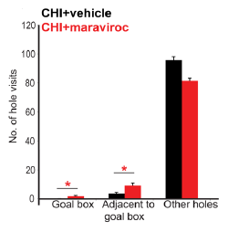
Figure 1A | Figure 1B | Figure 1C

Thus, we investigated the potential of CCR5 as a target in human stroke by studying recovery in patients with CCR5-Δ32 mutation in our TABASCO (Tel-Aviv Brain Acute Stroke Cohort) observational study (ClinicalTrials.gov Identifier: NCT01926691) of a post-stroke population (446 total patients, 68 carriers, mostly Ashkenazi Jewish). This group showed significantly better cognitive and functional outcome 1 and 2 years post-stroke. CCR5-Δ32 carriers showed better performance in memory, verbal function, attention and total cognitive scores compared to non-carriers (P = .033, P = .011, P = .024 and P = .047, respectively) after adjustment for age, gender and education, as well as in domains of the Montreal Cognitive Assessment (MoCA) score (Figures 2A and 2B) and in functional outcomes.⁴ The patients were categorized to groups according to their degree of white-matter hyperintensities (WMH) by the Fazekas score.²³ CCR5-Δ32 carriers showed better performance in total cognitive scores compared to non-carriers in each of these groups (P = .003, Figure 2C).

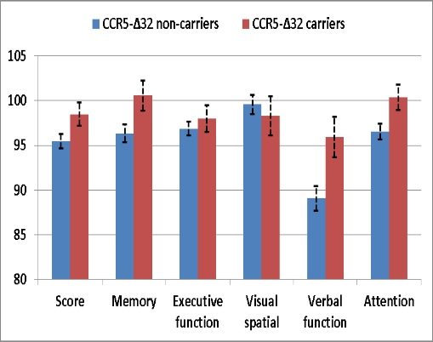  *0.047 *0.033 0.533 0.615 *0.011 *0.024 | 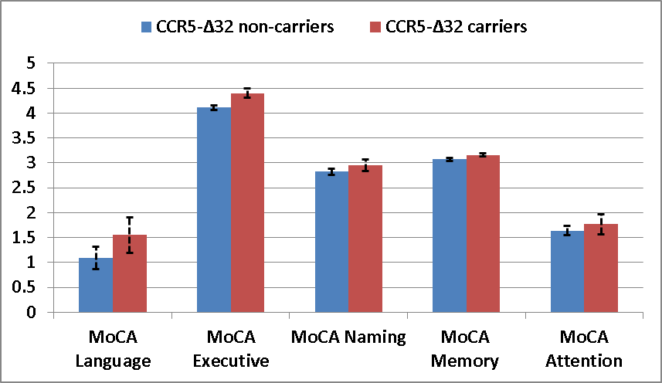  *<0.001 *0.047 *0.001 0.679 *0.048 | 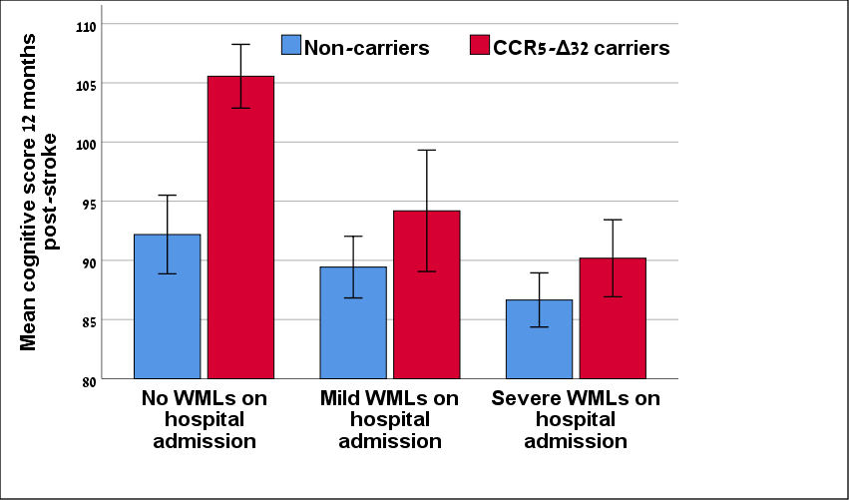
Figure 2A, 2B: Cognitive performance 1 year after stroke/TIA in CCR5-Δ32 carriers vs. non-carriers. |  | Figure 2C: Cognitive performance 1 year after stroke/TIA in CCR5-Δ32 carriers vs. non-carriers by groups of white-matter hyperintensities (WMH).

These results are consistent with the animal studies and support the hypothesis that a CCR5 loss of function enables better recovery in human post-stroke patients. Also strengthening this hypothesis are the results of the mental state in our cohort, which are another measure of recovery from the stroke and the extent of cognitive state/deterioration. CCR5-Δ32 carriers had significantly less anxiety and depressive symptoms up to 24 months after the index stroke compared to non-carriers after adjustment for age, gender and education (Figure 3). Accordingly, CCR5-Δ32 carriers showed lower depressive and anxiety scores compared to non-carriers in each of the WMH groups (P = .006 and P = .001, respectively; Figures 3B and 3D).

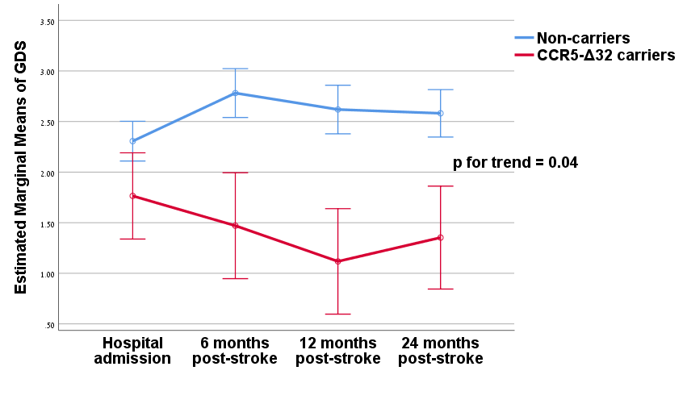 | Figure 3A:  General linear model (GLM) analysis of repeated measures of depression scores (GDS) in CCR5-Δ32 carriers vs. non-carriers.  CCR5-Δ32 carriers (15.2%) had fewer depressive symptoms at admission and at 6, 12 and 24 months after the index event compared to non-carriers (P = .035, P < .001, P < .001 and P = .006, respectively). The association of CCR5-Δ32 and depressive symptoms remained significant after adjustment for age, gender and education.
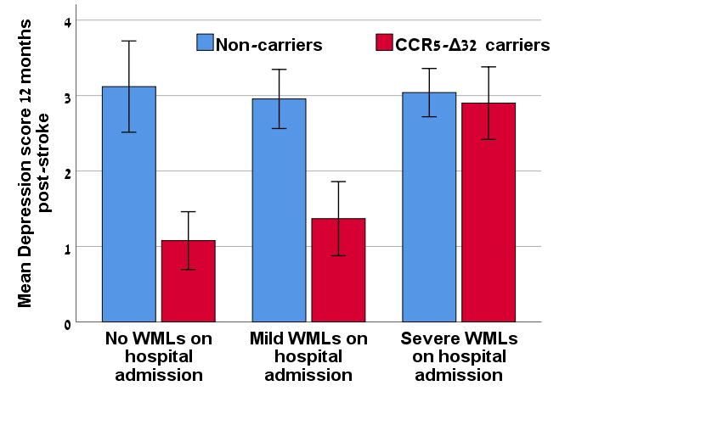 | Figure 3B:  Depression scores 1 year after stroke/TIA in CCR5-Δ32 carriers vs. non-carriers by groups of white-matter hyperintensities (WMH).
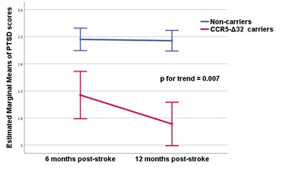 | Figure 3C:  General linear model (GLM) analysis of repeated measures of anxiety scores in CCR5-Δ32 carriers vs. non-carriers at 6 and 12 months after the index event compared to non-carriers. The association of CCR5-Δ32 and anxiety symptoms remained significant after adjustment for age, gender and education.
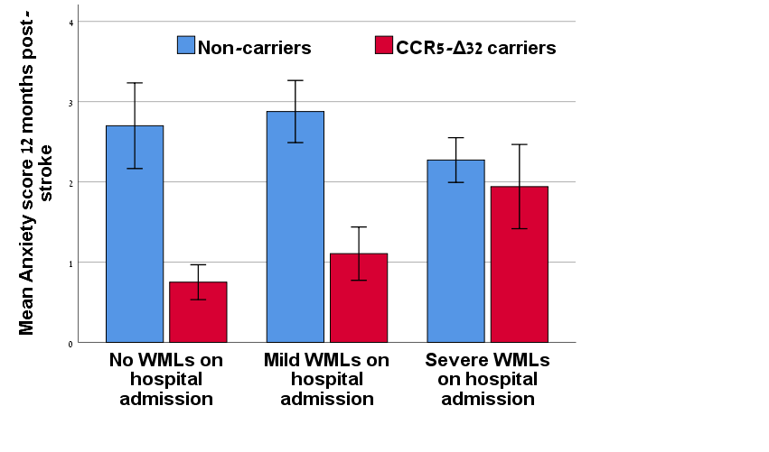 | Figure 3D:  Anxiety scores 1 year after stroke/TIA in CCR5-Δ32 carriers vs. non-carriers by groups of white-matter hyperintensities (WMH).

Recent data in an experimental-HIV model showed that Maraviroc reduced upregulation of inflammatory proteins in the frontal cortex, striatum and hippocampus of rats,²⁴ suggesting that Maraviroc may decrease inflammatory molecules, which are also upregulated in stroke and vascular dementia (VaD). Indeed, in our population, CCR5-Δ32 non-carriers had higher inflammatory biomarkers on admission compared with carriers of the mutation (P = .006 and P =.041 for c-reactive protein [CRP] and interleukin-6 [IL-6], respectively). Retrospective comparisons between cognitively intact and post-stroke cognitive impairment (PSCI) patients from the TABASCO showed significantly elevated inflammatory profile, mainly ESR, CRP and fibrinogen, in PSCI vs. intact patients (P = .06, P = .024 and P = .011, respectively). Increased CRP and ESR levels were repeated among the PSCI compared to the intact group 6, 12 and 24 months later (P = .009, P = .047; P = .012, P = .017; and P = .040, P = .005, respectively; Figure 4).
We have previously reported that higher levels of CRP and ESR were associated with smaller hippocampi and worse cognitive performance.²⁵ Prior reports showed that stroke-induced disruption of the blood-brain barrier (BBB) is aggravated and prolonged by systemic inflammation,²⁶ with subsequent damage to the white matter (WM). Figure 5 demonstrates images of two representative stroke patients from our cohort: a CCR5-Δ32 non-carrier with elevated inflammatory markers and a CCR5-Δ32 carrier with a normal inflammatory profile (no evidence of BBB leakage). Brain health and integrity are important factors in the brain’s capacity to compensate after infarctions. We assume that the stroke patients who went on to develop cognitive decline had increased inflammation as well as loss of WM integrity and cortical atrophy before the stroke, negatively influencing their brain plasticity. Hence, these patients may benefit from a new therapy strategy that both affects synaptic plasticity and reduces inflammatory responses.
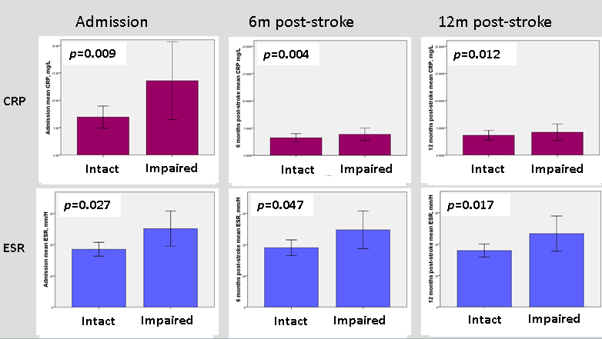 | Figure 4: Retrospect comparison of mean c-reactive protein (CRP) and ESR levels among stroke patients who developed cognitive impairment vs. those who remained intact.
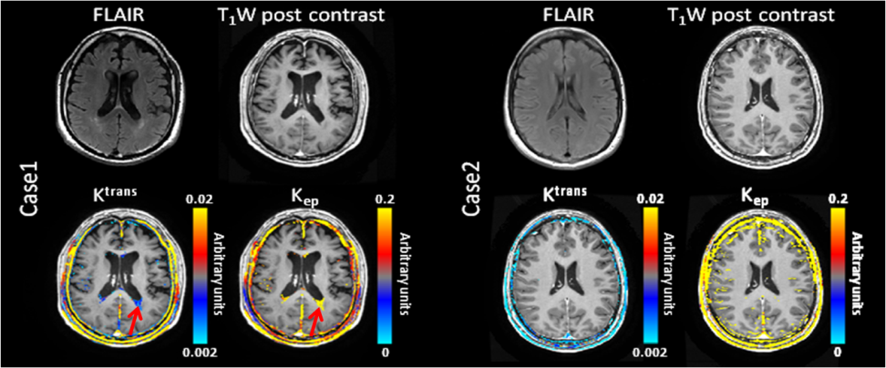 | Figure 5: FLAIR, T1 weighted post-contrast images and DCE calculated maps of K^{trans} and K_{ep} of 2 representative patients.  Case 1: A CCR5-Δ32 non-carrier stroke patient with elevated inflammatory markers showing regions with increase permeability (blood-brain barrier leakage, marked with red arrow) around the left lateral ventricle consistent with the presence of white-matter lesions.  Case 2: A CCR5-Δ32 carrier stroke patient with normal inflammatory profile showing no evidence of blood-brain barrier leakage.

The results support the hypothesis of a protective role for the CCR5-Δ32 mutation and for Maraviroc, a CCR5 antagonist, after brain ischemia. In terms of overall cognitive and mental recovery with human CCR5 loss of function, the improvement in recovery is significant across a large patient cohort (446 total patients, 68 carriers), similar in size to the only other positive recovery effect in stroke: fluoxetine administration²⁷ (FLAME study, n = 57). Although this fluoxetine study only measured motor recovery, the CCR5-Δ32 mutation has a bigger effect on recovery of neurological and cognitive impairments than does fluoxetine in this positive clinical trial. Results were prominent in patients with low and high white-matter lesion (WML) load, who are at risk for progression to dementia and may benefit from treatment with this drug.

3. Project Plan and Objectives
Objectives and Corresponding Endpoints
This study will evaluate the safety and efficacy of Maraviroc 150 mg and 300 mg per day compared with placebo in patients with recent subcortical stroke suffering from mild PSCI.
Specific objectives and corresponding endpoints for the study are outlined in the table below.

Corresponding Endpoints | Primary Safety Objective
• AEs related to the medication assignment, to rehabilitation practice or to other causes will be adjudicated by the Safety Committee with input from the PI.  • Nature, frequency, severity and timing of AEs and serious AEs.  • Physical and neurologic examinations, vital signs, blood tests and electrocardiograms (ECGs).  • AEs of special interest: blood analyses of liver function and renal function, specifically elevation of hepatic transaminases or bilirubin; elevation of serum creatinine. | To demonstrate the safety and tolerability of Maraviroc vs. placebo in patients with recent subcortical stroke who experience mild post-stroke cognitive impairment (PSCI).
Primary Efficacy Objective
• To evaluate the efficacy of Maraviroc 150 mg and 300 mg compared with placebo on change over time from baseline to week 76 in cognitive scores as assessed by CDR-SB.  A negative effect size of cognitive changes represents an improvement in consistency of cognitive symptoms across the included cognition metrics. | To evaluate the efficacy of Maraviroc compared with placebo on progression of clinical symptoms of  post-stroke dementia.
Secondary Efficacy Objectives
• Change from baseline to week 76 on cognition as assessed by VaDAS-cog, Trail Making Test A+B and global cognitive score based on repeatable computerized battery of cognitive tests (Neurotrax) and Montreal Cognitive Assessment (MoCA).  • Change from baseline to week 76 on function as by the stroke impact scale, activities of daily living (ADL) score, subsequent cardiovascular events, gait and balance scores and mean change in FIM, DEX and RNL; all-cause discontinuation.  • Change from baseline to week 76 on behavior assessed by the geriatric depression scale and NPI-Q total score. | To evaluate the efficacy of Maraviroc 150 mg and 300 mg compared with placebo on additional cognitive, functional and behavioral outcomes.
 | Biomarker Objectives
Imaging biomarkers: MRI-derived measurements over time such as volumetric changes in whole brain, ventricles, hippocampus, white-matter volume, integrity and connectivity, and locations and number of cerebrovascular lesions, lacunes, microbleeds or other structures.  • Blood/plasma biomarker: inflammatory and endothelial function profile over time, as well as plasma Abeta concentrations.  • CSF biomarkers: inflammatory and endothelial function profile, as well as CSF Abeta, t-tau, p-tau and S100β (a biochemical marker of inflammation that indicates astrocyte activation) concentrations over time in a substudy.  • Measures of carotid atherosclerosis (assessed by carotid Doppler peak systolic velocity and carotid intima media thickness). | To demonstrate the effect of Maraviroc 150 mg and 300 mg compared with placebo on markers of disease over time.
Timeline
Tasks |  | Milestones
Finalize study design and recruitment plan and obtain MoH/regulatory agency ERC approvals for all sites; investigators will assess the occurrence of AEs and serious AEs at all patient evaluation time points during the study. | 1st year, 1st quarter | Milestone 1: First meeting of the Safety Committee (before start).  Milestone 2: Start recruitment and start treatment period and study procedures.
Continue recruitment, study procedures and record of AEs.  AEs related to the medication assignment, to rehabilitation practice or to other causes will be adjudicated by the Safety Committee with input from the PI. | 1st year, 2nd quarter | Milestone 2: Recruitment of about 15% of the required patient sample and continued data collection.  Milestone 3: Achieve reliable and robust blood baseline measures for safety comparisons as well as blood and CSF inflammatory profile.
Continue recruitment, study procedures and record of AEs. | 1st year, 3rd quarter | Continue Milestone 3.  Milestone 4: Recruitment of about 40% (in total) of the required patient sample and continue treatment and study procedures; collection of raw data; database preparation.  Milestone 5: Review of safety data; second meeting of the Safety Committee.
Continue recruitment, study procedures and record of AEs. | 1st year, 4th quarter | Milestone 6: Recruitment of about 65% (in total) of the required patient sample; continue treatment period and study procedures; continue collection of raw data.
Continue recruitment, study procedures and record of AEs. | 2nd year, 1st quarter | Milestone 7: Recruitment of about 80% (in total) of the required patient sample; continue treatment period and all procedures.  Milestone 8: Merge of lab results with clinical database; interim safety analyses.  Continue Milestone 3 and continuous review of safety data.
Continue treatment period and study procedures; continue collection of raw data, follow-up visits and record of AEs. | 2nd year, 2nd quarter | Milestone 9: Recruitment of 100% (in total) of the required patient sample.  Milestone 10: Complete interim safety report; third meeting of the Safety Committee.
Continue treatment period and study procedures; continue collection of raw data, follow-up visits and record of AEs. | 2nd year, 3rd and 4th quarters; 3rd year, 1st quarter | Continue Milestone 3 and study procedures.  Milestone 11: Review of safety data; fourth meeting of the Safety Committee.
Continue treatment period and study procedures. | 3rd year, 2nd quarter | Milestone 12: Merge of lab and MRI results with clinical database; interim safety and efficacy analyses; interim safety and efficacy report; start MRI analyses.
End of treatment period and study procedures, including final efficacy and safety assessments. | 3rd year, 3rd and 4th quarters | Milestone 13: Fifth meeting of the Safety Committee.  Milestone 14: Merge of all raw data and start preparation of data for final analyses; completion of MRI analyses; final statistical analyses according to statistical analysis plan.  Milestone 15: Database lock and completion of clinical study report and final safety report.
Potential pitfalls
- The recruitment rate may be slower than anticipated. We will plan monthly meetings of local PIs and frequent assessment of recruitment rate. We will consider adding another site (Rambam Medical Center) in case of a too-slow recruitment rate.
- The sample size may be too small to determine efficacy. The study’s primary endpoint is safety. Nevertheless, learning from past small phase II trials, we planned a rather large trial which will include two treatment groups and a placebo.
- Given the limitations of clinical trial designs, the magnitude of effect for drugs for prevention may be difficult to ascertain, and Maraviroc may present efficacy only in a specific subgroup (such as those with higher inflammatory biomarkers or a particular grade of WML). Hence, we plan to perform subanalyses for both safety and efficacy measures accordingly.
- The inclusion of CCR5-Δ32 carriers may lower efficacy results. We will not exclude carriers, since Maraviroc may present an effect on carriers and since we would like to collect safety data from this group as well. Thus, we plan to perform subanalyses according to CCR5-Δ32 genotype.

4. Experimental Design and Methods
Design

We plan to perform a randomized, triple-blind, placebo-controlled clinical trial of Maraviroc therapy in patients diagnosed with recent (1–12 months) subcortical stroke who experience mild PSCI and have evidence of WMLs and small vessel disease (SVD) in neuroimaging.

We will compare Maraviroc versus placebo administered for 18 months in 110 participants.
Study Type: | Interventional (Clinical Trial)
Allocation: | Randomized (ratio 2:2:1 – Maraviroc 300mg, 150mg, placebo
Intervention Model: | Parallel Assignment
Intervention Model Description: | We plan a parallel-group, randomized controlled pilot trial at 3 sites in Israel to gather enough entries in a shorter time and to better generalize the results of this pilot phase II trial.
Masking: | Triple (Participant, Investigator, Assessor)
Primary Purpose: | Treatment

Methods
Eligible patients enrolled in the study will undergo a baseline visit (week 1) during which they will receive the study drug following completion of all relevant assessments. Patients will be randomly assigned to 72 weeks of treatment with either 300 mg/day Maraviroc, 150 mg/day Maraviroc or placebo (control group). Patients will be evaluated every 4 to 12 weeks during the trial using multiple cognitive tests and questionnaires. A final efficacy and safety assessment will be held 4 weeks after the patients’ last dose (week 76).
The patients will undergo two 3 Tesla brain MRI examinations at baseline (week 1) and at study completion (between weeks 72 and 76).
MRI acquisition and processing: The MRI protocol will consist of previously described pulse sequences.²⁸ All axial slices will be prescribed on the same orientation, covering the whole brain and aligned along the fourth ventricle-orbitofrontal orientation. MRI analyses will include assessment of the following: (1) Cerebral SVD burden, in accordance with STRIVE score.²⁹ This score determines chronic lacunar infarcts, WMH (to be graded using the Fazekas score²³), cerebral microbleeds (CMB) and enlarged perivascular spaces (PVS). (2) Tissue segmentation and brain atrophy measures as previously described.²⁸ (3) Characterization of microstructural integrity—calculation of the diffusion tensor imaging (DTI) maps³⁰ in major WM fiber tracts.
Characteristics of human participants
Inclusion Criteria:
Men and women aged 50 to 86 years; able to fully comprehend and sign an informed-consent form; fulfill the diagnostic criteria for PSCI/subcortical vascular cognitive impairment that developed after a documented stroke/TIA, as outlined by Skrobot and colleagues³¹ (this requires the presence of a cognitive syndrome, as defined in Section A below, and SVD, as defined in Section B below); impairment in at least one cognitive domain and mild to no impairment in instrumental activities of daily living (IADLs) / activities of daily living (ADLs), respectively (independent of the motor/sensory sequelae of the vascular event).
A. Cognitive syndrome is defined as (1) dysexecutive syndrome: some impairment in goal formulation, initiation, planning, organizing, sequencing, executing, set-shifting and maintenance or abstracting; (2) memory deficit: some impairment in recall, relative intact recognition, less severe forgetting or benefit from cues.
B. Small vessel ischaemic disease is defined as (1) evidence of relevant cerebrovascular disease by brain imaging (in the past 12 months), defined as the presence of both (i) periventricular and deep WMLs (grading scale >1 on the Fazekas score⁵) plus at least one lacunar infarct and (ii) absence of cortical and/or cortico-subcortical non-lacunar territorial infarcts and watershed infarcts, indicating large-vessel disease, signs of normal pressure hydrocephalus or other specific causes of WML; or (iii) presence or a history of neurological signs as evidence of cerebrovascular disease. In addition, individuals must meet the following inclusion criteria: MoCA score less than 26 at screening; community-dwelling; able to comply with scheduled visits, treatment plan and other trial procedures; able to walk independently; clinical dementia rating (CDR) = 0.5; Modified Rankin score <2.

Exclusion Criteria:
Patients diagnosed with dementia or significant cognitive impairment as defined by a MoCA score <20 at screening or with other neurological conditions (multiple sclerosis, Parkinson’s disease, epilepsy etc.) that affect cognition and mobility; presence of cortical involvement on neurologic examination including aphasia, extinsion etc.; absence of relevant SVD on brain imaging; diagnosed previously with a genetic cause of VCI (e.g., CADASIL); taking medications that may negatively affect cognitive function; unable to meet the specific scanning requirements of the 3T MRI; history of hepatitis or elevated hepatic transaminases or bilirubin; positive serology for hepatitis B or C; positive serology for HIV; history of renal insufficiency or serum creatinine over 1.6; diagnosed psychiatric disorders; diagnosis of attention deficit disorder; history of drug and alcohol dependence or substance abuse; prolongation of the corrected QT (CTc) interval; use of drugs with possible interactions with Maraviroc.
Recruitment and retention plans
Screening and patient evaluation: Patients followed up at stroke-specific outpatient clinics in the 3 tertiary stroke centers participating in the study and who meet entrance criteria may be eligible to participate in the study. After receiving a detailed explanation and signing informed consent, the participants will be further screened. All identifying information of participants will be saved in a separate password-protected study log available only to study investigators. All the gathered data will be de-identified and coded with a preassigned study ID.
The following evaluations and procedures will be performed:
- Demographic data: age, gender, ethnic origin, socioeconomic status and education level
- Verification of subcortical stroke/TIA history
- Clinical data—comorbidities, drug treatment and additional cardiovascular risk factors or events
- Verification of neuroimaging criteria for enrollment, including Fazekas score, number of CMBs and WML volume
- Blood pressures and heart rates, physical and neurological exam and electrocardiogram (ECG)
- Functional status as assessed by the Modified Rankin Scale (mRS), ADCS-ADL, Bartell score and FIM
- Neurologic disability as assessed by the National Institutes of Health Stroke Scale (NIHSS)
- Detailed cognitive assessment: VaDAS-cog score, CDR, Trail Making Test A+B, Neurotrax, MoCA
- Psychiatric evaluation using the Center for Epidemiologic Studies–Depression (CES-D) scale
- ADCS-ADL scale and quality of life (QoL), RNL, gait speed and velocity tests
- Carotid Doppler measurements including peak systolic velocity and intimal medial thickness (IMT)

Laboratory work up: Plasma and CSF samples may be used for exploratory biomarker assays and response to treatment. Blood samples for cell blood count, lipids profile, liver and kidney function and inflammatory markers: highly sensitive c-reactive protein (hs-CRP), tumor necrosis factor (TNF)-alpha, IL-6, IL-10, IL-1 β, IL-2 and IL-17A; CCR5 ligands (MIP-1α, RANTES) and Maraviroc concentration. Cytokine level will be determined in blood and CSF using ELISA (R&D Systems, USA) and ProcartaPlex™ Multiplex Immunoassay (Affymtrix eBioscience). In addition, Aβ 1-40 and 1-42, t-tau, p-tau and S100β levels in CSF and plasma will be determined using ELISA (IBL); genetic determination of CCR5 genotype; and Maraviroc concentration in CSF (for a subgroup).
Plasma, serum and CSF samples from all sites will be stored at –80ºC and shipped frozen for central laboratory analysis at Tel Aviv Sourasky Medical Center.

Randomization: Participants will be assigned to the control or experimental group using a 2:2:1 online, computer-generated randomized allocation schedule. Assignment (for all research sites) occurs automatically upon subject entry to the study. All members of the research team and study participants will be blinded as to allocation. The study statistician and Safety Committee will access drug assignment on an as-needed basis (adverse drug reaction).
Follow-up assessments: Follow-ups will be performed in weeks 4, 12, 24, 36, 48, 60, 72 and 76 and will include
physical and neurological exam, vital signs, cognitive and functional evaluation, record of AEs related or not related to the medication assignment, CES-D scale, ADCS-ADL scale and pill counts.
Quality control and analysis: All patient records and specimens will be tracked in a manner consistent with good clinical practice by a quality-controlled, auditable and appropriately validated laboratory information management system, to ensure compliance with data confidentiality as well as adherence to authorized use of specimens as specified in this protocol and in the informed-consent form.
Statistical considerations (sample size): These will be in accordance with previously described methods.³²⁻³³
The planned sample size of 80 participants in the treatment group (40 for each dosage) and 20 participants in the placebo group (ratio 2:2:1) is considered adequate for this study. A total of 110 patients is required (assuming a dropout rate of 10%) to ensure at least 100 completed patients. The sample-size determination was not based on a minimal power but was designed to allow stable estimates for the safety profile and to show a trend of improvement of cognitive scores (based on a battery of cognitive tests: VaDAS-cog, Neurotrax, CDR, MoCA) in the treatment groups compared to the placebo group. In the event that a positive trend of improvement is found, the 2 treatment groups will be unified and compared to the placebo group in order to increase statistical power.
Statistical Analysis: The data will be analyzed using the SAS ® version 9.4 (SAS Institute, Cary, North Carolina).
The primary endpoint will be safety assessments and the secondary endpoints will be efficacy assessments, as measured by the mean change in cognitive scores (based on a battery of cognitive tests: VaDAS-cog, Neurotrax, CDR, MoCA) from baseline to month 18 and in functional scores.
Other secondary endpoints:
- Change from baseline to month 18 in functional outcome, as measured by stroke impact scale, ADL score, geriatric depression scale, gait and balance scores.
- Change from baseline to month 18 in brain MRI–derived normalized measures of total brain/intracranial volume, white-matter volume, integrity and connectivity and hippocampal and cortex volume; change in locations and number of cerebrovascular lesions; change in carotid atherosclerosis status (carotid intima media thickness) and change in blood inflammatory profile.
General Considerations
All measured variables and derived parameters will be listed individually and will be summarized by tabulation and descriptive statistics.
For categorical variables, summary tables will be provided giving sample size, absolute and relative frequency and 95% CI for proportions.
For continuous variables, summary tables will be provided giving sample size, arithmetic mean, standard deviation, coefficient of variation (cv%) median, minimum and maximum and 95% CI for means.
All tests will be two-tailed, and a P value of 5% or less will be considered statistically significant.
The data will be analyzed using the SAS ® version 9.4 (SAS Institute, Cary, North Carolina).

Statistical Analysis
Safety analysis (primary endpoint): All safety data will be summarized in appropriate tables.
AEs will be coded according to coding dictionaries (MedDRA version 22.0 or higher) and presented in tables by system organ class (SOC) and preferred term (PT) and by treatment group. Safety will also be assessed by evaluating findings of physical examinations, vital signs, clinical laboratory test results and concomitant medications by treatment group. The changes from baseline in vital signs and clinical laboratory tests results will be displayed.

Efficacy Assessments
Primary outcomes analyses:
Stage 1 (analysis within each study group)—The paired t test or signed rank test for 2 means (as is appropriate) will be applied for testing the statistical significance of the difference in cognitive scores and in functional scores from baseline to month 18 within each study group.
Stage 2 (analysis between the study groups)—The analysis of covariance (ANCOVA) model will be applied in order to identify covariate variables suspected as related to cognitive scores and functional scores and to test the differences in cognitive scores and functional scores between the study groups adjusted to the above covariate variables suspected.
Secondary outcome analyses:
Stage 1 (analysis within each study group)—The paired t test or signed rank test for 2 means (as is appropriate) will be applied for testing the statistical significance of the difference in functional scores from baseline to month 18 within each study group.
Stage 2 (analysis between the study groups)—The ANCOVA model will be applied in order to identify covariate variables suspected as related to functional scores and to test the differences in functional scores between the study groups adjusted to the above covariate variables suspected.
Other outcome analyses (continuous variables):
Stage 1 (analysis within each study group)—The paired t test or signed rank test for 2 means (as is appropriate) will be applied for testing the statistical significance of the difference in continuous variables within each study group.
Stage 2 (analysis between the study groups)—The ANCOVA model will be applied in order to identify covariate variables suspected as related to continuous variables and to test the differences in continuous variables between the study groups adjusted to the above covariate variables suspected.
Other outcome analyses (categorical variables):
Stage 1 (analysis within each study group)—The paired t test or signed rank test for 2 means (as is appropriate) will be applied for testing the statistical significance of the difference in categorical variables within each study group.
Stage 2 (analysis between the study groups)—A chi-square test or Fisher exact test (as is appropriate) will be applied for testing the statistical significance of the difference in percentage of categorical variables between the study groups.
Stage 3 (analysis between the study groups)—Logistic regression will be applied for analyzing the difference in percentage of categorical variables with adjustment for baseline measure and for other covariates suspected as affecting the outcome and which will be found different between the study groups. In order to understand the potential longitudinal difference in the rate of disease progression by CCR5-Δ32 genotype, a longitudinal Cox PH model will be implemented as an important supportive analysis. This will be done by including the additional interaction term treatment arm × genotype.
Safety Plan
Several measures will be taken to ensure the safety of patients participating in this study. Eligibility criteria have been designed to exclude patients at higher risk for toxicities. Patients will undergo safety monitoring during the study, including assessment of the nature, frequency and severity of AEs. Investigators will assess the occurrence of AEs and serious AEs at all patient evaluation timepoints during the study. All AEs and serious AEs, whether volunteered by the patient, discovered by study personnel during questioning or detected through physical examination, laboratory test or other means will be recorded in the patient’s medical record and on the appropriate case-report forms.
The incidence and nature of AEs, serious AEs, imaging abnormalities, AEs of special interest and laboratory abnormalities will be assessed on a regular basis by an unblinded independent data monitoring committee (iDMC). The iDMC will serve all sites. Prof. Ronen Ben-Ami, Head of Infectious Diseases Unit at Tel Aviv Sourasky Medical Center (TASMC), with extensive experience in treating HIV patients with Maraviroc, will serve as the head of the iDMC for possible adverse drug reactions; other members will include the study statistician, an internal medicine expert (Prof. Shlomo Berliner) and two senior neurologists specializing in both cerebrovascular and memory disorders (Prof. David Tanne, Rambam Medical Center, and Prof. Amos Korczyn, Tel Aviv University). The committee will meet before the start of the trial, every 6 months after the first 10 subjects have completed a 2-month drug intervention and as otherwise needed (serious adverse reaction).

Interim analyses (IAs): The main purposes of the planned IAs are safety monitoring, dose adaptation and assessment of either futility or overwhelming efficacy with the potential consequence of discontinuing one active treatment arm or the whole study. All IAs will be conducted by the study statistician and iDMC based on unblinded data. Regular semiannual safety reviews will be conducted (with additional ad hoc reviews as needed) to review all safety data as determined by the iDMC. Primary futility efficacy analysis will be conducted once approximately 75% of the target number of events has occurred.

5. Description of Drug Discovery Team and Resources
The proposed study is planned to include one major site (TASMC) and two additional sites in Israel: Sheba Medical Center (PI: Dr. David Orion) and Hadassah Medical Center (PI: Prof. Ronen Leker). All three sites are professional medical centers that meet the highest standards and regulatory criteria. All study investigators have previous experience with investigator-driven clinical studies as well as extensive experience with stroke and dementia neuroimaging. All have access to the relevant eligible patients. In the Neurology Department–Stroke and Internal Department at TASMC, about 1500 patients who have experienced an acute stroke are treated each year, and about 2500 are treated at the stroke and dementia outpatient clinics. About 2000 patients who have experienced an acute stroke are treated each year and about 3000 are treated at the stroke and dementia outpatient clinics at Sheba Medical Center and Hadassah Medical Center together. Thus, we do not anticipate any problem in recruiting the required 110 patients for the study.

The PIs are Dr. Einor Ben Assayag and Dr. Hen Hallevi. Dr. Einor Ben Assayag has wide experience with clinical trials in the pharmaceutical companies as well as with investigator-driven clinical trials: currently, her team is running the TABASCO (Tel-Aviv Brain Acute Stroke Cohort, http://clinicaltrials.gov/show/NCT01926691), an exclusive prospective study of 575 first-ever stroke patients, all free of dementia at baseline, who were followed for ~8 years.
Dr. Hen Hallevi, director of the Neurology Department–Stroke at TASMC, has extensive experience as a local PI in leading FDA-regulated drug trials in stroke patients and will be responsible for ethical considerations and clinical decisions, together with Dr. Jeremy Molad and Dr. Estelle Seyman, both of whom are senior vascular neurologists.
All participants will undergo comprehensive cognitive and functional tests, advanced structural neuroimaging and collection and analysis of blood and CSF samples; frozen samples will be stored and processed centrally at TASMC. The same imaging protocol will be used at all sites and central analysis at TASMC under the supervision of Prof. Dafna Ben Bashat, Deputy Director and Head of MRI Systems, the Wohl Institute for Advanced Imaging, TASMC. Cognitive evaluations will be performed under the supervision of Dr. Noa Bregman, Head of the Memory Clinic, TASMC, with extensive experience as a local PI in leading FDA-regulated drug trials in patients experiencing all types of dementia. Psychiatric assessments will be performed under the supervision of Dr. Oren Tene, Head of the Psychiatric outpatient Clinic, TASMC.
Statistical and interim analyses will be conducted by Gil Harari, PhD, MediStat Ltd., Israel. Clinical operations oversight, site monitoring, management and medical monitoring will be provided by Clinical Trials Network Services (CTNS), directed by Prof. David Zeltser. An external consultor is Dr. Eyal Schwartzberg, former chief pharmacist and Head of the Pharmaceutical and Enforcement Divisions in Israel’s Ministry of Health.

Facilities available for the study performance
- Human resources—the trial team provides the infrastructure for clinical trials in post-stroke and mild cognitive impairment (MCI) patients. A very skilled study team, all are multilingual GCP trained investigators, including vascular neurologists, cognitive neurologists (memory clinic), a psychiatrist, research coordinators, a PhD student, a post-doc student, a laboratory technician and a study nurse.
- Doppler laboratory equipped with the relevant facilities for carotid Doppler measurements and software for measuring carotid IMT.
- Molecular biology and biochemistry laboratory equipped with the relevant facilities for cytokine analysis, as well as Aβ analysis, plate and tube shakers, plate reader–based screening assays, centrifuges and microcentrifuges, Sunrise™ microplate absorbance reader for 96-well plates with Magellan™ data analysis software, freezers and deep freezers (–80ºC) to store specimens.
- Office space—3 rooms equipped with computers and the computerized battery of neuropsychological tests.
- Neuroimaging—access to a research-only 3 Tesla MRI system (Prisma Siemens) at the Wohl Institute for Advanced Imaging, Tel Aviv Medical Center. Drs. Hallevi, Molad and Seyman are very experienced with assessment of diffusion and perfusion MRI.

