Digital Interaction Criticism: From Experimentation to Theorization

Dr. Imān Yūnis

* **Description of the Study**

This study sheds light on the critical process in treating digital text in an attempt to crystalize and consolidate the concept of ‘digital interactive criticism’ which emanates principally from levels of interaction between the elements of digital work itself on the one hand, and from the critics, readers, and author on the other. In this sense, interactive criticism becomes a natural response for the in-depth understanding and analysis of vehicles of literary digital works. To further elucidate this, I will review a summary of a research paper that my colleague, Dr. ʿĀyīda Naṣrallah, and I wrote about the topic in question, which we later published in a book entitled *Artistic Literary Interaction in Digital Poetry: The Būġāz Tree* (2015).

The distinctiveness of our research lies in its focus on the interactive critical process undertaken by myself and Dr. Naṣrallah (as critics from two different academic fields) in addressing and analyzing the elements of this poem, and which necessitated the integration of our critical tools; I belong to the field of literature, while she belongs to the field of art. This process also included the interaction between us and the author and readers. Therefore, it can be said that this research is the first empirical theoretical research in the field of ‘interactive digital criticism’ written by two academics from different fields.

The description of the process of our joint work as critics from two artistic fields depends on the intertwined critical tools from two differing viewpoints. It aims to engage the reader in the beauty, obstacles, and problems we faced during the interactive critical process and which enriched the analysis and complexity of the digital text. We hope that this experiment will open new horizons in the field of digital criticism. We further hope that it inspires other critics to treat digital literary texts from new aspects that emerge from digital literature and that it will help situate digital criticism in a broader and more comprehensive circle of digital art which can accommodate criticism tools beyond just those used for literary criticism.

* **Introduction**

Interactive literary criticism is, in our view, criticism in which two or more critics from different fields work together to understand and analyze elements of digital literary text by integrating critical instruments. In other words, it is a kind of criticism in which one or more critics interact to understand and analyze the work, and may involve interaction with the author himself and/or with the readers as well.

Before one can talk about the interactive critical process, one must first take a look at the content of the poem itself in order to understand the reasons that pushed us to investigate it. *The Būġāz Tree* is a digital interactive poem by the Moroccan poet, Mun‘am Al-Azraq, who at first wrote it as a normal poem in paper format and published it in the local newspaper. He later rewrote it in digital form in order to transform the poem entirely.

The poem talks about a series of earthquakes that struck the seaside region of Būġāz in the Strait of Gibraltar and about the destructive humanitarian, social, and economic consequences that resulted from these earthquakes. It is worth noting that these earthquakes were not naturally-occurring, but rather man-made— they resulted from works that were set up in an area not far away for the purpose of extending channels for the Mediterranean port.

Through this poem, the poet attempts to describe the city and its residents in the aftermath of this horrible disaster and the large-scale damage it left behind to houses, roads, and property. Dozens of houses were damaged, electricity polls collapsed, and many of the wells that the population relied on for water were drained. Fruit trees vanished within seconds; the residents thought they had been afflicted by a naturally-occurring earthquake, only to later discover that the earthquake was caused by humans. The unemployment rate soared and the economic situation deteriorated. Hundreds of people lost their homes, property, and livestock without any compensation— they were displaced from their homes and forced to settle elsewhere. Although the inhabitants surrendered much of their land for the construction of mega projects linked to the Mediterranean port, they were marginalized and excluded from the labor market, and their areas became subjected to very serious unnatural earthquakes by the indiscriminate work of random contractors, which the population termed ‘development earthquakes’.

The poet described this disaster with references to Amazigh culture at times, and from historical events at other times. He also sought to employ myth intensively. In addition, he used multimedia from images, colors, and lines as expressive forms that gave rise to ambiguity and posed additional challenges in understanding and analyzing text and required active participation between the fields of artistic and literary knowledge.

At first I tried to understand the poem on my own and analyze its various levels by drawing upon my knowledge of the theories of literary criticism. However, I found this poem as a vague puzzle on account of the cultural references (which were unfamiliar to me) and the density of its text and meta-text functions. This prompted me to refer to my colleague in the field of art. We went through a long process of interaction based on mutual dialogue between us and other parties, resulting in a complex and multi-faceted reading of the work.

* **Integration and Literary Criticism Tools:**

The following are some analytical models which reflect the levels of literary and artistic interaction between the elements of the poetry which necessitated the integration of technical and literary critical instruments in their analysis.

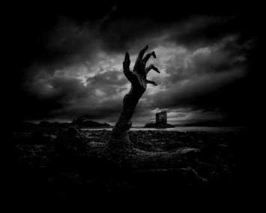

In the image above we see a picture of a branch of a collapsed tree ending with human fingers with sharp nails that suggest ferocity. The diagonally-upward hand shows the movement, growth, and extrusion. As is known in art, the downward trend is intended to provoke the recipient's eye with revolutionary connotations. In addition, placing the hand/tree in the foreground means focusing on it as a theme. In the distant background we see the ruins of a village in a foggy atmosphere — the hand may be a sign of those who were buried under the earthquake, while the tree’s branches turning into human fingernails to penetrate the earth symbolizes reviving the land.

If we look at the details of the tree, especially its cracked bark, it will become clear that it is not a normal tree, but an exceptionally old tree with a vast history. Some perennial trees have acquired a certain sanctity in the Arab culture to be found in the Holy Qur'an, such as figs and olives. And here we return to the relationship with the Būġāz tree as a place in the orbit of the poem. It is therefore possible to claim that the tree/hand is a metaphor for the city, where the nails grew after it came back to life again. The hand tied to the tree is related to the fact that the hand has a superficial texture similar to that of the tree, especially if the hand has experienced life. And the hand and the tree also have the qualities of production and fruit, and the hand and the tree are emanating from the whole human body/the earth.

This type of painting is known in art as ‘grotesque images’. These images cannot be read unilaterally, but can be interpreted through different lenses, which Mitchell referred to as ‘multi-stability’. One image evokes two different visions of one form that provokes infinite interpretations as a trick to mislead.[1] In addition, the absence of colors from the picture is also significant. The different shades black and white refer to several concepts related to the content of the text such as: destruction, mystery, fear, vanishing, absence and so on.

One of the motifs that the poet used frequently is ‘the cat’ — the cat appeared in several sections of the poem in different shapes and situations. Sometimes it appears in black, sometimes in both black and white, and sometimes only its head and eyes appear, in proportion to the content of the text attached. To demonstrate different connotations of different peoples and civilizations, especially among the Amazigh people, the black cat is associated with the world of the jinn and demons, and it is harmful to anyone who touches it it at night. Black cats also lack luck. The Amazigh believe that the cat has ‘99 spirits’, which enables it to escape death repeatedly, despite the fact that its body may be attacked or killed.[2]

The cat has other common connotations— it represents trickery, deception, and rudeness. It has often been employed in the arts as a woman[3], and has been employed in Arabic and Western literature as a symbol with political and social connotations.[4] The poet has been able to use the cat in the poem to employ rhetorical codes in a way that is compatible with its content, as in the following example:

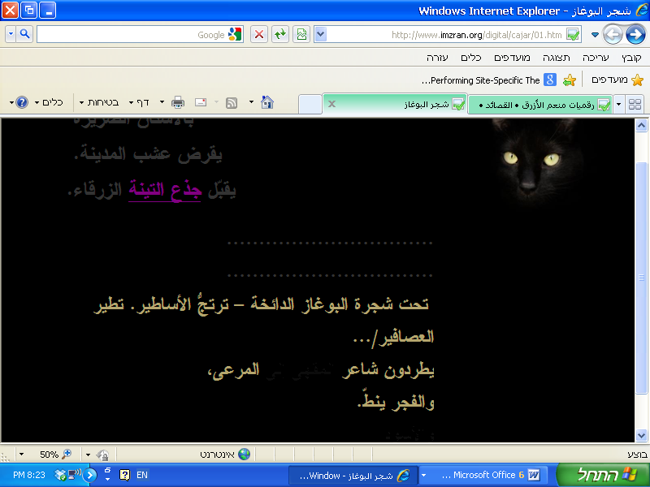

In the above picture we can see a black cat with two sharp black eyes shining in the black background of the page. The color of the black cat blends into the background of the closed and destroyed place. In the middle of the page we see two empty lines of dots. These two lines are like time, a pause that calls for reflection and waiting for the devastating event that cannot be expressed in words. These two lines contain words written in the color of the cat’s ruthless eyes in the darkness. In this sense, the cat bands together with the poet as an owner of vision — the poet saw what could not be seen. In his poem, the poet becomes like an evil cat that triumphs over whoever does him harm and is able to survive despite the calamities. He symbolizes all the poets who were attacked, expelled, and marginalized, but they possessed the cruel stubbornness of the cat to remain steadfast and keep their poetry. Thus, there is tragedy, challenge, resistance, and then survival.

The poet drew upon the cat's connection to the moon, as well. The moon has many connotations in art, literature, and legends. When the moon is red, it is related to femininity and symbolizes fertility. If it changes, or accompanies an animal, it may symbolize the occurrence of a certain event, which may be tragic, as the Almighty says[5]: The poet expressed this in the cover:

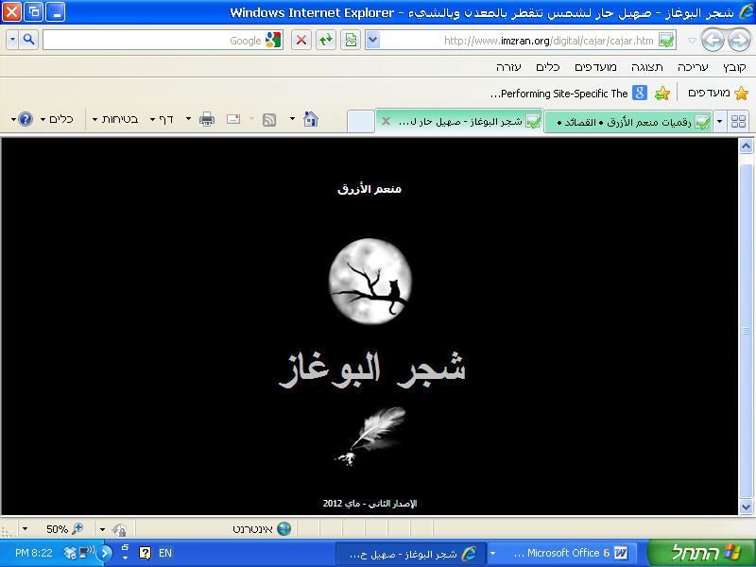

In this picture, the cat is seated on the leafy branch of the tree like death, and the tree symbolizes the Būġāz tree. The cat is in a position corresponding to the full moon, in reference to a disaster. As it is night, and night is the time of storytelling in Amazigh culture, it is as if the poet tells the recipient it is time to shorten this seemingly tragic story. The poet has also been able to employ colors with their different degrees, and insignia and symbolism, which we have tried to deduce based on what is common in artistic criticism for colors, on the one hand, and in literature on the other.

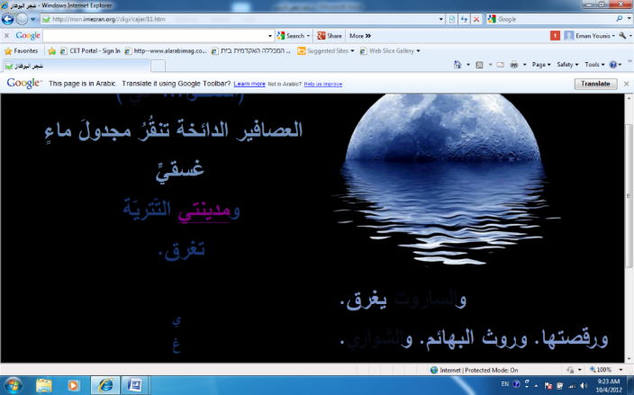

In this interface we see a picture of a moon sinking in water, and by moving the mouse it displays the text ‘my city’. The text is written in blue gradients, which is the dominant color in this interface with its various ramifications. Blue in art is a cold color that gives coldness to water.

In Arab literature and the Qur’an blue color can symbolize the misfortune of the fate, as Almighty said, "The day blooms in the pictures and the criminals will be spread on that day blue."[6] All these connotations are consistent with the meaning contained in the text. The text describes the sinking of the city explicitly as a tragic situation after the earthquake. The act of sinking is not only through meaning and color, but also through the topographical shape and the order of the words. The word ‘drown’ is written separately and arranged beneath each other, from top to bottom to simulate the process of drowning.

* **Interacting with Technology and Inventing New Aesthetic Values in Literary Criticism**

The employment of technology has led to the expansion of the new aesthetic values the literary text with which it has not had to contend in its paper format. It falls on us as literary critics to turn and pay attention to these values.

Before we examine our critical interaction with technology to highlight its role in adding new aesthetic dimensions to poetry, we will discuss the relationship between aesthetics and technology generally.

Aesthetics is connected to technology by the intermediate material that the artist uses, as aesthetics is concerned with resolving the qualitative nature of that material and its role in producing works of art. Indeed, since Heidegger wrote *On the Origin of the Work of Art*, he has touched on the importance of machines to art, claiming that technology is the basis of all innovation.[7]

Heidegger’s claim applies to digital literature as an artistic genre. In the poem *The Būġāz Tree*, for example, the poet takes the same (written) text and changes the medium thereof, radically altering the essence and method of reading the poem; making it richer and more fertile; and granting it other aesthetic dimensions absent in the poem’s paper format.

Since Heidegger, some artistic movements connecting technology and art have emerged, such as the Bauhaus Movement that began in Germany, to produce beautiful, usable doctrines for modern life. This tendency manifests itself in many works of architecture and products used in daily life, such as furniture and textiles. There have been aesthetic elements within technology itself. The design of many emergent machines underscores careful attention to aesthetics. This artistic trend went as far as considering any industrial product that could be a work of art to be as valuable as the fine arts. It also declared that technology itself is a creative endeavor resembling the efforts of artists, musicians, and toolmakers, as indicated by the devices that people use.

Technology, through the design of machines, relies on imagination, innovation, perception, and proficiency. This school of thought regarded the machine as an artistic tool, like the painter’s brush and the potter’s clay. Consequently, the machine started to be viewed as an extension of the human hand, as the computer is viewed as an extension of human consciousness. This led to the appraisal of industrial products’ aesthetic values. It also led to the emergence of new branches within the field of aesthetics, such as the *aesthetics machine*, which, as the name suggests, is concerned with studying the aesthetics of machines. Likewise, the use of machines led to the appearance of new aesthetic values within the arts. Aesthetic values connected to technology include *precision*, *flawlessness*, and *simplicity*.

The use of technology in writing in platforms such as hypertext and multimedia forces the writer to pay attention to several criteria that might affect the literary work’s aesthetic values. Among these criteria, which the writer would not have to heed on paper, are the following:

* Balance: The writer must not burden any part of the text with fundamental elements that are simultaneously absent in other parts of the text for risk of causing gaps in the text.
* Unity: Unity refers to the relationship between the visual elements. The images and texts that share common elements like color create the perception of a single meaning, unlike the incompatible elements that share no common denominator.
* Movement: There are two varieties of movement: the movement of the viewer’s eye as it follows the elements of the text on the screen and the movement of certain visual elements themselves. The lack of organized movement may confuse the reader and send them in multiple directions.
* Contrast: Contrasts refers to the interaction between the design elements, such as the contrast between light and dark, soft and coarse, cold and warm, and so on. All of these elements musts be considered through the viewer’s eye, lest they strain it.
* Parallelism: Parallelism refers to the way that the elements are arranged on the page.
* Proportionality: This refers to proportionality between three or more elements, such as the proportionality between the sizes and weights of the design.
* Rhythm: Rhythm is repetition of the design elements, such as lines, colors, and spaces, which give the design vibrancy and energy.[8]

Any discord between the aforementioned design elements disfigures the text and affects the reception of the aesthetic values within it. This means that the writer must learn new methods for writing and expression. They must study these elements thoroughly and know how to utilize them in an effective, positive way. In exchange, the critic must be aware of these elements and understand the programs upon which these texts are built in order to assess their strengths and weaknesses. This is what is known as *software art*.[9]

Regarding the relevance of these standards to the poem, we have noticed that their fundamentals have been observed, whether consciously on the part of the writer himself or the programmers who assisted him in implementing the work. Awareness of the fundamentals of electronic design has contributed to the preservation of harmony between the visual elements and different aspects of parallelism, unity, and balance. The colors of the images resemble those of the text and flow with the meaning in every aspect of the poem. Similarly, the distribution of the visual cues on the screen works with each element to bring forth the meaning that the author wishes to convey. Sometimes the image occupies the center of the screen, while other times it retreats to the side. This pattern occurs, too, with the written text. As a result, the movement of the reader’s eye follows accordingly.

Judging the aesthetics of digital text requires the critic to fully grasp two fundamental elements, those being:

* Data: Data refers to attention to the elements that the text comprises, such as the images, colors, font, etc., as well as their distribution and design.
* Process: Process is the software with which the text is built[10]. For example, the critic must observe the images that the writer edited using computer programs such as Photoshop.

This means that we had to examine the poem from these two angles. In addition to the interpretive reading of the literary work, it was necessary that we do a reading of the data and software. We should point out here that we could have enlisted the assistance of a third critic, but we preferred to focus on the artistic and literary aspects. At the same time, we were aware of the importance of the role that technology plays and were content to immerse ourselves in it to the extent that our critical faculties allowed.

During our interaction with technology and our interpretative reading of it, the technology required us to exchange our understanding of certain critical terms familiar to us with new understandings—for example, the concept of eloquence. Before the digital text, the stylistic eloquence of a text was gauged by the writer’s ability to employ diction to generate meanings, ideas, and artistic images; their use of literary devices like allegory, metaphor, allusion, assonance, and analogy; and their ability to convince and argue. However, with the advent of the digital text and the use of multimedia, the concept of eloquence has changed. It is now gauged by other standards and new devices. When a writer can master all technological capabilities in the service of a text, they use color as symbol, movement as meaning, music as suggestion, and image as allusion.[11]

Through our semiotic analysis of the different visual functions of the text, we endeavored to uncover the hidden eloquence by noting its new digital appearances and manifestations. We demonstrated the eloquence of expression in the image, color, and font, as well as the role of visual symbols in enriching the meaning. This confirms Simanowski’s thesis that the value of visual poetry is not latent in its presentation of new visual forms itself; rather, these new visual forms complement the semiotic meaning of the words.[12]

Consequently, our preoccupation reading the poem in its digital format (as opposed to reading in its paper format) was hidden within the search for internal relationships with the aesthetic medium used. This aesthetic medium finds visual expression in the relationship between the images and the utterances; between the colors, its tones, and its dimensions; between the words and their sizes; and in the ability of the visual functions to induce different feelings within us as critical viewers. This is what leads to the different aspects of reading and interpretation.

Accordingly, if the aesthetics of the traditional text are realized by the text’s deviation from the familiar through the eloquent styles used, then the digital text’s deviation from the familiar is achieved through the various media and techniques that it employs. Such digital eloquence opens the text to limitless readings.

The effect of hypertext on the aesthetics of the text can be traced to its importance in making the text a hybrid text, or a text combining multiple arts. All of the arts are interwoven within the text: drawing, film direction, photography, and calligraphy. This is what implored us to rethink multiple other terms such as ‘intertextuality’, ‘adaptation’, ‘embedding’, and others related to rhetoric that now require new definitions.

The employment of hypertext technology also led to the prominence of other forms of interaction with the text. Links which defined the way we view the text have been employed in the poem to navigate from one interface to the other — this is known as ‘point of view’.[13] Therefore, contrary to the case with paper text, it was not possible to view the entire poem at once, and thus we had to move from one link to the other in order to open the different interfaces and read their content. As we did this, we assumed the role of the exploratory reader who probes the nuances of ‘exploratory text’ (as Michael Joyce called it) in order to uncover its contents and significance.[14]

In addition to what was mentioned above, the links worked to guide the reading process on the one hand, and to split it up it on the other hand. We had to move between the interfaces, guided by the links that either allowed us to move forward or backward. In all instances, this technology did not lead to a linear reading of the poem, but to a multi-faceted reading with many internal intricacies, and we did not know where we would end up. The links enabled us to penetrate the body of the poem, or to traverse its outer surface, in an exploratory trip that took on a third dimension.

In the context of our reading of the hypertext technology is interactive critical reading, which can be said to have led to our physical interaction with the text through the click of the mouse, and to our moral interaction through our analysis of the links and their contents. This type of interaction is considered the simplest type of digital interaction (‘degree zero of interactivity’)[15], or what is also known as ‘weak interactivity’. All we could do was follow the trajectory by opening the links without the freedom of choosing between a number of paths given to build the meaning in the manner we want (as in some Western digital works where hypertext technology is employed in a manner that stimulates the greatest possible interaction between the reader/critic and the text).

* **Critical Interaction with the Author and the Reader**

Interactive digital criticism, according to our understanding of it, not only interacts with the elements of the text, rather exceeds that to the interaction with the author and the reader. These two parties cannot be ignored in a networked world in which we can communicate easily. It would seem illogical to not take advantage of this opportunity and benefit from it.

We interacted with the author via email, discussing different matters. We were able to urge him to document his poems digitally and to encourage him to write new digital poems. However, he did not refer us to the content to the same extent that he cooperated with us to decipher some of the symbols interchangeably (interactively).

In this regard, it is important to note that we drew the attention of the poet to the importance of the chronological order of his poems, what encouraged him to work and refine his poems, and below is his response:

“Had I realized the difficulty of the task not arising from the comparison of the texts and the time at which they were written, but rather from the restructuring of it (which I did not want to delve into at the time) I tried to rebuild my digital ‘nuggets’ in a complete non-chronological work, despite the fact that texts were written between 2003 and 2008. It became clear to me that the inclusion of these digital nuggets has remained incohesive and scattered since my first publication entitled *Horizon in the Night of the Blind* (1.0 — June 2008) which consumed my time for months. Today, as I write you this message, I would like to inform you that of the updated edition of *Horizon in the Night of the Blind: Supreme Poems* (2.0 — May 2013) — the texts have a common denominator: there is no intermediary between paper and pen. They are texts of great complexity and there is room to read them from a new perspective.”

Without a doubt, Al-Azraq’s letter above confirms the direct influence of the digital critic on the author. Al-Azraq had to document the gaps in his research by drawing upon our notes to him which highlighted areas which would not have been noticed through traditional paper criticism, as critics used to shared their notes and ideas on paper, without the ability to know the authors’ reaction to the critics’ notes. We find that digital criticism opens the door wide for positive interactive cultural exchange between the author and critic.

Our communication with the author also revealed to us some information related to the Amazigh culture that the poem was built upon. The poet is of Amazigh descent, and drew upon his cultural symbols, necessitating us to unearth the different Amazigh legends and history by drawing upon the text and communication with the author.

For example, through the author’s statement “be a Berber without pronouncing the letter ‘r’ with a western accent” he meant to reject the western influence that looked upon Amazighs negatively. Therefore, the educated and cultured poets, writers, and artists imposed their Amazighi culture through art and literature by inserting Amazighi words in their literary texts, called ‘site of memory’ according to Pierre Nora, and others. By that, they and others like them, have participated in enriching their culture and saving it from extinction.

As we adopted the interactive critique with the author, we also adopted it with the readers, by analyzing and screening their comments and taking them into account in order to work in a manner that re-critiques its lost boundaries. Ryan Gillespie claims that the main drawbacks brought by the internet and social networks are the dismantling and undermining of the functions of the author, the reader and the critic, and the demarcation of boundaries between them. As a result, there is a growing need for a systematic monetary process that has a clear scientific basis that distinguishes between the commentator and the expert critic.[16]

* **Discussion in the Process of Digital Criticism**

Our experience of critical writing together is very much like that between artists and poets or between researchers and critics from different fields in joint work. The presentation of the critical process in each research work is as important as the final product. Contemporary criticism has touched upon the importance of the presentation of the critical process as stated in the book *One Thousand and One Plateaus* by Gil Doloz and Felix Guterri. The critics devoted a whole chapter of the book to explaining their work as critics from two different fields.[17]

As long as digital work is operational, it also requires procedural critique. Breaking into the text of *The Būġāz Tree* requires a complex process, which falls within the context of theorization through experimentation, and falls within the scope of the aesthetic experience. It is clear that although we relied on the critical theories related to the subject during the course of the work, we did not adopt it literally, but instead we chose the interactive dialogue between us and the various parties. This led us to the continuous discussions that affected both the information and the analytical levels. We often each have to read research and articles pertaining to fields beyond the scope of our specializations. These readings contributed to the exploration of invisible semantic relations through the direct manifestation of text or image. We have not only delineated the descriptive aspect of the image or the text, but have sailed in different cultural references in order to capture meaning.

Often, we have to search for meaning for the various facets, to repeat the reading process more than once, sometimes in close periods and sometimes at odds. In many cases, we have to move away from the text so that each one of us can have insight into what we think individually, and then collect and re-examine them. This repeated reading process has resulted in the discovery of keys that we did not notice in the first readings, such as the words and phrases that appear only when the mouse passes them. Without a doubt, then, a text like The Būġāz Tree and others like it, require an atypical critic— a critic that can read in diverse directions and permeate the text from all angles. This critic, to whom we referred in our previous studies as a ‘hyper critic’, corresponds to the typical reader as ‘echo’. Because we are well-aware that it is often times difficult to surround a critic with critical tools outside his field of specialization, there is nothing wrong with using other critics, and this is precisely the interactive criticism that we mean.

Some like Hayes Roath view words as the foundation of every literary work, and other means are added to enrich the work and provide it with a distinctive quality in terms of production and reception. The nature of the work, in terms of technical standards that make it belong to a literary genre, has not changed— we maintain that the text is a poem, or a story, or a novel, before we use the words ‘interactive’ or ‘digital’ (which refer to the technique on which the text is based). On the other hand, even if we accept this view, the dimensions resulting from the change of technology cannot be ignored, especially in regard to judging the aesthetic values of the text and the functions of the writer, reader, and critic.

* **Summary and Conclusion**

The changes that resulted from the employment of technology in the literary text led to the occurrence of changes in the nature of literature and methods of production, reception, and criticism. We use the expression ‘the production of text’ instead of ‘the writing of text’ because the production (of text) is a type of process in which different media overlap, while the action of writing does not require anything other than a hand and pen. In this study we claimed that this new product text necessitates a different kind of criticism which we referred to as ‘interactive criticism’ and which is achieved through the interaction of the critic with a number of facets and stages in the creative system. Our interactive critique of the poem has been demonstrated through a complex process involving several levels, namely:

- the interactive with the contents of the text by returning to non-textual sources.

- incorporating technical and literary criticism tools into the understanding and analysis of technical-literary relationships between visual and textual functions in the poem.

- interaction with technology and the development of new aesthetic values

- interaction with the author.

- interaction with the reader’s comments.

In the attempt to understand the poem in its social contexts and its cultural and historical references, we had to broaden the reading circle beyond the text — we read Amazigh history and Moroccan folk legends, and we reviewed the news related to the earthquakes that afflicted the Būġāz region over the years and the material and moral losses. We also had to review some of the intellectuals mentioned in the poem, such as Ahmed Mubarak and Abdul Karim Naji, in addition to reviewing Greek, Amazigh, and Pharaonic (Egyptian) mythology. We also had to communicate with the author, Muna‘am Al-Azraq in order to understand some of the Amazigh words which complicated our understanding of the text. Furthermore, we looked at reader comments on the poem through the website— this enriched the critical vision of the work through an exchange of perspectives. This communication between us as readers and the author, and between other readers, indicates that in this virtual space the barriers between the writer, the reader and the critic fade— a chain of virtual communication opens up, leading to a reduction in the feeling of alienation and distance between them.

We strived to understand and analyze the technological literary interaction between the visual and textual functions in the poem through the integration of our critical tools borrowed from the fields of literature and art— two fields influencing enriching one another. Naturally, we did not forget to interact with technology and the different levels of technological analysis in order to uncover their additional value in providing the text with new aesthetic dimensions.

Concluding what was mentioned above, digital text can accommodate interactive criticism, bringing together an elite class of critics and experts in the different fields that employ digital texts — art, literature, music, cinematic production, programming, etc.— placing every expert in his own field. This opens the text to vast areas of interpretation that can enrich the work and gain fertility and vitality on the one hand, and on the other hand, through mutual dialogue, enriches the critics themselves. Furthermore, it opens their horizons in directions that are not possible through individual work, and herein lies the importance of interactive criticism. It remains to be noted that the ‘interactive criticism’ that we suggested in the present work is optional— we leave the critic who prefers to read the text without any external influences the freedom to do so.

References

Basṭāwisī, M. Al-Naṣṣ al-Adabī Bayna al-Maʿlūmātīya wa-l-Tawẓīf. *Āfāq al-Ibdāʿ wa-*

*Marjaʿīyatuhu fī ʿAṣr al-ʿUlūma* (Dimashq: Dār al-Fikr, 2011).

Clark, T.J. *The Painting of Modern Life: Paris in the Art of Manet and His Followers*, Revised

Edition. (Princeton: Princeton University Press, 1998).

Gillespie, R. The Art of Criticism in the Age of Interactive Technology: Critics, Participatory

Culture, and the Avant-Garde. *International Journal of Communication*, Vol. 6 (Los

Angeles: University of Southern California, 2012).

Heidegger, Martin. *Aṣl al-ʿAmal al-Fannī*, trans. Abū al-ʿĪd Dūdū (Al-Jazāʾir: Manshūrāt al-

Ikhtilāf, 2003).

Mitchell, W.J.T. Word and Image. *Critical Terms for Art History*, ed. Robert Nelson and Richard

Shiff (Chicago: University of Chicago Press, 1996).

Muhassib, H. *Ikhrāj al-Ṣuḥuf al-Iliktrūnīya ʿalā Shabkat al-Internet* (Al-Qāhira: Dār al-ʿUlūm

li-l-Nashr wa-l-Tawzīʿ, 2007).

Naṣrallah, A. and Yūnis, I. *Al-Tafāʿul al-Fannī al-Adabī fī al-Shiʿir al-Raqmī: Qaṣīdat Shajar*

*al-Būghāz Namudhajan* (Kfār Sābā: Markaz Abḥāth al-Mujtamaʿ al-ʿArabī fī Isrāʾīl,

Bayt Berl, 2015).

Rossario, G. *Electronic Poetry: Understanding Poetry in the Digital Environment* (Jyvaskyla:

University of Jyvaskyla, 2011).

Simanowski, R. *Against the Embrace: The Recovery of Meaning Through the Reading of Digital*

*Arts* (Minnesota: University of Minnesota Press, 2010).

Al-Talāwī, M. *Al-Qaṣīda al-Tashkīlīya fī al-Shiʿir al-ʿArabī* (Al-Qāhira: al-Hīʾa al-Miṣrīya al

ʿĀmma, 1998).

Wardrip-Fruin, Noah & Montfort, N. *The New Media Reader* (Cambridge & London: MIT Press,

2003)

1. Mitchell , 1996, p. 50.
2. Naṣrallah & Yūnis, 2015, p. 102.
3. Clark, 1999, p. 86.
4. Naṣrallah & Yūnis, 2015, p. 105.
5. Surah Al-Qamar 1
6. Surah Taha 102:6.
7. Heidegger, 2003, p. 77.
8. Muhassib, 2007, 285.
9. Basṭāwisī, 2011.
10. Wardrip-Fruin, 2003.
11. A number of critics have referred to the concept of ‘digital rhetoric’ and have used it in various studies. They have pointed to many other critical terms that have acquired new concepts because of changes made by technology. Arab criticism, however, still lacks a lexicon that redefines literary terms in the context of technological transformations.
12. Simanowski, 2010.
13. Rosario, 2011, p.111.
14. Rosario, 2011, p.111.
15. ibid, 2013, p 90.
16. Gillespie, 2012.
17. Wardrip-Fruin, 2003, p.1.