Polysulphate Trial

Alfalfa (*Medicago sativa* L.) grown on a Typic Hapludox (red yellow latosol) soil (pot culture experiment in a greenhouse)

When

* First fertilizer application: at sowing time
* Subsequent application (only K): after each harvest (7 harvests in all; harvested when 10% of the plants had flowered)

Where

Embrapa Pecuária Sudeste, in São Carlos, state of São Paulo, Brazil

Crop

Alfalfa (*Medicago sativa*)

Soil type: red yellow latosol (Brazilian acidic soil) (top soil from the 0–20 cm layer used for filling pots)

Measurements

* Shoot dry matter (in grams per plant; plants cut 10 cm above the soil surface)
* Total K, Ca, Mg, and S in dry matter (in leaves, in grams per kilogram of biomass)

Objective

To compare the effects of different doses of K, supplied through two sources, namely KCl and polyhalite, on dry matter yield and nutritional status (content of K, Ca, Mg, and S in leaves) of alfalfa

Treatments

The experiment was laid out as a fractionated factorial design with four replications and comprised seven main treatments and a control, namely (1) KCl alone, (2) KCl with a small dose of gypsum, (3) KCl with a large dose of gypsum, (4) 7 parts of KCl and 1 part of polyhalite, (5) KCl and polyhalite in equal proportions, (6) 1 part of KCl and 7 parts of polyhalite, and (7) polyhalite alone. Each main treatment consisted of three sub-treatments, each representing one of the three levels of K, namely 50 kg ha−1, 100 kg ha−1, and 200 kg ha−1. The total experiment therefore comprised 21 treatments and the control. The pot-grown plants also received P and micronutrients in quantities that were the same for all the 21 treatments.

Results

* Polyhalite was significantly more effective than KCl in obtaining higher biomass yields at all levels of K. Biomass yield was maximum (82 g of dry matter per plant, 191% of that in the control) at 200 kg ha–1 of K2O.
* When KCl was the only source of K, leaf S concentration decreased, and the higher the dose of K, the greater was the decrease.
* Sulfur uptake was significantly greater at higher doses of polyhalite.
* Calcium levels remained high in most of the treatments containing polyhalite, and especially so when it was the only source of K
* In polyhalite treatments, competition among nutrients disappeared and their uptake increased; the extent of these two benefits was directly proportional to the amount of polyhalite.

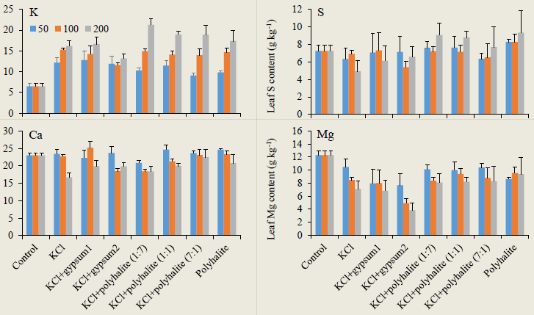

Leaf contents of K, S, Ca, and Mg (grams per kilogram of dry biomass) in response to different amounts (50, 100, and 200 kg −1 of K2O) and two sources (KCl and polyhalite) of K in a pot-culture experiment. Bars indicate standare error (SE).

*Source*: International Potash Institute, Switzerland