A Foreword from our CEO

Founded in 1966, Alonim Jerusalem has made a name for itself as an expert in developing residential real estate projects.

The company has a long legacy of quality construction, advanced architectural design, strict schedule adherence and working with the best building professionals in the business.

As CEO of the Alonim company, Chairman of the Jerusalem Area Building and Infrastructure Contractors’ Association, and Vice President of the National Contractors’ Union in the past, I see the urban renewal program laid out by the “TAMA 38” (“National Outline Plan”) mandate as the single most important pathway for continued urban growth and keeping up with housing demand in Jerusalem. The reason for this is simple: the reserves of land available for residential construction are dwindling due to the delicate political situation in the city.

Likewise, it is important to stress that the primary aims of urban renewal are to make buildings safer and more durable, as well as to refresh the outward appearance of the city’s neighborhoods.

Therefore, as the company’s CEO, I have made it a priority to channel our efforts into the field of urban renewal, the results of which – in the shape of a variety of projects all over Jerusalem – we invite you to enjoy.

Together, we will add hundreds of housing units to this great city over the next few years.

Yours sincerely,

Shmulik Levy

Alonim Jerusalem

Alonim Jerusalem, headed by Shmulik Levy, is a company deeply rooted in the city of Jerusalem, whose over 55 years of experience have given it the tools and know-how to build the perfect apartment for you. The company specializes in building residential projects, private villas, public buildings and more. As a leader in the field, Alonim has spearheaded a vast variety of TAMA 38 projects and is currently in the midst of a construction boom in the old Jerusalem neighborhoods. The company is committed to working with leading professionals in their respective fields, choosing prime locations, meticulous and uncompromising project execution, and quality customer service that is attentive to each client’s personal needs.

Alonim Projects

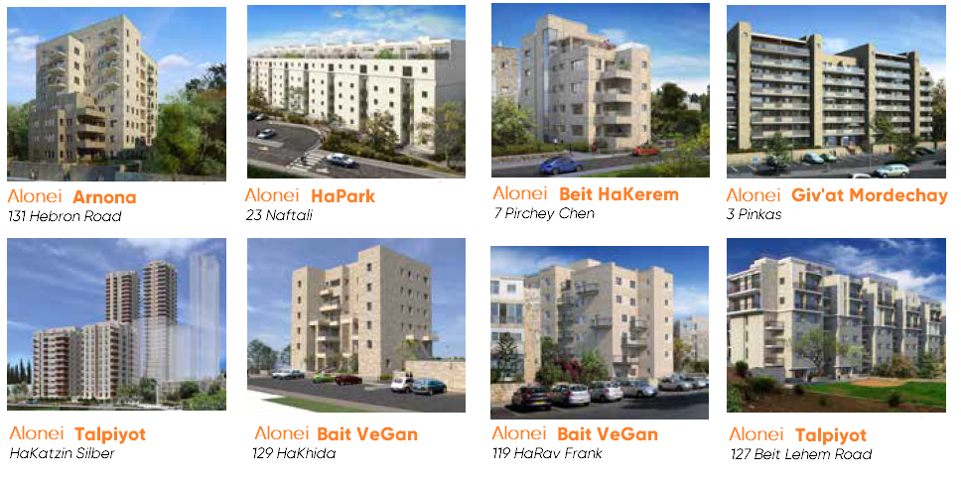

About the Project

**Alonei HaPark - The Perfect Combination of Location and Luxury**

At the present moment, a luxury residential project is taking shape on Naftali Street, in the heart of the picturesque Baq’a neighborhood. The project, entitled “Alonei HaPark” is adjacent to the Park HaMessila (“Train Track Park”) boardwalk, a quiet and peaceful green area that serves residents as well as visitors coming here to enjoy the unique and authentic atmosphere of one of Jerusalem’s most sought-after living locations – the Baq’a neighborhood and the German Colony.

The neighborhood is a singular mosaic of building styles that combines the charm of the old with the sophisticated chic of the new, making it a refreshing blend of history and modernity. An abundance of intimate coffee shops, upscale restaurants and hip bars are scattered along the quaint alleys, with a number of shopping centers located at a convenient distance nearby. Yet, as buzzing and vibrant as it is during the day, with nightfall the neighborhood settles into a pleasant atmosphere of peaceful calm.

The Baq’a and German Colony neighborhoods pride themselves on openness and on sustaining a diverse social fabric composed of people from all walks of Jerusalem life. Here we find religious and secular families living side by side with English and French-speaking communities, to name a few.

**The project includes a limited number of prestige duplex apartments measuring 140m2 and 160m2 with high-end finishes and balconies offering captivating views of Baq’a and the Germany Colony. The prime location of the project together with its top-of-the-line architectural and interior design give buyers the opportunity to enjoy an ideal living space.**

Alonei HaPark Accessibility

* Adjacent to Park HaMessila
* 5 minutes’ walk from the Emeq Refa’im and Beit Lehem Road high streets, where one can find a variety of coffee shops and restaurants
* 15 minutes’ walk from the “Yes Plant” cinema multiplex
* 30 minutes’ walk from the Western Wall
* Walking distance from shopping centers in the Talpiyot neighborhood and the Hadar Mall

|  |  |
| --- | --- |
| General: | * Smart home * Porcelain tiled floors (tile sizes 60x60, 45x90, 80x80 in a variety of patterns to choose from) * Living room fitted for home cinema installation * Intercom and color CCTV (videophone) installed at the building’s entrance * 4 hour consultation with an interior architect for personal customization of the apartment, with the exception of water and sewage points |
| Doors and windows: | * Designer front door * Pandoor Unique brand interior doors – a variety of models to choose from, flexboard core * An additional door for the secure room, same model * Double-glaze aluminum windows, Klil or equivalent, with insulating glass * Drei-Kipp window for secure room * UV windows, including screens |
| Kitchen | * High-end plywood kitchen cabinets, 10m long + built-in unit * Formica coating - 5 available models * Even-Keissar (Caesar Stone) type counter top, including flat sink installation - in a variety of available models * Double or single, acrylic or stainless steel kitchen sink, flat installation * Prestige Hamat faucets or equivalent * Gas-connected * Dishwasher ready |
| Bathrooms and toilets | * 30x30 floor tiles and wall cladding up to 2m high in a variety of patterns, sizes 10x30, 30x60, 15x60 * Wall-mounted toilets and concealed cisterns * Prestige Hamat faucets or equivalent * Cabinets in washrooms and bathrooms * 150L electric water heater with timer switch * Bathrooms primed for heater installation * Parental suite - en-suite bathroom with bathtub and shower |
| Electrical | * All electrical fittings are Gewiss brand or equivalent * Electric blinds throughout the apartment, apart from secure room and bathrooms * Television and phone outlets in every room * “Secondary” power switch in the parental suite * Lighting and electrical outlets throughout the apartment - at least 65 points * Three-phase 40x3 electricity |
| Air-conditioning | * Advanced technology central air-conditioning from one of the leading Israeli brands, including thermostat controls in every room. Includes dropped ceilings and plaster covering * Electric floor heating, including bathrooms and toilets. System powered by Standards Institute and IEC approved technology |
| Balconies | * Water point (with garden faucet) and water-protected power outlet on each balcony |

Apartment A / 4.5 room apartment / 140m2 / 25m2  balcony

Living room floor

* Entrance
* Kitchen
* Dining area
* Living room
* Balcony

Bedroom floor

* Bedroom
* Family room
* Secure room

This diagram, including any furniture, countertops and measurements contained therein, is for illustration purposes only. The sales contract comes with detailed technical specs and final floor plans and only those shall be considered binding, errors and omissions excepted.

Apartment B / 5.5 room apartment / 160m2 / 25m2 balcony

Living room floor

* Entrance
* Kitchen
* Dining area
* Living room
* Balcony

Bedroom floor

* Bedroom
* Parental suite
* Family room
* Secure room