# 

Engineering & Management, Service Systems

**Paper name:**

**Creating DSS to support sexual assault survivors WhatsApp helpline to improve call evaluations**

**| final project |**

**Student names:** Shiran Carmeli, ID: 034820472, Moriya Greenhut, ID:036815355

**Moderator:** Dr. Adi Fox

**Date of Submission:** 30/06/2022

# **Acknowledgements**

We would like to express our deep gratitude to Dr. Adi Fox who accompanied us throughout the process with great courtesy and professionalism. Our success is your success.

We would also like to thank Dr. Ohad Eisenhandler who helped and advised on all the statistical questions.

We would also like to thank the professional and naïve evaluators, Leahy, and Oren, who helped us validate the results.

To our families and parents who have brought us so far 😊.

**הערכת תודה**

ברצוננו להביע את תודתנו העמוקה לדר' עדי פוקס שליווה אותנו לאורך כל התהליך באדיבות ובמקצועיות רבה. הצלחתינו היא הצלחתך.

ברצוננו להודות גם לדר' אוהד איזנהנדלר שעזר וייעץ בכל השאלות הסטטיסטיות.

ברצוננו גם להודות למעריכים המקצועיים והנאיביים, ליהי ואורן, שסייעו לנו לתקף את התוצאות.

לבני משפחותינו ולהורינו שהביאונו עד הלום 😊

**Abstract**

The Haifa and North rape crisis center (HRCC) provide emotional support to victims/survivors of sexual assault and their support circles, by specially trained women volunteers. This project aims to improve the efficiency and quality of the support provided by the HRCC through WhatsApp to survivors of sexual assault.

This project was done in teamwork. Moriya Greenhut focused on the volunteer's aspect by giving them a tool that could improve their ability to identify the conversation type and thus give an adequate support. Shiran Carmeli focused on the managerial aspect, by giving the WhatsApp director a tool to evaluate the quality of the support and in this way also to improve it.

This project has 2 objectives. First, to produce a systematic tool which will help the call taker to identify more quickly and efficiently the type of conversation. Second, to create a defined set of criteria that can assess WhatsApp support calls with sexual assault survivors.

We managed to create a classification algorithm that can identify, with high accuracy, 3 conversation's types – "flashback" conversations, "self-harm" conversations, and "other" conversations. This tool can be used as a decision support tool for the HRCC's WhatsApp volunteers. Improving the ability to identify the type of the conversations will help the volunteers to give the callers more accurate response, quickly, and with more certainty about the suitable support strategy.

We also managed to create a defined set of criteria for evaluating support calls. Based on the criteria we were able to define what is considered an effective (good), ineffective (medium), and undermining (not good) call. We developed an evaluation form which gives a numerical score for the support call according to the evaluation criteria, and we showed that this proposed evaluation process improved the existing evaluation process.

We saw that the two tools we have developed have a high degree of accuracy. By developing the identification algorithm, we showed feasibility in improving the process of giving support. By developing the evaluation process, we showed an improvement in the efficiency and the quality of the support.

The tools we developed can improve the training process of new volunteers as well as the ongoing training. They can also help in the construction of conversation process and thereby further increasing the quality and efficiency of the support. Another advantage is in improving the efficiency and making call answering and evaluation processes faster.

This project is a pioneering infrastructure work in the field of support in general, and in the field of WhatsApp support to sexual assault survivors. Further research can develop the two tools we have developed, by automating the processes / making them online, expanding the call recognition algorithm, examining the evaluation criteria. Further research will also be able to expand the tools we have developed to other support channels, other support centers, and other helplines in other areas.

# **Table of Contents**

**Acknowledgements** 2

**Abstract** 3

**Table of Contents** 4

**Figures list** 6

**Tables list** 7

**1. Introduction** 8

**1.1. Background- Rape Crisis centers** 9

***1.1.1. Characteristic and Core Services*** 9

***1.1.2. Ways to connect RCCs*** 9

**1.2. Haifa and North Rape Crisis Center (HRCC)** 10

***1.2.1. The existing situation in HRCC*** 11

**2. Literature review** 13

**2.2. Identifying the type/ the purpose of the conversation** 14

**2.3. Criteria for evaluating and measuring WhatsApp support calls** 14

**2.4. The research questions** 16

***2.4.1. Research question 1: Identifying the conversation type*** 17

***2.4.2. Research question 2: Evaluating WhatsApp support calls*** 17

**Research question 1: Identifying the conversation type** 18

**3.1. Method** 18

**4.1. Results** 21

**5.1. Discussion** 22

**Research question 2: Evaluating WhatsApp support calls** 23

**3.2. Method** 23

**4.2. Results** 26

**4.2.1. Criterions that determine the quality of support calls** 26

**4.2.2. Testing the improvement in the evaluation process** 28

***4.2.2.1. The quality of evaluation processing*** 28

***4.2.2.2. The quantity of evaluation processing*** 30

**5.2. Discussion** 32

**6. Concluding discussion** 35

**6.1. Research contribution** 36

**6.2. Research limitations** 36

**7. Bibliography** 38

**8. Appendices** 40

**8.1. Appendix 1: A copy of a conversation** 40

**8.2. Appendix 2: Comparison table between the manual classification and the classification of the algorithm** 42

**8.3. Appendix 3: Evaluation form's rating scale:** 43

**8.4. Appendix 4- link to the evaluation form** 44

**תקציר** 45

# **Figures list**

Figure 1- 1: The process of receiving WhatsApp call in HRCC 11

Figure 3.1- 2: an example of using the algorithm 19

Figure 3.1- 3: an example of the percentages at the end of the conversation 20

Figure 3.1- 4: The work process 20

Figure 3.2- 5: The work process 24

Figure 4.2- 6: Weka's J48 algorithm decision tree 27

# **Tables lists**

Table 3.1- 1: Keywords defined for each conversation category 19

Table 4.1- 2: A comparison between classification algorithm and manual classification 21

Table 4.1- 3: Accuracy, precision, sensitivity, and specificity for the classification for each category 21

Table 3.2- 4: Call quality rating according to score's distribution 24

Table 3.2- 5: The attributes- our defined criteria for evaluating support calls 25

Table 4.2- 6: Weka's results output 26

Table 4.2- 7: criteria for evaluation "good" and "not good" support calls 28

Table 4.2- 8: A comparison between classification according to the existing method and the method we developed 29

Table 4.2- 9: Accuracy, precision, sensitivity, and specificity for the total classification and for each category 29

Table 4.2- 10: Values of N, X, Ra for the total conversation score and for each section of the conversation 30

Table 5.2- 11: descriptive statistics values compering 52 calls to 92 calls 33

Table 8.3- 12: Scoring support principles section 43

Table 8.3- 13: scoring principles contrary to support section 43

# **1. Introduction**

Rape Crisis Centers (RCCs) are community-based Non-profit organizations whose major purpose is providing support services and advocacy to sexual violence survivors. Haifa and North rape crisis center in Israel (HRCC) provides emotional support to victims/survivors of sexual assault and their support circles, by specially trained women volunteers. HRCC provides support through a telephone helpline, and since 2015 also through a WhatsApp helpline. In this project, we will focus only on HRCC's WhatsApp helpline. This project aims to improve the efficiency and quality of support provided through WhatsApp to survivors of sexual assault.

The existing situation in HRCC: There is no structured and uniform process of how to conduct a support call. Instead, the conversation "flows", from what the caller says. Furthermore, there is no evaluation or measurement of the existing support.

Our project has 2 objectives: first, to create a systematic tool which will help the call taker to identify more quickly and efficiently the type of conversation (and thus give more accurate support). Second, to create a defined set of criteria that can assess WhatsApp support calls with sexual assault survivors

This project was done in teamwork where each of us discussed a different research question. Moriya Greenhut dealt with the first research question of identifying the conversation type, and Shiran Carmeli dealt with the second research question of evaluating WhatsApp support calls.

**Research question 1: Identifying the conversation type**

Will developing a decision support tool to identify the type of conversation improve the process of giving support?

**Research question 2: Evaluating WhatsApp support calls**

1. which criteria determine the quality of support calls
2. will these criteria improve the evaluation process?

## **1.1. Background- Rape Crisis centers**

Rape Crisis Centers (RCCs) are community-based Non-profit organizations whose major purpose is to provide support services and advocacy to sexual violence survivors.

RCCs first appeared in 1972 as part of the feminist grassroots movement, designed to empower and serve women (Searles & Berger, 1995). Initially, RCCs were funded and staffed by community volunteers. In the 1990s of the 20th century, many centers started to employ professional consultants (Calhoun & Atkeson, 1991). Volunteers, however, remained an essential component in the services of RCCs, providing effective outreach, supportive counseling, information, and referral to rape crisis survivors and their support circles.

### ***1.1.1. Characteristic and Core Services***

According to Bein's research about core services and characteristics of Rape Crisis Centers (Bein, 2010), RCCs services include:

* **24/7 Crisis intervention**- giving support to individuals presenting a crisis, related to sexual violence. The principles of crisis intervention are:
  + Active listening and empathy.
  + Teaching reinforces skills.
  + Reduce current trauma symptoms
  + Provide information.
* **Support groups-** groups run by a trained facilitator.
* **Advocacy-** supporting and assisting a victim/survivor to define needs, explore options, and ensure rights (legal rights, medical information, etc.).
* **Prevention and awareness**- Community awareness events, and prevention education programs.

RCCs advocate a social justice approach which is victim-centered, with an emphasis on anti-oppression and empowerment. They support survivors' choices and ability to control their life. The service is 24/7, free, confidential, and is provided to all survivors.

### ***1.1.2. Ways to connect with RCCs***

While traditional rape crisis services have provided face-to-face therapy, RCCs made it possible to receive anonymous support by phone (hotline). RCCs also made it possible to obtain information about where to ask for help (Hellman & House, 2006).

With the use of the Internet in the 90th, Internet-based consulting and hotline services have formed a new resource for providing help - online counseling. It has opened new communication channels, especially for young people, who are the most common victims of sexual assault (Catalano, 2006). Online counseling can be conducted asynchronously (e-mail), which is time-delayed between a caller and a call taker's reply, or delivered synchronously (chat, videoconferencing), which is live and occurs in real-time (Richards, 2013).

Hotlines have expanded into new modes of communication including instant messaging and app-based chatting. According to Brody, Star & Tran (2020), chat-based hotspots and text messages are unique features that make them more attractive. They do not require users to find a private and soundproofed place to discuss private issues, users can be anywhere. When chatting or writing text messages, users can control the pace of conversations and discuss things they might be reluctant to say out loud.

As for the WhatsApp platform, this platform allows expression of thoughts and feelings that we usually do not express in face-to-face communication or even by phone. Considering the interpersonal space, WhatsApp often allows revealing anger and negative emotions. When dealing with the field of sexual trauma, sometimes the only way to "talk" about the trauma is through writing. In addition, the platform makes it possible to write more bluntly about the consequences of the trauma such as suicide attempts or self-harm (Vaknin et al., 2020).

## **1.2. Haifa and North Rape Crisis Center (HRCC)**

In our project, we will focus on the Haifa and North Rape Crisis Center (HRCC) in Israel. HRCC was established in 1979. HRCC helpline provides emotional support to victims/survivors of sexual assault and their support circles. The support is given by specially trained women volunteers. The focus of the given support is on "here & now", i.e., what the caller is feeling right now that has led her to call the helpline and how the call taker can help to ease the present. The support is not a substitute for psychological treatment.

The main communication channel is by phone. HRCC was the first hotline in Israel to give an emotional support on WhatsApp – by writing text messages. The WhatsApp helpline was established in 2015 as an experimental service. In 2020, HRCC began to develop this service by using WhatsApp business platform and by increasing its response hours, increasing the number of inquiries, and improving the quality and the efficiency of the support. At the end of 2020, the HRCC WhatsApp helpline joined "Kolmila" – the written support helplines of RCCs in Israel (which includes WhatsApp and chat).

In this project, we will focus only on HRCC's WhatsApp helpline. The WhatsApp helpline is managed on a software called LivePerson. By using this software, the WhatsApp director can view the content of the calls, track them, receive information about the call details and generate reports.

The process of receiving WhatsApp call in HRCC is illustrated in the flowchart below:

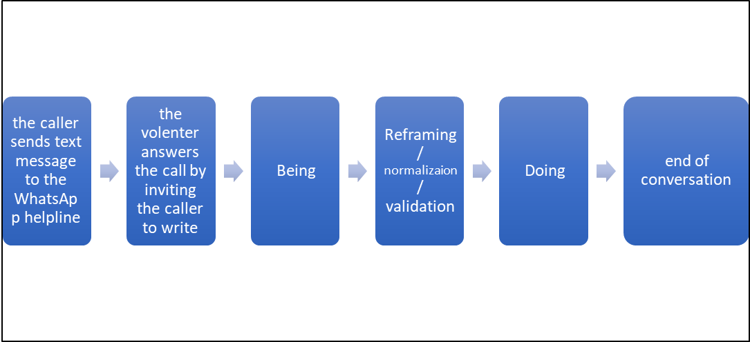

Figure 1- 1: The process of receiving WhatsApp call in HRCC

As we can see in Figure 1-1, the WhatsApp support call begins when the caller sends a text message to the WhatsApp helpline. Since the callers can call during call hours or not during call hours, at the beginning of the shift, the volunteer sends a message to the caller and invite her/him to write.

The main purpose of the support is "being" with the caller, which means identifying an emotional need and reflecting it to the caller. Usually, support calls also include additional support tools such as reframing (giving a different context or different point of view to the things the caller writes to give her/him a different perspective); normalization (showing the caller that her/his behavior and feelings are normal and are a consequence of the sexual assault); or validation (validating the sexual assault that occurred and the feelings that followed). If the caller asks for a specific need, the volunteer needs to check whether it is an urgent need and give an immediate answer, or not an urgent need, and then first suggest emotional support and only after this, giving solutions to the specific need. When ending the conversation, the volunteer invites the caller to call again if she/he needs and suggests all the communication channels with RCCs.

### ***1.2.1. The existing situation in HRCC***

**Conducting Call processes**

Today, there is no structured or uniform process of how to conduct a support call. Instead, the conversation "flows", following what the caller said. During the WhatsApp conversation, the volunteer needs to identify on "real-time" the purpose of the call, to understand the caller's needs, and to react accordingly. Sometimes the caller expresses his/her needs directly, and sometimes indirectly – a fact that makes the identification more difficult. This may result in the volunteer giving inaccurate support to those conversations.

**WhatsApp support call's evaluation process**

When we started our project in September 2021, there was no evaluation or measurement of the existing support. Occasionally the WhatsApp director gave a written evaluation to a random call, but this was not done regularly and there were no defined criteria for providing the evaluation. In December 2021 a new WhatsApp director started working and with more employment rates. She began to evaluate the support calls on a regular basis. The evaluation process was done manually and included reading the conversation's transcript and giving positive comments (to preserve) and negative comments (to improve). It also included suggestions for an alternative wording. At the end of this process, the volunteer received a written personal and individual evaluation to that call. Still, there were no defined criteria. Giving such a manual evaluation took about two hours for each WhatsApp conversation.

# **2. Literature review**

**2.1. The structure of support calls and its critical components**

The literature dealing with support on helplines has defined a number of characteristics that should be in a support call. : first, opening – a fluid call opening may significantly optimize the success of the conversation (Bloch & Leydon, 2019). Second, Identifying the purpose of the conversation (Hutschemaekers et al., 2019). Identifying a caller's need is also an indicator of service quality (Chiu & Lin, 2004). Third, recognizing the feelings of the caller and giving validity to the assault that occurred (Hutschemaekers et al., 2019). Forth, closings (Bloch & Leydon, 2019).

In our literature review we found out that there are several critical components of support conversation: One critical component is empathy (Pudlinksi, 2005). Empathy can provide a bridge between a caller’s problem presentation and the call-takers advice (Stommel & Molder, 2018).

Another critical component in support helplines is recognizing the expected symptoms of their clients. When dealing with the field of sexual assault, the symptoms that call takers should be aware of are post-trauma (PTSD) symptoms (*U.S Department of Justice- Annual Report National Institute of Justice*, 2002; Tjaden & Thoennes, 2006) and complex PTSD symptoms. Those symptoms include symptoms of overstimulation (a state of constant alertness, as if the danger may return at any moment), invasion (flashbacks- the experience of the event as if it is repeated continuously in the present), and dissociation and reduction (emotional numbness). Complex PTSD symptoms additionally include relationship difficulties, interpersonal communication problems, eating disorders, self-harm, depression, addictions, personality disorders, memory disruptions, and re-victimization (Herman, 1992).

It is important to note, that callers to RCCs usually do not talk about the assault that occurred, but rather about their difficulties and their symptoms of PTSD and complex PTSD (for example, a caller can talk about a flashback she is experiencing, nightmares, eating disorders, etc.). The support provided, even if it is "only" listening, should provide an appropriate response to this aspect of the conversation, and that's why it is crucial to recognize the expected symptoms and respond accordingly.

For the majority of helplines, it is the caller, not the call-taker, who has to clearly specify their need (Bloch & Leydon, 2019). Call takers should listen to what the caller brings to the conversation and to know how to distinct between the reason for the call and the problem. Their main role is to listen to the reason for the call rather than the problem. This distinction between "the problem" and "the reason" is also an important component in a support call and it improves the ability to give good support (Bloch & Leydon, 2019).

Call takers also need to be aware of their attitude towards the caller (Hutschemaekers et al., 2019).

Call takers are not always able to fully meet caller's expectations. This is because of the complexity of the problems and the limited epistemic and physical access to the callers and their concerns. This, in turn, can lead to downgraded expressions of satisfaction from the given support or the call taker.

## **2.2. Identifying the type/ the purpose of the conversation**

As mentioned before, RCCs clinical aims include helping with "here and now", that means reducing psychological distress and giving focused support for the issue presented (directly or indirectly) in the conversation. It requires the volunteer to identify, relatively soon at the beginning of the conversation, the purpose of the call and give an appropriate and accurate answer.

In our literature review, we found almost no existing criteria for identifying the type and the purpose of the call. The first to develop an algorithm for identifying the type of conversation were Xu, Z. et al. (2021). In their study they managed to detect users at risk of suicide in text-based counseling services in Hong Kong. They constructed a suicide-knowledge graph, representing suicide-related domain knowledge as a computer-processible graph. In this way, they were able not only to identify suicide risk, but also to differentiate between a crisis situation ana d non-crisis situation.

In another study, Xu, Y. et al. (2021) managed to create a systematic way to identify premature departure in online text-based counseling. The premature departure was used as indicative of heightened risk or dissatisfaction with the service or counselor.

## **2.3. Criteria for evaluating and measuring WhatsApp support calls**

There are several types of criteria for evaluating and measuring support calls. One type of criterion evaluates the process of the conversation. That means evaluating whether the call taker managed to identify the purpose of the call and provide an appropriate and accurate answer to that purpose.

Another type of criterion for evaluating and measuring support calls needs to evaluate the caller's condition, after the volunteer managed to identify the purpose/ type of the call, as done in a study on suicide risk detection in Hong Kong (Xu et al., 2021). For example, a caller that writes that she wants to hurt herself. The volunteer needs to evaluate her present condition. That is to identify whether the caller is only talking about her wish to hurt herself or whether there is an acute situation of hurting herself or even a suicide attempt. The call taker's way of reacting should be different in each condition.

Different type of criterion evaluates the support. That means evaluating whether the volunteer gave good and efficient support according to RCC's "support principals" and support tools. Such evaluation methods are based on 3 "core conditions" that was identified as important in effective counselling and therapy (Charles & Truax, 1967). First is empathy- understanding the feelings of the client from the client's point of view. The second is genuineness (also called concreteness or congruence)- refers to being a warm and “real” person in the counselling situation. And third is unconditional positive regard- unconditional caring about the client.

Accordingly, methods that rank possible responses of a person giving support to a person who is seeking for help, began to develop. Crisis Center Discrimination Index (CCDI) (Delworth et al., 1972) is an example of that kind of methods, and this index shows that high-quality volunteers perform better on this index than low-performing volunteers.

Evaluating the support according to RCC's support principles (for example see Helper’s Response List (Brian L. Mishara & Marc S. Daigle, 1997), or Fowler Technical Effectiveness Scale (Fowler & McGee, 1973), checks, among other things, whether the call taker:

* Recognized the specific emotion in the conversation and was able to reflect it to the caller.
* Tried to clarify or to give more meaning to what was said by the caller.
* Managed to reframe some of the caller's statements and feelings.
* Used sustained silence or pauses in the middle of a call taker’s sentence to force the caller to go on.
* Asked open questions aimed at orienting the call in a particular direction.
* Stated short and nondirective statements (“I see,” “Go on”) showing acceptance.
* Said words to lower the caller’s anxiety.

Another criterion that evaluates the support refers to the interactional dynamics during the conversation. Thorpe et al. (2020) found that interactional features of the call, and not simply provision of a call service, is a key success factor in reactive telephone support and determines the value of helpline support. In their study, they distinguished between 3 types of conversations: supporting, ineffective and undermining. The supporting conversations were characterized by developing a relationship of trust that enables joint information sharing (cognitive task), mutual trust and respect (emotional task), and personal approval and advice, to position the caller with agency to determine their subsequent actions (behavioral task). The ineffective calls focused on technical aspects and giving advises, provided nonspecific, generic affirmation, and the caller was positioned as unknowing and less component. Whereas the undermining calls made moral judgements of the caller's behavior, and were characterized by absence of appropriate affirmation, the caller was positioned as incompetent, and the interaction did not produce a shared understanding.

Another set of evaluation criteria checks quantitative elements, such as the duration of the call, the response time, the amount of interactions during the call, and the information that was collected during the call (age, gender, assault type, etc.) (MacDonald, 2015).

There are also evaluation criteria that specifically address the WhatsApp platform. Vaknin et al. (2020) Analyzed the use of WhatsApp as a therapeutic tool. They examined the structural aspect of WhatsApp and noted that the WhatsApp platform requires to write short and immediate messages. Compared to face-to-face treatment, WhatsApp requires immediacy. but, compared to a remote support by phone calls, the WhatsApp platform allows for latency and response time. WhatsApp messages are also characterized by the accuracy of the message. Another characteristic of WhatsApp communication is the preoccupation with questions of communication and availability (for example, engaging in questions and thoughts such as: "I see he read, then why didn't he answer me? "). Writing WhatsApp messages often includes emojis- a simple visual symbol designed to convey a short and clear emotional message. But the emojis also cause ambiguity that increases projection and increases the indefinite. This is in addition to intercultural gaps in the use of emojis as well as intergenerational gaps.

Evaluating a WhatsApp support call will include criteria such as the length of the received message and the sent message (number of words), was there an interaction of messages or a sequence of messages from only one side? how long did it take for a response message to be sent? were certain words used? were emojis used and what does it come to symbolize? were there word disruptions and how many?

In conclusion, to the best of our knowledge, in the existing literature, there are no studies regarding WhatsApp support conversations in rape crisis centers.

As we have seen, one important component in support conversation is identifying the type of call and the caller's condition already at the beginning of the conversation. The faster and more accurate a call taker will be able to identify the type of the conversation or its purpose, the support that the call taker will be able to give will be more accurate and efficient. Existing research recently began to develop identification algorithms (Xu, Z. et al., 2021, Xu, Y. et al., 2021). Following them, we would like to suggest a systematic decision support tool which will help HRCC call takers to identify more quickly and efficiently the type of conversation.

Also, we reviewed studies that suggested several types of criteria for evaluating helplines support calls, but there is no defined set of criteria that can assess WhatsApp support calls with sexual assault survivor.

Therefore, our project has two objectives. First, to produce a systematic tool which will help the call taker to identify more quickly and efficiently the type of conversation. In our project, we decided to focus only on conversations made by sexual assault survivors themselves. This is because we first wanted to develop a tool to improve the support for the survivors themselves. We also decided to focus only on the identification of 2 PTSD symptoms: flashbacks and self-harm. Because the existing research about identifying conversation's types is initial (and in Israel has not yet been done at all), we will not be able to develop an identification tool for all types of conversations at once. flashbacks and self-harm are 2 main symptoms of PTSD and Complex PTSD, they recur quite a lot in the WhatsApp helpline and have a distinct way of support, that is why it is important to distinguish between them.

Second, to create a defined set of criteria that can assess WhatsApp support calls with sexual assault survivor. Those criteria will help HRCC to assess the effectiveness of existing support. Based on these criteria, the WhatsApp director will be able to give volunteers a written evaluation which will be more quickly, systematically, and uniformly. This will help to maintain good and effective support and improve less effective support. This will also help to improve the training process of new volunteers as well as the ongoing training, by focusing on the insights learnt from good and effective support calls.

## **2.4. The research questions**

This project was done in teamwork where each of us discussed a different research question. Moriya Greenhut dealt with the first research question of identifying the conversation type, and Shiran Carmeli dealt with the second research question of evaluating WhatsApp support calls.

### ***2.4.1. Research question 1: Identifying the conversation type***

Will developing a decision support tool to identify the type of conversation improve the process of giving support?

### ***2.4.2. Research question 2: Evaluating WhatsApp support calls***

As part of this research question, we will examine 2 sub-questions. The first sub-question will ask which criteria determine the quality of support calls (whether it was a good/effective support, medium/ineffective support, or not good/undermining support).

The second sub-question will check whether these criteria will help the WhatsApp director to improve the evaluation process. Our hypothesis is that the new set of criteria will improve the evaluation process. Improvement in the evaluation process will be measured by its quality and quantity. As for the quality, our hypothesis is that there will be no significant difference between the existing evaluation and the suggested systematic evaluation process (i.e the tool we will develop will be as good as the existing evaluation). And that there will be no significant difference between different evaluators. As for the quantity, our hypothesis is that there will be an improvement in the ability to give more evaluations (the amount of the evaluations per unit time will increase with the tool we will develop compared to the existing situation).

In the following chapters, (method, results, and discussion), we will first deal with the first research question of identifying the conversation type, and then with the second question of evaluating WhatsApp support calls. Finally, we will refer to common conclusions.

# **Research question 1: Identifying the conversation type**

# **3.1. Method**

In the first stage, we conducted an in-depth interview with the WhatsApp director. The interview helped us to understand the types of calls received on the helpline and what responses they require, what are the characteristics of the calls, and whether there are keywords that, in her opinion, can indicate the type of call.

In the second stage, we conducted a text review of 30 calls, from a database of transcribed WhatsApp conversations received at HRCC. The transcripts were taken from HRCC's LivePerson software, which manages the HRCC's business WhatsApp account. We chose conversation with at least 5 interactions between the caller and the call taker, in order the get enough content to evaluate. We only selected the survivors' calls (and not one of their support circles). The transcripts were taken from January-April 2022. We have signed a confidentiality agreement stating that the information collected is only for research purposes and that we will not disclose any private information of callers in our study.

By reviewing words, we located the keywords that are identified/indicative the type of conversation, at our discretion. A word that was repeated in more than one conversation made it to the list.

By keywords, we've classified conversations into 3 categories of conversation types:

1. "Flashback" conversations - in which the main topic of the conversation is a flashback
2. "Self-harm" conversations – in which the main topic of the conversation was self-harm.
3. "Other" Conversations – conversations in which the main topics were not from the above topics and dealt with other topics.

As mentioned, we decided to classify into two main conversation's topics that are the most common topics, and which characterize sexual assault survivors – flashback and self-harm. Both had defined keywords. The rest of the conversations, in which the keywords did not appear, were classified as   
"other" conversations.

At the beginning of the work, we thought about conducting interviews/questionnaires for HRCC's WhatsApp volunteers, who are the ones who receive the calls and respond to calls. The interviews/questionnaires were designed to check which words during the conversation help them to deduce the conversation type and by that validating our choice of words. Finally, we decided not to hold the interviews/questionnaires, because the keywords found by reviewing the texts, combined with the in-depth interview with the WhatsApp director, were at an accuracy level above 90%.

In the third stage, we built an Iterative algorithm in the Excel software that classified the conversations, according to the following steps:

1. We defined keywords for each category (Table 1) according to the keywords we found in the call review.

Table 3.1- 1: Keywords defined for each conversation category

|  |  |  |
| --- | --- | --- |
| **Call type** | **Keywords** |  |
| Flashback | פלאשבק | Combinations  of flashback  in Hebrew |
| פלשבק |
| פלאש בק |
| פלש בק |
| קורה שוב | Happening again |
| Self-harm | פגיעה עצמית | Self-harm |
| פגעתי בעצמי | I hurt myself |
| לחתוך את עצמי | Cut myself |
| סכין | knife |
| שריטות | Scratches |
| חותכת את עצמי | Cutting myself |
| חתכתי | Cut |

1. We put into the algorithm a sample of 30 transcribed WhatsApp conversations. each conversation on a separate sheet and each message in a separate cell, messages of the caller and in parallel to them the response of the call taker. The full conversation is attached as Appendix 1.
2. We created a formula that scans each cell and checks whether a particular cell contains the keywords we defined. If a keyword appears in the cell, the number of words that appear in the cell in the conversation type column to which the words belong is returned. If no keyword is found in the cell, the number 0 is returned in the relevant call type column.

The Excel formula:

=IF(ISERROR(SEARCH($I$1,A2)),0,1)+IF(ISERROR(SEARCH($I$2,A2)),0,1)+IF(ISERROR(SEARCH($I$3,A2)),0,1)+IF(ISERROR(SEARCH($I$4,A2)),0,1)+IF(ISERROR(SEARCH($I$5,A2)),0,1)

An example of using the algorithm:

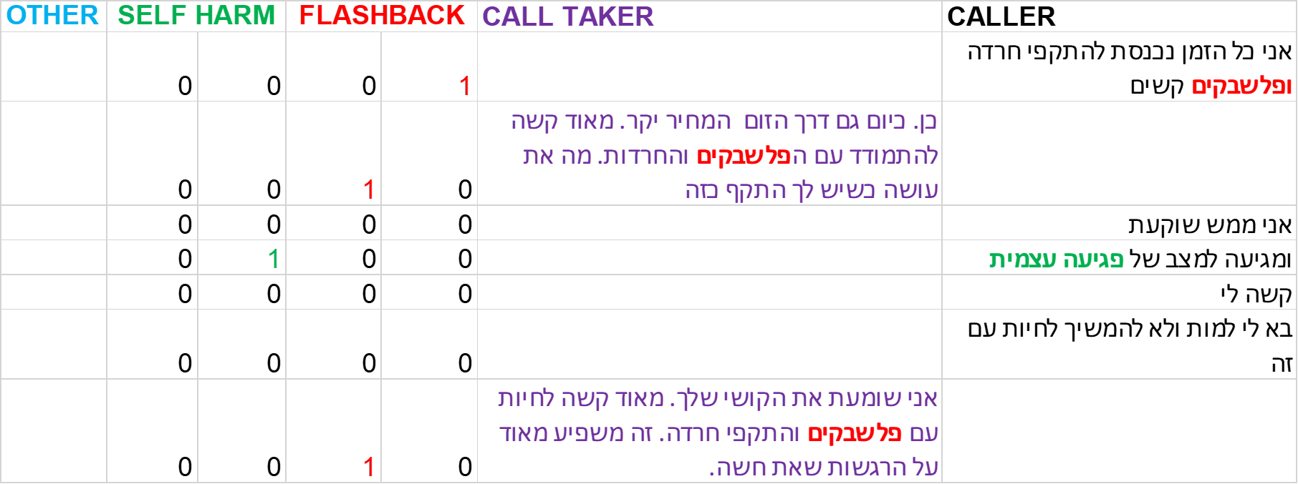

Figure 3.1- 2: an example of using the algorithm

1. At the end of the call, a summary of the number of keywords that appeared for each conversation type will be summarized, and this will be translated into percentages representing the option for each type of conversation.

The Excel formula:

=IF(ISERROR(C42/C43),0,(C42/C43))

An example of the percentages at the end of a conversation:



Figure 3.1- 3: an example of the percentages at the end of the conversation

1. We ran the algorithm on the 30 calls.

In the fourth step, after the algorithm classified the calls, we compared the classification results of the algorithm to the manual classification results. Comparison table is attached as Appendix 2.

Figure 4 illustrates and summarizes the work process described above:



Figure 3.1- 4: The work process

# **4.1. Results**

To test whether our classification algorithm was good and accurate, we compared it to the manual classification we made. Table 2 summarizes this comparison:

Table 4.1- 2: A comparison between classification algorithm and manual classification

|  |  |  |  |  |
| --- | --- | --- | --- | --- |
| Classification of the algorithm | | |  |  |
| Other | Self-harm | Flashback |  |  |
| 0 | 0 | 13 | Flashback | Manual classification |
| 0 | 2 | 0 | Self-harm |
| 12 | 1 | 2 | Other |

As we can see in table 2, in 90% of the calls, the algorithm was classified correctly.

Detailing the classification quality indicators of each category. table 3

summarizes the indicators of the classification:

Table 4.1- 3: Accuracy, precision, sensitivity, and specificity for the classification for each category



As we can see in table 3, the accuracy and the additional metrics are relatively high. This indicates that the classification of the algorithm is a good identification tool.

# **5.1. Discussion**

In this part of the project, we built an algorithm to identify the type of conversation. We built a tool that was able to iteratively identify the type of conversation, with high accuracy rates. This tool can be used as a decision support tool for the volunteers.

Improving the ability to identify the type of call will allow the volunteer to give the caller a response (support) adapted to the type of conversation more quickly, with more certainty about which support strategy to choose. This will allow to give better and more appropriate support. Hence, we were able to build a tool that could improve the process of providing support by developing an algorithm for identifying the type of conversation. In an initial, insignificant examination, the time it took to identify the type of call was reduced, leading to more calls being answered over a period.

The findings of our study should still be qualified, as we have proven the feasibility of improving the response by using the tool, but this has not yet been tested in practice, since the tool is not yet automatic and has not yet been used online.

In addition, the improvement will be reflected in:

1. At the managerial level, in terms of the training process of the volunteers - the WhatsApp director will be able to use the tool to know if the volunteer has identified the type of conversation and provided a tailored response and, if not, to guide and direct her.
2. In terms of the conversation process – it will be possible to develop a structured process of support call by providing tailored responses to the topics of conversation that arise.

# **Research question 2: Evaluating WhatsApp support calls**

# **3.2. Method**

The first step required us to define the criteria for assessing WhatsApp support calls. We defined the criteria according to the different types of criteria we found in the literature review. In addition, we conducted an in-depth interview with the WhatsApp director. Interviewing her helped us to learn from her "field experience" and to determine what she thinks are the criteria for evaluating the quality of the support.

Based on the literature review and the in-depth interview with the WhatsApp director, we defined 4 sections that need to be addressed in the process of evaluating a WhatsApp support calls: (1) conversation structure and content (2) using support principles (3) using principles contrary to support principles and (4) using WhatsApp platform. For each category, we built a set of questions and thus obtained a comprehensive "evaluation form" for WhatsApp support calls. We built the evaluation form using Google Forms. We gave scores for each question and thus received a score for each section as well as a weighted score for the entire conversation. "Conversation structure and content" and "Using support principles" sections were measured on a scale from 0 to 3. "Using principles contrary to support principles" section was measured on a scale from -3 to 0, and "using WhatsApp platform" section did not get any score. The final conversation score is the sum of the 3 sections above and it was measures on a scale from -3 to 6. Appendix 3 presents the evaluation form's rating scale. We built several versions of this evaluation form based on feedback and reviews given by the WhatsApp director until we got our final version. Link to evaluation form is attached – Appendix 4.

We took transcripts of WhatsApp calls. The transcripts were taken from January-April 2022.

26 WhatsApp support calls were evaluated according to the evaluation form. Each call was evaluated by 2 evaluators: a "professional evaluator" (evaluator from HRCC) and a "naïve evaluator" (evaluator not from HRCC). A total of 52 evaluation forms were completed, half were made by a professional evaluator and half by a naïve evaluator.

After getting a numeric score for each call, we set a new target variable that defined whether the call was "good", "medium" or "not good". Table 4 summarizes the quality of the conversation according to the score's distribution. This scores distribution gave the highest accuracy and therefore was selected.

Table 3.2- 4: Call quality rating according to score's distribution

|  |  |
| --- | --- |
| **Target variable- quality of the conversation** | **score** |
| good | >=4.5 |
| medium | >2 |
|  | <4.5 |
| not good | <=2 |

Then we randomly sampled 10 calls that were evaluated according to the existing method. These evaluations were made by 3 professional evaluators from HRCC, from December 2021 to February 2022. To be able to compare them to the evaluation form we developed, after reading each evaluation, we defined each call whether it was "good", "medium" or "not good". Then, we evaluated those conversations according to the evaluation form we developed.

It should be noted that a complete evaluation process contains not only filling an evaluation form and getting a numeric score, but also writing a verbal evaluation for the volunteer, based on the results of the evaluation form.

Figure 5 illustrates and summarizes the work process described above:

in-depth interview with WhatsApp director

Defining evaluation criteria and scale rating

Creating electronic evaluation form

Checking on random sample of 26 WhatsApp transcripts

26 professional evaluations

26 naïve evaluations

Target variable: good/ medium/ not good

Comparison to 10 existing evaluations

Total of 52 evaluations

** 40 more evaluations

Figure 3.2- 5: The work process

For our analysis, we used Excel and Weka. In Weka, we analyzed 52 instances with 26 attributes, test mode: 10-fold cross validation. Table 5 summarizes all the attributes according to which the algorithm classified whether the conversation was good/ medium/ not good.

Table 3.2- 5: The attributes- our defined criteria for evaluating support calls

|  |  |
| --- | --- |
| **Sec. 1-**  **conversation structure and content** | Opening |
| Initial contact - reflection of emotions |
| Body of conversation- reflection of emotions |
| Body of conversation- asking questions |
| Body of conversation- encouragement |
| Body of conversation- Recommendations 1 |
| Body of conversation- Recommendations 2 |
| Body of conversation- Recommendations 3 |
| Body of conversation- Recommendations 4 |
| Body of conversation- answer to specific need |
| End of conversation- Summary words |
| End of conversation- Invitation to call again |
| identify the purpose of the conversation |
| **Sec. 2-**  **using support principles** | reframing |
| validation |
| normalization |
| share of information |
| Suggestion options |
| Acceptance of the caller and or her behavior |
| showed the caller what is good for her |
| showed the caller the forces within her |
| the caller is positioned as someone who knows how to make decisions |
| **Sec. 3-**  **using principles contrary to support principles** | the volunteer told the caller what she should do |
| focused on technical assistance |
| focused on doing and was not on being |
| the volunteer tried to convince or argued with the caller |

# **4.2. Results**

# **4.2.1. Criterions that determine the quality of support calls**

To examine the question which criteria determine the quality of support calls are – we ran tree analysis J48 classification algorithm in Weka. Running other classification algorithms or in other score's distribution, gave lower accuracy. Therefore, we chose J48 algorithm, with the chosen score's distribution.

We got the following results, shown in table 6:

Table 4.2- 6: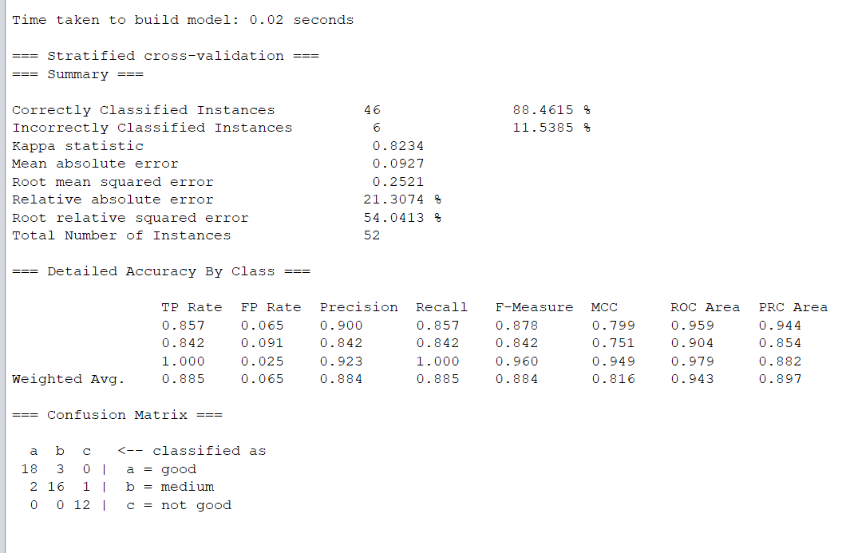 Weka's results output

As we can see in table 6, the accuracy of the J48 classification algorithm is 88.46% (the algorithm correctly classified 46 instances out of 52). All "not good" conversations were classified correctly. Even if there was a classification error, the error was for the adjacent category (there was no classification of a good conversation as not good one or vis versa). The precision, recall, F-measure, and ROC area are high, which means that the classifier is good (Avg. precision=0.88; Avg. recall=0.89; Avg. F-measure=0.88; Avg. ROC area=0.94).

Classification of "not good" conversations gave the best values, which means that the classifier best classifies this category (precision=0.92; recall=1; F-measure=0.96; ROC area=0.94). The classification of "good" conversations also gave high values, and thus considered a good classifier. (precision=0.9; recall=0.86; F-measure=0.88; ROC area=0.96). The classification of "medium" conversations was the lowest, but not much compared to "good" and "not good" conversations and is also considered a good classifier (precision=0.84; recall=0.84; F-measure=0.84; ROC area=0.9).

The decision tree we obtained, can give us important insights into the criteria that determine the quality of the call. The decision tree made from the J48 algorithm is presented in figure 6:

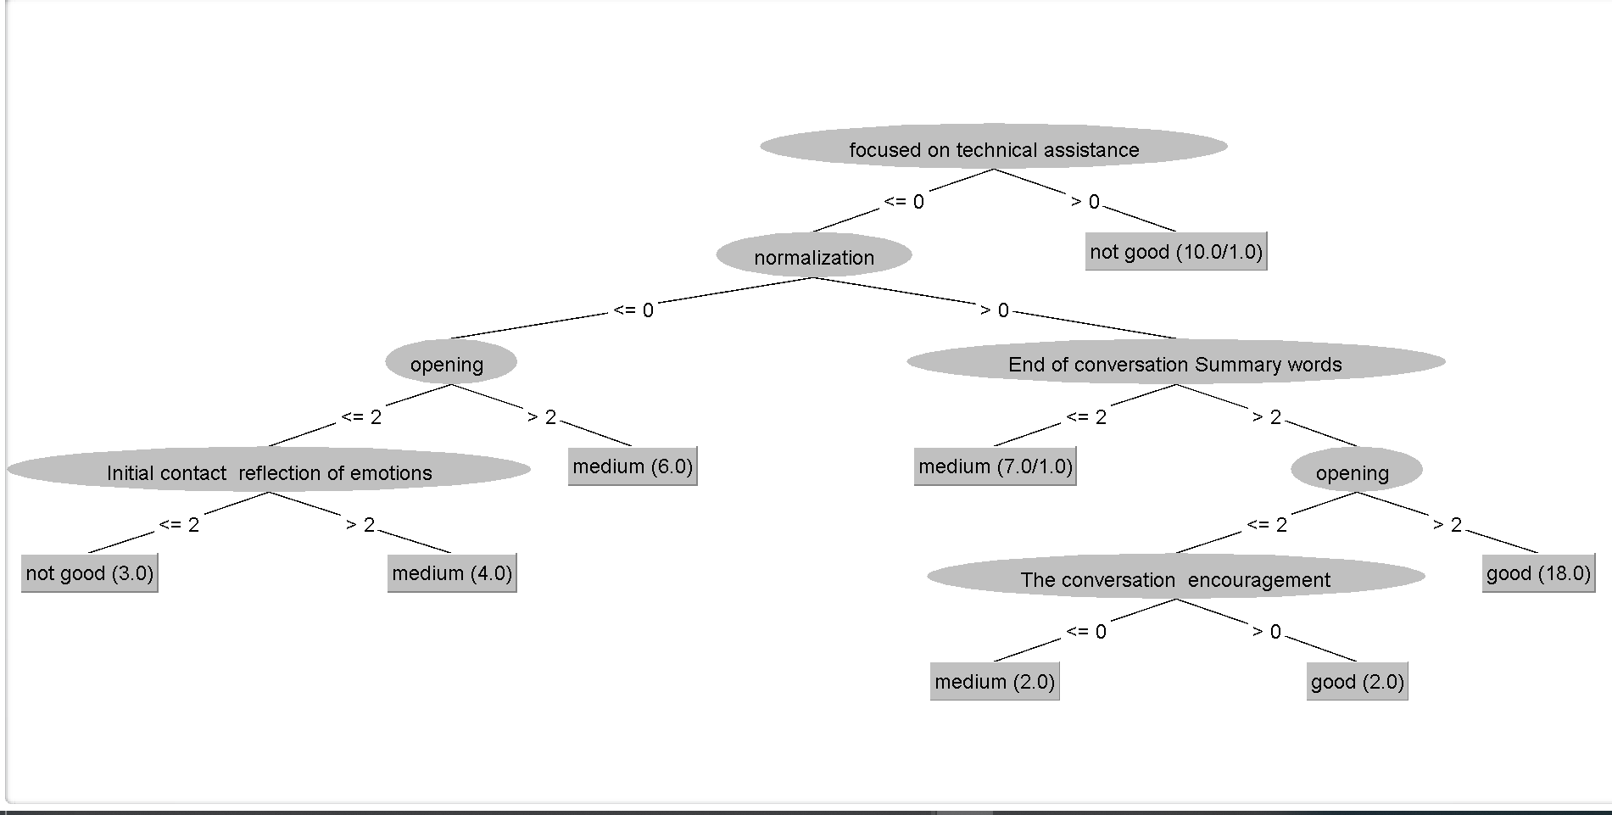

good

medium

not good

Sec. 1- conversation structure and content

Sec. 2- using support principles

Sec. 3- using principles contrary to support principles

**Colors by the sections of the conversation:**

Figure 4.2- 6: Weka's J48 algorithm decision tree

The first 2 levels of the decision tree are the most significant one, which means they have the maximum impact on determining quality of the call. The first 2 levels of the tree focus on support principles: the first – "focused on technical support" – is a principle which is contrary to support principles. The second level – "normalization" – is a support principle. The following levels include criteria that are related to the conversation structure and content.

As we can see, most conversations classified as "not good" focused on technical aspects, which means the volunteer gave support contrary to RCC's support principles (so it is no wonder that the call received a "not good" rating). A "not good" conversation also included lack of normalization, general opening words that didn't relate to the caller's words, and lack of reflection of emotions or reflection of general emotions at the beginning of the conversation.

A "good" conversation was one that included normalization, concluding words at the end of the conversation, and a good opening that related the caller's words. if the opening words where general words and didn't relate to the caller's words, the conversation was classified as "good" if there was an encouragement that specially addressed the caller.

Table 7 summarizes these findings about the criteria for evaluating a "good" and "not good" support calls:

Table 4.2- 7: criteria for evaluation "good" and "not good" support calls



To check maybe there was an overlap between using support principles (positive principle) and using principles that are contrary to support principles (negative principles), we tried to omit the negative principles. In this case, the accuracy decreased dramatically, and the misclassification was wider –"good" conversations classified as "not good", or "not good" conversation was classified as "good" ones. Given the decrease in accuracy, and because we did not want such misclassifications to happen, we concluded that such attributes cannot be omitted.

## **4.2.2. Testing the improvement in the evaluation process**

As mentioned before, we also wanted to test the improvement in the evaluation process. We tested the improvement by checking the quality and the quantity of the evaluation process.

### ***4.2.2.1. The quality of evaluation processing***

We compared the evaluation results of the existing evaluation method to the evaluation form we developed. Table 8 summarizes this comparison:

Table 4.2- 8: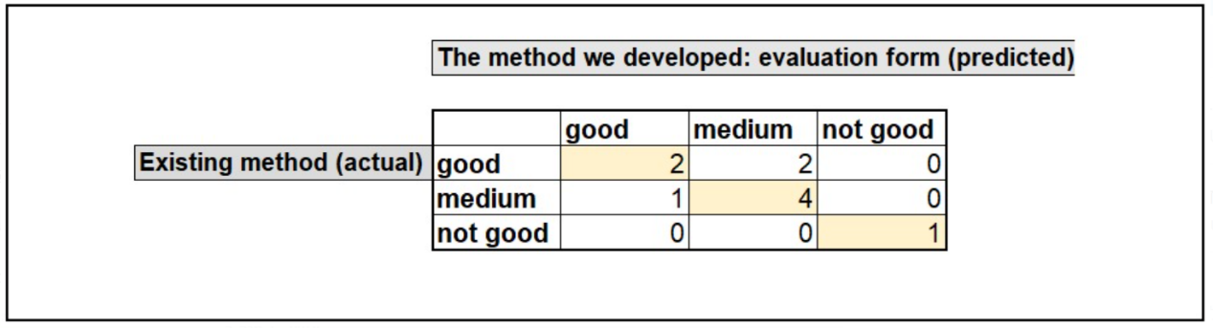 A comparison between classification according to the existing method and the method we developed

As we can see, 7 out of 10 conversations were correctly classified. All "not good" conversations were correctly classified. 2 conversations were classified as "medium" instead of "good" and 1 conversation was classified as "good" instead of "medium". There was no misclassification between "good" and "not good". Table 9 summarizes the accuracy, precision, sensitivity, and specificity for the total classification and for each category.

Table 4.2- 9: Accuracy, precision, sensitivity, and specificity for the total classification and for each category

|  |  |
| --- | --- |
| **0.80** | **total accuracy** |
| 0.70 | good accuracy |
| 0.70 | medium accuracy |
| 1.00 | not good accuracy |
|  |  |
| **0.70** | **total precision** |
| 0.67 | good precision |
| 0.67 | medium precision |
| 1.00 | not good precision |
|  |  |
| **0.70** | **total sensitivity** |
| 0.50 | good sensitivity |
| 0.80 | medium sensitivity |
| 1.00 | not good sensitivity |
|  |  |
| **0.85** | **total specificity** |
| 0.83 | good specificity |
| 0.60 | medium specificity |
| 1.00 | not good specificity |

As we can see in table 9, the accuracy and the additional metrics are relatively high. This indicates that the evaluation form we developed is a good quality call evaluator and it can replace the existing evaluation with a high level of accuracy and reliability.

To further test the quality of the evaluation process, and to test our evaluation form's reliability between judges, we also compared evaluations between the professional evaluators and the naïve evaluators. The H0 was that if there is a reliability between judges and if our evaluation form is a valid tool, there would be no significant difference between professional evaluators and naïve evaluators. We used two-tailed test sign test to examine this hypothesis.

Under the sign test assumption that $X\sim bin(N,α=0.05)$, we will define the critical value of $Ra$. the decision rule determines that if X $≤Ra$, we will reject H0.

Table 10 summarizes the values of N, X, $Ra$ for the total conversation score and for each section of the conversation:

Table 4.2- 10: Values of N, X, Ra for the total conversation score and for each section of the conversation

As we can see, for all categories shown in the table 10, $X≥Ra$. That means that we cannot reject H0, i.e., there is no significant difference between a professional evaluator and a naïve evaluator.

We also examined correlation between professional evaluators and naïve evaluators (r=0.77, *p*<0.05). And as we can see, there is also a high correlation between professional evaluators and naïve evaluators, which strengthen our hypothesis that there is no significant difference between different evaluators.

### ***4.2.2.2. The quantity of evaluation processing***

To examine the improvement in ability to give more evaluation per unit time, we compared the time it takes to give an evaluation in the existing method with the time it takes using the evaluation form we have developed.

According to WhatsApp director's estimates, it takes about 120 minutes to give a written evaluation to each WhatsApp call. Given the other tasks assigned to the WhatsApp director and her employment rates, a maximum of 1 evaluation per day is given. In a weekly calculation, only 4-5 evaluations are given.

The evaluation form we developed shortened the duration of the evaluation. The average time to complete the evaluation form was 7.6 minutes. According to the WhatsApp director, another 20 minutes of writing a verbal evaluation should be added. For the simplicity, we will determine that the evaluation process we proposed takes about 30 minutes. Which means, at the same unit time, WhatsApp director can evaluate 4 times more calls – 4 calls per day and 16-20 per week. Table 11 summarizes these findings. This is undoubtedly a significant improvement in the evaluation process ability.

# **5.2. Discussion**

In this part of the project, we defined a set of criteria for evaluating WhatsApp support calls. Using these criteria, we were able to classify whether the conversation was a "good", "medium", or "not good" conversation – a classification that helped us to decide whether there was effective/ ineffective/ undermining support. In addition, we were able to learn what are the criteria for a good support call (compared to a "not good" one). We built an evaluation form that helped to evaluate the quality of the call and we examined whether using this evaluation form improved the quality and the quantity of the evaluation process in HRCC WhatsApp helpline.

We showed that the classifier we built, based on the set of criteria for evaluating a support call, managed to classify, with high accuracy, the quality of the call and to determine whether it was a "good" (effective), "medium" (ineffective), or "not good" (undermining) conversation. The most accurate classification was of the end categories: "good"/ "not good" conversations, while the classifier even managed to correctly classify all the "not good" conversations. Hence, we managed to build an effective and accurate tool that knows to identify the quality of the call.

Based on the differences between a "good" and "not good" conversations, we were able to learn insights about the characteristics of "good" (effective) and "not good" (undermining) conversations. We saw that a "good" conversation involved the use of support principles, mainly creating an emotional discourse rather than discussing technical issues. It also involved normalization – statements that normalize the situation or the emotions that the caller is experiencing, and encouragement that especially related the caller. In terms of conversation structure and content, a good support call is a call in which the volunteer tried to recognize the emotions that the caller brought up (directly or indirectly) in the call and constantly related to the caller's words and expressed emotions. This indicates high levels of empathy of the volunteer and high emotional connection ability to the caller, which makes the support call good and effective.

Not good conversations were characterized by technical support or giving technical advice. They did not involve reflecting emotions or any emotional discourse. Another characteristic was that the volunteer treated the caller in a general and generic manner rather than in a personal manner.

What was "in the middle", i.e., what was between the characteristics of a "good" and "not good" conversations or included mixed characteristics of both a "good" and "not good" conversations was defined as "medium".

These findings are consistent with a previous study that examined characteristics of an effective, ineffective, and undermining support in breastfeeding support helpline (by phone) in Queensland Australia (Thorpe et al., 2020).

In the in-depth interview with the WhatsApp director, she placed great emphasis on reflecting emotions during the conversation as a key criterion for a good support conversation (reflecting emotions as a way of expressing empathy and expressing "being" in writing). However, this criterion was not reflected in the first 2 levels of the decision tree or as a criterion for good conversation. One possible explanation can be that the reflection of emotions, was indirectly expressed in the first level of the tree that examined whether the volunteer focused on technical support. By its very nature, reflecting emotions cannot be technical support and therefore it was not directly expressed. Another possible explanation is that if a "not good" conversation lacked a reflection of emotions (or included a reflection of only general emotions), it can be concluded that a "good" conversation includes an emotion reflection that especially address the caller.

Based on the differences between the characteristics of a good, medium, and not good conversations, WhatsApp director can get an overview of the quality of the existing support: What is the quality of the existing support in general, what is the quality of support of each volunteer, where are the strengths and weaknesses of each volunteer, etc. Accordingly, the WhatsApp director can give each volunteer a written individual evaluation with reference to the strengths (for preservation) and the weaknesses (for improvement) and examine the progress of each volunteer's learning ability. Monitoring the quality of support can help to improve it.

The evaluation form we developed has already been implemented in HRCC, and by the time of writing this project, another 40 evaluations have been added. Table 11 summarizes the descriptive statistical values comparing our 52 calls to 92 calls.

Table 5.2- 11: descriptive statistics values compering 52 calls to 92 calls

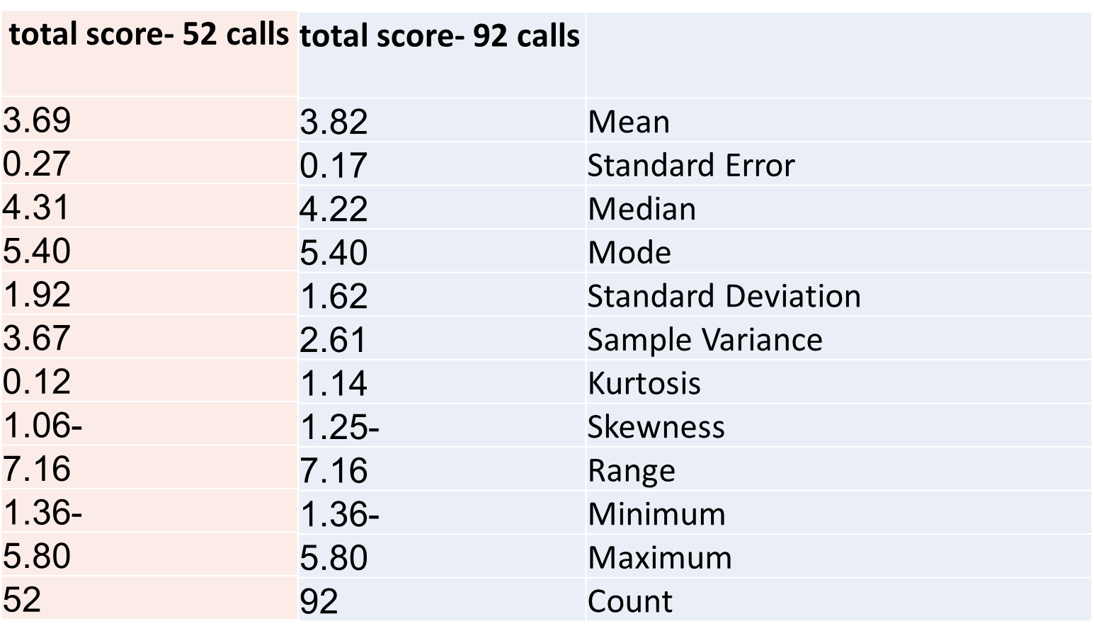

As we can see in table 11, the overall call score mean was 3.69 and improved to 3.82. The median decreased slightly, and the standard deviation and variance also decreased. Already in a short period time, there was an improvement in the quality of support and there was less variation in it. The sample is still small and wasn't tested for statistical significance , but it can teach us about the potential of the evaluation tool we have developed.

Regarding the question of whether the evaluation form we have developed improved the WhatsApp support calls' evaluation process at HRCC, we saw that it has indeed improved the process. We saw that there was no significant difference between the existing method and the suggested method, and they were equal in their quality. If there was any concern that because the suggested evaluation is structured and uniform, and not individual or personal as in the existing method, the evaluation will not be accurate enough, we saw that this concern was proven wrong. On the contrary, being a uniform and systematic evaluation process, with defined criteria, is an advantage over the existing method.

In addition, we saw no significant difference in the comparison between a professional evaluator and a naïve evaluator. Which means that each evaluator can fill out the evaluation form and we will get reliable results.

An operative implication is that the WhatsApp director is not necessarily required for filling out the evaluation form. Filling out the evaluation form by a naïve evaluator will make the evaluation process more efficient and cost effective. The WhatsApp director will receive a dashboard, which will present the scores of the calls, with information about who was the volunteer, number of calls during her shift, and with the total score of each conversation and its sections. Based on this dashboard, the WhatsApp director will be able to decide which conversations to focus on and give a specific evaluation to the volunteer.

Further research will try to use AI and computerize the process of filling out the evaluation form so that the process will be automated.

We also saw that there was a significant improvement in the number of evaluations that can be given in per unit time (evaluation that includes filling out the evaluation form and writing a written evaluation). We got 4 times more evaluations per unit of time, which is a significant efficiency increase.

Providing systematic evaluation process also helped the WhatsApp director to recognize recurring trends of repeated comments. Following this, another operative implication is a suggestion to develop a bank of written evaluations. The WhatsApp director has already implemented this suggestion, and this also shortened the duration of the evaluation process.

# **6. Concluding discussion**

Our project aimed to improve the efficiency and quality of support provided through WhatsApp to survivors of sexual assault. Each of us focused on a different aspect: Moriya Greenhut focused on the volunteer's aspect by giving them a tool that could improve their ability to identify the conversation type and thus give an adequate support. Shiran Carmeli focused on the managerial aspect, by giving the WhatsApp director a tool to evaluate the quality of the support and in this way also to improve it.

We have seen that the type of conversation identification was not part of the decision tree for determining the quality of the call. This is because identifying the type of conversation is the basis for the call process and for the call evaluation process.

Our joint project has led to several common conclusions and managerial insights: One managerial insight pertains to the training process of new WhatsApp volunteers and their ongoing training. The training process should begin with the provision of support strategies that are consistent with the conversation type identification. The training process should also focus on teaching and practicing the use of support tools. Mainly how to identify the caller's emotional need, and focus on "being" with the caller, rather than rushing to "doing" and giving advice or solutions. All, while constantly practicing on giving an empathic response that address specifically the caller's words. The ongoing volunteers' training should also focus on these principles.

The identification tool will also help the WhatsApp director to see if the call taker identified the conversation type correctly and gave the appropriate support. And if not, to guide and instruct the call taker. All will help to improve the quality of the given support.

Second managerial insight pertains the construction of the conversation process. Today, the conversation flows according to what the caller brings to the conversation. Using the two tools we developed can help HRCC in starting to create a structured process of answering a support call: Beginning that includes an inviting opening that addresses the caller's word; Making initial contact through reflecting emotions; While this initial discourse will help to identify the type of the conversation; Managing the main part of the conversation with the use of emotional discourse, an open-ended questions or clarification questions, encouragement that addresses the caller, and all by using support principles. This will also help to improve the support provided to sexual assault survivors. As the tools will become more developed it will be possible to further develop the construction of the conversation process.

The third managerial insight pertains time efficiency. The identification tool reduced the identification times, which enables a faster adequate response, and can also lead to answering more calls per unit time. In addition, using the evaluation form improved the efficiency of the evaluation process and enables, getting 16-20 evaluations a week. This can give the WhatsApp director more meaningful insights into the quality of support than just 4 evaluations a week made today. There is an average of 75 calls on the WhatsApp helpline per week. Improving the evaluation process will allow an evaluation of about 25% of incoming calls (instead of only 5%).

## **6.1. Research contribution**

This is the first time that a word recognition algorithm has been built as a decision support tool for HRCC volunteers.

This study is the first infrastructural work in a field on which follow-up studies can be based. By using the infrastructure, we have built, it can be used in other areas:

1. Specific to the helpline, the tool created, is currently in Excel software and operates offline. Based on this project it will be possible to develop a tool that will work online during the conversation.
2. In follow-up studies, it will be possible to examine whether identifying the type of conversation leads to better support. And even offer a support strategy for any conversation type.
3. Perhaps the possibility of answering a computerized bot that artificial intelligence, which contains, among other things, an algorithm for identifying the type of conversation, will be able to provide a response for callers.
4. In this work, we dealt with keywords in flashback and self-harm conversations, and follow-up studies will be able to create tools for classifying additional types of conversations – defined as 'other'.
5. It will be possible to develop a tool adapted to helplines in other areas (which are not only for victims of sexual assault).

In the field of evaluating the support, our research contribution is, that for the first time, to the best of our knowledge, a set of objective criteria has been defined, that enables systematic and uniform evaluation of the given support. The process we proposed improved the existing evaluation process and shortened the duration of the process.

By doing so, we also created an infrastructure that, for the first time, managed to turn qualitative criteria into quantitative and measurable criteria.

Further studies will also be able to test and refine the criteria we have defined and deeply examine whether there is an overlap between the criteria, so it is possible to reduce some criteria or perhaps find that the number of criteria for evaluation needs to be expanded.

## **6.2. Research limitations**

One of our research limitations is related to the anonymity policy of HRCC. Due to the policy of HRCC to maintain the anonymity of the callers, the support calls evaluation process cannot be done through contacting the caller (for example, conducting satisfaction surveys). The evaluation of the given support was only can based on the analysis of WhatsApp transcripts and was made only by referring the WhatsApp director and call takers.

Another limitation is that the research was done only on WhatsApp calls with sexual assaults survivors and only from HRCC. Further research will need to examine whether it is possible to generalize the criteria and evaluation process we proposed to the other RCCs in Israel, to other helplines in Israel, to other helplines around the world, and to other communication channels (such as telephone, chat).

Another limitation is that the manual classification is done by one encoder, and it is possible that the results would have been biased and if it had not been for another person performing the classification perhaps the results would have been different.

We also focused only on 2 types of calls- flashback and self-harm. All the rest was categorized as "other". Further research could continue developing the identification of the "other" category.

Another research limitation is that the conversations' scores scale was only from 1 to 3. Since our research that examine the criteria for evaluating the quality of WhatsApp support call is preliminary research, for the simplicity, we decided to choose a relatively low scale. Further research will develop a broader measurement scale and thus will be able to improve the accuracy of the evaluations.

Another limitation is related to the comparison between the existing method and the proposed method. First, we did not have many evaluations according to the existing method, so we only compared 10 calls. In addition, the comparison was difficult since the existing evaluation has no defined criteria.

Another research limitation is that the number of evaluators (professional and naïve) was relatively small (4 evaluators overall). It is possible that a larger number of evaluators will give different results. We recommend that in further research will be more evaluators (professional and naïve) for each call.

Despite the limitations, our research contribution – in being pioneer research, and in creating research infrastructure as well as an operational infrastructure for actual use – is in the ability to improve the quality and the efficiency of the support provided to sexual assault survivors. It also provides an infrastructure for improving the quality of support in other communication channels, other support centers, and other support organizations.

# **7. Bibliography**

*Annual Report National Institute of Justice 2 0 0 2*. (2002).

Bein Kris. (2010). *Core Services & Characteristics of Rape Crisis Centers: A Review of State Service Standards Second Edition*. http://www.resourcesharingproject.org/

Bloch, S., & Leydon, G. (2019). Conversation Analysis and Telephone Helplines for Health and Illness: A Narrative Review. *Research on Language and Social Interaction*, *52*(3). https://doi.org/10.1080/08351813.2019.1631035

Brian L. Mishara, & Marc S. Daigle. (1997). Effects of Different Telephone Intervention Styles with Suicidal Callers at Two Suicide Prevention Centers: An Empirical Investigation. *American Journal of Community Psychology*, *25*, 861–885.

Brody, C., Star, A., & Tran, J. (2020). Chat-based hotlines for health promotion: a systematic review. *MHealth*, *6*, 36–36. https://doi.org/10.21037/mhealth-2019-di-13

Calhoun, K. S., & Atkeson, B. M. (1991). *Treatment of rape victims: Facilitating psychosocial adjustment*. Pergamon Press.

Catalano, S. M. (2006). *Criminal victimization 2005*.

Charles B. Truax, R. R. C. (1967). *toward effictive counseling and psychotherapy* (3rd editio). Aldine publishing company.

Chiu, H. C., & Lin, N. P. (2004). A service quality measurement derived from the theory of needs. *Service Industries Journal*, *24*(1), 187–204. https://doi.org/10.1080/02642060412331301202

Delworth, U., Rudow, E. H., & Taub, J. (1972). *Crisis Center/Hotline – A Guidebook to Beginning and Operating*. IL: Charles C. Thomas.

Dustin K MacDonald. (2015). Methods of Evaluating Helplines and Hotlines. *Http://Dustinkmacdonald.Com/Methods-of-Evaluating-Helplines-and-Hotlines/*.

Fowler, D. ., & McGee, R. . (1973). Assessing the performance of telephone crisis workers: The development of a Technical Effectiveness Scale. *D. Lester & G.W. Brockopp (Eds.). Crisis Intervention and Counseling by Telephone*.

Hellman, C. M., & House, D. (2006). Volunteers serving victims of sexual assault. *The Journal of Social Psychology*, *146*(1), 117–123.

Herman, J. L. (1992). *Trauma and Recovery*. Basic Books.

Hutschemaekers, G. J. M., Zijlstra, E., de Bree, C., Lo Fo Wong, S., & Lagro-Janssen, A. (2019). Similar yet unique: the victim’s journey after acute sexual assault and the importance of continuity of care. *Scandinavian Journal of Caring Sciences*, *33*(4), 949–958. https://doi.org/10.1111/scs.12693

Pudlinksi, C. (2005). Doing empathy and sympathy: caring responses to troubles tellings on a peer support line. *Discourse Studies*, *7*, 267-–288.

Richards, D. (2013). Developments in technology-delivered psychological interventions. *Universitas Psychologica*, *12*(2), 571–579. https://doi.org/10.11144/Javeriana.UPSY12-2.dtdp

Searles, P., & Berger, R. J. (1995). *Rape & Society: Readings on the Problem of Sexual Assault*. Boulder, CO.

Stommel, W., & Molder, H. te. (2018). Empathically designed responses as a gateway to advice in Dutch counseling calls. *Discourse Studies*, *20*, 523–543.

Thorpe, K., Danby, S., Cromack, C., & Gallegos, D. (2020). Supporting, failing to support and undermining breastfeeding self-efficacy: Analysis of helpline calls. *Maternal and Child Nutrition*, *16*(2). https://doi.org/10.1111/mcn.12919

Tjaden, P., & Thoennes, N. (2006). *Special Extent, Nature, and Consequences of Rape Victimization: Findings From the National Violence Against Women Survey*. www.ojp.usdoj.gov/nij

Vaknin O, Donsky Y, & Sofri I. (2020). הקול-הרביעי: הווטסאפ – הטקסט המלווה את השעה הטיפולית. *בין המילים*, *17*, 29–45.

Xu, Y., Chan, C. S., Tsang, C., Cheung, F., Chan, E., Fung, J., Chow, J., He, L., Xu, Z., & Yip, P. S. F. (2021). Detecting premature departure in online text-based counseling using logic-based pattern matching. *Internet Interventions*, *26*. https://doi.org/10.1016/j.invent.2021.100486

Xu, Z., Xu, Y., Cheung, F., Cheng, M., Lung, D., Law, Y. W., Chiang, B., Zhang, Q., & Yip, P. S. F. (2021a). Detecting suicide risk using knowledge-aware natural language processing and counseling service data. *Social Science & Medicine*, *283*, 114176. https://doi.org/10.1016/J.SOCSCIMED.2021.114176

Xu, Z., Xu, Y., Cheung, F., Cheng, M., Lung, D., Law, Y. W., Chiang, B., Zhang, Q., & Yip, P. S. F. (2021b). Detecting suicide risk using knowledge-aware natural language processing and counseling service data. *Social Science and Medicine*, *283*. https://doi.org/10.1016/j.socscimed.2021.114176

**8. Appendices**

## **8.1. Appendix 1: A copy of a conversation**





## **8.2. Appendix 2: Comparison table between the manual classification and the classification of the algorithm**



## **8.3. Appendix 3: Evaluation form's rating scale:**

The evaluation form's scores were measured as follows:

(1) conversation structure and content- answers to each question were converted to a scale of scores from 1 (not good) to 3 (good). This section received a weighted score from 1 to 3.

(2) using support principles- The evaluation form contained 9 support principles. We counted how many support principles appeared in the call. We find out that the average use of support principles was 3.65, the mode was 4 and the maximum was 7. accordingly, we decided to group the categories and score them on a scale from 0-3, as summarized in table 12:

Table 8.3- 12: Scoring support principles section

|  |  |
| --- | --- |
| **Score** | **number of support principles** |
| 0 | 0 |
| 1 | 1 |
| 2 | 2-3 |
| 3 | 4 and more |

(3) using principles contrary to support principles- The evaluation form contained 4 principles contrary to support principles. Scoring this section was done as scoring the previous section. We find out that the average use in this section was -0.35, the mode was 0 and the maximum was 4. The score of this category was on a scale from 0 to -3, and summarized in table 13:

|  |  |
| --- | --- |
| **Score** | **Number of principles contrary to support principles** |
| 0 | 0 |
| -1 | 1 |
| -2 | 2 |
| -3 | 3 and more |

Table 8.3- 13: scoring principles contrary to support section

(4) using WhatsApp platform- did not get any score, only verbal evaluation. We decided not to score this section because we realized that comments in this section did not affect the quality of the call, just its form, and the volunteer immediately responded to the comment and corrected what was needed to be corrected, so that the comment did not repeat.

The final score is the sum of the 3 sections above and it was measures on a scale from -3 to 6

## **8.4. Appendix 4- link to the evaluation form**

<https://forms.gle/Tpe3Sh11HEp3ZEAE8>

# **תקציר**

מרכז סיוע לנפגעות ונפגעי תקיפה מינית חיפה והצפון נותן סיוע רגשי לנפגעות ונפגעי תקיפה מינית ולמעגלי התמיכה שלהם. השירות ניתן על ידי מתנדבות שעברו הכשרה מיוחדת למתן סיוע מרחוק. מטרתו של פרויקט זה לשפר את איכות ויעילות הסיוע שניתן דרך אפליקציית הווטסאפ לנפגעות תקיפה מינית במרכז הסיוע חיפה והצפון.

פרויקט זה הינו פרויקט משותף. מוריה גרינהוט התמקדה באספקט של המתנדבות נותנות הסיוע ויצרה בעבורן כלי תומך החלטה, שיעזור להן לזהות בקלות ובמהירות רבה יותר את סוג השיחה שהתקבלה וכך לתת מענה מותאם לצרכיהן ומהר יותר. שירן כרמלי התמקדה באספקט הניהולי ופיתחה עבור מנהלת קו הווטסאפ כלי שיעזור לה להעריך את איכות הסיוע שניתן על ידי המתנדבות ובדרך זו גם לשפר אותו.

לפרויקט זה 2 מטרות. הראשונה, לייצר כלי סיסטמתי שיעזור למתנדבת מקבלת השיחות לזהות במהירות וביעילות את סוג השיחה. השנייה, לייצר סט מוגדר של קריטריונים שיוכלו להעריך את איכות שיחת הסיוע בווטסאפ עם נפגעות תקיפה מינית.

הצלחנו לייצר אלגוריתם זיהוי שיכול לזהות, עם רמת דיוק גבוהה, 3 סוגי שיחות: שיחות מסוג "פלאשבק", שיחות מסוג "פגיעה עצמית" ושיחות מסוג "אחר". אלגוריתם זה יכול לשמש כלי תומך החלטה למתנדבות. שיפור היכולת לזהות את סוג השיחה, יוכל לעזור למתנדבות לתת לפונות ולפונים לקו הווטסאפ מענה יותר מדויק, מהר יותר ועם יותר ודאות לגבי אסטרטגיית הסיוע הנכונה לסוג הפניה.

בנוסף, הצלחנו לייצר סט מוגדר של קריטריונים להערכת איכות שיחת הסיוע. בהתבסס על קריטריונים אלה, הצלחנו להגדיר מה נחשבת שיחה טובה/ אפקטיבית, שיחה בינונית/ פחות אפקטיבית או שיחה לא טובה/ בכלל לא אפקטיבית ואפילו מערערת. פיתחנו טופס ההערכה שנותן ציון מספרי לשיחת הסיוע על סמך קריטריוני ההערכה שהוגדרו. הראנו, שתהליך ההערכה המוצע שיפר את תהליך ההערכה הקיים.

ראינו ששני הכלים שפיתחנו הם בעלי רמת דיוק גבוהה. על ידי פיתוח אלגוריתם הזיהוי הראנו ייתכנות לשיפור תהליך מתן הסיוע. על ידי פיתוח תהליך ההערכה, הראנו שיפור ביעילות ובאיכות של הסיוע.

הכלים שפיתחנו יכולים לשפר את תהליך ההכשרה של מתנדבות חדשות כמו גם את ההכשרה השוטפת שלהן. כלים אלו יכולים גם לעזור בתהליך של הבניית שיחת סיוע (במקום המצב הקיים שבו השיחה "זורמת" לפי מה שהפונה אומרת ומה שהמתנדבת עונה לה), ובכך להגביר את האיכות והיעילות של הסיוע הניתנים. יתרון נוסף הוא בשיפור היעילות, קרי ביכולת לתת מענה ולהעריך את הסיוע בצורה מהירה יותר.

פרויקט זה הוא מחקר חלוצי, אשר מניח תשתית מחקרית ויישומית בתחום של סיוע בכלל ובתחום של סיוע בווטסאפ לנפגעות תקיפה מינית בפרט. מחקרי המשך יוכלו לפתח את שני הכלים שפיתחנו, על ידי הפיכת התהליכים לאוטומטיים/ און ליין, הרחבת אלגוריתם הזיהוי לזיהוי סוגי שיחות נוספים ובחינת קריטריוני ההערכה שהוגדרו. מחקרי המשך יוכלו גם להרחיב את הכלים שפיתחנו לערוצי סיוע נוספים (טלפון, צ'אט וכד'), למרכזי סיוע נוספים בארץ ולקווי סיוע אחרים בתחומים נוספים.



הנדסה וניהול- מסלול מערכות שירות

**שם העבודה:**

**סיוע לנפגעות ונפגעי תקיפה מינית-**

**יצירת כלי תומך החלטה לזיהוי סוג השיחה המתקבלת בקו סיוע לנפגעות ונפגעי תקיפה מינית בווטסאפ**

**ויצירת סט מוגדר של קריטריונים להערכת איכות שיחות הסיוע**

**| פרויקט גמר |**

**שם הסטודנטיות:**  שירן כרמלי, ת.ז. 034820472

מוריה גרינהוט, ת.ז. 036815355

**שם המנחה:** דר' עדי פוקס

**חתימת המנחה:** ________________________

**תאריך ההגשה:** 30/6/2022