August 14th, 2020

Manuscript Number; 3  
Entitled; Association between Ambient Temperature, Particulate Air Pollution and Emergency Room Visits for Conjunctivitis

Dear Dr. Robin L. Cassady-Cain, PhD  
Editor in chief,

Please see our revised submission of the manuscript entitled "Association between Ambient Temperature, Particulate Air Pollution and Emergency Room Visits for Conjunctivitis ". We have carefully reviewed the comments of the reviewers, and would like to thank them for their thoughtful suggestions, which we think have substantially improved the quality of our manuscript. We have addressed the comments below in this letter, and in the revised manuscript attached. Please note, we have submitted both the revised version with the ‘track changes’ mode, as well as a ‘clean’ copy.

We sincerely hope the revisions made will meet your approval.

Looking forward to hearing from you,

Soltan Khalaila, MD,

Corresponding author.

***Reviewer 1:***

General comment:

The authors have addressed some of my comments, but there are still many serious issues needed to be addressed, particularly the organization and presentation of the results.

***Reviewer 1, Major point 1***

The associations between temperature and conjunctivitis visits in different seasons were non-linear, reverse U-, U- or J-shapes. It should be cautious to use the linear function to quantify this association.

Response:

Thank you for this important point, we absolutely agree with the reviewer and we clarify this crucial point in the text page 9 line 237 .

“*There is an overall non-linear association between temperature and conjunctivitis. But for certain temperature ranges at summer and autumn where considered the relevant temperature range for each season. We have formally assessed the linearity assumptions for the different temperature ranges. The linear positive association between temperature increments and incidence of conjunctivitis (Fig. 2) was established for the following ranges: for summer at temperatures between 24 and 28oC the incidence increased 8.1% for each rise of 1 degree Celsius, and for autumn at temperatures between 13 and 23 oC the incidence increased 7.2% for each rise of 1 degree Celsius”*

***Reviewer 1, Major point 2***

I think most important highlight in this paper is the associations between temperature, particulate matter and conjunctivitis visits. Therefore, I would suggest the authors prepare for the results focusing on this point, especially the quantitative estimates on their associations. And it is good to provide the estimates of per 10 μg/m3 changes in air pollution and 10 oC changes in temperature in association with conjunctivitis visits by all the possible subgroups (age, gender, season, conjunctivitis and non-conjunctivitis visits) (maybe in the form of table). And when interpreting these effect estimates, it is good to provide the 95%CI together.

Response:

Thank you for these important comments, we consider each one and we have rearranged the focus of the paper

The estimates provided for PM10 are per 10 μg/m3 changes

Separate analysis was performed for seasons, gender and age. We clarify it in the text page 7 line 180.

*“Stratified analysis by season (fall, winter, spring, summer), gender (female, male) and age (0-18 years old, 18-65 years old, and above 65) was performed. The estimates provided for PM10 are per 10 μg/m3 changes in air pollution*”

As for the temperature, we wanted to emphasize the effect of change for every change in one unit Celsius so it will be more accurate. Trying 10 units of change in Celsius degrees miss the delicate changes in different temperatures.

***Reviewer 1, Major point 3***

Only the single lags of environmental factors were provided. But as these effects could last for several days, so it is better to provide the cumulative lag effect of these environmental variables.

Response:

Thank you for this point. We tested the association separately between up to lag of 6 days, and also a cumulative effect of 7 days.

We clarify this point in the text (page 7 line 172, page 9 line 243) and figure 2 right panel.

“First, conditional logistic regression (Bateson et al., 1999) models were used to test a possible non-linear association of daily mean temperature on incidence of conjunctivitis for lag 0 to lag 6 and the cumulative effect of 7 days…”

“*This association remained after taking into account n up to a 6-day lag between exposures and developing conjunctivitis for both autumn and summer*”

***Reviewer 1, Major point 4***

For the methodology section, provide more description on the stratification analysis, and please provide a clear definition on the season. Also, what the statistical method was used to compare the difference of the conjunctivitis (or non-conjunctivitis disease) within subgroups (such as season, gender)?

Response:

Thank you for these important comments. Following the comments we have updated the methods section.

We added a description of the defined seasons to our methods *“Seasons were defined according to Alpert et al.,(2004); winter (December 7-March 30), summer (May 31-September 22) …)”* page 5 line 119

We provide description on the statistical method in statistical section page 7 line 172 *“*The statistical analysis included two steps. First, conditional logistic regression (Bateson et al., 1999) models were used *…..”*

page 7 line 180 *“Stratified analysis by season (fall, winter, spring, summer), gender (female, male) and age (0-18 years old, 18-65 years old, and above 65) was performed……”*

***Reviewer 1, Major point 5***

Please add the descriptive information on conjunctivitis and other ophthalmological diseases to table 2, and move the table 1 to the supplemental material.

Response:

We have added the relevant information to the table2 and moved table 1 to the supplemental material.

***Reviewer 1, Major point 6***

Discussion section needs to be greatly improved. Please provide summary sentences on the main results of this study to the first paragraph, and shorten those sentences on other diseases, such as cardiovascular and respiratory disease. In addition, the limitations and public health implications are totally missed.

Response:

We appreciate this crucial comment and we considered all points and fixed them

We add first paragraph describing the main results of the study, page 9 line 250 *“The main result of our study is the significant association between temperature….” And we* and shorten those sentences on other diseases.

We add section on limitation, page 12 line 318 “*6. LIMITATIONS* ***Our study investigates a specific region with specific climate conditions considered as a dry, hot semi-desert climate with a limited population; however, our hospital is a tertiary……”***

We add paragraph describe the public health implications in the background section page 3 line 63 *“Conjunctivitis significantly impacts health care systems; outbreaks can cause significant morbidity, high health care costs and loss of workdays, which eventually result in financial burdens….”*

***Reviewer 1, Major point 7***

Appendix Table 2, the way to present the effects of temperature seems a little strange, which were listed following two types of particulate matter. I think the authors calculated the effects of temperatures by separately adjusting for PM10 and PM2.5. Previous studies reported that the effects of temperature were relatively stable with adjustment of air pollution. Maybe, when estimating the effect of temperature, the authors can try to adjust for both particulate matters. If so, the supportive reference should be cited and interpretation of this application should be provided in the methodology section.

Response:

Thank you for your comments,

We tested the effects of temperatures by separately adjusting for PM10 and PM2.5 due to the high correlation between the last two. The high correlation can be seen in the attached plot of PM10 and PM2.5 from the monitoring data of Israel for  the years 2005-2019.

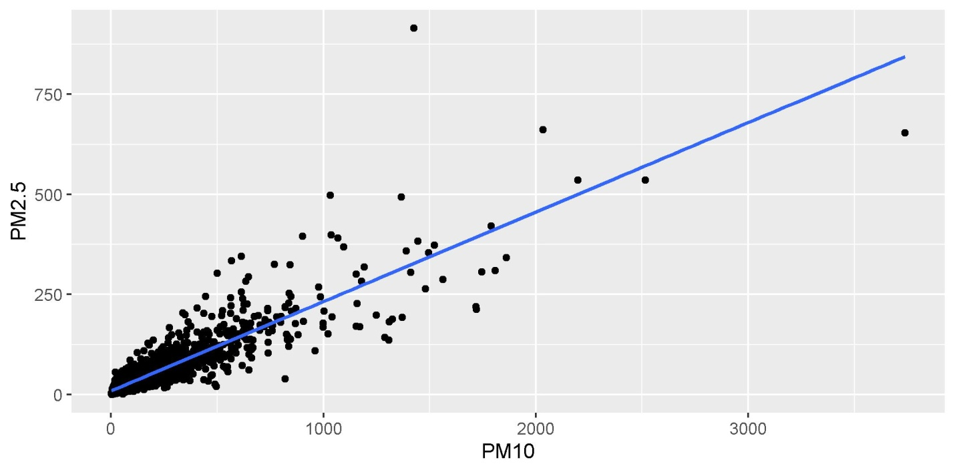

***Reviewer 2:***

General comment:

For this version, there are still several problems required to be clarified.

***Reviewer 2, Major Point 1***

The authors provide daily satellite remote sensing data at 1 × 1 km spatial resolution for each patient. It seems that these air pollution data were assigned according to the residential address of each patient. Please clarify.

Response:

Thank you for this comment, we agree with the reviewer and we clarify this in the text page5 line 131 *“using a hybrid satellite-based model that provides daily satellite remote sensing data at 1×1 km spatial resolution (Kloog et al., 2015; Shtein et al., 2018) according to the residential address of each patient”*

***Reviewer 2, Major Point 2***

Lines 156-157: why selected the references at 7, 14, 31 days before and after the event? For my view, it is more common to use the exposure at the same day of the week within the same month as the reference. At least, the supportive reference is warranted.

Response:

Thank you for pointing it out, the selected references are 7,14,21,28 (not 31) days before or after the event, we have corrected it: page 7 line 169 *“These days were chosen to be the 7, 14, 21,28 days before the event, and 7, 14, 21,28 days after the event.”*

***Reviewer 2, Major Point 3***

Lines 215-220: it is too subjective to select the ranges of 24℃ and 28℃ in summer, and of 13℃ and 23℃ in autumn? One solution (maybe it is not the best one) is using temperature with OR of 1.0 as threshold, then estimate the effect per 1 ℃ change below or above this threshold.

Response:

Thank you for this important point, we absolutely agree with the reviewer and we clarify this crucial point in the text page9 line237 .

“*There is an overall non-linear association between temperature and conjunctivitis. But for certain temperature ranges at summer and autumn where considered the relevant temperature range for each season; we noticed a form of linear positive association between temperature increments and incidence of conjunctivitis (Fig. 2). For summer at temperatures between 24 and 28oC the incidence increased 8.1% for each rise of 1 degree Celsius, and for autumn at temperatures between 13 and 23 oC the incidence increased 7.2% for each rise of 1 degree Celsius”*

***Reviewer 2, Major Point 4***

From Table 2 and Figure 2, the maximum daily mean temperature could reach as high as 28.11℃ in winter? Please check your data.

Response:

The climate in the Southern Israel (Negev desert) is hot and dry, featured by a negligible amount of rainfall through the entire year, thus daily mean temperature could reach as high as 28.11℃ in winter.

*Page 8 line 207 “The climate in the study region is relatively hot and dry classified as Csa climate type by Köppen climate classification (Rubell et al.,2011)”*

***Reviewer 2, Minor Point 1***

I am confused about the labels of x-axis in Figure 2. Please change "Mean Temperature LAG0" as "Lag 0 day", and if "Mean Temperature 7 days" means moving average of temperature at lag 0-6 days, please use "Lag 0-6 days".

Response:

Thank you for this point, we agree with the reviewer and corrected.

***Reviewer 2, Minor Point 2***

Lines 159-161 and Lines 164-165, please merge these two sentences, as so many replicated information.

Response:

Thank you for this comment, we deleted the duplication.

***Reviewer 2, Minor Point 3***

There are still many typos, such as Line 235, "With" should be "with".

Response:

We appreciate this comment and correct all typos.