18.02.2019

**1. Equation for/Comparison to? the curve obtained from the experiment when the shortening is high enough to allow the bends? To take control:**

The points on the experiment’s graphs are a result of the shortening calculation after finding and  using the values of  and from the experiment, and substituting them into the following equation:



The values of and  were calculated using the Least Squares method with the results of the experiments. With this method, there are in effect three matrices. The first is of the values of  after substituting the results of the experiment, the second is of the calculation of the parts of the equation that are dependent on  from the results of the experiments, and the third is with the unknowns and . The values of and  were calculated using MATLAB software, where the calculation of the matrix of the amplitudes and  was performed by dividing the shift /displacement? matrix  from the experiments by the matrix of terms containing  from the experiment. This is without a minimum requirement, since this method is calculated from the outset for a minimum error. The consecutive/continuous lines in the following graphs are the results of the experiment obtained on the Instron device normalized, and the dotted purple line and the points on it are the approximation calculation as obtained by the analytical model described above.

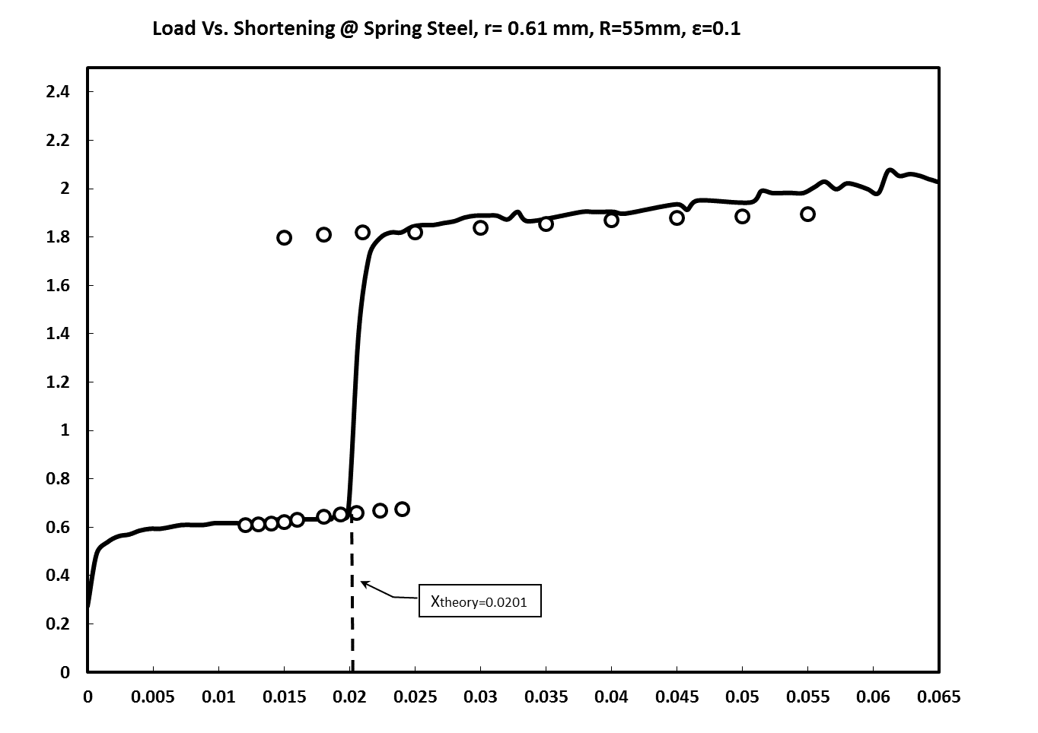







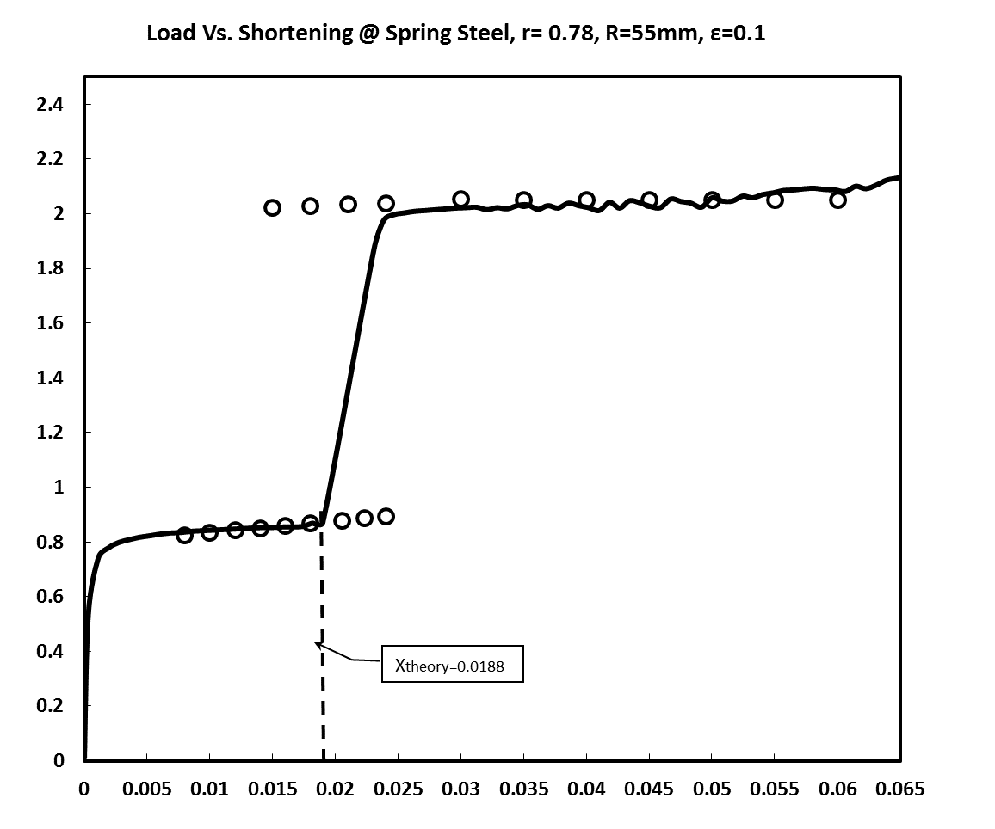

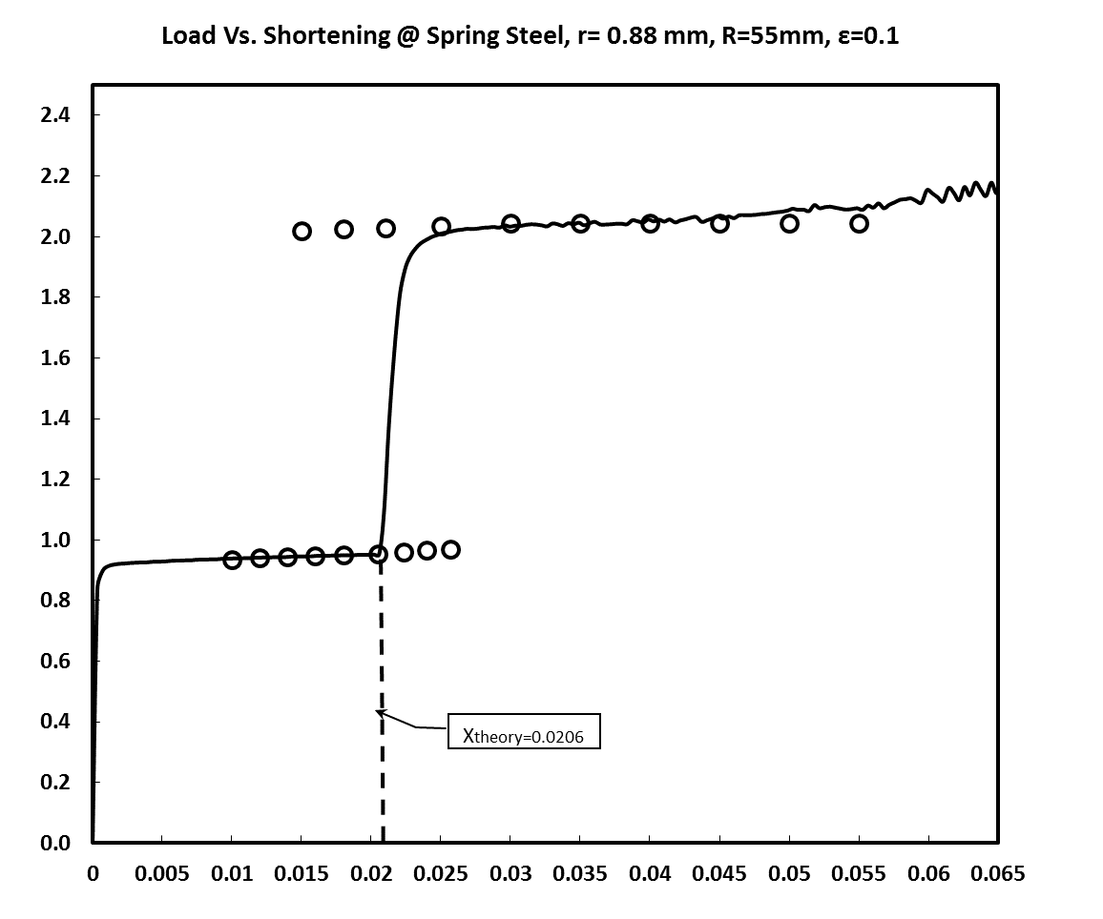

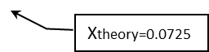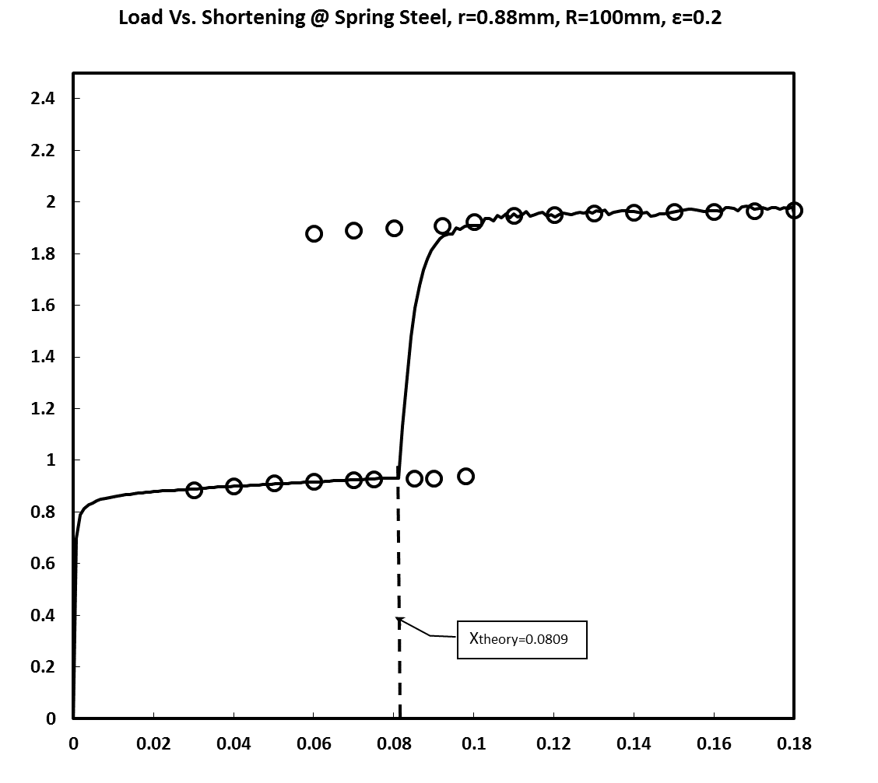 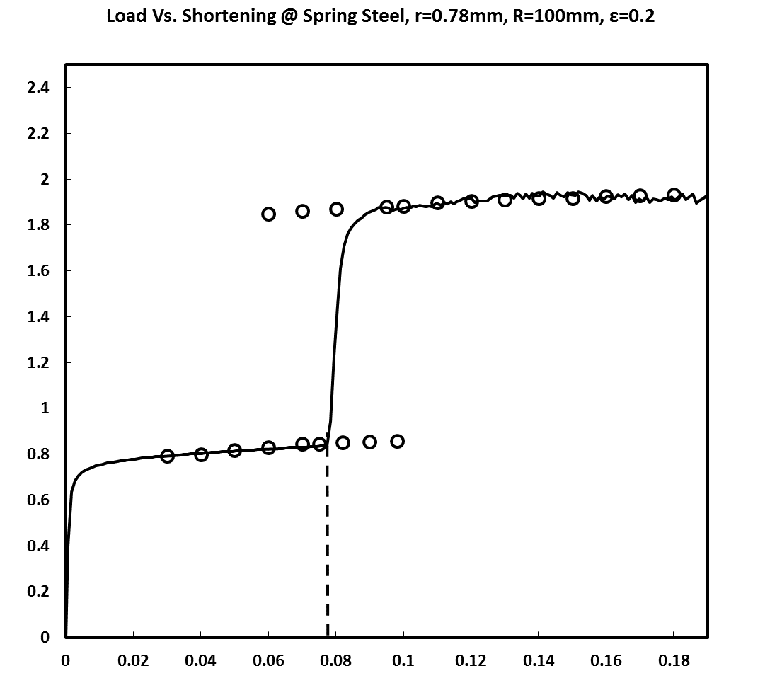

**2. Calculation of the sinking??sagging?deflection? displacement? curves from the expression  in five experiments, for several values of :**

2.1 To describe the curves and calculate values of , we used load and shortening data for all five experiments, until the stage where the fiber came in contact with the cylinder wall:



To find the location and first critical load  of the first point of contact in the cylinder, we solve the two equations , where the conditions of contact are: . Following are the results we also examined in the graphs below, which we obtained as a result of substituting the values of  that were obtained from Equation (1) and substituting different values of  until there was contact by the fiber with the cylinder wall in the range of :

1. For the fiber of radius 0.61 mm and cylinder radius of 55 mm: 
2. For the fiber of radius 0.78 mm and cylinder radius of 55 mm: 
3. For the fiber of radius 0.88 mm and cylinder radius of 55 mm: 
4. For the fiber of radius 0.78 mm and cylinder radius of 100 mm: 
5. For the fiber of radius 0.88 mm and cylinder radius of 100 mm: 

2.2 At this stage an approximation was calculated ahead of the first contact, assuming that , using linearization we obtain:

|  |
| --- |
|  |

Using these equations, we calculate  and obtain:

1. For the fiber of radius 0.61 and cylinder radius of 55 mm: 
2. For the fiber of radius 0.78 mm and cylinder radius 55 mm: 
3. For the fiber of radius 0.88 mm and cylinder radius 55 mm: 
4. For the fiber of radius 0.78 mm and cylinder radius 100 mm: 
5. For the fiber of radius 0.88 mm and cylinder radius 100 mm: 

In addition, a calculation was made to find the second critical load and location of the second contact point on the cylinder.

For fiber radius 0.61 mm, fiber length 530 mm and cylinder radius 55 mm:





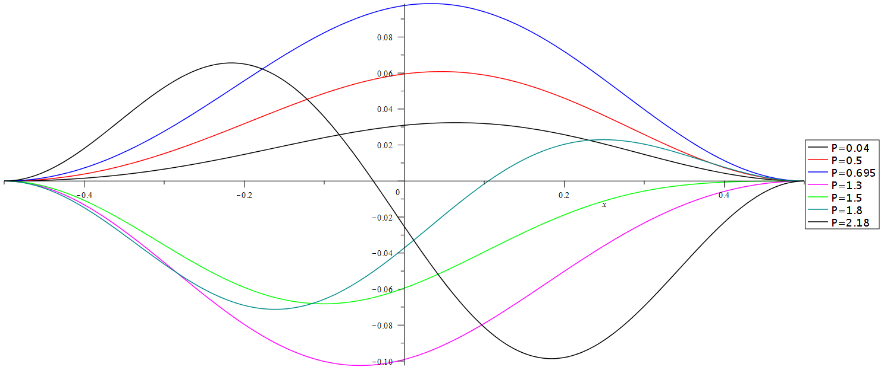

For fiber radius 0.78 mm, fiber length 530 mm and cylinder radius 55 mm:





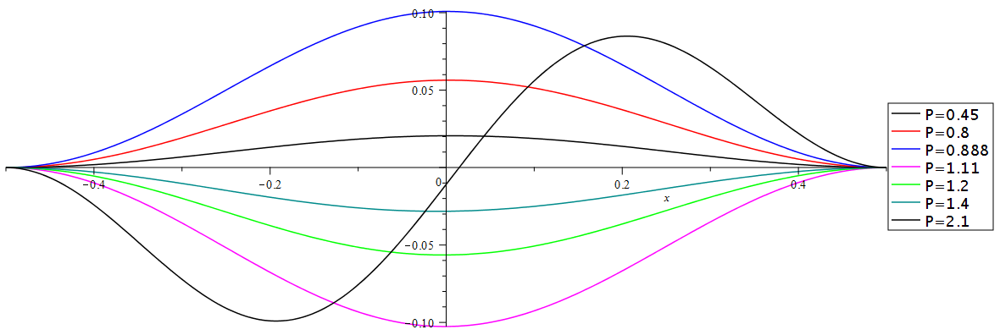



For fiber radius 0.88 mm, fiber length 530 mm and cylinder radius 55 mm:





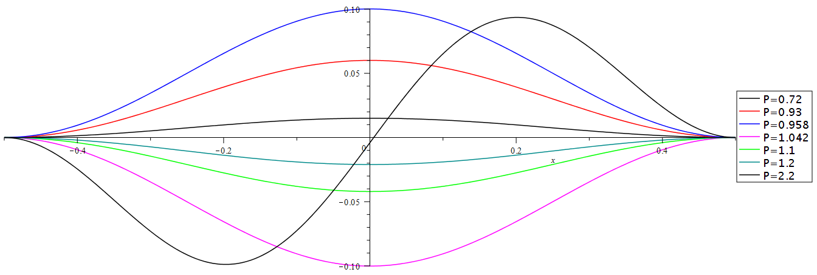



For fiber radius 0.78 mm, fiber length 530 mm and cylinder radius 100 mm:

For fiber radius 0.78 mm, fiber length 530 mm and cylinder radius 100 mm:





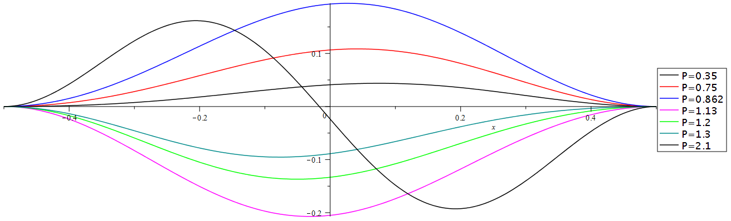



For fiber radius 0.88 mm, fiber length 530 mm and cylinder radius 100 mm





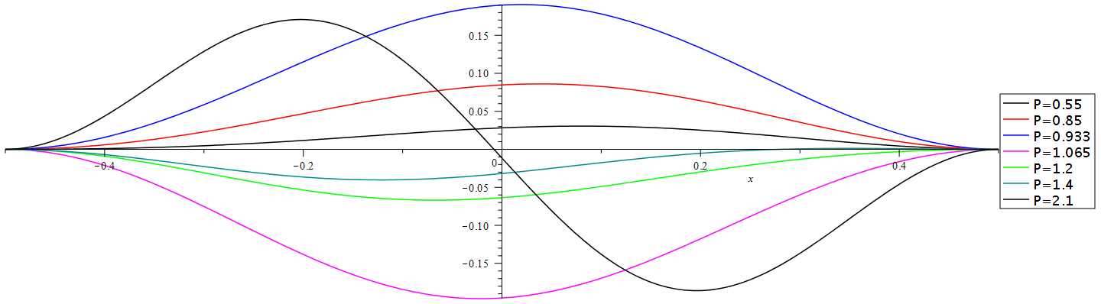



**Location of the section from the experiment used to calculate the amplitudes**

1. For fiber radius 0.61 mm, fiber length 530 mm and cylinder radius 55 mm:

Range: 

The number of points is 12

1. For fiber radius 0.78 mm, fiber length 530 mm and cylinder radius 55 mm:

Range: 

The number of points is 12

1. For fiber radius 0.88 mm, fiber length 530 mm and cylinder radius 55 mm:

Range: 

The number of points is 23

1. For fiber radius 0.78 mm, fiber length 530 mm and cylinder radius 100 mm:

Range: 

The number of points is 36

1. For fiber radius 0.88 mm, fiber length 530 mm and cylinder radius 100 mm:

Range: 

The number of points is 40

**Defining a boundary condition in a numeric simulation**

As shown in the diagram, the fiber at the end of one side (on the side where no force is applied) is fixed to the x, y, z axes for both shift and rotation around each axis. At the other end of the fiber, where the force is applied, the fiber is fixed to rotate on the three axes and does not have the ability to rotate around them. On the two other axes that are not parallel to the movement of the end of the fiber, the end of the fiber is fixed, and cannot move in the direction of these axes. On the axis that is parallel to the movement of the end of the fiber, the end of the fiber has a constraint that enables it to move in parallel to the axis for a defined displacement of 80 – 100 mm, as happened in the experiment.

Regarding the contact, there is a definition of contact between two rigid bodies (in the software it is defined as “hard contact”) and friction between the internal wall of the cylinder and the fiber.

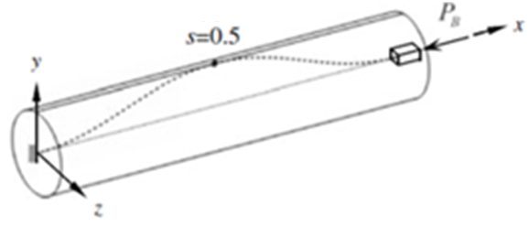

End fixed with six degrees of freedom (no ability to shift or rotate on any axis.)

End fixed with five degrees of freedom (without ability to rotate on any axis, and without ability to move on the y, z axes) and ability to shift on axis (–x).