**Western Apocalyptic Time and Personal Authentic Time**

Bina Nir

## Introduction

Time is a culture-dependent concept. Throughout the various periods of Western civilization, different concepts of time – some contradictory, some complimentary – have been competing against each other. Westerners today, at least those inhabiting secular cultures, I shall argue live along two axes of time. The first of these is a linear historical and cultural timeline which strives towards the “end of days”, a timeline that is based on a foundational religious narrative that has been transformed by the culture. The second is a personal and authentic timeline which characterizes capitalism and the culture of individualism. This cultural perception of time manifests itself in the discourse, as well as in literature and in the arts.

In this article, we will look at these two axes of time and examine their religious roots. Religion is an explicit marker of culture. The religious doctrines of any given culture reflect its thought systems and cultural values. The Christian religion and culture of the West were based on the Jewish scriptures that were transmitted throughout the different regions of the Roman Empire. Christianity preserved and diffused the books of the Old Testament canon.[1] Both religions view the Old Testament as a holy text, as the absolute truth, the product of divine revelation. While the Catholic Church mitigated the authority of the text with the authority of tradition, the Lutheran Reformation magnified the importance of the written word. Luther rejected this authority and established the doctrine of “Sola Scriptura” – one had to read the scriptures. By doing so, the Reformation placed the Jewish holy books at the heart of European identity.[2] Therefore we will look for the roots of the Western cultural perception of apocalyptic time in the texts of the Bible and the Christian scriptures, all while examining the development of personal, authentic time. We will also demonstrate the representations of these two concepts of time in the paintings of Chaya Agur.[3]

## The **Linear** Timeline

In Western Judeo-Christian thought, time has a beginning: “In the beginning God created the heaven and the earth”,[4] and an end: “And it shall come to pass in the last days”.[5] Linear Biblical time is irreversible and strives wholly towards the final event, the establishment of the Kingdom of Heaven.[6] The prophets promise us that we have a deciding influence on this end: “For if ye thoroughly amend your ways and your doings…Then will I cause you to dwell in this place, in the land that I gave to your fathers, for ever and ever”.[7] Man, in the Bible, finds himself within the stream of time, at any moment of which he may be subjected to the test of whether or not he succeeds or fails to live up to God’s will.[8]

This perception of time as an arrow leading from Genesis to Apocalypse, lies at the foundation of Western culture and can be described as a vector. This vector has an ascending trajectory, as opposed to a horizontal one, similar to the vector of fiscal time. Since there is hope for future success, the future is always perceived as a higher, more perfect point in time. In other words, the upward pointing vector represents our concept of time as having upward momentum.

Ability to influence the future “In the last days”

“In the beginning”

Earthly time in the Bible is linear and this fact is evident not only in the cosmology of the creation story. For example, the task assigned to Moses has a linear timeline with upward momentum, in that there is an expectation of future success. This looking forward towards the future, which appears for the first time in the Old Testament as opposed to the predetermined future commonly accepted in the ancient world, brings about a new idea of faith. Time is not circular, but unidirectional and irreversible. The recognition of God’s will in the present contains the hope for a better future, a future in which one can be rewarded. This perception is manifest when God says to Abraham: “Get thee out of thy country, and from thy kindred, and from thy father's house, unto a land that I will shew thee. And I will make of thee a great nation, and I will bless thee, and make thy name great; and thou shalt be a blessing”; [9] “I will multiply thy seed as the stars of the heaven, and as the sand which is upon the sea shore”.[10]

“In the beginning God created” – marks the beginning of time. In the argument over the question of whether the universe had a beginning, and if so what that beginning was, there are two main schools of thought. The first, which includes Judaic, Christian and Muslim thought, claims that the universe was created *ex nihilo*, out of nothing, and that humanity must constantly make progress, as that is its essence. “But there was nothing corporeal before heaven and earth…For whatsoever that were of which such a voice was made, unless it was made by thee, it could not be at all”.[11] The second school is the one expressed by Plato and Aristotle’s conception of God, according to which he is a designer and an architect, but not a creator. The material world is perceived as eternal rather than created. “If now this universe is fair and its Artificer good, it is plain that he looked to the eternal”;[12] “God… having received all that is visible not in a state of rest, but moving without harmony or measure, brought it from its disorder into order”;[13] “So the universal design of the ever-living God… and he made it a sphere in a circle revolving, a universe one and alone”;[14] “For the pattern is existent for all eternity ; but the copy has been and is and shall be throughout all time continually”.[15]

“The last days” – marks the end of time. The first verse of Genesis also lays the foundation for the end, possibly even for the apocalypse. If there is a genesis, there must be an apocalypse. The Bible’s linear perception of time leads from the creation to the end of days, and it is along this timeline that history runs its course.[16] The arrow of time presents generation after generation, event after event, up until the present moment, from which there stretches a direct, continuous line towards the end point – the last days, the apocalypse.[17] The prophets of Israel had much to say about the end of days, and about its dependence on the conduct of the community and the nation: “In the last days the mountain of the Lord’s temple will be established as the highest of the mountains; it will be exalted above the hills, and peoples will stream to it”;[18] “This is what the Lord says: Restrain your voice from weeping and your eyes from tears, for your work will be rewarded, declares the Lord. They will return from the land of the enemy”.[19]

This belief in the end of days penetrated Christianity mainly through the Book of Revelations, the Revelation of John. This book was heavily influenced by the apocalyptic revelations of Daniel, which became a kind of model for all the visionary revelations that came after it: “And he said, Behold, I will make thee know what shall be in the last end of the indignation: for at the time appointed the end shall be”.[20] The things described in Daniel’s vision became a cornerstone of historical perception in Western culture. Empires come and empires go, colliding with one another and replacing each other in turn, but this essential structure is the singular purpose that binds this process in an inevitable movement towards the end. The Revelation of John consists of a series of visions composed sometime around the end of the first century C.E. and attributed to John of Patmos, Jesus’s beloved apostle. It was a call for Christians to persevere in their faith and to look forward to the final triumph over their enemies. According to Christian dogma, the history of mankind begins with the fall, the original sin in the Garden of Eden and Adam and Eve’s subsequent exile, and continues through to the final salvation.

The foundations laid in the Book of Daniel were elaborated upon towards the end of the Second Temple period, in anticipation of the Temple’s destruction.[21] There are those who maintain that this literature had been written out of despair and loss of faith in daily religious worship as having an influence on the salvation of the individual and of the nation.[22] The idea of the apocalypse in the New Testament is rooted in the Old Testament,[23] and this fact raises two somewhat contradictory points: the Christian conception of apocalyptic time is not possible without the basic assumption of Biblical time, however, at the same time, it requires a sharp deviation from the way time is perceived in the Old Testament, perhaps even a rupture.[24] The Hebrew Bible, unlike many ancient eastern cultures, ignores the supernatural and places the human experience within one-dimensional, earthly time. In such a view of time, the end of days is included as part of historical reality. The Old Testament sources don’t put forth a coherent vision of salvation, but rather a series of apocalyptic motifs which place an emphasis on the momentum towards salvation and redemption in the last days. Klausner[25] stresses that the Israelites were the only ancient people who had a messianic outlook and this legacy, he claims, was passed on to the Western world by way of Christianity.

Saint Augustine is the one to adjust the Judaic model of history and time to fit Christianity. [26] Augustine defines internal, experiential time, and identifies the past with historic memory, while the future is identified with expectation. According to him, human civilization is consistently advancing and developing. Yet, in parallel to this time, Augustine talks about the eternal time inhabited by God; mystical time. “In the Eternal nothing passeth away, but that the whole is present”.[27] Augustine attempts to find a solution and bridge the gaps between two contradictory concepts: eternal mystical time and linear earthly time. In his view, there is no conflict between the two. In the Christian West, these two dimensions of time co-exist, the extra-natural mystical time occurs alongside the historical, earthly time. History, thus, in the Christian-Augustine conception, is linear.

Western history, at least in Western liturgical writings, has a beginning and an end.[28] All of Christian philosophy takes place within the sequence of time and thus within history. The story of humanity’s origins, as it is told in the West, assumes the existence of progress[29] and development, or in other words, an upwards trajectory, as expressed by the arrow of Biblical time. This linear conception of history and its division into segments, which follow one another as they get closer and closer to the end, has become dominant in all the cultural spaces that rely on the Bible as the cornerstone of their world view.[30] The foundation for this is laid out as early as the Book of Genesis.

Genesis, which is a “book of origins”, tells us of the “origin of heaven and earth” as well as the genealogy of families, tribes and nations. The book describes acts that denote either progress or regression as far as the fulfillment of mankind’s mission – as mandated by God – is concerned. In other words, acts that express loyalty to the mission or rebellion against it. The book then goes on to report on the successes and failures of the chosen ones to advance the great promise inherent in their mission. This is the same principle according to which the stories of the Israelites’ origins had been selected throughout the first five books of the Old Testament. The Hebrew Bible is characterized by a historiosophical approach, that is to say, the writing is influenced by the experience of history, the impressions made by historical events and hope for the future. The Biblical story is composed of the history of ideas and of ideals, written down with linear uniformity that did not exist in the first place.[31] This Biblical underpinning has had an influence on cultural domains that are marked by modernity, capitalism and democracy. They are founded on a Christian world view which had inherited the Judaic conception of time and history through the Old Testament.[32] However, while the Hebrew Bible’s framework sees history as a process separate from the divine, the inclusion of God in the course of history was an innovation brought about by Christianity.

The writing of history, generation after generation, was influenced by the way the Biblical stories were told. The three historical religions had imprinted our consciousness with a perception of history as a succession of patriarchs.[33] Such a historical approach evaluates people and epochs by their contribution to humanity’s success. Even the terms “Renaissance” and “The New Era”, which succeeded the so-called “Dark Ages”, express a belief in historical forces of renewal and redemption. This belief is Judeo-Christian in its essence – the belief that we are moving towards a new era, an era of successes and accomplishments, as opposed to the failures of the past.

A created world must make room for history, because only under this assumption can one reject the theory of the eternal return of past events: the sequence of generations, without beginning or end, would transform time into a cyclical phenomenon without hope or meaning. Christianity is a historian’s religion – the Christian holy books are history books and Christian worship commemorates episodes from the life of God on earth, alongside Church liturgy and the Acts of Saints. There is another, even deeper sense, in which Christianity is fundamentally historical. The fate of humanity, which unfolds between the fall and Judgment Day, stands before the eyes of Christianity as a continuous adventure. Western civilization, unlike many other cultures, has great expectations of time. People of action, in the West, have to constantly learn lessons from the past if they wish to succeed in the future. [34] History has a style and an order, which grow more perfect over time.

## The Rift between Mystical Time and Earthly Time

It is a commonly accepted basic assumption today that the Bible perceives time as being linear, as opposed to other cultures which think of time as being cyclical.[35] There are, however, those who oppose this generalizing notion and the assumption that unlike the Greek concept of time, which is mainly spatial, the Biblical concept of time is temporal and rhythmical, as manifested by its division into fixed periods. These approaches claim that both the Bible and the Greek texts contain examples of these two concepts of time simultaneously. There are even some who claim that the Bible also espouses the cyclical view of time,[36] alongside the linear view, as exemplified in the calendar, which is the cyclical time of the seasons in the Land of Israel;[37] however, we would be wise to note that the condition for maintaining this schedule is the linear, historical memory.

The belief in one, extra-natural, creator God took control away from the wheel of fortune, the forces of nature and the deterministic fate that make up the foundation of the cyclical time paradigm. Linear, Biblical time places the Biblical Israelite within specific time; the Biblical Israelite is driven through time by God’s will towards a better future at the end of days, however the Bible sees linear history as a process separate from God.

Nevertheless, there are two kinds of time in the Bible: the eternal, mystical time relegated to God and the historical, linear time which courses from Genesis to Apocalypse – earthly time. For Biblical man, earthly time is unmistakably linear and dependent on obeisance to God’s will, however God himself exists outside of this time, as an eternal being. The Bible paints time as a resource belonging to God,[38] which he then dispenses willingly to man. As the composer of the Psalms puts it: “The day is thine, the night also is thine: thou hast prepared the light and the sun… thou hast made summer and winter”.[39] Partaking in the experience of mystical, divine time, which is holy, is given to men on special occasions, instances when man retires from linear, earthly time to experience another kind of time. The creator, who is the master of time, plucks the Sabbath out of ordinary time, out of the linear sequence, makes it holy and relegates it to divine time. Linear time is the time of toil, effort and work towards a purpose. The Sabbath thus becomes a holy day, because it is differentiated from ordinary days and their sequentiality. It is outside of the realm of human activity, for man is not allowed to do as he pleases on the Sabbath and the day is marked by a prohibition of work. This tangible distinction of the Sabbath, which is essentially different from all other days, generates the experience of another kind of time, divine-mystical time:[40] “But the seventh day is the Sabbath of the Lord thy God: in it thou shalt not do any work… and rested the seventh day: wherefore the Lord blessed the Sabbath day, and hallowed it”.[41]

In Jewish culture, holy time is differentiated from mundane, ordinary time. Eternal time belongs to God and so do the heavenly bodies which dictate the human calendar year – the sun and the moon are also subject to God’s will. When he wants to, God can change their course and stop time: “Sun, stand thou still upon Gibeon; and thou, Moon, in the valley of Ajalon. And the sun stood still, and the moon stayed…So the sun stood still in the midst of heaven, and hasted not to go down about a whole day”.[42] Man had experienced holy, mystical time, that eternal present, in the Garden of Eden.[43] From the moment humanity was cast out of Eden, God, the master of eternal time, has been granting them special occasions on which they can partake of this time.

The Hebrew monotheism is the first to come up with the idea of God which exists outside of nature while controlling its forces. God reveals himself to man through his actions in history, by appearing in earthly, human time. It through the transference of God from the realm of nature to the realm of history that Judaism has allowed God to be distanced from mankind. Unlike the pagan religions, in which the cyclical powers of nature are ever-present and man inhabits the same mystical time as them,[44] the God of the Old Testament exists outside of nature in the eternal present and reveals himself to humans periodically, conducting his relationship with them linearly in the course of human time. This he does through miracles, revelations, and the envoy of angels.

The authors of the Old Testament share the idea that the divine real is scary and awful; a glimpse into mystical time is therefore a powerful experience. In the first chapters of the Bible, mystical time is very close to human time, which is still in the process of becoming. God is very much involved in the lives of the first humans: he breathes life into the first man, creates woman, abandons the Garden of Eden, and allows people to hear his voice. The first humans and God stroll around the Garden of Eden together; it is planted firmly within mystical time (even though it already contains the Tree of Life, forbidden to the humans). The guarding of the Tree of Life begins with the expulsion, with the beginning of human time: “So he drove out the man; and he placed at the east of the garden of Eden Cherubims, and a flaming sword which turned every way, to keep the way of the tree of life”.[45] The exile of man out of Eden brings about the initial rift between divine time and earthly, linear time, reserved for human.

In the cultures of the East, mystical time is generally contained within earthly time. In Mesopotamia, human actions are a reproduction of a mythical model, a repetition of the actions of the gods, or of the ancient ancestors.[46] In cultures where the concept of time is cyclical, earthly time is not disconnected from mystical time. Every creation recreates the explicit cosmogenous act of creating the universe. To ensure the continued existence of reality one must ritually reenact the divine act of creation, which means reverting to cosmic time. In these cultures, secular time has no meaning. Rituals combine the two kinds of time and make it so that during them man doesn’t exist in meaningless secular time, since he is emulating a divine archetype.[47]

In Catholicism, mystical time is linked to the religious experience.[48] The Church promised unconditional love to all those who took refuge under its wing and offered humanity a way to believe that God loves us and has forgiven us. The universe was a simple place to understand: man stood at its center with heaven or hell as his future destination, in the promised mystical time. With the acceleration of secularization processes in Europe at the end of the Middle Ages and during the Renaissance,[49] humanity’s longing for mystical time diminished whereas linear, earthly time became more and more significant.

The loss of connection to this mystical, religious time happened gradually. In the agrarian, pre-industrial society, people lived according to the calm and regular rhythm of the seasons and the calendar of agricultural work. The belief that beyond these time-marking events there was a realm of eternal time provided a measure of confidence in time. The process of secularization and the transition to life according to the clock in the earthly realm, as opposed to the calendar in conjunction with eternal time, gave people living in Western cultures new norms and worldviews regarding time: the secular man had been exiled out of Eden for good, tossed into earthly time, and this new freedom imbued him with fear and a fierce appetite for competition, success and glory.

We can demonstrate the loss of connection to eternal, mystical time by referring to the painting “Crossing Nature” by Chaya Agur.[50] In an interview with the painter, she explains that the title “Crossing Nature” has a double meaning in relation to the painting – it refers to the crucifixion of nature as well as the act of angering nature, or going against its laws. The painting depicts the paradox of the eternal time that Jesus represents as the son of God and the linear time of the ever-changing natural phenomena represented by his human form. The crucifixion represents Jesus’s transition from a human existence in linear time to an eternal divine existence, as well as the opportunity given to mankind via the crucifixion to free themselves from the burden of linear time. At the same time, the crucifixion also describes what is happening to Jesus’s body, which is a coherent part of nature and subject to its physical laws just like any other creature in the material world. The subject of the crucifixion is very common in pictorial art and there have been countless different interpretations and depictions of it by different artists. However, the emphasis always tends to be on Jesus’s suffering and/or on the suffering of those around him. Here on the other hand, the figure of Jesus on the cross is positioned in the midst of beautiful and indifferent nature which carries on unperturbed in the face of the crucifixion. The dove above Jesus’s head is an example of this dualism – on the one hand, it is the Christian symbol of the holy spirit hovering over him, but on the other hand it is also an animal which uses its environment for its own need, and as such is busy building a nest for its chicks out of Jesus’s long hair. The figure of Maria on the distant horizon was painted as the grieving mother based on the model of Michelangelo’s “Pieta”. However, yet again, unlike the customary depictions of Jesus’s mother, she is not by his side. Instead, she is distant and symbolically representative of the two kinds of time – as the eternal mother of God on the one hand and as a human body painted in the shape of an hourglass whose time is running out. Instead of a halo, her head is crowned by a clock-face.

The two kinds of time present in the painting are not separate – eternal time contains linear time, and vice versa. This is the painter’s attempt to illustrate the paradox of time in the human experience. Man as a creature of nature, made from the dust and destined to return to it, and Man as a creature made in the image of God conduct a shared existence within the human frame. The painting contains other elements from the painter’s symbolic world which amplify the paradox of time within existence: the lyre bird is the eternal soul being raped (at Jesus’s feet) by a lizard-like creature which symbolizes a connection to the earth. Inside the water, we see the hybrid creature born from this coupling – a lizard with lyre wings hesitantly walking on stilts.

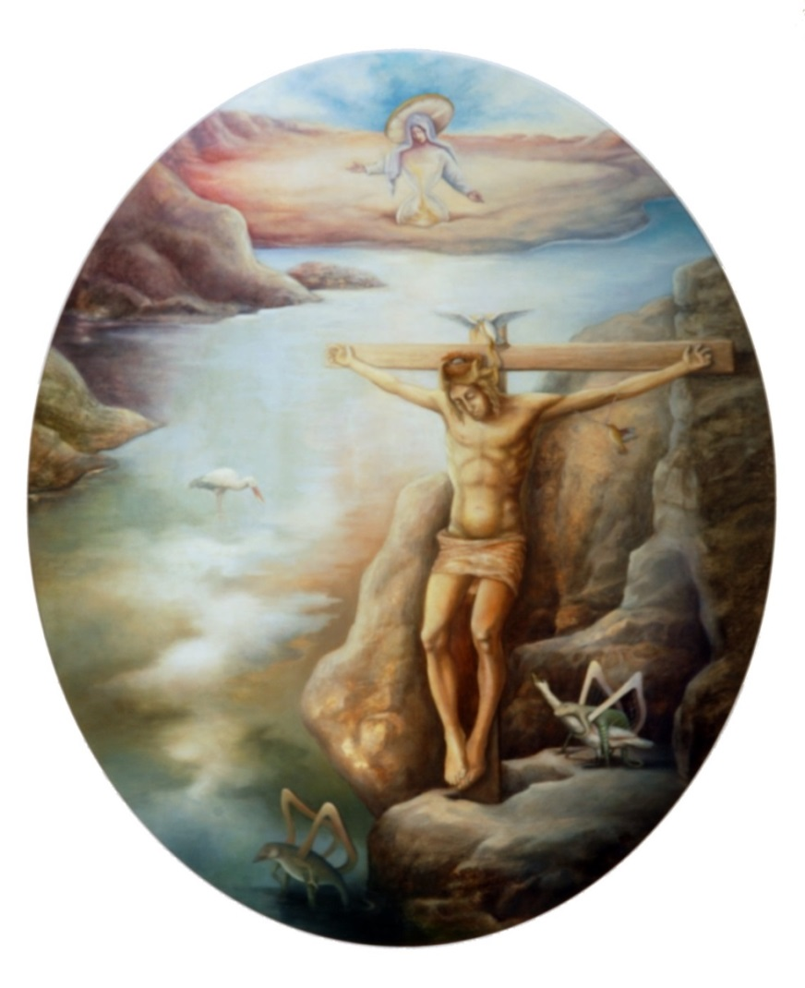

Figure 1: Chaya Agur, Crossing Nature, oil on canvas, 40 x 50 cm.

We shall also demonstrate the loss of the connection to mystical, eternal time belonging to God and the angels, and the entrenchment within earthly time which provokes the appetite for material success and earthly glory, through the paining “Falling Angel” by Chaya Agur.[51] This painting, pained with mixed techniques, depicts an angel falling from mystical time down to earthly time as he crumbles into the treasures of which he is composed. Diamonds and gems scatter everywhere. His broken wing is trapped within the “fake” light of the “cow” which overflows with the milk of success and earthly riches. On the right side of the painting, we see a heavenly chicken laying golden eggs and casting the diamonds out as bait – an image of wealth and fleeting success. Humanity is represented by masks (the fake self that acts according to the convention of its historical time). The masks have gaping mouths, ready to swallow the wealth pouring down into them. One of them, at the front of the painting, is reaching out a hand to grab the fleeting wealth that is raining down before it.

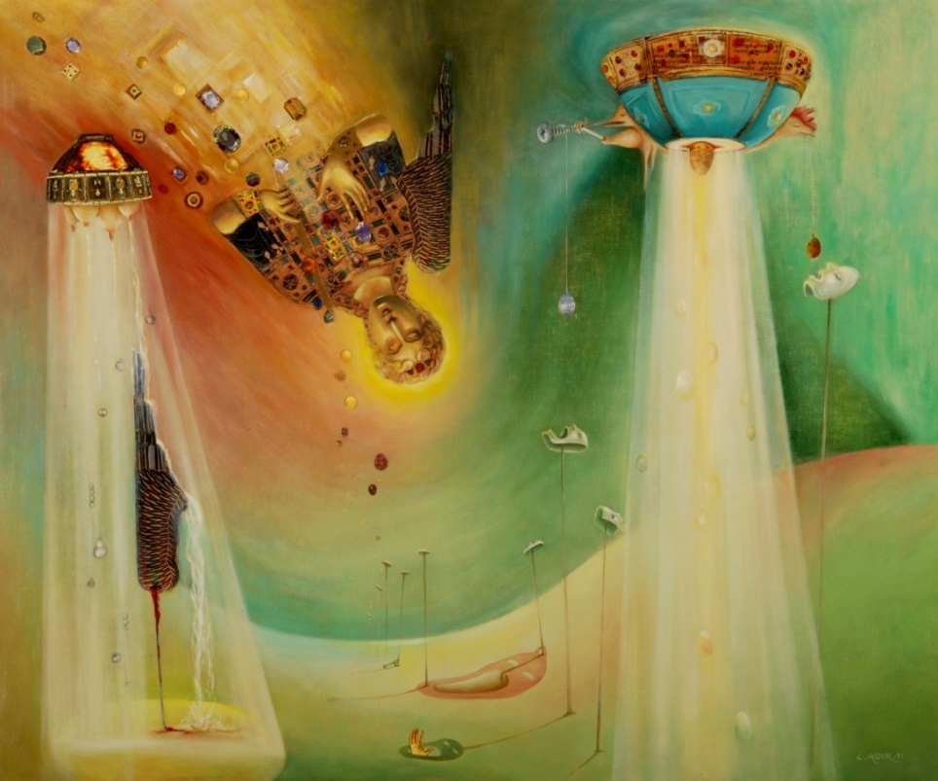

Figure : Chaya Agur, Falling Angel, mixed techniques, 50 x 60 cm.

## Personal Authentic Time

The Renaissance is regularly presented as the period that saw the birth of the individual, in the modern sense of the word. However, the discovery of the Human during the Renaissance is not a complete innovation, but rather a new version of a phenomenon whose roots are firmly planted in the foundations of Western culture. Individualism is tightly bound up with the birth of the self-awareness necessary for the development of the individual. This self-awareness had already developed all the way back in the classical era and in the ancient Jewish tradition,[52] however the rise of individualism in its modern reincarnation was made possible by secularization:[53] individualism allowed man to abandon his ties to the moral structure of God’s universe in order to accept any “truth” he discovered.

Somewhat paradoxically, individualism developed within Christianity despite the lack of freedom Christians experienced under the yoke of the Catholic Church. Christianity teaches the individual to distinguish between good and evil and allows him to “fulfill himself”. In Judaism and in the classical Greek tradition, the individual actually has less responsibility than in Christianity: the Christian doctrine emphasizes the power of spiritual activity and the potential of the individual to increase his divine capacities through spiritual labor. By doing so, Christianity contributed to the development of self-awareness and this self, the one who wields this authority, is perfected during the Renaissance.[54]

The process of secularization also influenced the way the West approached history. Up until the thirteenth century, historiography was decisively Christian and dependent on theology, i.e. the religious establishment, which determined categorically which sources were worthy of historical attentions and which were forbidden.[55] The people of the Renaissance, on the other hand, adopted the approach of Cicero, who called history “the teacher of life”, and focused on human drama, human relationships, human weaknesses and successes.[56] History too went through a process of secularization, based on the arrow of earthly time, as it is characterized in the Bible. That is to say, it is informed by the idea that understanding human experiences of the past is helpful in understanding the present and can even be used to predict the future.

These combined phenomena of secular individualism and the return to earthly time can be witnessed in Renaissance art.[57] The link between art and cultural mores is rather complex. The study of art history is based on the nature of the connection between works of art and cultural trends or the zeitgeist in different fields of human culture.[58] We can agree that Renaissance art celebrates the empowered individual, the self as a source of truth and this through a process of self-discovery, the creation of the unique self. An example of this can be found in the biographies of the Renaissance. Biography provides a study of the individualistic marks of distinction attributed to important persons.[59]

The race towards the future inside earthly time has led, among other things, to the development of the modern conception of time,[60] along with the growing importance of competition. Through this process, minutes became valuable and time became such a precious resource that humans feel they must not waste in on worthless pursuits.[61] For example, the Renaissance artist Alberti Batista,[62] in order to make the most of his time, began each day by making a precise schedule. Man became master of his fate and time became a personal resource.

As we mentioned, this appearance of the individual along with his unique perception of time is reflected in Renaissance art in many ways, including in the technique of perspective drawing. Perspective captures an individualistic view of the world since it depicts the observer’s personal point of view within earthly time. The retreat of mystical time is the retreat of the simultaneous point of view, which is a way of looking from the standpoint of divine eternal time, bearing no perspective geometrical considerations.

The practice of perspective, which was developed in the Renaissance, attests to a change in the conception of time: the estimation of perspective is chronological and causal. As the observer moves through time and space – his personal perspective changes. Therefore the reality seems to change with every passing unit of time. This is a shift from the perception of eternal time and mystic symbolism to a perception of time influenced, among other things, by new scientific thought governed by logic and the observer’s individual experience within a system. Perspective is a graphic representation of objects in three-dimensional space, according to the individual’s optical perception of reality. When the observer moves through time, at any point in time the objects in the depicted space are drawn from his personal, individual perspective. Man is then placed at the center of the act of observation as an investigator of reality, as opposed to the eternal, divine point of view which dominated art over the previous centuries. The description of the world through the light entering the lens of the observer’s eye turns the discrete observer – the artist – into the focal point of the world.

The painting “Death of a Soldier on a Mondrian Battlefield” by Chaya Agur[63] is a good demonstration of the perspective technique. Pieter Cornelis Mondriaan was a Dutch painter, one of the founders of Modernism, who painted in primary colors and in accordance with the golden ratio in an attempt to simplify reality, claiming that these were the basic components of reality and aesthetics. According to Mondrian, these were the eternal elements and thus he chose not to use perspective which transports us from the eternal to the temporary. In the painting “Death of a Soldier on Mondrian’s Battlefield”, Chaya Agur inserts the linear time of perspective into Mondrian’s flat and eternal time. Linear time, of course, contains the tenses – past, present and future – and thus Agur represents death as belonging to the non-eternal time of perspective. The soldier’s grave, the canons and the fields of color converge on a single point, the vanishing point of the perspective. Perspective is limited: it cannot see space or time beyond the vanishing point, and death in the painting represents temporality. Agur’s painting also expresses a critique of male logic, expressed by linear time, while female time is represented as cyclical, thus the male symbols in the painting are the ones painted in perspective.

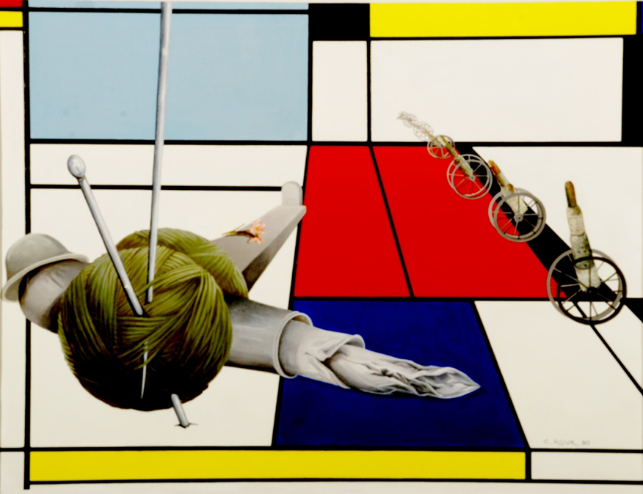

Figure : Chaya Agur, Death of a Soldier on a Mondrian Battlefield, oil on canvas, 80 x 60 cm.

Today, Westerners live along two parallel axes of time. On the communal and cultural level, the linear time axis is manifested in the grand narratives of history, democracy and capitalism. On the personal and authentic level, Western man is caught up in the race towards future success, which is also founded on linear thought and anticipation towards the future, albeit on the individual scale. In terms of the religious underpinning of the linear timeline, there is a distinction to be made between approaches that see God as responsible for salvation, and those that see man as capable of influencing his fate and driving the wheel of fortune. When humans believe they can affect their future, they develop the motivation to launch into a pursuit through time of future personal and authentic success. This motivation may be religious in its origins, but it has undergone a process of secularization.

Nevertheless, the axis of personal time is also based on religious patterns of thought. The belief that man can influence his future stems from the Biblical conception of time. In the second half of the second century, the Greek the philosopher Galen was the first to point out the difference between the Biblical and Greek cultures and claimed that the fundamental divergence between the two is the result of two different cosmologies.[64] Galen maintains that the principle of God’s free will could only arise on the backdrop of Biblical cosmology, according to which God has the power to bring matter into a state of order. God’s will designs a different future and contains the possibility of creation, change, renewal, exchange, irreversibility and improvement. Galen adds that the lack of free will in classical Greek culture is also a result of its proper cosmology. In an eternal and deterministic world, free will cannot exist – everything is in the hands of fate and necessity. The Old Testament, which posits a world created *ex nihilo,* pre-supposes the existence of free will.[65] This free will is at the basis of the personal authentic axis of time.

In today’s technological, consumer capitalist society, time has become a valuable personal resource linked to success and achievement and perceived as an authentic form of capital. Social and economic success today is measured in terms of efficacy and optimal results within a limited frame of time. Whoever cannot meet the deadline or perform according to schedule, is considered unfit or a failure. It was in 1748 that Benjamin Franklin uttered his famous maxim: “Time is money”.[66] This attitude towards time in the West has produced an economic metaphor of time known as “temponomics” – the combination of time and economics. Temponomics assumes that time is a resource that ought to be considered in the same way we consider money, which therefore makes it possible to “earn time”, “save time” and even “sell time”.[67]

Time “passes”, time “goes”, time “flies” and time “runs out”. Western man feels as if time itself is in motion. Time is experienced as a central resource that is constantly depleting. It is a unit of value, a form of tender, capital to be invested and consumed and most importantly an important resource for success.[68] Some have even proclaimed modern man “drunk on time”.[69] Our current Western myth is a chronic lack of time. Secular life in the West, which is devoid of faith or the belief in the everlasting soul, is imbued with the feeling that time in general is a linear progression towards extinction. In the personal dimension, Westerners live with the temporal biological feeling of our lives rushing by us, and of ever-nearing death and personal decimation. Time-based expressions such as the “ticking biological clock” paint life as a kind of organic clock who time is limited and allotted in advance.

## Epilogue

As this article shows, the Biblical arrow of time which underpins the foundation of Western culture and leads us from Genesis to Apocalypse is also present in the grand narratives of the modern age. The concept of progress as it relates to history cannot exist without the assumption of a beginning and an end, similarly to the way Marx’s predictions assumed that the proletariat revolution would achieve the final goal of the classless society. The axis of historical time is presented as having a definite end. In parallel, the rise of consumer society, whose interest lies in the personal authentic axis of time, has led to the development of a more individualistic and subjective perception of time.

However, while the overall perception of time in the West is linear, today, in the digital age, we are witnessing the emergence of new, different and alternative ideas of time. We can also identify a return to mystical simultaneous time – to observation from the “divine” viewpoint. It is possibly nowadays to see or experience the whole world simultaneously, thanks to an immense capacity of memory, which is not unlike the complete memory that is possible on the level of a higher power such as God.[70] The creation of a virtual environment can also be likened to world creation. [71] A virtual reality is not necessarily similar to everyday reality. The virtual world can be very different from the real world, even in its most fundamental principles. Such an environment takes us back to the dream time characteristic of surrealist art. The dream does not follow the laws of reality or of any particular style – every artist has their own personal, subjective environment.

Let us examine this surrealist dream time in the painting “The Two Madonnas” by Chaya Agur,[72] which depicts several realities existing simultaneously, side by side. This is a time that contains everything – the past, the present and the future. We can see how every single thing in the painting stems from the same source, the same figure – Mary. Mary personifies creativity and the energy of the world on the abstract, non-religious plain. Everything arises from the shape elements of her dress and crown – the source is singular while the shapes are infinite. The spaces in the painting seem isolated from one another, which is what linearity feels like, however, in fact, all times co-exist simultaneously. The poet drowning in the sea (represented by the harp), Laocoön and his sons battling reality, they are all struggling against something which is not stable or real, which flows out of the dress and comes back to it – this is dream time and cyclical, feminine time. Everything stems from the same figure and makes its way back to it. Mary’s hands are crossed and she is depicted in a stable position which is symbolic of the Platonic ideal reality. Her eyes look with compassion upon the entirety of creation, which the second Madonna, her American counterpart in the bottom right corner, is the Madonna of materialism.

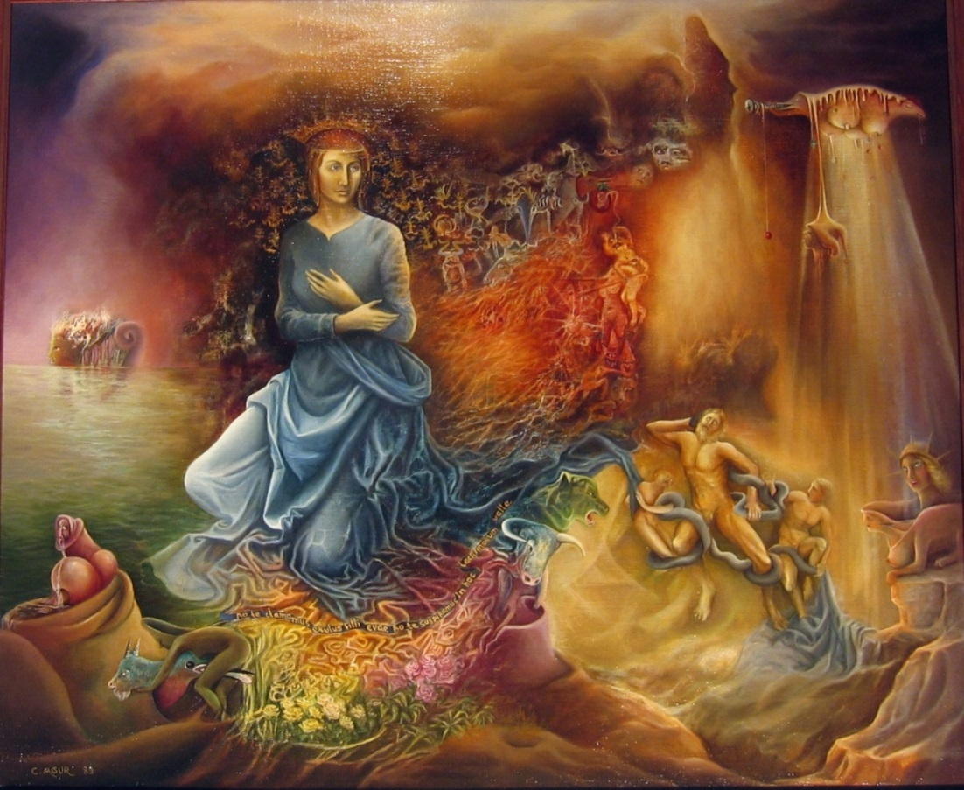

Figure : Chaya Agur, The Two Madonnas, oil on canvas, 60 x 50 cm.

## Bibliography

Agur, Elie, 1997, Poem of Time and Space, Netherlands: Pace Safortim.

Arbel, Binyamin, 2002, The Italian Renaissance – Emergence of a Secular Culture, Hebrew, Jerusalem: Ministry of Defense Press.

Augustine, 1950, The Confessions of St. Augustine, translated: J. G. Pilkington, New York: International Collectors Library.

Bloch, Marc, 1964, The Historian’s Craft, translated: Peter Putnam, New York: Vintage Books.

Burckhardt, Jacob, 1944, The Civilization of the Renaissance in Italy, translated: S. G. C. Middlemore, London: Phaidon Press.

Bluedorn, Allen C., 2002, The Human Organization of Time, Redwood City: Stanford Business Books.

Carr, Edward H, 1987, [1964], What is History?, New York: Penguin Book, 2nd ed.

Dan, Joseph, 2000, The Apocalypse Then and Now, Hebrew, Herzlia: Yediot Aharonot Press and Hemed Books.

Dan, Joseph, 2009, Chaos Theory and the Study of History, Hebrew, Tel Aviv: Dvir Publishing.

Dihle, Albrecht, 1982, The Theory of Will in Classical Antiquity, Oakland: University of California Press.

Efron, Yehoshua, 2004, The Origins of Christianity and the Apocalypse in Jewish History, Hebrew, Tel Aviv: Hakibutz Hameuhad.

Eliade, Mircea, 1959, Cosmos and History: The Myth of the Eternal Return, translated: W.R. Trask, New York: Harper Torch Books.

Eliav-Feldon, Miri, 1997, The Protestant Reformation, Hebrew, Jerusalem: Ministry of Defense Press.

Eyal, Nitza, 1996, Real Time: The Artist’s Personal Experience of Time, Hebrew, Tel Aviv: Modan.

Flusser, David, 2009, Jesus, Hebrew, Tel Aviv: Dvir Magnes and Zmora Bitan.

Friedman, Doron, 2006, Virtual Environments, Hebrew, Jerusalem: Ministry of Defense Press.

Fromm, Erich, 1941, Escape from Freedom, New York: Holt, Rinehart and Winston.

Fromm, Erich, 1966, You Shall Be As Gods: A Radical Interpretation of the Old Testament and its Tradition, New York: Fawcett Premier.

Funkentstein, Amos, 1991, Old Times and New Times, Hebrew, Mahshavot (Thoughts) 61.

Gelander, Shamai, 2001, On the Perception of Time in the Bible – A Different Outlook, Hebrew, Beit Mikra 46, 2

Hacohen, Ran, 2006, Renewing the Old Testament: Hebrew Scholars in Germany and Biblical Criticism in the 19th Century, Hebrew, Tel Aviv: Hakibutz Hameuhad.

Hern, Ya’ali, 2006, Political Messianism in 16th-17th Century France, in: Kaplan Yossef (ed), Ends of Centuries Ends of Eras, Hebrew, Jerusalem: Zalman Shazar Center for Jewish History.

Huizinga, Johan, 1955, The Waning of the Middle Ages, translated: F. Hopman, London: Penguin.

Kaufman, Yehezkel, 1972, The History of Israel’s Faith, Hebrew, Jerusalem: Mossad Bialik Press.

Kern, Stephen, 1983, The Culture of Time and Space 1880-1918, Cambridge: Harvard University Press.

Klausner, Joseph, 1926, Jesus of Nazareth: His Life, Times and Teaching, translated: Herbert Danby, New York: The McMillan Company.

Leibowitz, Yeshayahu, 2002, Faith, History and Beliefs. Articles and Lectures, Jerusalem: Academon Press.

Levine, Robert, 2006, A Geography of Time, New York: Basic Books.

Malkin, Ya’akov, 2003, Judaism Without God, Jewishness as Culture, the Bible as Literature, Jerusalem: Keter Press.

Nir, Bina, 2016, The Failure of Success, Hebrew, Tel Aviv: Resling Books.

Plato, 1888, The Timaeus of Plato, edited: R. D. Archer-Hind, Cambridge: Cambridge University Press.

Rauch, Leo, 1978, Faith and Revolution: The Philosophy of History, Hebrew, Tel Aviv: Yahdav Press.

Rosen, Avi, 2016, The Art of Cyberspace, Hebrew, Tel Aviv: Resling Books.

Russell Bertrand, 1945, The History of Western Philosophy, New York: Simon and Schuster.

Sand, Shlomo, 2004, The Historian, Time and Imagination, Hebrew, Tel Aviv: Am Oved.

Schweid, Eliezer, 1984, The Book of Time Cycles, Hebrew, Tel Aviv: Am Oved.

Shanahan, Daniel, 1992, Toward a Genealogy of Individualism, Amherst: University of Massachusetts Press.

Vernant, Jean-Pierre, 2002, The Universe, The Gods and Men: Ancient Greek Myth, translated: Linda Asher, New York: Harper Collins Perennial.

Zakay, Dan, 1998, Psychological Time, Hebrew, Jerusalem: Ministry of Defense Press.

Zeligman, Yitzhak Arieh, 1992, Studies in Biblical Literature, Hebrew, Jerusalem: Hebrew University Press.

1. Malkin 2003, 44.
2. Hacohen 2006, 23; Eliav-Feldon 1997, 30.
3. The painter Chaya Agur, who was born in Israel and lived in the Netherlands for 35 years, has since 1978 exhibited her paintings regularly in the Netherlands (Amsterdam, The Hague and Rosendale) and throughout Europe (Paris: The World Center for Contemporary Art, Nancy: Galerie Poirel, Barcelona: Marlborough Art Gallery). In Israel, Agur exhibited in 2009 at the Municipal Gallery in Afula and in 2010 at the Jerusalem Theater for the Performing Arts. Between 2002–2007, she ran a private gallery in central Amsterdam, "The Crane", and for many years she taught painting and drawing in her private studio in The Hague. Agur, uses mixed techniques, oil paints, watercolors and drawing. Her art is influenced by Dali and Chagall and her style can be called surrealist-symbolic.
4. Genesis 1:1.
5. Isaiah 2:2.
6. Leibowitz 2002.
7. Jeremiah 7:5–7.
8. Rauch 1978, 10–11.
9. Genesis 12:1–2.
10. Genesis 22:17.
11. Augustine 1950, 238.
12. Plato 1888, 89.
13. Ibid, 93.
14. Ibid, 103–105.
15. Ibid, 123.
16. Dan 2000, 19.
17. Zeligman 1992, 102–103.
18. Micah 4:1.
19. Jeremiah 31:16.
20. Daniel 8:19.
21. Flusser identifies a link between ancient Christianity and certain schools of thought in Second Temple era Judaism. His overall conclusion is that Jesus himself associated with the sages and that there is a common denominator between Jesus’s philosophy and different factions of Judaism at the end of the Second Temple period, including patterns of belief concerning the end of days (Flusser 2009,132–131.
22. Dan 2000, 38.
23. Efron 2004, 269–270.
24. Dan 2009.
25. Klausner 1926.
26. Russell 1945, 353–354.
27. Augustine 1950, 231–232.
28. Bloch 1964, 5-6.
29. Carr 1987, 109–113.
30. Dan 200, 265–308.
31. Zeligman 1992, 102–103.
32. Russell 1945, 363–364.
33. It is telling that the chroniclers of the Middle Ages could not help but begin their accounts of the present generation by relating it back to Adam, the first man (Sand 2004, 24).
34. Bloch 1964, 5-6.
35. Cultures which maintain circular time, generally speaking, see no point in planning for the future or anticipating it, for the future is nothing but a repetition of what has already happened in the past. In the Indian Hopi language there are no terms that represent the past, the present or the future. In Western culture, where time is an independent dimension, it is independent of the type of activity that takes place in it. A culture of time and fate like that of the Chaldeans, on the other hand, has given rise to astrology, because in their perception, time, which is the course of the stars, determines fate (Zakay 1998, 90–93).
36. Gelander believes that Isaiah presents a cyclical concept of time in his promise that at the end of days when people internalize their faith, the universe will be recreated, with a more perfect world order. “For, behold, I create new heavens and a new earth: and the former shall not be remembered, nor come into mind” (Isaiah 65:17). Gelander 2001, Book 2, 124.
37. Schweid 1984, 14–15.
38. As Judah Halevi expresses it: “The slaves of time – slaves of slaves are they”. Time is a slave – it is subjugated to God.
39. Psalms 74:16–17.
40. Schweid 1984.
41. Exodus 20:10–11.
42. Joshua 10:12–13.
43. Agur 1997, 213–215.
44. In Greek mythology the mystical, eternal time is the time of the gods, but sometimes human beings could experience it too. During the Golden Age, when gods and humans coexisted, the gods had not yet retreated to the summit of Mount Olympus, but rather shared the land with mankind, specifically in the Macona valley. Humans lived alongside the immortals, and remained forever young (Vernant 2002, 47-48).
45. Genesis 3:24.
46. Eliade 1959, 22.
47. Funkenstein, 1991.
48. Christians believe in the end of days when humanity will join the eternal, mystical time. The prophecy about the King of the end of days first appeared in the letter "On the Time and Place of the Appearance of the Antichrist," sent by Adso, the abbot of Emperor Louis IV's widow, in 954. The letter says that at the end of days the King of the Franks will rise up and unite the East and the West by conquering the Holy Land. As the end of miracles approaches, Gog and Magog will burst forth from the north but they will be defeated by the Christian King. After the victory, the King will ascend to the Mount of Olives, spread out his hands, lay down his crown and return his soul to the Creator. Then, after every authority and jurisdiction in Israel has been destroyed, the Antichrist will be revealed and the events of the Apocalypse will begin (Yali Haran 2005, 129).
49. Arbel 2002, 87–88.
50. Figure 1. Chaya Agur, “Crossing Nature”.
51. Figure 2. Chaya Agur, “Falling Angel”.
52. The God of the Old Testament allows man to be free. Although God is a legislator, a reward giver and a punisher, reward and punishment are not arbitrary acts, such as Calvin's God's decisions about human destiny. The God of the Bible reveals to man the purpose of his life and how he must go about achieving said purpose, but he does not force him in any particular direction. While idolatry demands servitude, the monotheistic worship of God enables self-consciousness by experiencing life as a problem (Fromm 1966, 47).
53. Shanahan 1992, 56.
54. Ibid, 53.
55. Arbel 2000, 87–88.
56. Ibid, 90.
57. We must keep in mind that Renaissance culture as we know it was the culture of the upper classes, those with power and money, and not of the merchants and the petite bourgeoisie (Fromm 1941, 47).
58. Arbel 2002, 105; Huizinga 1955, 244–245.
59. Burckhardt 1944, 171–172.
60. Levine 2006, 51–67.
61. Fromm 1941, 58.
62. Bluedom 2002, 227.
63. Figure 3. Chaya Agur, “Death of a Soldier on a Mondrian Battlefield”.
64. Dihle 1982.
65. Kaufman 1972, 244.
66. Levine 2006, 90.
67. Zakay 1998, 93–94.
68. Nir 2016.
69. Eyal 1996, 141.
70. Rosen 2016.
71. Friedman, 2006.
72. Figure 4. Chaya Agur, “The Two Madonnas”. The painting was printed on a postcard in Paris in 1989 as part of the “Artists and Masters of the 20th century” series.