|  |  |  |  |  |  |  |  |  |
| --- | --- | --- | --- | --- | --- | --- | --- | --- |
| Examples of two lessons from each unit from the ICT program | | | | | | | | |
|  | Unit 1 | | Unit 2 | | Unit 3 | | Unit 4 | |
|  | Lesson 1 | Lesson 2 | Lesson 3 | Lesson 4 | Lesson 5 | Lesson 6 | Lesson 7 | Lesson 8 |
| Subject | Animals | Animals  Shared task | States of matter | States of matter  Shared task | Respiratory system | Respiratory system  Shared task | Digestive system | Digestive system  Shared task |
| Learning materials (CET) | Ebag.CET Website  (Digital Content Unit and Digital Schoolbook)  Appendix F  *Image 1* | Ebag.CET Website  (Digital Content Unit and Digital Schoolbook)  Appendix F  *Image 2* | Ebag.CET Website  (Digital Content Unit and Digital Schoolbook)  Appendix F  *Image 3* | Ebag.CET Website  (Digital Content Unit and Digital Schoolbook)  Appendix F  *Image 4* | Ebag.CET Website  (Digital Content Unit and Digital Schoolbook)  Appendix F  *Image 5* | Ebag.CET Website  (Digital Content Unit and Digital Schoolbook)  Appendix F  *Image 6* | Ebag.CET Website  (Digital Content Unit and Digital Schoolbook)  Appendix F  *Image 7* | Ebag.CET Website  (Digital Content Unit and Digital Schoolbook)  Appendix F  *Image 8* |
|  | Online cooperative tasks | | | | | | | |
| Cooperative learning tool |  | Shared Google Docs |  | Shareable panel task |  | Shared MS Word file |  | Combined digital tool and shareable file. |
| Task Focus | Organizing animals into a table based on characteristics | Providing examples of materials in different states | Describing function of elements of respiratory  system | Arranging of digestive system components |
| See | Appendix B | Appendix C | Appendix D | Appendix E |
| Appendix A | |  | |  | |  | |

**Appendices**

The following appendices provide detail concerning the lesson plans for the ICT program which formed the basis of our study. There are 6 appendices (A to F) which illustrate ICT learning material drawn from the lessons delivered to the treatment group. The learning material and tasks reproduced here are drawn from 4 Units of the curriculum from the Ebag.CET website. Each Unit is composed of two 45-minute lessons. Appendix A reports a complete plan for lessons 1 and 2 of Unit 1. English translations of the online cooperative tasks are reported in Appendices B to E. Screenshots of the digital interface experienced by the students at each stage of the lesson are included in Appendix F (Images 1 to 8). The table below is designed as a guide to the interactions between the various appendices.

**Appendix A**

|  |  |
| --- | --- |
| An example of lesson planning for the first unit of the ICT program (lessons number 1 and 2) | |
| Component | Lesson planning |
|  | The fifth grade |
| Time frame | Two lessons of 45 minutes each |
| Classroom set-up and technological environment | The lesson takes place in the plenum. The teacher has access to a projector stand and interactive whiteboard.  Students have computers in the computer lab. |
| Field of knowledge/the topic of the lesson | From the educational curriculum |
| Learning continuity | The lesson includes a learning sequence related to the animal world unit.   * The unit concerns the living environments of animals, lessons about the characteristics of animal life, and lessons about animal subsistence. * The learning outcomes of the unit are supported by online lessons concerning animal matching and vertebrates and invertebrates. |
| Content goals | Outcomes  Students should be able to:   * describe animal adaptations to their environments; * describe characteristics common to insects and mollusks as examples of invertebrate characteristics; * describe common traits and characteristics of vertebrates: fish, amphibians, reptiles, birds and mammals.   Concepts  Students should have conceptual knowledge about:   * Habitats: environmental adaptations, body structure, behaviors; * Invertebrate classes: insects, mollusks; * Vertebrate classes: Fish, amphibians, reptiles, birds, mammals; |
| Information Technology Skills | * Using a variety of communication tools. * Media literacy and Information: finding information; assessing information; visualizing and illustrating; using multiple information types (text, image, voice); understanding copyright. * Communication skills: email; collaborative editing. * Problem solving: identifying problems; defining the need for information to solve problems; displaying a solution space. * Interpersonal skills and collaborative work: collaborative editing; building common knowledge on a file, on site, in a discussion group. * Independent learning and conduct while maintain ethical and network-protected conduct: ICT tasks (independent learning; learning from feedback; learning while acquiring knowledge). |
| Lesson structure and organization of group work | **Lesson 1**  Introducing the theme of the lesson – matching animals with suitable environments.  (5 minutes)  Intermediate summary.  (5 minutes)  Explanations – frontal teaching.  View animal examples.  (10 minutes)  Lesson 1 is an individual workshop on Ebag.CET website. It is a matching task concerning animals and suitable environments. Each student enters Ebag with their own personal password.  Students also work with their digital workbook.  (15 minutes)  *See Image 1*  **Lesson 2**  Two tasks about invertebrates and vertebrates:   1. Task on Ebag.CET.   (15 minutes)  *See Images 2 and 3.*   1. Collaborative group research assignment using Google with group presentation at the end of the lesson.   (30 minutes)  See section E. |
| Required prior knowledge | * Characteristics of animal life: the traits and characteristics of each animal class. * Problem solving: identifying problems; defining the need for information to solve problems; displaying a solution space. * Media literacy and Information: finding information; assessing information; visualizing and illustrating; using multiple information types (text, image, voice). |
| Lesson product | Online tasks prepared by teacher:   1. Teacher sends assignment to students on Ebag.CET. Students submit assignments individually at end of the lesson to receive feedback. 2. Teacher assigns collaborative assignment to student groups. Students submit assignment as group. Students receive feedback on final product. Product evaluation reflects attainment of lesson outcomes in terms of content and ICT skills. |
| Addressing cognitive diversity | * Lesson incorporates multiple representations of the same information to accommodate diversity in cognitive style. * Different ranked tasks are available. * Students may be directed to continue to learn and perform tasks on the Ebag.CET website. |
| Assessment method  (learning and product) | * Reference to learning outcomes and learning processes * Teacher feedback > student revision > teacher feedback * Student reflective summary * Peer-assessment in plenum * Evaluation using the product |

**Appendix B**

**Animals (vertebrates/invertebrates)**

Each group chooses one of the following categories and classifies the animals that belongs to it.

A- Classify the following animals according to the appropriate category:

Eagle, ant, snake, frog, comb, cat, bulb, salamander, crocodile, mullet, dog, lioness, turtle, dory, cockroach, butterfly, toad.

B- Each group adds animals in its category to the table below.

|  |  |  |  |  |  |
| --- | --- | --- | --- | --- | --- |
| Birds | Reptiles | Fish | Amphibians | Mammals | Insects |
|  |  |  |  |  |  |
|  |  |  |  |  |  |
|  |  |  |  |  |  |
|  |  |  |  |  |  |

*See Image 4*

**Appendix C**

**States of matter**

Task instructions:

Each group gives examples of solid, liquid and gaseous substances on a shared board on Lino.

*See Image 5*

**Appendix D**

**Respiratory system**

Task instructions

1. This is a picture of the respiratory system. Use the following words to label the organs correctly.
2. Choose an organ and use Google to do research about its structure and function. Write what you find out in the table below.

*Find an appropriate picture of the respiratory system on Google Images and place label arrows.

|  |  |  |
| --- | --- | --- |
| Function | Structure | Organ |
|  |  |  |

*See Image 6*

**Appendix E**

Digestive system

Task instructions

A – Each group arranges the stages of digestion according to the correct order that occurs in the digestive system.

The organs are:

Small intestine, stomach, mouth, esophagus, twelve.

B- Choose an organ in the digestive system and describe what happens to the food in it.

*See Images 7 and 8*

**Appendix F**

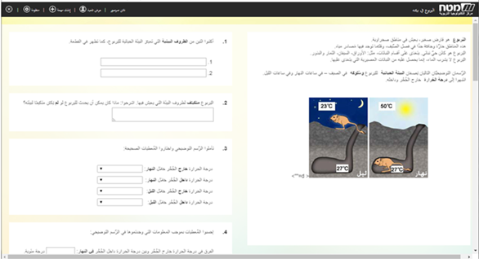

*Image 1*

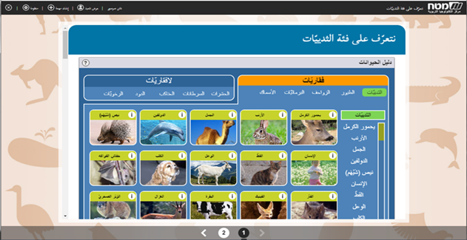

*Image 2*

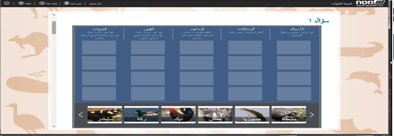

*Image 3*

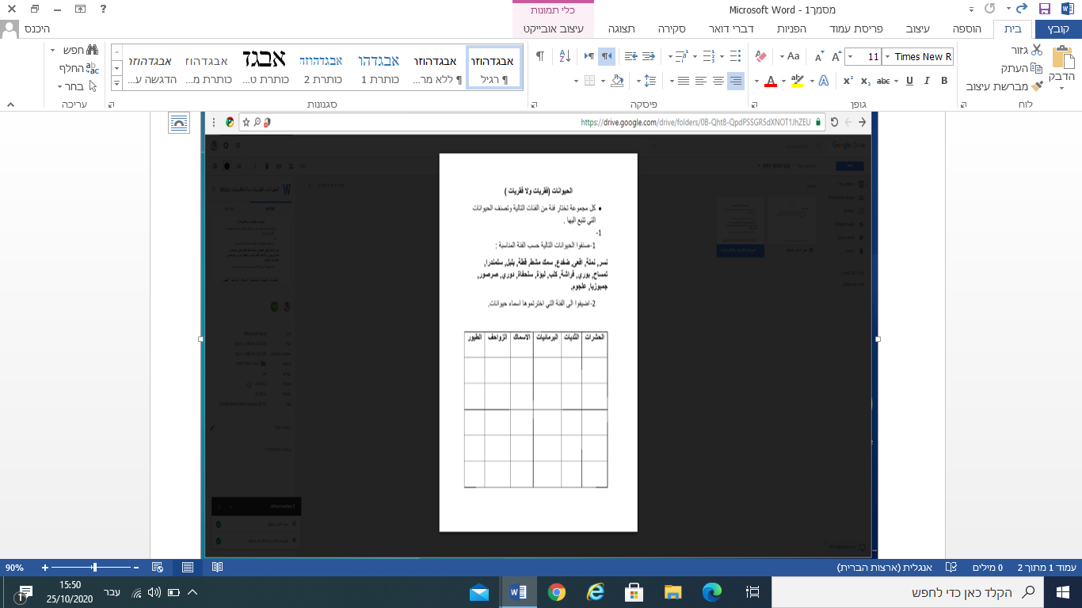

*Image 4*

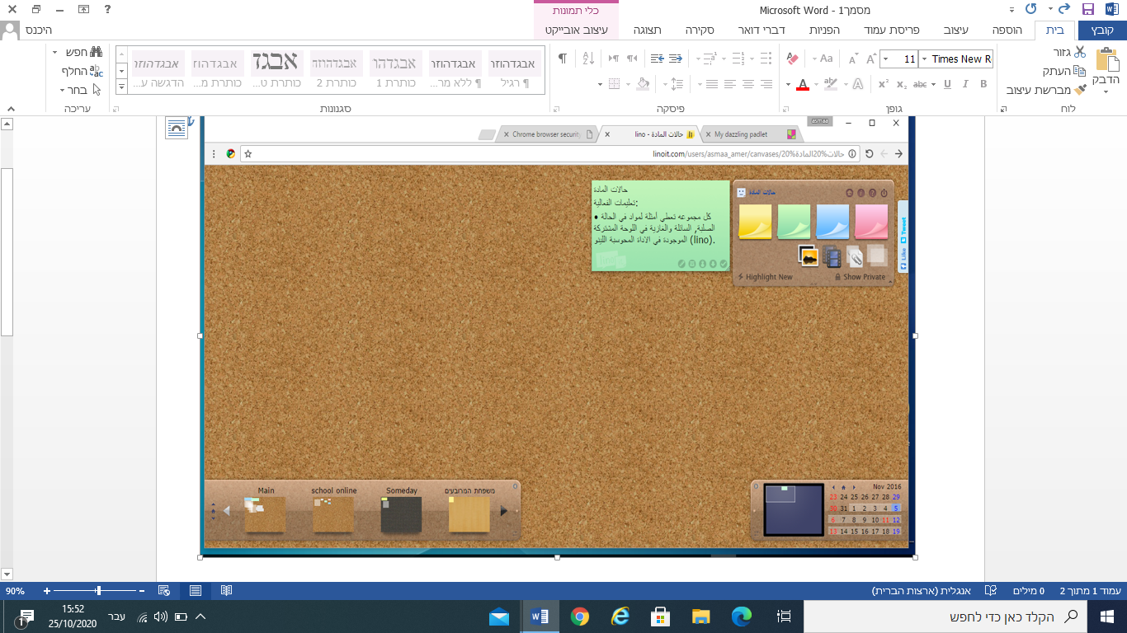

*Image 5*

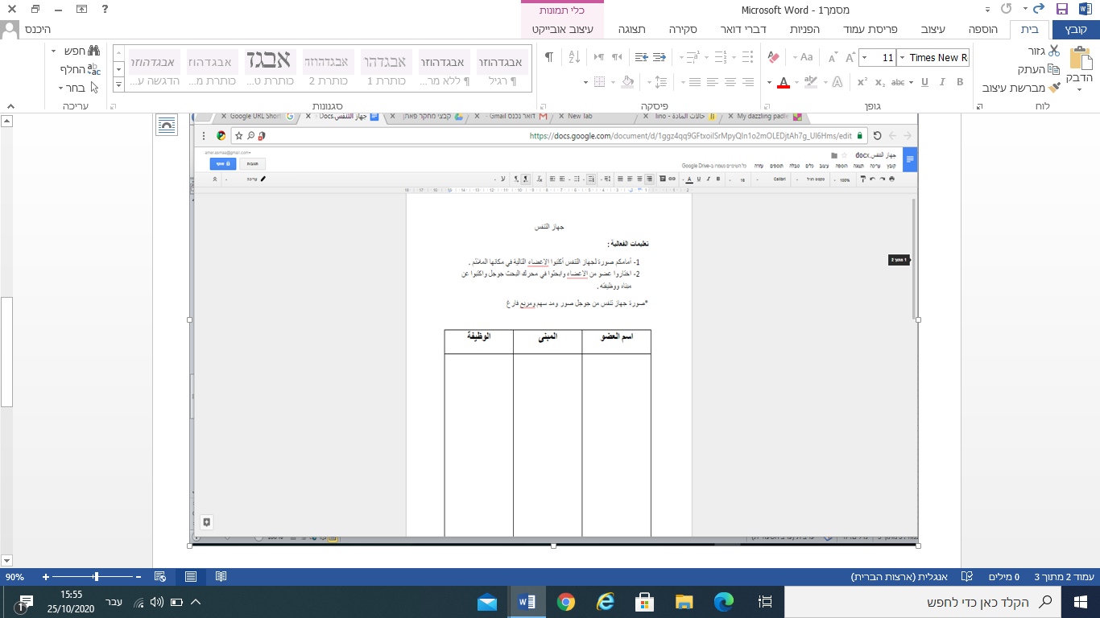

*Image 6*

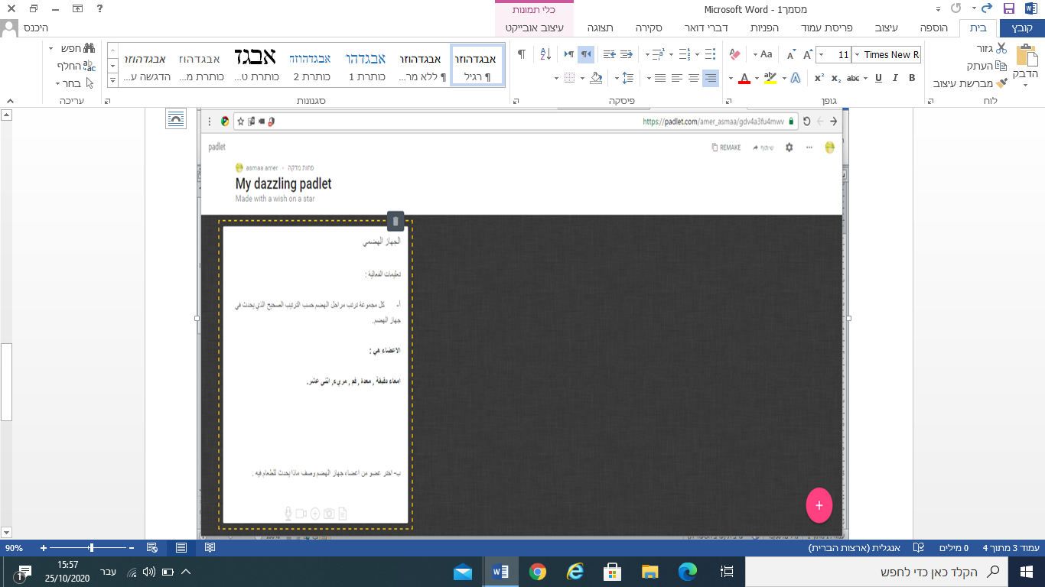

*Image 7*