**From Collective Form to Combinatory Behavior**

**Chandler Ahrens**

Graduate School of Architecture,Washington University in St. Louis, Missouri cahrens@wustl.edu

**Abstract**

Design innovation in architecture can be driven by combining different types of elements. Of the many different combinations architecture can incorporate, this article focuses solely on the interaction between geometric elements. Several important architects and theorists whose design proposals and texts have contributed to the discussion will be studied to clarify the operational strategies of different methods of geometric combination: Fumihiko Maki’s strategies of aggregation through a collection of elements; Stan Allen’s elaboration of aggregation strategy, where elements can be removed or added without affecting the overall collection; Robert Venturi’s strategies of juxtaposition and superimposition; and Thom Mayne expansion of juxtaposition and superposition by employing Boolean operations strategies in conjunction with aggregation strategies. These references provide valuable resources for teaching strategies of combination to architecture students. Combination, in the pedagogical context, is defined as two or more geometric elements or sets of elements that interact through adjacency, aggregation, superposition, or subtraction, with the new combined assembly having the potential to be distinct from the original elements. This article examines the pedagogical implications of two computational approaches of incorporating combinatory methods: image-based and object-based. Combinatorics emphasizes designing the relationships between different elements so that the resulting system generates systems that emerge from relationships rather than element composition. A key benefit is that the system can produce results extending beyond students’ preconceived notions. Students can then analyze and learn from the results of their experiments, following a learning-through-making, inductive approach. An important aspect of this approach is using computation to design the relationships of elements, with computation becoming a design partner enabling students to rapidly iterate and understand the implications of the relationships they have designed. Computation accelerates the evolution of the design process and reveals the complex interactions of combinatory behavior.

**Keywords:** parametric modelling, digital fabrication, drawing/model hybrids, combinatorics

**Introduction**

Fumihiko Maki’s theories of urban form set forth in his seminal book, *Investigations in Collective Form*, continue to influence contemporary notions of combination, emphasizing relationships between forms, programs, and events at the urban and individual building scale. Maki organizes the elements that contribute to urban form into three categories: Compositional Form, Megastructure, and Group Form, which he identifies as having the potential to respond to urban conditions he defines as dynamic fields of interrelated forces (Maki, 1964). Group Form promotes flexibility in the system—elements can be added or removed without adversely affecting the entirety. Components of the group are acknowledged for their difference, united through relationships rather than formal similarity. Maki describes a flexible system in which different elements are knit together, defining a strategy of aggregation. Stan Allen expands the dialogue about aggregation in his description of field conditions, aggregation being an assemblage of similar elements. Of relevance for this discussion is his emphasis on the space between elements, as he explains that “form matters, but not so much the form of things as the forms between things,” which relates simultaneously to the urban and architectural scale (Allen, 1999, p. 92). While repetition is the important aspect of aggregation for Allen, for Maki, difference is easily accepted without necessarily exploiting it.

Differences between elements can be mined to generate a rich architectural entity when dissimilar elements are juxtaposed. The uneasy relationship between purposely differentiated elements interacting is the subject of Venturi’s groundbreaking book, *Complexity and Contradiction in Architecture*, published in 1966*.* For Venturi, the juxtaposition of different elements can “embody the difficult unity of inclusion rather than the easy unity of exclusion (Venturi, 1966, p. 16). The combination of dissimilar elements reveals relationships that are sometimes awkward, but it concomitantly exposes layers of elements that comprise a building. Rejecting the exclusionary approach, Venturi describes the difficult unity as a “both-and” approach that seeks the potential inherent in combination to generate formal richness through ambiguity as a dialogue between architectural elements. Venturi’s “both-and” approach incorporates both the contractions, difficulty, lack of clarity and the new reading of the combined entity. Such an inclusive strategy creates a new condition within the whole that measures beyond the sum of its parts. An approach to the “both-and” is the multifunctioning building, which Venturi describes as having “complex and contradictory hierarchies of scale and movement, structure and space within a whole (Venturi, 1966, p. 34). He specifically references Maki’s *Collective Form*, acknowledging the importance of Maki’s strategies of aggregation that are inclusive of difference.

Venturi expands on the productive difference among elements beyond matters of scale and hierarchy to those of juxtaposition and superposition. In particular, it is the superposition that holds the potential for a new condition to emerge from the combination. A simple example of a new condition is one which results from the superposition of two sets of parallel lines, where one set is non-parallel to the second set, resulting in a visual effect of a moiré pattern. Superposition operates as a union of disparate elements, but additional forms of relationships are also possible, such as the subtraction or intersection of elements. Venturi found richness in “creating order and then purposely breaking it, which enhances the existence of the order in the first place by calling attention to the moment of interruption” (Venturi 1966, p. 41). What would be more disruptive than operations that dramatically alter the geometry of the elements being combined? Exploring the full range of combination, Mayne embarked on a series of drawdles (drawing/model hybrids) to explore the limits of combination. One of the most dominant forms of combination is subtraction, since it uses one element to cut into another, leaving a void as a trace of the interaction. The removal of geometry can have a range of results, from being barely noticeable to being almost completely transformative, to the point the original elements can barely be read. The drawdle experiments are highly systematic, all consisting of a combination of four elements that vary in hierarchy, quantity, scale, and, most importantly, their rules for interaction with other elements. While the drawdle experiment is didactic to illustrate the potential of combination, similar processes operate within the buildings and urban design proposals produced at Mayne’s office, Morphosis. In Mayne’s book, *Combinatory Urbanism: The Complex Behavior of Collective Form*, a contributory chapter by Stan Allen describing Mayne’s urban design process, discusses operative design processes in which the displacement of control to a series of intricate local rules for combination generates complex effects (Allen 2011, pp. 53–64). Establishing the rules for interaction is what converts the ideas of combination into an operational strategy. To bring the argument to a close, in *Combinatory Urbanism*, Mayne specifically refers to the influence of Maki’s *Collective Form* in the work of Mayne’s Morphosis, which evolved a combinatoric method of design, focusing on designing a set of rules for interaction between architectural elements rather than composing the elements. Referencing Maki’s critique of Compositional Form, the design method provides an operational strategy where there is “no fixed ideal notion of the thing [building] because the elements can change within the rules of the system (Mayne, 2919, p. 121).

**Experiments**

In order to develop a pedagogy for methods of combination, a process for students to run experiments must be defined. The operational strategy of combining with varying hierarchies, quantities, scale, and rules of interaction, whereby the architecture is the result of a process, is ideally suited to computational techniques. By embedding information into the rules for interaction, computational techniques reveal recognizable patterns of connected behavior between forms. Such combinatoric methods include additive aggregations that produce field conditions and/or juxtaposition, topological differentiation, subtractive collisions, and intersections. This article explores the pedagogical implications of incorporating tangents of combinatory methods through two different computational approaches: image-based and object-based. The Fabricated Drawings class explored the image-based approach and The Past’s Future studio concentrated on the object-based approach. While each technique produces different results, with each, students were able to rapidly iterate due to parametric scripting that focuses on the relationship between elements. For students unfamiliar with both scripting and combinatoric methods, the rapid generation of geometry enabled them to develop a rubric of possibilities that they can analyze and compare in order to identify characteristics to carry forward in subsequent iterations. The students taking the optional Fabricated Drawings seminar class are typically graduates or undergraduates who are halfway through their studies, so they already have basic skills in design technology. The course is structured toward active learning, where students, guided by a series of tutorials, design and fabricate a set of physical drawings which provide a foundation from which the students can customize their parametric scripts. As an optional seminar, the class provides one of the few opportunities in their curriculum to specifically focus on introducing advanced modeling and digital fabrication techniques.

**Image as Information—Fabricated Drawings**

At the *Software—Information Technology: Its New Meaning for Art*, exhibition held at the Jewish Museum in New York in 1970, one of the participating artists, Les Levine, described the computationally generated image as the hardware and the information that generates it as the software (Levine 1970, p. 61). When considering the image (hardware) as a result of information that has been processed (software), we can also conversely consider the image as information that can not only generate new images, but can also create formal and spatial conditions. Relationships embedded in the information in an image can be translated into geometry while maintaining the initial organization; the information can reveal patterns when filtered and extracted to make them explicit. From a pedagogical perspective, the image provides information that can be culled, and is actually less important than the information that is extracted. However, in our visually dominant culture that is constantly trying to interpret messages, suggesting that the image and any meanings it may convey are not important challenges the common approach to images. In the pedagogical context, process is more significant than the image itself, and examining an image for its potential to provide useful information rather than meaning becomes important. The goal is for students to develop a system for establishing relationships. The system needs data, and an image provides data that are not random, but have inherent relationships that can be mined to organize the system.

**System**

To define the relationship between image and geometry, simple rules must be established. This includes the translation of image to geometry based on types and characteristics (lines, surfaces, and volumes) as well as rules for combination. In his article “Systems Generating Systems,” Christopher Alexander supports creating simple rules that define relationships among a range of elements. These elements can range from physical parts of a building to the culture in which the building belongs. Such a generalization of the elements makes the use of such a system malleable to many situations, as the multiplicity of inputs can vary the behavior of the elements. For Alexander, “the word ‘system’ does not refer to a single thing at all, but to a kit of parts and combinatory rules capable of generating many things (Alexander 1968, p. 90). The rules apply to both the global and the local behavior of how elements are combined with other elements. The local behavior is established at the elemental level, affecting the elements in immediate adjacency. Elements of the same type, or organized in a group to have the same behavior, display a global effect, whereby a change at the local level affects the whole due to the series of interactions with the other elements. Thus, an important aspect of the “holistic behaviour is that instability which occurs in object that are very vulnerable to a change in one part: when one part changes, the other parts change also (Alexander 1968, p. 90). Such instability can be beneficial to a creative design process and may yield unexpected results, or even fully expected results. Still, what is the benefit of designing a system to generate systems if it produces something that has already been considered or produced? The valuable pedagogical implications of designing a system is its potential for innovation, revealing relationships previously not considered.

**Computation**

In the Fabricated Drawings course projects, students were tasked with designing a system rather than a composed drawing. A system that establishes behaviors does not require computation, according to Christopher Alexander’s methods. Yet computation can greatly assist as a facilitator for sampling and filtering information, categorizing it, and translating the relationship between these procedures to detect the results of the combinations. The goal of the system is to generate thick drawings using 3D geometry and to optimally fabricate these drawings. The system design is based on behaviors established between sets of elements that can have different characteristics based on the same type or completely different types of elements (i.e., line versus volume). The computational system samples an input image and filters the information into sets of data that become the input to generate subsequent sets of geometric elements. Combination occurs at the level of the image, whereby the two images used in the sampling process create a dialogue between the kinds of information entered into the system. The type of geometry and its characteristic were determined by the focus of each exercise. The class provides an introduction to visual programming and an opportunity for students to learn how to use digital fabrication tools. Each of the exercises was paired with a piece of digital fabrication equipment—a line with a laser cutter, a surface with a computer numerical control router, and volume with a 3D printer. The class has run for several years and is continually evolving, but it has generally followed a progression in complexity from line to surface to volumes.

The first examination in the series focused on lines. More specifically, it explored generating sets of lines that are organized by the data extracted from the sampled images. In addition to the organization, the characteristic of each set of lines was defined by the data, which included the degree of thickness, orientation, angle, material, and/or color. Since the different groups arose from filtered data from the same image, there was an inherent relationship between the sets. The set of lines created a field of related, but not necessarily repeated, elements that references Allen’s theory of field conditions. The combinatory aspect was achieved by the groups of lines generated from the second sampled image that was overlaid on the lines from the first set, referencing Venturi’s ideas of superadjacency. While the collection of lines generated from both images intersected, they generally did not alter each other and thus remained independent, in a state of aggregation. The important lesson from this exercise is that the accumulation of all the lines together created the reading of the collective form. The figure below is an example of a resulting image from a collection of lines produced by a student in the Fabricated Drawings class (Fig. 1).

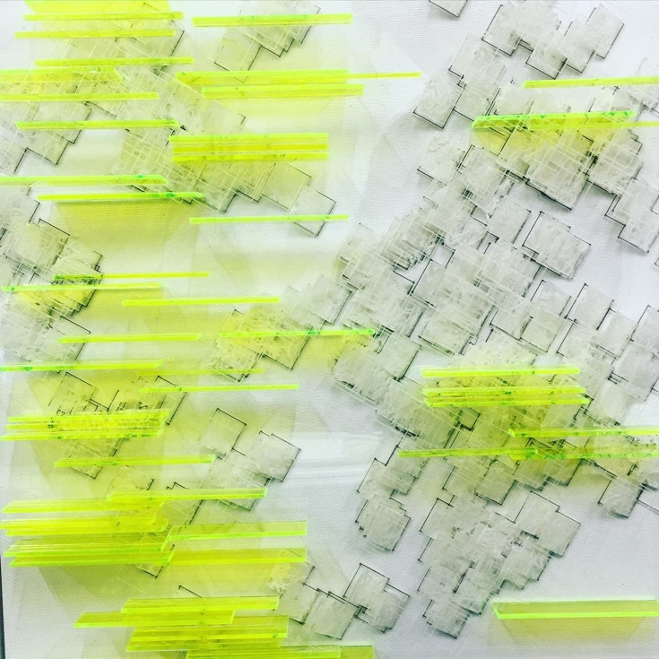

**Figure 1:** Image-based example of a thick drawing from a collection of lines. Image credit: Katherine Katz and Corinna Siu

The second investigation focused on surfaces. The same images from the exercise with lines continued to be used, mining the data to generate one surface per image. The two surfaces were overlaid, mutually trimming out the part of surfaces that intersect. The intersecting operation generated a new combined entity. When two surfaces started to cut into each other, the geometry was more aggressively transformed in a way that was beyond just aggregation or superposition. This method of combination is moving toward a process that uses violent juxtaposition – to reference Venturi – to reveal a more complex entity emerging from the operation. Seeking a “both-and” condition, the operation retains traces of the identity of both surfaces and generates a new combined entity.

The third investigation focused on volumes. Similar to the previous exercises, the same two images were sampled and the data generated sets of volumes per image. With volumes, the students were urged to develop more aggressive relationships through cutting procedures. The violence of the juxtaposition was made explicit through Boolean operations of cutting, intersecting, and joining. Not overlooking the “both-and” aspect, aggregation and proximity were still utilized where lines and surfaces could be employed in addition to volumes. When considering the evolution of interaction from line to surface to volume, the latter provides the most opportunities to reveal the process that was performed. Volumes offer opportunities that are far more transformative than a surface due to the thickness, which leaves more of a trace of the cutting volume because the void is volumetric (Figs. 2 and 3). The resulting operations of the students’ work was more aggressive than the examples Venturi shows in his chapter “Contradiction Juxtaposed;” this avoids the issue of whether this is a fair reading of his intentions. Or, we can say that his ideas laid the foundation for further exploration to find the limits of contradiction and juxtaposition.

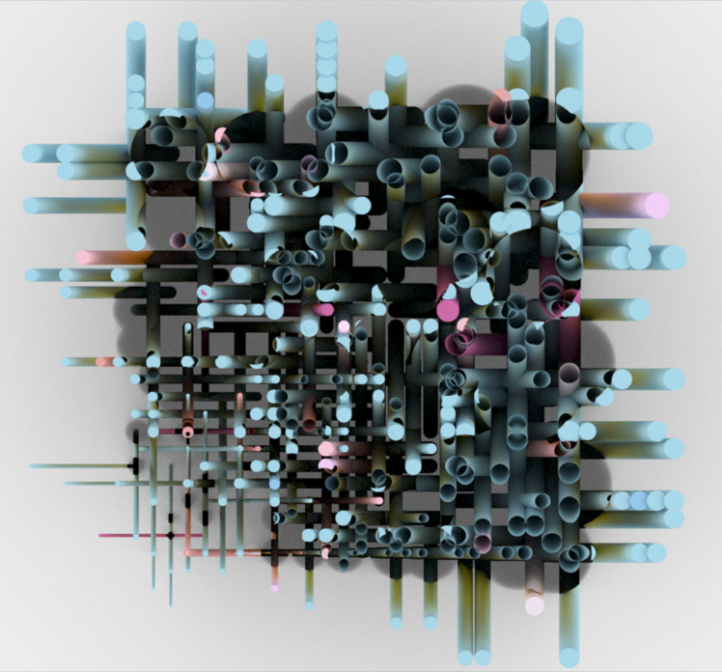

**Figure 2:** Image-based example of a thick drawing of cut volumes. Image credit: Donzhe Tao

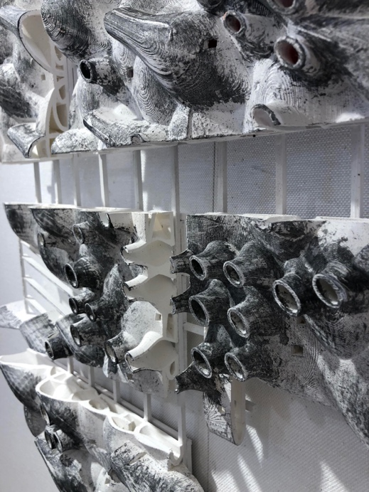

**Figure 3:** Image-based example of a thick drawing of cut volumes. Image credit: Chang Jiang & Derek Luth

If Venturi laid the foundation for an uneasy juxtaposition of elements, then Mayne expanded on the idea to advance the limits of complex relationships through interaction. Mayne refers to this as a combinatory operational strategy. Relationships are designed through simple rules that define how different elements behave and interact with other elements. The behavior includes scale variation, quantity, and density of repeated elements. The interactions include a range from more benign aggregation to more aggressive cutting operations that drastically alter the geometry. Yet, the main distinction from previous ideas of collective forms, field conditions, and juxtaposition, are the degree of transformation of the elements that are combined with a combinatory operational strategy. At times, the geometry of the elements remains intact and legible, while more aggressive combination produces a new entity that leaves only minor traces of the original parts. In this sense, the volumetric exercise the students perform in the class is closer to Mayne’s investigations in combinatorics due to the more aggressive geometric operations.

**Object as Information—The Past’s Future Studio**

In contrast to the Fabricated Drawings class, the Past’s Future studio moved directly into volumetric combination, although the starting point was quite different. The studio investigated historic objects and proposed speculative alternate histories in order to generate new objects. Specifically, the studio looked at inventions displayed at the Louisiana Purchase Exposition of 1904, held in St. Louis, Missouri. During that time, expositions were venues for sharing knowledge of new technologies with the public. Records show that there were approximately 117 miles (188 km) of exhibits at the St. Louis exposition, and the studio students were asked to research and select an object that was on display there. They created a detailed digital model using the limited information they could find from the history museum library. They were then asked to propose a speculative alternate future for the object that had to differ from what actually occurred. They built a detailed model of the speculative future object that had evolved from the past to its new form. With the two elements of the past and the future objects, the students were asked to create combinations to form a new, third object that was a result of the rules they designed. This was an exercise to introduce the idea of combination that purposely did not use buildings as the starting objects. It proved effective because the many pre-conceived ideas about use of buildings can easily undermine or diminish any rules for combination. Using historic and non-existent future objects provided enough distance from preconceived ideas that the students were able to focus on the abstract nature of combining as a separate process.

This exercise differs from the volumetric exercise in the Fabricated Drawings class in that the students started with singular objects rather than a field of elements. In a field, you can read a series of interactions to identify similarities and differences from many combined elements, while the object-based approach tends to appear more transformative when the original objects are less recognizable after combination. This is due in part to the increased geometric complexity of the original objects, which, when combined, produces more idiosyncratic conditions. Students also tended to deploy several operations, such as union, intersection, and cutting within one combined entity. The sequence in which they deploy the multiple operations has a dramatic effect on the result. To further elaborate on the geometric combination, details from the object models created subtractive and additive patterns along the faces of the new combined object. In this sense, field conditions can be read as being applied to the surface (Figs. 4 & 5).

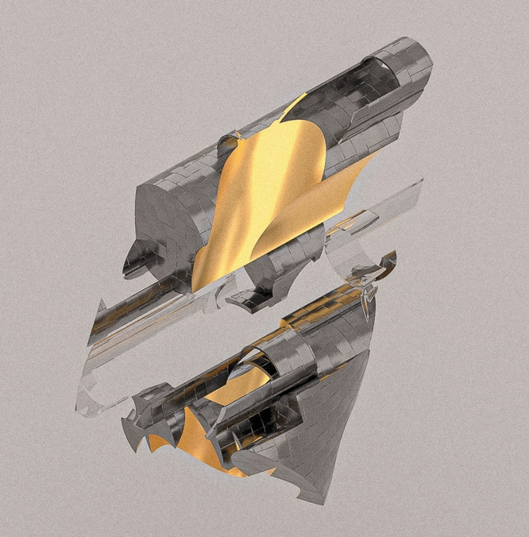

**Figure 4:** Object-based combination. Image credit: Liujie Lu

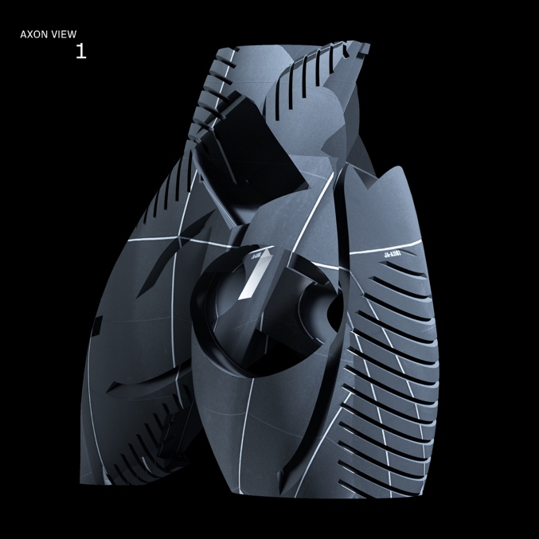

**Figure 5:** Object-based combination. Image credit: Noah Sturbois

Volumetric combinations are violent not only in terms of what Venturi described regarding architecture order, but also computationally. The intersections of complex geometric volumes, far too laborious to calculate manually, require significant computational power and time to process. Compared with the brute force method of 3D modeling, in which Boolean operations permanently change the geometry, students use parametric software to manage the relationships of elements in the combination process. The non-linear control enables students to design and adjust the behavior of individual elements at any point in time in the design process in order to quickly generate families of options. The parameters include scale and position, and more importantly, can be made in relation to other elements, exhibiting patterns of behaviors. In this sense, computation provides a way to manage the violence.

The students further intensified the combination process by texture mapping the new combined object with images from the historic object. The use of the texture map can amplify differences in parts of the combined entity or it can unify disparate elements into a whole. The students were charged with determining how the texture map, particularly its scale and placement, would either clarify or camouflage the geometry.

**Conclusion**

There are several pedagogical implications associated with using combinatory techniques that revolve around the question of how to teach creative innovation. These interrelated implications include running inductive experiments, designing operational strategies, utilizing computation, and grounding the process within the context of existing and evolving architectural theory. So, how does one teach innovation? Clearly there are many answers to this broad question, but the combinatory process offers an opportunity for students to discover potential from running experiments where the results are difficult to predict. In particular, when the experiments operate outside of preconceived ideas, then unexpected results potentially can occur, with both failure and innovation possible. By running inductive experiments, students are able to learn by creating and analyzing the results. Fortunately, the experiments can be run multiple times so that students learn to see patterns of behavior emerging, revealing conditions not previously considered.

In running experiments, students are learning from using an operational strategy, which in this case involves designing a system that generates systems. The advantage of teaching an operational strategy is that it provides a clear process for running an experiment without being overbearing, meaning each student designs their own rules for interaction. There is authorship, but it changes from authoring a composed entity to designing the rules that create the resulting entity. An operational strategy tasks students with establishing a series of rules which is algorithmic and lends itself quite easily to computation. Computation provides a way to quickly deploy an operational strategy to iterate families of options that students can analyze, compare, and extract lessons from. When combining complex geometry, speed and quantity of iterations matter. Students are able to see patterns emerge when there are enough results to compare, allowing them to better predict the behavior of the systems they designed. The ability to predict the behavior informs how the system should be modified to produce desired results.

A final pedagogical implication is that referencing historic and current architectural theory provides context through which students can understand the evolution of design thinking. By taking part in experiments, the students are empowered through their contribution to this evolution. Hopefully, they will continue to make contributions to advance the progress beyond the confines of the institutions, extending the trajectory from collective form to combinatoric behavior.

References

Alexander, C., 1968. Systems generating systems. *Architectural Design*, 7/6, p. 90.

Allen, S., 1999. *Points + Lines: Diagrams and projects for the city*. New York, NY: Princeton Architectural Press.

Allen, S., 2011. Thom Mayne’s information landscapes. In: T. Mayne, *Combinatory urbanism: The complex behavior of collective form*. Culver City, CA: Stray Dog Café, pp. 53–66.

Levine, L., 1970. Systems burn-off residual software. In: J. Burnham (Ed.), *Software—Information technology: Its new meaning for art* [Catalog]. New York, NY: Jewish Museum, p. 61.

Maki, F., 1964. *Investigations into collective form*. St. Louis, MI: The School of Architecture, Washington University.

Mayne, T., 2019. Interview. In: C. Ahrens and A. Sprecher (Eds.), *Instabilities and potentialities: Notes on the nature of knowledge in digital architecture*. New York, NY: Routledge, ch. 9.

Venturi, R., 1966. *Complexity and contradiction in architecture*. New York, NY: Museum of Modern Art.