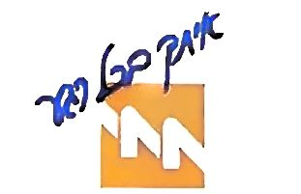 | Israel Electric Corporation, Ltd.
 | Bi-monthly Invoice
Electric Corporation
 |  |  | Tax Invoice/Receipt – Original 2021-451197935
To: |  |  | Company Number: 520000472
Ariel Kor |  |  | Reports to consolidated businesses № 558418570
47 Ramat HaGolan |  |  | Netiv Haor 1. Haifa
Jerusalem 9770328 | 209-850-299 |  | Contract invoice number: 340896076
 |  |  | Invoice period of 27 days
Return address: 44 Gershon HaMelamed, Jerusalem |  |  | from 21/07/2021 until 16/08/2021
 |  |  | Date of invoice preparation |  |  | At your service, 24 hours a day:  Company website: www.iec.co.il  Where you can pay invoices, enter meter readings, and find information on various topics.
 |  |  | 17/08/2021
Consolidated Invoice
Consumption charge – Total of 4795 kWh |  |  | 2,272.57 |  |  | 103 for Service  To report issues, and for billing and  consumer services:
Payment in respect of capacity (KVA) |  |  | 20.63
Fixed charge |  |  | 187.83
Various debits and credits |  |  | -0.91
Total before VAT |  |  | 2,480.12 |  |  | From landlines & cell phones – 103
VAT at 17.00% |  |  | 421.62
Total including VAT for billing period |  |  | 2,901.74
 |  |  |  |  |  | Calling the 103 hotline is free, from any phone.
 |  |  |  |  |  | Do not pay this invoice
 |  |  |  |  |  | Your account will be charged on 06/09/2021
 |  |  |  |  |  | Credit card number ending in digits 0511
Total payment (NIS) |  |  | 2,901.74
 |  |  |  | Your electricity consumption in kWh (orange)
 |  |  |  | compared to average consumption in your residential area (blue)
Notifications
■ For your attention!!!
You can now pay with your credit card even sums greater than NIS 10,000.
Payment by credit card for sums greater than NIS 10,000 will be charged a fee of 8 NIS for each NIS 1,000 (from first thousand above 10,000).
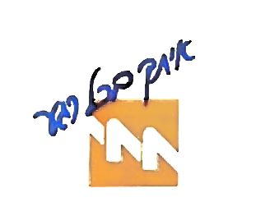
Customer’s name:
Ariel Kor |  | Voucher/Credit Notice |  |  |  | 2021-451197935
 |  |  | Contract account number: 340896076 |  |  | Periodic invoice  from 21/07/2021 until 16/08/2021
Amount to be paid in NIS |  |  | Not for payment |  |  | Do not pay this invoice
Invoice charged by fixed payment
Billing credit card ends with digits 0511

