**Conservative and Liberal Worldviews and Social Policy Attitudes Among University Students: Interactions between Culture and Religion**

Ariela Keysar, Nurit Novis-Deutsch, Janne Kontala and Peter Nynäs

**ABSTRACT**

Religion influences individuals’ social policy attitudes both directly and indirectly. These effects involve different aspects of religion. This paper examines how the impact of religion on social policy attitudes varies according to national and cultural contexts. We analyzed attitudes of young adults toward same-sex marriage, abortion, and euthanasia using the Young Adults and Religion in a Global Perspective (YARG) study, which spanned 13 countries from four continents and targeted 4,964 university students aged 18–30. By using path models, we found that among various indices of religiosity, self-identified religiosity is the most important predictor of social policy attitudes. Across cultures and national groups, self-identified religiosity has a strong direct effect and an additional indirect effect by shaping value preferences, which in turn affect social policy attitudes. We also found that although religiosity consistently correlates positively with conservative values and negatively with liberal values, culture also has an important impact on social policy attitudes. Measured on a scale of individualism versus collectivism and controlling for religiosity, values, and demographics, the more collectivist the country, the lower the support for liberal values and progressive social policy preferences, and the greater the support for conservatism. These findings have important implications for the understanding of the relative weight of religiosity, culture, and nationality in predicting social policy attitudes.

**INTRODUCTION**

Religion affects social policy attitudes both directly and indirectly. Directly, religious traditions inform their adherents about desired social norms and how those norms should be pursued (Saucier, 2000). For example, many religions proscribe abortion, require that marriage be heterosexual, and prohibit euthanasia, positions that their adherents tend to adopt (Danyliv & O'Neil, 2015; Kosmin & Keysar, 2006; Whitley, 2009; Yen & Zempeli, 2017). Indirectly, religions shape value preferences and worldviews (Schwartz, 2108) which in turn, lead to liberal or conservative social policy attitudes (Caprara et al., 2018). These direct and indirect effects suggest that the robust positive correlation which is typically found between religiosity and conservative attitudes (Caprara et al., 2018; Hood, Hill & Spilka, 2009; Schwartz et al., 2012; Van der Brug et al., 2009) is driven by two sources: values and religion. Novis-Deutsch et al. (2019) found that the relative weights of the direct and indirect effects of religion on social policy attitudes depend on what aspect of religiosity is being measured (e.g., belonging or practice). They also found that while the direct effect of religiosity on social policy attitudes is the most powerful, a smaller but significant portion of religion’s effect on social policy can be explained by the mediating influence of cultural values.

It remains unclear, however, to what extent the direct and indirect effects of religiosity on social policy attitudes operate similarly across national and cultural contexts. Previous studies targeted predominantly Protestant cultures, and data on non-Christian populations is particularly sparse (cf., Caprara, 2018). An important possibility to consider is that cultural surroundings have a major impact on which patterns of values can be included, managed and integrated into the identity of religious individuals and which cannot. Consider, for example, the being deeply religious in Sweden and being deeply religious in Ghana differ. The religious Swede lives in a secular, individualist culture that emphasizes, perhaps above all else, personal choice and social equality (Kasselstrand, 2015). This individual’s religious faith is more likely to have found a way to accommodate liberal values. The religious Ghanaian lives in a collectivistic culture that stresses values of conservatism, such as respect for authority and honoring tradition (Hunsberger, Owusu & Duck, 1999). Usually, religion supports and reflects these conservative values, posing no cognitive dissonance for a religious individual living in a collectivist country such as Ghana. Now imagine a non-religious Swede in contrast to a non-religious Ghanaian. The non-religious Swede is likely to experience congruency between his or her liberal humanistic values and secular worldview. Not so the non-religious Ghanaian, who holds cultural values supporting traditionalism, but at the same time professes a non-religious worldview. It is more likely that the non-religious Ghanaian’s secular worldview will have found a way to maintain respect for tradition and authority, thus minimizing any possible dissonance between his or her secularism and cultural values.

Our goal in this paper is to present and analyze cross-cultural data in a manner that can identify differences and similarities in cultural patterns of interaction between the direct and indirect effects of religion on social policy attitudes among young adults from diverse cultural contexts. Our data source is the Young Adults and Religion in a Global Perspective (YARG) study (Nynäs et al., 2019). YARG is a mixed-methods project conducted from 2016 through 2018 in 13 countries from four continents, and targeting university students aged 18–30. For these analyses, we utilized data collected from 4,964 participants who completed value surveys, attitude questionnaires, and extensive religiosity probes, and provided demographic information. They also participated in qualitative interviews which are not used in this paper.

**LITERATURE REVIEW**

**The Interplay between Conservatism and Liberalism**

The clash between liberal and conservative worldviews, or the left-right polarization (Noël & Thérien, 2008)[1] is often referred to as a “culture war” (Flanagan & Lee, 2003; Frimer et al., 2014, p. 1205; Hunter, 1991). This polarization has intensified over the past decade (Bornschier, 2010; Carmines, Ensley & Wagner, 2012; Pew Research Center, 2014). It is reflected not only in voting patterns, economic policies and foreign policies across the globe, but also in attitudes towards social inequality, arms control, environmentalism, same-sex marriage, abortion, euthanasia and more (Kriesi, et al., 2012; Sherkat, 2014); even in daily lifestyle choices (Pew Research Center, 2014). While attitudes towards social issues are directly affected by the teachings and policies of organized religions about these issues (Hood, Hill & Spilka, 2018), religion can indirectly affect social ideology by shaping ideological worldviews. The terms *liberal* and *conservative* can be used either to connote political positions or broad worldviews. In this paper, we refer to the latter meaning and deem liberalism and conservatism to reflect worldview constructs, which precede political positioning and shape voting patterns.

According to the classic definitions of liberalism and conservatism, the essence of the ideological difference between them can be considered the importance placed on the value of freedom. Liberalism, as its name implies, places an especially high worth on freedom. For classical liberals, this leads to the favoring of small governments, and more recent American-style liberals emphasize social justice (Gaus, Courtland and Schmidtz, 2018). Both types tend to favor autonomy, choice, and tolerance. In contrast, the conservative position values experience and authority, viewing society as held together by family, private property, and traditions. Within conservatism there are also different political nuances. For example, libertarianism is often viewed as a type of conservatism, at least among Americans, if not among Europeans. Generally, all variations of conservatism emphasize stability, duty over rights and rules over reason (Kekes, 1997; Oakeshott, 1991). When applied to political ideologies, the distinction between liberalism and conservatism becomes murkier. In Western Europe, liberalism clearly corresponds to the left and conservatism to the right. In Eastern Europe and other previously or currently Communist nations, there is less of a direct correspondence between liberal and conservative worldviews and political affiliation. Finally, in the United States, those identifying as conservatives frequently champion “freedom” while those identifying as liberals call for restrictions in order to further social justice. Some scholars claim that the conservative-liberal divide is actually a unidimensional continuum reflecting the importance of freedom (Jost, 2006). Indeed, this approach has been shown to predict voting patterns in multiple locations (ibid.). Others argue that liberalism and conservatism are two and opposing dimensions which can nonetheless be synthesized so that it is possible, although unusual, to be both conservative and liberal (Barnea and Schwartz, 1998; Hamilton, 2016). A bi-dimensional political space typically reflects differing economic and cultural attitudes, and best explains voting patterns in many countries (Bornschier, 2010; Feldman & Johnson, 2014). [2] In this paper, we will treat liberalism and conservatism as related but separate, rather than assume them to be opposites. We therefore ran all our analyses separately for conservatism and for liberalism.

**Religion, Conservatism and Liberalism**

Religiosity is strongly and consistently associated with ideological and political conservatism across countries. Caprara et al. (2018) recently found that religiosity was related to right-wing politics and conservative ideologies in 15 of the 16 countries they tested, an association that did not vary with gender, age, income, or education.

But what links religious beliefs to social attitudes? An obvious candidate is value preferences. According to Schwartz’s highly validated theory of Basic Human Values (Schwartz, 1992, 2001, 2006, 2012), basic values are trans-situational goals, varying in importance (e.g., rankable), that serve as guiding principles in the life of a person or group. In the most recent iteration of the Basic Human Values theory, 19 basic values, which are recognized across societies, form a circular motivational continuum (Schwartz, 2012). These values are construed as two sets of higher order values: conservatism versus openness to change; and self-enhancement versus self-transcendence (Schwartz et al. 2012; see Figure 1).-- Insert Figure 1 here --

Values can explain why the left-right distinction does not substantially align with the liberal-conservative division in some countries, such as those with a history of communism. Variation in patterns of values and political ideology occurs when “the political history of a country has imbued a particular political value with a meaning different from that in most other countries” (Schwartz et al., 2014, p. 902). Similarly, Caprara et al. (2017) found that after controlling for basic personal values, the contribution of religiosity to political self-positioning on a conservative-liberal scale was significant and substantial only in countries where religion has played a prominent role in the public sphere (e.g., Israel, Poland, United States), whereas other countries showed a marginal or small unique contribution of religiosity to political self-positioning.

While Caprara et al.'s study (2018) examined the three-way relationship among values, religiosity and social ideology using self-reported religiosity and reported conservatism or liberalism, Novis-Deutsch et al. (2019) expanded the analytical scope by using direct and indirect scales to measure these constructs. Using Schwartz's more recent 19-value model and testing multiple facets of religiosity (e.g., religious belonging, religious identity and religious practice), they found that religion affects ideological worldviews both directly and indirectly. There was a direct relationship between religiosity and positions on issues such as homosexuality and same-sex marriage, but there was also an indirect relationship in which values mediated the correlation between religiosity and social policy attitudes. These findings can be summarized in the following theoretical model (See Figure 2). This model suggests that religiosity directly reduces liberal attitudes towards social policy, while also indirectly affecting these attitudes in two complementary ways: by lowering liberal attitude values (LIB values; see the *Measures* section of this paper for details on how this measure was calculated), thus reducing the positive impact of these values on liberal attitudes towards social policy; and by enhancing conservative values (CONS values, ibid), thus increasing the negative impact of these values on liberal attitudes towards social policy.

--- Insert Figure 2 here ---

Studies by both Caprara et al. (2018) and Novis-Deutsch et al. (2019) support such a model, but they may have overlooked important cultural differences in these universal patterns. We next conjecture how the religion-social policy relationship might be moderated by culture and nationality.

**The Predicted Role of Culture and Nationality in Determining the Effect of Religion on Social Policy**

Broad cultural constructs have been shown to affect behaviors, attitudes, beliefs, cognitive schemas and even the basic sense perceptions of their members (Kitayama & Cohen, 2010). For example, some cultures promote a more allocentric worldview (concerned with others) while others promote a more idiocentric one (concerned with self). This affects the way members interpret social stimuli, behave in social situations, and rank values (Heine, 2015). Cultural elements, such as the role of the group, level of tolerated uncertainty, and the structure of cultural hierarchy tend to form interrelated and coherent structures that can distinguish the world’s main “cultural regions” (Triandis, 2010). Given that culture’s effects are powerful enough to affect virtually every aspect of perception, emotion, cognition, and behavior, culture is also likely to affect the relationship between religiosity and social attitudes.

Our study builds on Hofstede's model of national culture (2010), which consists of cultural dimensions, or aspects of a culture that can be measured relative to other cultures and that can reflect preferences for one dimension over another. Combining these dimensions generates cultural profiles that distinguish nations from one another and establishes broader cultural-regional patterns. Hofstede's model outlines six cultural dimensions: individualism/collectivism; low/high power distance; low/high uncertainty avoidance; long-term/short-term orientation; masculinity/femininity; and indulgence/restraint. We focused on two key distinguishing dimensions: individualism vs. collectivism and power distance.

Individualism vs. collectivism refers to the degree to which people in a society are integrated into groups. Individualistic societies display loose connections between persons and groups. In effect, such societies expect individuals to look after themselves. In contrast, collectivist societies bind people and groups together much more strongly, forming strong, intrinsically cohesive groups that ultimately expect their individual members to prioritize group needs over their own. As a rule, individualism is more commonly found in developed and Western countries, while collectivism is more prevalent in developing and Eastern countries.

Power distance refers to the level at which members of a society accept an unequal distribution of power in any kind of structure in that society. Power distance represents inequality as being defined from the perspective of those with less power, suggesting that a society's level of inequality is endorsed at the grassroots level as well as at the leadership level (Hofstede, 2011, p. 9). Power distance and individualism vs. collectivism have both been found to strongly correlate to the wealth of nations, and they also correlate with one another. High power distance is typically found in East European, Latin, Asian, and African countries and low power distance is more common in Germanic and English-speaking Western countries (Hofstede, 2010).

A set of studies on 76 countries resulted in a ranking in which countries were positioned relative to each other on their scores in each of the six cultural dimensions identified by Hofstede (Hofstede, 2011.) We make use of this national-level ranking in our study.

In addition to the cultural context, national context also affects the role of religion in the public sphere (Caprara et al., 2017). Belonging to a nation involves sharing a set of historical events, filtered through collective memory schemas (Olick et al., 2011). This means that the role and impact of religion on attitudes and outcomes is moderated through national history and ethos. For example, in Israel, historical circumstances led to a conflation of the definitions of religion and ethnicity. Consequently, 40% of Israeli Jews who are considered secular define themselves as religiously Jewish but at the same time as non-religious (CBS Israel, 2016). To cite another example, in Finland, some 71.9% of the population consider themselves Christians (Tilastokeskus, 2019) but only 4% attend weekly religious services (Pew Research Center, 2018), a gap partially accounted for by a combination of national-historical circumstances and identity politics (Finland's strained relations with the Soviet Union, and *inter alia*, with atheism). It is important, therefore, to test each national context individually to explore its effect on the relationships among religiosity, values and social attitudes, while controlling for broader cultural contexts.

This study tested the following hypotheses, which are presented in general and in operationalized terms:

1. The more individualistic a culture, the more liberal values will moderate the effect of religiosity on social attitudes, whereas the more collectivist a culture, the more conservative values will moderate the effects of religiosity on social attitudes.

Operationally, the variance among young adults’ social policy preferences will be moderated by Hofstede’s national ranking of the individualism vs. collectivism dimension. As a result, those from high-individualism countries will show increased support for liberal social policy, increased support for liberal values, less support for conservative values, lower levels of religious belonging, identification and practice, and a weaker indirect effect of religion on social policy preferences than do those from high-collectivism countries.

1. The greater the cultural power distance, the more equality will moderate the effect of religiosity on social attitudes, whereas the lower the power distance, the less equality will moderate the effects of religiosity on social attitudes. A parallel set of operational hypotheses was generated regarding the distinction between low vs. high power distance cultures.

The results regarding the cultural power distance were very similar to those of individualism vs. collectivism. Due to space limitations, we report findings only concerning the first dimension of individualism vs. collectivism, which are applicable to the cultural power distance as well.

In addition, we examined the exploratory question of w r with no hypothesized directionality.

**METHOD**

**Participants**

Participants were part of the Young Adults and Religion in a Global Perspective (YARG) study conducted by Nynäs et al. (2019). In this mixed-methods project, surveys were administered to 4,964 respondents in 13 countries. All participants were active students at the time of the study and the overwhelming majority were between the ages of 18–30. In-depth interviews were then conducted with a nationally proportional subsample of 562 interviewees. The surveys were administered in local languages using convenience sampling with purposeful sampling schema, which targeted diverse higher education institutions in each country. The participating countries were Canada (n=410), China (n=325), Finland (n=484), Ghana (n=420), India (n=298), Israel: Arabs (n=429), Israel: Jews (n=332), Japan (n=324), Peru (n=321), Poland (n=299), Russia (n=343), Sweden (n=328), Turkey (n=347), and the U.S. (n=304).

**Measures**

This study utilizes only some of the measures used in the full YARG project. Some of the data collected was used to form new measures specifically targeting the hypotheses of this study.

***A measure of social liberal/conservative policy preference***

To explore the relationships between liberal/conservative orientation and social policy preference, we constructed a combined measurement of social policy preferences relating to issues on which liberals and conservatives are expected to differ. We averaged the agreement of participants (1–5 Likert scale) to statements indicating support for same-sex marriage, same-sex adoption, legal abortion under various conditions (rape, threat to the woman's health, and the woman's choice), euthanasia, and medically assisted suicide. Reliability (Cronbach’s alpha) of the scale was .853.

***Value measures***

The PVQ-5X scale (Schwartz, 2012), which measures participants’ values on

a 19-consruct value circle, was used in this study. For this study, we devised a novel way of grouping a subset of Schwartz’s values. The values that we propose as reflecting liberal attitudes are not included among the four higher-order value constructs described in the introduction: openness to change vs. conservatism and self-enhancement vs. self- transcendence. Rather, they include twoof the openness to change values: self-direction/ thought and self-direction/ action. Two additional values referred to in this study are: universalism/concern and universalism/tolerance. The value of universalism/environmental was excluded as it did not appear to relate directly to the principle of liberalism. We suggest this new grouping based on the core values of liberalism —freedom, equality and autonomy — and on previous findings of consistent positive correlations between these core values and liberal attitudes.

We used the PVQ-5X to measure participants’ values but aggregated the value scores differently than previously done, by averaging the z-scores of tradition, conformity, and security values in order to obtain a “conservatism” score (CONS) and averaging the z-scores of self-direction and universalism values to obtain a “liberal values” score (LIB). Figure 1 shows the location of LIB values (in gray) in relation to the established second-order value groups.

**Religiosity measures**

We used three measures of religiosity.

*Religious belonging* was measured dichotomously according to answers to the question:

Do you consider yourself as belonging to one or more religious groups, communities, or traditions? (Yes or No).

*Religious self-identification* was measured on a 0–10 scale according to answers to the question:

Regardless of whether you consider yourself as belonging or close to a particular religious group, community, or tradition, how religious would you say you are?

*Religious practice* was measured on a 0–10 scale according to answers to the question:

Apart from when you are at religious ceremonies or services, how often do you engage in private religious or spiritual practices, such as worship, praying, or meditation?

***Analytic plan***

We tested each of the 13 countries separately, and then grouped them by Hofstede’s (2011) cultural individualist/collectivist index (I/C) and power distance index (PD), creating two pairs of contrast groups (See Table 1 for ranking).

* 1. High individualism (Canada, Finland, Poland, Sweden, U.S.) versus high collectivism (China, Israel: Arabs, Peru)
     + - 1. High PD countries (China, Ghana, India, Israel: Arabs, Japan, Russia, Poland Turkey ) versus low PD countries (Canada, Finland, Israel: Jews, Sweden, U.S.)

In most cases, the countries in each category had similar rankings (See Table 1 for rankings). The top five to six countries, including the Scandinavian countries, Canada and the United States ranked high both on individualism and low on power distance. On the other end of both scales, representing more collective societies, are China, Ghana, and Israeli Arabs. Discrepancies are noticeable regarding Peru, the most conservative country, which ranks relatively high on the power distance scale, as well as regarding Israeli Jews, who are lowest on the power distance scale, with both Peru and Israeli Jews only mid-level on individualism/collectivism.

-- Insert Table 1 here –

To analyze meaningful differences in our model by cultural dimensions, we used multi-variable path analysis, an extension of multivariate regression, to estimate the magnitude and significance of the hypothesized causal connections among these variables (Pedhazur, 1982). We began with a simpler bi-variable analysis assessing the relationships between levels of religiosity and culture.

**RESULTS**

**Bivariate Analysis**

We divided students in each country according to their religiosity level: those who defined themselves as highly religious (chose 8–10 on the 0–10 point religiosity scale), those who defined themselves moderately religious (chose 2–7 on the same scale) and those who defined themselves as non-religious (chose 0–1 on the scale).

Overall, religious students were less likely to support liberal social policies than were those who self-identified as non-religious. The differences were all highly significant at p< 0.001. However, culture had an impact on attitudes toward social policies. In China and Japan, there were no religiosity differences, and in India and Ghana the gaps between the religious and not religious were quite small. Especially large gaps were found in Russia and Poland and among Israeli Jews. Overall, the differences among the 13 countries in support of liberal social policies were greater than those within countries, among both the religious and the non-religious, suggesting a strong effect of culture (See Figure 3a).

-- Insert Figure 3a here --

At the same time, countries were not internally uniform and did not necessarily have a shared religious environment. Therefore, we compared countries regarding the gap between the most religious and the least religious students, measured by self-identification on a scale from 0 (not at all religious) to 10 (very religious). The largest gaps were found in Canada, Ghana, Russia, and Sweden (See Figure 3b).

Religiosity patterns were most markedly contrasted in Sweden and in Ghana. While the share of non-religious in Sweden exceeded 50%, and the very religious in Sweden amounted to under 5%, in Ghana, the share of the very religious approached 50%, while the non-religious amounted to under 4%.

The more collectivist the country ranked on the individualism/collectivism scale, the more likely a student from that country was to self-identify as religious (coefficient=0.258) and to engage in private religious practice (coefficient=0.212). These significant correlations explain the indirect effects of culture on social policy preferences.

Insert Chart 3b here

**Overall YARG Sample Model**

The most important predictor of the social policy index was religious self-identification. The negative coefficient confirmed that the more religious the young adult was, the less likely he or she was to support policies such as same-sex marriage, legal abortions, and assisted suicide. This religious indicator was dominant and explains most of the variance (R2 change=0.273). The second dominant factor was the country scale of individualism vs. collectivism, with R2 change=0.108. Liberal values followed with a positive effect, while private religious practice had a negative effect on the social policy index. Both liberal values and private religious practice were less important predictors of social policy attitudes, as was religious belonging. Gender was found to play only a minor role compared with religiosity, albeit a statistically significant one. (see Table 2)

-- Insert Table 2 here --

**Path Models**

To assess the direct and indirect effects of religiosity on social policy preferences, we conducted a series of linear regression models to evaluate the effects of gender, values, culture, and religiosity on the social policy preference index. All 4,964 YARG students were included in the initial analyses with respect to CONS values, which assessed all three measures of religiosity: religious belonging (yes/no), religious practice, and a self-reported religiosity scale (0–10). We ran a second parallel analysis for the same sample assessing all of the above, replacing CONS values with LIB values. As hypothesized, in both analyses, all of the variables tested predicted a portion of the variance in social policy attitudes (see Table 2). The full models of social policy preferences as the dependent variable were quite robust, explaining 46% of the variance (R2=0.464).

*Testing individualistic and collectivist samples for the quality of correspondence to the general model*

The next step involved adding the element of culture to the models. In the first step, religiosity, with its three different levels, was the dependent variable, while culture (the country’s individualism/collectivism scale) and gender were the independent variables. In the second step, the dependent variable had two models, one with LIB values and the other with CONS values, while the independent variables were the three different levels of religiosity, the culture scale, and gender. In the third step, the Social Policy Preferences Index was the dependent variable, while all the other factors were tested as independent variables. Two path models are presented, one with liberal values and one with conservative values.

We found highly significant direct effects of both religiosity and culture on social policy preferences. Religiosity and culture also affected social policy preferences indirectly through their effects on values. The direction reversed between the two models. Higher religiosity positively correlated with higher support of CONS values and lower, negative coefficient support of LIB values.

The direct effects of the country/culture, measured as individualism vs. collectivism, on preferences for liberal social policies were stronger than the direct effects of religiosity. For example, the coefficient of the direct effect of religious self-identification was -0.255 while the coefficient of the direct effect of the country’s individualism/collectivism scale was -0.282 (Figure 4). Similarly, Figure 5 shows that the direct effect of religious self-identification was -0.230 and of the country’s scale -0.293. In both models, the effects were highly significant (p<0.001).

In these analyses, the total effect of religiosity, combining the direct and indirect effects, was greater than that of the other explanatory variables, which explains its dominance, measured by the R2 change (see p. 15). Religiosity was expressed most powerfully when it was measured as a personal identity construct. Religious practice followed religiosity in importance, and reported dichotomous religious belonging had the weakest impact.

The same patterns emerged for both CONS and LIB values with respect to religious self-identity and religious practice. Religiosity affected social policy preferences directly and indirectly, via each of the CONS and LIB value sets. However, there were differences between the two ways of measuring religiosity. Self-reported religiosity had a stronger indirect effect than did religious practice, once again validated by the differences of the R2 change: 0.273 for self-identification verus 0.024 for religious practice (See Table 2).

Turning to the other variables in our model, students’ expression of liberal values had a significant and positive effect on progressive social policy preferences: specifically, in terms of support for same-sex marriage, legal abortion and euthanasia. In contrast, conservative values had a negative and somewhat stronger effect on social ideology.

The more collectivist the country, the lower (negative coefficient) was the support of liberal values (coefficient -0.216 for individualism/collectivism scale), and the greater (positive coefficient) was the support of conservatism (with a somewhat lower coefficient of 0.152) (See Figures 4 and 5).

When all other factors are included in the regression models, gender appeared to be only a minor factor, with small yet statistically significant male-female differences in liberal values (coefficient of 0.103) and in various religious aspects (coefficient of 0.084 for private religious practice).

*---Insert Figures 4 & 5 here* *---*

**Differences among Countries**

Strong negative effects of religiosity level, measured by self-report, on support of liberal policies emerged in various cultures, religious and secular ones, with the exception of China and Japan.

We ran regression models for each country, for liberal values and conservative values separately . The rankings of countries according to the models were similar regardless of whether the values were liberal or conservative. Israeli Jews ranked at the top, followed by Finland and Poland, while Ghana and India were at the bottom.

The explanatory power of the regression models is illustrated by the large R­2, indicating the weight of religiosity in shaping worldviews, exceeding the effects of the value of both LIB and CONS, primarily among Israeli Jews and in Finland and Poland.

Consistently, in every country, the effect of liberal values on social policy preferences was positive. The effect was negative for conservatism. However, it was difficult to detect a consistent pattern. For example, we found weak coefficients, similar for liberal values and for conservatism,among Israeli Jews, with stronger ones among students in Finland and Poland at the top of the ranking. While these coefficients did not present a coherent pattern, they did show a stronger effect for liberal values than for conservative values in Poland, while in Finland, the stronger effect is for conservatism (See Tables 3 & 4).

*The cases of Sweden and Ghana*

We hypothesized that the worldviews of a religious young adult in Sweden would be mitigated by the cultural context of the liberal society. Similarly, a less religious or not religious young adult in Ghana would be exposed to a collectivist culture, mitigating attitudes towards support of abortions, same-sex marriages and euthanasia. Again, in both kinds of societies, religious young adults in Sweden and non-religious young adults in Ghana represent but a small share of young adults.

We found that the self-defined level of religiosity was consistently highly significant and negatively associated with support of liberal social policies: the higher the level of religiosity, the less support for liberal social policies. In Ghana, only the factor of self-identification was significant, with a coefficient of -0.179. In Sweden, the relationship between self-identification and support for liberal social policies was stronger, with a coefficient of -0.288. In addition, in Sweden, religious belonging was significant, with a coefficient of -0.163, while private religious practice was only marginally significant, with a coefficient of -0.119. One explanation for this finding is that in Sweden, the student sample was religiously more diverse than in Ghana.

Values and culture also played roles in the different settings. In both Sweden and Ghana, liberal and conservative values were held with nearly equal intensity, but were associated with different social policy preferences in each country. The coefficients for liberal values and conservatism were significant in Sweden (coefficients of 0.139 and -0.138 respectively), and similar but only marginally so in Ghana (coefficients of 0.085 and -0.085 respectively).

**DISCUSSION**

By using path models to consider the relative effects of religion, culture, nationality, and values on social policy attitudes, we found that culture is a key factor in explaining the relative contribution of these variables, illustrated in the model by the relative strength of the standardized coefficients (Figures 4 & 5).

In this section, we will discuss the implications of our study according to the order of our hypotheses and research questions:

1. *There are both universal and culturally determined patterns in the ways in which religion affects ideology.*

Our analyses demonstrated that, across cultures, religion affects ideology both directly and indirectly among young adults. Although the relative strength of the various religious aspects varies across national contexts, their direction is consistent. Higher religiosity is positively associated with conservatism and negatively associated with liberal values and liberal social policies: specifically, support of abortions, same-sex marriages, and assisted suicide.

Beyond these general patterns, culture, as well, has an important impact in shaping worldviews of young adults even after the various important aspects of religiosity are controlled for in our models. The countries represented in the YARG study encompass diverse religions and traditions. These countries represent a wide range of religious affiliation, including some that are mainly Evangelical (Ghana), mainly Catholic (Poland), predominantly Jewish (Israeli Jews) or predominately Muslim (Israeli Arabs), to name a few. The 13 countries also vary in the nature of their societies. Some of these countries are more individualistic (e.g., Canada, Sweden, and the United States) while others are more collectivistic (e.g., China, Ghana, and Israeli Arabs). Our findings confirm the assumption that there are shared cultural patterns within a society (Thomson, 2010). The more individualistic the country, the greater the support for liberal social policies. The more collectivistic the country, the lower the support for legal abortions, same-sex marriages, and assisted suicide.

In the introduction, we noted Caprara et al.'s (2018) finding that after controlling for basic personal values, the contribution of religiosity to political conservatism/liberalism was substantial only in countries where religion has played a prominent role in the public sphere. This observation highlights the role of the historical and geo-political national context in the formation of social policy attitudes. Our study, referring to some societies that are more traditional than those used in Caprara et al. (2018), such as Ghana, India, Israeli Arabs, and Peru, highlights a second important distinguishing factor influencing the relationship between religiosity and attitudes toward social policies: the cultural construct of collectivism vs. individualism. The cultural context and religiosity need not conflict with one another. Indeed, it is likely that more than one factor affects the relationship between religiosity and ideological attitudes when considered cross-culturally. Specifically, it is reasonable to assume that both specific national contexts and broad cultural contexts contribute to these relations. Consequently, this study and that of Caprara et al.(2018) complement each other.

1. *Comparing the quality of the correspondence of various measures of religiosity to cross-cultural studies*

The strongest indicator of religiosity, affecting social policy preferences as well as liberal and conservative values, is self-assessment of personal religiosity, whereby participants placed themselves on a scale from “0 - not at all religious” to “10 - very religious.” Self-assessment of one’s degree of religiosity was found to be the most reliable indicator of religion’s impact, outperforming self-reported level of religious activity and religious belonging. It is likely that when participants are asked to place themselves on a scale of personal religiosity, they compare their own level of religiosity to that of others in their society. Their reference group then is cultural, which produces a culturally contextual indicator of religiosity. This measure might also be less ambiguous for young adults across different cultures and less susceptible to social desirability bias than reporting on religious activity, such as participation in religious services, which can explain why “religious practice” was less predictive than degree of religiosity. The third measure, a yes or no “belonging to a religion” question, was found to be the least reliable indicator of religiosity. This might reflect the fact that religious belonging by a broad yes/no criteria includes not only those who actively belong to specific religious communities or are members of houses of worship, but also those who nominally belong, often by default, to a religious tradition. For example, belonging to the state religion is the default status for Jews in Israel or for Lutherans in Sweden (Dencik, 2007).

The finding that the self-reported degree of religiosity is the most significant indicator of religion’s impact in cultural comparative studies should prove valuable to social scientists determining which aspects of religiosity to probe when comparing diverse populations worldwide.

**Limitations and Alternative Interpretations**

In any study involving individual-level data aggregated at group levels, the importance of distinguishing among levels of analyses is paramount (Fischer & Poortinga, 2018). Hofstede has noted the importance of distinguishing between the societal culture level and individual level differences (Hofstede, 2011, p. 8), warning researchers that culture and personality are linked, but only statistically. There is a wide variety of individual personalities within each national culture, and national culture scores should not be used for stereotyping individuals. Schwartz, too, distinguished individual-level analyses from aggregated group ones. Schwartz (1994, 2006) postulated that the cultural universe of values can be captured by seven cultural value orientations. Note that a seven-orientation model is not quite the same as a 10- or 19-set one. Among these value orientations, embeddedness, the equivalent of conservatism, and egalitarianism, the equivalent of liberal values, correspond clearly the subject of discussion of this study. However, as Fischer (2010) noted, in a study considering Hofstede's cultural dimensions and Schwartz's value structure, the structure of values at the individual and country levels, while not fully isomorphic, is quite similar. Values show substantial structural similarity, well beyond chance levels, across individual and country levels.

Another point worth considering and perhaps testing in future studies relates to the directionality of the effects of values and religiosity. This study follows a long tradition of value studies which considers religion to precede and predict value preferences for individuals, under the assumption that people are born into religious traditions and form their value preferences somewhat late in life. However, inasmuch as religion is not the default option in some cultures, but can be freely chosen, switched or rejected, the directionality might be reversed. For example, in some contemporary societies in Western Europe, it would be possible for a person to choose to become involved with a religion that best harmonizes with his or her values (Nynäs & Lassander, 2010).

This study employed a cross-sectional correlational design, which is a weakness, since cross-cultural correlational designs typically do not allow any conclusive evidence of causality (Fischer et al., 2018). Another point to note is that the multi-level aspect of this study, involving individual, religious, national and cultural levels, makes it difficult to obtain a clear picture of nested or embedded effects. However, reality is multi-leveled, and our study attempts to reflect the complexity of today's lives, which involve multiple identities, some interrelated, others clashing (Novis-Deutsch, 2015). This study might serve as an interesting example of a quantitative study paving the way for a qualitative one. A careful qualitative inquiry following this quantitative exploration might better reveal how individuals, religious or not, of a certain cultural mindset weave all of the many sources of influence together to form their social attitudes and ideological worldviews.

Finally, the YARG study is based on convenience samples. However, its dataset is large and diverse, comprising Eastern and Western societies, some dominated by one religion, others more religiously pluralistic. The study also focused on one subsection of society: 18–30 year-old students. This focus on young adults who are all college or university students resulted in the YARG study participants all sharing a similar educational level yet nonetheless representing the millennial generation in many diverse cultures. Inevitably, there are limitations to the generalizations of our findings and models for less educated millennials worldwide.

However, choosing to focus on this population offers us a cross-cultural portrait of beliefs, values and attitudes of the Y-generation, potentially tomorrow's leaders. Young people are often harbingers of societal trends (Keysar, 2014). In addition to being the future members of society, they are less committed to past habits and beliefs; are often more educated than the previous generation; tend to be the first to reflect changes in social norms and lifestyle; and express, more than any other cohort, the anxieties and uncertainties of the current age (Berkinsher, 2014, p.440). It is important to understand the sources of their social policy attitudes because they will be soldiers in the culture wars of tomorrow.

**REFERENCES**

Barnea, Marina F. and Shalom H. Schwartz. 1998. Values and voting. *Political Psychology* 19: 17-40.

Beit-Hallahmi, Benny. 2015. *Psychological Perspectives on Religion and Religiosity.* London & New York: Routledge.

Berger, Peter L. and Thomas Luckmann. 1967. *The Social Construction of Reality*. New York: Doubleday Anchor Book.

Burkimsher, Marion. 2014. Is religious attendance bottoming out? An examination of current trends across Europe. *Journal for the Scientific Study of Religion* 53(2): 432-445.

Bornschier, Simon. 2010. The new cultural divide and the two-dimensional political space in Western Europe. *West European Politics* 33(3): 419-444.

Caprara, Gian Vittorio, Michele Vecchione, Shalom H. Schwartz, Harald Schoen, Paul G. Bain, Jo Silvester, Jan Cieciuch et al. 2018. The contribution of religiosity to ideology: Empirical evidences from five continents. *Cross-Cultural Research* 52(5): 524-541.

Carmines, Edward G., Michael J. Ensley and Michael W. Wagner. 2012. Who fits the left-right divide? Partisan polarization in the American electorate. *American Behavioral Scientist* 56(12): 1631-1653.

CBS, Israel. 2016. The population in Israel, by selected years, religion and population group. Jerusalem, Israel: The Israeli Central Bureau of Statistics.

Danyliv, Andriy and Ciaran O'Neill. 2015. Attitudes towards legalising physician provided euthanasia in Britain: The role of religion over time. *Social Science & Medicine* 128: 52-56.

Dencik, Lars. 2007. The Paradox of Secularism in Denmark: From Emancipation to Ethnocentrism? In *Secularism* *& Secularity: Contemporary International Perspectives,* Barry A. Kosmin and Ariela Keysar (eds). Hartford: Institute for the Study of Secularism in Society and Culture.

Fischer, Ronald and Ype H. Poortinga. 2018. Addressing methodological challenges in culture-comparative research. *Journal of Cross-Cultural Psychology* 49(5): 691-712.

Fischer, Ronald, C-Melanie Vauclair, Johnny RJ Fontaine and Shalom H. Schwartz. 2010. Are individual-level and country-level value structures different? Testing Hofstede’s legacy with the Schwartz Value Survey. *Journal of cross-cultural psychology* 41(2): 135-151.

Flanagan, Scott C. and Aie-Rie Lee. 2003. The new politics, culture wars, and the authoritarian-libertarian value change in advanced industrial democracies. *Comparative Political Studies* 36(3): 235-270.

Frimer, Jeremy A., Danielle Gaucher and Nicola K. Schaefer. 2014. Political conservatives’ affinity for obedience to authority is loyal, not blind. *Personality and Social Psychology Bulletin* 40(9): 1205-1214.

Gaus, Gerald, Shane D. Courtland and David Schmidtz. 2018. Liberalism. *The Stanford Encyclopedia of Philosophy* (Spring 2018 Edition), Edward N. Zalta (ed.), Retrieved on 22.6.18 from <https://plato.stanford.edu/archives/spr2018/entries/liberalism>

Hamilton, Andy. 2016. Conservatism. *The Stanford Encyclopedia of Philosophy* (Fall 2016 Edition), Edward N. Zalta (ed.), Retrieved on 22.6.18 from <https://plato.stanford.edu/archives/fall2016/entries/conservatism>

Hofstede, Geertz. 2011. Dimensionalizing Cultures: The Hofstede Model in Context. Online *Readings in Psychology and Culture*, 2(1) at: .https://doi.org/10.9707/2307-0919.1014

Hunsberger, Bruce, Vida Owusu and Robert Duck. 1999. Religion and prejudice in Ghana and Canada: Religious fundamentalism, right-wing. *The International Journal for the Psychology of Religion* 9(3), 181-194.

Jost, John T. 2006. The end of the end of ideology. *American Psychologist* 61(7): 651–670.

Kasselstrand, Isabella. 2015. Nonbelievers in the church: A study of cultural religion in Sweden. *Sociology of Religion*, 76(3), 275-294.

Kekes, John. 1997. What is conservatism? *Philosophy*, 72(281): 351-374.

Keysar, Ariela. 2014. From Jerusalem to New York: Researching Jewish Erosion and Resilience *Contemporary Jewry*, 34(2): 147-162.

Kosmin Barry A. and Ariela Keysar. 2006. *Religion in a Free Market.* Paramount Market Publishing.

Kriesi, Hanspeter, Edgar Grande, Martin Dolezal, Marc Helbling, Dominic Höglinger, Swen Hutter and Bruno Wüest. 2012. *Political conflict in Western Europe*. Cambridge University Press.

Mayer, Egon, Barry Kosmin and Ariela Keysar. 2001. *American Jewish Identity Survey. Center for Jewish Studies*, The Graduate Center of the City University of New York.

Novis-Deutsch, Nurit, Ariela Keysar, Benny Beit-Hallahmi, Slawomir Sztajer, Maria Klingenberg and Thea Piltzeker**.** (2019). Rhetorics of conservative and liberal values in relation to religiosity among Y-generation university students. in M. T. Lassander, P. Nynäs, M. Shterin, B. W. Kwaku Golo, P. Stenner, & S. Sjö (Eds.), *Young adults in higher education and religion: A global perspective on the worldviews and values of the next generation in charge*. Routledge

Nussbaum, Martha. C. 2013. *Sex and social justice*. Oxford: Oxford University Press.

Nynäs Peter and Lassander Mika (2010) *Viewpoints to the World: Faith Prototypes and Their Relation to Motivational Values and Reflective Functioning in Different Activist Groups*. Research plan, PCCR, Religionsvetenskapliga institutionen, Åbo Akademi.

Oakeshott, Michael. 1991. *Rationalism in Politics and Other Essays*. Indianapolis: Liberty Press.

Olsen Marvin R. 1962. Liberal-Conservative Attitude Crystallization. *The Sociological Quarterly* 3(1): 17-26.

Pedhazur, Elazar J. 1982. *Multiple Regression in Behavioral Research*, 2nd ed., Holt, Rinehard and Winston.

Pew Research Center. 2014. Political polarization in the American public. Accessed on 4.6.19 at <https://www.pewresearch.org/wp-content/uploads/sites/4/2014/06/6-12-2014-Political-Polarization-Release.pdf>

Pew Research Center. June 13, 2018. The age gap in religion around the world. Retrieved in 20-9-19 at https://www.pewforum.org/2018/06/13/the-age-gap-in-religion-around-the-world/.

Putnam, Robert D. and David E. Campbell. 2012. *American grace: How religion divides and unites us.* Simon and Schuster.

Rokeach, Milton. 1973. *The nature of human values*. New York: Free Press.

Schwartz, Shalom H. 1992. Universals in the content and structure of values. In M. P. Zanna (Ed.), *Advances in experimental social psychology* (Vol. 25, pp. 1– 65). New York: Academic Press.

Schwartz, Shalom H. 2012. An Overview of the Schwartz Theory of Basic Values. *Online Readings in Psychology and Culture* 2(1).

Schwartz, Shalom H. and Tammy Rubel. 2005. Sex Differences in Value Priorities: Cross-Cultural and Multimethod Studies. *Journal of Personality and Social Psychology* 89(6): 1010-1028.

Sherkat, Darren E. 2014. *Changing faith: The dynamics and consequences of Americans’ shifting religious identities*. New York University Press.

# Tilastokeskus. 2019. *Belonging to a religious community by age and sex, 2000-2018*. Finland Government. Retrieved Sept 20, 2019: http://pxnet2.stat.fi.

# Thomson, Irene Taviss. 2010. *Culture wars and enduring American dilemmas.* Michigan, MI.: The University of Michigan Press

Vassilis Saroglou and Antonio Munoz-Garcia. 2008. Individual differences in religion and spirituality: An issue of personality traits and/or values? *Journal for the Scientific Study of Religion* 47(1): 83-101.

Whitley Jr, Bernard E. 2009. Religiosity and attitudes toward lesbians and gay men: A meta-analysis. *International Journal for the Psychology of Religion* 19(1): 21-38.

Yen, Steven T. and Ernest M. Zampelli. 2017. Religiosity, political conservatism, and support for legalized abortion: A bivariate ordered probit model with endogenous regressors. *The Social Science* 54(1): 39-50.

**Figures**

Figure 1: The 19 Values in the Refined Values Theory with LIB Values Highlighted

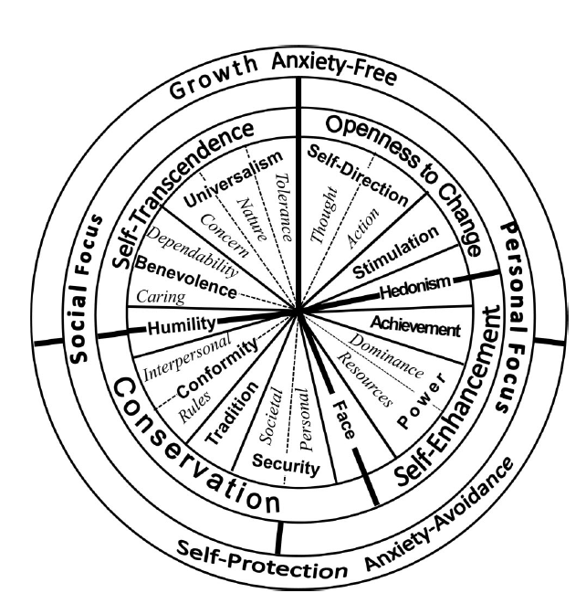

Reproduced from Schwartz, 2012, p. 669.We have added highlighted higher order LIB values.

Figure 2: Theoretical Model of Direct and Indirect Relationships among Religiosity, Liberal and Conservative Values and Liberal Attitudes Towards Social Policy

A picture containing text, map

Description generated with very high confidence

Figure 3a: Mean Scores of Support for Liberal Social Policies

By Level of Religiosity in 14 Cultures

Figure 3b: Percentage of Highly Religious and Non-Religious Students (n=4964) in the 13 Countries of the YARG Study

Figure 4: Path Analysis of Overall YARG Sample, from Individualism vs. Collectivism Cultural Index to Social Policy Preferences according to Gender, Religion and Liberal Values

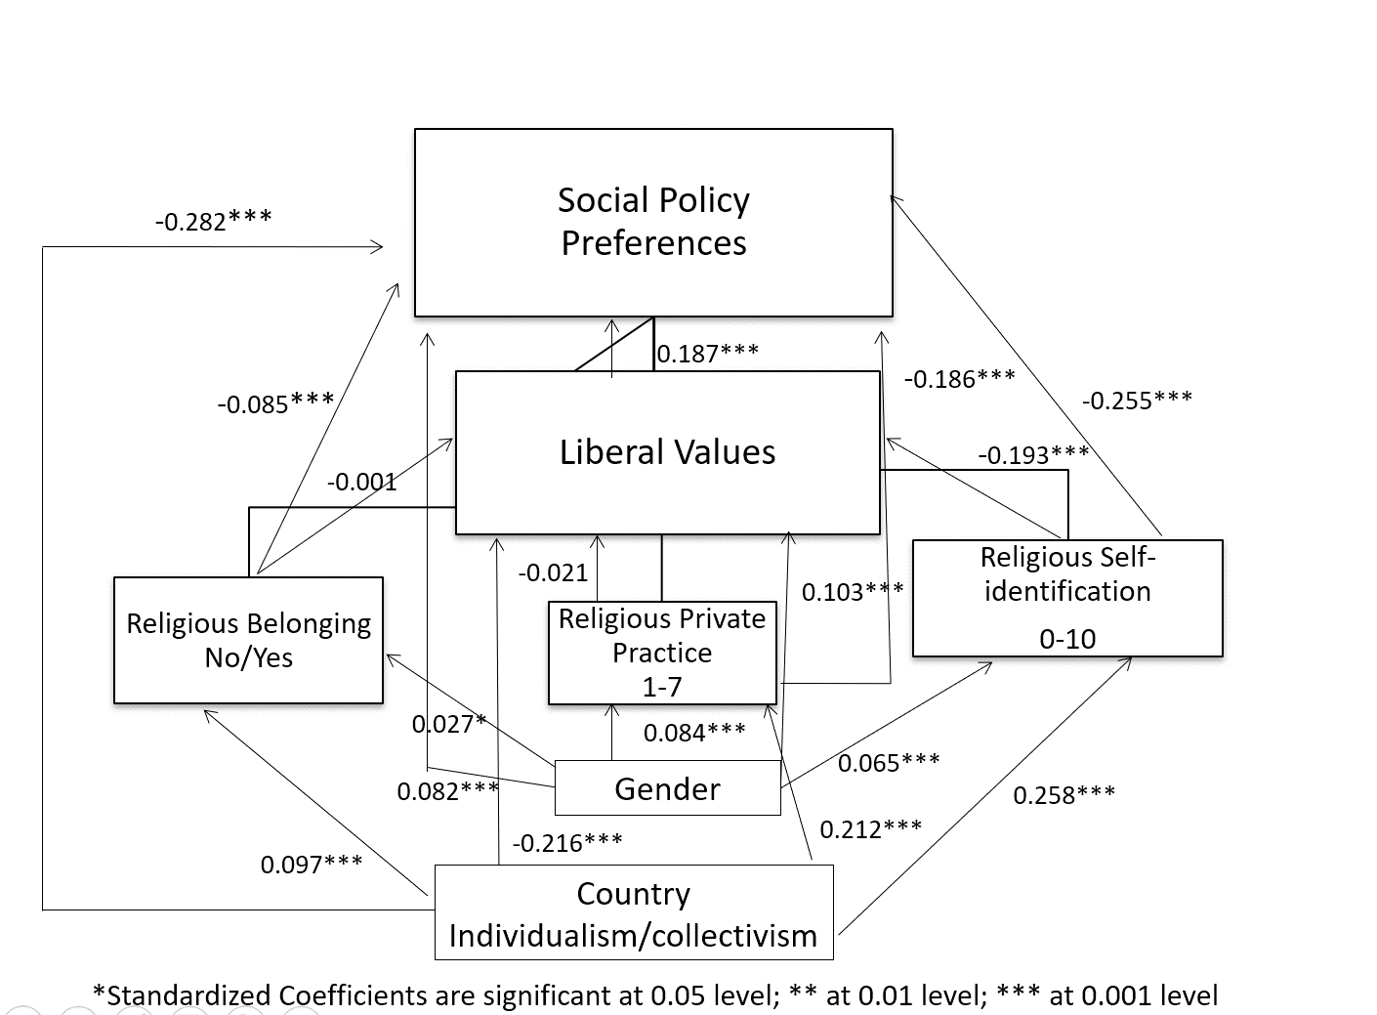

Figure 5: Path Analysis of Overall YARG Sample, from Individualism vs. Collectivism Cultural Index to Social Policy Preferences according to Gender, Religion and Conservative Values

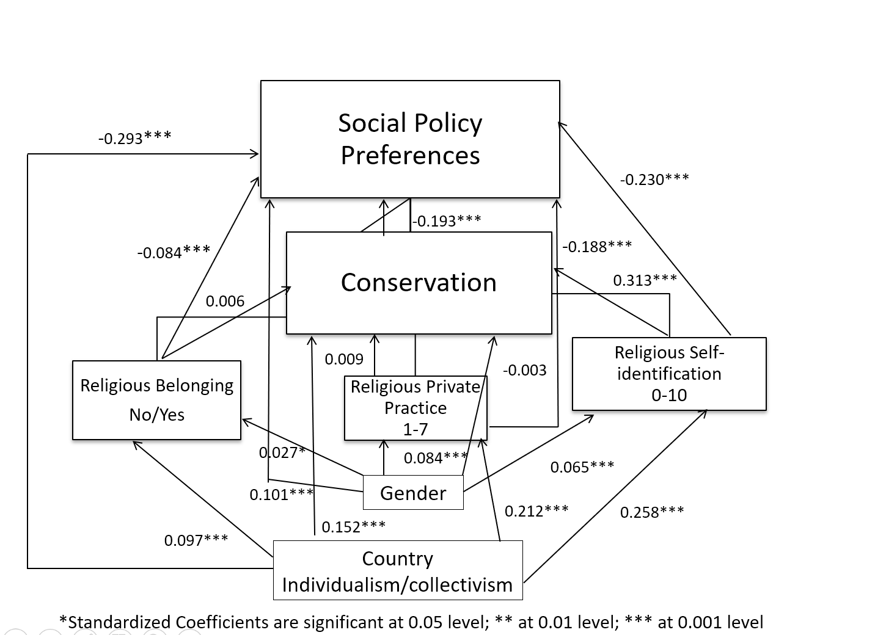

**Tables:**

Table 1: Rankings of 13 YARG Countries by their Location on Hofstede's (2011) Ranking of 76 Countries by Cultural Dimensions (Individualism vs. Collectivism) and Power Distance

|  |  |
| --- | --- |
| Individualism vs. Collectivism | Power Distance |
| Most Individualism | Lowest Power Distance |
| 1: United States | 1: Israeli Jews |
| 2: Canada | 2: Sweden |
| 3: Sweden | 3: Finland |
| 4: Finland | 4: Canada |
| 5: Poland | 5: United States |
| 6: Israeli Jews | 6: Japan |
| 7: Japan | 7: Peru |
| 8: India | 8: Turkey |
| 9: Russia | 9: Poland |
| 10: Turkey | 10: Israeli Arabs |
| 11: Israeli Arabs | 11: India |
| 12: China | 12: Ghana |
| 13: Ghana | 13: China |
| 14: Peru | 14: Russia |
| Most Collectivism | Highest Power Distance |

Table 2: Linear Regression: Predictors of Social Policy Preferences

|  |  |  |
| --- | --- | --- |
| **Variable** | **Standardized Beta Coefficient** | **R2 hange** |
| Religious self-identification | -0.225*** | 0.273 |
| Individualism vs. collectivism | -0.276*** | 0.108 |
| LIB values | 0.126*** | 0.036 |
| Private-religious practice | -0.183*** | 0.024 |
| CONS values | -0.131*** | 0.010 |
| Gender | 0.087*** | 0.008 |
| Religious belonging | -0.085*** | 0.005 |
| *<0.05; ***<0.001 |  | **R2=0.464** |

Table 3: Support of Social Policies Regression Analysis for Each Country by LIB Values and Religiosity

|  |  |  |  |
| --- | --- | --- | --- |
|  | **Standard Coefficients** | |  |
| **Country** | **Religiosity** | **Liberal values** | **R2** |
| Israeli Jews | -0.688 | 0.091 | 0.508 |
| Finland | -0.584 | 0.137 | 0.366 |
| Poland | -0.51 | 0.222 | 0.364 |
| Sweden | -0.466 | 0.136 | 0.242 |
| Canada | -0.434 | 0.238 | 0.282 |
| Israeli Arabs | -0.404 | 0.186 | 0.22 |
| Russia | -0.395 | 0.313 | 0.318 |
| Peru | -0.387 | 0.271 | 0.269 |
| Turkey | -0.342 | 0.286 | 0.254 |
| U.S. | -0.327 | 0.262 | 0.197 |
| India | -0.205 | 0.165 | 0.084 |
| Ghana | -0.201 | 0.0871 | 0.048 |
| China | -0.0981 | 0.0481 | 0.011 |
| Japan | -0.0361 | 0.209 | 0.046 |

Table 4: Support of Social Policies Regression Analysis for Each Country by CONS Values and Religiosity

|  |  |  |  |
| --- | --- | --- | --- |
| **Country** | **Standard Coefficients Religiosity** | **Standard Coefficients Conservatism** | **R2** |
| Israeli Jews | -0.666 | -0.088 | 0.506 |
| Finland | -0.516 | -0.218 | 0.39 |
| Poland | -0.488 | -0.167 | 0.339 |
| Sweden | -0.45 | -0.143 | 0.244 |
| Canada | -0.421 | -0.174 | 0.254 |
| Russia | -0.42 | -0.224 | 0.274 |
| Israeli Arabs | -0.383 | -0.216 | 0.231 |
| Peru | -0.329 | -0.258 | 0.252 |
| Turkey | -0.3 | -0.322 | 0.267 |
| U.S. | -0.291 | -0.254 | 0.19 |
| Ghana | -0.184 | -0.0841 | 0.047 |
| India | -0.172 | -0.244 | 0.113 |
| China | -0.098 | -0.142 | 0.029 |
| Japan | -0.0421 | -0.106 | 0.013 |

1 Not statistically significant

1. Some studies on values and ideology have used the conservative-liberal distinction, while others have used the left-right distinction. Typically, the former implies a broader range of attitudes on social and moral issues, while the latter refers to political voting preferences. The differences between the two are often a matter of convention. In some countries, such as the United States and the United Kingdom, use of the terms conservative-liberal is preferred (consequently used in survey questions), while most European countries prefer the left-right distinction. Often the two sets of terms are used side by side or interchangeably, with right associated with conservative and left associated with liberal (Caprara et al., 2017). We follow Schwartz in preferring the terms conservative-liberal because of their broader range and utility (Schwartz, Researchnet, May 2018).
2. This does not mean that liberalism-conservatism is the *only* meaningful dimension organizing political ideologies. A multi-dimensional space probably better reflects political ideology differences among individuals (Schwartz, Caprara & Vecchione, 2010), with the liberal-conservative polarity being but one of the dimensions (Barnea & Schwartz, 1998).