

Atlas Dynamics

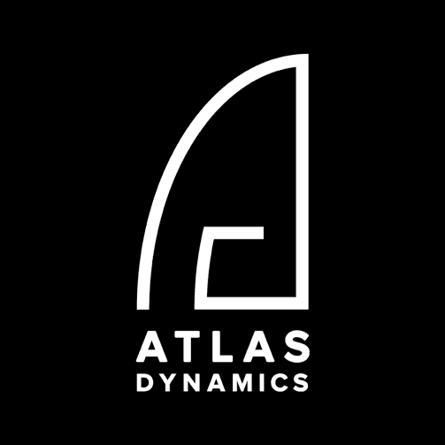

February 2021

Company Overview & Evaluation Report

**Table of Contents**

Investment opportunity summary ………………………………………………………………………..……….…… 3

The challenge: Autonomous, multi-task & robust DIB …………….……………………………………….… 10

The solution: Atlas Dynamics ………………………………..…………………………….……......................... 10

DIB (Drone-in-a-box) Market Size and dynamics ……………………………………………..……………...… 14

The competitive landscape ……………………………………………………………………………………… ……..... 20

Atlas financial analysis & valuation …………………………………………………………………………… … ….… 27

Appendix: Capital Asset Pricing Model (CAPM) model for Atlas ………………………………..…….… 29

**Investment Opportunity Summary**

Autonomy is the single most important feature driving demand for future defense and security drone solutions. As autonomy improves, drone-in-a-box (DIB) providers will make up an increasingly large percentage of those domains.

**Increased demand for autonomous drones, advanced AI that streamlines data collection and processing, and growing interest in solutions that can remotely conduct repeatable inspections are the primary drivers of the DIB market.** Overall, improved autonomy is facilitated via enhanced sensor robustness, computing power, and software. This can include precision landing systems such as those provided by robust charging pads. In addition, software that enables unmanned traffic management will utilize information from autonomous drone flights.

This has led to **a growing trend of drone-agnostic DIB solutions coming to market.** While these solutions are generally less capable than DIB products with proprietary drones, as commercial off-the-shelf (COTS) drone technologies advance in the coming years there will be fewer distinctions between agnostic and proprietary DIB solutions. In particular, global militaries have shown increased interest in deployable DIB (“off-the-shelf military”) solutions that enable them to conduct surveillance and intelligence-gathering operations while minimizing threats to personnel.

On the other hand, there remain several roadblocks to market growth. The most significant of these is regulatory restrictions that require pilots to maintain visual contact while operating commercial drones; however, FAA restrictions and conservative approaches toward the adoption of new tactical technological solutions on the battlefield also represent limitations.

**Nevertheless,** **technological advances and demonstrations of safe operations have led to increasingly permissive waivers to regulations in some regions—thereby catalyzing market potential growth.**

**The solution: Atlas Dynamics**

**Atlas Dynamics is a designer and manufacturer of autonomous UAV systems for professional use cases that work with prominent defense, security, and infrastructure institutions in the U.S., E.U., and Israel.**

The company portfolio can meet most demands and trends of the DIB market, particularly in the defense and security domains. In addition, Atlas Dynamics develops DIB solutions based on continuous evaluation of the sensors, processors, and software that enable autonomous operation. The company integrates both existing and new technologies into its products, and has a strong R&D function. This applies to the drones, their docks, and all associated data-storage and -processing services the company offers.

**Atlas Dynamics is particularly known for its sensors and subsystems, which are smaller than those of competitors and can improve platform aerodynamics** while reducing weight; this helps platforms achieve longer flight durations even if battery energy densities remain the same. With regard to charging drone platforms, which are almost all fully electric, Atlas Dynamics’ DIB solutions either charge the battery via a charging pad or use an interior mechanism to swap the depleted battery for a pre-charged one. Overall, the solutions provide high value in battlefield or other extreme situations for end-users.

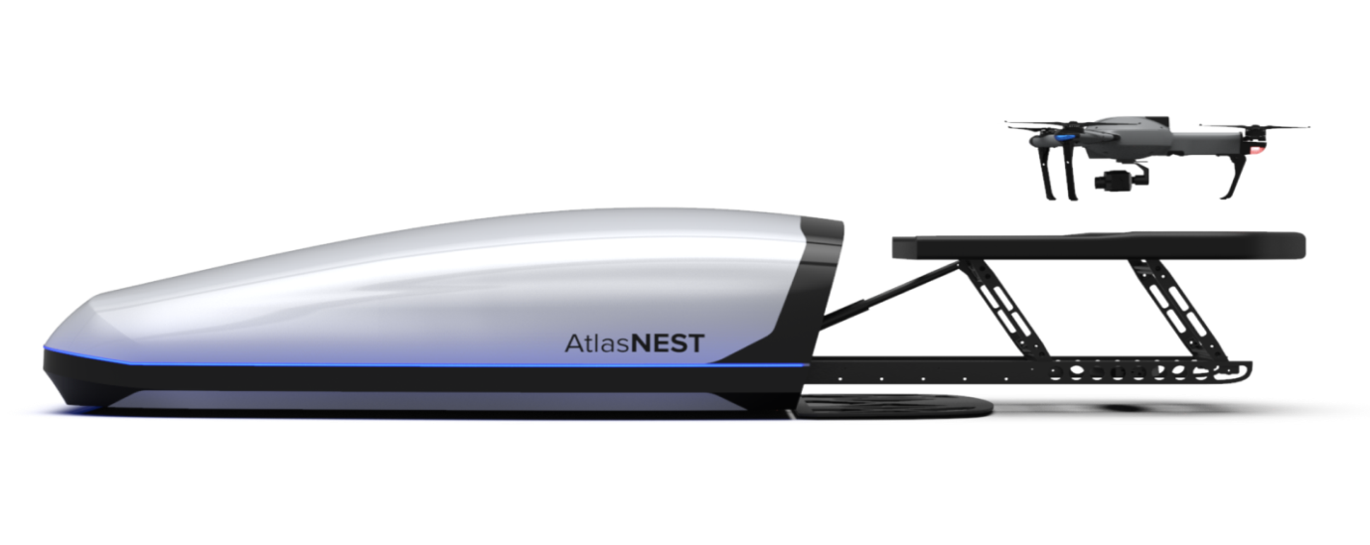

After reviewing the DIB market in depth, it is clear that **the company is well-positioned in this field, where there has been increased demand for autonomous drones to conduct military applications and for DIB solutions for use in austere and urban environments, mainly for security purposes.**

Indeed, the company’s military-grade drone has become popular with European defense entities and NATO. In addition, there has been significant penetration into the security market (European homeland security agencies) via its Atlas Pro drones, which are designed to operate in conditions of extreme cold for hours.

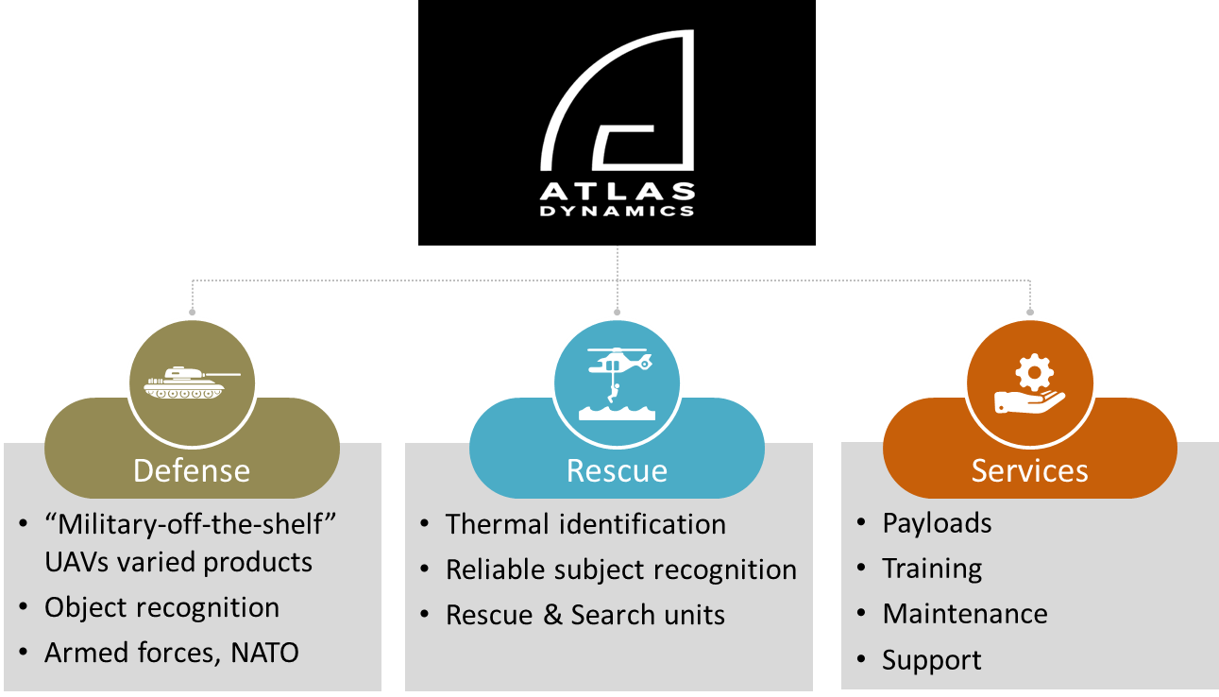

While the DIB market is nascent, it is poised for growth. After an initial period when it was difficult to defend business cases because of regulatory restrictions, which caused some early competitors to fail, the market is now buoyed by advances in enabling technologies and increased regulatory openness and acceptance. Some companies[1] tried to provide solutions before the market demand was there, and before technology and regulations allowed. Thus, the market is mainly bifurcated by the type of drone utilized and how drone batteries are charged.

**The DIB market**

After an initial period when it was difficult to defend business cases because of regulatory restrictions, which caused some early competitors to fail, the market is now buoyed by advances in enabling technologies and increased regulatory openness and acceptance, due to end-users’ (armed forces, homeland security agencies) desire to deploy new low-cost and effective tactical platforms.

**As a demonstration of the DIB market’s potential growth, according to Frost & Sullivan the market was worth an estimated $47.5 million in 2020 and is expected to increase to $865.9 million by 2024, for a total value of nearly $2 billion over a five-year period.**

After 2021, the DIB market growth rate is forecast to be relatively consistent. This could be affected by the potential acceleration of favorable regulations, but will still be tempered by the relatively high cost of DIB systems. Based on the present trajectory, DIB market revenue should exceed $1 billion by 2025.

It should be noted that as the DIB market matures, the cost per system should decrease due to economies of scale. This, coupled with favorable regulations, could lead to years of significant growth beyond the forecast period.

While DIB companies providing solutions that utilize proprietary drones will aim to drive down costs, drone-agnostic DIB solution providers will continually integrate more capable drones into their docking stations and garages. This should lead to more equal revenue distribution between segments as the market matures.

While both system and revenue CAGRs are greater than 100% over the forecast period, it is important to highlight that the growth rate from 2020 to 2021 is nearly 300%, which has a significant effect on the overall CAGR spread over only four periods.

In sum, companies that can efficiently scale up manufacturing will gain a strategic advantage. This factor will likely favor growth in the drone-agnostic DIB solutions market because there will be fewer roadblocks to the mass manufacture of less-complex solutions.

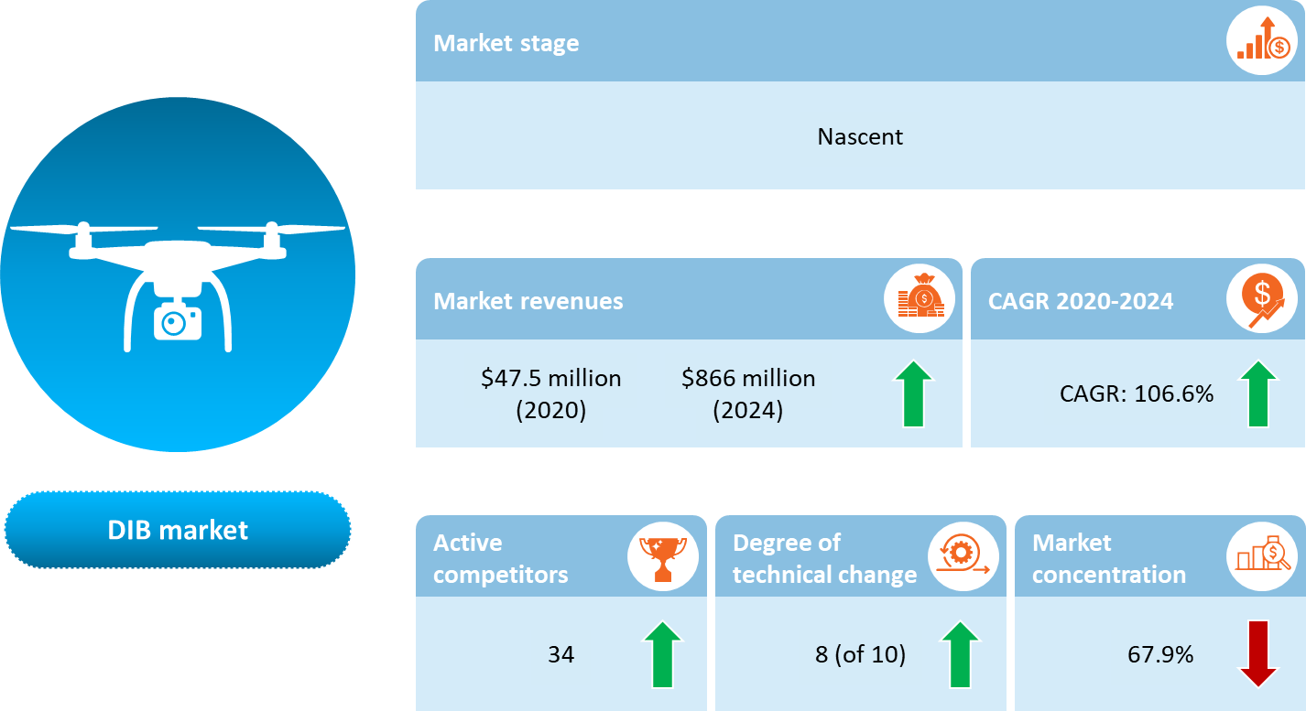

**Based on our full analysis, we value the company's equity in the range of $65.4 million to $73.3 million, and on average $69.2 million.**

**The Challenge : Autonomous, Multi-Task, and Robust DIB**

Autonomy will continue to drive the DIB market. The greater a drone’s autonomy, the more in-demand it will be. Developing hardware and software to improve the autonomous flight characteristics of both COTS and proprietary drones represents a significant growth opportunity for DIB providers, commercial drone OEMs, and third-party software providers.

In order to operate autonomously in low-altitude environments, small unmanned aerial systems (UASs) will be required to avoid other airborne vehicles. **Detect-and-avoid (DAA) capabilities enabled by various sensors** are emerging as the primary means of risk mitigation for autonomous drone operations. There is thus significant opportunity for companies that can provide robust DAA solutions.

Small, autonomous drones are becoming more popular for interior applications such as mobile security and inventory management, mainly because the operation of drones inside large buildings is not subject to the same strict rules that govern such operation in regulated airspaces. As such, the **size, weight, and power (SWaP) of drones’ sensors and subsystems** on have major impacts on the capabilities of each platform. Power refers to the amount of electrical load required to operate a sensor or subsystem on the drone.

**Atlas Dynamics: New Capabilities, New Applications, New Markets**

Atlas Dynamics’ portfolio can meet most demands and trends in the DIB market, and represents the next evolution in the DIB line of products.

Atlas technology allows the user to operate several UAVs in tandem on the same mission, as well as in multiple locations. This technology is not only cost-effective but also allows for near-limitless surveillance and enables the user at the C2 station to seamlessly collect data.

Battery technologies that provide the same energy density in a smaller form factor, or that can provide increased power in the same form factor, can also contribute to optimizing SWaP. As such, the company’s DIB platforms reflect its high energy standards (in terms of power to size ratio).

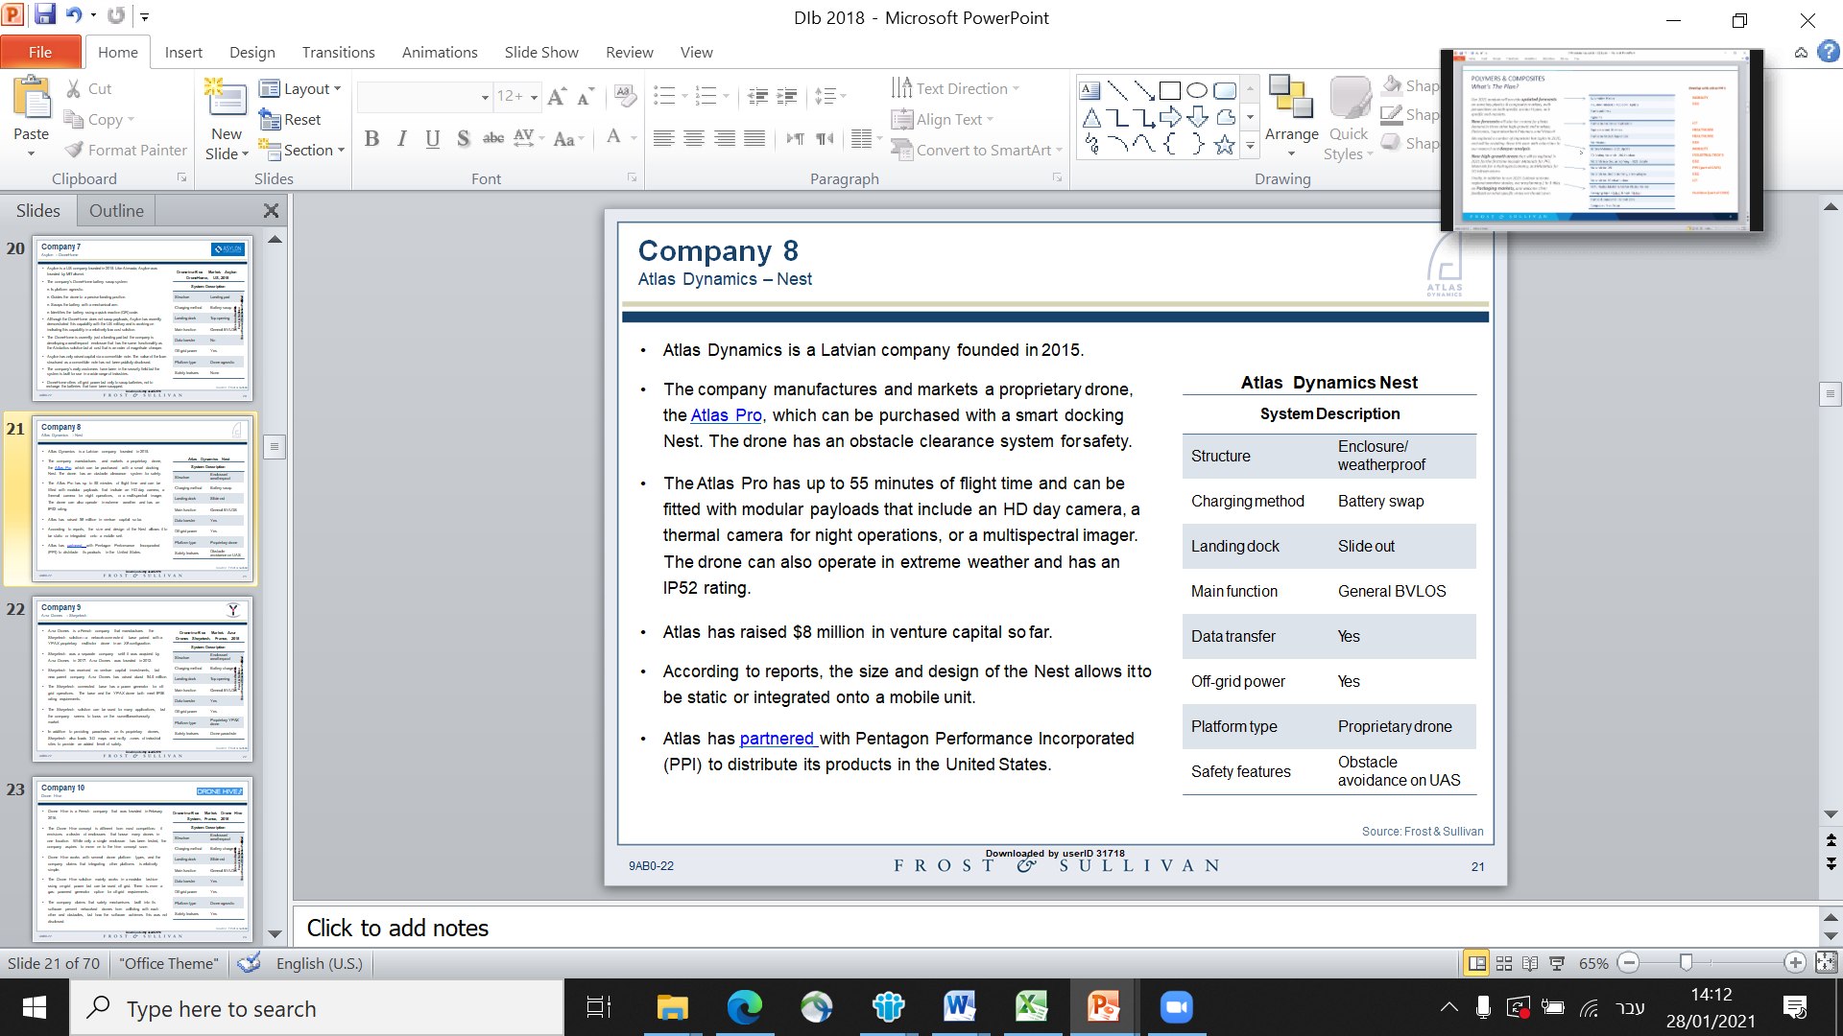With regard to the line of products, the main display is the **AtlasNEST**, an advanced docking station for autonomous takeoff, landing, and battery swapping. The primary [use of the technology](https://cts.businesswire.com/ct/CT?id=smartlink&url=https%3A%2F%2Fwww.youtube.com%2Fwatch%3Fv%3DVWLMAnjtdAU%26feature%3Dyoutu.be&esheet=51976681&newsitemid=20190430005308&lan=en-US&anchor=use+of+the+technology&index=3&md5=0a0f8e28b1e21d3447ea7bdb32ca025e) is for perimeter security and first response at sensitive facilities, providing C2 with accurate real-time data without risking human operators during real-time decisions. The AtlasNEST provides a wide array of deployment capabilities for constant readiness and preplanned missions. It is designed for the company’s proprietary AtlasPRO UAV—a versatile, high-end platform with an operating time of 50 minutes, a communication range of 10 km, HD streaming, the ability to survive extreme conditions, and optional modular payloads that include an HD day camera, a thermal camera for night operations, and a multispectral imager. The drone can also operate in extreme weather and has an IP52 rating.

Recently, the company launched the **AtlasMESH** Multi-UAV Communication System. This incorporates three unique features: control of multiple UAVs from one ground control station for continual mission operation beyond battery-life limitations through the "UAV Hot Swap”; video stream from one UAV to numerous ground control stations or smartphones; and the use of an AtlasPro UAV as a physical relay.

With regard to R&D, the company is currently testing the additional AI-based module for its line of UAVs, with the intention of enhancing operational and data analytics DIB capabilities.

Atlas Dynamics’ extended product line represents lucrative opportunities for growth and expansion into other DIB applications and uses in the very near future. Notable among this line are the following:

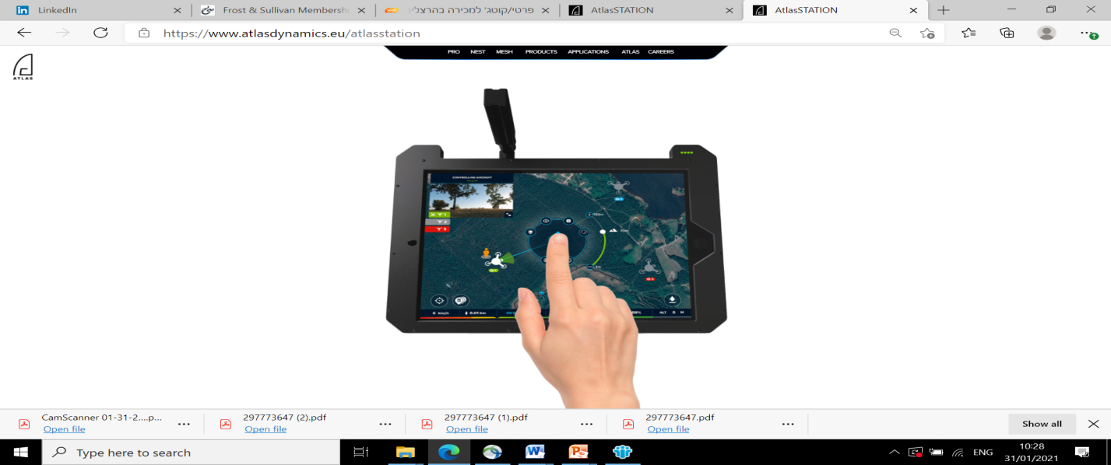

* 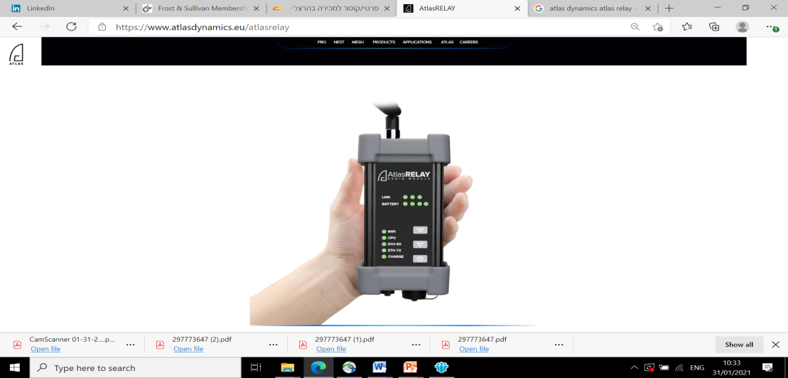**AtlasSTATION.** This portable and easy-to-use ground control station was created with simplicity of operation as its core guideline. This aircraft was designed such that even those with no experience can fully utilize all AtlasPRO capabilities in just a few hours’ time, enabling more users in the team to learn how to operate our drones.
* **AtlasRELAY.** This is a portable relay module to BVLOS datastream. It serves as a mediator between drone and operator to control UAVs behind a line of sight, and increases coverage and capacity between AtlasPRO and AtlasSTATION in the targeted areas.

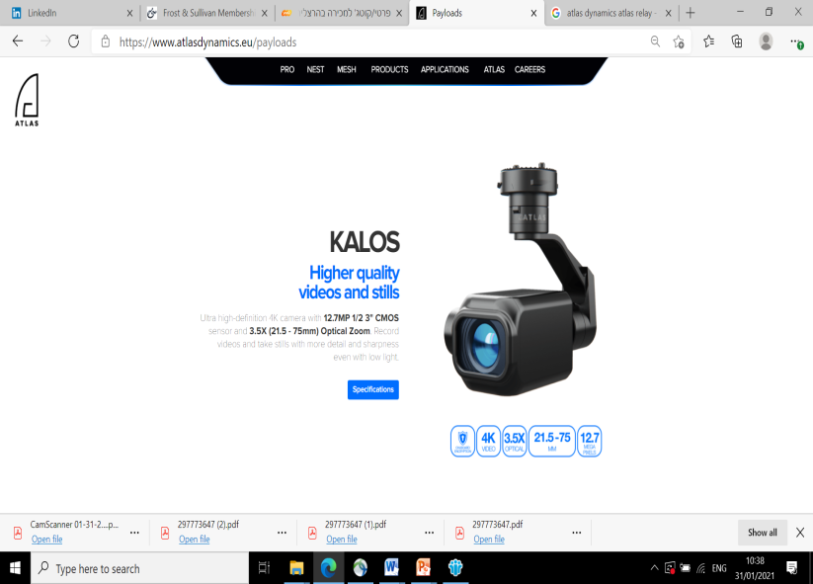

* **Payloads.** These areinterchargeable sensors (plug & play as a USB stick), suitable for a wide variety of missions. Atlas selects high-quality sensors and builds payloads around them, increases their functionalities, and adds a proprietary three-axis gimbal, all of which contribute to maintaining a clear and stable image even under extreme weather conditions.

***The Team **pls fill in\*\****



**Jacob BenArie**

**CEO & Co-founder (MBA**)

Experience: Managing Director, Q2Pharma;

CEO of Betalin Therapeutics; Beta-Stim; Orgenesis (Nasdaq: ORGS); Sender Medical



**Prof. Jesse Yishai Lachter**

**Chief Medical Officer & Inventor**

Experience: Gastroenterologist, Prof. of medicine, and former Head of EUS Service, Rambam Health Care Campus.



**Eli Ben Porat**

**Head of Business Development (MBA)**

Experience: VP Business Development & Sales, Nrgene; Director of Biz Dev, Zeraim Gedera (sold to Syngenta for $95 million).

**Market estimations for Atlas dynamics applications**

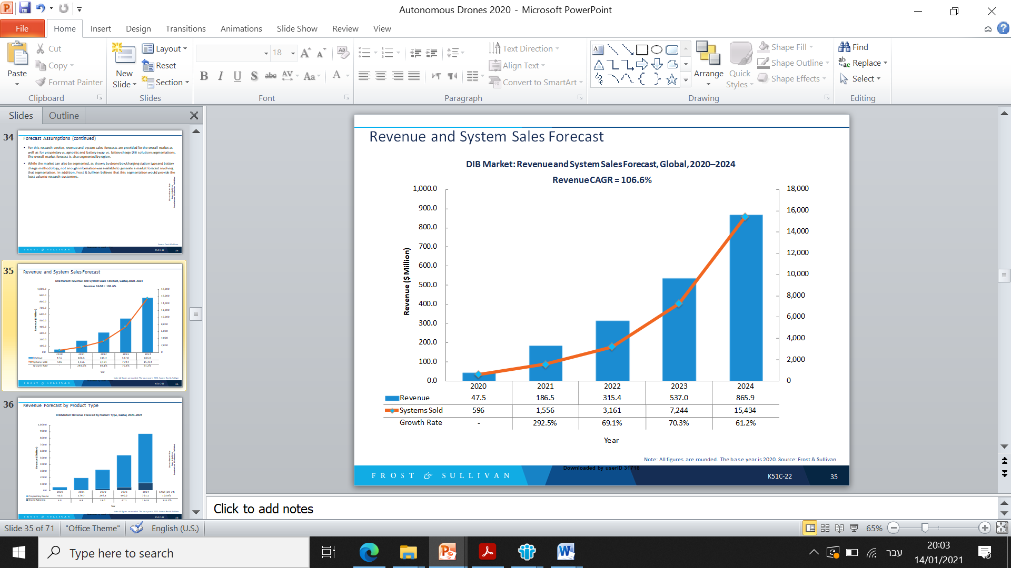Between 2020 and 2024, the DIB market is expected to generate more than $1.95 billion in revenue; 2020 is the first year in which this market has generated significant sales.

After 2021, the DIB market growth rate is forecast to be relatively constant. This could be affected by a potential acceleration of favorable regulations being implemented, but even then will still be tempered by the relatively high cost of these systems. On the present trajectory, DIB market revenue should exceed $1 billion by 2025.

As the DIB market matures, cost per system should decrease due to economies of scale. This, coupled with favorable regulations, could lead to years of significant growth beyond the forecast period.

Revenue from DIB solutions that utilize proprietary drones is forecast to far outpace revenue from drone-agnostic solutions; however, drone-agnostic system sales are expected to exceed proprietary drone solutions after 2023. This is mainly because of the much lower cost of DIB solutions that utilize COTS drones.

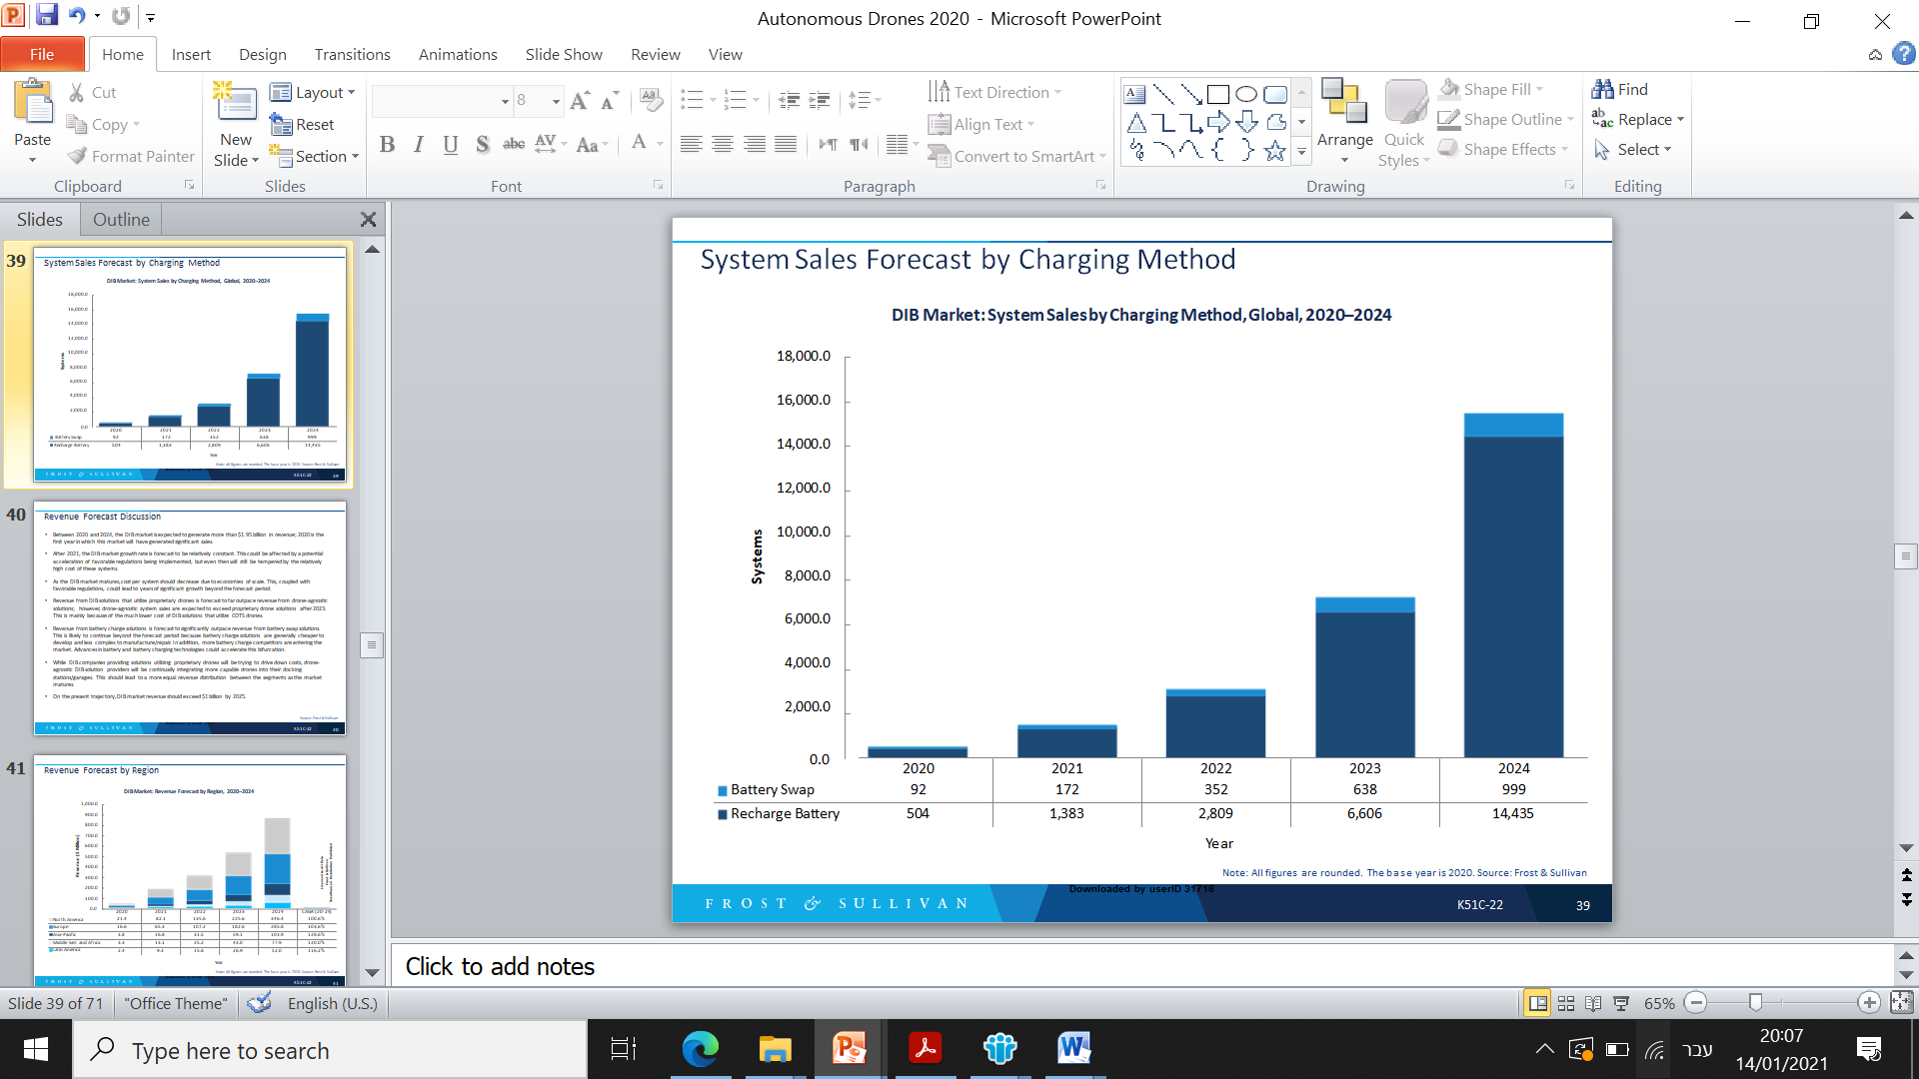Revenue from battery charge solutions is forecast to significantly outpace revenue from battery swap solutions. This is likely to continue beyond the forecast period because battery charge solutions are generally cheaper to develop and less complex to manufacture/repair. In addition, more battery charge competitors are entering the market. Advances in battery and battery charging technologies could accelerate this bifurcation.

While DIB companies providing solutions utilizing proprietary drones will be trying to drive down costs, drone - agnostic DIB solution providers will be continually integrating more capable drones into their docking stations/garages. This should lead to a more equal revenue distribution between the segments as the market matures.

While both system and revenue CAGRs are greater than 100% over the forecast period, it is important to highlight that the growth rate from 2020 to 2021 is nearly 300%, which has a significant effect on the overall CAGR spread over only 4 periods.

Per-system price will decrease from about $77,000 to $53,400 over the forecast period. This shows that competitors expect sales costs to decrease substantially as demand forces production at scale.

Companies that can efficiently scale up manufacturing will gain a strategic advantage. This factor will likely favor growth in the drone-agnostic DIB solutions market because there will be fewer roadblocks to mass manufacturing of less-complex solutions.

**In terms of global venture capital investments** **so far**, as most participants in the market are start-up companies, 2018 and 2020 represent a pick in investments, with $148.2M and $184.9M in respectively.

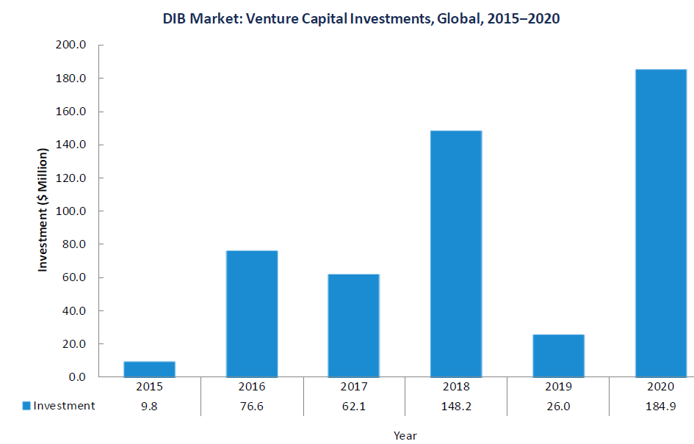

**From a regions perspective**, although North America and Europe will have the largest market shares, they also exhibit the lowest CAGRs. This is mainly because these were the first regions to adopt DIB technologies. Still, North America is forecast to be the largest region in 2024, with almost 40% share of the global market.

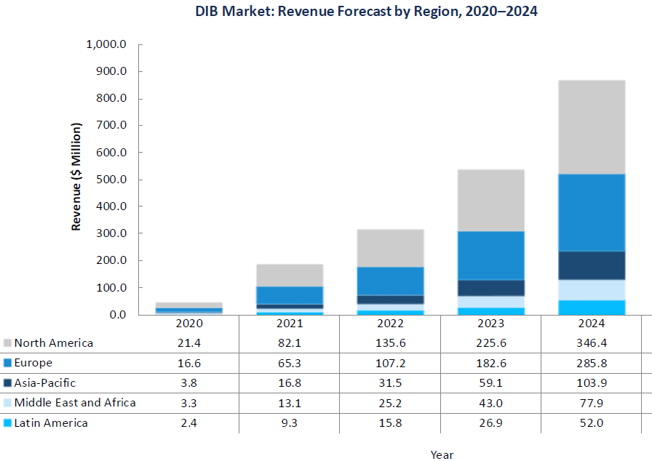

Among solutions that are targeting a single application, the two applications that are most popular are package delivery and security. Other applications are Oil and Gas, Precision agriculture, and others. In surveillance, it could also include long-distance inspections of things like power lines, pipelines, and railroads.

**The market is nascent and is expected to exceed $865 million in revenue by 2024. The demand for autonomy in commercial drone operations to minimize manpower costs and maximize return on investment (ROI) is the most impactful driver of DIB market growth.**

**Although the DIB market is nascent, it is on the verge of achieving strong growth. To Frost & Sullivan assessment, the market worth an estimated $47.5 million in 2020 and grow to an expected total of $865.9 million by 2024 for a total value over a 5-year period of nearly $2 billion.**

After a lull in 2019, 2020 was a banner year for venture capital investment in companies that are providing, or plan to provide, DIB solutions. **Expect this investment to continue for the next several years as the market transitions from nascence to growth**

***Market trends***

There seems to be a trend toward drone enclosures and landing pads utilizing inductive charging to eliminate the need for making electrical contacts.

Less-expensive drone enclosures favor using off-the-shelf consumer and prosumer drones to keep overall system costs down, while expensive, large enclosures hope to gain market share by offering on-demand industrial applications 24/7.

Most large investments continue to favor DIB companies that manufacture larger, weatherproof enclosures that utilize proprietary drones. Among solutions that are targeting a single application, the main applications that are most popular are package delivery, security and military, as armed forces search for more autonomous solutions that act as force multipliers and are generally not limited by commercial use regulations. In addition, military services are less sensitive to the relatively high cost of proprietary DIB systems.

***Market drivers***

**The Demand for Autonomous Drones is Accelerating, Especially for Urgent Operations:**

* Autonomy is the single most impactful feature of airborne drones that will drive demand for DIB solutions.
* The entire concept behind DIB solutions is providing customers with an automatic method for completing, or enhancing, operations that have been historically conducted by human workers.

**Autonomous drone demand is driven by the fact that autonomy:**

* Reduces the total amount of manpower, which is one of the highest costs of most business operations.
* Allows for certain applications to be conducted in a faster manner and with more precise data when compared with traditional methodologies.
* While militaries are demanding more autonomous systems, it is expected that commercial demand will outpace military demand as regulations become less restrictive.

**AI is Expanding the Ability for Autonomous Drones to Execute a Wider Range of Applications:**

* AI is advancing rapidly and there is a noticeable competition between software developers to create
* The best learning models for capturing, processing and disseminating data.
* Most operators were not prepared for the overwhelming amount of data that drones can gather. AI will increasingly assist with filtering unneeded or unwanted data while more precisely identifying and categorizing targeted data.
* A growing number of companies, such as Alphabet/Google, are providing [real-world datasets](https://ai.googleblog.com/2020/11/announcing-objectron-dataset.html) to inform and train machine learning models and deep learning algorithms. Overall, robust AI will reduce the time to data in most drone applications.

**Demand is Increasing for Drone-based Solutions in Remote or Austere Locations that Require Frequent, Repeatable Operations that can Provide Telepresence**

* The logistics to conduct drone operations can be considerable, especially when operations are being conducted in locations supported by limited infrastructure.
* The energy and construction industries are increasingly demanding and adopting technologies that allow them to inspect structures and assets remotely. This capability results in cost savings and improved safety.
* Frequency and repeatability are both strongly supported by on-site DIB solutions, especially if they have the flexibility to operate on or off the electrical grid.

**The COVID-19 Response has Highlighted the Benefits that Drones can Provide:**

* The pandemic is creating more demand for solutions that require little or no human interaction. In addition, it is becoming clearer that drones can replace manpower in several operations / applications.
* The growing need to deliver critical medical supplies and other items has created more opportunities for small drones and DIB solution providers.
* In general, the COVID-19 response has resulted in a heightened awareness that drones can provide cost and safety benefits in daily operations during black swan or gray rhino events. This has led to a concerted effort to accelerate regulatory reform that permits more commercial drone BVLOS operations.
* COVID-19 has had both positive and negative effects on the DIB market. On the positive side, the pandemic response has caused an increase in demand for autonomous drone solutions. On the negative side, DIB competitors have been unable to provide potential clients with live product demonstrations. The positive effects of the COVID-19 response seem to be far outweighing the negative.

**Some DIB Solution providers are promoting the DIB-as-a-service and drone-on-demand business Models**

* DIB-as-a-service seeks to provide specific solutions to clients on a subscription basis that would be charged monthly or annually.
* A few companies are exploring drone-on-demand by placing DIB solutions around a specified area then allowing clients to request drone services as needed. These services would be charged on a per-flight basis.
* Both business models aim to provide services/solutions while removing the upfront fixed costs which can be prohibitive to small businesses.
* Expect more technology companies to investigate this model as demand for autonomous drones grows.

***Market restrains***

**Because Global Regulations Generally Require Pilots to Keep Commercial Drones within the Visual Line of Sight, DIB Solution Demand has been Limited**

* The greatest advantage of autonomous drones is that they can reduce manpower costs. As long as regulations require pilots to maintain in-person visual contact with their drones, the benefit of autonomy will be curtailed.
* There has been progress with global regulatory agencies allowing more BVLOS drone flights; however, most of these waivers have still required visual observers.

**Many DIB Competitors Claim to Provide Autonomous Systems, but Relatively Few have Demonstrated Mature Capabilities**

* Many DIB competitors claim advanced capabilities but many have yet to conduct enough operational flights to demonstrate proof of concept.
* More than half of current market participants are either pre-revenue or deployed their first systems in 2020.

**Some Companies Own Patents that Could Diminish Competitors’ Ability to Compete and/or Grow in Certain Regions**

* Several DIB competitors own patents on their technologies that could limit the ability of other DIB solution providers to compete in the areas where specific patents can be enforced.
* Non-DIB companies also own patents on technologies such as precision landing systems and battery swapping mechanisms. This adds to the cost and complexity of determining whether a certain DIB competitor can market its solutions in different countries.

**COVID-19 Pandemic has Limited Competitors’ Ability to Execute Product Demonstrations**

* While the response to COVID-19 has resulted in additional opportunities for utilizing small drones, related lockdowns and travel restrictions have hampered the ability of DIB companies to demonstrate the features and capabilities of their solutions.
* Some competitors have resorted to virtual demonstrations, but the effectiveness of these tactics has yet to be ascertained.
* Large companies have shown significant interested in DIB solutions; small companies often request demonstrations but, more often than not, do not purchase solutions. Virtual demonstrations could even further reduce a small company’s likelihood of investing in a DIB system.

**Market that is still used to drones operated by humans**

The drone industry is still focused on human operators conducting drone missions when, in the future, many operations will be conducted remotely. Competitors must demonstrate and educate potential customers on technological capabilities and the way ahead.

**The competitive landscape**

The DIB market is made up of 3 basic types of systems: large enclosures, small enclosures and landing pads (or stations). Large enclosures are relatively expensive but provide weather protection for larger drones and, in some cases, allow for battery swapping rather than charging only. This allows for shorter drone downtime.

Small enclosures almost always require drone charging and often provide less weather protection than the larger, sturdier enclosures. They are generally less expensive than the large drone hangars, and competitors are hoping to capitalize in industries with applications that require very portable, low-cost autonomous drone solutions.

Landing pads are the least expensive option and provide no weather protection for drones as they charge and/or drop off payloads. Most landing pad solutions are envisioned as a network of landing pads that allow flexible operations in large areas.

More than 30 DIB competitors provide autonomous or semi-autonomous DIB solutions around the globe. Current market competitors are in various stages of product development. The companies that are still in the development stage are at a distinct disadvantage to companies that have already launched products. As such, the number of market participants is expected to increase, but within five years competition will drive many underperformers out of the market. Note, that the Chinese government and companies are investing heavily in the prospect of autonomous drone operations launched from networked drone hangars and/or pads monitored from a manned control center.

Competition in this market, which will be similar to the commercial drone platform market, will be intense and require a lot of capital to weather the storm of slow regulatory progress.

Very few companies are good at all components of autonomous drone operations. Companies developing and/or manufacturing drone enclosures or landing pads may gain synergies by working with companies that have already developed robust computer vision, AI, networking, and advanced sensor capabilities.

**The top 5 companies account for nearly 70% of the current market**, but this is likely to decrease as several new entrants plan to bring solutions to market in 2021. To Frost & Sullivan assessment, the top companies in the market by estimated revenue include Atlas Dynamics, Skydio, Asylon, Easy Aerial, Percepto, Antwork, Airobotics and Azur Drones.

The top 5 companies all – mainly stationed in the U.S. and Israel[2] (Top two countries in drone technology, especially in the military space) - provide DIB solutions that utilize proprietary drones. This is mainly because drone-agnostic DIB solutions are generally less expensive on a per-unit basis and DIB companies that provide proprietary drones entered the market first.

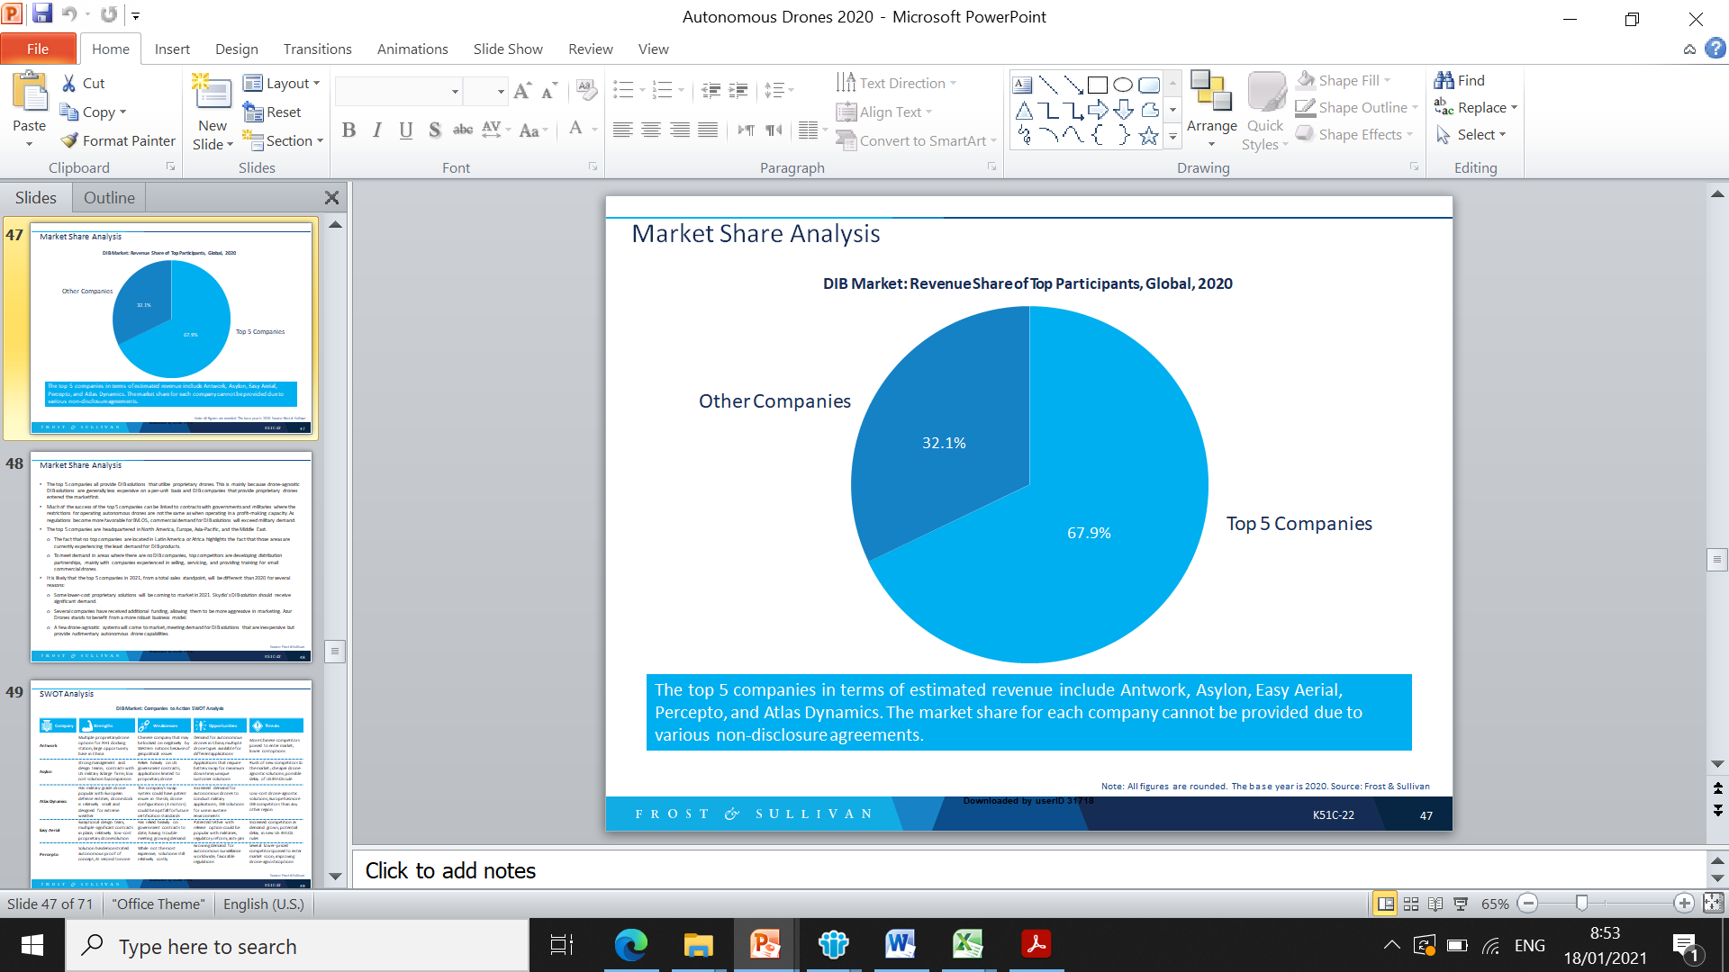Much of the success of the top 5 companies can be linked to contracts with governments and armed forces where the restrictions for operating autonomous drones are not the same as when operating in a profit-making capacity. As regulations become more favorable for BVLOS, commercial demand for DIB solutions will exceed military demand.

To meet demand in areas where there are no DIB companies, top competitors are developing distribution partnerships, mainly with companies experienced in selling, servicing, and providing training for small commercial drones.

It is likely that the top 5 companies in 2021, from a total sales standpoint, will be different than 2020 for several reasons:

* Some lower-cost proprietary solutions will be coming to market in 2021.
* Several companies have received additional funding, allowing them to be more aggressive in marketing.
* A few drone-agnostic systems will come to market, meeting demand for DIB solutions that are inexpensive but provide rudimentary autonomous drone capabilities.
* Fewer than half of market competitors currently have deployed solutions.
* Traditional defense conglomerates such as Lockheed Martin are less interested in the market in its early stages, in a way that leaves more room for small-medium players to shape demands, technologies and trends.

Following is a brief description of the top six main competitors who currently lead the DIB market: Asylon, Easy Aerial, Percepto, Antwork, Airobotics and Azur Drones

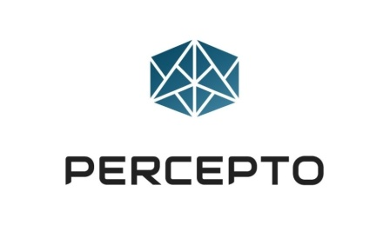

Percepto is an Israeli company founded in 2013. The company launched an Indiegogo campaign in 2015 to fund development of an add-on computer vision accessory for drones.

The company graduated from developing computer vision add-ons to creating fully autonomous drones and base stations driven by real- time computer/machine vision and advanced AI through its proprietary PerceptoCore technology. PerceptoCore is built on an NVIDIA Tegra system on a chip.

According to the company, PerceptoCore provides the capability to conduct multiple missions without human intervention. This includes a capability to [safely operate even when there is no C2 link](https://www.roboticstomorrow.com/article/2018/01/autonomous-industrial-drones/11181) to the Sparrow.

Once Sparrow lands autonomously, it can have its battery charged and perform self checks to determine whether any maintenance is required. Unlike consumer and prosumer drones, Sparrow can operate in heavy rain, snow, wind, and dust.

Unlike most competitors, Sparrow lands via computer vision every time so it does not need any GPS or communication links to dock onto a Percepto base. Percepto bases have an IP65 rating.

The company has raised $12 million, until late 2020.

**However, While not the most expensive, solution is still relatively costly. As such, several lower-priced competitors are poised to enter market soon. Also, improving drone-agnostic options pose a threat to the company.**

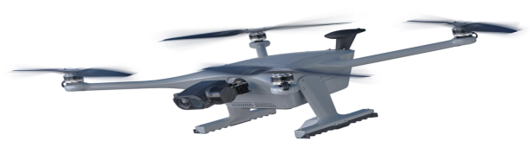

Source: Percepto



Antwork, founded in China at 2018, is a technology company dedicated to building urban aerial delivery networks. The company designs and develops drones, unmanned stations, and cloud-based UTM and operations management systems that are seamlessly integrated into smart city infrastructures. In 2019, China’s aviation authority approved the company to be the first licensed drone delivery airline in the country. The company holds large base in China, with multiple proprietary drone options for RH1 docking station. In addition, the company works with Japanese collaboration Over Drone-Based Delivery Service.

However, **this Chinese company may be observed on negatively by Western nations because of geopolitical issues.** Also, more Chinese competitors are poised to enter the market and lower cost options.

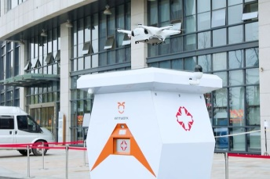

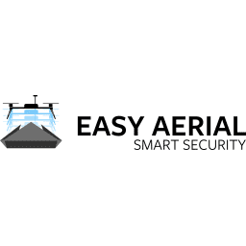

Easy Aerial, founded at 2015 in the U.S., specializes in the design, development, manufacture, and software integration of high-quality, rugged, and fully autonomous aerial monitoring solutions of multi-purpose drones for constant and on- demand surveillance without the need of human intervention. The company holds relatively low-cost proprietary drone solutions.

**However, The company has relied heavily on government contracts to date, and having difficulties in meeting growing demand. Thus, increased competition as demands grows; and potential delay in new US BVLOS rules might limit company attractiveness in the market.**

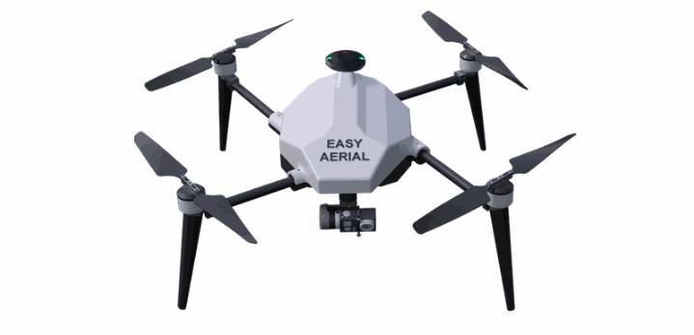

Source: Easy Aerial



Asylon, founded in the U.S at 2015, has assembled a team of roboticists, technologists, and subject matter experts with more than 50 years of combined military, civilian, and commercial experience. It labels itself as an aerial infrastructure company. The company has contracts with US military & large firms.

**However, the company relies heavily on US government contracts, while applications limited to proprietary drone. In addition, rush of new competitors to the market threatens the company business model, due to cheaper drone-agnostic solutions. Also, possible delay of US BVLOS rule can impact the company.**

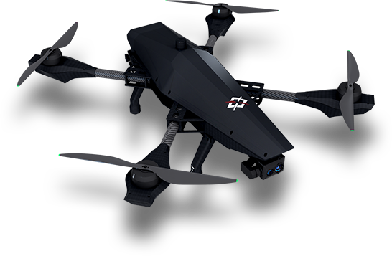

Source: Asylon

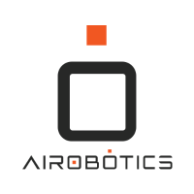

Airobotics is an Israeli startup launched in 2014. The Airobotics solution includes a proprietary drone called Optimus and an industrial-grade, fully enclosed ground station called Airbase. The company has raised $61 million in a series of funding rounds. Notable investors include Microsoft and Nokia. In 2017, it became the [first company in the world](http://www.airobotics.co.il/press-releases/airobotics-granted-worlds-first-approval-fly-fully-automated-commercial-drones-without-pilot/) certified to fly autonomous commercial drones BVLOS. The certification was CAAI and allows Airobotics to conduct UAS flights without a pilot present.

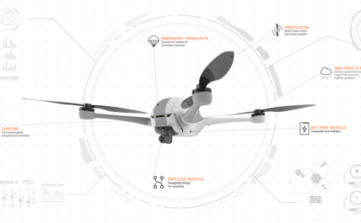

Source: Airobotics

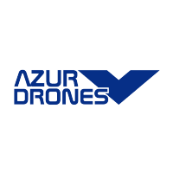

Azur Drones, founded at 2012, is a French company that manufactures the Skeyetech solution: a network-connected base paired with a YPAX proprietary multirotor drone in an X8 configuration.

Skeyetech was a separate company until it was acquired by Azur Drones in 2017. Skeyetech has received no venture capital investments, but new parent company Azur Drones has raised about $4.5 million. The Skeyetech connected base has a power generator for off- grid operations. The base and the YPAX drone both meet IP56 rating requirements.

The Skeyetech solution can be used for many applications, but the company seems to focus on the surveillance/security market. In addition to providing parachutes on its proprietary drones, Skeyetech also loads 3-D maps and no-fly zones of industrial sites to provide an added level of safety.

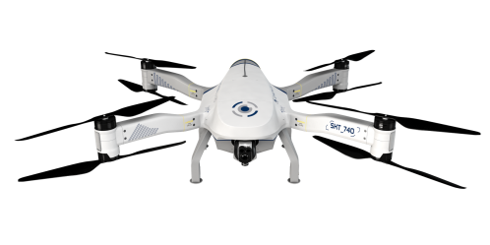

Source: Azure drones

**To frost & Sullven assessment, Atlas Dynamics expected for further business growth, due to increased demand for autonomous drones for military applications. In addition, the company DIB solutions for use in austere environment will also improve its attractiveness.**

**Financial Analysis and Valuation**

***Valuation method and approach***

Valuing a firm’s growth can be challenging due to its limited (if any) cash flow and uncertain future. In the discounted cash flow (DCF) approach (the accepted method used in financial valuations) there are several modifications to a company's growth valuation. In general, there are four primary methods to value a company:

1. Real options. This valuation method is utilized for pre-clinical and early-stage clinical programs or companies where the assessment is binary during the initial phases and based upon scientific-regulatory assessment only (binomial model with certain adjustments).
2. Pipeline assessment. This valuation method is used for early-stage companies before the market stage, where time-to-market (in terms of full operations) may be several years. The company's value is taken as the total discounted cash flow for its products or signed agreements plus unallocated costs and an assessment of its technology platform.
3. DCF valuation. This method applies to companies with products that have a positive cash flow from operations.
4. Market benchmark (multiples and recent deals). This method values the company’s growth based on multiples, whereby revenue multiples to cash flow multiples can serve as a benchmark for similar companies in a comparable growth stage.

Atlas has a solid business model accompanied by revenues and signed contracts with several multinational clients, so we expect to see rapid growth in the next few years, as well as increasing cash flow. Thus, Atlas' valuation was conducted using the DCF valuation method with growth firm elements, as we will elaborate later. We also used industry market benchmarks to validate the company’s equity value.

**Valuation Using the DCF Method**

***Revenues and gross profit forecast***

Atlas was founded in ___ by three individuals. In April 2019 Atlas raised $13 million from Fortissimo Capital Fund ($31.4 million pre-money valuation). Below is Atlas’ cap table as per January 1, 2021.

|  |  |  |
| --- | --- | --- |
| Shareholder | Shareholder name | % Issued |
| *Co-Founder* | Ivan Tolchinsky | 28.20 |
| *Co-Founder* | Guy Cherni | 8.34 |
| *Co-Founder* | Omri Cherni | 7.36 |
| *Former Employee* | Igor Zhydanov | 9.70 |
| *Seed Investor* | MYT Group Ltd. | 2.76 |
| *Series A Investor* | Fortissimo Capital Fund | 43.64 |
| *Total* |  | ***100.00*** |

Atlas’ revenues in 2020 were $2.2 million, with $1.4 million from sales of AtlasPro and approximately $760k from sales of spare parts, training, support, and maintenance. The GP margin was 53.9% and operating expenses mainly came from R&D costs ($2.7 million) and S&M and G&A of $600k.

Looking at 2021 and beyond, Atlas is operating based on contractual booking, where revenues are estimated at 50% of all bookings. Below, we present the company’s closed-won contracts for 2020, and a detailed forecast and bookings information for 2021. Based on our assumptions and assessments we provide a probability percentage for each forecast. We assume rapid growth in 2021, with estimated revenues of $10.9 million. As describe above, between 2020 and 2024 the DIB market is expected to generate more than $1.95 billion in revenue; 2020 is the first year in which this market will have generated significant sales.

Atlas is aiming to penetrate U.S. and European markets in the next few years. We assume 30% to 45% growth in our forecast. We expect Atlas to have doubled its revenues by 2024, reaching $28.7 million. We assume a conservative steady-state GP margin throughout our forecast of 57.6%, similar to our 2021 numbers.

Below, we present our revenues and GP forecast.

Below we present 2020 booking and revenues recognization:

Below we present 2021 booking and revenues recognization:

Below, we present our forecasting for the company's revenues and GP in 2021– 2027:

***Other Parameters:***

* **Opex costs** - are R&D, S&M and G&A. We maintain a steady-state relative to 2021 forecast with revenue growth, i.e., R&D costs will be a fixed 5%, S&M will be 10%, and G&A will be 4% out of revenues.
* **Tax** – Atlas is registered in Ireland with 12.5% corporate tax rate. We assume Tax payments will initiate starting from 2025 based on the company carry forward tax.
* **Working capital needs** – we assume 30 days, net out of revenues growth.
* **CAPM –** we assume 15.23% based on our CAPM (see appendix).

Below, we present our P&L forecasting for the years 2021 – 2027:



**Equity Value**

* **Non operational assets and liabilities** - the company has, as of 31/12/20, cash of $1.5M and no loans.

***Sensitivity analysis***

The table below presents Atlas' equity value matched with different capitalization rates (along with a 1.5% growth rate). We set a range of 0.5% change from our CAPM model (see Appendix).

|  |  |  |  |
| --- | --- | --- | --- |
| Terminal growth/ CAPM | 14.7% | 15.2% | 15.7% |
| 2.5% | 76,705 | 72,129 | 67,981 |
| 2.0% | 73,344 | **69,176** | 65,378 |
| 1.5% | 73,344 | 69,176 | 65,378 |

We value the Company's equity value, using the DCF method in the range of $65.4M to $73.3M and on average $69.2M

***Capital raising info***

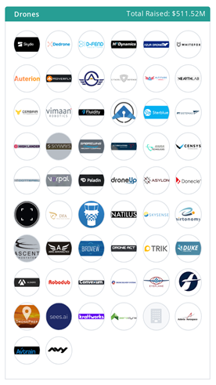We also explored recent (2019 till today) deals for drones firms by industry breakdown (Defense vs. logistics for example). We found that the vast majority of investments were with aerospace and defence as can see below (same sub industry Atlas is operating in). Also, we found that 56 deals have been made with drones firms (aerospace & defence) in 2020 in **different stages** with a **median post money** valuation of **$90.25M**.

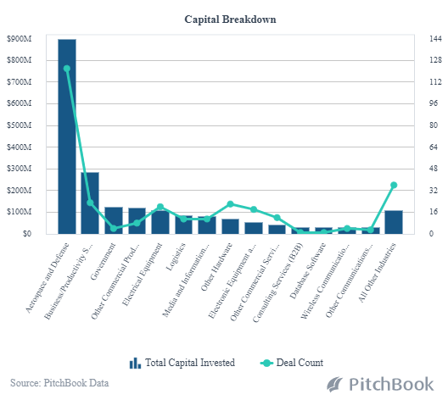

**Appendix: Capital Asset Pricing Model (CAPM) model for OnePass Medical**

The cost of equity capital (ke) represents the return required by investors. The capitalization rate is calculated using the CAPM (Capital Asset Pricing Model). It is based on Israel long-term 10-year governmental bond with a market risk premium and based on Professor Aswath Damodaran's (NY University) commonly used sample ([www.damodaran.com](http://www.damodaran.com) ). As of January 2021, the equity risk premium for Ireland was estimated at 5.54%. A three-year market regression averaged Beta is 0.86, according to a sample of 72 companies representing global Aerospace and Defense companies. We used an unleveraged beta of this sample, which is higher than a leveraged beta, due to the high rate of cash versus debt.

CAPM model (ke) is estimated as follows***: ke = rf + β(rm-rf) + P***

Atlas is considered as a small cap company, in which marketability and size premiums need to be considered. Duff and Phelps' data research in the years 1963-2020 indicates that a 10.24% premium needs to be added to the CAPM for small cap companies. We therefore estimate the company's CAPM to be 15.2%.

|  |  |  |  |
| --- | --- | --- | --- |
| CAPM Model |  | Value | Source |
| **Long-term (10 years) Bond** | R(f) | 0.23% | Ireland governmental bonds (10Y) |
| **Market Risk Premium** | R(m)- R(f) | 5.54% | Based on Professor Damodaran's sample (01/21) |
| **Beta Unleveraged** | Β | 0.86 | Averaged Beta, sample of 72 firms (01/21) |
| **Cost of Capital** | Ke | 4.99% |  |
| **Size Premium** |  | 10.2% | Duff and Phelps data, 10dz. |
| **CAPM** | **CAPM** | 15.2% |  |

1. Aerovinci went bankrupt in 2018. Aptonomy, Drone-X, and HiveUAV have also gone dark. It seems UAVIA initially planned to have a drone box, or protected docking station, but has abandoned development of that product.
2. The fact that no top companies are located in Latin America or Africa highlights the fact that those areas are currently experiencing the least demand for DIB products.