**EFECTIVENESS AND SAFETY OF A NEW DISPOSABLE VAGINAL DEVICE FOR THE NON-SURGICAL MANAGEMENT OF PELVIC ORGAN PROLAPSE (POP) IN WOMEN**

**Abstract**

Hypothesis / aims of study:

A new disposable vaginal device for the management of POP was developed. The device is inserted vaginally in small dimensions within an applicator, by the user herself, at her home environment. Within the vagina the device opens to become a ring. Following insertion, the applicator is removed and discarded and the device may remain within the vagina for up to 7 days, when the user pulls a string and the device collapses and is comfortably removed from the vagina in small dimensions, for disposal. The user may insert the next device immediately or later, at her will.

The aim of the study was to evaluate effectiveness (objective & subjective) and safety of the new disposable vaginal device, when used by the user herself at her home environment.

Study design, materials and methods

The study was prospective, multi clinic, single arm, open label, hypothesis driven and statistically powered, home use performance study. Following screening and size fitting, device usage lasted 45 days, through visit 5. During that time subjects were allowed to use as many devices as they wished, for a period of 1-7 days each. During the device usage period, subjects had to fill out a diary, denoting each device’s usage length, functionality and adverse events.

Four almost identical device models were tested sequentially. Statistical analysis was done on results from all models. The 1st performance endpoint was the percentage of subjects with an improvement from baseline of at least 1 POP-Q stage.

Results

52 subjects completed the study per protocol in 3 clinics. 24 subjects completed one part of the study, 14 completed 2 parts, and 14 used the device during 3 parts, altogether 94 usage cycles in which 992 devices were used over 3393 usage days, an average of 36.1±5.70 days per subject.

66 subjects (70.2%) had POP-Q stage 3 prolapse, while 28 (29.8%) had stage 2 prolapse, at study start. At visit 5, 90 subjects (97.8%) had complete reduction of the prolapse (stage 0), while 2 subjects (2.2%) had stage 1 prolapse. Objective assessment showed that 100% of subjects had 2 POP-Q stages reduction while using the device and 97% of subjects with stage 3 prolapse (64/66) had 3 stages reduction (p<0.0001). Subjective assessment of POP related symptoms was carried out using an author compiled symptom score which showed mean improvement from 29 to 2.7 (P<0.0001). Modified PFIQ-20 QoL questionnaire showed significant improvement in QoL, from score of 33.6 to 5.1 (p<0.0001), and modified PFIQ-7 showed improvement from 24.9 to 0.7 (p<0.0001).

There were 91 device related adverse events (AE’s), recorded in a diary, and all recovered. There were no serious AE’s, most AE’s were mild (98.9%), of short duration and anticipated (87.9%), and included mainly spotting, discomfort and some pain. Most AEs occurred within 7 days from study start, and before using the first 5 devices (learning curve). There were no cases of vaginal infections, and there was only one case of urinary infection.

Satisfaction rate was high and most users considered the device as easy to use.

Concluding message

This new disposable vaginal device for the management of POP was found to be efficacious (with significant objective prolapse reduction and subjective relief of POP symptoms) and safe for use, with minimal mild and anticipated AE’s.

**Introduction**

While minor degrees of POP affect up to 75% of women who have had a vaginal delivery[1], symptomatic POP with descent beyond the hymen affects 3% to 6% of the population[2]; Approximately 3.5 million USA women currently suffer from symptomatic POP[3], of them only 210,000 - 300,000[4] women undergo surgical interventions. Vaginal pessaries are the most common non-surgical means of management of all stages of POP[5]. Pessaries are considered to be a relatively safe method of managing POP without serious side effects.[6],[7],[8] and the ACOG practice bulletin recommends pessary trial use prior to any surgical management[9].

Existing pessaries function well, but compliance reduces over time. The median discontinuation rate was found to be 49.1%[10]. The main reasons for discontinuation were inability to insert and remove the device, failure to retain the pessary, discomfort, desire to move to another mode of treatment (e.g. surgery), and sexual disturbances.

**This study analyzed the effectiveness, safety and POP symptom improvement of** the ProVate Device vaginal ring pessary. The device is disposable, supplied in a sterile container ready for immediate insertion, compressed in an applicator during insertion, available for self insertion, maintains a inimal self-touch procedure, is easily removed by the user for sexual intercourse and is provided in six sizes..

Figure 2-The ProVate Device

Figure 1 shows the ProVate Device in different configurations, compacted and deployed, with and without the applicator, within and outside the body.

|  |  |
| --- | --- |
|  | 07.tif |
| Figure 3b-The ProVate support, within its applicator, inserted intra-vaginally. | Figure 3a The ProVate support, in its compacted mode |
| 09.tif |  |
| Figure 3d-The ProVate support in its deployed (ring shape) mode, during use | Figure 3c-The ProVate support in its narrow compact mode, without the applicator. |
|  | |
| Figure 3e-The ProVate support in its narrow compact mode, pulled out of the vagina for disposal | |

Figure 1-The ProVate Device in different configurations

**Materials & Methods**

This study assessed the effectiveness and safety of the *ProVate* vaginal pessary. The study was designed to test up to four (4) *ProVate* device models in an iterative fashion***.*** Minor design improvementswere made to each of the models tested, mainly to the applicator system, based on the results of the previous model. The objective of the study was to confirm that the ProVate Device, is effective and safe for regular use. The study was designed as a prospective, multi clinic, one arm, open label, non-randomized, non-controlled, R&D supporting, home use performance study.

Effectiveness: prolapse change was assessed by the Baden and Walker Halfway Grading for POP stage and the POP-Q scale at visit 5 and at the various visits, and POP symptoms change during the study as assessed by the POP symptom questionnaire. Change quality of life was assessed by the modified PFDI-20 and PFIQ-7 questionnaires The entire validated PFDI-20 questionnaire includes questions on various pelvic floor disorders which are beyond the scope of this study; hence subjects were requested to respond only to questions that are pertinent to POP. In this modified score, 10/20 questions of the original PFDI-20 questionnaire were utilized. Possible scores in this questionnaire were 0-4, where 0=not at all, 4=very much. Results were normalized to the 100 scale. Modified PFIQ-7. The entire validated PFIQ-7 questionnaire includes questions on various pelvic floor disorders which are beyond the scope of this study; hence subjects were requested to respond only to questions regarding POP (Modified PFIQ-7). Possible scores in this questionnaire were 0-3, where 0=not at all, 3=very much. Results were transformed to a scale of 0-100.

1. Various functional aspects of the device
2. Satisfaction and ease of use
3. POP related symptoms score was devised by ConTIPI Medical Ltd. (Caesarea, Israel) as an author compiled questionnaire. POP related complaints (symptoms) were graded 0-4 (0 being “no complaint at all” and 4 being “significant complaint”), and scores during visit 1 (before using the device) and visit 5 (while using the device) were analyzed and compared. Results were normalized to the 100 scale.

Safety

1. Rate and incidence of anticipated Adverse Events (AE). Anticipated AE’s include:
   * 1. Vaginal wall trauma (e.g. erosions, abrasions, ulcerations), Vaginal/Urine infection, pain, bleeding, discomfort, de-novo or worsening urinary incontinence and constipation.
2. Rate and incidence of Serious Adverse Events (SAE): rate and incidence of all AE’s (anticipated and non-anticipated, serious and non-serious, related and unrelated to the study device), and rate and incidence of device intactness. Adverse events were reported in one of the following methods: diary, scheduled meeting with the investigator, non-scheduled call from the subject, scheduled weekly telephone call to the subject.

Study population included female subjects, aged 21 to 80 years, who were in good general health, physically able to vaginally insert the device alone, had symptomatic sensation of vaginal prolapse, ability to attend clinic visits ability to retain 61-91 mm pessary.and POP-Q stage 2 – 4 prolapse at >=vaginal sites (Figure 2). Subjects were recruited from in three clinics (Gynecology & Urogynecology) in Israel.

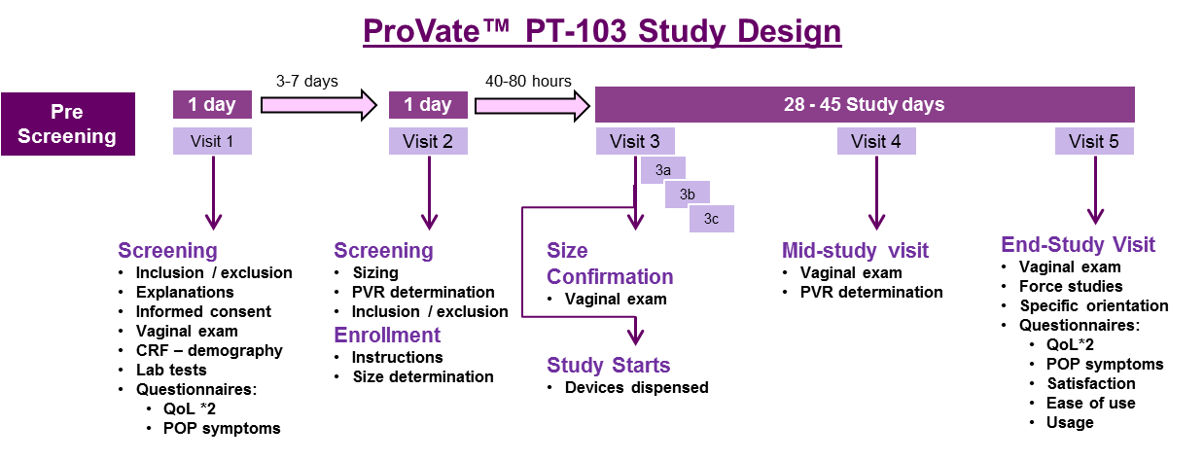

Exclusion criteria included previous inability to accommodate tampons or vaginal pessaries; current participation in another clinical study; co-morbid condition(s) or severe systemic disease that could limit the subject’s ability to participate in the study; pregnancy, suspected pregnancy or intention to be pregnant during the course of the study, abnormal vaginal bleeding in the past 6 months, previous vaginal surgery during the last 3 months, severely atrophic vagina, existing vaginal or vulvar laceration, symptomatic vaginal or urinary tract infection as determined by physical examination and lab results, recurrent urinary tract infections and abnormal cervical cytology.

Figure 2-Study Time line

The full analysis set (FA) includes all subjects who were enrolled and for whom the study device insertion was initiated (even if the insertion process was never completed). The FA analysis set served as the main analysis set for safety assessments. The per-protocol analysis set (PP) included all subjects from the FA analysis set, who used the study device models for at least 20 days, with no major protocol deviation. The PP analysis set served as the main analysis set for the effectiveness and performance analyses.

Statistical analyses were performed using SAS v9.4 (SAS®, SAS Institute Cary, NC USA) software. The required significance levels of findings were<= .05. All statistical tests were two-sided, if not defined otherwise. Where confidence limits are appropriate, the confidence level was 95%.

**Results**

* + 1. **Subject Disposition Probably will give-up this figure**

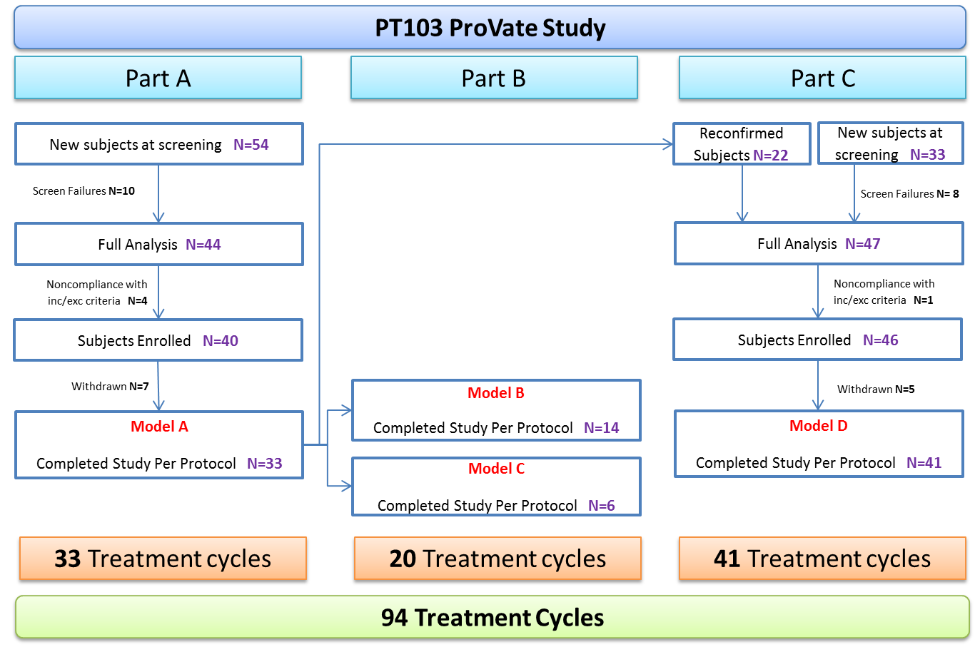

Figure 3-Subject disposition within the PT103 study

Of the 129 subjects screened, 111 wre enrolled, and a further 17 prematurely discontinued the study. Reasons for premature termination included Adverse Events (low extremities pains (1), DeNovo SUI (1) and discomfort (1), inability to insert the device (2), wish for surgery (1), inability to be fitted with available device’s size (8), and protocol violations (3), resulting in an eventual sample of X. In the Per Protocol set, there were 94 usage cycles in which 992 devices were used over 3,393 usage days, an average of 36.1±5.70 days per subject. In the Full Analysis set (safety), 1,592 devices were used over 3,558 study days. The mean age of the participants (N=x) was 60.4±9.72, with the majority of the participants between 61-70 (52.3%). Their mean BMI was 25.8±4.46. Of the 105 reported deliveries, 108 were spontaneous vaginal births, and 4 were with cesarean section. Almost all of the participants (81.1%) were postmenopausal.

*Reducing POP stage*

At baseline 28 subjects had POP-Q stage 2 prolapse, while 66 subjects has POP-Q stage 3 prolapse. Following insertion of the device, the prolapse was reduced substantially, (Table 2) and in visit 5, 90 subjects had no prolapse (POP-Q stage 0), and two subjects had POP-Q stage 1. All subjects had at least one stage improvement in the POP-Q scale while wearing the ProVate device (<0.0001). This improvement was shown at all three sites with no statistically significant difference between sites, hence all study site data were pooled.

*Secondary Effectiveness Endpoint -POP symptoms change*

Figure 4 shows results for the POP Symptom Score obtained from Visit 1 (prior to device use) and visit 5. Mean total scores of all POP related complaints were significantly reduced (from 29 to 2.7; p<0.0001).

Figure 4-Comparison of POP related symptoms average scores before using the ProVate Device and while using the device (PP, All Cohorts, p<0.0001)

Quality of Life (QoL) scores

Figure 5-Comparison of the Modified PFDI 20 average Score before using the ProVate Device (Visit 1) and while using the device (Visit 5) (PP, All Cohorts, p<0.0001)

Between the percent of subjects reporting that they had no problem (scored “not at all” for specific items of the PFDI-20 questionnaire) ranged between 5.3% and 76.6% at baseline but increased to 80.6% through 98.9% at the end of usage period (Figure 5). The difference between visit 1 and visit 5 of 28.52 (SD=20.31) in mean total score of the modified PFDI-20 questionnaire is statistically significant (p<.0001). The mean total PFIQ-7 score was 24.9 at visit 1 and 0.7 at visit 5, (P<0.0001), demonstrating significant reported improvement in QoL.

Figure 6-Comparison of PFIQ-7 scores from before and while using the ProVate Device.

*Adverse Events*

General safety analyses were conducted on the Full Analysis Population (FA). Table 4 shows breakdown of AE’s into Non-Device Related (NDRAE) and to somehow Device-Related (DRAE).

In the pooled analysis, 124 adverse events were reported (55.9%) (Figure 7). The most common AE’s were discomfort and spotting, which are anticipated for all devices that are used vaginally. Vaginal wall trauma was only seen at part A of the study, not seen again following proper training by the investigators. The largest part of the AE list consists of sporadic AE’s, usually of 1-2 complaints each.91 device-related AEs (45%): one (0.8%) AE was recorded prior to study onset, three (2.4 %) during recruitment, 38 (30.6%) during size confirmation, and 82 (66.1%) during usage. 91 (73.3%) AEs were determined to be potentially related to the device (in 50 subjects): 33 (36.3%) during sizing and 58 (63.7%) during the entire device usage phase. There were no device-related SAEs and All AE’s were completely resolved with no sequelae.

Figure 7-Frequency of the types of Device Related AE’s within All Cohorts, further divided into anticipated and non-anticipated (FA)

As with other vaginal devices, a learning/accommodation period, during which subjects become accustomed with the device, was expected. Most AEs occurred during the sizing phase (where the subjects became aware of the new device) and during the beginning of the usage phase (where subjects became accustomed with the device). It was clear that AEs were reduced while subjects became more experienced with device usage.

Weeks from visit 3

AEs

Figure 8-Break down of Device Related AE’s by weeks from visit 3 (FA, all cohorts)

Figure 9-Break down of Device Related AE’s by the number of device in the study (FA, cohort D in blue, all cohorts in red))

*Specific Safety points: vaginal infections, UTIs and urine retention.*

No subject reported vaginal infections. There were two cases of UTIs, both resolved through antibiotic usage. (Figure 7). Post-Void Residual (PVR) urine volume was studied by ultrasound scan before insertion of the first device, and with the device deployed within the vagina. Before using the device, mean PVR was 15.0±15.56 ml (range 0-53.5 ml). While using the device, during visit 4, mean PVR was 14.1±21.9 ml (range 0-90.7 ml). There was no significant difference in PVR before and while using the ProVate Device.

**Discussion**

Despite its frequency, POP is mainly a quality of life condition, and in most cases treatment is not mandatory. Therefore, management should be tailored to suit needs and perceptions of the individual woman. Vaginal ring pessaries have been used effectively for the non-surgical management of POP for many years and function well in most cases, substantially reducing vaginal wall prolapse. However, usage may be cumbersome, even bothersome, and their reusable structure is associated with vaginal discharge, unpleasant odor infections, functional sexual disturbances and need to involve a medical provider for insertion/removal.

The ProVate Device is a disposable flexible vaginal ring pessary designed to overcome many of the faults of existing ring pessaries. It is designed to allow the users to insert and remove it by themselves, at their own discretion, with no required cleaning. The ProVate Device, therefore, allows women to take control over their POP management.

Success of any POP management may be discussed in two ways: anatomical reduction of prolapse and alleviation of prolapse symptoms. There are many cases in which anatomical correction does not alleviate prolapse quality of life symptoms, hence the importance of recording both points.

In our study. reduction to stage/grade zero (0) was achieved in over 94% of subjects, and rest (6%), acheived stage/grade one (1). Quality of life also increased considerably in the areas of X and X reported relief from major POP symptoms.

Level of complaints before the study and while using the ProVate Device were compared and a significant improvement was noticed while using the device These achievements are comparable to results achieved while using existing vaginal pessaries, where 85%12 of subjects reported relief of POP symptoms.

In most cases of pessary usages, the user is unable to insert or remove the device by herself; in a study among 496 British gynecologists, 10.7% of the users discontinued usage because of “dislike of the changing procedure”15. In our study, only 15.3% subjects discontinued the study, In other studies, discontinuation rates range from 37 to 80%, the main reasons being expulsion of the pessary, discomfort, desire for surgery and inability to insert/remove the device by the user.

Disposable home self-use devices, such as the ProVate device, may allow women to use the device when they choose, and for their preferred allowed length of time. This was described by women in the study as “freedom to decide”.

The ability to control POP management was noted verbally by the study subjects during the visits to the clinic and included: the ability to have unhindered intercourse at their own time and wish – which only required a pull on the string, and inserting a new device later; The ability to have some “device free intervals” – some women felt that they don’t need to have a new device inserted immediately following removal of the previous one, and enjoyed some time of POP-symptom-free periods, which allowed them to remain without a vaginal device for some time, until they felt the need to insert a new device.

**Safety**

When a woman initially uses any intra-vaginal device, it is common to note that the first period of usage is accompanied by some discomfort and, occasionally, other mild adverse events. This period is a learning and accommodation period, in which the user gains an understanding as to how to place the device properly and becomes accustomed with its sensation. The medical literature cites conflicting data on the prevalence of AE’s within groups of pessary users. While Hanson et al[11] report only 14.5% of any complaints within pessary users; Bai et al[12] report 73.1% adverse events, while West & Moore21 found 56% adverse events with pessaries (including bleeding, purulent foul smelling discharge, severe discomfort, constipation and urinary symptoms). This huge variability in complication rate most likely reflects a difference in reporting. An ongoing daily/weekly follow-up of complaints and findings among users, as was employed in this study, will likely lead to much larger proportion of complaints, as compared with retrospective reporting. However, despite fairly high rate of minor complications in the literature, many users who are well fitted with pessaries report being satisfied with this management and wish to continue its use.

Vaginal wall trauma, a very well-known and described adverse event of pessary usage, occurs in 19.3% of long term pessary users[13] (range 3-24%[14].) In our study, there were seven cases of erosions, which were noted by the investigator only (not the subjects), and were believed to be caused by the initial trials to insert the device.

Urogenital infections are rather common in women. However, in our study, there were no subject’s complaints or clinical signs and symptoms of vaginal infection. A survey of 2000 women in the US found that 10.8% of women >18 years reported at least 1 presumed UTI during the last 12 months[15]. In our there was only one case of symptomatic UTI, and one case of presumed UTI, which may or may not be attributed to the ProVate Device.

As the remaining device related AE’s were mainly mild, together with the absence of vaginal infections or UTIs, we may conclude that the ProVate Device is safe for use.

The primary and secondary endpoints our study were successfully achieved, covering efficacy, safety, functionality and improved quality of life.

Acknowledgements

Funding: This study was funded by X (grant number X). Conflict of Interest: Author A has received research grants from Company A. Author B has received a speaker honorarium from Company X and owns stock in Company Y. Author C is a member of committee Z. If no conflict exists, the authors should state: Conflict of Interest: The authors declare that they have no conflict of interest.

**General comments:**

1. **All figures need to be removed from manuscript, saved in jpg format in separate files and figure titles need to be included at end of manuscript before references. Only 6 tables/figures can be included and the more figures the less text we can include. If quality of life is the main success point here, needs to be strengthened in discussion section and compared to other pessary studies more .****References**

1. Nygaard I, Barber M. Prevalence of symptomatic Pelvic floor disorders in US women. JAMA. 2008 September 17;300(11)1311-1316
2. Swift S, Woodman P, O’boyle A et al. Pelvic Organ Support Study (POSST): the distribution, clinical definition, and epidemiologic condition of pelvic organ support defects. Am J Obstet Gynecol 2005;192(3):795-806.
3. Wu JM, Hundley AF, Fulton RG, Myers ER. Forecasting the prevalence of pelvic floor disorders in USA women, 2010-to 2050. Obstet Gynecol 2009:114(6): 1278-1283
4. Barber MD, Brubaker L et al: Comparison of 2 trans-vaginal surgical approaches and perioperative behavioral therapy for apical vaginal prolapse. JAMA;2014;311(10):1023-1031
5. McIntosh L (2005) The role of the nurse in the use of vaginal pessaries to treat pelvic organ prolapse and/or urinary incontinence: a literature review. Urol Nurs 25(1):41–48
6. Atnip SD. Pessary use and management for pelvic organ prolapse. *Obstetrics & Gynecology Clinics of North America*. 2009; 36(3): 541-63 .
7. Hanson LAM, Schulz JA, Flood CG, Cooley B, Tam F. Vaginal pessaries in managing women with pelvic organ prolapse and urinary incontinence: Patient characteristics and factors contributing to success. *International Urogynecology Journal and Pelvic Floor Dysfunction*. 2006; 17(2): 155-159.
8. Vierhout ME. The use of pessaries in vaginal prolapse. *European Journal of Obstetrics Gynecology and Reproductive Biology*. 12004; 17(1): 4-9.
9. Committee on Practice Bulletins-Gynecology, American College of Obstetricians and Gynecologists. ACOG Practice Bulletin No. 79: Pelvic organ prolapse. Obstet Gynecol. 2007;109(2 Pt 1):461-473.
10. Coelho SCA, De Castro EB, Juliat CRT: Female pelvic organ prolapse using pessaries: systematic review. Int Urogynecol J DOI 10.1007/s00192-016-2991-y
11. Hanson LA, Schultz JA, Flood CG, Cooley B, Tam F:Vaginal pessaries in managing women with pelvic organ prolapse and urinary incontinence; patient characteristics and factors contributing to success. Int Urogynecol J pelvic floor Dysfunct 2006;17(2):155-9
12. BAI SW, Yoon BS, Kwon JY, Shin JS, Park KH et al. Survey of the characteristics and satisfaction degree of the patients using a pessary. Int Urogynecol J pelvic floor Dysfunct 2005;16(3):182-6
13. Ramsay S, Tu LM, Tennenbaum Cara. Natural History of pessary use in women aged 65-74 versus 75 years and older with pelvic organ prolapse: a 12-yer study. Int Urogynecol J pelvic floor Dysfunct 2016;27(8):1201-1207
14. Dessie SG, Armstrong K, Modest AM, Hacker MR, Hota LS: Effect of vaginal estrogen on pessary use. Int Urogynecol J 2016; 27:1423-1429
15. Foxman B: Epidemiology of Urinary Tract Infections: Incidence, Morbidity and Economic Costs. Am J Mewd 2002;113(1A):5s-13s