

Author Questionnaire (Book Proposal)

- The main title should be less than 57 characters, which will show up as 19 characters / line x 3 lines. Make sure it specifically conveys the topic of your book. Avoid phrasing your title in the form of a question.
“Japanese Enterprises and German Enterprises”

- Indicate whether your book is a single-authored volume, a co-authored volume or an edited volume.

■Single-Authored Volume
□Co-Authored Volume (maximum of three co-author names on the cover)
□Edited Volume (maximum of three the volume editor names on the cover) (edited volumes typically
include more than five chapters by chapter contributors

C. Indicate the Name(s) of the Author(s) or Editor(s) in the order that they should appear on the front cover of the book. Also indicate one main title(s), one main institution(s), e-mail and postal address (es). The name(s), title(s) and institution(s) will also appear inside the book.

Name of volume author/editor 1 (main corresponding author/editor): Toshio Yamazaki
Institution (One main institution): | Ritsumeikan University
Faculty/Department: | College of Business Administration
Title (Professor/Associate Professor/Etc.): | Professor
e-mail address: | tyt01363@ba.ritsumei.ac.jp
Complete postal address: | 567-8570
Building Name, Floor & Room Number | Building A, 9th floor, Room Number 9414
Telephone number: | +81-72-665-2440 (072^665-2440)
ORCID id (if you have one)*:

* If you do not have an ORCID id, register for free here: https://orcid.org/
* To ensure secure postal delivery, please indicate details of the building name, floor, room number, and telephone number.

- Please provide us a brief summary for marketing your book within 1,000 to 1,900 characters (including spaces and punctuation marks) (Approximately 150 - 200 words). Please see Appendix 1 of this document for details on how to write the description. Springer’s online SEO copy-editor will later copy-edit your summary.

The purpose of this book is to analyze and compare corporate expansion in postwar Japan and Germany. It explores how distinctive Japanese and German business management styles were created and evolved through the adoption of American management methods, such as the US de-concentration policy and reconcentration of monopolies. For the first time, the book draws on many fields related to business administration, such as the concentration of enterprises, management and production systems, management education, marketing, organizational structure, and corporate governance. The book compares the Japanese and German models. Japanese enterprises developed a management system that was suitable for American and Japanese markets, not the least due to underdeveloped Asian markets. Meanwhile, German enterprises established a management system for European markets. On the one hand, the book considers the specificities of the Japanese management model, predicated on thorough cost reduction and few product defects. The German management model, on the other hand, emphasized differentiation based on product quality with high functionality, paying attention to core markets and workers’ skills. The book argues that corporate expansion determined the regionalization in each country: Japan’s transformation toward “Asianization,” which depended on production and markets in Asia after the 1990s, and Germany’s consistent “Europeanization” after the war in two complementary ways: (1) a heavy reliance on the European region and (2) the endeavor to advance European integration. Transformations of business management are analyzed using the author’s original framework “Re-framing” to explain the adaptation, modification, and adjustment of one country’s particular management style to another receiving nation. These arguments reframe how we understand the historical processes of corporate expansion and provide milestones for a comparative study of management through common factors and characteristics of management in each country.

- Please write a short SEO Metadata description within 130-150 characters (characters, including spaces and punctuation marks – not words). Springer will later copy-edit your metadata description.

This book compares business management in postwar Japan and Germany, arguing that processes of regionalization shaped each country’s corporate expansion.

- Please tell us three unique selling points (USPs) of your book (under 60 – 110 characters (including spaces and punctuation marks) each). USP’s should show why a customer wants to buy your book and they will show up front and center on springer.com. Springer will later edit these USPs.

1. | Argues that industrial concentration and its influence on corporate expansion shaped competition structure.
2. | Compares how postwar Japanese and German management styles emerged through the deployment of American management.
3. | Examines how postwar business management in Japan and Germany determined the trend toward regionalization.

- Please provide more than 6 keywords that are applicable to your book. These key words will be used for Search Engine Optimization. Keywords should be single words or two-word phrases, not multi-word phrases, that potential readers are likely to use on search engines to find the content. They should be concrete and specific, yet concise. Each keyword should be no longer than 64 characters (including spaces and punctuation marks).

1. | Americanization
2. | Business management/German enterprise
3. | German enterprise
4. | Industrial concentration
5. | Japanese enterprise
6. | Regionalization

- Please provide us the table of contents. It does not matter if it is only a tentative one.

Preface

Chapter 1 Introduction: Research Topics and Analytical Framework
1.1 Awareness of the Issues of this Book
1.2 Research Topics
1.3 Prior Research and Issues Thereafter
1.4 Analytical Framework

Part 1 Total System of Business Management and Characteristics of Management in Japan and Germany
Chapter 2 Overview of the Total System of Business Management in Postwar Japan and Germany
2.1 Overview of the Total System of Business Management in Japan after World War II
2.2 Overview of the Total System of Business Management in Germany after World War II
Chapter 3 Characteristics of Business Management in Japan and Germany
3.1 Commonalities of Business Management among Major Countries
3.2 Characteristics of Japanese Business Management
3.3 Characteristics of German Business Management

Part 2 System of Postwar Industrial Concentration
Chapter 4 Structures and Functions of Large Corporate Groups
4.1 Influence of the US De-concentration Policy on Monopolies in Japan and Germany
4.2 New Developments in the System of Large Corporate Groups in Japan
4.3 New Developments in the System of Large Corporate Groups in Germany
4.4 Japanese and German Characteristics regarding the System of Large Corporate Groups
Chapter 5 New Developments of the Industrial System Based on Industry–Bank Relationships
5.1 New Development of Industrial Concentration Based on Industry–Bank Relationships in Japan
5.2 New Development of Industrial Concentration Based on Industry–Bank Relationships in Germany
5.3 Japanese and German Characteristics of Industrial System Based on Industry–Bank Relationships

Part 3 Americanization of Business Management and “Re-framing” in the Postwar Boom Years
Chapter 6 Deployment of American Management Education
6.1 Deployment of American Management Education in Japan
6.2 Deployment of American Management Education in Germany
6.3 The Characteristics of Japanese and German Deployment of American Management Education
6.4 Re-framing in the Deployment of American Management Education in Japan and Germany
Chapter 7 Deployment of Human Relations
7.1 Deployment of Human Relations in Japan
7.2 Deployment of Human Relations in Germany
7.3 The Characteristics of Japanese and German Deployment of Human Relations
7.4 Re-framing in the Deployment of Human Relations in Japan and Germany
Chapter 8 Deployment of Industrial Engineering
8.1 Deployment of Industrial Engineering in Japan
8.2 Deployment of Industrial Engineering in Germany
8.3 The Characteristics of Japanese and German Deployment of Industrial Engineering
8.4 Re-framing in the Deployment of Industrial Engineering in Japan and Germany
Chapter 9 Deployment of the Ford System
9.1 Deployment of the Ford system in Japan
9.2 Deployment of the Ford system in Germany
9.3 Re-framing in the Deployment of the Ford system in Japan and Germany
9.4 The Rollout of Mass-Production Systems and Japanese and German Manufacturing
Chapter 10 Deployment of Marketing Methods
10.1 Deployment of Marketing Methods in Japan
10.2 Deployment of Marketing Methods in Germany
10.3 The Characteristics of Japanese and German Deployment of American Marketing Methods
10.4 Re-framing in the Deployment of American Marketing Methods in Japan and Germany
Chapter 11 Deployment of a Divisional Structure
11.1 Transformation of Business Strategy and Deployment of Divisional Structure in Japan
11.2 Transformation of Business Strategy and Deployment of Divisional Structure in Germany
11.3 The Characteristics of Japanese and German Deployment of the Divisional Structure
11.4 Re-framing in the Deployment of Divisional Structure in Japan and Germany
Chapter 12 “Re-framing” in the Americanization Process and Japanese-Style Management and German-Style Management during the Postwar Boom Years
12.1 Japanese- and German-Style Adaptation in the “Americanization” of Business Management
12.2 “Re-framing” in the Americanization Process and Japanese-Style Management
12.3 “Re-framing” in the Americanization Process and German-Style Management

Part 4 Business Management in the Periods from the 1970s to the 1980s and after the 1990s
Chapter 13 Development of Mass Production Systems in Japan and Germany from the 1970s to the 1980s and Its Significance
13.1 Social and Economic Background Regarding the Reforms of the Mass Production System
13.2 Production System Reforms in Japan
13.3 Production System Reforms in Germany
13.4 Significances of the Reforms of the Mass Production System in Japan and Germany
Chapter 14 Transformation toward Shareholder Value-Oriented Management and Corporate Governance in Japan and Germany after the 1990s: Resurgence of the Americanization of Business Management
14.1 Influence of US-led Financialization in Japan and Germany
14.2 Transformation toward the Shareholder Value-Oriented Management Model in Japan
14.3 Transformation toward the Shareholder Value-Oriented Management Model in Germany
14.4 “Re-framing” in the “Americanization” of Business Management in Japan and Germany
14.5 Changes of Characteristic in the “Americanization” of Business Management after the 1990s and Their Significance

Chapter 15 Conclusion: Significance of Comparative Study of Business Management in Japan and Germany
15.1 Pursuit of Economic Rationality in Each Country: Comparison of the US, Japan, and Germany
15.2 The Postwar Reforms and Democratization of Economy and Their Influences on Business Management and Corporate Expansion in Japan and Germany
15.3 Industrial Development and Industrial Structure and Their Influences on Business Management and Corporate Expansion in Japan and Germany
15.4 Inter-firm Relationships and Their Influences on Business Management and Corporate Expansion in Japan and Germany
15.5 Regional Conditions and Their Influences on Business Management and Corporate Expansion: Different Paths toward the Global-Regionalization in Japan and Germany

- Is this book originally written in English, or translated from another language? If it is a translation, please provide its original title, publisher’s name and publishing year.

This book is translated from Japanese.
Original title:
Publisher:
Publishing year:

- Product category (Please select only one option from the list below.)

□ Handbook
■ Monograph (Edited Volume)
□ Proceedings
□ Textbook (for undergraduates)
□ Textbook (for graduates/advanced undergraduates)
□ Springer Briefs
□ / Other ( )

- Please select 3-6 sub-disciplines that cover your book’s topic from Column F Subject Name in the separately supplied spreadsheet.

Business and Management
Corporate History
Economic History
Management Education
Marketing
Modern History
(in alphabetical order)

- Please point out at least one title that is most similar to your title in terms of its purpose and its target readers that is offered by a publisher other than Springer.

Title: | German and Japanese Business in the Boom Years. Transforming American Management and Technology Models
Author(s)/Editor(s): | Akira Kudo, Matthias Kipping, Harm G. Schröter (eds.)
Publisher: | Routledge
Print ISBN (ISBN-13): | 9781138864023
Publication year: | 2015 (First publishing: 1st Edition 2004)
Hardback or Paperback: | Hardback
Pages: | pp.1-304
Price: | 42.39￡
How is your book different: | - The edited book attempts to clarify the transformation of American management and technology in Japan and Germany through two case studies of the same industrial sector. Although it shows that the scope of Americanization was much broader and deeper in Japan than in Germany, the deployment of individual major American management methods is, however, not examined. My book directly compares these processes in Japan and Germany. It points out the unique factors at work in each country and demonstrates how, through a combination of American management and Japanese and German traditions, business management developed in both countries.  - Based on the author’s original framework to explain how one management style well established in a particular country was adapted and transformed into a different style in another country―“Re-framing”―, my book analyzes business management in relation to the adaptation, modification, and adjustment of American management methods, which made them compatible with the structural peculiarities of Japanese and German capitalism.  3. My book traces the development of Japanese and German enterprises after the 1950s and 1960s. It also pays attention to each country’s significant embeddedness in regional economic structures in Europe and Asia, as well as their deep connections with the United States. It demonstrates that the German business management model emphasized differentiation based on product quality with high functionality adaptable for European markets. In turn, the Japanese management model focused on thorough cost reduction and few product defects suitable for American and Japanese markets due to the underdeveloped Asian markets.

Title: | Americanization and Its Limits: Reworking US Technology and Management in Post-war Europe and Japan
Author(s)/Editor(s): | Jonathan Zeitlin, Gary Herrigel
Publisher: | Oxford University Press
Print ISBN (ISBN-13): | 9780199269044
Publication year: | 2004 (First publishing: 2000)
Hardback or Paperback: | Hardback
That | pp.1-410+xvi
Price: | ＄74
How is your book different: | - This book stresses that though postwar American technology and management pursued selective adaptation, such a process was not a negative phenomenon. Rather, it indicates creative modifications and innovative hybridization. However, the factors of such hybridization are not explained. Based on the author’s original framework “Re-framing,” my book specifies which factors determined the adaptation, modification, and adjustment of American management methods, which elements of American management and Japanese or German management were combined and hybridized, and how distinctive Japanese or German management styles were built through these processes. It provides many tables that account for the overall conditions of the deployment of American management methods.  - The edited book only singles out specific issues of business management in each country. Instead, my book compares relevant topics of business management, such as management systems, production systems, management education, marketing, organizational structure, business strategy, and corporate governance. It also compares the cooperative and interdependent structures based on the concentration of industry and competition structures in Japan and Germany. My comparative analysis also tackles the characteristics of business management and corporate expansion in both countries.  - Based on the author’s original framework, my book grasps the environmental factors that regulate and determine the overall management style within a country’s capitalistic economic system―the “Total system of business management.” My book analyzes business management in relation to Japanese and German capitalism, as well as the cooperative, interdependent structures that arose from such a concentration of industry. Overall, the book attempts to account for this fundamental transformation in business management.

Title: | Der produktive Blick. Wahrnehmung amerikanischer und japanischer Management- und Produktionsmethoden durch deutsche Unternehmen
Author(s)/Editor(s): | Christian Kleinschmidt
Publisher: | Akademie Verlag
Print ISBN (ISBN-13): | 3-05-003657-5
Publication year: | 2002
Hardback or Paperback: | Hardback
Pages: | pp.1-453
Price: | €64.8
How is your book different: | 1. Kleinschmidt demonstrates that the worldwide deployment of American management methods was a selective process of adaptation. While Germans were eager to adopt marketing, public relations, and advertising, the implementation of human relations and management education followed “the German special way.” However, Kleinschmidt does not always grasp this process sufficiently, including factors that shaped the combination of American and German management styles. My book compares German-style adaptation and Japanese-style adaptation within the overall Americanization of business management, paying due attention to five common factors via the author’s framework “Re-framing.” It provides an overall framework for business management in each country through the study of management values, various institutions, the structure of productive forces, and industrial and market structures.  - Examining various issues of business management in Japan and Germany from the end of World War Ⅱ to the present day, notably the deployment of American management methods and reforms of mass production system, my book tackles the specificities of management and corporate development in each country. It attempts to explain the stages of postwar transformation in business management.  - Kleinschmidt demonstrates how Japanese management focused on production methods using the teamworking system, quality control circle, and just-in-time production. In Germany, the process was selective and sporadic, and these methods did not diffuse due to limitations of transfer channels and managers’ lack of willingness to adopt them. However, German automobile enterprises had attempted to reform the mass production system using microelectronics technology, skilled workers through functional integration of direct and indirect labor, and by borrowing some elements from the Japanese production system in the 1970s and the 1980s. Based on a systematic comparison of production system reforms, my book explores these reforms in Germany, including the introduction of microelectronics technology, teamworking, small group activities at the workplace, and the Japanese production system. It argues that the reforms in Germany were limited, which in turn shaped how the module production system evolved after the 1990s.

- 本書に関係する本で，Springer社から出ている本を1冊以上教えてください．Springer社の本は，www.springer.comから選んでください．
Please point out at least one title which is related to your book and offered by Springer. You can search for our books on www.springer.com

Title: | Americanization of the European Economy
Author(s)/Editor(s): | Harm G. Schröter
Print ISBN (ISBN-13): | 978-1-4020-2884-7
Publication year: | 2005
Hardback or Paperback: | Hardback
Pages: | pp.1-268+xii
Price: | €117.69
How is your book different:  How is this title related: | - Schröter evaluates the economic influence of the USA on Europe focusing on the transfer of cultural values. He argues that the Americanization was not a smooth, continuous process: while more economically advanced countries tend to be more deeply affected by Americanization than less developed ones, smaller countries seem to be more Americanized than larger ones. However, the implementation of American management methods in Germany is not sufficiently analyzed. Here, my book highlights the influence of proper German management values regarding technology, production, and quality reflecting market characteristics and consumer behavior in Europe. This model stands in contrast to Japanese management values, which focus on collectivism and cooperation between enterprises and among corporations, unlike the contracting relations prevailing in the USA.  - By comparing Germany in Europe with Japan in Asia, my book analyzes the significance of German business management, which evolved within regional structures in Europe, and Japanese business management, which developed depending on US markets because of underdeveloped Asian markets. Germany has pursued “Europeanization” in two distinct ways: (1) heavy reliance on the European framework (2) the endeavor to advance European integration. In contrast, Japan has evolved without a common market structure similar to the E.U., using both production and the market to become independent from the United States. The corporate expansion, based on peculiar management models in postwar Japan and Germany, shaped different paths toward regionalization in each country.  3. Schröter considers a much longer period from the 1880s to the present day. Regarding the Americanization after the 1980s, he stresses the triumph of finances, market capitalization, and the strong influence of American shareholder value management. However, the actual conditions of such changes are understudied. My book points out how the Americanization of business management evolved over time, from efficiency improvement to the maximization of investors’ returns in the capital market that differs from the standards of the real economy. My book stresses the convergence process toward the shareholder value-oriented management model in Japan, whereas such a change has not occurred in Germany due to the specificities of the Americanization in Europe.

N. What kind of people do you think will read your book? (Please select only one option from the list below.)
(1) Popular/General
(2) Lower undergraduates
(3) Higher undergraduates
(4) Graduates
■(5) Researchers
(6) Other:

O. If you selected (2), (3) or (4) in quesiton N above, please inform us of the names of the courses and universities which will adopt your textbook.

P. Please provide, if any, the name of a book series in which you would like your book to be published.

Q. Expected number of pages after type-setting: pages(A type-set page includes 504 words on average.)

340 pages

R. Expected number of tables and figures: Color tables and figures: Black & white tables and figures: .

Tables: 12
Figures: 2

S. By when can you send your sample chapters or writing sample (30 - 50 pages). (Writing sample means a paper/article with a similar topic that you have published in the past.)

Month__March__ Date__3__ Year_2021__

T. By when can you send us your final manuscript (complete with all figures and after English copy-editing, conducted by a native speaker of English, and roughly formatted in Springer style)?

Month_ April___ Date__14__ Year 2021__

U. 略暦（最大4000文字）
Please provide details of your area of work, honors, etc. which underline the usefulness of your work to the reader. This information will be used in marketing materials. Note: Please repeat the above information for all authors and editors of the work. Short bio (max.4000 characters).

Toshio Yamazaki
University: Ritsumeikan University, Japan
Department: College of Business Administration
Title/Position: Professor

Other affiliations: Graduate School of Business Administration, Ritsumeikan University

Academic background: 1. Doctor of Business Administration (March 1999)
2. 1981-1985 Faculty of Commerce, Doshisha University, Japan
3. 1985-1987 Doctoral Program (1st Semester), Graduate School, Division of Commerce, Doshisha University (Master of Commerce)
4. 1987-1990 Doctoral Program (2nd Semester), Graduate School, Division of Commerce, Doshisha University, Japan

Research activities: 1. Japan Academy of Business Management
2. Japan Association for the Comparative Studies of Management
3. Japan Association of Business History

Subject of research: International comparative study of business administration

Research summary: Comparative Study on business management in Japan, Germany, and the United States
The target is to develop a corporate theory based on management studies, made through comparative studies on the process of development of corporate management and management systems in Japan, Germany, and the United States

Present specialized field: Management (keyword: Business administration)
Business History (Keyword: Comparative business history)

Receiving a prize: Academic Award of the Japanese association for the Comparative Study of Management, 2015 (Receiving a reward: Mai 2015)
“German Business Management: A Japanese Perspective on Regional Development Factors” Springer, 2013

V. Please submit the full English CVs of the volume author(s)/volume editor(s). The CV(s) should include a list of the author’s publications(journals/books), any experience as a journal editor, and awards/honors, in addition to professional/educational experiences. For multi-author volumes, please provide a short bio for chapter authors as well.

Curriculum vitae (CV)

Name: Toshio Yamazaki

Date of birth: 22. 3. 1962

University: Ritsumeikan University, Japan
Department/ Course: College of Business Administration (Department of Business Administration)
Title/Position: Professor

Academic degree: Doctor of Business Administration (March 1999)

Academic background
1981-1985 Commerce, Faculty of Commerce, Doshisha University
1985-1987 Doctoral program (1st Semester), Commerce, Graduate School, Division of Commerce, Doshisha University
1987-1990 Doctoral program (2nd Semester), Commerce, Graduate School, Division of Commerce, Doshisha University

Business career
1989-1990 Assistant professor, Faculty of Humanity, Koch University
1990-1992 Lecturer, Faculty of Humanity, Koch University
1992-1994 Associate professor, Faculty of Humanity, Koch University
1994-2001 Associate professor, College of Business Administration, Ritsumeikan University
2001- Professor, College of Business Administration, Ritsumeikan University

Research activities
Japan Academy of Business Management
Japan Association for the Comparative Studies of Management
Japan Association of Business History

Subject of research
International comparative study of Business Management

Research achievement
Books: 1. Inter-firm Relationships in Germany: Structures and Functions of Personnel Connection between Enterprises (Language: Japanese), Moriyama shoten, 2019, pp.1-544.
2.Comparison of Business Management in Japan and Germany (Language: Japanese), Moriyama
shoten, 2007 pp.1-612.
3. German Business Histrory before World War II (Language: Japanese), Moriyama shoten, 2015, pp.1-362.
4. German Business Management: A Japanese Perspective on Regional Development Factors
(Language: English), Springer, 2013, pp.1-247.
5. Contemporary German Enterprise (Language: Japanese), Moriyama shoten, 2013, pp.1-602.
6. German Capitalism after World War II and Business Administration (Language: Japanese), Moriyama shoten, 2009, pp.1-562.
7. Reconstruction of Modern Business Management Study (Language: Japanese), Mpriyama shoten, 2005, pp.1-502.
8. The Rationalization Movement in Germany during National Socialism (Language: Japanese), Moriyama shoten, 2001, pp.1-459.
9. The Rationalization Movement in Germany during the Weimar Republic (Language: Japanese), Moriyama shoten, 2001, pp.1-462.
10. History of Business Management System in Germany (Language: Japanese), Moriyama shoten, 1997, pp.1-378.

Receiving a prize: Academic Award of the Japanese association for the Comparative Study of Management, 2015 (Day of receiving a reward: 5.2015)
“German Business Management: A Japanese Perspective on Regional Development Factors” Springer, 2013

W. Please list up four to five names and e-mail address of professors (or researchers with equivalent expertise), if any, by whom you would like to have your manuscript reviewed. We will use this list as a guide to find referees for your manuscript. However, please note that the actual referee(s) may not be the ones in your list, and we will not be able to disclose their names to you.

Name 1: | Christian Kleinschmidt
Title: | Professor
Institution: | Philipps Universität Marburg, Germany
e-mail address: | Christian.kleinschmidt@staff.uni-marburg.de
Name 2: | Masaru Yoshimori
Title: | Emeritus Professor
Institution: | Yokohama National University, Japan
e-mail address: | Yoshimori-masaru-dj@ynu.ac.jp
Name 3:
Title:
Institution:
e-mail address:
Name 4:
Title:
Institution:
e-mail address:
Name 5:
Title:
Institution:
e-mail address:

X. If you are interested in publishing your book as an Open Access book, please let us know. For further details about our Open Access books, please see https://www.springer.com/gp/open-access/books

Y. If there is anything else you would like to mention about this book, please let us know.

Springer Japan
Editorial department: Economics, Business
Administration, Statistics, and Law

Appendix 1: Instructions for Writing a Book Description

The Description (Question D of this Author Questionnaire) will be printed on the back cover of the printed book as well as on the home page for your book on Springer.com and the product page on Amazon. Please follow the instructions below in writing the description.

- Length: 1,000 to 1,900 characters (including spaces and punctuation marks) (This is roughly 200 - 350 words.)

- Do not use the title of your book in the first two sentences.

- Begin with what is new about this book (compared to other similar books in the field).

- Articulate in the first or second sentence on what is specific to this book and how it is different from others.
(e.g. This is the first book to …..)

- Start your paragraph with one of the following openers:

- This (edited) book/volume/work/anthology/study/collection…
- The research and its outcomes presented here…
- is about…
- is devoted to….
- contains…
- focuses on…
- …. & …. form the cornerstone of this work (by international/world-renowned experts/authors).
- At the heart of this book is the matter of…

Other examples
- This is the second edition of a well-received book that reflects the state of the art in… This comprehensive reference text examines the current state of… which encompasses…
- A major objective of this monograph is to identify the key determinants of …
- This book covers many aspects of …
- The main focus of this monograph is …
- The idea of this monograph is to present the latest results related to…
- The purpose of this book is to thoroughly prepare the reader for research in string theory, at an intermediate level.
- This book shows how scientists, water managers, and policy makers approach drought and water scarcity in arid and semi-arid regions.
- How can anthropology and demography be used in conjunction in the field of population and development? This work addresses that question in 3 parts…

- Focus on the benefits of the book (how it solves problems in the field; latest insights and latest analyses), the scope of your project, the core themes, arguments, issues and/or topics of the work.

- Do not tell what your product IS but rather tell what your product DOES.

- Do not list up summaries of each chapter.

- Avoid describing the field your title is about or beginning your description with back-ground information or context. Expected readers are already familiar with the field. That's why they want your book. If you must provide context, please make sure to keep it to a minimum.

- Your description will be copy-edited by a native English speaker.

・ Example of a good book description:

Monetary Economics in Globalised Financial Markets
Belke, Ansgar, Polleit, Thorsten (Springer, 2011)
http://www.springer.com/978-3-540-71002-8

This book integrates the fundamentals of monetary theory, monetary policy theory and financial market theory, providing an accessible and comprehensive introduction to the many-sided interrelations between these fields of research. It provides the reader with the intellectual groundwork indispensable for understanding the workings and interactions of today’s globalised financial markets. The topics addressed in this book include, inter alia, alternative money supply regimes, money demand functions, monetary policy transmission, monetary policy effectiveness and the natural rate of unemployment, monetary political business cycles, and monetary policy strategies. Basic valuation models for stocks, and bonds and asset price linkages across currency areas are covered as well. Illustrated by carefully chosen examples and supported by extensive data analyses, this book is highly recommended to readers who seek an in-depth and up-to-date integrated overview about the ever-expanding theoretical and quantitative fields of monetary and financial economics. (1,062 Characters / 142 Words)

Description on Springer.com

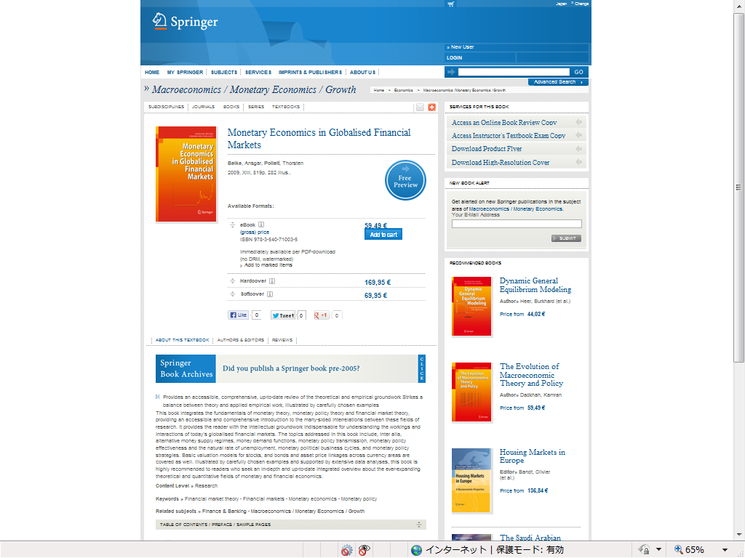

Description on Amazon

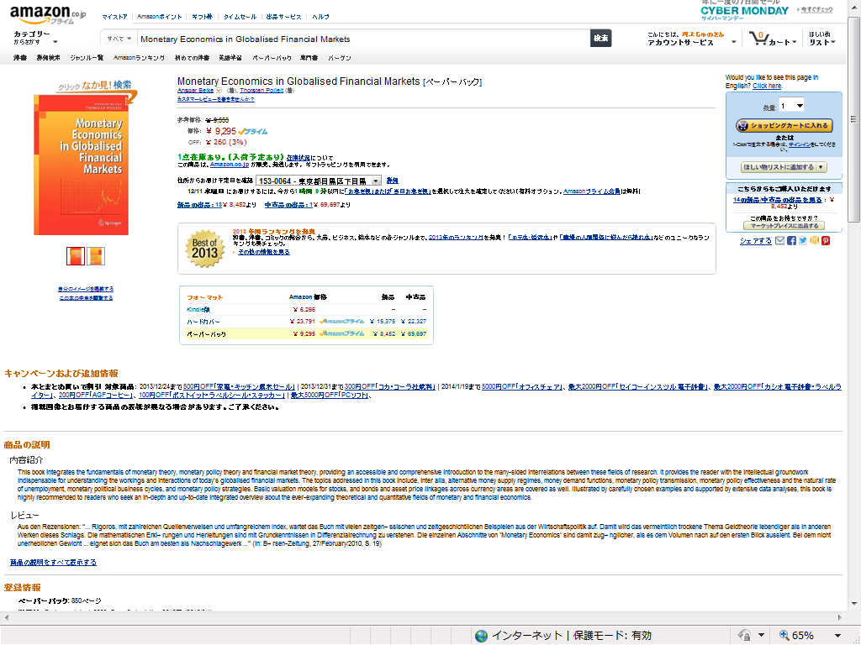

Back cover text



