Background on the News Items Being Examined
The first incident studied was that of Israa Abed, an Arab resident of Israel, who was accused of intending to stab Israeli soldiers at a bus station in the Israeli city of Afula in October of 2015, was shot by the soldiers immediately following the stabbing, leaving her badly wounded. The Israeli press claimed that she had been holding a knife, while other Arab media platforms claimed that she had been holding her sunglasses.
Second, the reactions to the case of Nashat Milḥim were examined. Milhim was an Arab/Palestinian Israeli who carried out a shooting attack in Tel Aviv on January, 2016, leaving three Israelis dead. He was subsequently shot dead in a firefight with police forces in his hometown of Arara in northern Israel.
The last dispute examined was that which arose following the proposal made in April of 2016 by Knesset member Bezalel Smotrich of the right-wing Bayit Yehudi (Jewish Home) party to segregate Jewish and Arab women in maternity wards in Israeli hospitals. A firestorm of controversy erupted between Arabs and Jews on the social networks, especially on Facebook in reaction to his proposed plan.

Methodology
Facebook has become a global documenting arena wherein anybody can express and chronicle whatever they want through posts, comments, links, and even screenshots. Before the advent of Facebook and other social media outlets, it was extremely difficult for individuals to document their attitudes and real-time reactions and discourse about events. Today, the task of reporting and chronicling public attitudes is now much easier given the pervasive use of social media. For this study, content analysis of 539 Facebook comments was conducted. The comments were screenshotted randomly from different Israeli Facebook pages and included comments of both Jews and Arab/Palestinians living in Israel that were made in response to controversial news items about the conflict between Jews and Arab/Palestinians living in Israel which appeared on the Facebook platform.
In total, 296 comments by Jewish Israelis and 243 comments by Arab/Palestinians living in Israel were collected. Then, the nature of the comments was categorized. Comments including obscene, anti-social, or inflammatory language were categorized as comments with “offensive reactions.” Comments with clearly positive language or reactions were categorized as “friendly comments/reactions.” Comments with no indication of either positive or a negative reaction were considered “neutral reactions” that were subsequently categorized as friendly comments.
Findings
As stated previously, attitudes of Israeli Jews and Arabs/Palestinians Arabs towards controversial events that were expressed on Facebook were gathered for the purpose of this study. The attitudes were divided into two groups of offensive and friendly comments, with neutral and defensive comments both being categorized as friendly comments. This section presents a sample of the comments posted about the three incidents under study together with their translations. A table summarizing the findings for each incident is also included.
Incident I: The Shooting of Israa Abed
The following are samples of the comments posted by different Jewish Israeli Facebook users following this incident.

- Comment 1 1
- 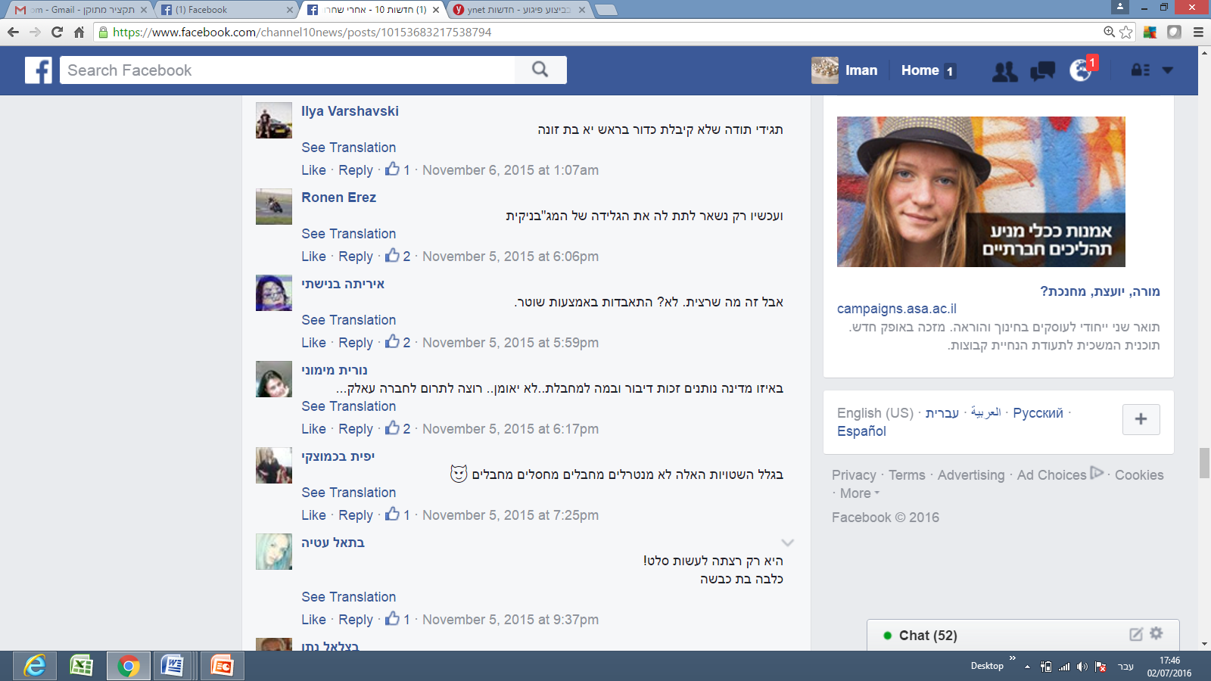
Translation: “Just be grateful that you did not get a bullet in your head, you bitch.”

Comment 2
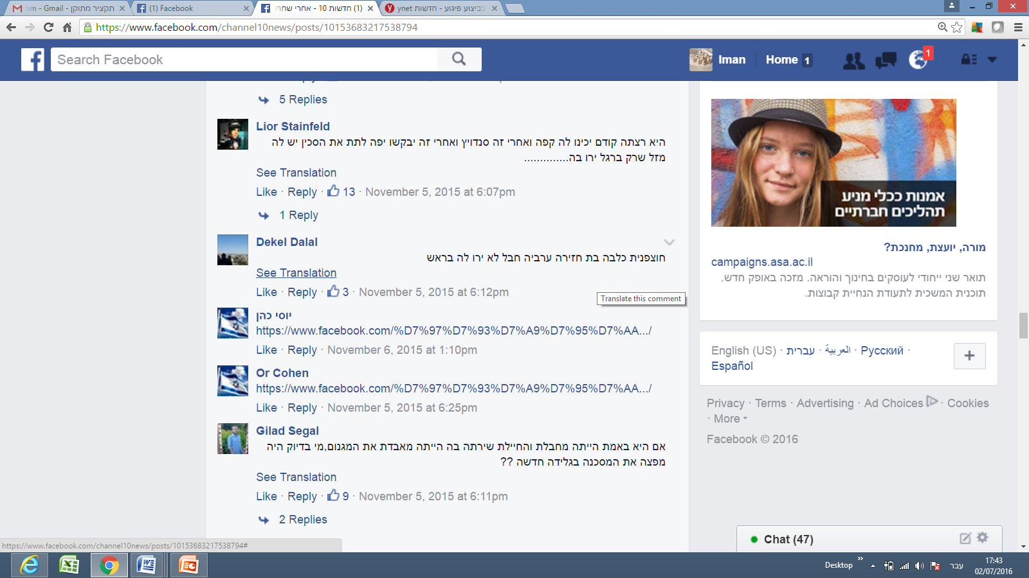
Translation: “You are a daughter of a pig, a bitch, an Arab; it’s too bad you weren’t shot in the head.”
Comment 3
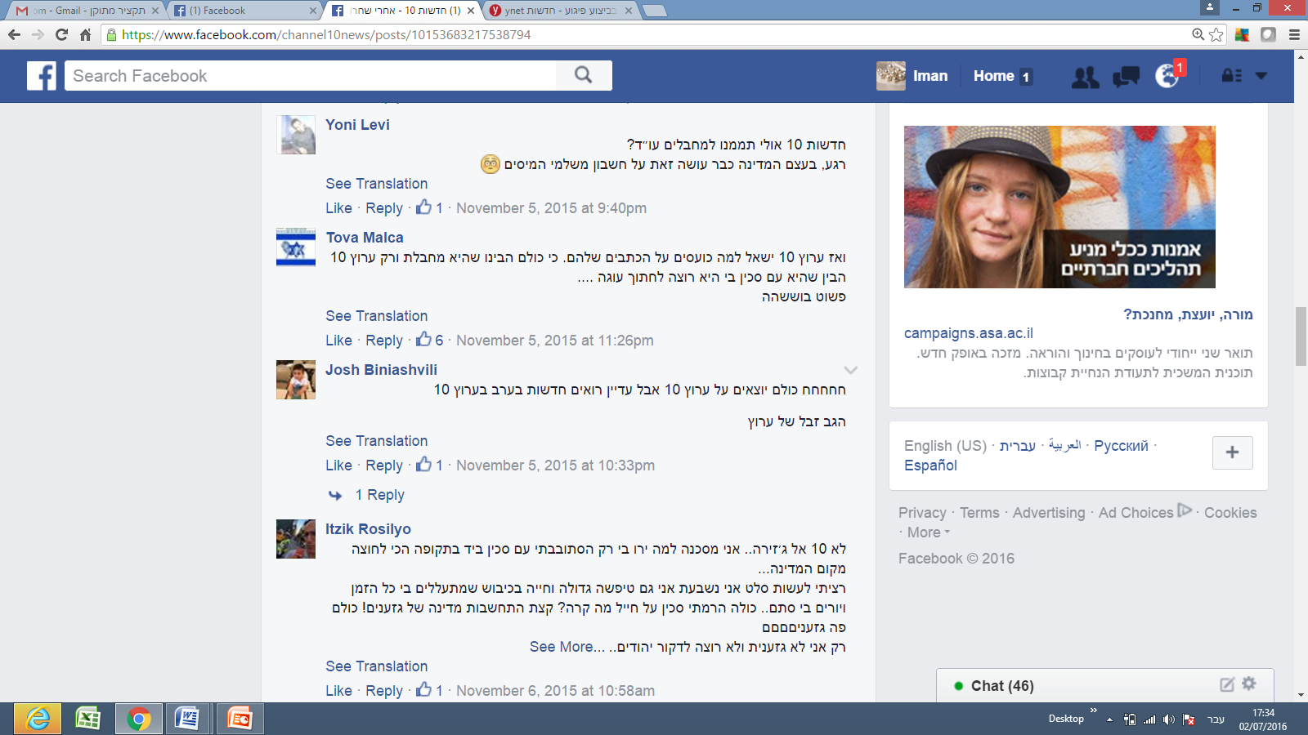
Translation: “Not Channel 10, but Al Jazeera. [the following was written sarcastically, but as if quoting Israa Abid]: ‘I am an unfortunate victim. Why did they shoot at me? I was only wandering in the street with a knife in hand during one of the tensest times since the founding of the country.’
“[Continuing sarcastically]: ‘I only wanted to prepare salad. I swear. I am a big idiot living under occupation. They abuse me all the time, and shoot at me for no reason... All I did was raise a knife towards a soldier! So, what?! Just show a bit of consideration, you country of racists! You are all racistsss!
I am the only one who is not racist, and I do not want to stab Jews....’”

Table 1: Attitudes Expressed on Facebook Following the Israa Abed Shooting
 | Jewish Israelis | Arab/Palestinian Israelis | Total
Offensive Comments | 45:48  94% | 26:50  52% | 56:98  73%
Friendly/Neutral Comments | 3:48  6% | 24:50  48% | 42:98  28%

Incident II: The Shooting of Nashat Milhim

The following are samples of the comments posted by different Jewish Israeli Facebook users following this incident.
Comment 1
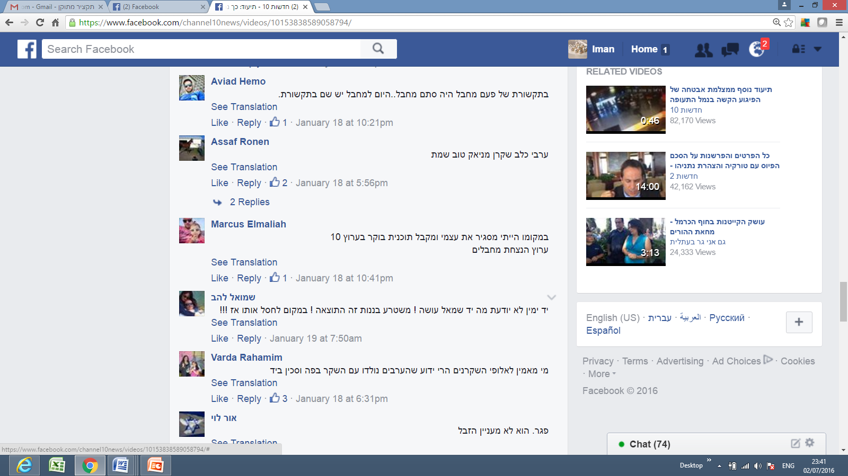
Translation: “An Arab dog, liar, maniac; good that he’s dead.”
Comment 2
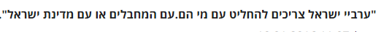
Translation: “Israeli Arabs should decide with whom they belong: with the terrorists or with the country of Israel?”
Comment 3

Translation: “Who believes the champions of lies [meaning Arabs]? Everyone knows that Arabs are born with a lie in their mouths and a knife in their hands.”

Comment 4

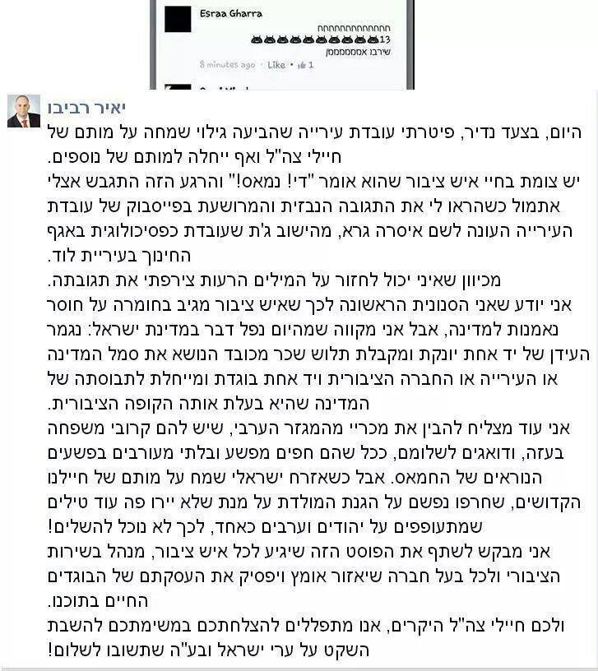
Table 2: Attitudes Expressed on Facebook Following the Killing of Nashat Milhem
 | Jewish Israelis | Arabs/Palestinian  Israelis | Total
Offensive  Comments | 128:150  85% | 19:93  20% | 147:243  60%
Friendly/Neutral/ Defensive  Comments | 22:150  15% | 74:93  80% | 96:243  40%

Incident III: MK Bezalel Smotrich’s Call to Segregate Arab and Jewish Women in Maternity Wards in Israeli Hospitals
The following are samples of the comments posted by different Jewish Israeli Facebook users following this incident.
Comment 1
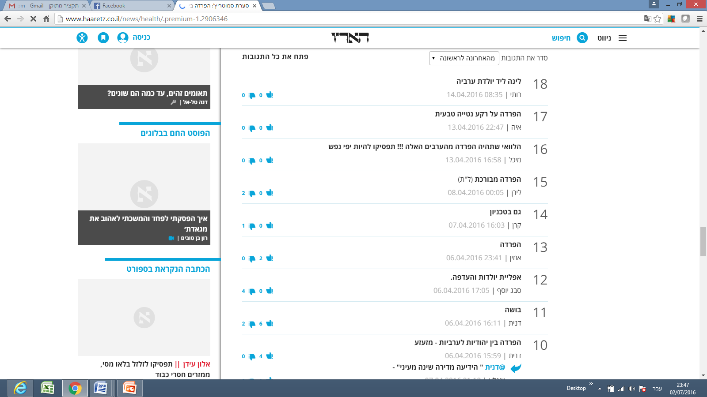
Translation: “I wish there would be segregation from those Arabs!!! Stop being bleeding hearts!”

Comment 2
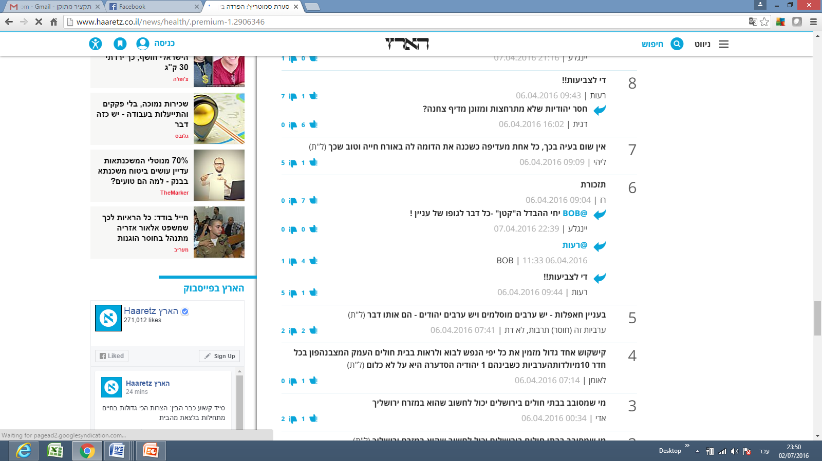
Translation: “Regarding get-togethers: there are Arab Muslims, and Arab Jews [referring to the Jews who say the call for segregation is immoral]- they are both the same.
“Arabness is a (lack) of culture; it’s not a religion.”
Table 3 Attitudes Expressed on Facebook Following Call to Segregate Arab and Jewish Women in Delivery Wards

 | Jewish Israelis | Arabs | Total
Offensive  Comments | 47:98  47% | 92:100  92% | 139:198  70%
Defensive/ Neutral  Comments | 51:98  52% | 8:100  8% | 59:198  30%

These findings indicate a very high percentage of negative attitudes expressed following controversial incidents by both parties under study. Of the 296 comments made by Jewish Israelis, 220, or 74%, could be characterized as expressing negative attitudes, and 137 of the 243 comments made by Israeli Arabs, or 56%, expressed negative attitudes toward Jews. The total negative comments from both parties amounted to 66% of the total number of the comments gathered for the study, with 357 of the 539 comments displaying negative attitudes.
Discussion
The frequency with which both Jewish Israelis and Arab/Palestinian Israelis used offensive language about the other as well as their strong negative attitudes toward the other regarding the incidents under examination reveal a fragmented and polarized political and social landscape vulnerable to significant inflammation or incitement. These findings also support the proposition that peaceful channels of communication between Jewish Israelis and Arab/Palestinians Israelis are rare. In addition, it is clear from the findings presented that Jewish Israelis commenting on Facebook are far more likely to use offensive words than are their Arab/Palestinian Israeli counterparts. One possible explanation for this finding is that Jewish
Israelis feel more secure about expressing their true opinions, regardless of how offensive they are, believing that they are less likely to face legal or security consequences. In contrast, Arab/Palestinian Israeli commentators are more reluctant to express their views freely, as they feel more vulnerable to being pressured or even arrested by Israel’s security apparatuses than do their Jewish counterparts.
A further examination of these findings also raises the question of the relative absence of left-wing views expressed. Mass communication theories, specifically Noelle-Neumann's (1979) spiral of silence theory, which posits that some people are not willing to state their real opinions due to fear of isolation from the overwhelming majority opinion, may help understand this phenomenon. According to Noelle-Neumann, public opinion amounts to "pressure to conform." In essence, public opinion is a general social climate, a prevailing moral and aesthetic trend in society that monitors human activity much like a "public eye" from which nobody can remain unseen (Noelle-Neumann, 1985, p.84). Furthermore, she argues that the essential meaning of the term lies in "the interaction between the inclinations, abilities, and convictions of the individual and the agreement of the many, to which the individual has to subordinate himself if he does not want to place himself in isolation outside society” (Noelle-Neumann, 1979, p.151). According to Noelle-Neumann, it is through the media of mass communication that people in modern societies come to learn about public opinion. This is certainly the case in the context of social media networks and can help explain why the overwhelming majority the posts by Jewish Israelis examined expressed anti-Arab sentiments, as
she posits, it is through the media of mass communication that people in modern societies come to know public opinion. the mass media, given their ability to portray trends and shifts in the climate of opinion, can bring its compelling force, its threat of isolation, to bear on their audiences. the media in this way serve as the principal conduits (and not entirely neutral ones, in her view) for conveying the inescapable social pressure of public opinion.
. However, the original spiral of silence theory may account for the abscence of "left wing" or say "less extreme" responses from the Jewish commentators: Apparently, most of the comments by the Jewish commentators are against Arabs living in Israel, and thus the "left-wing" commentators may feel under pressure should they reveal their true opinions, because they fear to be rejected by the majority status. Noelle Neumann claims that people

Arabs are a minority in Israel. In addition, in many cases in the past where Arab/Palestinian Israelis revealed negative attitudes towards the Jewish community, the Arab/Palestinians Israelis experienced troublesome consequences at the very least. For example, an Arab/Palestinian Israeli woman was fired from her job at a Jewish Israeli municipality after writing on her Facebook wall that she wished more Israeli soldiers had been killed following the death of some Israeli soldiers.
Another well-known incident, which was frequently discussed and shared on Facebook pages and other media platforms, including Al Jazeera and all Israeli mainstream media, such as Channels 2 and 10, was that of the popular Arab journalist Anas Abu Daabes, who had written a satirical Facebook post during a time when wildfires were raging in Israel. The post, after having been translated using Google Translate, lost its satirical meaning and was interpreted as an incitement for Arab/Palestinian Israelis to commit arson, leading to Abu Daabes’ arrest. These incidents likely made Arab/Palestinians Israelis reluctant to reveal their true attitudes towards Jewish citizens, especially during times of crisis or regarding controversial issues. Many Arab/Palestinian Israelis using Facebook are certain that their Facebook posts are scrutinized more closely by Israel’s security apparatuses than are those of their Jewish counterparts. In the case of Abu Daabis, for example, many Arab Facebook users shared screenshots on their walls of other comments by Jewish Facebook users which clearly called for arson.
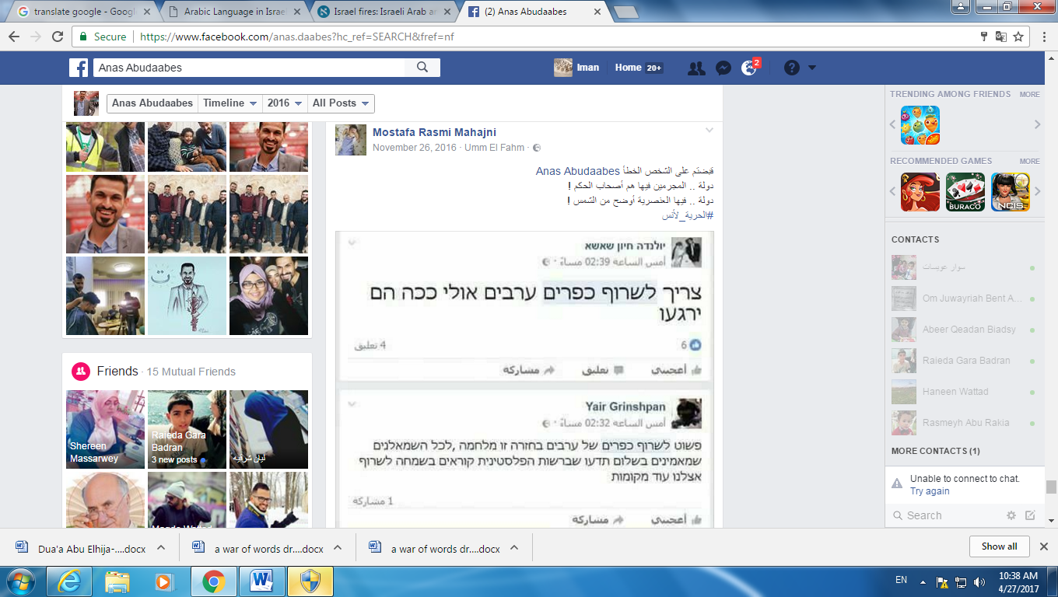
Translation of the Arabic text:
“You have arrested the wrong person, Anas Abudaabes.
In this country the criminals are the governors!
In this country racism is as clear as the light of the sun!
#Freedom to Anas!”
Translation of the Hebrew texts:
Comment 1:
“We have to burn all Arab villages; maybe this way they will calm down.

Comment 2:
“We simply need to burn Arab villages in return. This is a war, and all the leftists who believe in peace should know that in the Palestinian Authority, they are happily calling for more fires in our country.”

The findings also demonstrate a difference between Jewish Israelis’ reactions to controversies involving physical threats or confrontations and to controversies involving ideological or ethical issues, such as that of segregating Arab and Jewish women in maternity wards. The latter case evoked far fewer offensive comments from Jewish Israelis. However, even these comments revealed a sub-category of attitudes, with Jewish Israelis criticizing Jews who sympathized or affiliated with Arab/Palestinian Israelis. Arab/Palestinian Israelis were also much more confident about expressing their opinions
about the segregation controversy, as the issue clearly involved racism rather than a physical or threat of physical harm.

Author (if available). Title of article. (full date of article). Retrieved from:http://www.haaretz.com/israel-news/1.682928 vs. Author (if available). Title of article. (full date of article). Retrieved from http://www.aljazeera.com/news/2015/10/terrorist-state-151011084548356.html
Author (if available). Title of article. (full date of article). Retrieved from http://www.haaretz.com/israel-news/1.696321
Author (if available). Title of article. (full date of article). Retrieved from http://www.jpost.com/Israel-News/Report-Various-Israeli-hospitals-separate-pregnant-Jewish-Arab-on-request-450271
:Thetingw wrote on e has written on her wall that s
Author (if available). Title of article. (full date of article). Retrieved from http://hasa.co.il/?p=305466
The Facebook post in question ended with the tag:#satire_not_serious and #the_smoke_is_blinding_the_eyes_and_heart. See the link to the original post which was mistranslated: Author (if available). Title of article. (full date of article). Retrieved from https://www.facebook.com/anas.daabes/posts/10209996280477068 See also the comment on the story in Haaretz: Author (if available). Title of article. (full date of article). Retrieved from http://www.haaretz.com/israel-news/.premium-1.755367
See: https://www.facebook.com/permalink.php?story_fbid=1248838305139564&id=100000402186492

