Report

The Effects of the Gasoline Leak on the Avrona Nature Reserve’s Ecological System: Monitoring Plan for Microbats

**Submitted to *Ma’arag***

**Report for the 2016 Research Year**

**By**

**Carmi Korine**

**Ben-Gurion University of the Negev**

**January 2017**

**Background**

Microbats (heretofore: Bats) are of foremost importance to ecological system as they are the main, nocturnal predators of insects, and as such, function as the primary regulators of insect population sizes in varied ecological systems, including deserts (Kunz et. al. 2011). A third of all mammal species in Israel are bats, of which there are 33 subspecies the world over (Dolev and Pravolotzky, 2002). All bat species are protected by legislation in Israel, other than fruit bats. The vast majority of bat species are in danger of extinction, starting from species predicted to go extinct in the future, all the way to species in immediate danger of extinction (Dolev and Pravolotzky, 2002). According to the information gathered in Israel, there are likely to be sixteen subspecies of microbats and one of fruit bats in the *Arava* region (Amihai et. al. 2015, Yom-Tov and Kadmon 2008). The acacia trees in the *Arava* are preferred hunting zones for the bats, and all fifteen species that live in the desert can be found there, including especially rare species such as Little Black Serotine and Nycteridae (Hackett et. al. 2013). The groups of bats who hunt around the acacia trees include species which hunt insects on top of the trees, and those which collect them from the ground around the trees. The bats’ activity can essentially be used as an indirect measure of the acacia trees’ vitality. Because the food sources in arid areas are rather limited, any direct damage to them by pollution may directly damage the bats who find sustenance from the insects which develop on the trees, or my indirectly damage them by limiting their food sources.

**Research Goal:**

To compare and quantify the entirety of possible effects that oil pollution in the Avrona Nature Reserve may have on the activity and behavior of key species such as bats, through long-term monitoring, in order to assess if the pollution could indicate changes in the ecological system’s function. My assumption is that oil pollution has both a direct and an indirect effect on the bats’ food sources, and I predict that the bats’ activity will decrease, as well as serve as an indirect measure of acacia tree vitality.

**Work Methods:**

Research Areas: Bat sampling was performed in five zones of the polluted territories and in five control zones (Map 1). The sampling was performed in the Spring, Summer and Autumn.

Bat Sampling: In each observation session, I placed a bat detector on the ground at a 45-degree angle. The bat detector records super-auditory (high frequency) bat sounds which the bats broadcast, in order to identify the bat species present and searching for food in the area. The detector was placed adjacent to the acacia tree. Bat species have different voice frequencies in the desert (Hackett et. al. 2016), so that an analysis of the recordings using a designated computer program allows for identification of the bat species on the hunt in the given location. Since the majority of bat species in the areas sampled broadcast sounds at frequencies that do not overlap with one another, the recording analysis can reliably differentiate between the different species.

The bat detectors used were ANABAT II by Titley Electronics, Australia (from sunset until first light, for example from 5:30 pm until 5:00 am in the winter). The detectors provided information regarding the presence of bat species (Species Wealth) and regarding each species’ activity. It should be noted that in the recordings, voices cannot be ascribed to individuals, such that in bat studies, the abundance of the species are not calculated. Instead, the wealth of species (i.e. how many species there are) and each species’ general activity is calculated. Each detector was placed for five straight days and each sampling in every area lasted ten days. The sampling was conducted at every lunar phase; the placement of the detectors was random.

Analysis of Figures: When the field work and voice recording analysis were completed, I compared the bats’ activity and the species wealth between polluted areas and control areas, using Anova and non-parametric tests.

**Results**

***Bat Species Wealth and Activity in the Spring***

During the Spring, nine distinct species of bats were recorded in control areas, and eight were recorded in polluted areas (the polluted areas are referred to in the report as the “treatment” areas) (Fig. 1 and Figs. 7-8), but no significant differences were found in the average species wealth between control and treatment (p > 0.52). The average bat activity in polluted areas was higher (Fig. 2) but not significantly different (p > 0.07) than that of bats in the polluted areas (Fig. 2). In each area, the most common bat during the Spring was the Bodenheimer Bat.

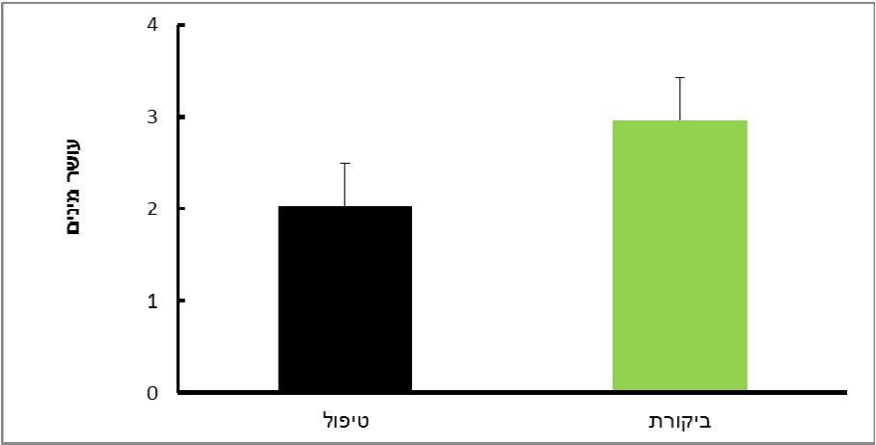

**Treatment**

**Wealth of Species**

*Figure 1:* Wealth of Microbat species in the control and polluted areas of Avrona during the Autumn.

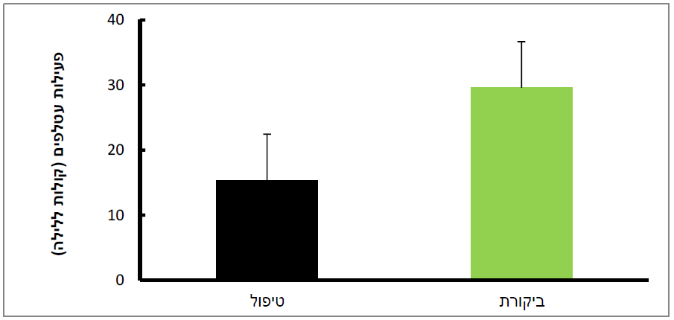

**Intensity of Bat Activity (Night Voices)**

**Control**

**Treatment**

*Figure 2:* Intensity of activity (voices/night) of microbats in the control and polluted areas of Avrona during the Autumn.

***Bat Species Wealth and Activity in the Summer***

During the Summer, eleven distinct species of bats were recorded in control areas, and nine were recorded in polluted areas, yet the species wealth did not differ (p > 0.5) between treatment and control areas (Fig. 3 and Figs. 7-8). The average bat activity was significantly higher in control areas than in polluted areas (Fig. 4). Certain bat species (White-rimmed and Bodenheimer) were most common, and the rat-tailed bats also had a large presence.

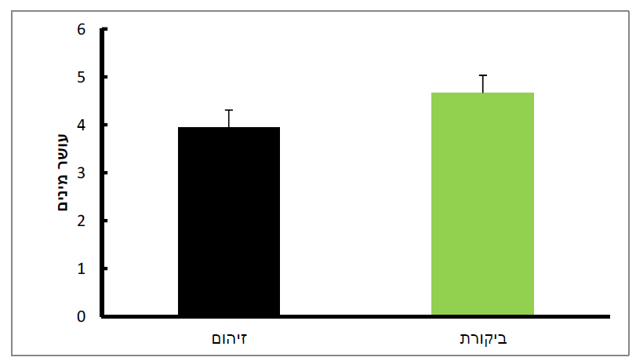

**Control**

**Pollution**

**Wealth of Species**

*Figure 3:* Wealth of Microbat species in the control and polluted areas of Avrona during the Summer.

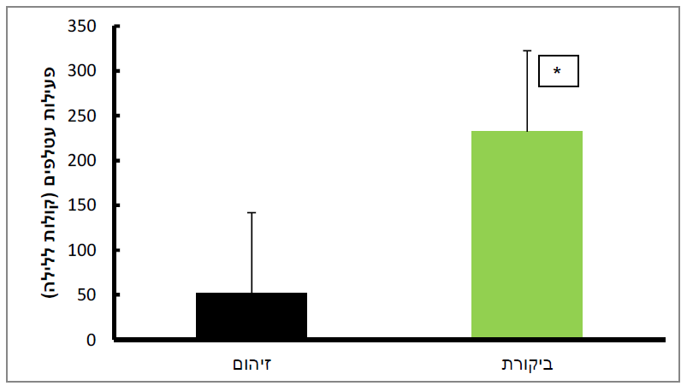

**Intensity of Bat Activity (Night Voices)**

**Control**

**Pollution**

*Figure 4*: Intensity of activity (voices/night) of microbats in the control and polluted areas of Avrona during the Summer. Asterisk denotes a statistical significance.

***Bat Species Wealth and Activity in the Autumn***

During Autumn, no significant differences were found in species wealth (Fig. 5 and Figs. 7-8) or activity (Fig. 6) between the control and treatment areas. Bodenheimer was again the most common species present.

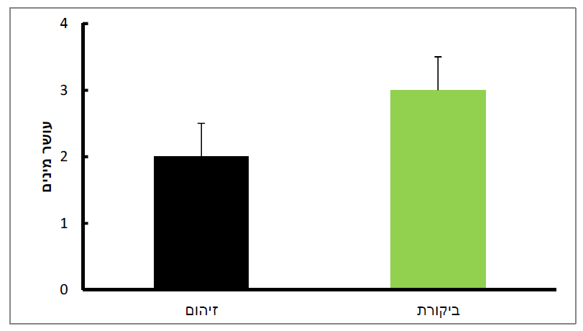

**Wealth of Species**

**Control**

**Pollution**

*Figure 5:* Wealth of Microbat species in the control and polluted areas of Avrona during Autumn.

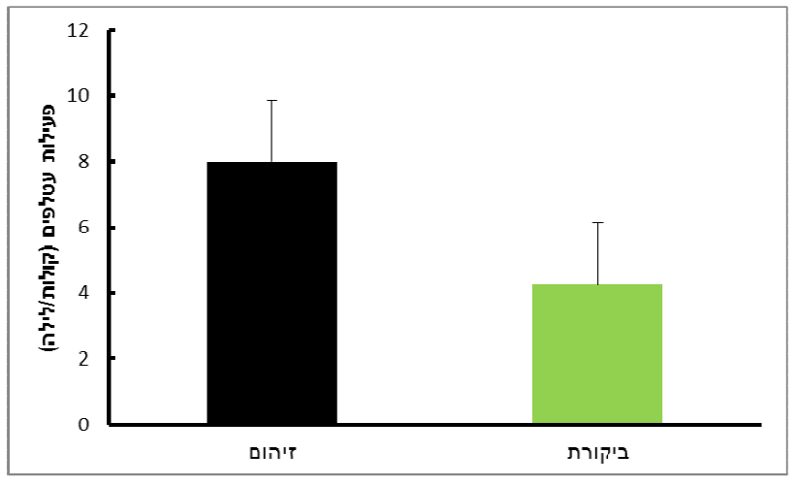

**Intensity of Bat Activity (Night Voices)**

**Pollution**

**Control**

*Figure 6:* Intensity of activity of bats in the control and polluted areas of Avrona during Autumn.

***Bat Species During the Year in Control and Polluted Areas***

Species wealth in control areas during the sampled seasons is presented in Figure 7. A total of eleven microbat species were recorded, five of which (45%) were recorded throughout the year. During the Summer, species wealth was significantly higher than during Spring or Autumn (p < 0.038, F2,12 = 4.48).

Species wealth in polluted areas during the sampled seasons is presented in Figure 8. A total of twelve microbat species were recorded, four of which (33%) were recorded throughout the year. As in the control areas, during the Summer, species wealth was at its highest (p < 0.04, F2,12 = 4.34).

*Figure 7:* Wealth of Microbat species in the control areas during each season of sampling in Avrona. Letters denote significant differences between the seasons.

*Figure 8:* Wealth of Microbat species in the polluted areas during each season of sampling in Avrona. Letters denote significant differences between the seasons.

*Figure 9:* Bat activity in control and polluted areas in each season of sampling in Avrona. Different letters denote significant differences between the seasons.

***Microbat Activity During the Year in Control Areas and Polluted Areas***

The average bat activity in control areas during the Summer was significantly higher than in the Spring and Autumn (Fig. 9, p > 0.02, F2,12 = 5.68). Significant differences between bat activity at different times of year were not found in polluted areas (Fig. 9, p > 0.051, F1,12 = 3.81).

*Figure 10:* Microbat activity during nighttime sampling in control and polluted areas during the Spring and Summer in Avrona.

No dependency was found between the bats’ activity and the sampling days in either area. Having said that, it should be noted that the line diagonal in control areas is positive, while in treatment areas, it is negative. Autumn results are not presented because the Autumn sampling was disrupted by rainfall in the area, and because of possible effects of the full lunar phase during the second half of the sampling.

**Discussion and Conclusions**

The goal of this research throughout the year was mean to assess the wealth and activity of microbats in the Avrona Nature Reserve for the first time, in both the polluted and control areas. The reserve is suited to a wide variety of microbats due to its hot climate and abundance of acacia trees which serve as hunting grounds of various foods for desert bats.

Based on extant data in the literature regarding activity and microbat species wealth in polluted areas (principally in areas in which water sources were polluted [Clark 1981]) or in agricultural areas in which there is extensive use of insecticides (Wickramasinghe et. al. 2003), I predicted that species wealth and their activity would be lower in polluted areas than in control areas. The results of the first year of monitoring partially support these predictions.

Oil pollution in desert areas can have direct, but mostly indirect effects on bats. Bats tend to drink from open water sources, and various species hunt food above said sources. In the event that pollution damages the layers of runoff water and groundwater, it may cause damage to bats who drink from them directly (Clark and Krynitsky 1978) or indirectly, by hunting aquatic insects which were affected by the pollution (Cain et. al. 1992). Another indirect effect is the hunting of land insects which were also affected as a result of ground pollution (Clark, 1981). Moreover, the pollution may influence the variety and availability of insects, and as such lead to a decrease in local bat species wealth (Vaughan et. al. 1996). A survey of the literature reveals that microbats which sought food above polluted water sources were indirectly damaged in a slew of ways from ingesting the polluted insects (Naidoo et. al. 2013).

The monitoring results reveal no significant differences between polluted and control areas in the Spring and Autumn, regarding species wealth and activity. In the summer, however, the season with the highest bat activity, it was found that their activity was also significantly higher in control areas than in polluted areas. The level of bat activity in polluted areas did not change throughout the year, while in control areas, activity reached its peak in the Summer, similar to other desert areas (Korine and Pinshow 2004; Feldman et. al. 2009; Korine et. al. 2015). This may hint that though the bats search for food in polluted areas, insect variety and perhaps overall presence there as well may not be high. More support of this explanation can be seen in the bats’ activity in polluted areas throughout the sampling days, which decreased over time, as opposed to the steady or increasing activity of bats in control areas.

All the species of bats recorded in Avrona, except for the White-Rimmed and Wizard bats, are at various levels of danger of extinction- anywhere from vulnerable populations to species already almost completely extinct. Therefore, this research is of paramount importance and has great potential for preserving the Microbat species in the arid *Arava* area.

*In Summary:*

* 12 Microbat species were recorded in polluted areas and 11 were recorded in control areas, comprising 69-75% of all desert species (Yom-Tov and Kadmon 2008). This makes the Avrona Reserve the most important site for Microbats to search for food.
* Of 12 species, 10 are at various stages of danger of extinction. This figure testifies to the importance of the Reserve as a food site and perhaps also as a safe sleeping site for desert Microbats.
* In the Summer, the Microbats’ activity was significantly higher in control areas than in polluted areas. It can be assumed that in damaged areas, the variety and density of nocturnal insects are smaller, and the odor of the oil in polluted areas may prevent the bats from seeking food there.
* Bat activity and species wealth increase throughout the year. In the Summer in control areas, just as in other areas of Israel, the activity is at its highest. This model was not found in the polluted areas, and may also indicate that bat activity in polluted areas is limited.

Continuation of Research:

1. Continued sampling in the second year of research, taking care not to sample during full lunar phases.
2. Expansion westward of sampling areas within the polluted territory.
3. Work alongside monitoring of nocturnal insects, as much as possible.

**Literature**

Dolev, A. an Provoltsky, A. 2002. The Red Book of Vertebrates in Israel: A List of Endangered Speaces. The Israeli Nature and Parks Authority and the Society for the Protection of Nature in Israel.

Amihai A., Yidov, S., Dolev, A., Sabah A., Malihi, Y., Tsoar, A., Talbi, R. and Lider, N. 2015, The National Monitoring Plan for Bats in Israel: A Review of Microbats in Israel 2014. The Israeli Nature and Parks Authority, Mammal Center, the Society for the Protection of Nature in Israel.

Cain, D.J. Luoma, S.N. Carter, J.L. et al (1992) Aquatic insects as bioindicators of trace element contamination in cobble-bottom rivers and streams. Canadian Journal of Fishery and Aquatic Science 49: 2141-2154.

Clark, D.R. Jr. 1981. Bats and environmental contaminants: a review. United States Fish and Wildlife Service, Special Science Report-Wildlife 235:1-27.

Clark D.R. Jr, and Krynitsky, A.J. 1978 Organochlorine residues and reproduction in the little brown bat, Laurel, Maryland—June 1976. Pestic Monitoring Journal 12:113-116.

Feldman, R. Whitaker, J.O. and Yom-Tov, Y. 2000. Dietary composition and habitat use in a desert insectivorous bat community in Israel. Acta Chiropterologica 2:15-22.

Hackett T. Korine, C. Holderied, M.W. 2013. The importance of Acacia trees for insectivorous bats and arthropods in the Arava desert. PLoS One 2:e52999.

Korine, C. Adams, A. Shamir, U. and Gross, A. 2015. Effect of water quality on species richness and activity of desert-dwelling bats. Mammalian Biology 80:185-190.

Korine, C. and Pinshow, B. 2004. Guild structure, foraging space use, and distribution in a community of insectivorous bats in the Negev Desert. Journal of Zoology 262: 187-196.

Naidoo, S. Vosloo, D. Schoeman, M.C. 2013. Foraging at wastewater treatment works increases the potential for metal accumulation in an urban adapter, the banana bat (Neoromicia nana). African Zoology 48:39-55.

Vaughan, N. Jones, G. and Harris, S. 1996. Effects of Sewage effluent on the activity of bats (Chiroptera: Vespertilionidae) foraging along rivers. Biological Conservation 78:337-343.

Wickramasinghe, L. P. Harris, S. Jones, G. and Vaughan, N. 2003. Bat activity and species richness on organic and conventional farms: impact of agricultural intensification. Journal of Applied Ecology 40:984-993.

Yom‐Tov, Y. and Kadmon, R. 1998. Analysis of the distribution of insectivorous bats in Israel. Diversity and Distributions 4:63-70.