Behavioral Instruments in Consumer Contract Law (A Lecture)
Meirav Furth-Matzkin*
I would like to begin by thanking Professors Brigitta Lurger and Karl Stoeger for inviting me to lecture at the conference on Nudging and Information at the University of Graz. The topic of this talk is: “Behavioral Instruments in Consumer Contract Law,” and I was specifically asked to focus on the United States’ regulatory approach.
First let me give you a little background.

- Behavioral Market Failures in Consumer Markets
By now, it is an undisputable and universally acknowledged truth that consumers almost never read the fine print before signing or clicking “I agree.” In fact, researchers have already found that non-reading consumers may even agree to terms that require them to sell their first-born children in order to obtain Wi-Fi access, or to trade their souls to the devil for a videogame. Consumers face an incredible amount of fine print in their daily lives, and it is practically impossible for them to read every contract they click through or sign.
If this is not problematic enough, sellers often make it even harder for consumers to read and understand these standardized agreements by using long forms, small fonts, and complex legal jargon. It is not surprising that no one reads these egregiously lengthy and often unintelligible agreements. In fact, it is probably even rational not to read them. Nonetheless, these agreements are generally legally binding.
Sellers gain from consumers’ non-readership because they can insert unfair and one-sided terms into their boilerplates without worrying that these terms will discourage consumers from entering into the transaction. Such terms may include, for example, waivers of the consumer’s right to a jury trial, class action waivers, and clauses governing choice of law or forum.
But even when they disclose certain terms clearly enough to make consumers aware of them, sellers often design contracts in ways that take advantage of consumers’ cognitive biases and systematic misperceptions. For example, consumers may underestimate the probability that a product will fail to work or will cause damage. As a result, sellers might be incentivized not to offer a warranty, concluding that consumers will not be willing to pay the full costs of the warranty. Or take another example: credit card late payment fees. Consumers, being overly optimistic, might underestimate the probability of their not paying their credit card bills on time. In these cases, credit card issuers can increase the late payment fees while seducing consumers to enter into the agreement by lowering the more salient annual fees. This can lead to consumers entering into transactions that are not financially optimal for them.
- Regulatory Solutions
In light of the recognition that sellers often insert one-sided or exploitative terms into their boilerplate agreements, scholars have consistently called for stronger and broader regulation of consumer contracts, and regulators have taken measures in accordance with this approach. I will now address the various regulatory instruments governing consumer contract law in the United States.
One principal instrument is disclosure. Indeed, disclosure is probably the most commonly used tool in American consumer protection law today. Disclosure mandates are attractive because disclosure provides information to consumers while avoiding excessive intervention in the market. The only problem is that disclosure mandates usually do not work. And they do not work mainly because, just like the rest of the fine print, disclosures usually remain unread. Furthermore, even if consumers try to read the disclosed information, they often do not understand it, let alone succeed in incorporating this information into their decision-making processes. Sellers are not incentivized to convey the disclosed information in an effective manner. In fact, they have incentives to do precisely the opposite. Consider the following anecdote. When I visited Bank of America a few days ago, the bank officer persuaded me to enroll in another credit card program, and he made me extremely uncomfortable when I tried to actually read the agreement before clicking through to the end and signing. He said: “Trust me, that just says what I told you a few minutes ago. You can sign here.” He made it very clear that I was expected not to read, but just to trust him. This example illustrates the bottom line: that disclosure has generally failed to adequately protect consumers from exploitative practices and contract terms.
In light of the recognition that disclosure alone cannot provide a solution to the problem of exploitative fine print, there is an ongoing trend towards enhancing consumer protection by adopting stronger and more coercive regulatory tools. We can roughly divide these tools into two main types. The first one consists of judicial intervention ex post, whereby courts can police contract terms using common law doctrines such as unconscionability or fraud to strike out clauses deemed exploitative or extremely unfair. The second one consists of mandatory restrictions on permissible contracting ex ante. These restrictions either prohibit the inclusion of certain contract terms or force sellers to include certain terms in their contracts. For example, the U.S. residential rental sector is characterized by comprehensive ex ante regulation. Landlords are prohibited from, among other things, disclaiming the warranty of habitability (which is the implied warranty that the rented premises are fit for human occupation), or disclaiming their liability for loss or damage caused to the tenant or to third parties on the leased premises as a result of the landlord’s negligence. There are many other markets in which substantive regulation has been adopted, including the credit card and insurance markets.
- Does Substantive Regulation Adequately Protect Consumers?
In the time I have left, I will focus on these more substantive measures, and I will try to convince you that we should at least be concerned that even these stronger measures may not adequately protect consumers. This is because all of these regulatory measures heavily rely on consumers to initiate action against a non-compliant seller. However, because consumers could often mistakenly perceive the contract as enforceable and binding, even when it is voidable or already void under the law, it unlikely that they would initiate any action.
Now, I will quickly point out that, like in Europe, the United States has public enforcement mechanisms and consumer advocacy groups that may help protect consumers; but these, too, often rely on consumer initiative in making complaints.
I will now present two studies casting doubt on the possibility that consumers will complain when they face contractual arrangements that are simply unenforceable or deceptive.
  - Unenforceable Terms in the Residential Rental Market
Let us examine the residential rental market as a first example. As I mentioned, landlords are not allowed to include clauses disclaiming their negligence liability in their residential lease agreements. But what happens if they nonetheless include such terms? One possibility is that nothing will happen because the terms are unenforceable and therefore legally meaningless, and because residential leases, like other types of standard form contracts, typically remain unread and therefore cause no harm. And indeed, this is the conventional wisdom in consumer contracts scholarship today.
But here, it is important to make two important distinctions. First, there are different types of consumer contracts, and it is possible that even if certain types, mostly involving low-stake transactions, like the purchase of online software, largely remain unread, others, associated with high-stake transactions, like renting or buying a home, will be read by substantial proportions of consumers.
Second, and perhaps more importantly, it is essential to draw a distinction between readership or non-readership ex ante and readership ex post. Namely, as I have found in my work, even if consumers do not always read their contracts ex ante, before entering the agreement, they might look at their contracts later when a problem or a dispute with the seller or landlord arises. And, at this point in time, they are likely to rely on their contracts as their main, or even only source of information about their rights. In so doing, they might misperceive unenforceable terms as enforceable and binding, causing them to limit or forego their rights and remedies. Consequently, they may refrain from pursuing their valid legal rights and claims, and end up bearing costs that the law deliberately and explicitly imposes on the seller or landlord.
To test this hypothesis, I surveyed a random sample of 279 tenants from Massachusetts about their rental experiences. Among other things, I asked them to describe what they did when they encountered a rental problem. My survey results revealed that a remarkably high proportion of the surveyed tenants, 51 percent, reported reading the relevant parts of their leases when something went wrong. Building on these findings, I conducted a series of experiments in which tenants were asked to read scenarios about rental problems and then reported on how they would behave.
In these experiments, participants were asked to assume that they had recently moved into a rented apartment. They then read a scenario in which after moving in, the roof in their rented apartment started leaking, and their landlord failed to fix it, even after they had sent the landlord a letter of complaint. In the scenario, two months later, rain water leaked into their apartment from the faulty roof and damaged their television set.
Before reading the scenario, participants were randomly assigned to read and sign one of three residential rental contracts. The contracts were completely identical but for one contract term. Participants assigned to the enforceable term condition read a contract containing a clause acknowledging the landlord’s liability in negligence for damage caused to the tenant or third parties in the leased premises. Those assigned to the unenforceable term condition read a contract containing a clause disclaiming the landlord’s liability for damages to the premises. And participants assigned to the no term condition read a contract that said nothing about the landlord’s liability for loss or damage to the tenant. After reading the scenario, participants were asked to respond to an open-ended question about how they would behave under the circumstances described in the scenario. Three independent research assistants coded their responses. Strikingly, the findings revealed that tenants who read an unenforceable liability disclaimer were almost three times more likely to bear the TV’s repair costs than were tenants who read an enforceable liability provision (acknowledging the landlord’s negligence liability) or even a silent lease.
These results illustrate that sellers and landlords have a strong financial incentive to use their contracts to misinform non-drafting parties about their legal rights. Indeed, in one of my previous studies, I found that unenforceable terms are regularly included in residential lease agreements in Massachusetts. Unenforceable liability disclaimers, for example, were present in 23 percent of the sampled contracts.
Now you may think that this is an American problem, so let me give you a European example. It involves a company you may have heard about: Apple. In 2009, Apple was fined €900,000 for misleading consumers about their warranty rights. All Apple did was inform its customers that they were entitled to a one-year warranty free of charge, and then offer them an extension of their warranty to two or even three years if they purchased the “Apple Care Protection Plan.” What Apple did not tell its customers was that they were automatically entitled to a two-year warranty free of charge under the law. Remarkably, two years after having been fined for this misrepresentation, the European Union Justice Commissioner, Ms. Vivian Reding, reported that Apple continued to misinform consumers about their warranty rights in at least 21 European Union member states.

  - Fraud and Fine Print Cases
Sellers are able to misinform consumers about the law because of the combination of consumers’ ignorance of the law and their underlying assumption that whatever the contract says is binding. In fact, in a study conducted in collaboration with Roseanna Sommers, we found that consumers feel so committed to the fine print that they fail to realize that their contracts may be voidable even when they were signed as a result of clear and material fraud.
Notably, consumer fraud is one of the main concerns pervading consumer contract law today. In fact, according to a report by the Federal Trade Commission, as many as 25 million Americans fall prey to consumer fraud every year. In many of these cases, the fine print that the defrauded consumer signs, typically without reading, contains a statement that contradicts, qualifies, or disclaims the seller’s prior representations. For example, in the context of mortgage loan agreements, loan officers often lure consumers into signing floating rate loan agreements after promising them that the interest on their loan is fixed. In the insurance context, too, homeowners are often promised that they will receive full coverage, only to find out, when something bad happens, that their policies cover only limited types of damages, like damage due to fire or wind. I am guessing that many of you have, at a certain point in time, made a purchase while relying upon a written advertisement or the salesperson’s statements, and ended up with a product materially different from what you were promised and had in mind.
By now I hopefully do not need to convince you that the practice of including fraudulent and fine print clauses in consumer agreements is harmful. In fact, it not only harms consumers, but potentially harms the aggregate welfare. From an economic perspective, efficient markets require that consumers enter into only those transactions that make them better off. And for that to happen, consumers need accurate information.
Because of the social costs associated with these misleading practices, it is not surprising that all jurisdictions in the U.S. have adopted a firm anti-deception approach. The common law doctrine of fraud allows consumers to void a contract or term that conflicts with a seller’s fraudulent representation. In addition, all fifty states have adopted consumer protection statutes, or UDAPs (Unfair and Deceptive Acts and Practices Laws), that have even looser requirements for proving fraud. Finally, the Draft Restatement of Consumer Contracts calls for any standard contract term inconsistent with a company’s prior representation to be deemed presumptively deceptive, and to be rendered voidable without having to prove reliance. As a result of these stronger protections, consumers are not barred from bringing a fraud action based on the claim that their contract conflicts with the seller’s prior statement. Indeed, barring consumers from bringing claims in fraud and fine print cases would effectively grant sellers a license to deceive consumers.
This hostile approach towards fraud and fine print cases is supposed to protect consumers, but Sommers and I feared that these regulatory measures might fail to achieve their intended effect because all of these measures rely on consumer initiative to take action against the deceptive party. We posited that consumers’ psychology would discourage them from complaining or from taking sellers to court in fraud and fine print situations, because consumers might blame themselves for failing to read the fine print and might believe that courts do the same. To explore this hypothesis, we conducted a series of experiments.
In one study, participants read three scenarios based on real cases representing three different consumer sectors in which fraud and fine print cases are relatively prevalent: the auto loan, telecommunications, and mortgage industries. For example, in the auto loan scenario, participants read about a consumer named William who decided to buy a new car. On the day of his purchase, a salesperson from the auto company suggested that William enroll in a payment program that was supposed to help him finance his car. After enrolling, William began to notice that the auto company charged fees every time it debited his account. He quickly did the math and realized that the plan actually ended up costing him money. Importantly, we emphasized to participants that the fee was a material fact: William would not have enrolled in the program had he known about the fee. When poor William complained, the company’s representative referred William to the “terms and conditions” in the paperwork he had signed, without reading, when he enrolled in the program.
For the purposes of the experimental manipulation, participants were randomly assigned to one of three experimental conditions. In the fraud only condition, the seller verbally promised William that the company would not charge any fees, but the company did so anyway. Now, importantly, in this condition, there was no conflicting fine print. Namely, the contract was silent about the fees. In contrast, in the fine print only condition, the seller did not mention any fees verbally, but the contract explicitly allowed the company to charge them, and William was surprised to learn about these fees simply because he had failed to read the fine print. Finally, in the fraud and fine print condition, the seller verbally promised William that the company would not charge any fees, but the contract contained a conflicting term allowing the company to charge these fees. These are the typical fraud and fine print situations we discussed earlier.
Participants were then asked to indicate on a seven-point scale whether they agreed with the following randomly presented statements: (1) A court would probably rule that William was legally required to pay the fee if William sought to void the transaction; (2) It is fair to require William to pay the fee; (3) William consented to pay the fee; and (4) William had fair notice about the fee.
Now let us have a look at the results.
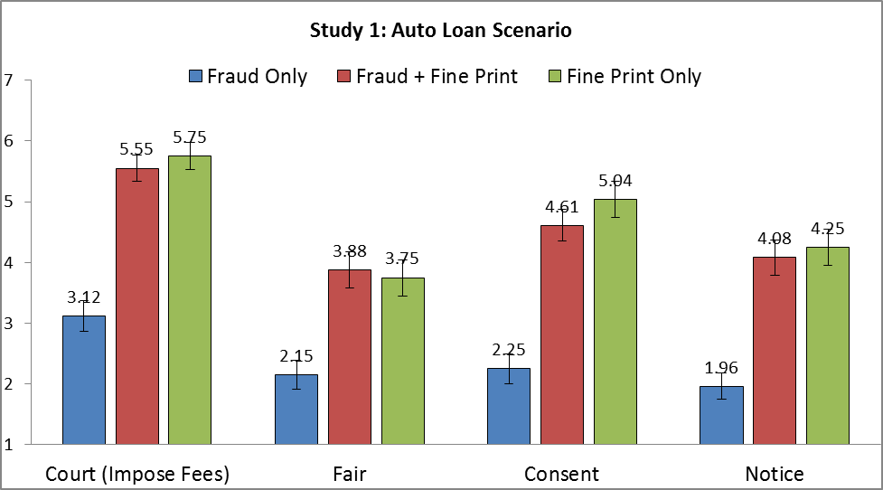
The results revealed that, as we expected, participants in the fraud only condition largely believed that William would not be legally required to pay the fee and that it was unfair to require him to pay as he had not consented or received fair notice about the fee.
Now let’s look at participants’ conclusions under the fraud and fine print condition. I remind you that this condition is identical to the fraud only condition, with one important difference: this time, after the seller told William there would be no fees, William signed a contract in which the fee was disclosed. And here, the findings were surprising, as there were no significant differences between the
fraud and fine print and fine print only conditions across all dependent measures. Participants felt that the consumer was bound to pay the fee in the presence of the fine print disclosure, regardless of whether there was a prior misrepresentation. These findings suggest that consumers place excessive weight on the fine print, and that they believe they are bound by whatever the contract says, notwithstanding any prior misrepresentations.

Importantly, as the following figure illustrates, we also observed a mismatch between consumers’ legal judgments and their moral intuitions.

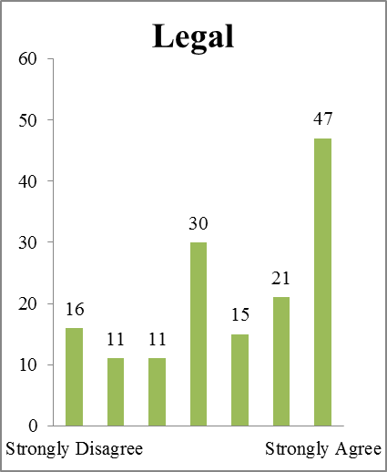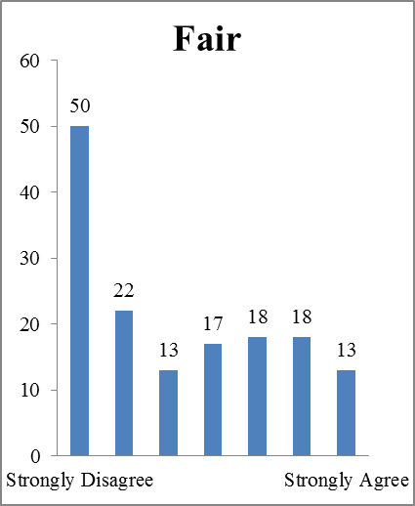
Lay Perceptions of Fraud & Fine Print Cases
Even though consumers generally thought it was unfair to impose the fees on the non-reading and defrauded consumers, they generally thought that the current state of the law demanded this outcome.
We also asked participants what they would do if they were in the consumer’s shoes. Three independent research assistants coded participants’ qualitative responses. Remarkably, most participants in the fraud only condition, 85 percent, expressed interest in taking some kind of action, including legal action, against the company. Some mentioned tarnishing the company’s reputation or complaining to management. In contrast, participants in the other two conditions involving the fine print permitting the fees exhibited the opposite trend. Most of them expressed willingness to pay the fees and learn their lesson going forward, while the proportion of respondents expressing interest in taking some sort of action shrank by half, from 85 percent to about 30 percent. These findings illustrate that the fine print plays a role in shaping not only people’s perceptions, but their decisions as well.
- Concluding Remarks
So, what can we learn from all of this? We began by observing that consumer markets are prone to, and often suffer from, behavioral market failures. These failures are the result of the interaction between consumer psychology and imperfect information on the one hand, and market forces on the other hand. Consequently, we see that sellers often use one-sided terms in the fine print, or even terms that exploit consumers’ systematic biases or misperceptions.
We then surveyed the regulatory tools that policymakers use in order to combat these deceptive market practices, with a focus on the stronger, more coercive, tools in the policymaker’s arsenal. But we saw that although these tools are promising, they might not achieve their intended effect due to their main reliance upon consumers to take action. This is because as long as consumers remain uninformed about the law, they are unlikely to complain or take action against a deceptive company, even when they face unenforceable or deceptive terms, and even when they are victims of pre-contractual misrepresentations. I therefore believe that public enforcement mechanisms should be prepared to take on the lion’s share of enforcement, as consumers, because of their formalistic intuitions about the contract and the law, are unlikely to protect themselves.

* Incoming John M. Olin Research Fellow and Lecturer in Law, University of Chicago Law School; S.J.D. candidate, Harvard Law School. This lecture builds on heavily on three main papers: (1) Meirav Furth-Matzkin, On the Unexpected Use of Enforceable Contract Terms: Evidence from the Residential Rental Market, 9 J. Legal Analysis 1 (2017); (2) Meirav Furth-Matzkin & Roseanna Sommers, Fool Me Once, Shame on Me: How Consumers and Lawyers Perceive the Fine Print in Deception Cases 1–55 (Harvard John M. Olin Center for Law, Economics, and Business Fellows’ Discussion Paper Series, Discussion Paper No. 82, 2018), http://www.law.harvard.edu/programs/olin_center/fellows_papers/pdf/Furth_82.pdf ; and (3) Meirav Furth-Matzkin, Bargaining in the Shadow of the Contract 4 Ala. L. Rev. (2019).
See, e.g., Tess Wilkinson-Ryan, The Perverse Behavioral Economics of Disclosing Standard Terms, 103 Cornell L. Rev. 117, 118–20 (2017) (observing “the now-uncontroversial fact of universal non-readership”); David A. Hoffman, From Promise to Form: How Contracting Online Changes Consumers, 91 N.Y.U. L. Rev. 1595, 1605 (2016) (“[O]f course, almost no one reads any of these additional, increasingly long contracts.”); Zev J. Eigen, Experimental Evidence of the Relationship between Reading the Fine Print and Performance of Form-Contract Terms, 168 J. Inst. & Theoretical Econ. 124, 132 (2012) (finding that nearly a third of study participants failed to review online contracts at all, and the mean time spent reviewing the contract among the remaining participants was under two minutes); Yannis Bakos, Florencia Marotta-Wurgler & David R. Trossen. Does anyone read the fine print? Consumer attention to standard-form contracts, 43 J. Legal Stud. 1 (2014); Omri Ben-Shahar & Carl E. Schneider, More Than You Wanted to Know: The Failure of Mandated Disclosure (2014).
Agatah Blaszczak-Boxe, Give Up Firstborn for Free Wi-Fi? Some Click ‘I Agree,’ CNET (Sept. 30, 2014), http://www.cnet.com/news/give-up-firstborn-for-free-wi-fi-some-click-i-agree/;Fox News Staff, 7,500 Online Shoppers Unknowingly Sold Their Souls, Fox News (Apr. 15, 2010), http://www.foxnews.com/tech/2010/04/15/online-shoppers-unknowingly-sold-souls.html.
Meirav Furth-Matzkin, On the Unexpected Use of Enforceable Contract Terms: Evidence from the Residential Rental Market, 9 J. Legal Analysis 1 (2017) [hereinafter Furth-Matzkin 2017]; see also, e.g., Alleecia M. McDonald & Lorrie F. Cranor, The Cost of Reading Privacy Policies, 4 J.L. & Pol’y for Info. Soc’y 543, 563–64 (2008) (estimating that it would take people 244 hours per year, on average, to read privacy policies if they actually attempted to do so for every contract they sign or click through).
Debra Pogrund Stark & Jessica M. Choplin, A License to Deceive: Enforcing Contractual Myths Despite Consumer Psychological Realities, 5 N.Y.U. J.L. & Bus. 617, 656–58 (2009).
Furth-Matzkin 2017, supra note 3.
See David Gilo & Ariel Porat, The Hidden Roles of Boilerplate and Standard-Form Contracts: Strategic Imposition of Transaction Costs, Segmentation of Consumers, and Anticompetitive Effects, 104 Mich. L. Rev. 983, 984 (2006); see also Edith Warkentine, Beyond Unconscionability: The Case for Using “Knowing Assent” as the Basis for Analyzing Unbargained-for Terms in Standard Form Contracts, 31 Seattle U. L. Rev. 469, 515 (2007) (observing that one-sided terms are often covertly inserted by drafting parties into their boilerplates); Russell Korobkin, Bounded Rationality, Standard Form Contracts, and Unconscionability, 70 U. Chi. L. Rev. 1203, 1206 (2003) (noting that drafting parties often exploirt consumers’ cognitive biases); Meirav Furth-Matzkin, Bargaining in the Shadow of the Contract, 4 Ala. L. Rev. (2019) [hereinafter Furth-Matzkin 2019].
Margaret J. Radin, Margaret, Boilerplate: The Fine Print, Vanishing Rights, and the Rule of Law (2013).
Oren Bar-Gill, Seduction by Contract: Law, Economics, and Psychology in Consumer Markets (2012); Korobkin, supra note 6; Melvin Eisenberg, Behavioral Economics and Contract Law (Eyal Zamir & Doron Teichman eds., 2014).
See, e.g., Gilo & Porat, supra note 6, at 985 (noting that “there is a risk that the supplier will extract payment from the consumer without the latter being aware of the fact that the payment does not reflect the reduction of value due to the harsh clause”); see also Thomas J. Miceli & Kathleen Segerson, Liability versus Regulation for Dangerous Products when Consumers Vary in their Susceptibility to Harm and May Misperceive Risk, 9 Rev. L. & Econ. 341 (2013) (arguing that strict product liability is prefereable when consumers misperceive risk, in order that the price of the product may then accurately reflect the associated risk).
Bar-Gill, supra note 8, at 15–16; Michael S. Barr, Sendhil Mullaintahan, & Eldar Shafir, Behaviorally Informed Financial Services Regulation 12 (2008).
Id.
See, e.g., Magnusson-Moss Warranty-Federal Trade Commission Improvement Act, 15 U.S.C. §§ 2301–2312 (1976) (prohibiting sellers from disclaiming the Uniform Commercial Code’s implied warranty provisions); Credit Card Accountability Responsibility and Disclosure Act, 12 C.F.R. §§ 226.18, 226.5a (2009) (instituting price caps and other prohibitions, as well as heightened disclosure obligations).
Ben-Shahar & Schneider, supra note 1.
Id.
Id.
See Restatement of Consumer Contracts (Preliminary Draft No. 3, October 26, 2017), at 4; see also Eyal Zamir & Yuval Farkash, Standard Form Contracts: Empirical Studies, Normative Implications, and the Fragmentation of Legal Scholarship, 12 Jerusalem Rev. Legal Stud. 137, 162–67; Margaret J. Radin, Boilerplate: The Fine Print, Vanishing Rights, and the Rule of Law 218–32 (2013)
Furth-Matzkin 2017, supra note 3.
Furth-Matzkin 2019, supra note 6.
Furth-Matzkin 2017, supra note 3; Meirav Furth-Matzkin & Roseanna Sommers, Fool Me Once, Shame on Me: How Consumers and Lawyers Perceive the Fine Print in Deception Cases 1–55 (Harvard John M. Olin Center for Law, Economics, and Business Fellows’ Discussion Paper Series, Discussion Paper No. 82, 2018), http://www.law.harvard.edu/programs/olin_center/fellows_papers/pdf/Furth_82.pdf;Tess Wilkinson-Ryan, The Perverse Behavioral Economics of Disclosing Standard Terms, 103 Cornell L. Rev. 117 (2017) ; Dennis P. Stolle & Andrew J. Slain, Standard Form Contracts and Contract Schemas: A Preliminary Investigation of the Effects of Exculpatory Clauses on Consumers’ Propensity to Sue, 15 Behav. Sci. & L. 83 (1997).
Furth-Matzkin & Sommers, supra note 19.
Furth-Matzkin 2017, supra note 3; see also, e.g., URLTA §1.403(a)(4) (1972).
Furth-Matzkin 2017, supra note 3.
Id.
Furth-Matzkin 2017, supra note 3; Furth-Matzkin 2019, supra note 6.
See Furth-Matzkin 2017, supra note 3, at 36–40.
Id.
Furth-Matzkin 2019, supra note 6.
Furth-Matzkin 2019, supra note 6.
Furth-Matzkin 2017, supra note 3.
Id. at 26.
Mateja Djurovic, The Apple Case: The Commencement of Pan-European Battle Against Unfair Commercial Practices, 9 Eur. Rev. Cont. L. 253–266 (2013).
Zack Whittaker, EU Plans Stronger Consumer Law Enforcement After Apple Warranty Case, ZD.net (Mar. 19, 2013), https://www.zdnet.com/article/eu-plans-stronger-consumer-law-enforcement-after-apple-warranty-case/.
Furth-Matzkin & Sommers, supra note 19.
See Keith B. Anderson, Consumer Fraud in the United States: An FTC Survey, FTC (2004), https://www.ftc.gov/sites/default/files/documents/reports/consumer-fraud-unitedstates-ftc-survey/040805confraudrpt.pdf; Keith B. Anderson, Consumer Fraud in the United States: The Second FTC Survey, Ftc Staff Rpt. (2007), https://www.ftc.gov/sites/default/files/documents/reports/consumer-fraud-united-states-secondfederal-trade-commission-survey-staff-report-federal-trade/fraud.pdf.
E.g., Belleville Nat’l Bank v. Rose, 456 N.E. 2d 281 (Ill. App. Ct. 1983) (discussing a case in which mortgage fraud occurred via legal documentation reflecting different loan terms than promised, with a floating instead of a fixed interest rate); ; see also Stark & Choplin, supra note 4.
See Furth & Sommers, supra note 19, at 8; see also Korobkin, supra note 6, at 60; Richard A. Posner, Economic Analysis of Law 14–15 (5th ed. 1998).
See Restatement (Second) of Contracts §§ 164, 1.04 (Am. Law Inst. 1981) (rendering voidable contracts involving justifiable reliance by one contracting party on a fraudulent or material representation by the other party); Restatement of Consumer Contracts (Preliminary Draft No. 3, October 26, 2017), at § 6.
Carolyn Carter, Consumer Protection in the States: A 50-State Report on Unfair and Deceptive Acts and Practices Statutes, Nat’l Consumer L. Ctr. (2018), http://www.nclc.org/images/pdf/udap/report_50_states.pdf.
Restatement of Consumer Contracts (Preliminary Draft No. 3, October 26, 2017).
Stark & Choplin, supra note 4.
Furth-Matzkin & Sommers, supra note 19, at 19–21.
Id. at 16.
Id. at 21.
Id.

