**Banners:**

1. Beresheet – Luxury Living in The Judean Hills
2. Beresheet – Creating a Community of the Highest Standard
3. Beresheet – The Best Assisted-Living
4. Beresheet – Take Part in a New Experience of Living
5. Beresheet – An Innovative Habitation Concept for Seniors
6. Beresheet – A Luxurious Residential Community in the Heart of Nature
7. Beresheet – A Residential Community at a Standard You Have Never Experienced
8. Beresheet – Creating a New Residential Community Together

**This Is Your Time to Live Better**

Beresheet assisted living facility – a living experience for seniors located in the Judean Hills – a standard like none you have ever experienced!

**Schedule an introductory meeting before everyone else**

Full name:

Phone number:

**Send**

Or dial *2349

Beresheet, the place for new beginnings

For the first time in Israel, in the pastoral Motza neighborhood (on the outskirts of Jerusalem), we are offering a retirement experience for seniors who wish to be part of a community, allowing each and every member to fulfill themselves to the utmost, both as individuals and together. Our residents are invited to become active members in the community, influencing decision making, choosing cultural activities, and participating in the household management. All of this while surrounded by fascinating people of the highest quality, and living in a luxurious complex, allowing you to experience your best years in a warm, supportive, and intimate place. This is a truly unique experience, unlike anything you have ever seen before.



**This Is Your Time to Improve Your Quality of Life**

An extensive amount of thought was put into the design of Beresheet, in order to create a place that will allow you to lead the highest quality of life – a life of luxury and full of experiences. A semi-Olympic swimming pool, an innovative gym, a prestigious synagogue, a splendid recreation hall, and a wide range of leisure activities – when you live with us, you can enjoy these services and more, every single day. You are invited to come and live the good life – to enjoy everything life has to offer. The green spaces, the friendly coffee shop, and the historic nature reserve, which is open to the public, will allow you to experience the open environment with friends, family, and the local community.



**This is Your Time to Do What You Really Love**

After years of taking care of everyone around you, it is time to focus on you. This is your time to be daring – to fulfill your desires, discover your hidden talents, expand your horizons, and make new friends. Join us, and become a part of a strong, engaged community. Discover a wide variety of cultural and social activities, and a home in which every tenant can enjoy their personal preferences and lead the lifestyle that suits them best.

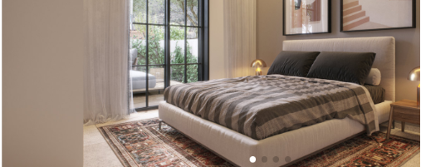

**This is Your Time to Feel at Home**

The facilities includes 300 apartments of the highest building standard, with gardens or balconies, and stunning views. Every apartment includes fully equipped double bathrooms, to provide for a future caretaker if required, and smart home technologies. Everything has been designed with the utmost thought and consideration, so that you feel you are living in a home uniquely tailored to you.



**This is Your Time to be a Part of Family Community**

Beresheet is the flagship project of the Lilac House group, a group with 30 years of experience and professional reputation with senior living solutions. We are proud to be the first group in Israel to introduce a new, up-to-date way of living for senior citizens, doing away with the traditional structure of assisted living facilities, and creating a community living experience of the highest quality. We consider personal contact to be the most important element in our new living experience, and make it a point to know each and every resident personally. We do our best to listen to what you have to say and build a supportive community together, an environment you can call home.

**For the First Time in Years, New Retirement Housing in Jerusalem**

100% personal care * 30 years of experience * A housing experience like none you’ve ever had * A 5 minutes’ drive from Jerusalem * A community center * Breathtaking views * Endless possibilities to fulfill yourself

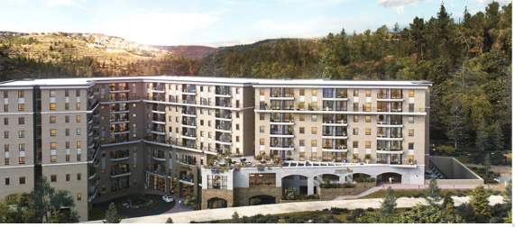

**This is Your Time to Feel Safe**

We know that an interesting, secure, and happy life begins with good health. For this reason, our premises provide its tenants with a variety of medical services, including an innovative nursing department, round the clock personal medical supervision, and a recovery unit, ensuring that you will not need to change your place of residence in the future. The house has everything required to provide you with security and peace, so that you can enjoy your longevity and in the best quality of life.

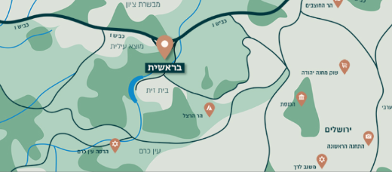

**This is Your Time to be Close to Everything**

We are located a 5 minutes’ drive from Jerusalem, and 40 minutes’ drive from Tel Aviv, in the very heart of Motza – a long-established, provincial, affluent, community village, surrounded by magical green mountains. We are located near Highway 16, a new highway currently being paved, which will provide an additional entrance to Jerusalem, as well as direct access to the south and central sections of the city, and a direct exit to Tel Aviv.

**Schedule an Introductory Meeting before Everyone Else**

Guarantee your place in the newest assisted-living facility in Israel

Fill your details below, and we will contact you as soon as possible

Full name:

Phone number:

E-mail address:

**Send**

* Motza, Jerusalem • call us now • [shirim@lichak.co.il](mailto:shirim@lichak.co.il) • follow us!