**EVALUATION OF SEIZER 8 SC (BIFENTHRIN) FOR CONTROLLING ANDEAN POTATO WEEVIL (*Premnotrypes vorax*) IN POTATO CROPS**

**Colombian Agricultural Institute (ICA) TRIAL REGISTRATION**

**PRELIMINARY REPORT**

Conducted by: Technical Department RAAL AGRO

Raquel Valbuena Cortes. ICA Reg. No. 002233, August 2005

**Soraca, 19 October 2010**

**EVALUATION OF SEIZER 8 SC (BIFENTHRIN) FOR CONTROLLING ANDEAN POTATO WEEVIL (*Premnotrypes vorax*) IN POTATO CROPS**

**ICA TRIAL REGISTRATION**

**SPECIFIC OBJECTIVES**

2.1. Determine the efficacy of SEIZER 8 SC (Bifenthrin) for controlling Andean potato weevil (*Premnotrypes vorax*).

2.2. Establish the most appropriate dose of SEIZER 8 SC to recommend in a phytosanitary management program.

2.3. Evaluate the phytocompatibility of SEIZER 8 SC (Bifenthrin) in the treated plots.

**Documentation**

The copies of the protocol approved by ICA/ PROFICOL ANDINA B.V SUCURSAL COLOMBIA are in Annex 1.

**MATERIALS AND METHODS**

The materials and calibration used were those mentioned in the protocol, i.e., a Royal Condor knapsack pump with a hollow cone nozzle and constant pressure valve at 35 psi, calibrated in each application.

The trial was located in three areas with previous potato weevil problems. The plots are uniform and representative of potato cultivation. All plots are for a second commercial harvest.

The presence of adult weevils was verified at each site. The first treatment was applied in the early part of the complete germination phase, or first weeding; the second application accompanied the second hilling or mounding; and the test product was applied for the third and last time at maturation.

Table 1 shows the location and potato variety in each trial.

|  |  |  |  |
| --- | --- | --- | --- |
| **General information** | Site One | Site Two | Site Three |
| Department | Boyacá | Boyacá | Boyacá |
| Municipality | Motavita | Siachoque | Soraca |
| District | Versalles | Tocavita | Chaine |
| Operation | La Laguna | El Paramo | Santa Rosa |
| Farmer | Cipriano Ferro | Segundo Lopez | Daniel Sosa |
| Potato variety | *ICA ÚNICA* | *ICA ÚNICA* | *PARDA PASTUSA* |

**TABLE 1. General information on each Seizer 8 SC trial. Boyacá**

Table 2 shows the schedule of applications and the net calibrated spray rates (L/Ha) for substance applied.

|  |  |  |  |  |  |  |
| --- | --- | --- | --- | --- | --- | --- |
| APPLICATION | SITE ONE: MOTAVITA | | SITE TWO: SIACHOQUE | | SITE THREE: SORACA | |
| DATE | L/Ha. | DATE | L/Ha. | DATE | L/Ha. |
| 1 | **07-Sept-10** | **195** | **21-Sept-10** | **208** | **01-Oct-10** | **303** |
| 2 | **05-Oct-10** | **298** | 20-Oct-10 |  | 02-Oct-10 |  |
| 3 | 05-Nov-10 |  | 23-Nov-10 |  | 10-Dec-10 |  |

**TABLE 2. Schedule and record of applications in the Seizer 8 SC trial in Boyacá.**

Table 3 shows the products and dosage being evaluated in the trial.

|  |  |  |
| --- | --- | --- |
| **TREATMENT** | **PRODUCT** | **DOSE (L/Ha.)** |
| 1 | SEIZER 8 SC | 1.3 |
| 2 | SEIZER 8 SC | 1.5 |
| 3 | SEIZER 8 SC | 1.8 |
| 4 | BRIGADA 10 EC | 1.2 |
| 5 | TST |  |

**TABLE 3. Dosage of Seizer 8 SC for the three locations in Boyacá.**

The photos below illustrate the field setup of each trial site. The final results and report will be drafted in April 2011.

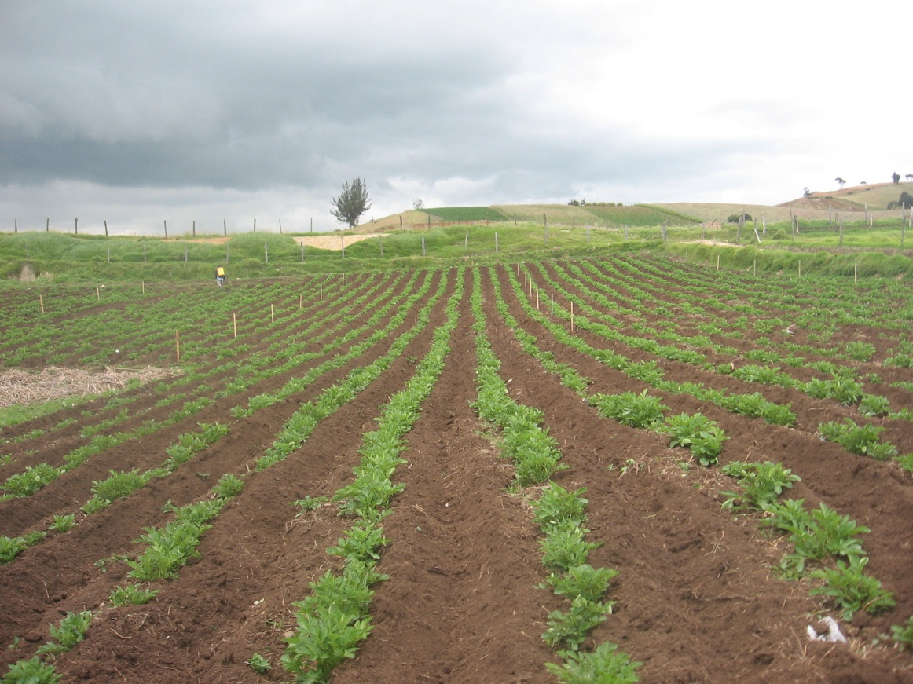

IMAGE 1. Panorama of the test site in Soraca, *parda pastusa* variety.

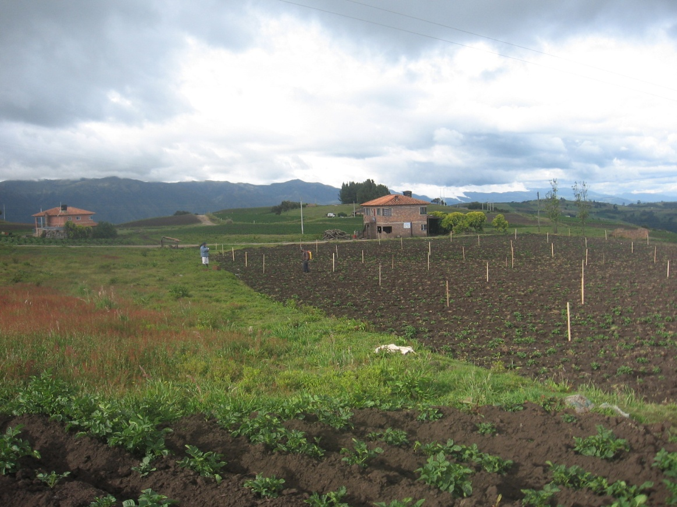

IMAGE 2. View of the test site in Motavita.

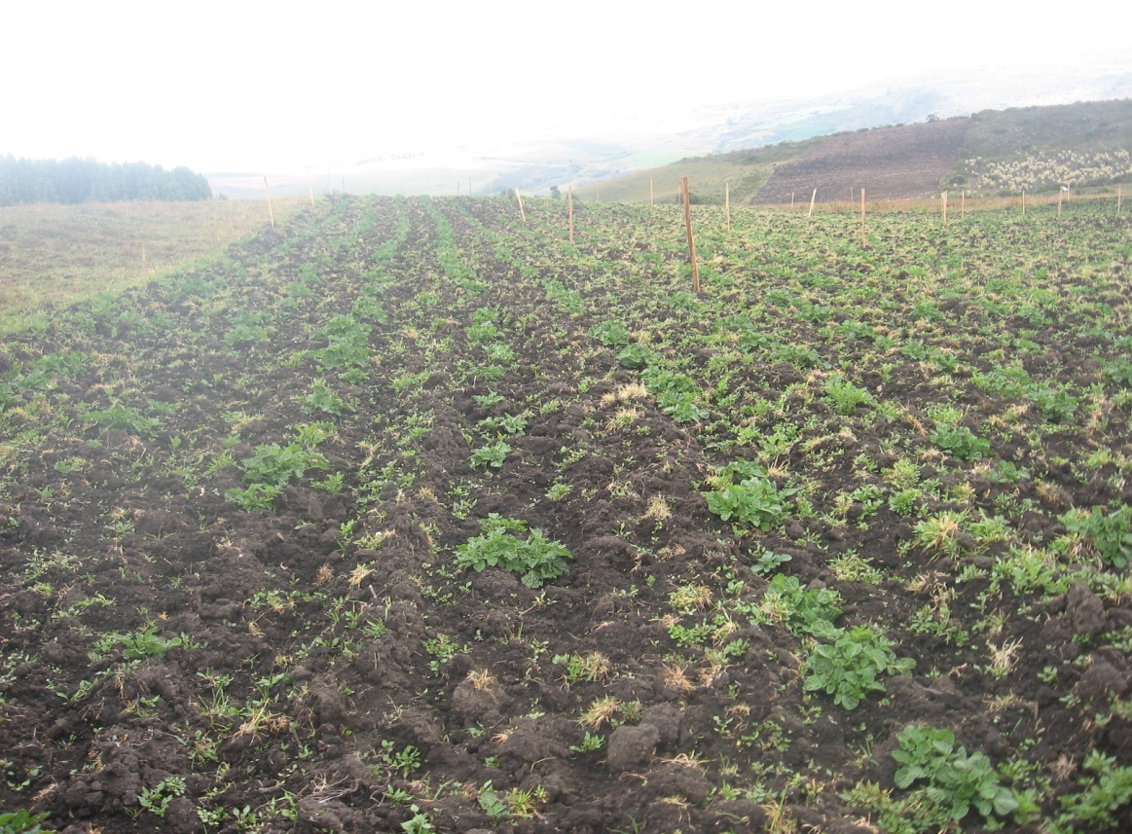

IMAGE 3. View of the Siachoque site.