**Ministry of the Interior State of Israel**

**Birth Certificate**

|  |  |  |  |
| --- | --- | --- | --- |
| **Family name** | Polk | **First name** | Ziv |
| **Father’s first name** | David | **Maternal grandfather’s family name** | Shabo |
| **Mother’s first name** | Renana | **ID number** | 343233110 |
| **Sex** | Female |  |  |
| **Nationality** | Jewish | **Religion** | Jewish |
| **Born in** | | | |
| **Residential area** | Kefar Sava | **Name of hospital** | Meir |
| **Date of birth** | | | |
| **Hebrew** | 1 Av 5777 | **Gregorian** | 24 July 2017 |

It is hereby confirmed that the newborn is registered in the birth register.

This certificate was issued in accordance with Section 30 of the Population Registry Law of 1965 at the Population and Immigration Authority, Jerusalem on 16 Av 5777 (8 August 2017).

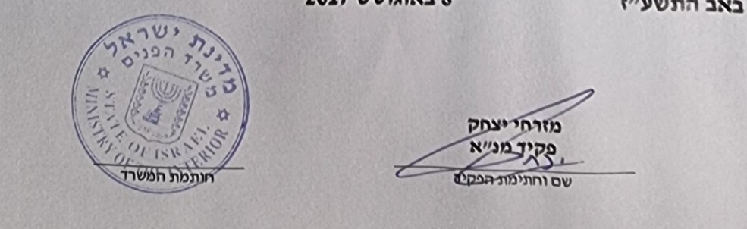

To: Renana Shabo

Barkan 3

Barkan 4482000

Ministry of the Interior 11/2016