16 Nisan 5781

29 March 2021

**RADHAZ-ELF /Institutional Client/153**

**Mr. Gal Gronner – Gronner DEL Engineers Ltd.**

[gal@grdel.co.il](mailto:gal@grdel.co.il), Tel: 04-8559111, Fax: 04-8559100, Mobile: 050-5213945

**Mr. Hagai Shoshani GIC Consulting for Industry,** Tel: 08-3750890, Mobile: 054-6565645

**Mr. Aharon Buzaglo** **– Bar Ilan University** – Mobile: 054-6603316

**Mr. Gadi Bognim, Bar Ilan University** – Mobile: 054-6603318

**Subject: Practical and Theoretical Survey of Magnetic Field Flux Along the Southern Alternative of Metro M2 Route on the Bar Ilan Campus**

**References**

1. Guidelines on the Limits of Exposure to Radiofrequency Electromagnetic Fields in the Frequency Range from 100 kHz to 300 GHz, ICNIRP – International Radiation Protection Association Guidelines, Health Physics, January 1988, Volume 54, No. 1.
2. Guidelines of the Radiation Commissioner of the Environmental Protection Ministry, July 2002, Limiting Magnetic Field Flux to an Environmental Exposure Threshold; update of Environmental Protection Ministry recommendations in September 2013 to an exposure threshold in line with the recommendations of the experts committee appointed by the ministry.
3. EMC Engineering Ltd. Document, Prediction of Magnetic Field Flux on the Metro M2 Line, 18 August 2019.
4. Professional opinion of Moshe Netzer - Electromagnetic Radiation, National Infrastructure Plan 102, southern alternative of Metro M2 line, 6 December 2020.
5. Professional opinion of Moshe Netzer on Effects of Electromagnetic Fields on Scientific Equipment at Bar Ilan University, 1 November 2020.
6. **Administrative Data and Executive Summary**
   1. Survey Objective

Mapping the magnetic field flux at a frequency of 50 Hz, which exists along the southern alternative route of the Metro M2 line on the Bar Ilan University campus. The measurements were compared to an estimate made for the Metro M2 line (Reference 3).

* 1. Safety Criterion and Electromagnetic Compatibility

Safety of exposure to magnetic field flux – see Chapter 2

Electromagnetic compatibility – see the table below from Reference 5

|  |  |  |  |  |
| --- | --- | --- | --- | --- |
| Building | Distance from the Metro | Bar Ilan Data | Results of Theoretical Estimate (References 3, 5) | |
| Sensitivity of scientific equipment to electromagnetic fields | Static magnetic field flux from normal driving current | Static magnetic field flux from short current or maximum load |
| Meters | mG | mG | mG |
| 202 | 123 | 1-10mG AC  No DC data | 0.28 | 0.82 |
| 204 | 123 | Low sensitivity | - | - |
| 205 | 111 | No data | 0.075 | 0.35 |
| 206 | 49 | 10µG AC | 1.0 | 3.7 |
| 207 | 82 | Moderate sensitivity | 0.14 | 0.46 |
| 208 | 72 | Not given | 0.17 | 0.6 |
| 209 | 43 | High sensitivity | 0.5 | 1.7 |
| 211 | 42 | 1-10mG AC  No DC data | 0.52 | 1.8 |
| 212 | 5 | Low sensitivity | - | - |

* 1. Time and Place of the Test

The background radiation survey was performed on 17 March 2021 between 10:00 – 14:00. Measuring at this time ensures maximum magnetic field flux density values in accordance with seasonal load under overhead power circuits passing near the surveyed field.

The test points for measuring were at a height of 1 meter.

* 1. Survey Customer

Engineer Gadi Bognim.

* 1. Survey Execution

Baruch Seror – Authorization of the Environmental Protection Ministry for Radiation Measurement, License No. 2050-03-5, EFC Engineering and Safety Ltd.

* 1. Measurement Method and Equipment

Direct measurement of magnetic field flux using wide band measuring equipment -- Tenmars TM-192D S.N 120600218 Triaxle ELF Magnetic Field Meter, calibration validity September 2021

* 1. Description of the Location where the Mapping was Performed, and Sources of Magnetic Field Flux

Magnetic field flux values were measured on the southern alternative route of the Metro M2 line on the Bar Ilan University campus.

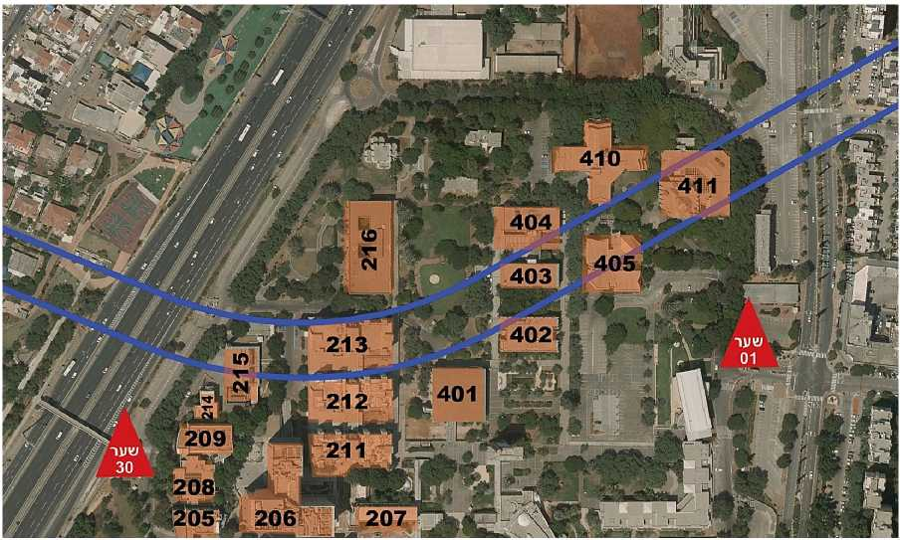Figure 1: Area of the route of the southern alternative of the Metro M2 line (marked in blue) on the Bar Ilan University campus.

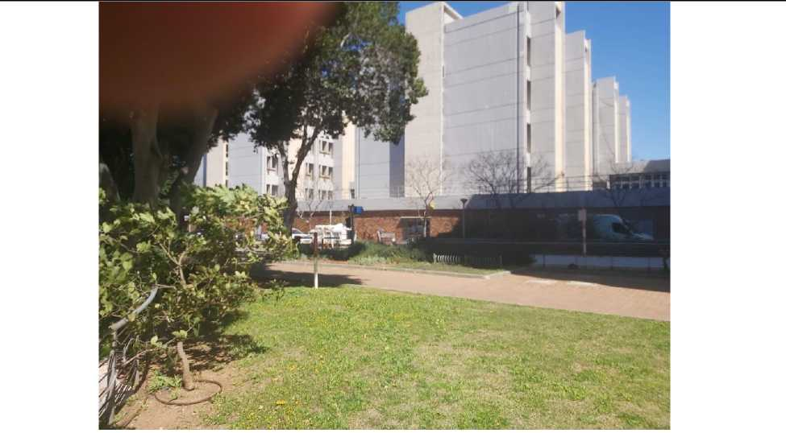

Photo 1: View of part of the measured area

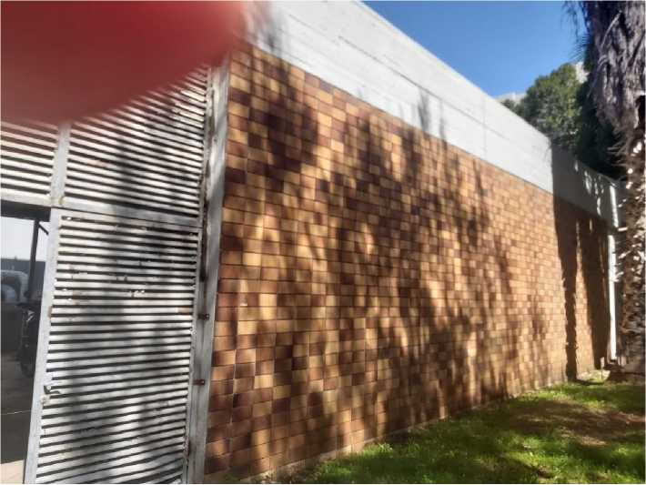

Photo 2: View of part of the measured area

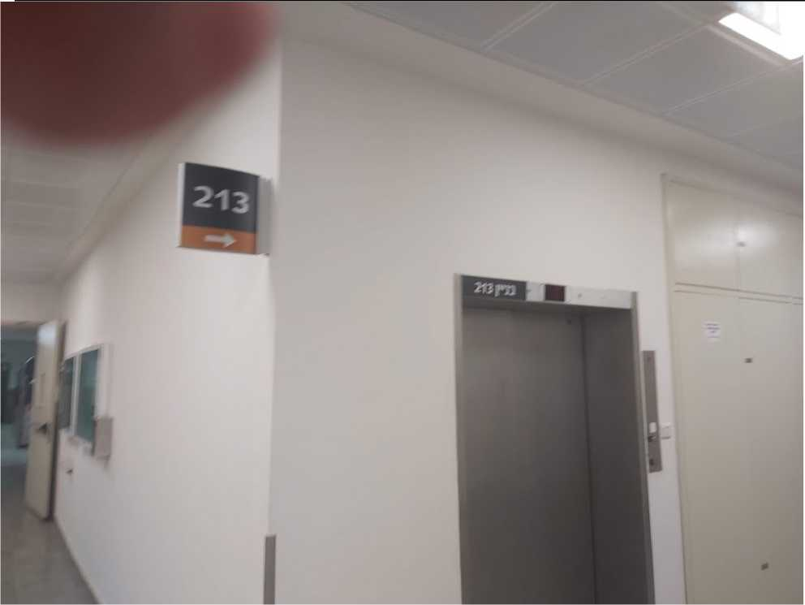

Photo 3: Ground floor of Building 213 which is above the Metro M2 route

1. The Safety Criterion[2]

**Limiting Exposure to a Magnetic Field as a Function of the Exposure Duration (March 2020 update)**

This type of radiation was described by the World Health Organization as a carcinogen. The higher the current flowing through the facility, the greater the magnetic field generated around the facility. In Israel, as in many other countries, no legal mandatory threshold for chronic exposure to a magnetic field originating in an electrical facility has been established yet. Chronic exposure, or continuous, prolonged exposure, is defined as the permanent presence of people in a legally built building, for at least four hours a day, at least five days a week. A quantitative index must be determined for many needs, including: designing the engineering of electrical systems near other land-uses, for extended amounts of time; issuing construction and operating permits for electrical facilities; and interpreting measurements performed around electrical facilities. In consideration of existing information, practices in developed countries, and thresholds that electrical companies adhere to voluntarily in developed countries, the Health Ministry and the Environmental Protection Ministry proposed a daily average threshold with maximum typical electrical consumption: 4 mG. This value is based on low morbidity concerns from exposure to a magnetic field that, on an annual average, does not exceed 2 milligauss. Likewise, statistics show that the ratio between the average current per day and high peak consumption is twice the annual average current. On a day with typical peak consumption, there is 60% usage of the electrical system capability (but there are facilities where the usage rate is different). If the electrical current at the time of measurement is known or measured, the exposure measurements should be normalized according to the ratio between the maximum current that can flow through the facility, and the current flowing through it at the time of measurement. It is not always possible to measure or estimate the current passing through the facility at the time when magnetic field exposure measurements are being carried out. In the absence of this value, when the source of exposure is a facility within a building, activating all the main consumers in the building, such as the air conditioning system, is sufficient representation of the maximum load at the time of the measurement. When the source of the exposure is electrical lines for which the current passing through them is not known, the normalization coefficient is determined at the discretion of the permit holder, between 2 and 5.0 according to the season, area, time of measurement, and more. There are places where the exposure is 24 hours a day, such as the exposure within a residential building (bedrooms, guestrooms, kitchen, closed-in balconies, etc.). However, there are places where exposure is limited and exposure time is within certain hours, such as workplaces, public and private transportation, transit areas, open balconies, private gardens, etc. Though there is no clear evidence to precisely describe the relationship between the exposure time and health impacts, it is advisable to act on the side of caution and assume a direct linear relationship between the duration of the exposure and its intensity. With this assumption, it is possible to use the average daily index of 4 mG, as maximum typical electrical consumption, for the purpose of assessing the exposure level as a function of exposure duration.

The proposal below serves as guidelines, for exercising discretion in plans in proximity of a populated area and an electrical facility, for each case individually. For example, it is recommended not to use this type of average regarding exposure in educational institutions, where there are children under 15. In such a case, plans must ensure that radiation in the classrooms does not exceed 4 milligauss in any place where the children sit. In the rest of the areas of educational institutions (hallways, schoolyards, etc.), the index of 4 mG on average per day with maximum typical power consumption is to be used, for the purpose of assessing the level of exposure as a function of exposure duration.

If a person is located in the vicinity of an electrical facility for T hours every day, the exposure near the electrical facility is BW. Its total average exposure throughout the day is B0, and the exposure for the rest of the time is:

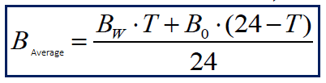

Outside the vicinity of an electrical installation, exposure generally does not exceed 4 milligauss, but is 1 mG on average. Therefore, B0 = 1 mG. If there is a reliable measurement of the background radiation greater than 1 mG, that measurement should be used. According to the joint recommendation of the Health Ministry and the Environmental Protection Ministry, the average exposure on a day with maximum typical power consumption must be lower than 4 milligauss, so 4 mG > B; therefore, if the daily time spent in the vicinity of the electrical facility is known, the exposure in milligauss should be limited as it appears in the formula:

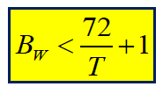

If the radiation level BW is known, as a result of calculation or measurement and normalization to maximum current, the time in presence of the exposure source should be limited as it appears in the formula:

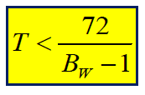

This considers only the worst case, without accounting for the low exposure on weekends or rest days, in order to err on the side of caution.

These values are the basis for determining the need to address the reduction of exposure around existing facilities.

**Warning**: Do not use these formulas for exposure time lower than an hour per day, or for exposure levels lower than 1 milligauss.

Exposure to a Magnetic Field -- Time

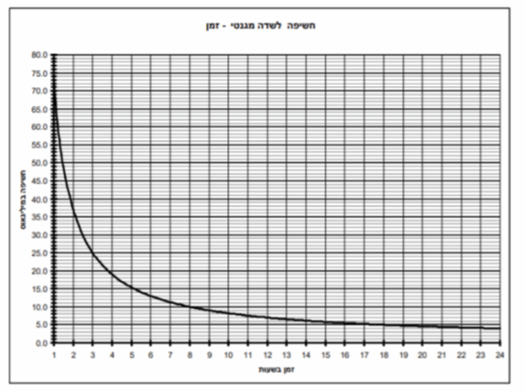

Exposure (milligauss) vs. Time (hours)

|  |  |  |  |  |  |  |  |  |  |  |  |  |  |
| --- | --- | --- | --- | --- | --- | --- | --- | --- | --- | --- | --- | --- | --- |
| Exposure time (hours) | 1 | 2 | 3 | 4 | 5 | 6 | 7 | 8 | 9 | 10 | 12 | 18 | 24 |
| Exposure level (mG) | 73 | 37 | 25 | 19 | 15.4 | 13 | 11.3 | 10 | 9 | 8.2 | 7 | 5 | 4 |

1. **Measurements**

Magnetic field flux density is measured in milligauss (mG). The values presented are the vector weighting of the magnetic field flux on the x, y, and z axes.

Measurements were performed at a height of 1 meter.

**Table 1: Magnetic Field Flux Measurements around the Campus’ Building Layout**

|  |  |  |  |  |  |  |
| --- | --- | --- | --- | --- | --- | --- |
| **No.** | **Measuring point** | **Building** | **Coordinates** | **Measure-ments**  **(mG)** | **Current consumption at time of measuring**  **A** | **Notes** |
| 1 | Outside, nearby | 215 | 185130/663886 | 0.88 |  |  |
| 2 | Southeast side | 215 | 185136/663870 | 0.75 | 400 |  |
| 3 | Between building 215 and 212 |  | 885164/66387 | 0.38 |  |  |
| 4 | Inside structure | 212 | 185195/663877 | 20 | 130 | Under cable ladder |
| 5 | Next to electric cabinet room S6 | 212 | 185203/663878 | 2.6 |  |  |
| 6 | Next to the stairs opposite the elevator | 213 | 185211/663918 | 0.5 | 120 |  |
| 7 | In front of the entrance to Beit Gasner | 213 | 185182/663935 | 0.43 | 120 |  |
| 8 | In the yard between building 213 and 403 |  | 185260/663927 | 1.2 |  |  |
| 9 | On the west side | 403 | 185316/663964 | 0.3 |  |  |
| 10 | Next to the men’s bathroom | 403 | 182348/663958 | 1 | 663 |  |
| 11 | School of Advanced Studies | 403 | 185352/663970 | 0.3 |  |  |
| 12 | Outside the building near the cafeteria | 405 | 185368/663983 | 0.25 |  |  |
| 13 | Hallway | 405 | 182363/663996 | 0.4 | 100 |  |
| 14 | Synagogue | 411 | 185436/664006 | 0.25 | 112 |  |
| 15 | Outside | 411 | 185447/664040 | 0.25 |  |  |
| 16 | Floor 2 – Room A001 HIMFIV | Nano building | 185194/663795 | 0.25 | 1800 |  |
| 17 | Floor 1 – Parking lot no. 62 | Nano building | 185329/663817 | 0.49 |  |  |
| 18 | Michael Rosenbloom Lab | 209 | 158211/663834 | 0.5 | 240 |  |
| 19 | Animal Research Center 45A entrance to Room 002 | 208 | 185115/663810 | 0.3 |  |  |
| 20 | Next to Room 005 | 208 | 185105/663803 | 0.45 |  |  |
| 21 | Room 16 Schottenstein Lab | 214 | 185103/663863 | 0.5 | 22 |  |

**Interim summary**: Table 1 shows the reference measurements of the magnetic field flux density in open space and buildings on the BIU campus, in the areas adjacent to the Metro M2 route. In addition, magnetic field flux was measured in laboratories that may house equipment sensitive to magnetic field flux. The tests were performed during hours when the university was active during the coronavirus period.

During the testing, building current consumption data came from the control room. The data readings are of phase currents.

At all the points tested, the magnetic phase flux level was low and did not exceed 1 mG, except at Point 4, where magnetic field flux density was measured as high as 20 mG. The high level resulted from performing the measurement underneath a concealed electrical cable ladder.

1. **Summary and Conclusions**

This report presents the practical reference measurements of magnetic field flux density in the open space and buildings of the Bar Ilan University campus, in the area of the southern route alternative of Metro M2. In addition, measurements were performed in areas where there are laboratories operating that might house scientific equipment sensitive to magnetic field flux. The tests were carried out at hours when the university was active during the coronavirus period. At the time of the tests, building current consumption data was provided from the control room. Data readings are of the current intensity. According to the guidelines of the Environmental Protection Ministry, magnetic field flux measurements were performed 1 meter above ground.

At all points surveyed besides Point 4, the magnetic field flux density was between 1 mG and 4 mG. At Point 4, magnetic field flux density was measured at 20 mG. The high reading is evidence that the measurement was performed under a concealed electrical cable ladder. This level is not representative of the background magnetic field flux on the university campus. It can be seen from the results of the prediction in Appendix A that the background level of magnetic field flux on the Bar Ilan campus is similar or higher than that expected at ground level from the Metro infrastructure with a third-rail or fourth-rail feed system.

Regards,

Moshe Netzer iNCE

Electromagnetic Compatibility and Radiation Safety Engineer

Environmental Protection Ministry Permit 2050-01-4

**Appendix A: Predicted Radiation Level Above the Metro M2 Route at Ground Level**

**A-1: Metro System with Third Rail**

Figure A-1 shows the daily average magnetic field flux, with a ripple current of 13.8 amps for two trains traveling in opposite directions, with a current of 1500 amps in a third-rail system. The illustration shows the following findings regarding the magnetic field flux on ground above the tunnel:



The magnetic field flux reduces to an average daily current of 4 mG within the Metro tunnel, about 8 meters below the ground. Above ground, the magnetic field flux (0.4 mG) is similar to the background levels that exist even without the Metro, as shown in this report in Table 1.

**A-2: Metro System with Fourth Rail**

Figure A-2 shows the daily average magnetic field flux, with a ripple current of 13.8 amps for two trains traveling in opposite directions, with current of 1500 amps in a fourth-rail system. The illustration shows the following findings regarding the magnetic field flux on ground above the tunnel:



Magnetic field flux above the ground: The magnetic field flux reduces to 4 mG above the track platform, 8 meters under ground. Above ground level, the magnetic field flux is very low (0.5 mG), lower than the typical background levels. The Metro train would be in motion at a maximum load of 1500 A in the tunnel.