{ Draft -- Feb.1 2018; replace with a blank line in final submission }

When Mathematics Meets Art:

Does Art Contribute to the Understanding of Mathematical Concepts?

Liora Nutov¹

¹Mathematics Department, Gordon Academic College, Haifa, Israel; lioran@gordon.ac.il

Abstract
This paper presents a mixed methods study whose objective was to learn about a possible contribution of art to the understanding of mathematical concepts learned in the online asynchronous course “When Mathematics Meets Art”. The math concepts were tessellations, zero and infinity, golden sections, spatial vision, dimension and self- similarity. The research sample consisted of 130 pre-service math teachers who submitted 20 different assignments constructed to reflect math knowledge. The assignments were graded based on a pre-designed rubric. The results suggest that there is a positive and significant partial overlap between math and art assessments (r = .25, p <.01). The math-art connection is innovative, intriguing, fun and inspiring;online learning, however, remains a challenge.

Why STEAM in Online Pre-service Teachers Education Courses?
Science, technology, engineering and mathematics appear everywhere in our day-to-day lives. Politicians, educators, scholars and even businessmen, therefore, have been seeking to improve STEM (Science, Technology, Engineering and Mathematics) education and making it accessible to everyone. In the last decade, the contribution of art to STEM has become obvious; thus today, STEAM (Science, Technology, Engineering, Art and Mathematics) is becoming a more common practice at every level of education: -- elementary school (e.g. [9],[14]), high school (e.g. [7], [15]) and higher education (e.g. [13], [11]).
The funs name various benefits to the integration of art into STEM. In particular, it encourages learners to develop critical and creative ways of thinking while seeking solutions to questions, problems and natural phenomena; to look for multiple solutions and not to practice known rule algorithms; to develop the ability to bridge different areas of knowledge by transferring knowledge from one field to another; to function and live with uncertainty and an inaccurate definition of events under investigation; to pay attention to the finest details that can ultimately make a big difference in the outcome; to find expression in forms more complex than words and numbers; to think through and with a given material; to experience through senses that cannot be reached in any way other than the arts; to adapt to different learning styles (e.g, [16], [3]).
Along with the many benefits of STEAM, there are challenges that must be considered. Teachers who wish to adopt this teaching approach must have content knowledge and professional security not only in teaching STEM but also in the arts, which requires more extensive preparation [6]. Oreck [10] points out another challenge -- the implementation of STEAM by policymakers places pressure on teachers with expectations of immediate increase in student achievements, while at the same time teachers' creativity and autonomy is suppressed by requiring adherence to established curricula.
Another growing educational trend is online learning in various settings. The supporters of this educational style (e.g. [8]) claim that among its benefits are the development of learning skills required in the 21st century whereby the learner must develop a capacity for independent learning in addition to group study; learner identification of reliable sources of information available online; accessibility of higher education to people who cannot reach university facilities (e.g. remote geographical distance, confinement to home or hospital, non-flexible work hours); introduction of a variety of teaching methods (e.g. video integration, reading articles, online practice with instant feedback). Along with the advantages of online learning there are considerable challenges, such as social isolation of the learner; insufficient communication with the instructor; difficulty in receiving immediate assistance that may be required by the learner [12]. Online education does not suit everyone. Benson and Samrakirama [2] emphasize the importance of seniority in higher education: freshmen need a closer relationship with the instructor and less autonomy in the learning process. This point should be considered when designing an online course in particular for pre-service elementary school mathematics teachers, as some of them may develop math anxiety [1].
To meet the needs of STEAM education with all its advantages and challenges, it is important to prepare teachers so that they can bridge traditional education with an interdisciplinary approach that includes the arts. They must experience it before implementing it. These principals guided me in designing the course “When Mathematics Meets Art”.

When Mathematics Meets Art
The course “When Mathematics Meets Art” was offered for the first time in the fall of 2017 at Gordon Educational College in Israel for pre-service elementary school teachers majoring in mathematics and science or in mathematics and special education. It is an online asynchronous semester-long course, i.e. 14 weeks. The objectives of the course are: expanding students' mathematical knowledge; executing a small-scale math inquiry task; creating a community of learners; applying mathematical concepts to daily life, natural occurences and art. The course consists of six math topics presented in the following order: tessellations, zero and infinity (in calculating area and perimeter), golden sections, spatial vision (focusing on impossible figures), dimension and self-similarity. The topics were selected using three criteria in relation to the elementary school curriculum: to deepen student mathematical knowledge of topics included in the curriculum (zero and infinity, spatial vision); concepts mentioned in the curriculum but not studied in depth (dimension and self-similarity); concepts that are not taught in the curriculum but are tightly coupled with both mathematics and art (tessellations and the golden section).
The course was designed on the Moodle platform and consists of six units, one for each mathematical concept as indicated above. The following are the student requirements for each course unit: (1) Students take part in a forum discussion or answer a survey. These tasks are designed to check their prior knowledge (15% of final grade; students are graded for participation and not for knowledge); (2) Students study the mathematical concept theoretically through a specially prepared video, an article or PowerPoint presentation. They then apply their acquired knowledge by solving exercises or carrying out an inquiry task. Finally they check their knowledge through a short online test (test score is 20% of final grade); (3) Students contribute an artwork (it need not be original) to an online cooperative gallery (9% of final grade); (4) A final exam (56% of final grade).

Student Math and Art Assignments
Mathematical assignments were designed based on prior knowledge of the students and the mathematical depth that could be achieved in the course. Due to limited space considerations, I have chosen to present an example of a task that focuses on zero and infinity. Students are familiar with the mathematical properties of zero and know the concept of infinity as well as the concepts area and perimeter. The purpose of this inquiry task is to show them the fascinating encounter between zero and infinity in one object -- Koch's Island (Figure 1).

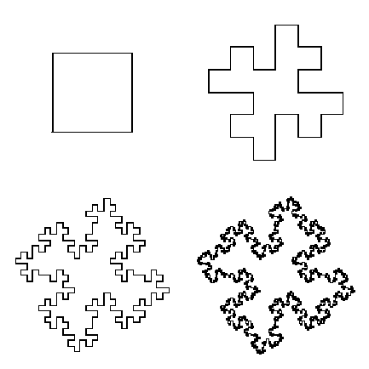  Step 0 | Step 1 | Step 2 | Step 3

Figure 1: The Koch Island Fractal
Answer the following questions for a given Koch Island:
- If the side of the square in Step 0 is 1 cm long, what is the perimeter of the Koch Island in Step 1? Step 2? Step 3? Step n?
- If the side of the square in Step 0 is 1 cm long, what is the area of the figure that appears in Step 1? Step 2? Step 3? Step n?
- Try to find examples of other planar figures where area and perimeter relations have the same nature as in the Koch Island.
Art assignment. The instruction for each art contribution was: “Upload an original artwork (or the artwork of an artist) that expresses your interpretation of the math concept studied. Add one short sentence explaining your choice”. Although the art assignment was the smallest part of the course grade, many students invested a great deal of effort in it. Following are five representative original artworks (Figure 2):
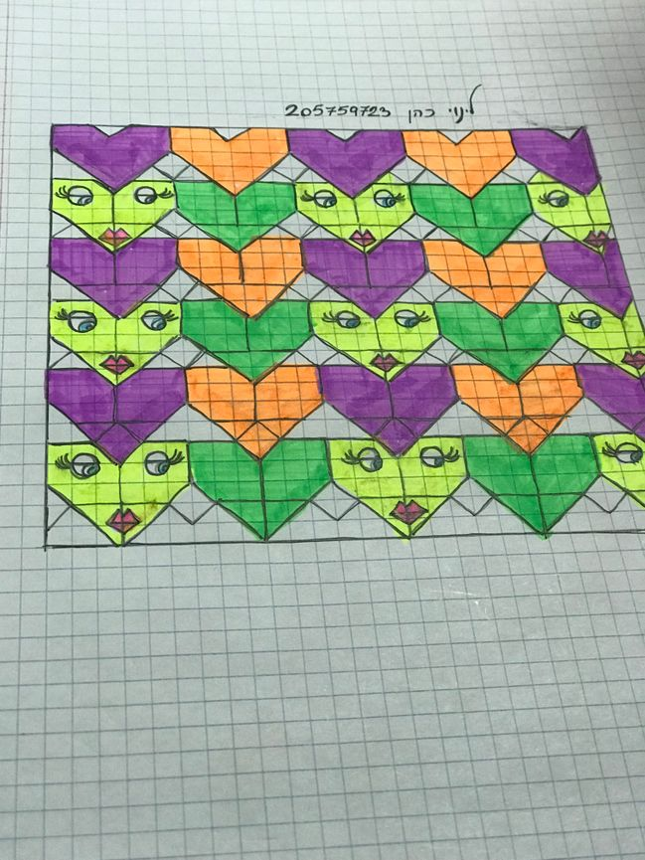  (a) | 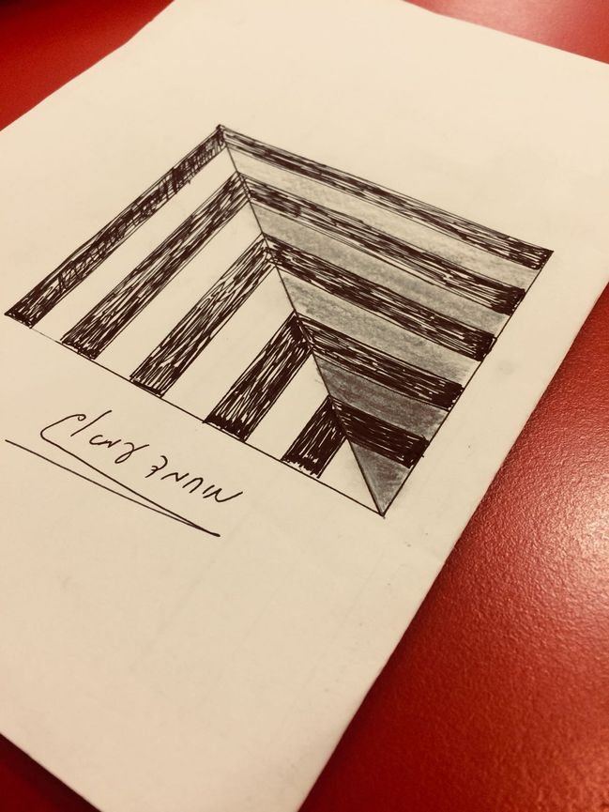  (b) | 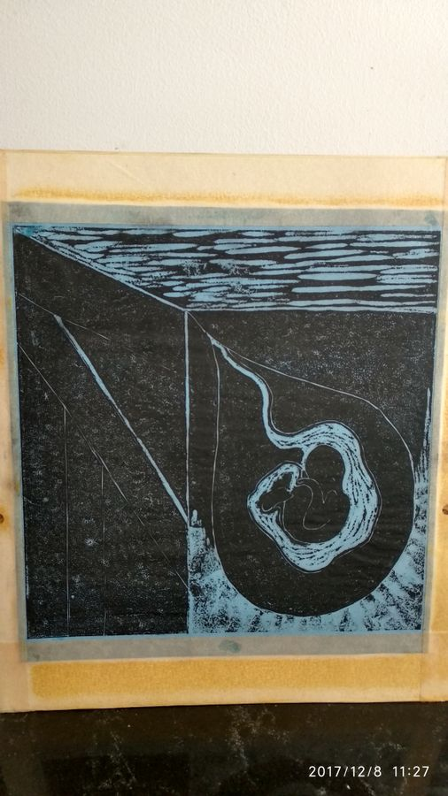  (c)

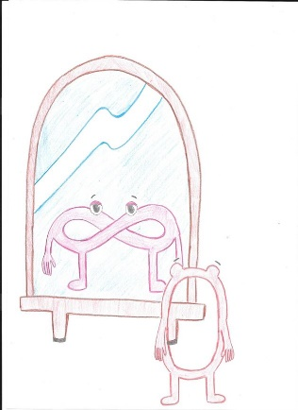  (d) | 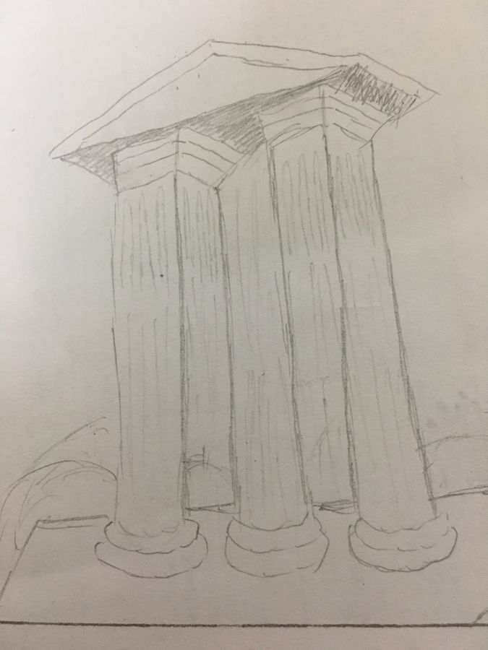  (e)
Figure 2: Students' original art: (a) Student 1:Escher-style tessellations, (b) Student 2: Dimension, (c) Student 3: Golden ratio, (d) Student 4: Zero and infinity, (e) Student 5: Impossible gate

Does Art Contribute to the Understanding of Mathematical Concepts?
To answer the question in the heading above, explanatory design research was found the most suitable approach from among the mixed method research strategies [5]. In the first phase of the study, quantitative data was collected and analyzed. In the second phase, the quantitative data was interpreted by the qualitative data. In this manner the advantages of the two research paradigms are exploited; using a quantitative method, one can examine the relationship between variables, while the qualitative method supplies the participants' interpretation of the quantitative findings.
The research questions are: (a) Does artwork contribute to student understanding of mathematical concepts? (b) What is the essence of the contribution of artwork to student understanding of mathematical concepts? (c) What are the advantages and challenges of learning mathematics in combination with art in an online course?
The research tools used: Online tests: At the end of each unit, the students executed an online test, designed to examine the mathematical knowledge acquired. The students were allowed two attempts to answer the test. They could see their grade only after the second submission. The test grade was the higher of the two. The test was checked automatically based on pre-determined criteria.
Collaborative galleries: The unit gallery consisted of the student art contributions. The students could choose to contribute an artwork (original or not original) with a short explanation of how the mathematical concept under study in the unit is expressed in it. Students may comment on the contributions of their colleagues and may indicate 'like'. The Padlet website was selected for the cooperative art galleries.
Semi-structured interviews with students: An interview guide was designed for this purpose. On the course website the students were asked to volunteer for an interview. There were 8 interviews in total, which took place at the college and lasted 30-60 minutes.
Course evaluations: At the end of each unit, students could voluntarily fill in an online survey that referred to the math tasks, the virtual gallery and the contribution of artwork to learning the mathematical concept presented in that unit. A total of 101 responses were collected for the first four units (42 for tessellation, 23 for zero and infinity, 24 for golden section and 12 for spatial vision).
Data analysis: The quantitative data was statistically analyzed and an attempt was made to find a link between the math content (online tests) and the artwork. The qualitative data (interviews and online survey) was analyzed by the Strauss-Corbin method [14]: at the first stage, each of the interviews was analyzed in order to identify central and secondary themes. At the second stage, an attempt was made to identify links among the different categories and to define major categories and sub-categories. In the final stage of the analysis, an attempt was made to link the quantitative and qualitative findings.

The Results
This section presents preliminary results of the study (not all data is available yet, as the course is still ongoing, ending in February 2018). In this mixed methods study, the quantitative data was the student scores on the online math tests and artwork; the qualitative data was semi-structured interviews and student course evaluations. Table 1 summarizes student grades of four course units (now already available from the six). The grades are presented in the chronological order in which the units were taught. The math test grades indicate that the chronological order of the units can be correlated with the complexity of the mathematical concepts. The artwork grades show a different picture: on one hand the number of students who did not submit any artwork increases with time -- from 13 in the first unit to 29 in the last. On the other hand, the largest number of original artwork was submitted in the first unit, but most of these (97/130) were of poor quality (the highest grade for this group was 70%). As the course progressed, the quality of the artwork improved but the number of original artworks submitted declined. It is interesting to note that the average grade for the artwork was quite stable; it ranged from 70 to 75, with the exception of the first unit.

Table 1: Descriptive statistics of grades in online tests and artwork.

 | N | Minimum | Maximum | Mean | Std. Deviation
Tessellation test | 130 | 0 | 9 | 9.15 | 3.331
Tessellation artwork | 130 | 0 | 10 | 6.11 | 2.537
Zero and infinity test | 130 | 0 | 10 | 9.07 | 1.753
Zero and infinity artwork | 130 | 0 | 10 | 7.63 | 2.998
Golden section test | 130 | 0 | 10 | 8.12 | 2.006
Golden section artwork | 130 | 0 | 10 | 7.22 | 3.177
Spatial vision test | 130 | 0 | 10 | 7.08 | 2.279
Spatial vision artwork | 130 | 0 | 10 | 7.50 | 3.474
The next step for defining the possible contribution of art to student understanding of mathematical concepts was to calculate Pearson correlations for the online math tests and the artwork. Table 2 summarizes the data analysis.

Table 2: Correlations for online tests and artwork.
 |  | TT | TA | ZIT | ZIA | GST | GSA | SVT | SVA
TT | Pearson Cor.  Sig. (1-tailed)  N | 1  130 | -0.79  .185  130 | -.349**  .000  130 | .032  .360  130 | -.255**  .002  130 | -.007  .467  130 | -.238**  .003  130 | -.001  .494  130
TA | Pearson Cor.  Sig. (1-tailed)  N |  | 1  130 | .283**  .001  130 | .230**  .004  130 | .229**  .004  130 | .482**  .000  130 | .176*  .023  130 | .343**  .000  130
ZIT | Pearson Cor.  Sig. (1-tailed)  N |  |  | 1  130 | .236**  .003  130 | .668**  .000  130 | .231**  .004  130 | .507**  .000  130 | .294**  .000  130
ZIA | Pearson Cor.  Sig. (1-tailed)  N |  |  |  | 1  130 | .211**  .008  130 | .190*  .015  130 | .138  .059  130 | .161*  .033  130
GST | Pearson Cor.  Sig. (1-tailed)  N |  |  |  |  | 1  130 | .336**  .000  130 | .584**  .000  130 | .294**  .000  130
GSA | Pearson Cor.  Sig. (1-tailed)  N |  |  |  |  |  | 1  130 | .183*  .019  130 | .217**  .006  130
SVT | Pearson Cor.  Sig. (1-tailed)  N |  |  |  |  |  |  | 1  130 | .438**  .000  130
SVA | Pearson Cor.  Sig. (1-tailed)  N |  |  |  |  |  |  |  | 1  130
* Correlation is significant at the 0.05 level (1-tailed).
** Correlation is significant at the 0.01 level (1-tailed).

Abbreviations: Tessellation math test (TT); Tessellation artwork (TA); Zero and infinity math test (ZIT); Zero and infinity artwork (ZIA); Golden section math test (GST); Golden section artwork (GSA); Spatial vision math test (SVT); Spatial vision artwork (SVT).

The grades of the online math test for tessellations stand out in Table 2 – the Pearson’s correlation is negatively correlated with all other math tests and it is zero, or near zero, with different artwork. Four possible explanations for this are: (1) Beginner's adjustment -- this unit was the first in the online math course and students were not yet accustomed to this kind of learning. (2) Student learning habits -- at this point in the school year most students had not yet organized a community of learners (both of these hypotheses will be discussed later). (3) Lack of familiarity with the topic – this topic is not included in any school or college curriculum. (4) Beginning of the semester -- students may join or drop the course during the first two weeks of the semester. Each of these explanations should be explored in depth after all data is available. What is also noteworthy is that the tessellation artworks are positively correlated to all other variables.
The data in Table 1 point out that in three out of four units (ZIA, GRT and SVT) there are significant positive correlations between artwork and math knowledge. Moreover, in these same three units, there is significant positive correlation between online math tests and artwork. That is, it is reasonable to postulate that the artwork helps students understand the mathematical concepts. To verify this conclusion, a single index of all math tests (that is, scores for all four math tests) was calculated, as well as for artwork; both indices showed reliability of Cronbach alpha: α=0.60 and α=0.63, which is a reasonably good result. A positive correlation of r = .25, p <.01 was found between the two indices. This result suggests that there is a positive and significant partial overlap between the mathematics and art worlds; in what follows we refer to this as ‘math-art land’.
The qualitative data analysis outcome may be presented in three main categories: (a) math-art land is innovative, intriguing, fun and inspiring; (b) math and art contribute to one another; (c) the challenges of online learning.
Math-art land is innovative, intriguing, fun and inspiring. The innovation of the course was expressed in several ways: the link between math and art, and learning math as an online course. Here is how one of the students described her thoughts about math-art land:
This is amazing. The math-art connection was a new experience for me. I never thought about it in this way. It showed me a new way to look at math. The art gave me a comprehensive, spatial vision on the math topic… it was beyond anything I knew… it was an eye opener. [anonymous survey]
The words describing math-art land -- “fun, enjoy, interesting, fascinating” appeared more than 60 times in the four relevant surveys. In her interview, Laura (not her real name) expressed her curiosity about the artwork:
I check the course site every day, sometimes even twice a day. I check out what's new and look to see whether or not the artwork the students post meet your requirements. Some of them really do meet the requirements and some do not. Nevertheless, I find all the artwork interesting.
Another student, Moran, described her motivation to explore the math-art land by saying: It blew me away. I simply sat down and drew.
Most of the students do not have any prior art education therefore it was only natural that mathematical complexity would be inversely proportional to the number of original artworks. Natalie describes her own experience:
At first, I tried to draw an original artwork for the golden ratio but it was too hard. I tried to draw the sunflower; it didn't work, so I uploaded something from the internet. It was simpler.
Orly talked about her motivation to contribute an original artwork to the gallery. Although she cannot draw well, she asked her brother to do it for her. When he became too busy to help her, she took the time to look for artwork which did not already appear on the site.
First, my brother drew a picture for me and then he did not have any more time for it. So I looked at what girls uploaded to the gallery and then found a few pictures I wanted to upload. I wanted something original so I searched for pictures with the golden ratio… And then I sat down and checked where the golden ratio was in the picture ... only then I uploaded the picture to the gallery.
Some students liked the math-art land concept and would like to use the model in their own career:
I like the concept. It is good to teach kids some math and then to ask them to draw it. They like drawing.
The students pointed out the reciprocal contribution of math and art to their learning: the artwork helped them understand math concepts, and the math concepts triggered artwork. Here is how Anat experienced the contribution of artwork to her mathematical understanding: “The artwork explained the measurements and it helped me implement what I learned”. Another student wrote in the survey:
I did not create an original artwork in the Escher style but it seems to me a great exercise to implement and to practice everything we are learning in this unit.
Mary, whose hobby is drawing, described the contribution of math to her artwork:
It helped me formulate the idea and the way to draw it ... I was thinking about the relationship between mathematics and the picture I am drawing... math inspired me to draw unconventional pictures. [This student drew “The impossible gate” Figure 2b].
Most of the students found it difficult to express the contribution of the artwork verbally, but they sensed it. Here is one representative excerpt:
Of course the artwork helps to understand math but I don’t know how exactly to explain it. I just feel it does helps.
Challenges of the online math course. All the students pointed out that it was their first asynchronous online math course. Here is a typical response: “We are used to learning math in a traditional way and suddenly you come and everything is online…” Some of them have had online courses before but did not like this way of learning: “I am generally against online courses”. Most of them found the experience frustrating: “This is the first time we are learning mathematics online and it is difficult. It is frustrating...”. Susan asked me at the interview to write down her words verbatim:
Please write: Math is not suitable for online learning. I need to see the teacher's eyes, the teacher's face when he explains, because usually the facial expressions hold hints… the teacher pointing out some direction…
Some of the students feel pressure to obtain high grades because they plan to go for a Master's degree which requires an average above 85. Their anxiety related to grades serves as a barrier; as a result they don't dare to experience meaningful learning. Here is a very honest and moving excerpt from Susan’s interview:
… and if my answer will be wrong? Sometimes I feel like I have an angel and a devil sitting on my shoulders. One says: "Say what you think!" And the other says: "And if it will not be good?" Do you understand what I am saying? I am afraid of getting low grades. There is nothing that can be done about it, Liora -- no matter how you look at the situation, this is the world we are living in. Grades -- that's what college life is all about. This is what the academic institution is all about.
To overcome the challenges of online learning, many of the students formed a community of learners – they get together and learn the mathematical concepts in a group, helping each other perform the inquiry tasks and even take the online tests together. Moran describes her way of learning online:
I can not learn alone. I joined a group and we all study together. I have to study with someone. We sit and do online tests and inquiry tasks together. This is the way I learn.

Summary and Conclusions
The research objectives were to examine the possible contribution of art to student’ understanding of mathematical concepts, and to explore math-art land, as well as to identify the challenges of learning mathematics in combination with art in an online course. The preliminary research results confirm the hypothesis that there is a possible overlap between math and art, inspired by a mathematical concept. This overlap, math-art land, can help students deepen their mathematical ability to solve a given assignment or to perform an inquiry task; it can also help them develop mathematical intuition, since art enables expression that is beyond words and numbers [3].

I believe that math-art land holds great potential for math education, particularly at the elementary school level. As a lecturer at an educational college, I see it as my responsibility to expose the pre-service teachers to STEAM as well as to online learning. In that spirit, my future plans are to complete the data analysis as soon as the course ends and to verify the preliminary results. In addition, I am planning to organize an exhibition of the original artwork of the students and to study its impact on the entire Mathematics Department -- among both students and staff.
The course “When Mathematics Meets Art” is a new online course and the research results point out several directions to improve the course so that it could meet student needs more precisely. The questions I will consider are:
- What previous math knowledge do students need to lower pressure and what are the best ways to provide it?
- How can the enthusiasm of the students be retained throughout the semester so that math-art land retains relevance and vitality and have a significant contribution to their learning journey?
- Original student artwork versus professional artwork: which is more beneficial for student learning?
- How to combine related artwork in online math tests so that both components -- math and art -- are equally important?

References
[1] | M. H. Ashcraft, "Math anxiety: Personal, educational, and cognitive consequences," Current Directions in Psychological Science, 11(5), pp. 181-185, 2002.
[2] | R. Benson and G. Samarawickrema, "Addressing the Context Of E-Learning: Using Transactional Distance," theory to inform design. Distance Education, 30(1), p. 5–21, 2009.
[3] | J. Burton, R. Horowitz and H. Abeles, "Learning in and through the arts: The question of transfer," Studies in Art Education, , pp. 228-257, 2000.
[4] | A. Corbin and J. Strauss, Basics of Qualitative Research: Techniques and Procedures for Developing Grounded Theory, 3rd edition, SAGE Publications, 2008.
[5] | J. W. Creswell and V. L. Plano Clark, Designing and Conducting Mixed Methods Research, 2 nd edition, Los Angeles | London | New Delhi Singapore | Washington DC.
[6] | E. Eisner, The Arts and the Creation of Mind, New Haven & London: Yeal Universiry Press, 2002.
[7] | L. Dietiker, "What Mathematics Education Can Learn From Art: The Assumptions, Values, and Vision of Mathematics Education," Journal of Education, 195(1), pp. 1-10, 2015.
[8] | K. Larkin and R. Jamieson-Proctor, "Using Transactional Distance Theory to Redesign an Online Mathematics Education Course for Pre-Service Primary Teachers," Mathematics Teacher Education and Development, 17(1), pp. 44-61, 2015.
[9] | U. E. Okbay, Art in the Middle School Mathematics Classroom:: A Case Study Exploring Its Effect on Motivation. Unpublished Masters thesis, Ankara: Bilkent University, 2013.
[10] | B. Oreck, "Artistic choices: A Study of Teachers Who Use the Arts in the Classroom," International Journal of Education & the Arts, 7(8), pp. 1-27, 2006.
[11] | K. Peltonen, "Crystal flowers in halls of mirrors: Mathematics Meets Art and Architecture," in Bridges Conference Proceedings, Jyväskylä, Finland, Aug. 9–13, http://archive.bridgesmathart.org/2016/bridges2016-41.html, 2016.
[12] | R. Reiser and J. V. Dempsey, Trends and Issues in Instructional Design and Technology (3rd ed.), Upper Saddle River, NJ: Pearson, 2013.
[13] | E. Sendova and T. Chehlarova, "Studying Fine-Art Compositions by Means of Dynamic Geometry," in DynaMath 12 Conference, Nitra, Slovakia, 2013.
[14] | H. Thuneberg, H. Salmi and K. Fenyvesi, "Hands-On Math and Art Exhibition Promoting Science Attitudes and Educational Plans," Education Research International, pp. 1-13, 2017.
[15] | R. Ward, "Modeling Effective Pedagogical Strategies for Teaching Mathematics," The Charter Schools Resource Journal, pp. 1-9, 2006.
[16] | A. S. Zimmerman, "Developing Confidence in STEAM: Exploring the Challenges that Novice Elementary Teachers Face," The STEAM Journal, 2(2), article 15, 2016.

