State Orthogonality Interferometer Combining: Generalization of the HOM Effect

Avi Marchewka

8 Galei Tchelet St., Herzliya, Israel

avi.marchewka@gmail.com

Abstract

Are photons either bunched or unbunched, or do these represent particular cases of a wider phenomenon? This study will show that bunched and unbunched photons are indeed two extreme cases of a process parameterized by a continuous parameter, called the bunching parameter. This research indicates primariy that the state orthogonality interferometer can be used for the construction and measurement of the full range of values of the bunching parameter. Finally, this paper will demonstrate how the HOM effect is generalized as an application of the bunching parameter,. Unlike the HOM effect, where the interference is only between the two photons, the states produced by the state orthogonality interferometer exhibit both single photon interferences and two indistinguishable photon interferences, a property that fermions do not seem to have.

1. Introduction

The exchange degeneracy symmetry of identical particles gives rise to a new kind of interference: that between the particles’ wave functions. This interference plays a role in several important quantum physics effects, such as the electron configuration of atoms, the behavior of light, Fermi-Dirac and Boss-Einstein statistics, and many more. Among these effects is the bosons bunching of indistinguishable bosons (also called boson enhancements). Bunching refers to the preference of indistinguishable bosons to be found in the same state in contrast to the preference of distinguishable particles under the same scenario. The footprint of bosons bunching is found in a variety of cases, including:

### [the Hanbury Brown-Twiss effect](https://www.nature.com/articles/s41598-017-02408-6) [1], HOM [2], Gיhosh Mandel [3], and atomic optics [4].

Feynman [5] gave a quantified measure of bosons bunching, showing that the probability of finding  indistinguishable bosons in the same state is  higher than for  distinguishable bosons (see also Fano [6])

However, it has been shown that the reality is actually more complex and subtle. In fact, Feynman's claim does not hold in general. For example, in Marchewka and Granot [7] it is shown that the measure of a spatial probability of indistinguishable bosons is equal to those of distinguishable bosons. That is, the  rule doesn't hold, and in fact, it is not well defined in the limiting case where the detector size goes to zero [8].

It is very tempting, as is often done, to ascribe the bunching of indistinguishable bosons due to “attractive forces” between the indistinguishable bosons [9]. However, this view is also only partially true. It has been shown [10-12] that when two bosons are released from a trap, the bosons behave as if they have “repelling forces” which govern their behavior.

Finally, one way to generalize the bosons bunching for Schrödinger particles has been suggested in Mousavi and Miret-Artés [12]. This generalization defines a "bunching parameter," which is equal to N! in the special case considered by Feynman.

The aim of this paper is threefold. First, in Section 2, the boson parameter for the two photons’ fields will be formulated by reformulating the bunching parameter in the second quantization language. Then, in Section 3, the state orthogonality interferometer will be represented with different realizations of the photons’ state orthogonality. This interferometer enables "tailor-made" states of arbitrary state orthogonality of photons and their corresponding bunching parameters, particularly a “tailor-made" state that is not produced in natural light. Finally, in Section 4, these "tailor-made" states are employed in the HOM experiment, and it is then shown that such states generalize the HOM effect.

The notation of the “first quantization” follows Cohen-Tannoudji and Laloe [14], and in the “second quantization” we follow Gerry and Knight [15].

2. Bunching Parameter for Two Photons

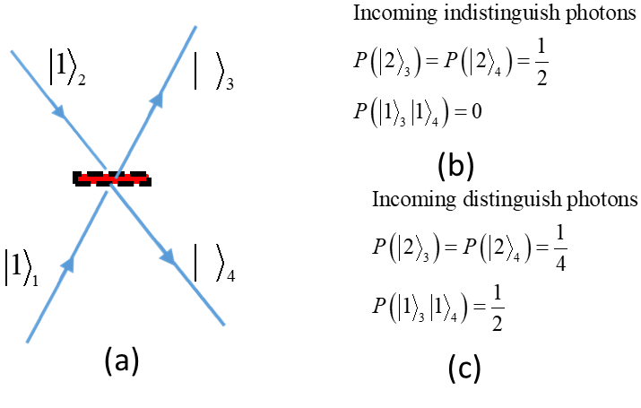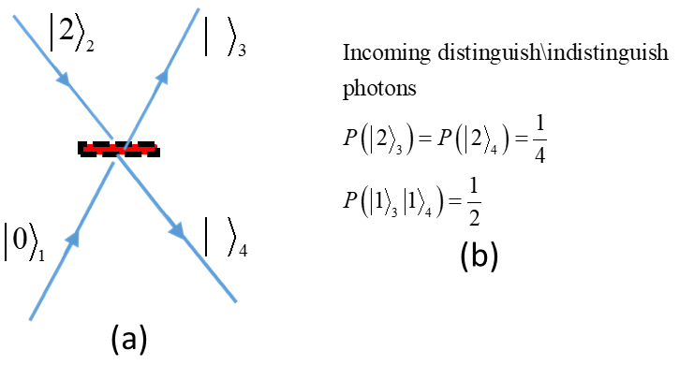The HOM [2] effect clearly demonstrates the bunching of two photons. In Fig. 1(a), the schema of the HOM experiment is represented. Two photons enter simultaneously from different legs onto a symmetric beam splitter. The notation is as employed by Gerry and Knight [15]. For example, , refers to one particle in leg 2. The photons’ probability to be found on the outcoming legs is given in Fig. 1(b) for indistinguishable photons and in Fig.1(c) for distinguishable photons (for example, by their polarization degree of freedom). As seen in Fig. 1(b), the indistinguishable photons are always emitted together, whereas, as seen in Fig. 1(c), distinguishable photons are emitted together only half of the time, and half of the time they are emitted to different legs. This preference of the indistinguishable bosons to be emitted together is a manifestation of the bosons bunching. In Fig. 2, two photons enter simultaneously on the same leg of the beam splitter. In Fig. 2 (b), shows the probability of finding the emitted photons. It appears that the probability of finding the emitted photons is independent of the photons being distinguishable or not: the difference between the indistinguishable and distinguishable photons disappears. These examples illustrate that the distinguishability of the photons is not the only condition that plays a role in whether they are bunched or not.

Figure 1: schema of the HOM experiment

Figure 2: two photons enter simultaneously on the same leg

2.1 The Bunching Parameter--First Quantization

Consider two particles in a two-dimensional space with an orthonormal base of two states  :



with



The scalar product of the two states (Equation ):



Here we follow the notation of Gerry and Knight [15]. The index inside the ket  represents the particle, and the Greek letter is the state the particle is in.

If the two particles are distinguishable bosons, where one of the bosons is in the state  and the other is in the state , their joined wave function is:



where and is the normalization constant given by the condition.

From Equation

