State Orthogonality Interferometer Combining: Generalization of the HOM Effect

Avi Marchewka

8 Galei Tchelet St., Herzliya, Israel

avi.marchewka@gmail.com

Abstract

Are photons either bunched or unbunched, or do these represent particular cases of a wider phenomenon? This study will show that bunched and unbunched photons are indeed two extreme cases of a process parameterized by a continuous parameter, called the bunching parameter. This research indicates primarily that the state orthogonality interferometer can be used for the construction and measurement of the full range of values of the bunching parameter. Finally, this paper will demonstrate how the HOM effect is generalized as an application of the bunching parameter,. Unlike the HOM effect, where the interference is only between the two photons, the states produced by the state orthogonality interferometer exhibit both single photon interferences and two indistinguishable photon interferences, a property that fermions do not seem to have.

# Introduction

The exchange degeneracy symmetry of identical particles gives rise to a new kind of interference: that between the particles’ wave functions. This interference plays a role in several important quantum physics effects, such as the electron configuration of atoms, the behavior of light, Fermi-Dirac and Boss-Einstein statistics, and many more. Among these effects is the bosons bunching of indistinguishable bosons (also called boson enhancements). Bunching refers to the preference of indistinguishable bosons to be found in the same state in contrast to the preference of distinguishable particles under the same scenario.

The footprint of bosons bunching is found in a variety of cases, including: the [Hanbury Brown-Twiss effect](https://www.nature.com/articles/s41598-017-02408-6) [1], Hong, Ou, and Mandel [2], Ghosh and Mandel [3], and atomic optics (Jeltes [4]).

Feynman [5] gave a quantified measure of bosons bunching, showing that the probability of finding  indistinguishable bosons in the same state is  higher than for  distinguishable bosons (see also Fano [6])

However, it has been shown that the reality is actually more complex and subtle. In fact, Feynman's claim does not hold in general. For example, in Marchewka and Granot [7] it is shown that the measure of a spatial probability of indistinguishable bosons is equal to those of distinguishable bosons. That is, the  rule doesn't hold, and in fact, it is not well defined in the limiting case where the detector size goes to zero (Marchewka, [Granot](https://scholar.google.co.il/citations?user=uXEZPrQAAAAJ&hl=iw&oi=sra), and Schuss [8]).

It is very tempting, as is often done, to ascribe the bunching of indistinguishable bosons as being due to “attractive forces” between the indistinguishable bosons [9]. However, this view is also only partially true. It has been shown [10-12] that when two bosons are released from a trap, the bosons behave as if they have “repelling forces” which govern their behavior.

Finally, one way to generalize the bosons bunching for Schrödinger particles has been suggested in Mousavi and Miret-Artés [12]. This generalization defines a "bunching parameter," which is equal to N! in the special case considered by Feynman.

The aim of this paper is threefold. First, in Section 2, the boson parameter for the two photons’ fields will be formulated by reformulating the bunching parameter in the second quantization language. Then, in Section 3, the state orthogonality interferometer will be represented with different realizations of the photons’ state orthogonality. This interferometer enables "tailor-made" states of arbitrary state orthogonality of photons and their corresponding bunching parameters, in particular a “tailor-made" state that is not produced in natural light. Finally, in Section 4, these "tailor-made" states are employed in the HOM experiment, and it is then shown that such states generalize the HOM effect.

The notation of the “first quantization” follows Cohen-Tannoudji and Laloe [14], and in the “second quantization” we follow Gerry and Knight [15].

# Bunching Parameter for Two Photons

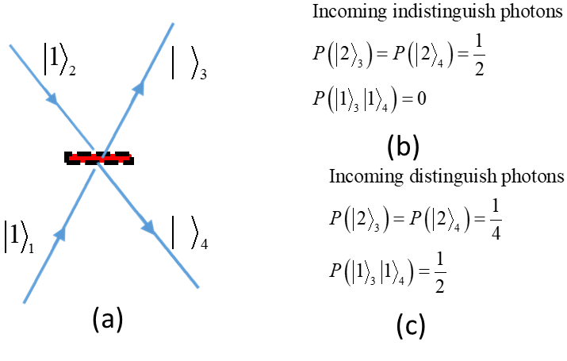

Figure 1: SCHEMA OF THE HOM EXPERIMENT

The HOM (=Hong-Ou-Mandel, [2]) effect clearly demonstrates the bunching of two photons. The schema of the HOM experiment is represented in Fig.1(a). Two photons enter simultaneously from different legs onto a symmetric beam splitter. The notation is as employed by Gerry and Knight [15]. For example, , refers to one particle in leg 2. The photons’ probability to be found on the outcoming legs is given in Fig. 1(b) for indistinguishable photons and in Fig.1(c) for distinguishable photons (for example, by their polarization degree of freedom). As seen in Fig. 1(b), the indistinguishable photons are always emitted together, whereas, as seen in Fig. 1(c), distinguishable photons are emitted together only half of the time, and half of the time they are emitted to different legs. This preference of the indistinguishable bosons to be emitted together is a manifestation of the bosons bunching.

Figure 2: schema of the HOM experiment

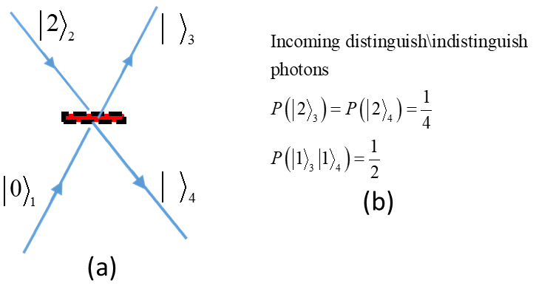

Figure 2: TWO PHOTONS ENTERING SIMULTANEOUSLY ON THE SAME LEG

In Fig. 2, two photons enter simultaneously on the same leg of the beam splitter. In Fig. 2 (b), shows the probability of finding the emitted photons. It appears that the probability of finding the emitted photons is independent of the photons being distinguishable or not: the difference between the indistinguishable and distinguishable photons disappears. These examples illustrate that the distinguishability of the photons is not the only condition that plays a role in whether they are bunched or not.

2.1 The Bunching Parameter--First Quantization

Consider two particles in a two-dimensional space with an orthonormal base of two states  :



with



The scalar product of the two states is (by Equation ):



Here we follow the notation of Gerry and Knight [15]. The index inside the ket  represents the particle, and the Greek letter is the state the particle is in.

If the two particles are distinguishable bosons, where one of the bosons is in the state  and the other is in the state , their joined wave function is:



where and is the normalization constant given by the condition.

From Equation



From Equations , the probability for the two distinguishable bosons to be in the same state, for example, , is



However, the joined wave function of two indistinguishable bosons has to be symmetrical (Cohen-Tannoudji, Diu, and Laloe, [14]). That is,



where is the symmetric operator defined for two particles as



with  and  is the permutation operator.

Normalization of the joined bosonic wave function  gives, from Equation ,



That is, Equation becomes



The probability of finding the two indistinguishable bosons in the same state, for example, , is



Using Equations and, the bunching parameter is defined by the ratio



Before discussing the bunching parameter, we derive it in the formalism of the second quantization.

2.2 Bunching Parameter for Photons: Second Quantization

In the second quantization, the initial state (Equations ) for distinguishable photons becomes,



where the first photon is denoted by operator , the second photon is denoted by the operator ,and the normalization is given by Equation .

With the following bosonic commutation relations



It is convenient to define



The following commutation relation follows:



The number-like operators of the states in Equation are  with, and with.

The joined wave function of the two distinguishable photons is



By the normalization ,we have:



The probability of finding both particles in the same state, for example,  is



If, instead of two distinguishable bosons, the bosons are indistinguishable, the wave function becomes



with the bosonic commutation relation



Accordingly, we use the definition



The following commutation relation follows



The number- like operator for the particles generated by is  , with.

The joined indistinguishable wave function is



where  is the normalization of the joined indistinguishable bosons.

Imposing the normalization  gives



The probability to find both indistinguishable bosons to be in the same state, say  with the normalization  , is



Using Equations and, the bunching parameter is



Equations and are clearly the same.

Since , it follows that the bunching parameter is  .

It is instructive to compare this with the examples described in Fig.(1) and Fig.(2). In Fig.(1), the two photons have an orthogonal wave function, that is, . It follows from Equation that  and thus



That is, the probability of finding the two indistinguishable bosons is twice as much as if the two bosons were indistinguishable, as can indeed be seen in Fig.1(b) and Fig.1(c).

However, if the two bosons enter in the same leg, as in Fig. (2), then. Then Equation gives  . Thus,



That is, the probability to find the two distinguishable bosons is the same as two indistinguishable bosons, as can indeed be seen in Fig. 2(b).

As usual, the quantity that is invariant under a unitary transformation plays an important role. Let us show that the bunching parameter is indeed invariant under a unitary transformation.

Consider two different two-dimensional spaces, with bases  and.

The bunching parameter for the base is



Similarly, the bunching parameter for the base is



These bases are related by a unitary transformation



under which the scalar product is invariant, so . Thus, by Equations , we have-- that is, the bunching parameter is invariant under a unitary transformation.

For typical cases of photons being emitted from separate sources, such as atoms, the photons are in orthogonal states, with  . Since the bunching parameter is invariant under a unitary transformation, it follows that, to change the bunching parameter, one needs a non-unitary transformation. This will be discussed in the next section.

# The State Orthogonality Interferometer

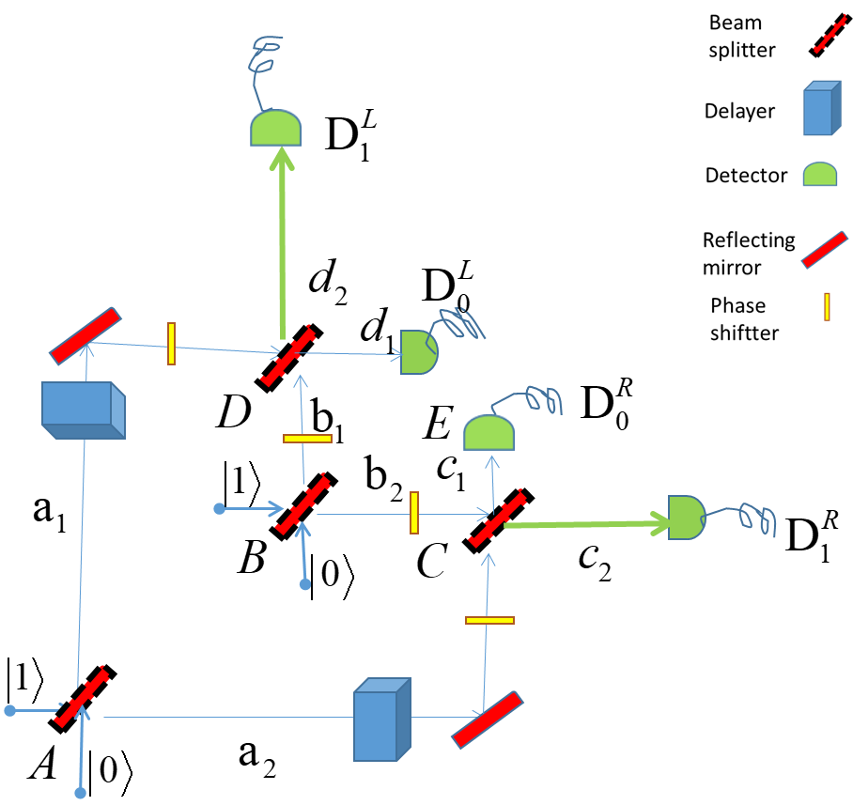

Figure 3: THE STATE ORTHOGONALITY INTERFEROMETER

Due to the separate nature of atoms, two indistinguishable photons emitted by the atoms are orthogonal, with. Therefore, their bunching parameter is . Indeed, since the original HOM experiment (Hong, Ou, and Mandel, [2]), the boson bunching with has been demonstrated in many variations, as in, for example, Jeltes et. al [4]. This gives rise to the question of how to achieve other values of the state orthogonality , and accordingly, a bunching parameter with  . The interferometer described in Fig. (3) can be used to tail photons to have a state orthogonality .

In Fig. 3, there are two incoming photons, one on the incoming legs of beam splitter, and one on the incoming legs of beam splitter. The delays at  and at are set in such a way that the photons that come from beam splitter and reach beam  splitter and beam splitter simultaneously.

The photons will be detected eventually in one of the four detectors. Each of the beam splitters is unitary:



where  . The phase shifter at each leg will be denoted by the leg where it is-- that is, , where  . To keep the notation simple, we first consider the case



We will plug it back in later, as necessary.

The amplitude of the photons entering the beam splitter  is given by



where the subscript notation is as in Gerry and Knight [15] and above. The letter  above or below the arrow indicates that the photon passes through the  beam splitter.

The amplitude of the photons entering the beam splitter  is given by



Now if the detectors both read zero, we are left with the states at legs  and . Such conditional processes at detectors are known as “post selected measurements”, as stated by Aharonov, Bergmann, and Lebowitz [16].

Then the photons’ state at  is given by



And the photons’ state at  is given by



The respective wave functions of the photons are



where  and  are the normalization constants determined by the condition. Using the commutation relations in Equations , we find



Defining



the joined wave function is

 .

We can use Equation to calculate the overall normalization 



And also, from Equation , we calculate



If, however, the two photons are distinguishable (say, by their respective polarization), Eq. is unchanged:



But because the photons are distinguishable, the creation operator in is set to 



by means of the commutation relations in Equations .

The single-photon wave functions are



where  and  are the normalization constants determined by the condition. Using Equations gives  and .

Defining



the joined wave function of the distinguishable photons is



And the normalization  gives .

Using Equations and for the state orthogonality (Equations and ), the bunching parameter becomes, by ,



In the case where the phase of the interferometers in Fig. 3 is not zero, that is,, the output amplitude will be modified.

The modification at legs  and  is



And the modification at legs  and 



Since  for all , the normalization in Equation is unchanged.

The bunching parameter with a non-zero phase (Equation ) now becomes



The representations of the reflected and transmitted coefficients of the beam splitter is the general matrix for a beam splitter



such that  and .

In particular, we select



where  is the index of the beam splitter.

It is important to keep in mind that the state orthogonality interferometer may be used in three different ways:

* As an interferometer to track two distinguishable photons
* As an interferometer to track two indistinguishable photons. In practice, we will receive non-trivial state orthogonality, 
* And, as in this paper, to combine the two above ways to find the bunching parameter.

Now we will focus on three cases of the state orthogonality interferometer:

* The case where all phases are zero: ,
* The case where all phases give real value output amplitudes, and
* Lastly, the case where different conditions hold for each photon (see below).
  1. Case of Zero Phases

To see the range of values for the bunching parameter that this interferometer realizes,we will consider the simplified version of that interferometer.

If we choose the beam splitters  and  to be symmetrical,  , the range of the bunching parameter is given by Equation , as shown in Fig. 4.

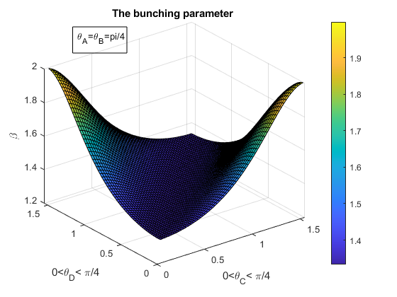

Figure 4 the bunching parameter range

That is, for a simple setup, where the beam splitters  and  are symmetrical, the bunching parameter range is more than 70% of its full range (see Fig. 4). However, it is not hard to get a full-range parameter. For example, setting  gives a full-range bunching parameter.

3.2 Real Value Output Amplitudes.

Producing real value amplitudes can be done by adding phase shifters at the legs , as, for example, with the following phases



and the amplitude modification is



as can be checked directly by Equations , to see that all amplitudes at the legs  and  will have real values.

In this case, the bunching parameter becomes



where the normalization is unchanged. The range of  is .

* 1. An Important Case (see below)

The resent and the title for this setup will became clear in the next section.

For the last setup, consider the following conditions:

1. All modulus amplitudes at legs  and  are equal
2. The phase between the wave function at leg  as compared to leg  of one of the photons (for example, ) is 
3. There is no phase difference between the amplitude of the second photons (for example,).

Condition A can be met by setting  . Then, the amplitude is, .

Condition B can be achieved by adding phase shifts and to the amplitudes of photons  at leg  and leg  . The wavefunction is given by



Accordingly, we have



Condition C. To produce the same amplitude for a photon in leg  as in leg  for photon , we have



One way to meet Conditions and is



Using Equation , the orthogonal state is  , and thus



Next, we will use the results of Section 3.2 and 3.3 to show the generalization of the HOM effect. 3.4 Generalization of the HOM Effect

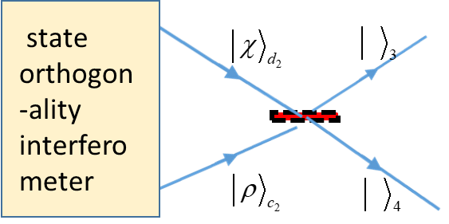

Figure 5: state orthogonality in the HOM setup

As an application of the state orthogonal interferometer, let us see how it changes the bunching behavior in the HOM effect. The HOM effect yields results with the following two properties:

1. Fig 1(a), the coincidence probability of the outgoing indistinguishable photons at different legs is measured as,
2. Fig 1(b), the joined photons will appear half of the time on the upper leg, and half of the time on the lower leg.

Our goal here is to show how both of these properties can be generalized.

To do that, let us consider the following steps:

1. Remove the detectors .
2. The wave functions at the legs  and .are the input of the symmetric beam splitter, as shown in Fig. 5.
3. Set the wave function amplitude at  and  , as in Cases 3.2 and 3.3 above.

3.5 Case 3.2 as the Input of the HOM Experiment--A Generalization of Property A.

One may directly calculate the results of this case in the HOM setup as in Fig. 5. Here we chose to do that via the bunching parameter. First, run two *distinguishable photons* in the interferometer. As a result, their amplitudes are a real value: the probability to find them together at the output is given by (see the Appendix for details):



Now, running two indistinguishable photons in the same setup, but for distinguishable photons, the probability to find them together is as in Equation



By probability conservation, the probability to find the indistinguishable photons in *different legs* is



which equals zero only for  --that is, the HOM Effect cases. Thus, this is a generalized result of the HOM effect.

3.6 Case 3.3 as an Input of the HOM Experiment, a Generalization of Property B.

First, we will run two *distinguishable photons* in the interferometer. As a result, by their amplitude setup l (see the Appendix for details) we have



Note that since the construct of distinguishable photons  have a phase relation, it will only be emitted in each leg, while the distinguishable photons  have equal probability to be emitted in either leg.

Now, running two indistinguishable photons in the interferometer, the probability to find them together is given by Equation



and thus . That is, all of the indistinguishable photons are emitted together, but in the same leg.

In the HOM case with Property B above, the indistinguishable photons will be emitted half of the time in the lower leg, and half of the time in the upper leg. This is a generalization of Property B of the HOM effect.

# Discussion and Summary:

In Section 2, the theoretical bunching parameter was derived for two photons (Equation ). It yields the rule that indistinguishable photons appear at times as distinguishable photons, with a bunching parameter such that . The underlying property is that the bunching parameter depends on the state orthogonality of the two indistinguishable photons, such that .

The HOM effect (as in Jeltes [4]), illustrated in Fig. 1, is then understood as a special case withand thus. However, in natural circumstances, photons are produced from separate atoms. Then their initial states are orthogonal, i.e., . Thus, a bunching parameter of  is not an everyday phenomenon. This posits a question, and a challenge, of how to produce states with a bunching parameter other than 2.

Therefore, in Section 3, using the post selected measurements [16?] we introduced the state orthogonality interferometer (Fig. 5). This interferometer exhibits state orthogonality, and by extension, the bunching parameter. In order to see further application of the interferometer, we considered three specific interferometer setups. In Section 3.1, we used the setup where and for all . Those set up over the range  produced a full bunching range, i.e., fullorthogonality of the states, as in Fig.

In order to show an example that constitutes a generalization of the HOM effect, two further setups of the interferometer were given in Sections 3.2 and 3.3.

Finally, in Section 4, we categorize the HOM effect by two properties:

1. Two indistinguishable photons emitted together, and
2. Two indistinguishable photons emitted half of the time to the one leg and half of the time to the other leg together.

Then by Equation we show that the setup of Section 3.2 for indistinguishable photons that enter in different legs in the HOM experiment violates Property A.

In other words, the HOM effect of two photons interferes with . The generalization of Property B is given by means of the setup in Section 3.3. Equation shows that indistinguishable photons will be emitted to a single leg. This clearly generalizes Property B of the HOM effect.

Another way to categorize the generalization of the HOM effect that we represented here is as follows: Whereas in the HOM effect, the interference is only between the two photons, in the case of state orthogonality, where  , both single photon interference and two photons interference occurs.

Or, stated in a more general way, state orthogonality for photons combine interferences of a single photon with itself, and of two indistinguishable photons with one another. It seems that this property is unique to photons (bosons).Indeed the state orthogonality for fermions is always . The hunch is that, according to the state orthogonality, fermions don’t exhibit the same process of single fermion interference and two fermion interference at the same time.

More details about the HOM dip for the state orthogonality interferometer, for example, the modification of HOM dip and other applications will be discussed elsewhere.

I wish to thank Dr. Oskar Pelc and Dr. Oded Kenneth for their helpful comments on this paper.

# Appendix

1. Derivation of Equation —Probability of Two Distinguishable Photons

Consider one photon superimposed on two incoming legs of a symmetric beam splitter  . Then,



with the normalization  .

In the case where  the probability to find the photons at the output legs is



Thus, the probability of two distinguishable photons to be together in one leg is  --that is, as shown in Eq. .

1. Derivation of Equation

Consider the case



which gives .

[1] Hanbury Brown, R.; Twiss, Dr R.Q. (1956). ["A Test Of A New Type Of Stellar Interferometer On Sirius"](http://www.cmp.caltech.edu/refael/league/hanbury.pdf) . *Nature*. **178**: 1046–1048.

[2] C. K. Hong; Z. Y. Ou & L. Mandel (1987). "Measurement of subpicosecond time intervals between two photons by interference". *Phys. Rev. Lett*. **59** (18): 2044–2046.

[3] Ghosh R, Mandel L. “Observation of non-classical effects in the interference of two photons”. *Phys Rev Lett*. 1987;59(17):1903-1905.

[4] T. Jeltes, et al,” Comparison of the Hanbury Brown-Twiss effect for bosons and fermions".

*Nature* **445**, 402 (2007).

[5] Feynman, R. P., R.B. Leighton, and M.L. Sands, *“The Feynman Lectures in Physics*”,Vo III Addison-Wesley 1963.

[6] Fano, U. (1961). "Quantum theory of interference effects in the mixing of light from phase independent sources".*American Journal of Physics*. **29** (8).

[7] Marchewka, A., Granot, E. “Destructive interferences results in bosons anti bunching: refining Feynman’s argument”*.* *Eur. Phys. J. D* **68,**243 (2014).

### [8] A Marchewka, [E Granot](https://scholar.google.co.il/citations?user=uXEZPrQAAAAJ&hl=iw&oi=sra), Z Schuss**:** “ [On the spatial coordinate measurement of two identical particles‏](https://www.sciencedirect.com/science/article/pii/S0375960116002620)” *Physics Letters A,* 2016‏

### 

[9] W. J. Mullin and G. Blaylock, “Quantum statistics: Is there an effective fermion repulsion or boson attraction”?, *Am. J. Phys.***71**, 1223 (2003) and references therein

[10] Avi Marchewka and Er'el Granot, "Role of Quantum Statistics in Multi-Particle Decay Dynamics", *Annals of Physics*, 355, 348–359 (2015);

[11] Avi Marchewka and Er'el Granot, “Quantum Dynamics Arising from Statistical Axioms”  [*arXiv:1009.3617*](https://arxiv.org/abs/1009.3617)**.**

[12] Mousavi, S.V., Miret-Artés, S. “Dissipative two-identical-particle systems: diffraction and interference”. *Eur. Phys. J. Plus* **135,**83 (2020).

[13] Marchewka, A., Granot, E. State orthogonality, boson bunching parameter and bosonic enhancement factor”. *Eur. Phys. J. D* **70,**90 (2016)

[14] Cohen-Tannoudji, C, Diu, B., and Laloe, F. (1977), “Quantum mechanics”, vols. II, *John Wiley*, New York.

[15] C. Gerry and P. Knight, “Introductory Quantum Optics” (2004) *Cambridge*.

[16] Y. Aharonov, P. Bergmann, and J. Lebowitz, Phys. Rev. 134, B1410 (1964).