State orthogonality interferometer combining: Generalization of HOM effect

Avi Marchewka

8 Galei Tchelet St., Herzliya, Israel

avi.marchewka@gmail.com

Abstract

Are photons either bunched or unbunched, or are these particular cases of a wider phenomenon? Here we will show that bunched and unbunched photons are indeed two extreme cases of a process parameterized by a continuous parameter, called the bunching parameter, and (mainly) we will suggest the state orthogonality interferometer that can be used for the construction and measurement of the full range of values of the above bunching parameter. Finally, as an application of the bunching parameter, we will show how the HOM effect is generalized. Unlike in HOM effectת where the interferences is only between the two photons, the stats produces by the states orthogonally interferometer exhibit both single photon interferences and two indistinguish photon interferences. A property that Fermions does not seen to have.

1. Introduction

The exchange degeneracy symmety of identical particles gives rise to a new kind of interference, the interference between the particles’ wave functions. This interference plays a role in several important quantum physics effects, e.g. the electron configuration of atoms, behavior of light, Fermi-Dirac and Boss- Einstein statistics, and many more. Among those is the bosons bunching of indistinguishing bosons (also named bosons enhancements). Bunching refers to the preference of indistinguishing bosons to be found in the same state compared to distinguishing particles under the same scenario. The footprint of bosons bunching is found in a variety of cases. To mention a few:

### [Hanbury Brown-Twiss effect](https://www.nature.com/articles/s41598-017-02408-6) [1], HOM [2], Gיhosh Mandel [3], atomic optics [4].

Feynman [5] gave a quantified measure of the bosons bunching. He showed that the probability of finding  indistinguishing bosons in the same state is  higher than for  distinguishing bosons (see also [6])

However, it has been shown that this picture is more subtle, and in fact, Feynman's claim does not hold in general. For example, in [7] it is shown that the measure of a spatial probability of indistinguishing bosons is equal to those of distinguishing bosons. That is, the  doesn't hold, and in fact, it is not well defined in the limiting case where the detector size goes to zero [8].

It is very tempting, as is often done, to describe the bunching of indistinguishing bosons due to “attractive forces” between the indistinguishing bosons[9]. However, this view is also only a partial truth. It has been shown [10-12] that when two bosons are released from a trap, the bosons behave as if they have “repelling forces” which govern their behavior.

Finally, a way to generalize the bosons bunching for Schrödinger particles has been given at [12]. This generalization defines a "bunching parameter", which is equal to N! in the special case considered by Feynman.

The aim of this letter is threefold. The first one, in section 2, is to formulate the bosons parameter for two photons’ fields. To do this, the bunching parameter will be reformulated in the second quantization language. Then, in section 3, the state orthogonality interferometer will be represented with different realizations of the photons state orthogonality. This interferometer enables "tailor-made" states of arbitrary state orthogonality of photons and its corresponding bunching parameter. In particular so, a tailor-made" state that is not produced in natural light. Finally, in section 4, we use those "tailor-made" states in the HOM experiment. Then, we show that such states generalize the HOM effect.

The notation of the “first quantization” follows [14] and in the “second quantization” we follow [15].

2. Bunching parameter for two photons.

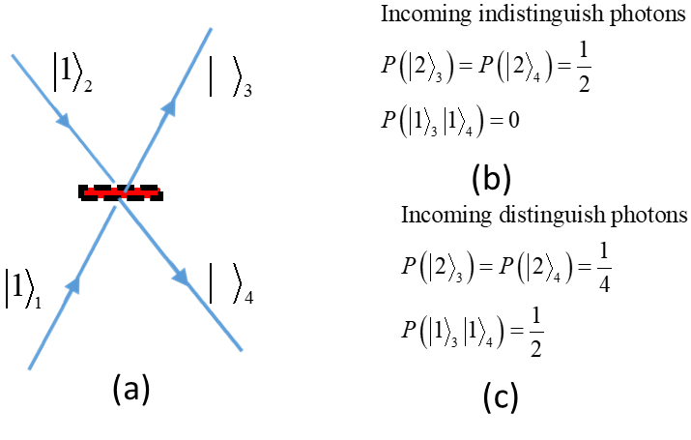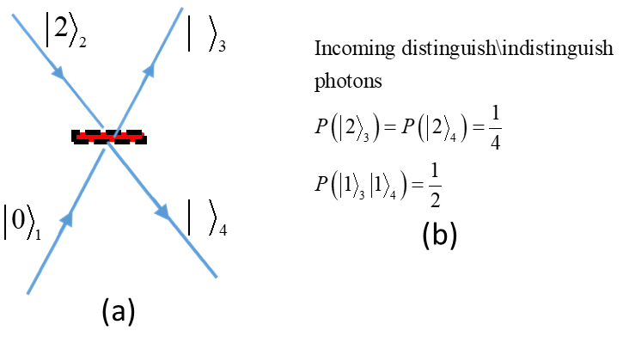The HOM [2] effect demonstrates clearly the bunching of two photons. In Fig 1(a), the schema of the HOM experiment is represented: two photons enter simultaneously from different legs onto a symmetric beam splitter. The notation as in [15], for example, , means one particle in leg 2. The photons’ probability to be found on the outcoming legs, is given at fig 1 (b) for indistinguishing photons and in fig.1(c) for distinguishing (say by their polarization degree of freedom) photons. As seen in fig1(b), the indistinguishing photons are always emitted together, whereas, as seen by fig1(c), distinguishing photons are emitted together only half of the time, and half of the time emitted to different legs. This preference of the indistinguishing bosons to emit together is a manifestation of the bosons bunching. In Fig 2 two photons enter simultaneously on the same leg of the beam splitter. In fig 2 (b) the probability of finding the emitted photons is given. It turns out that the probability of the emitted photons is independent of photons being distinguishing or not: the difference between the indistinguishing and distinguishing photons disappears. From these examples we can see that the distinguishability of the photons is not the only condition that plays a roll whether to be bunched or not.

Figure 1: schema of the HOM experiment

Figure 2: two photons enter simultaneously on the same leg

2.1 The bunching parameter fist quantization

Consider two particles in a two-dimensional space with an orthonormal base of two states 



With



The scalar product of the two states



Here we follow the notation of [15]. The index inside the ket  represents the particle, and the Greek later is the state the particle is in.

If the two particles are distinguishing bosons, one of the bosons is in the state  and the other is in the state , their joined wave function is,



Where and is the normalization constant given by the condition.

From



From the probability for the two distinguishing bosons to be in the same state, say , is,



However the joined wave function of two indistinguishing bosons has to have symmetries [14]. That is,



Where is the symmetric operator defined for two particles as



With  and  is the permutation operator.

Normalization of the joined bosonic wave function  gives



That is becomes



The probability of finding the two indistinguishing bosons in the same state, say  , is



Using and the bunching parameter is defined by the ration



Before discussing the bunching parameter, we derive it in the formalism of the second quantization.

* 1. Bunching parameter for photons: second quantization

In the second quantization the initial state for distinguishing photons become,



Where the first photon denoted by operator , the second photon denoted by the operator ,and the normalization is given by .

With the following bosonic commutation relation



It is convenient to define



The following commutation relation follows



The number like operators of the states are  with, and with.

The joined wave function of the two distinguishing photons is



By the normalization we have .



The probability of finding both particle in the same state, say  is



If instead of the two distinguishing bosons the bosons are indistinguishing the wave function became



Whith the bosonic commutation relation



Accordingly we use the definition



The following commutation relation follows



The number like operator for the particles generated by are  with .

The joined indistinguishing wave function is



Where  is the normalization of the joined indistinguishing bosons.

Imposing the normalization  give



The probability to find both indistinguishing bosons to be in the same state, say  with normalization  , is



Using and the bunching parameter is



Equations and are clearly the same.

Since,  it follows that the bunching parameter is  .

It is instructive to compare this with the examples described at fig (1) and fig (2). In fig (1) the two photons have orthogonal wave function, that is . It follow from equation that  and thus



That is the probability to find the two indistinguishing bosons is twice as much as if the two bosons were indistinguishing, indeed as can be seen in fig 1(b) and Fig 1 (c).

However if the two bosons entering in the same leg, as in fig(2), then . Then equation gives  . Thus,



That is, the probability to find the two distinguishing bosons is the same as two indistinguishing bosons, indeed as can be seen in fig 2(b).

As usual, the quantity that is invariant under unitary plays an important role. Let us show that the bunching parameter is indeed invariant under unitary transformation.

Consider two different two-dimensional spaces, with bases  and .

The bunching parameter for the base is



Likewise the bunching parameter for the base is



These bases are related by a unitary transformation



under which the scalar product is invariant, so . Thus by we have, that is the bunching parameter is invariant under a unitary transformation.

For typical cases of emitting photons from separate sources, e.g. atoms, the photons are in orthogonal states,  . Since the bunching parameter is invariant under unitary transformations, it follows that to change the bunching parameter one needs an a non-unitary transformation. This will be discussed next.

1. The state orthogonality interferometer

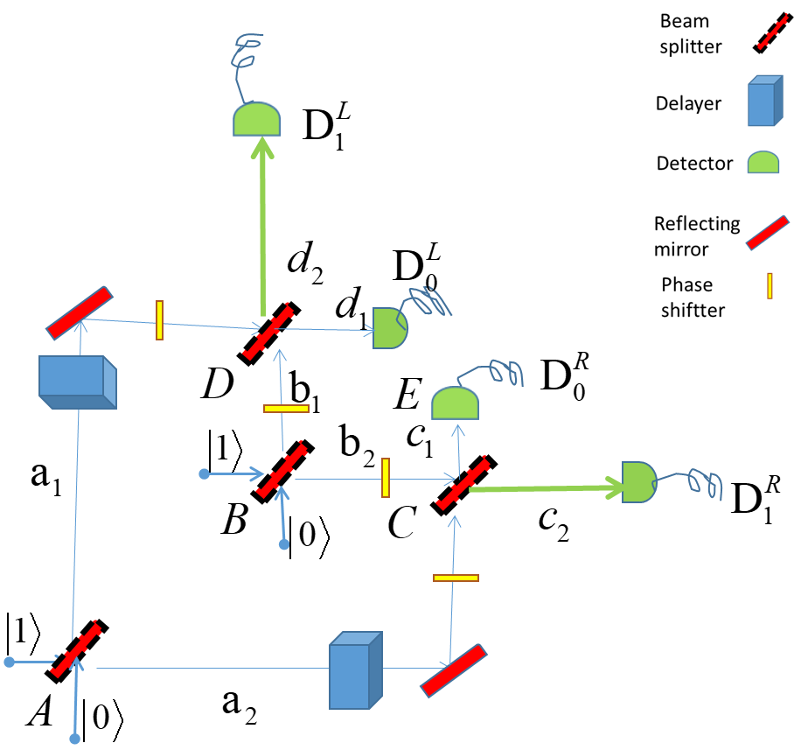Due to the separate nature of atoms, two indistinguishing photons emitted by the atoms are orthogonal, . Then, their bunching parameter is  . Indeed, since the original HOM [2] experiment, the bosons bunching with has been demonstrated in many variations, e.g. [4]. This gives rise to the question of how to realize other values of the state orthogonality , and accordly the bunching parameter with  . The interferometer described in Fig (3) can be used to tail photons to have a state orthogonality . In Fig 3. Two incoming photons, one at the incoming legs of beam splitter, and one on the incoming legs of beam splitter.. Setting the delays at  and at such that the photons that come from beam splitter and reach the beam  splitter and beam splitter simultaneously.

Figure 3: the state orthogonality

interferometry

The photons will be detected eventually in one of the four detectors . Each of the beam splitters is unitary:



Where  . The phas sifter at legs will denoted according the leg it is at, that is  where  . To keep the writing clean we first consider the case



Later we plug it in back as needed.

The amplitude of the photons entering the beam splitter  is given by



Where the subscript notation is as in [15] and above. The  above and below the arrow denotes the photon passes the  beam splitter.

The amplitude of the photons entering the beam splitter  is given by



Now if the detectors both have zero reading, we are left with the states at legs  and . Such processes of condition on detectors are known as post selected measurements, e.g. [16].

Then the photons state at  is



And the photons state at  is



Accordingly, the wave functions of the photons are



Where  and  are the normalization constants determined by the condition.. using the commutation relation we find



Defining



The joined wave function is as follows



we can use to read out the overall normalization 



And also, from , read out



If however the two photons are distinguishing photons (say by their polarization) Eq. is unchanged



But because the photons are distinguishing, the creation operator in is set to



with the commutation relation .

The single-photon wave functions are,



Where  and  are the normalization constant determined by the condition. Using gives  and .

Defining



Then the joined wave function of the distinguishing photons ןs



And the normalization,  gives .

Using and for the state orthogonltiy and the bunching parameter became



In case where the phase of the interferometers Fig3. are not zero ,the output amplitude will be modify.

The modification at arm  and 



And the modification at arm  and 



Since  for all  the normalization is unchanged.

The bunching parameter whit phase now became



The representations of the reflection and transmitted coefficients of the beam splitter is the general matrix for beam splitter



Such as  and .

In particular we chooses



Where  is the indexing of the beam splitter.

It is important to keep in mind that the stats orthogolity interferometer may be used in tree deferent ways:

* As interferometer to tallied two distinguish photons
* As interferometer to tallied the indistinguish photons. In pratcule got non trivial stats orthogonality, 
* And, as here, combine the two above to fine the bunching parameter.

Now we will focus in tree cases of the stats orthogonltey interferometer: when all phase are zero , where all output phases give real value amplitudes, and finally case where each photons holed deferent conditions (see below).

* 1. 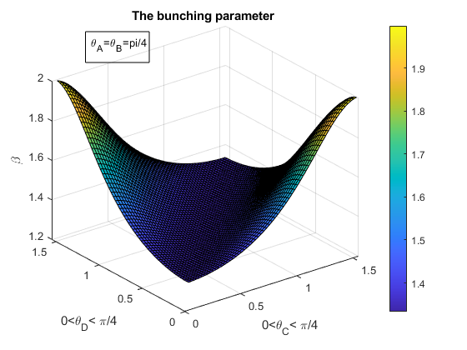Case of zero phases

To see the range of values for the bunching parameter that this interferometer realizes we will consider the simplified version of that interferometer.

If we chose the beam splitters  and  to be symmetric,  the bunching parameter show in fig4. That is, for a simple setup, when the bean splitters  and  are symmetric, the range of the bunching parameter range is more then 70% to its full range (see Fig 4). However, it is not hard to get full range parameter. For example setting  give full range bunching parameter.

Figure 4 the bunching parameter range

3.2 Real value output amplitudes.

To produces a real value amplitudes can be done by adding phase shifters at the legs . For example the following phases



And the amplitude modification is,



As can be checked directly at , to see that all amplitude at the legs  and  will have real value.

Then the bunching parameter became



Where the normalization is unchanged. The rang of  is  .

* 1. An important case (see below )

The resent and the title for this setup will became clear in the next section.

For the last set consider the following condition

1. all modulus amplitude a t legs  and  are equals
2. The phase between the wave function at leg  to the leg  of one of the photons, say , is 
3. No phase between the amplitude of the second photons, say.

Condition 1. can meet by setting  . Then, the amplitude is, .

Condition 2. By adding phase shift and the amplitudes of photons  at amplitudes leg  to the leg  is



Accordingly we have



Condition 3. To produces the same amplitude for photon leg  to the leg  for photons  we have



One way to meet condition and is



Use the stats orthogonal is  and thus



Next we will use the results of section 3.2 and 3.3 to show the generalization of HOM effect.

1. Generalization of the HOME effect

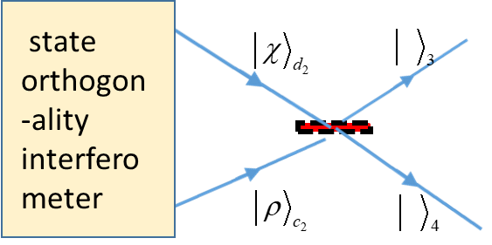 As an application of the stats orthogonal interferometer let see how it changes the bunching behavior of the HOM effect. The results of home effect has the following two property:

Figure 5 the stats orthogonal in HOM set up

1. Fig 1(a), the coincidence probability of the outgoing indistinguish photons at different legs is measured to give,
2. Fig 1(b), the joined photons will appear half of the time on the upper leg and half of the time on the lower leg.

Our intention here is to show both of those property can be generalized.

To do that consider the following steps:

1. Remove the detectors 
2. The wave functions at the legs  and .are the input of symmetric beam splitter as in Fig. 5.
3. Set the wave function amplitude at  and  according to case 3.2 and 3.3 above

4.1 Case 3.2 as input of HOM experimented. A generalization of property a.

One may calculate directly the results of this case in the HOM set as Fig5. Here we chose to do that via the bunching parameter. First run two *distinguish photons* in the interferometer. As a results their amplitude are a real value the probability to fined then together at the output (see appendix for detail)



Now, running two indistinguish photon in the same set but for distinguish photons the probability to fine then together is



By probability conservation the probability to fin the indistinguish photons in *deferent legs* is



Which zero only for  , the HOM cases. Thus, a generalized the results of HOM effect.

4.2 Case 3.3 as input of HOM experiment, a generalization of property b.

First we will run two *distinguish photons* in the interferometer. As a results their amplitude set up l (see appendix for detail) we have



Note that since the construct of distinguish photons  has phase relation it will only omitted in giving leg, while distinguish photons  has equal probability too omitted at either legs.

Now, running two indistinguish photon in the interferometer, the probability to fine then together is



And thus . That is, all the indistinguish photon emitted together but in the same leg.

Whereas in the HOM cases, property b. above, the indistinguish photons will emitted half of the time in the lower leg and half of the time in the upper leg. Thus, a generalized the b. property of HOM effect.

1. Discussion and summary:

In section 2 the theoretical bunching parameter has derive for two photons . It give the roll that indistinguish photons appear , , times a distinguish photons. The underline property that the bunching parameter depend in is the stats orthogonality of the two indistinguish photons , such as . The HOM effect [4] ,Fig 1, is then understood as special case with and thus . However, in natural circumstances photons are produced from separate atoms, then their initial states are orthogonal i.e. . Thus, a bunching parameter of  is not an everyday phenomenon. This post a question, and challenge, how to produces stats whit bunching parameter others then 2. Therefore, in secation3, using the post selected measurements [] we introduced the states orthogonality interferometer Fig.5. This interferometer exhibit of stats orthogonality and accordingly thy bunching parameter. In order to see further application of the interferometer tree specific set up of the interferometer consider. In 3.1 the set of and for all  has taken. Those set up over the range  production full bunching range i.e. full stats orthogonality, Fig. Aiming to show an examples that constituted a generalization of the HOM effect two further set up of the interferometer has given at 3.2 and 3.2. Finley, in section 4, we categorize the HOM effect by two property: a two indistinguish photons emitted together and b. two indistinguish photons emitted half of the time to the one leg and half of the time to the other leg together. Then show that the setup of 3.2 for indistinguish photons that enter in deferent legs in HOM experiments violet property a. Put it in another way, HOM effect of two photons interfere with . The generalization of property b given via the setup 3.3. Eq. show that indistinguish photons will emitted to a single leg which clearly generalize property b of HOM effect. Another way to categorize the generalization of HOM effect that we represented hear is as follow: while in HOM effect the interferences is only between the two photons, in the case of states orthogonality  both type of interference , single photons interference and two photons interferences, take place.

Or in more general way, states orthogonality for photons combine interferences of single photon whit itself and of two indistinguish photons whit one another. It seems that this property is unique to photons (bosons).Indeed the stats orthogonality for fermiums is always . And, hunch, according to the stats orthogonality fermiums doesn’t exhibit in the same process single fermium interferences and two fermions interferences at the same time.

More detail HOM dip for stats orthogonality interferometer e.g. the modification of HOM dip and other application will discusses elsewhere.

I wish to thank Dr. Oskar Pelc and Dr. Oded Kenneth for their helpful comments on the paper.

Appendix

1. Equation

Consider one photons on superposed on two incoming legs of symmetric beam splitter  . Then,



Where the normalization  .

In the case where  the probability to fine the photons at the at the output legs



Thus the probability of two distinguish photons to be together in one les is  that is .

1. Equation

Consider the case



Which gives .

[1] Hanbury Brown, R.; Twiss, Dr R.Q. (1956). ["A Test Of A New Type Of Stellar Interferometer On Sirius"](http://www.cmp.caltech.edu/refael/league/hanbury.pdf) . *Nature*. **178**: 1046–1048.

[2] C. K. Hong; Z. Y. Ou & L. Mandel (1987). "Measurement of subpicosecond time intervals between two photons by interference". *Phys. Rev. Lett*. **59** (18): 2044–2046.

[3] Ghosh R, Mandel L. “Observation of nonclassical effects in the interference of two photons”. *Phys Rev Lett*. 1987;59(17):1903-1905.

# [4] T. Jeltes, et al,” Comparison of the Hanbury Brown-Twiss effect for bosons and fermions".

*Nature* **445**, 402 (2007).

[5] Feynman, R. P., R.B. Leighton, and M.L. Sands, *“The Feynman Lectures in Physics*”,Vo III Addison-Weslel 1963.

[6] Fano, U. (1961). "Quantum theory of interference effects in the mixing of light from phase independent sources".*American Journal of Physics*. **29** (8).

[7] Marchewka, A., Granot, E. “Destructive interferences results in bosons anti bunching: refining Feynman’s argument”*.* *Eur. Phys. J. D* **68,**243 (2014).

### [8] A Marchewka, [E Granot](https://scholar.google.co.il/citations?user=uXEZPrQAAAAJ&hl=iw&oi=sra), Z Schuss**:** “ [On the spatial coordinate measurement of two identical particles‏](https://www.sciencedirect.com/science/article/pii/S0375960116002620)” *Physics Letters A,* 2016‏

[9] W. J. Mullin and G. Blaylock, “Quantum statistics: Is there an effective fermion repulsion or boson attraction”?, *Am. J. Phys.***71**, 1223 (2003) and references therein

[10] Avi Marchewka and Er'el Granot, "Role of Quantum Statistics in Multi-Particle Decay Dynamics", *Annals of Physics*, 355, 348–359 (2015);

[11] Avi Marchewka and Er'el Granot, “Quantum Dynamics Arising from Statistical Axioms”  [*arXiv:1009.3617*](https://arxiv.org/abs/1009.3617)**.**

[12] Mousavi, S.V., Miret-Artés, S. “Dissipative two-identical-particle systems: diffraction and interference”. *Eur. Phys. J. Plus* **135,**83 (2020).

[13] Marchewka, A., Granot, E. State orthogonality, boson bunching parameter and bosonic enhancement factor”. *Eur. Phys. J. D* **70,**90 (2016)

[14] Cohen-Tannoudji, C, Diu, B., and Laloe, F. (1977), “Quantum mechanics”, vols. II, *John Wiley*, New York.

[15] C. Gerry and P. Knight, “Introductory Quantum Optics” (2004) *Cambrigde*.

[16] Y. Aharonov, P. Bergmann, and J. Lebowitz, Phys. Rev. 134, B1410 (1964).