**How we met**

The name **Canaan** as it appears in the Old Testament is a general term that was prevalent among the cultures of the Near East as early as 2000 BCE. The term Canaanite refers to a variety of **ethnic groups** with distinct cultural identities that populated the country from the third millennium to the end of the second millennium BCE.

These groups formed a **culture** that was so **developed** and powerful that in the 17th century BCE, the Canaanites invaded Egypt and established a kingdom in the Nile Delta (**the Land of Goshen**). The Egyptians called these rulers ***heqa khasut***(a foreign ruler) (hyksos in Greek). In 1540 BCE, Pharaoh Ahmose I **banished** the Canaanites from Egypt, **conquered** their last stronghold in Canaan (Tel al-‘Ajul), and ushered a period of about 350 years during which Canaan became an **Egyptian colony** and its kings the vassals of Pharaoh.

Around 1200 BCE, amid a **crisis** that spread across the ancient Near East, empires contracted and nations were uprooted. Subsequently, the Egyptians retreated from Canaan and cleared the area for new cultures such as the Philistines, the Israelites, the Ammonites, and the Edomites.

The Canaanites **integrated** into these cultures, whereas the city dwellers who lived along the northern shore of Canaan would over time become the nation of the Phoenicians.

Although the culture of the Canaanites would never return to its former glory, the Canaanites strongly **influenced** the new settler cultures particularly in the realm of religion.

Canaanite society

**Nabateans** began to appear in the Land of Israel in the beginning of the third millennium BCE – during the founding of the **first cities** by the Canaanites. The establishment of the cities introduced a new dimension – **an urban society** characterized by social stratification, but without a monarchy. Yet these cities **collapsed** at the end of the third millennium for reasons unknown.

About 200 years later, Canaan experienced the dawning of a **new era**. Amid the sparsely populated country, towns and villages were formed and consolidated into **city states** and small kingdoms. The three largest were Hatzor, Shechem, and Jerusalem. Governing the city was a **single ruler** and a class of warring **nobles** whose protection enabled the existence of small towns and villages (XXXXXXX). The rulers formed alliances to increase wealth and to deal with rival cities and nomadic tribes whose herds grazed between the cities.

Society as a whole was patriarchal, but some **women** achieved high status as priestesses and even governors/queens of royal cities.

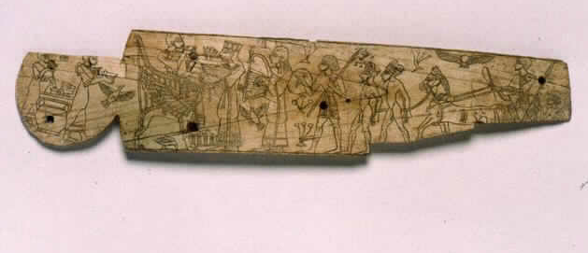

Canaanite governor. To the right, the victorious governor is seated in his chariot with prisoners in front. On the left, the governor is seated on a throne during the triumphal celebrations with his wife standing before him. The description contains many elements of Egyptian art such as birds, swamp plants, and a winged sun.

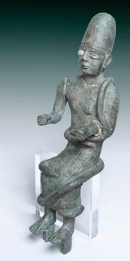

Figurine. A king sits on a throne, wrapped in a cloak with thick edges.

Law and order

The growth of the **urban** **and** **social** **system** in Canaan likewise generated an administrative system whose officials documented the affairs of the kingdom, which involved tax collection, contracts, distribution of salaries, etc. Additionally, as befitting Canaan's position between Egypt and Mesopotamia, scarabs (Egyptian-style seals) and **cylinder seals** (Mesopotamian-style seals), were used to stamp documents and goods.

Administrative documentation of the city’s international affairs was recorded using **cuneiform inscription** on clay plates, but the greatest contribution the Canaanites made to future generations was their development of **alphabetic script** (1700 BCE), whose roots are in Proto-Sinaitic inscription (1800 BCE). The latter was likely invented by merchants inspired by Egyptian pictographic writing.

Legal matters were probably conducted in accordance with a **code of conduct** inspired by the Codex of the King of Babylon (Iraq) - **Hamurabi**. This complex and efficient system would lay the foundations of the administration in the Land of Israel for thousands of years.

The economy

The economy of Canaanite society was based on **agriculture** and **animal farming**, yet the Canaanites' wealth stemmed from their positioning as a bridge between Egypt in the south, the Mesopotamian empires (Iraq) in the north, and the long coastline and its convenient routes.

Owing to the domestication of the **donkey** and the development of **sailing**, Canaan also participated in the expansive trade around the Mediterranean Sea.

The cargo of a **wrecked** Canaanite **ship** found off the coast of Turkey revealed tin copper, glass, ivory, resin, scarlet snails, decorative objects, and Canaanite jars containing oil, wine, and wheat. Moreover, a correspondence of the King of Mari (Syria) to the King of Hatzor shows that **through Canaan**, gold passed from Egypt, dyed fabrics were transferred from Canaan, as did musicians, while in return tin originating in Afghanistan, wool, and seals were transferred from Mari.

The Canaanites were so well-known as merchants that the very name **Canaan** in the Bible, referred to a **merchant** (Isaiah 23:8).

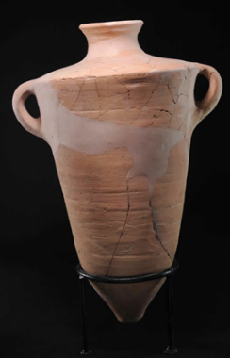

A Canaanite pitcher. Used to transport agricultural goods mainly at sea.

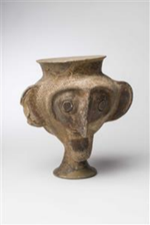

Goblets of this kind were made in Canaan and exported to Egypt through the Hyksos.

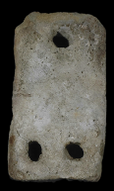

Wooden rods incorporated into the lower holes, anchored the ship. The rope was tied to a hole at the top of the anchor.

The good life

Trade enabled the accumulation of **wealth**, and brought cultural influences as well as a class hierarchy. Members of the upper class lived in large houses built in the desirable areas of the city, in the proximity to the **palace** and temples. The rooms were divided into different units such as washrooms, sleeping quarters, and warehouses, and were at times equipped with drainage systems.

**Feasts** were held in palaces and affluent people adorned their residences with **luxury items**, scented themselves with rare cosmetics, and ate from fine dishes imported from neighboring countries and extending to the Baltic Sea. **Spices** arriving from the Far East brought vanilla, cinnamon, citrus oil and ginger to their tables.

Great gods!

Canaan was positioned within the **cultural sphere** of Syria and Mesopotamia, sharing the same **deities** that characterized the region. Nevertheless, the **Canaanite pantheon** was infiltrated by influences of the Egyptian world. Since life in Canaan depended on precipitation, the central deities were the **rain and fertility gods** that governed human life, animals, and vegetation. **Ba'al** was the storm god and his wife **Ashera** was perceived as the goddess of the sea. Ba'al's brother, **Mot**, signifies death and wilting. A lesser degree of gods were the **refa’im** (ghosts), the spirits of the proto-heroes who became deified.

The deities resided in temples and places of worship in the wild, while priests took care of their needs by offering **sacrifices**, conducting religious **rituals**, offering sacraments, and lighting **incense**. According to Canaanite belief, everything in life was directed by the gods: prophecy and **magic** were developed to communicate with the gods and receive their protection.

Apart from established religion, **domestic ceremonies** were held to ensure fertility and health, as evidenced by many pottery figurines found in them. These figurines may be the **Teraphim** mentioned in the Old Testament (Genesis 31: 19).

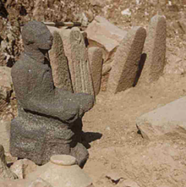

Temple of the Tombstones. The central tombstone is decorated with a pair of hands carrying a crescent symbol. This is probably the temple of the moon god - Sin.

Hatzor Temple. The temple is built in a pattern: a hall, shrine area, and inner sanctum. The lower part is coated with orthostates, or basalt stone slabs, with carved lion-shaped orthostates in the front.

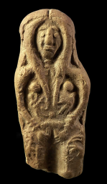

The mother goddess figurine (Ashera) is depicted with twins in her belly and ibexes grazing from the Tree of Life. The tree is a symbol of the goddess. These figurines were also found in private houses and graves.

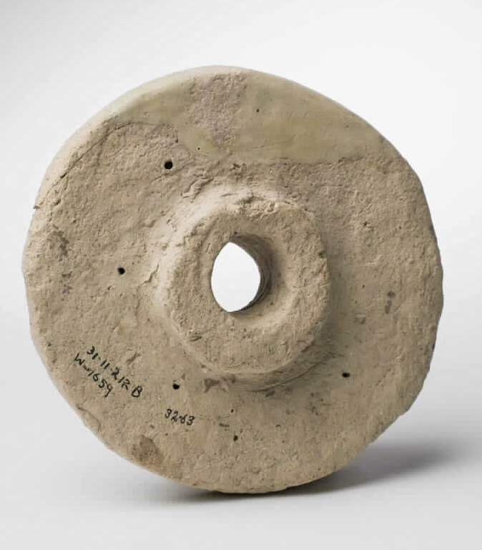

Wheel model. Models of this type were probably used in the worship of the goddess Shapash (Shapshu) the mistress of horses.

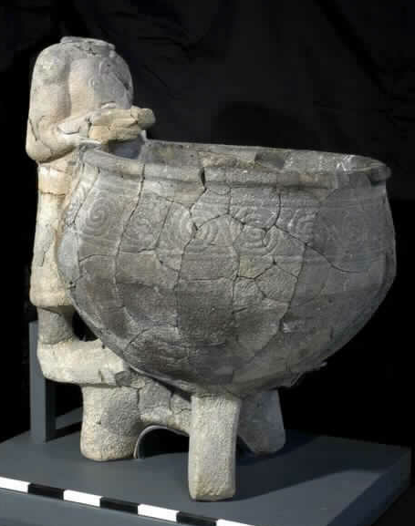

The statue of god Ba'al-Hadad, or the statue of the king facing a basin for religious ritual.

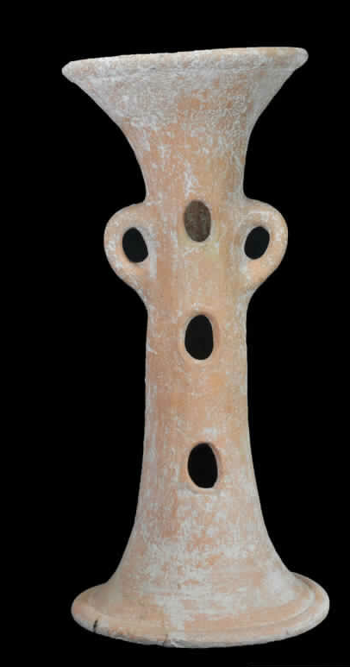

Ritual pedestal. On top of it, a bowl with incense or offerings was placed. This pedestal was found together with other implements in a storage pit containing sacred vessels from a Canaanite temple.

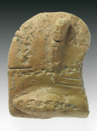

Liver model. Such models were used in the instruction of reading signs in the liver of the victim.

Fortified cities and fierce warriors

The wealth of the Canaanite cities attracted **enemies** and they were therefore surrounded by slippery walls, moats and watchtowers whose construction was influenced by the **fortifications** found in northern and central Syria. At times a city contained an inner **fortress** as well.

The Canaanites did not have a regular army, and fighters were called to battle as needed. The fighter's **weapons** included: bows, axes, swords, spear daggers, lances and a sling, and scaly armor that was used as defense. In addition to the infantry, the **nobles** and kings fought on horse-drawn **chariots** led by a driver and carrying soldiers.

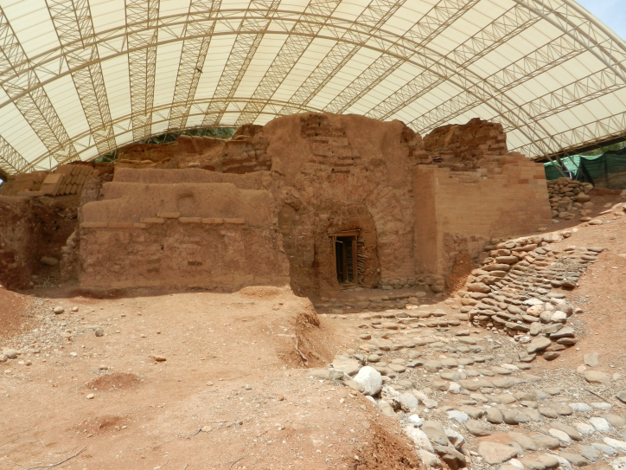

Dan City Gate. This arched gate is among the earliest in the world (1800 BCE), made of mud bricks and towers on both sides. A battery abutting the gate hampered access to the city. Photo: Israel Nature & Parks Authority.

Home, sweet home

**The village house** consisted of a single room or a number of rooms surrounding an open courtyard. A section of the courtyard was sometimes covered. A second story was usually built atop the lower-level rooms, connected by an external staircase. The house foundation was made of unrefined mud bricks atop unhewn stones. The floors were made of leveled dirt or were paved with small pebbles while the roofs were made of wood and plaster.

Since these communities were **demilitarized settlements**, these houses were often attached to one another and formed a protection belt for the settlement.

The **courtyard** was the area for cooking and processing food, spinning and weaving, and storing food in large jugs and silos, etc. The livestock was also gathered in the courtyard and possibly even in the lower rooms. Residential buildings in the **city** had a high level of organization. Many of the houses abutted the city walls and alleys ran in-between the houses.

The courtyard houses that were developed and refined by the Canaanites continue to exist **to this day** in the rural building tradition.

Home **furnishings** consist of stools, benches, tables, storage boxes and, in rare cases, beds. **House wares** included storage, cooking and serving implements, as well as auxiliary tools for various crafts.

What’s in style?

Canaan was famous for the **colored textile** industry to the extent that the word Canaan in the Hurrian language meant "**scarlet**." The biblical stories mention a number of the **garments and jewelry** used throughout the country during the period of the forefathers, such as festive clothes, woolen cloaks, striped cotton shirts, and shoes.

**Wool** and delicate plant fibers such as **linen** were woven into robes that were commonly used at the time. The robes were fastened by brooches made largely of **bronze**, and some of **gold** **and silver**. Furs, tassels, and helmets were added to the nobility's **ornate garments**.

For adornment and added **splendor** they wore beaded necklaces, earrings, rings, bracelets, and wreaths made of simple and precious metals and minerals, as well as seashells, faience (artificial blue material) and in rare cases even glass.

Much of the jewelry bore **symbols** of their spiritual world to provide protection to the wearer.

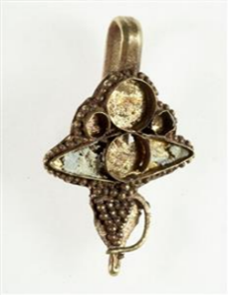

Earring, hanging from a headdress.

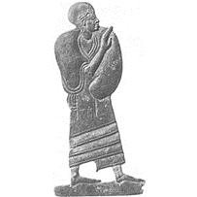

Plaque with a Canaanite noble figure. The nobleman is wearing a robe and wrapped in a cloak, and wears a helmet on his head.

To health!

Healing methods relied on **trial** and error as well as **belief**. Uses of charms and spells were very common along with medicinal plants and parts of animals. Disease was considered as a punishment by the gods and the healers were mostly clerics and shamans.

Egypt had a **medical school** where the [xxxxxx] learned to diagnose patients and prescribe medicine (677 medicines are mentioned in papyri). It is likely that under the influence of the Egyptians who ruled Canaan, the Canaanites also used medicine derived from herbs, roots, urine, gold, minerals, and organs.

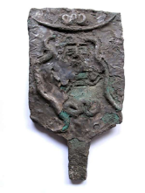

Ritual (xxxxx). Snakes twist around a goddess figure.

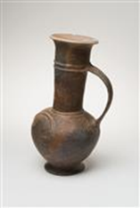

According to some researchers, and attested to by remains found in a few vessels, vessels such as this were used to store opium, one of the drugs used in medicine.

**Rest in peace**

**Belief** in **life after death** dictated the form and customs of burial. The grave was equipped as a **home for the deceased** with everything needed for their existence: food and drink, weapons, and personal items. Talismans were buried along with the dead for protection in the **afterlife**.

The deceased was often buried in his **clothes**, but on rare occasions, the Canaanites borrowed the burial practices of their neighbors and used **coffins**.

Natural caves or **tombs** dug into rooms were prepared for the dead. Children and babies were mostly buried in jars beneath the floors of the houses close to their **family**.

In the beginning of the second millennium BCE, the Canaanites customarily buried a **young animal**, primarily a sheep or goat, along with the dead. Apart from providing sustenance, the beast likely served as **sacrifice** by substituting for the dead (much like in the sacrifice of Isaac), thereby enabling the latter's **resurrection** in the afterlife.

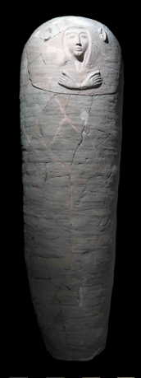

The Canaanite nobility adopted some of the customs of the Egyptian rulers.